ANA 515 Assignment 3, Visualizations Activity

Mel Sparks

4/17/2022

## Greenhouse Gas Emissions Dataset

This dataset contains information regarding how many tons of greenhouse gas emissions are produced annually in the world and by country from 1990 to 2018. I’m hoping to ascertain whether greenhouse gas production has increased or decreased worldwide, as well as if any top producing countries have made progress towards decreasing their annual output.

## This dataframe has 8 rows and 30 columns. Below, we can see a sample of how the dataframe looks.

## Country X2018 X2017 X2016 X2015 X2014  
## 1 China 11705.81 11408.26 11207.66 11149.68 11155.76  
## 2 United States 5794.35 5613.64 5676.92 5586.69 5711.15  
## 3 India 3346.63 3202.82 3073.24 3002.17 2988.34  
## 4 European Union (27) 3333.16 3401.95 3387.97 3046.38 2990.49  
## 5 Russia 1992.08 1939.26 1918.26 1791.21 1841.26

By looking at the dimensions, we can ascertain that the dataframe continues for another 20+ years. This won’t work for the type of visualizations I mentioned that we wanted to look at in the intro, so we’ll take a few steps to reformat the dataframe.

## Now the dataframe has 29 rows and 9 columns. Below, we can see a sample of how the dataframe looks now.

## Year China United States India European Union (27) Russia  
## 29 1990 2873 5543 1009 4279 2885  
## 28 1991 3023.38 5501.92 1064.49 4202.13 2788.70  
## 27 1992 3154.54 5583.80 1096.71 4058.11 2551.94  
## 26 1993 3377.79 5691.26 1128.44 3984.95 2294.62  
## 25 1994 3528.81 5782.20 1174.78 3968.32 2011.47

# Visualization 1

## First I want to see the trends for the top GHG emission producing countries for the given time period (1990 - 2018).

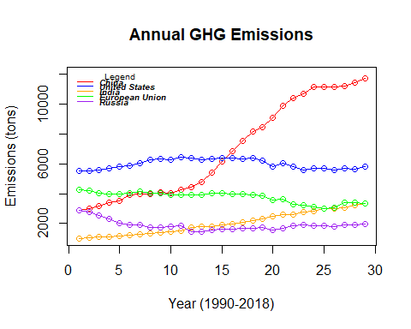

In the graph above, we have the top five GHG producing countries/regions in the world. We can see that China has drastically increased it’s GHG emissions over the years. All other top producing countries, by comparison, have either mostly stayed the same – with the exceptions of Russia, who has allegedly somewhat decreased it’s production over the years, and India, who has increased steadily, but not by the margin that China has.

# Visualization 2

I’m also interested in the overall production of GHG emissions worldwide. I want to make a simple graph that shows the change in greenhouse gas emissions worldwide from 1990 to 2018.

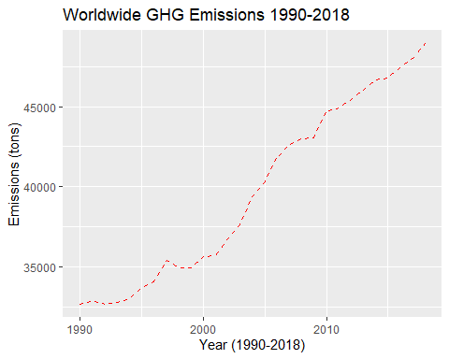

In the graph above, we can see that greenhouse gas emissions have been increasing worldwide since 1990. This isn’t entirely surprising – in fact I expected GHG emissions to have increased over the years. The thing that is somewhat surprising is that this graph makes me wonder who the key contributors are to the increase. We already know that China’s production has drastically increased, but I don’t think they account for the increase overall.

# Visualization 3

I want another graph that’ll show how much each country/region contributes to the overall increase of GHG emissions over the years. Ideally, I would like to make a stacked bar chart that shows the cumulative increase – starting with just the top 8 producing countries/regions to keep things simple*.

## *Joke’s on you, Melinda. This turned out to be anything but simple.

NOTE: I wasn’t sure if we were allowed to use our visualization from the discussion post as a part of this assignment. I really wanted to show a bar or area chart that tracked the cumulative GHG production and compare it to worldwide production. I feel like if I could change the scale on the y-axis that it would produce something better, but R keeps throwing an error that I can’t apply a ylim() that is discrete because the data is continuous. This is the bar chart I created.

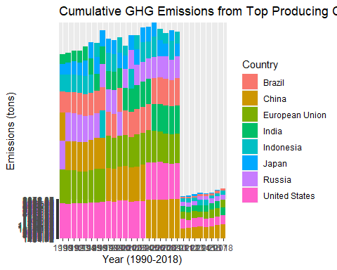

As you can see, the x-axis scale is crowded, the y-axis scale ate itself, and after 2010 the bars appear to wrap so that they look considerably smaller than they actually are. I’m not sure how to fix this, but I figured I’d leave it because I’ve spent several hours trying to work it out. If I had to guess, I would say that ggplot2 just isn’t equipped to do what I’m asking and I need a different package.