Standing Water on top of Inlet for Dual Drainage

XPSWMM simulates standing water on top of the inlet when a dual drainage link is draining to an inlet without any street links downstream

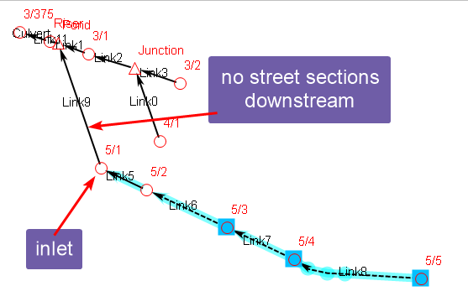

As shown below, the water rises at the inlet and never falls. And the profile shows standing water on the downstream section of the street.

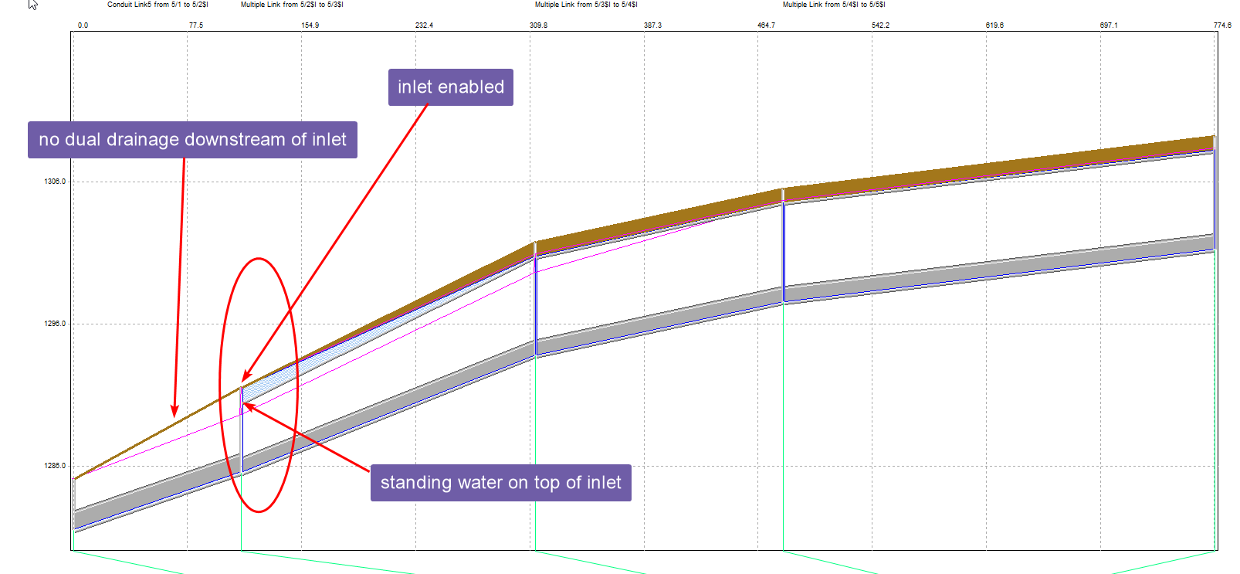

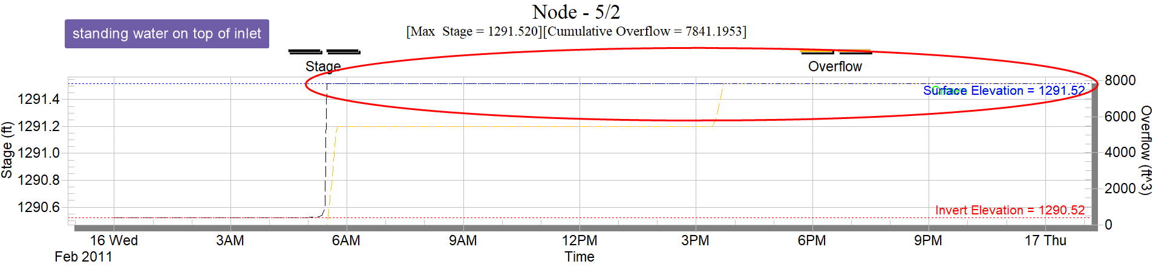

This can be resolved by,

* Disable the inlet
* Add a street section downstream

