Training: 100%|██████████| 322/322 [03:23<00:00, 1.58it/s]
Validating: 100%|██████████| 83/83 [00:24<00:00, 3.35it/s]
Epoch 1/15 | Train Loss: 1114.760204 | Val Loss: 761.538486
-> New best model saved to /content/CNN1.pth
Training: 100%|██████████| 322/322 [03:21<00:00, 1.60it/s]
Validating: 100%|██████████| 83/83 [00:25<00:00, 3.30it/s]
Epoch 2/15 | Train Loss: 415.061411 | Val Loss: 649.209107
-> New best model saved to /content/CNN1.pth
Training: 100%|██████████| 322/322 [03:19<00:00, 1.61it/s]
Validating: 100%|██████████| 83/83 [00:25<00:00, 3.30it/s]
Epoch 3/15 | Train Loss: 320.564740 | Val Loss: 563.797093
-> New best model saved to /content/CNN1.pth
Training: 100%|██████████| 322/322 [03:19<00:00, 1.62it/s]
Validating: 100%|██████████| 83/83 [00:24<00:00, 3.34it/s]
Epoch 4/15 | Train Loss: 286.505963 | Val Loss: 494.797701
-> New best model saved to /content/CNN1.pth
Training: 100%|██████████| 322/322 [03:20<00:00, 1.61it/s]
Validating: 100%|██████████| 83/83 [00:24<00:00, 3.33it/s]
Epoch 5/15 | Train Loss: 236.639942 | Val Loss: 561.137482
Training: 100%|██████████| 322/322 [03:19<00:00, 1.61it/s]
Validating: 100%|██████████| 83/83 [00:25<00:00, 3.32it/s]
Epoch 6/15 | Train Loss: 229.818046 | Val Loss: 483.487397
-> New best model saved to /content/CNN1.pth
Training: 100%|██████████| 322/322 [03:19<00:00, 1.61it/s]
Validating: 100%|██████████| 83/83 [00:25<00:00, 3.31it/s]
Epoch 7/15 | Train Loss: 188.895069 | Val Loss: 468.905958
-> New best model saved to /content/CNN1.pth
Training: 100%|██████████| 322/322 [03:20<00:00, 1.61it/s]
Validating: 100%|██████████| 83/83 [00:25<00:00, 3.27it/s]
Epoch 8/15 | Train Loss: 186.023506 | Val Loss: 438.258517
-> New best model saved to /content/CNN1.pth
Training: 100%|██████████| 322/322 [03:19<00:00, 1.61it/s]
Validating: 100%|██████████| 83/83 [00:25<00:00, 3.24it/s]
Epoch 9/15 | Train Loss: 162.818097 | Val Loss: 509.387596
Training: 100%|██████████| 322/322 [03:20<00:00, 1.60it/s]
Validating: 100%|██████████| 83/83 [00:25<00:00, 3.29it/s]
Epoch 10/15 | Train Loss: 161.482720 | Val Loss: 532.610318
Training: 100%|██████████| 322/322 [03:22<00:00, 1.59it/s]
Validating: 100%|██████████| 83/83 [00:25<00:00, 3.21it/s]
Epoch 11/15 | Train Loss: 145.087490 | Val Loss: 567.730003
Training: 100%|██████████| 322/322 [03:23<00:00, 1.58it/s]
Validating: 100%|██████████| 83/83 [00:26<00:00, 3.17it/s]
Epoch 12/15 | Train Loss: 136.709026 | Val Loss: 470.507369
Training: 100%|██████████| 322/322 [03:23<00:00, 1.58it/s]
Validating: 100%|██████████| 83/83 [00:25<00:00, 3.22it/s]
Epoch 13/15 | Train Loss: 142.476025 | Val Loss: 771.591322
Training: 100%|██████████| 322/322 [03:23<00:00, 1.58it/s]
Validating: 100%|██████████| 83/83 [00:25<00:00, 3.21it/s]
Epoch 14/15 | Train Loss: 136.098144 | Val Loss: 562.724585
Training: 100%|██████████| 322/322 [03:23<00:00, 1.58it/s]
Validating: 100%|██████████| 83/83 [00:26<00:00, 3.17it/s]
Epoch 15/15 | Train Loss: 108.852376 | Val Loss: 437.097471
-> New best model saved to /content/CNN1.pth

Training finished in 56.69 minutes.

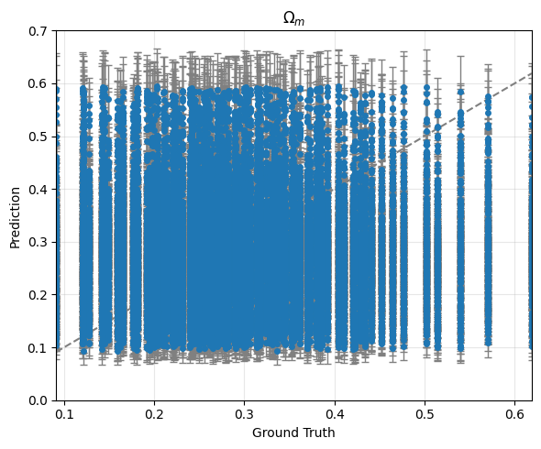
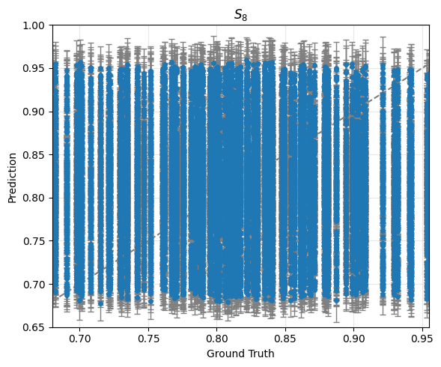

Validation

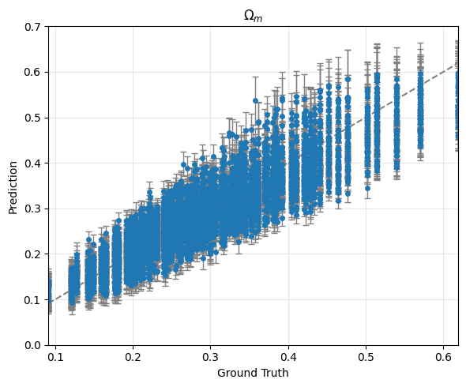
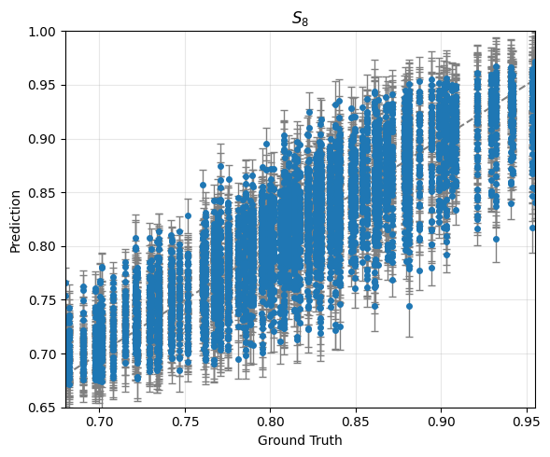

Training:
averaged score: -84.48043503185365
averaged error bar: [0.02267613 0.01754786]

Validation:
averaged score: 4.790086832450075
averaged error bar: [0.02269692 0.01753321]

ReLU

Training: 100%|██████████| 322/322 [03:18<00:00, 1.62it/s]
Validating: 100%|██████████| 83/83 [00:24<00:00, 3.32it/s]
Epoch 1/15 | Train Loss: 787.805404 | Val Loss: 1310.094359
-> New best model saved to /content/CNN1.pth
Training: 100%|██████████| 322/322 [03:18<00:00, 1.63it/s]
Validating: 100%|██████████| 83/83 [00:24<00:00, 3.38it/s]
Epoch 2/15 | Train Loss: 337.910860 | Val Loss: 698.400308
-> New best model saved to /content/CNN1.pth
Training: 100%|██████████| 322/322 [03:14<00:00, 1.65it/s]
Validating: 100%|██████████| 83/83 [00:23<00:00, 3.47it/s]
Epoch 3/15 | Train Loss: 272.374509 | Val Loss: 435.467071
-> New best model saved to /content/CNN1.pth
Training: 100%|██████████| 322/322 [03:16<00:00, 1.64it/s]
Validating: 100%|██████████| 83/83 [00:22<00:00, 3.62it/s]
Epoch 4/15 | Train Loss: 242.295794 | Val Loss: 441.496417
Training: 100%|██████████| 322/322 [03:16<00:00, 1.64it/s]
Validating: 100%|██████████| 83/83 [00:23<00:00, 3.54it/s]
Epoch 5/15 | Train Loss: 202.135801 | Val Loss: 651.177619
Training: 100%|██████████| 322/322 [03:16<00:00, 1.63it/s]
Validating: 100%|██████████| 83/83 [00:22<00:00, 3.69it/s]
Epoch 6/15 | Train Loss: 186.747203 | Val Loss: 420.787493
-> New best model saved to /content/CNN1.pth
Training: 100%|██████████| 322/322 [03:17<00:00, 1.63it/s]
Validating: 100%|██████████| 83/83 [00:23<00:00, 3.52it/s]
Epoch 7/15 | Train Loss: 177.719922 | Val Loss: 404.529109
-> New best model saved to /content/CNN1.pth
Training: 100%|██████████| 322/322 [03:20<00:00, 1.61it/s]
Validating: 100%|██████████| 83/83 [00:23<00:00, 3.46it/s]
Epoch 8/15 | Train Loss: 161.614286 | Val Loss: 419.667762
Training: 100%|██████████| 322/322 [03:21<00:00, 1.60it/s]
Validating: 100%|██████████| 83/83 [00:22<00:00, 3.75it/s]
Epoch 9/15 | Train Loss: 151.347828 | Val Loss: 426.585305
Training: 100%|██████████| 322/322 [03:20<00:00, 1.61it/s]
Validating: 100%|██████████| 83/83 [00:23<00:00, 3.47it/s]
Epoch 10/15 | Train Loss: 139.760414 | Val Loss: 573.320020
Training: 100%|██████████| 322/322 [03:22<00:00, 1.59it/s]
Validating: 100%|██████████| 83/83 [00:25<00:00, 3.23it/s]
Epoch 11/15 | Train Loss: 140.827671 | Val Loss: 396.161478
-> New best model saved to /content/CNN1.pth
Training: 100%|██████████| 322/322 [03:23<00:00, 1.58it/s]
Validating: 100%|██████████| 83/83 [00:24<00:00, 3.37it/s]
Epoch 12/15 | Train Loss: 136.853231 | Val Loss: 409.642954
Training: 100%|██████████| 322/322 [03:23<00:00, 1.58it/s]
Validating: 100%|██████████| 83/83 [00:25<00:00, 3.22it/s]
Epoch 13/15 | Train Loss: 128.319108 | Val Loss: 441.294756
Training: 100%|██████████| 322/322 [03:23<00:00, 1.58it/s]
Validating: 100%|██████████| 83/83 [00:23<00:00, 3.60it/s]
Epoch 14/15 | Train Loss: 124.376114 | Val Loss: 443.941092
Training: 100%|██████████| 322/322 [03:22<00:00, 1.59it/s]
Validating: 100%|██████████| 83/83 [00:23<00:00, 3.47it/s]
Epoch 15/15 | Train Loss: 120.219204 | Val Loss: 418.611888

Training finished in 55.92 minutes.

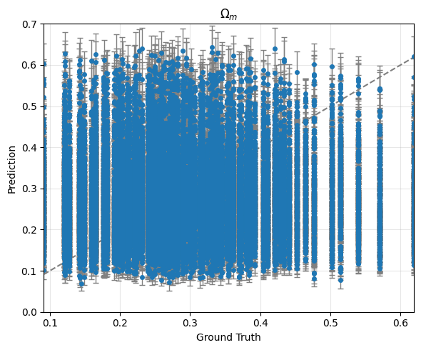
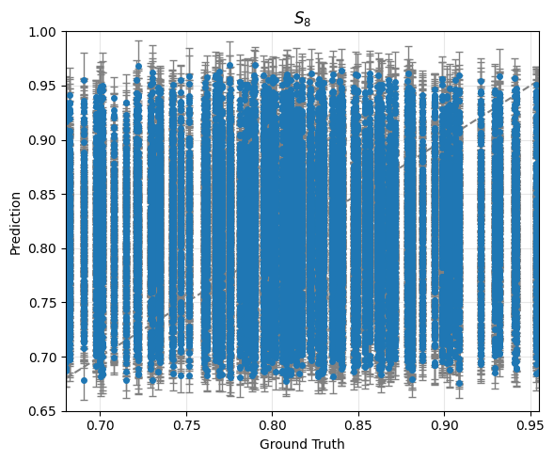

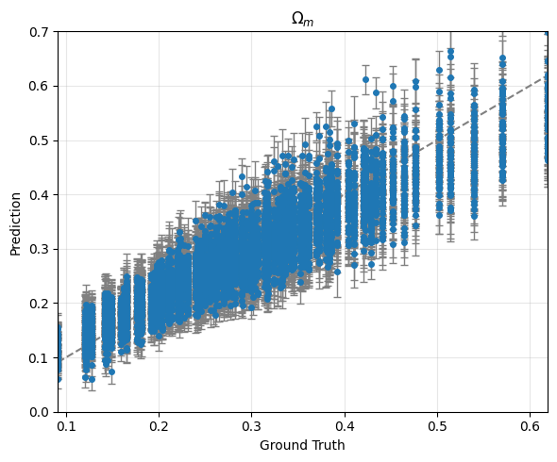
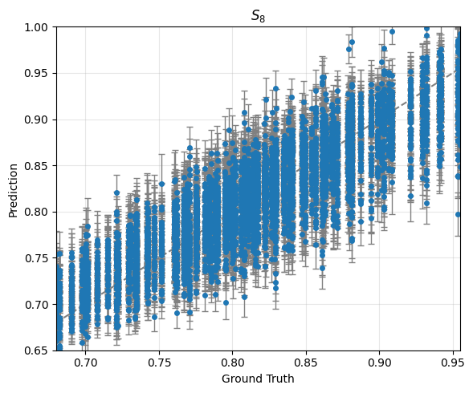

Training:
averaged score: -46.92068280865576
averaged error bar: [0.03883003 0.02707462]

Validation:
averaged score: 7.9950733846027155
averaged error bar: [0.03851442 0.02689829]

