Training: 100%|██████████| 322/322 [06:49<00:00, 1.27s/it]
Validating: 100%|██████████| 83/83 [00:36<00:00, 2.26it/s]
Epoch 1/15 | Train Loss: 829.347686 | Val Loss: 681.169241
-> New best model saved to /content/CNN2.pth
Training: 100%|██████████| 322/322 [07:18<00:00, 1.36s/it]
Validating: 100%|██████████| 83/83 [00:41<00:00, 2.01it/s]
Epoch 2/15 | Train Loss: 374.373224 | Val Loss: 624.725693
-> New best model saved to /content/CNN2.pth
Training: 100%|██████████| 322/322 [07:19<00:00, 1.36s/it]
Validating: 100%|██████████| 83/83 [00:40<00:00, 2.03it/s]
Epoch 3/15 | Train Loss: 287.877662 | Val Loss: 470.156205
-> New best model saved to /content/CNN2.pth
Training: 100%|██████████| 322/322 [07:20<00:00, 1.37s/it]
Validating: 100%|██████████| 83/83 [00:40<00:00, 2.03it/s]
Epoch 4/15 | Train Loss: 255.576005 | Val Loss: 740.578831
Training: 100%|██████████| 322/322 [07:21<00:00, 1.37s/it]
Validating: 100%|██████████| 83/83 [00:40<00:00, 2.05it/s]
Epoch 5/15 | Train Loss: 237.351226 | Val Loss: 475.213369
Training: 100%|██████████| 322/322 [07:24<00:00, 1.38s/it]
Validating: 100%|██████████| 83/83 [00:40<00:00, 2.05it/s]
Epoch 6/15 | Train Loss: 203.834209 | Val Loss: 600.942042
Training: 100%|██████████| 322/322 [07:24<00:00, 1.38s/it]
Validating: 100%|██████████| 83/83 [00:40<00:00, 2.05it/s]
Epoch 7/15 | Train Loss: 194.127852 | Val Loss: 852.471647
Training: 100%|██████████| 322/322 [07:25<00:00, 1.38s/it]
Validating: 100%|██████████| 83/83 [00:41<00:00, 2.01it/s]
Epoch 8/15 | Train Loss: 182.294538 | Val Loss: 1082.070242
Training: 100%|██████████| 322/322 [07:26<00:00, 1.39s/it]
Validating: 100%|██████████| 83/83 [00:41<00:00, 2.00it/s]
Epoch 9/15 | Train Loss: 168.697443 | Val Loss: 471.813086
Training: 100%|██████████| 322/322 [07:27<00:00, 1.39s/it]
Validating: 100%|██████████| 83/83 [00:41<00:00, 2.00it/s]
Epoch 10/15 | Train Loss: 141.618800 | Val Loss: 665.789081
Training: 100%|██████████| 322/322 [07:28<00:00, 1.39s/it]
Validating: 100%|██████████| 83/83 [00:41<00:00, 2.00it/s]
Epoch 11/15 | Train Loss: 137.986969 | Val Loss: 490.190707
Training: 100%|██████████| 322/322 [07:29<00:00, 1.40s/it]
Validating: 100%|██████████| 83/83 [00:41<00:00, 2.00it/s]
Epoch 12/15 | Train Loss: 132.978866 | Val Loss: 548.231440
Training: 100%|██████████| 322/322 [07:29<00:00, 1.40s/it]
Validating: 100%|██████████| 83/83 [00:41<00:00, 2.00it/s]
Epoch 13/15 | Train Loss: 132.037535 | Val Loss: 575.523248
Training: 100%|██████████| 322/322 [07:30<00:00, 1.40s/it]
Validating: 100%|██████████| 83/83 [00:41<00:00, 2.00it/s]
Epoch 14/15 | Train Loss: 122.121873 | Val Loss: 509.447396
Training: 100%|██████████| 322/322 [07:31<00:00, 1.40s/it]
Validating: 100%|██████████| 83/83 [00:41<00:00, 2.00it/s]
Epoch 15/15 | Train Loss: 118.723626 | Val Loss: 882.760199

Training finished in 121.01 minutes.

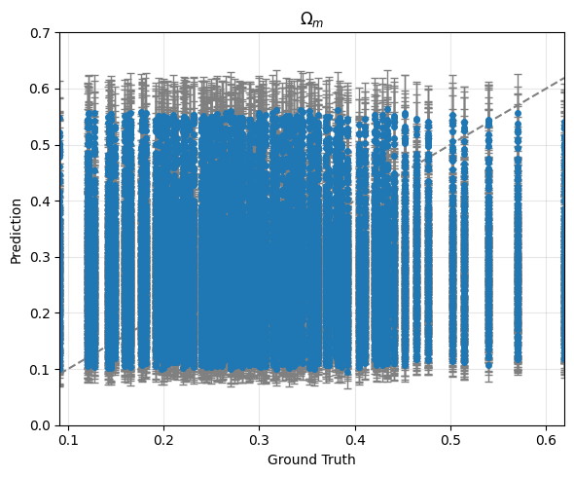
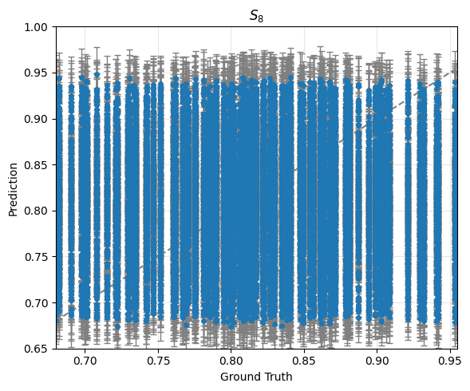

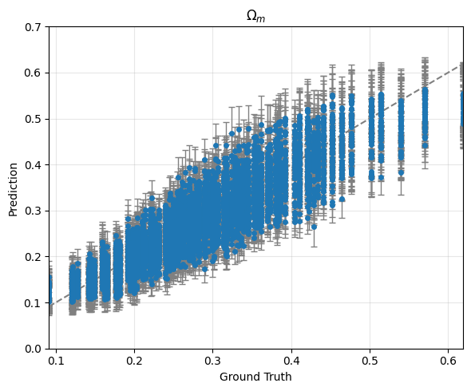
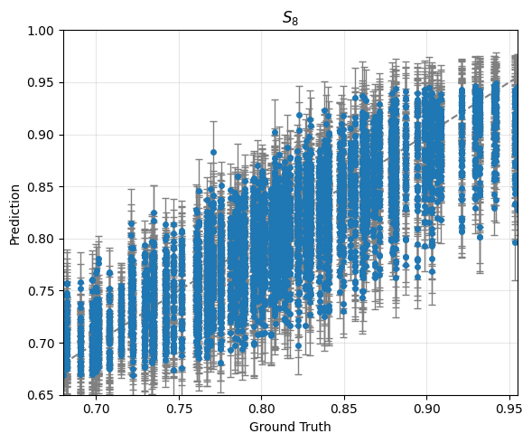
Training:
averaged score: -45.93662432496003
averaged error bar: [0.03710164 0.0258798 ]

Validation:
averaged score: 7.511496541479698
averaged error bar: [0.03770495 0.02595376]

Training: 100%|██████████| 322/322 [07:06<00:00, 1.32s/it]
Validating: 100%|██████████| 83/83 [00:41<00:00, 1.98it/s]
Epoch 1/15 | Train Loss: 673.770131 | Val Loss: 635.025637
-> New best model saved to /content/CNN2.pth
Training: 100%|██████████| 322/322 [07:12<00:00, 1.34s/it]
Validating: 100%|██████████| 83/83 [00:43<00:00, 1.91it/s]
Epoch 2/15 | Train Loss: 312.671152 | Val Loss: 967.938235
Training: 100%|██████████| 322/322 [07:14<00:00, 1.35s/it]
Validating: 100%|██████████| 83/83 [00:44<00:00, 1.88it/s]
Epoch 3/15 | Train Loss: 265.610693 | Val Loss: 455.630510
-> New best model saved to /content/CNN2.pth
Training: 100%|██████████| 322/322 [07:18<00:00, 1.36s/it]
Validating: 100%|██████████| 83/83 [00:44<00:00, 1.88it/s]
Epoch 4/15 | Train Loss: 210.247739 | Val Loss: 445.269185
-> New best model saved to /content/CNN2.pth
Training: 100%|██████████| 322/322 [07:20<00:00, 1.37s/it]
Validating: 100%|██████████| 83/83 [00:44<00:00, 1.88it/s]
Epoch 5/15 | Train Loss: 195.088903 | Val Loss: 1531.276988
Training: 100%|██████████| 322/322 [07:27<00:00, 1.39s/it]
Validating: 100%|██████████| 83/83 [00:45<00:00, 1.83it/s]
Epoch 6/15 | Train Loss: 177.912141 | Val Loss: 538.023864
Training: 100%|██████████| 322/322 [07:31<00:00, 1.40s/it]
Validating: 100%|██████████| 83/83 [00:45<00:00, 1.80it/s]
Epoch 7/15 | Train Loss: 171.339961 | Val Loss: 713.385555
Training: 100%|██████████| 322/322 [07:34<00:00, 1.41s/it]
Validating: 100%|██████████| 83/83 [00:46<00:00, 1.80it/s]
Epoch 8/15 | Train Loss: 155.406282 | Val Loss: 891.896021
Training: 100%|██████████| 322/322 [07:37<00:00, 1.42s/it]
Validating: 100%|██████████| 83/83 [00:46<00:00, 1.77it/s]
Epoch 9/15 | Train Loss: 150.246280 | Val Loss: 397.522994
-> New best model saved to /content/CNN2.pth
Training: 100%|██████████| 322/322 [07:39<00:00, 1.43s/it]
Validating: 100%|██████████| 83/83 [00:46<00:00, 1.80it/s]
Epoch 10/15 | Train Loss: 141.910958 | Val Loss: 683.786409
Training: 100%|██████████| 322/322 [07:41<00:00, 1.43s/it]
Validating: 100%|██████████| 83/83 [00:47<00:00, 1.76it/s]
Epoch 11/15 | Train Loss: 141.637872 | Val Loss: 510.624206
Training: 100%|██████████| 322/322 [07:43<00:00, 1.44s/it]
Validating: 100%|██████████| 83/83 [00:46<00:00, 1.77it/s]
Epoch 12/15 | Train Loss: 141.175854 | Val Loss: 414.133763
Training: 100%|██████████| 322/322 [07:43<00:00, 1.44s/it]
Validating: 100%|██████████| 83/83 [00:47<00:00, 1.75it/s]
Epoch 13/15 | Train Loss: 125.017915 | Val Loss: 546.422892
Training: 100%|██████████| 322/322 [07:45<00:00, 1.45s/it]
Validating: 100%|██████████| 83/83 [00:47<00:00, 1.74it/s]
Epoch 14/15 | Train Loss: 126.576715 | Val Loss: 456.089392
Training: 100%|██████████| 322/322 [07:45<00:00, 1.45s/it]
Validating: 100%|██████████| 83/83 [00:47<00:00, 1.75it/s]Epoch 15/15 | Train Loss: 124.593934 | Val Loss: 543.246116

Training finished in 124.16 minutes.

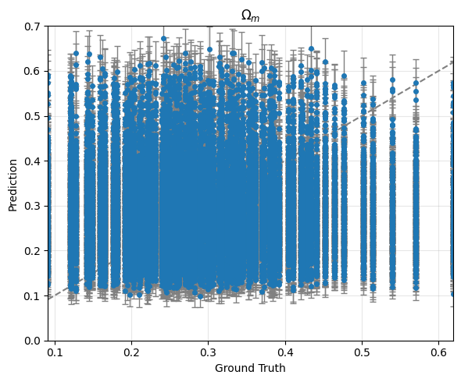
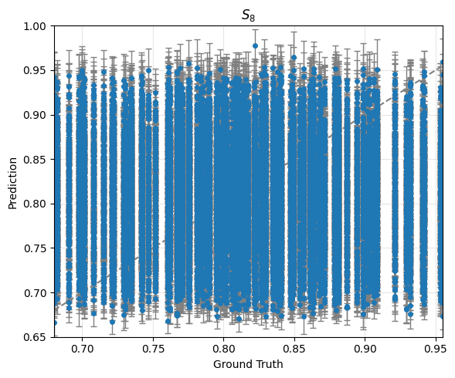

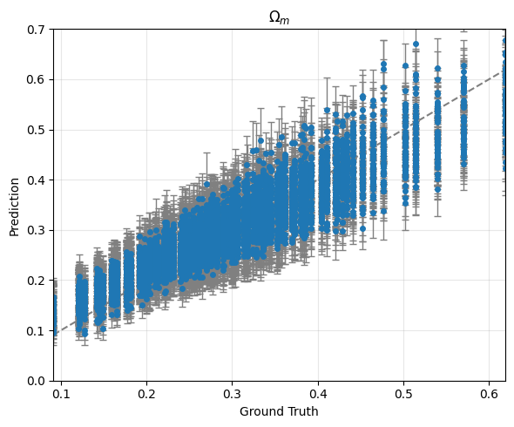
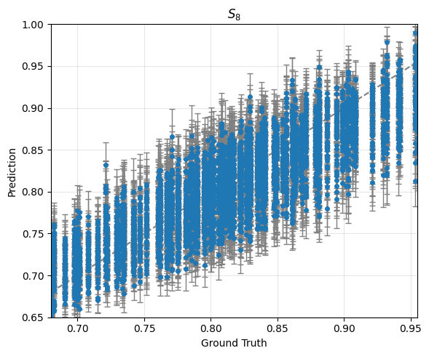

Training:
averaged score: -36.84084005588764
averaged error bar: [0.04515683 0.03062729]

Validation:
averaged score: 8.332775207153473
averaged error bar: [0.04536607 0.03028953]

