Training: 100%|██████████| 322/322 [02:11<00:00, 2.45it/s]
Validating: 100%|██████████| 83/83 [00:14<00:00, 5.83it/s]
Epoch 1/15 | Train Loss: 804.865169 | Val Loss: 515.809380
-> New best model saved to /content/CNN3.pth
Training: 100%|██████████| 322/322 [02:11<00:00, 2.44it/s]
Validating: 100%|██████████| 83/83 [00:14<00:00, 5.77it/s]
Epoch 2/15 | Train Loss: 372.101966 | Val Loss: 1275.096645
Training: 100%|██████████| 322/322 [02:11<00:00, 2.45it/s]
Validating: 100%|██████████| 83/83 [00:14<00:00, 5.82it/s]
Epoch 3/15 | Train Loss: 294.219373 | Val Loss: 469.177822
-> New best model saved to /content/CNN3.pth
Training: 100%|██████████| 322/322 [02:11<00:00, 2.45it/s]
Validating: 100%|██████████| 83/83 [00:14<00:00, 5.68it/s]
Epoch 4/15 | Train Loss: 242.099768 | Val Loss: 483.430555
Training: 100%|██████████| 322/322 [02:12<00:00, 2.42it/s]
Validating: 100%|██████████| 83/83 [00:14<00:00, 5.64it/s]
Epoch 5/15 | Train Loss: 202.086708 | Val Loss: 458.279048
-> New best model saved to /content/CNN3.pth
Training: 100%|██████████| 322/322 [02:11<00:00, 2.44it/s]
Validating: 100%|██████████| 83/83 [00:14<00:00, 5.58it/s]
Epoch 6/15 | Train Loss: 181.407495 | Val Loss: 951.543970
Training: 100%|██████████| 322/322 [02:12<00:00, 2.42it/s]
Validating: 100%|██████████| 83/83 [00:14<00:00, 5.54it/s]
Epoch 7/15 | Train Loss: 165.384464 | Val Loss: 577.827730
Training: 100%|██████████| 322/322 [02:12<00:00, 2.44it/s]
Validating: 100%|██████████| 83/83 [00:14<00:00, 5.58it/s]
Epoch 8/15 | Train Loss: 152.905260 | Val Loss: 438.466466
-> New best model saved to /content/CNN3.pth
Training: 100%|██████████| 322/322 [02:11<00:00, 2.45it/s]
Validating: 100%|██████████| 83/83 [00:14<00:00, 5.69it/s]
Epoch 9/15 | Train Loss: 143.639991 | Val Loss: 452.426186
Training: 100%|██████████| 322/322 [02:12<00:00, 2.43it/s]
Validating: 100%|██████████| 83/83 [00:14<00:00, 5.56it/s]
Epoch 10/15 | Train Loss: 139.151213 | Val Loss: 1003.112717
Training: 100%|██████████| 322/322 [02:12<00:00, 2.42it/s]
Validating: 100%|██████████| 83/83 [00:14<00:00, 5.71it/s]
Epoch 11/15 | Train Loss: 129.100309 | Val Loss: 456.701388
Training: 100%|██████████| 322/322 [02:13<00:00, 2.41it/s]
Validating: 100%|██████████| 83/83 [00:15<00:00, 5.51it/s]
Epoch 12/15 | Train Loss: 124.290930 | Val Loss: 482.747202
Training: 100%|██████████| 322/322 [02:13<00:00, 2.42it/s]
Validating: 100%|██████████| 83/83 [00:14<00:00, 5.61it/s]
Epoch 13/15 | Train Loss: 118.240964 | Val Loss: 628.260831
Training: 100%|██████████| 322/322 [02:12<00:00, 2.43it/s]
Validating: 100%|██████████| 83/83 [00:14<00:00, 5.58it/s]
Epoch 14/15 | Train Loss: 117.324924 | Val Loss: 406.496950
-> New best model saved to /content/CNN3.pth
Training: 100%|██████████| 322/322 [02:12<00:00, 2.43it/s]
Validating: 100%|██████████| 83/83 [00:14<00:00, 5.60it/s]
Epoch 15/15 | Train Loss: 115.087841 | Val Loss: 444.698828

Training finished in 36.76 minutes.

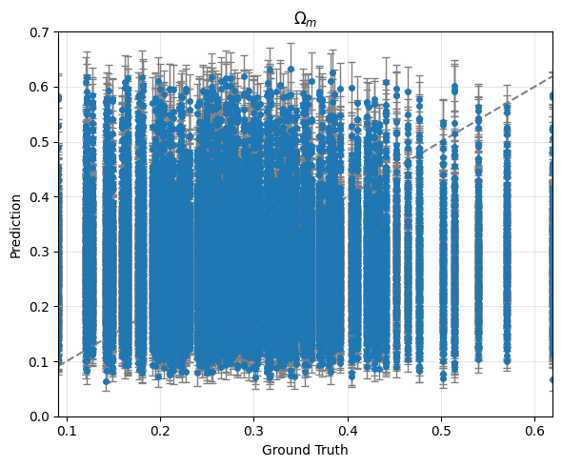
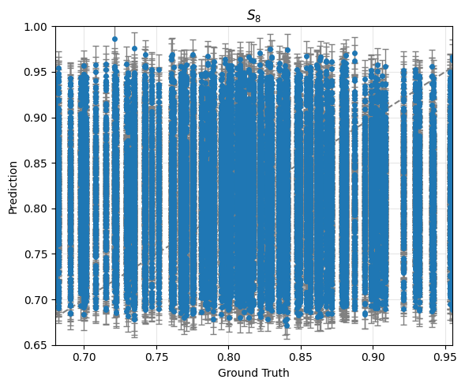

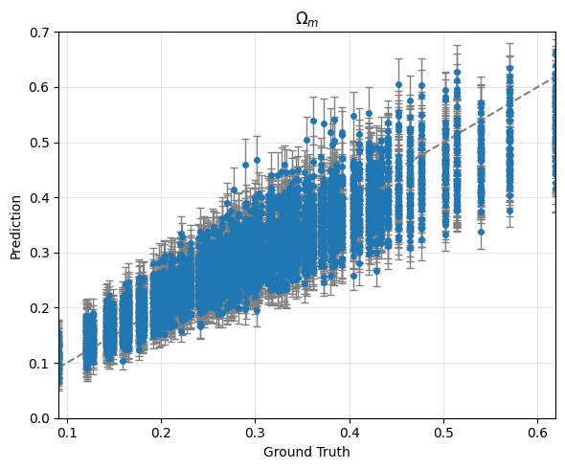
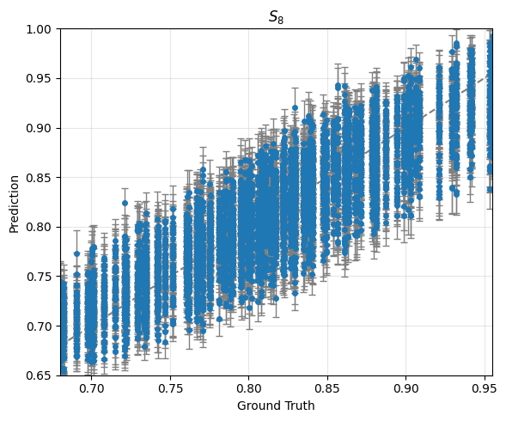

Training:
averaged score: -59.69230403198534
averaged error bar: [0.03150288 0.02150772]

Validation:
averaged score: 7.598036100798704
averaged error bar: [0.03192044 0.02170242]

