Training: 100%|██████████| 322/322 [02:10<00:00, 2.46it/s]
Validating: 100%|██████████| 83/83 [00:14<00:00, 5.73it/s]
Epoch 1/15 | Train Loss: 1348.694701 | Val Loss: 2663.358443
-> New best model saved to /content/CNN4.pth
Training: 100%|██████████| 322/322 [02:10<00:00, 2.46it/s]
Validating: 100%|██████████| 83/83 [00:14<00:00, 5.83it/s]
Epoch 2/15 | Train Loss: 606.508334 | Val Loss: 727.530997
-> New best model saved to /content/CNN4.pth
Training: 100%|██████████| 322/322 [02:10<00:00, 2.47it/s]
Validating: 100%|██████████| 83/83 [00:14<00:00, 5.72it/s]
Epoch 3/15 | Train Loss: 474.745801 | Val Loss: 548.832713
-> New best model saved to /content/CNN4.pth
Training: 100%|██████████| 322/322 [02:10<00:00, 2.47it/s]
Validating: 100%|██████████| 83/83 [00:14<00:00, 5.89it/s]
Epoch 4/15 | Train Loss: 424.018668 | Val Loss: 1602.313794
Training: 100%|██████████| 322/322 [02:10<00:00, 2.47it/s]
Validating: 100%|██████████| 83/83 [00:14<00:00, 5.80it/s]
Epoch 5/15 | Train Loss: 391.262112 | Val Loss: 862.398796
Training: 100%|██████████| 322/322 [02:10<00:00, 2.46it/s]
Validating: 100%|██████████| 83/83 [00:14<00:00, 5.90it/s]
Epoch 6/15 | Train Loss: 361.097987 | Val Loss: 445.094236
-> New best model saved to /content/CNN4.pth
Training: 100%|██████████| 322/322 [02:10<00:00, 2.46it/s]
Validating: 100%|██████████| 83/83 [00:14<00:00, 5.75it/s]
Epoch 7/15 | Train Loss: 332.766271 | Val Loss: 450.598665
Training: 100%|██████████| 322/322 [02:10<00:00, 2.46it/s]
Validating: 100%|██████████| 83/83 [00:14<00:00, 5.83it/s]
Epoch 8/15 | Train Loss: 305.017059 | Val Loss: 453.880972
Training: 100%|██████████| 322/322 [02:11<00:00, 2.45it/s]
Validating: 100%|██████████| 83/83 [00:13<00:00, 5.93it/s]
Epoch 9/15 | Train Loss: 290.913926 | Val Loss: 986.749917
Training: 100%|██████████| 322/322 [02:10<00:00, 2.46it/s]
Validating: 100%|██████████| 83/83 [00:14<00:00, 5.86it/s]
Epoch 10/15 | Train Loss: 275.593668 | Val Loss: 989.638879
Training: 100%|██████████| 322/322 [02:10<00:00, 2.46it/s]
Validating: 100%|██████████| 83/83 [00:14<00:00, 5.82it/s]
Epoch 11/15 | Train Loss: 255.095811 | Val Loss: 391.267229
-> New best model saved to /content/CNN4.pth
Training: 100%|██████████| 322/322 [02:11<00:00, 2.45it/s]
Validating: 100%|██████████| 83/83 [00:14<00:00, 5.73it/s]
Epoch 12/15 | Train Loss: 243.244923 | Val Loss: 419.659220
Training: 100%|██████████| 322/322 [02:12<00:00, 2.44it/s]
Validating: 100%|██████████| 83/83 [00:14<00:00, 5.72it/s]
Epoch 13/15 | Train Loss: 230.361276 | Val Loss: 845.579327
Training: 100%|██████████| 322/322 [02:11<00:00, 2.45it/s]
Validating: 100%|██████████| 83/83 [00:14<00:00, 5.74it/s]
Epoch 14/15 | Train Loss: 227.980890 | Val Loss: 469.226390
Training: 100%|██████████| 322/322 [02:10<00:00, 2.46it/s]
Validating: 100%|██████████| 83/83 [00:14<00:00, 5.85it/s]
Epoch 15/15 | Train Loss: 214.752424 | Val Loss: 404.342088

Training finished in 36.31 minutes.

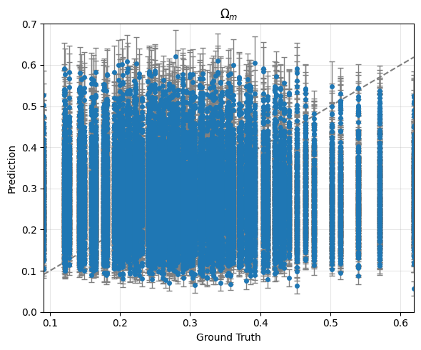
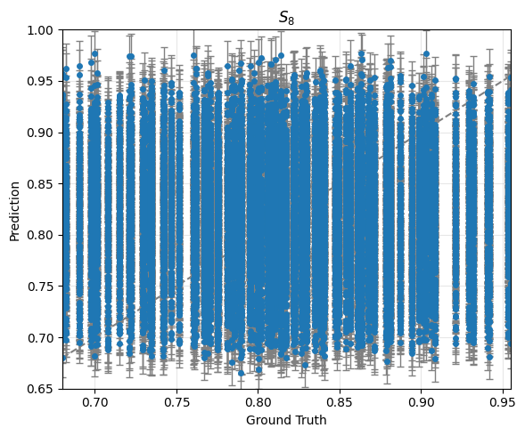

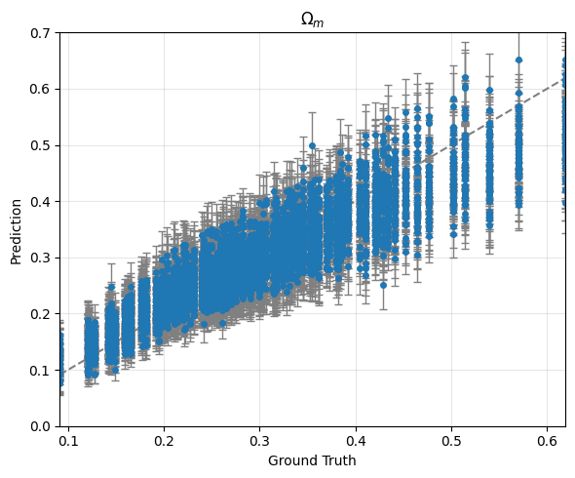
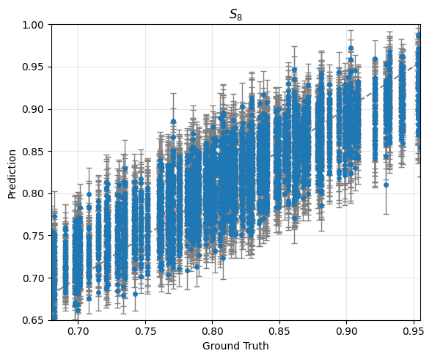

Training:
averaged score: -38.57714977422365
averaged error bar: [0.0419369 0.02940839]

Validation:
averaged score: 8.627578626921123
averaged error bar: [0.04220685 0.02908227]

Training: 100%|██████████| 322/322 [02:08<00:00, 2.50it/s]
Validating: 100%|██████████| 83/83 [00:13<00:00, 6.16it/s]
Epoch 1/15 | Train Loss: 967.145197 | Val Loss: 459.064401
-> New best model saved to /content/CNN4.pth
Training: 100%|██████████| 322/322 [02:06<00:00, 2.55it/s]
Validating: 100%|██████████| 83/83 [00:13<00:00, 6.09it/s]
Epoch 2/15 | Train Loss: 441.685612 | Val Loss: 552.812847
Training: 100%|██████████| 322/322 [02:07<00:00, 2.52it/s]
Validating: 100%|██████████| 83/83 [00:11<00:00, 7.11it/s]
Epoch 3/15 | Train Loss: 374.919639 | Val Loss: 537.169905
Training: 100%|██████████| 322/322 [02:07<00:00, 2.53it/s]
Validating: 100%|██████████| 83/83 [00:14<00:00, 5.87it/s]
Epoch 4/15 | Train Loss: 334.131744 | Val Loss: 625.405807
Training: 100%|██████████| 322/322 [02:07<00:00, 2.52it/s]
Validating: 100%|██████████| 83/83 [00:12<00:00, 6.73it/s]
Epoch 5/15 | Train Loss: 304.338241 | Val Loss: 387.931576
-> New best model saved to /content/CNN4.pth
Training: 100%|██████████| 322/322 [02:07<00:00, 2.52it/s]
Validating: 100%|██████████| 83/83 [00:13<00:00, 6.11it/s]
Epoch 6/15 | Train Loss: 271.208380 | Val Loss: 1133.946853
Training: 100%|██████████| 322/322 [02:07<00:00, 2.53it/s]
Validating: 100%|██████████| 83/83 [00:14<00:00, 5.82it/s]
Epoch 7/15 | Train Loss: 248.351982 | Val Loss: 693.542840
Training: 100%|██████████| 322/322 [02:07<00:00, 2.52it/s]
Validating: 100%|██████████| 83/83 [00:14<00:00, 5.88it/s]
Epoch 8/15 | Train Loss: 228.505422 | Val Loss: 618.614518
Training: 100%|██████████| 322/322 [02:08<00:00, 2.51it/s]
Validating: 100%|██████████| 83/83 [00:14<00:00, 5.84it/s]
Epoch 9/15 | Train Loss: 226.117769 | Val Loss: 468.534714
Training: 100%|██████████| 322/322 [02:12<00:00, 2.44it/s]
Validating: 100%|██████████| 83/83 [00:14<00:00, 5.88it/s]
Epoch 10/15 | Train Loss: 203.363789 | Val Loss: 464.871221
Training: 100%|██████████| 322/322 [02:09<00:00, 2.49it/s]
Validating: 100%|██████████| 83/83 [00:12<00:00, 6.88it/s]
Epoch 11/15 | Train Loss: 203.678503 | Val Loss: 2262.625392
Training: 100%|██████████| 322/322 [02:09<00:00, 2.49it/s]
Validating: 100%|██████████| 83/83 [00:14<00:00, 5.81it/s]
Epoch 12/15 | Train Loss: 167.767933 | Val Loss: 366.502746
-> New best model saved to /content/CNN4.pth
Training: 100%|██████████| 322/322 [02:08<00:00, 2.50it/s]
Validating: 100%|██████████| 83/83 [00:14<00:00, 5.91it/s]
Epoch 13/15 | Train Loss: 163.700238 | Val Loss: 399.602148
Training: 100%|██████████| 322/322 [02:08<00:00, 2.50it/s]
Validating: 100%|██████████| 83/83 [00:12<00:00, 6.76it/s]
Epoch 14/15 | Train Loss: 170.915406 | Val Loss: 646.059511
Training: 100%|██████████| 322/322 [02:08<00:00, 2.50it/s]
Validating: 100%|██████████| 83/83 [00:14<00:00, 5.78it/s]
Epoch 15/15 | Train Loss: 151.940003 | Val Loss: 509.110123

Training finished in 35.49 minutes.

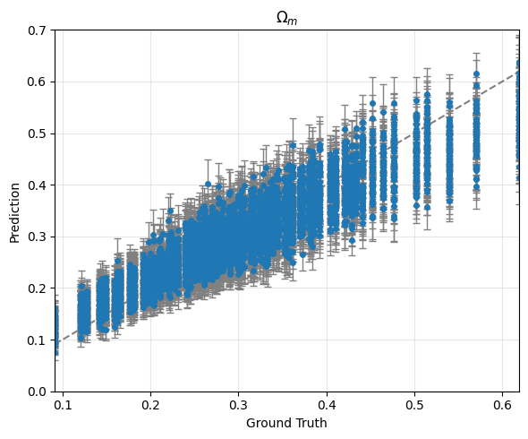
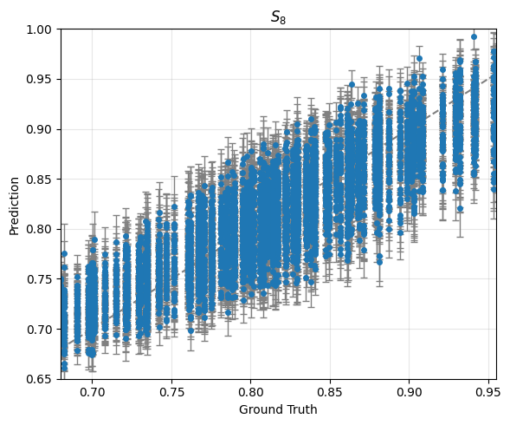

Training:
averaged score: -43.896126942197085
averaged error bar: [0.03663329 0.02566323]

Validation:
averaged score: 8.851363117638716
averaged error bar: [0.03677004 0.02523321]

Training: 100%|██████████| 322/322 [02:17<00:00, 2.34it/s]
Validating: 100%|██████████| 83/83 [00:14<00:00, 5.59it/s]
Epoch 1/15 | Train Loss: 1446.086423 | Val Loss: 1385.466047
-> New best model saved to /content/CNN4.pth
Training: 100%|██████████| 322/322 [02:19<00:00, 2.31it/s]
Validating: 100%|██████████| 83/83 [00:15<00:00, 5.44it/s]
Epoch 2/15 | Train Loss: 555.177179 | Val Loss: 505.174732
-> New best model saved to /content/CNN4.pth
Training: 100%|██████████| 322/322 [02:20<00:00, 2.29it/s]
Validating: 100%|██████████| 83/83 [00:14<00:00, 5.73it/s]
Epoch 3/15 | Train Loss: 415.928069 | Val Loss: 801.663106
Training: 100%|██████████| 322/322 [02:17<00:00, 2.34it/s]
Validating: 100%|██████████| 83/83 [00:14<00:00, 5.68it/s]
Epoch 4/15 | Train Loss: 359.771019 | Val Loss: 459.201802
-> New best model saved to /content/CNN4.pth
Training: 100%|██████████| 322/322 [02:15<00:00, 2.37it/s]
Validating: 100%|██████████| 83/83 [00:14<00:00, 5.56it/s]
Epoch 5/15 | Train Loss: 320.567038 | Val Loss: 548.048886
Training: 100%|██████████| 322/322 [02:21<00:00, 2.27it/s]
Validating: 100%|██████████| 83/83 [00:15<00:00, 5.45it/s]
Epoch 6/15 | Train Loss: 278.886295 | Val Loss: 584.922744
Training: 100%|██████████| 322/322 [02:21<00:00, 2.28it/s]
Validating: 100%|██████████| 83/83 [00:15<00:00, 5.44it/s]
Epoch 7/15 | Train Loss: 260.678278 | Val Loss: 852.906392
Training: 100%|██████████| 322/322 [02:22<00:00, 2.27it/s]
Validating: 100%|██████████| 83/83 [00:14<00:00, 5.55it/s]
Epoch 8/15 | Train Loss: 249.640577 | Val Loss: 556.083108
Training: 100%|██████████| 322/322 [02:22<00:00, 2.26it/s]
Validating: 100%|██████████| 83/83 [00:15<00:00, 5.46it/s]
Epoch 9/15 | Train Loss: 220.437001 | Val Loss: 558.194650
Training: 100%|██████████| 322/322 [02:22<00:00, 2.26it/s]
Validating: 100%|██████████| 83/83 [00:15<00:00, 5.46it/s]
Epoch 10/15 | Train Loss: 215.267723 | Val Loss: 1156.701028
Training: 100%|██████████| 322/322 [02:21<00:00, 2.27it/s]
Validating: 100%|██████████| 83/83 [00:15<00:00, 5.34it/s]
Epoch 11/15 | Train Loss: 182.297037 | Val Loss: 484.216200
Training: 100%|██████████| 322/322 [02:22<00:00, 2.26it/s]
Validating: 100%|██████████| 83/83 [00:15<00:00, 5.44it/s]
Epoch 12/15 | Train Loss: 179.189970 | Val Loss: 616.897253
Training: 100%|██████████| 322/322 [02:13<00:00, 2.42it/s]
Validating: 100%|██████████| 83/83 [00:13<00:00, 6.00it/s]
Epoch 13/15 | Train Loss: 169.016695 | Val Loss: 447.736688
-> New best model saved to /content/CNN4.pth
Training: 100%|██████████| 322/322 [02:10<00:00, 2.46it/s]
Validating: 100%|██████████| 83/83 [00:14<00:00, 5.82it/s]
Epoch 14/15 | Train Loss: 170.652273 | Val Loss: 442.501305
-> New best model saved to /content/CNN4.pth
Training: 100%|██████████| 322/322 [02:11<00:00, 2.45it/s]
Validating: 100%|██████████| 83/83 [00:14<00:00, 5.82it/s]Epoch 15/15 | Train Loss: 169.230250 | Val Loss: 471.578524

Training finished in 38.40 minutes.

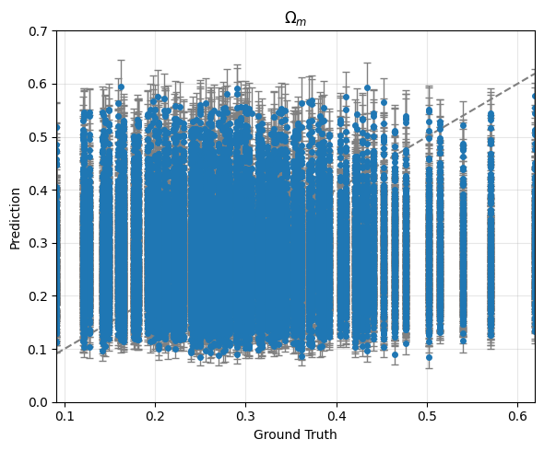
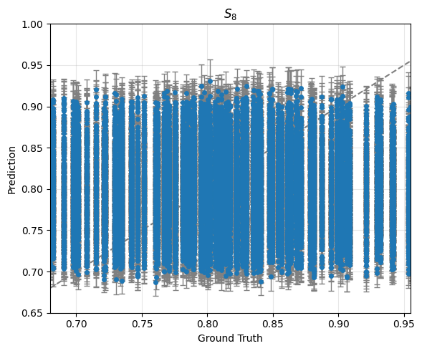

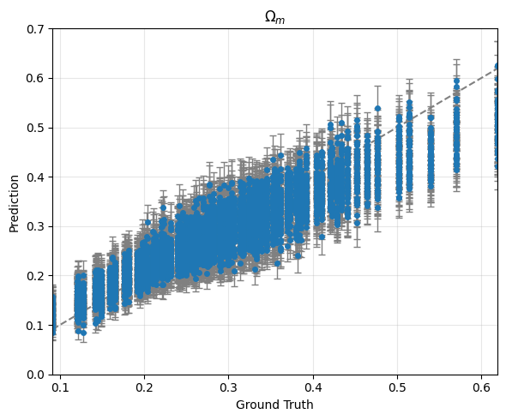
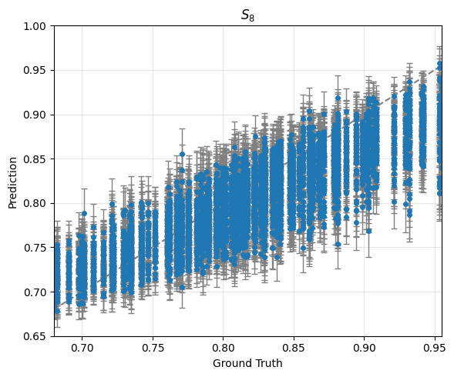

Training:
averaged score: -39.07105656513385
averaged error bar: [0.03794212 0.02661635]

Validation:
averaged score: 8.01608034392894
averaged error bar: [0.03783716 0.02609486]

