Denario : 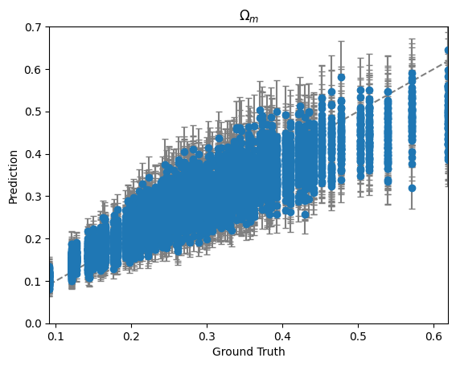
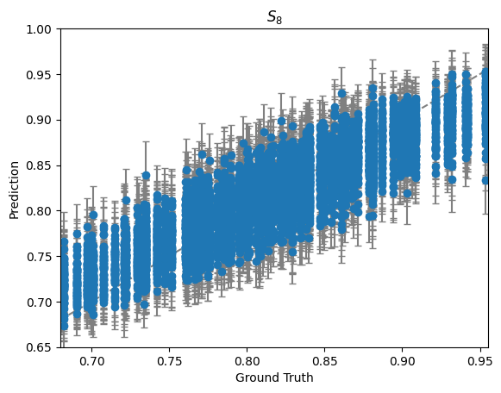

averaged score: 8.387599703672834
averaged error bar: [0.04537246 0.0302369 ]

