Baseline:

Training: 100%|██████████| 322/322 [02:16<00:00, 2.36it/s]
Validating: 100%|██████████| 83/83 [00:16<00:00, 5.18it/s]
Epoch 1/15 | Train Loss: 2.789028 | Val Loss: 1.568284
-> New best model saved to /content/drive/MyDrive/Phase1_starting_kit_CNN_Direct_baseline.pth
Training: 100%|██████████| 322/322 [02:25<00:00, 2.22it/s]
Validating: 100%|██████████| 83/83 [00:17<00:00, 4.76it/s]
Epoch 2/15 | Train Loss: 1.348361 | Val Loss: 1.277947
-> New best model saved to /content/drive/MyDrive/Phase1_starting_kit_CNN_Direct_baseline.pth
Training: 100%|██████████| 322/322 [02:24<00:00, 2.22it/s]
Validating: 100%|██████████| 83/83 [00:18<00:00, 4.44it/s]
Epoch 3/15 | Train Loss: 1.215829 | Val Loss: 1.123200
-> New best model saved to /content/drive/MyDrive/Phase1_starting_kit_CNN_Direct_baseline.pth
Training: 100%|██████████| 322/322 [02:24<00:00, 2.22it/s]
Validating: 100%|██████████| 83/83 [00:14<00:00, 5.86it/s]
Epoch 4/15 | Train Loss: 0.131930 | Val Loss: 0.714632
-> New best model saved to /content/drive/MyDrive/Phase1_starting_kit_CNN_Direct_baseline.pth
Training: 100%|██████████| 322/322 [02:26<00:00, 2.20it/s]
Validating: 100%|██████████| 83/83 [00:16<00:00, 4.89it/s]
Epoch 5/15 | Train Loss: -0.738932 | Val Loss: 0.991703
Training: 100%|██████████| 322/322 [02:26<00:00, 2.19it/s]
Validating: 100%|██████████| 83/83 [00:17<00:00, 4.73it/s]
Epoch 6/15 | Train Loss: -1.324514 | Val Loss: 0.019349
-> New best model saved to /content/drive/MyDrive/Phase1_starting_kit_CNN_Direct_baseline.pth
Training: 100%|██████████| 322/322 [02:23<00:00, 2.24it/s]
Validating: 100%|██████████| 83/83 [00:17<00:00, 4.86it/s]
Epoch 7/15 | Train Loss: -1.677957 | Val Loss: -1.044411
-> New best model saved to /content/drive/MyDrive/Phase1_starting_kit_CNN_Direct_baseline.pth
Training: 100%|██████████| 322/322 [02:25<00:00, 2.21it/s]
Validating: 100%|██████████| 83/83 [00:16<00:00, 5.03it/s]
Epoch 8/15 | Train Loss: -1.918129 | Val Loss: -0.718452
Training: 100%|██████████| 322/322 [02:29<00:00, 2.16it/s]
Validating: 100%|██████████| 83/83 [00:16<00:00, 5.05it/s]
Epoch 9/15 | Train Loss: -2.048485 | Val Loss: 3.658799
Training: 100%|██████████| 322/322 [02:24<00:00, 2.23it/s]
Validating: 100%|██████████| 83/83 [00:17<00:00, 4.65it/s]
Epoch 10/15 | Train Loss: -2.318354 | Val Loss: 1.739946
Training: 100%|██████████| 322/322 [02:23<00:00, 2.24it/s]
Validating: 100%|██████████| 83/83 [00:18<00:00, 4.45it/s]
Epoch 11/15 | Train Loss: -2.451676 | Val Loss: 1.309146
Training: 100%|██████████| 322/322 [02:27<00:00, 2.19it/s]
Validating: 100%|██████████| 83/83 [00:17<00:00, 4.77it/s]
Epoch 12/15 | Train Loss: -2.592232 | Val Loss: 0.122617
Training: 100%|██████████| 322/322 [02:30<00:00, 2.14it/s]
Validating: 100%|██████████| 83/83 [00:18<00:00, 4.39it/s]
Epoch 13/15 | Train Loss: -2.596410 | Val Loss: 1.745138
Training: 100%|██████████| 322/322 [02:31<00:00, 2.13it/s]
Validating: 100%|██████████| 83/83 [00:17<00:00, 4.62it/s]
Epoch 14/15 | Train Loss: -2.946744 | Val Loss: -0.739137
Training: 100%|██████████| 322/322 [02:34<00:00, 2.09it/s]
Validating: 100%|██████████| 83/83 [00:17<00:00, 4.63it/s]
Epoch 15/15 | Train Loss: -2.990232 | Val Loss: -0.795100

Training finished in 40.91 minutes.

averaged score: 7.735698835045951
averaged error bar: [0.04517587 0.03164865]

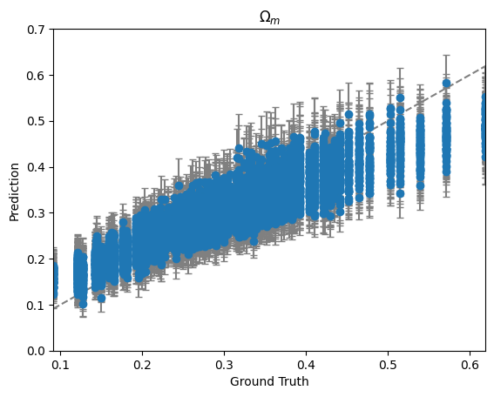
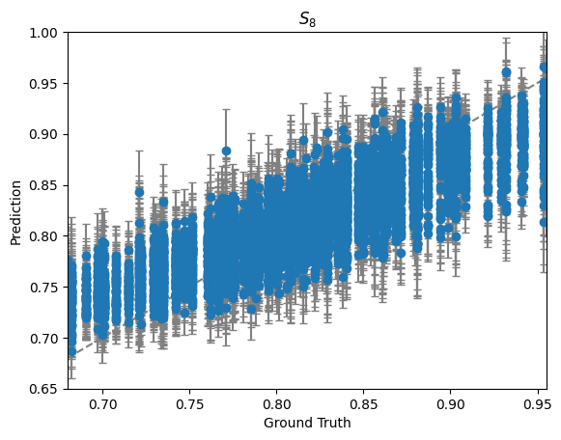
Second Time :
Training: 100%|██████████| 322/322 [02:19<00:00, 2.30it/s]
Validating: 100%|██████████| 83/83 [00:14<00:00, 5.79it/s]
Epoch 1/15 | Train Loss: 3.857019 | Val Loss: 1.783331
-> New best model saved to /content/Phase1_starting_kit_CNN_Direct_baseline.pth
Training: 100%|██████████| 322/322 [02:23<00:00, 2.24it/s]
Validating: 100%|██████████| 83/83 [00:17<00:00, 4.82it/s]
Epoch 2/15 | Train Loss: 1.376678 | Val Loss: 1.638645
-> New best model saved to /content/Phase1_starting_kit_CNN_Direct_baseline.pth
Training: 100%|██████████| 322/322 [02:21<00:00, 2.27it/s]
Validating: 100%|██████████| 83/83 [00:15<00:00, 5.20it/s]
Epoch 3/15 | Train Loss: 0.654430 | Val Loss: 0.888190
-> New best model saved to /content/Phase1_starting_kit_CNN_Direct_baseline.pth
Training: 100%|██████████| 322/322 [02:23<00:00, 2.25it/s]
Validating: 100%|██████████| 83/83 [00:14<00:00, 5.73it/s]
Epoch 4/15 | Train Loss: -0.457471 | Val Loss: 0.939636
Training: 100%|██████████| 322/322 [02:29<00:00, 2.15it/s]
Validating: 100%|██████████| 83/83 [00:17<00:00, 4.66it/s]
Epoch 5/15 | Train Loss: -0.920296 | Val Loss: 0.467817
-> New best model saved to /content/Phase1_starting_kit_CNN_Direct_baseline.pth
Training: 100%|██████████| 322/322 [02:30<00:00, 2.14it/s]
Validating: 100%|██████████| 83/83 [00:16<00:00, 5.04it/s]
Epoch 6/15 | Train Loss: -1.429749 | Val Loss: -0.133200
-> New best model saved to /content/Phase1_starting_kit_CNN_Direct_baseline.pth
Training: 100%|██████████| 322/322 [02:27<00:00, 2.19it/s]
Validating: 100%|██████████| 83/83 [00:15<00:00, 5.36it/s]
Epoch 7/15 | Train Loss: -1.639582 | Val Loss: -0.122204
Training: 100%|██████████| 322/322 [02:27<00:00, 2.18it/s]
Validating: 100%|██████████| 83/83 [00:16<00:00, 5.10it/s]
Epoch 8/15 | Train Loss: -1.834624 | Val Loss: 0.053051
Training: 100%|██████████| 322/322 [02:27<00:00, 2.19it/s]
Validating: 100%|██████████| 83/83 [00:15<00:00, 5.38it/s]
Epoch 9/15 | Train Loss: -1.976270 | Val Loss: 2.540864
Training: 100%|██████████| 322/322 [02:29<00:00, 2.16it/s]
Validating: 100%|██████████| 83/83 [00:17<00:00, 4.67it/s]
Epoch 10/15 | Train Loss: -2.258444 | Val Loss: -0.709784
-> New best model saved to /content/Phase1_starting_kit_CNN_Direct_baseline.pth
Training: 100%|██████████| 322/322 [02:24<00:00, 2.22it/s]
Validating: 100%|██████████| 83/83 [00:17<00:00, 4.83it/s]
Epoch 11/15 | Train Loss: -2.310369 | Val Loss: 0.549078
Training: 100%|██████████| 322/322 [02:26<00:00, 2.21it/s]
Validating: 100%|██████████| 83/83 [00:15<00:00, 5.43it/s]
Epoch 12/15 | Train Loss: -2.388606 | Val Loss: 0.352790
Training: 100%|██████████| 322/322 [02:28<00:00, 2.17it/s]
Validating: 100%|██████████| 83/83 [00:16<00:00, 5.07it/s]
Epoch 13/15 | Train Loss: -2.428029 | Val Loss: -0.208424
Training: 100%|██████████| 322/322 [02:28<00:00, 2.17it/s]
Validating: 100%|██████████| 83/83 [00:15<00:00, 5.51it/s]
Epoch 14/15 | Train Loss: -2.558020 | Val Loss: -0.902122
-> New best model saved to /content/Phase1_starting_kit_CNN_Direct_baseline.pth
Training: 100%|██████████| 322/322 [02:25<00:00, 2.21it/s]
Validating: 100%|██████████| 83/83 [00:14<00:00, 5.69it/s]
Epoch 15/15 | Train Loss: -2.708553 | Val Loss: 0.694119

Training finished in 40.55 minutes.

Validation plot
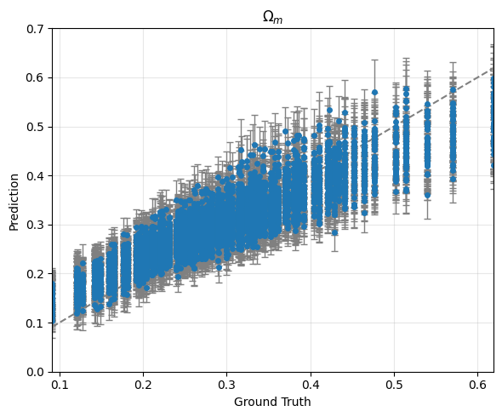
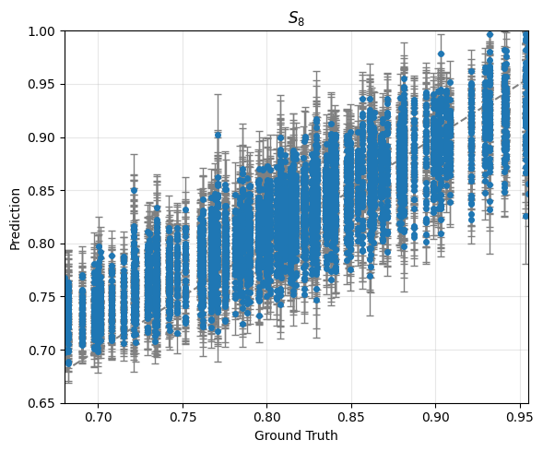
Training plots :
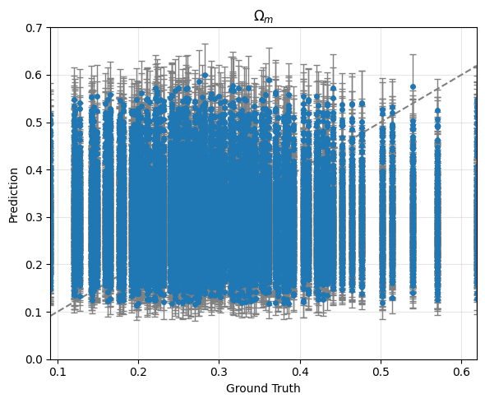
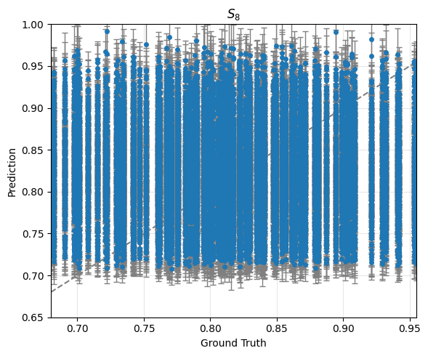

Training
averaged score: -35.35202993713961
averaged error bar: [0.0392099 0.02622042]

Validation/Test
averaged score: 7.781933995160765
averaged error bar: [0.03958124 0.02604696]

