# Hydrosens

# Management monitoring

## Context

The client Ms. Mouton makes a lot of experiments testing different products from her subject study. She follows a protocol, and she takes pictures of the results. She visualizes the absorption of the water on a treat piece of paper regarding the duration. The point is today, everything is made by hand. These experiments require a lot of precious time of Ms. Mouton. The main point of this project is to automatize these steps following the same protocol. The project is spliced in two parts. The first part concerns the physical tools necessary to automatically take pictures in repeatable environment. The second part treats the development of the software to detect when the product fails.

## Objectives

Criteria of Ms. Mouton:

* Easy user interface
* Gain some times.

Criteria for the consistency and the usage of the project:

* Make the experiment repeatable, same samples, same results:
  + Same environment
  + Fixed position of the camera and same lighting condition
  + Fixed position of the sample
* Usage guide

Functionalities:

1. Acquire picture every defined time.
2. Once the absorption is detected:
3. Visualize experiment result: at which time absorption occurred.
4. Visualize the flow rate of absorption.
5. Store the results.

## Management tools

* Github
* Teams
* Roadmap and Backlog

## First meeting – Story mapping 02/02/2023.

1. Understand the project of the client.
2. Understand the need of the client.
3. The steps of the project: Design a prototype, create a data processing tool, test and improve.
4. Create something simple of usage.
5. Functionalities:
   * Data output: absorption or not, amount of water, time at which absorption occurred, flow rate.
   * Let the user choose the duration between pictures.
   * Export a csv file with results.
   * Stop the experiment when all samples absorbed.
6. To contact Ms. Mouton, use Teams or in face to face at school.

## Second meeting – Monitoring 02/10/2023.

1. Budget:

* Camera 2k: over 15€
* Use the camera giving but the teacher, Logitech 720p.
* Light: circular light or led -> we can test both.
* Check for wood if we build the box or buy a folding box.
* A budget can be assigned by the school.

1. The box:

* Number of samples: between 4-8 samples.
* Looking for a hydrophobic floor.

1. Program:

* Add a name for the folder of each experiment.

Third meeting – Monitoring 02/17/2023.

We had a meeting without the client Ms. Mouton.

We have decided to share our files via github and we practiced using it. We came to the conclusion that we should buy as soon as possible everything we need, and we also have a camera from Mr. Gademer.

To do for next time:

* Create the list of tasks regarding the roadmap.
* Search ideas for the floor box.
* Ask Cyril Durant if we can get the wood to establish the budget.
* Presentation: Why do we want to build the box ourselves? And the budget.
* Create a report of last week meeting.
* Create the list of tasks regarding the roadmap.

## Fourth meeting – Monitoring 02/24/2023.

**News**

How to put water droplets on all the samples on the same time? (With an acceptable delay of 10 seconds).

According to the meeting this morning. We will reduce the number of samples to a maximum of 4. Indeed, the amount of water put on the paper is very precise and need a pipette to be realized.

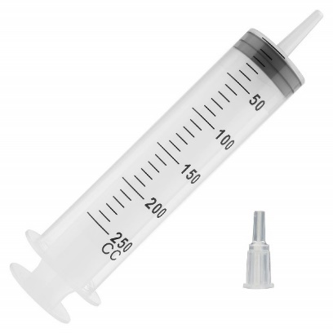In a second time we can think about a system which can facilitate the experiment’s process. The two possibilities are the software method, in other words put sample one after the other. Second possibility, to create an easy-to-use support as showed by the following pictures:

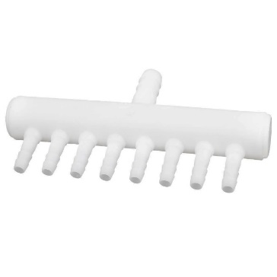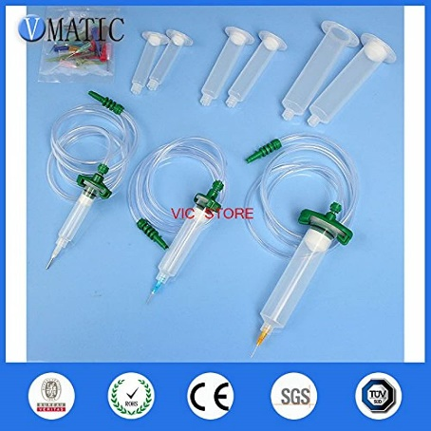

We propose two possibilities for the floor of the box:

* Plastic cotenant, to buy.
* Acrylic panel, to build.

**Decisions**

We will make the box by ourselves with wood.

**To do in a short term:**

Ask Cyril Durant for the wood to start the construction of the box.

The next meeting will take place the 10/03/2023 at 9:45 a.m., if we don’t have enough news, we can push the meeting for the next week.

## Fifth meeting – Monitoring 10/03/2023.

### Management meeting

1. The road map.

The road map’s big steps must include a title that represents a deliverable. It’s important to precise that dates are just hypothetical because it’s almost impossible to have a vision of the work so early in the project.

1. Backlog

The tool must be shared with all the participants of the project to make it dynamic. We must create a Kanban board to visualize the progress of the work.

Example:

|  |  |  |  |
| --- | --- | --- | --- |
| Backlog | To do | Doing | Done |
| Box |  |  | Get the wood |
| Cut the wood |  |  |
|  |  |  |  |
|  |  |  |  |

The main purpose of the Kanban is to update it every week to highlight the progress compared to the previous meeting. It also involves the client in the monitoring of the tasks.

### Client meeting

1. The water drop solution:

It can resolve the issue; Ms. Mouton will check for materials that allow to implement the solution in the lab.

In all the cases, it’s not an expensive solution. We can test the implementation of the solution.

1. Sample of pictures

Picture name = Number of carbon chain – Dilution – minutes (example= C12-5-2)

1. Fully transparency box

The documentation must be understandable for everyone who don’t know anything about the project with a granularity of the construction of the box, for the physical part. The code will be commented and detailed about the functions for any other people who want to discover it.

The next meeting will take place the 24/03/2023 at 9:45 a.m., if we don’t have enough news, we can push the meeting for the next week.