# Stethoscope

## Introduction:

## Schematics

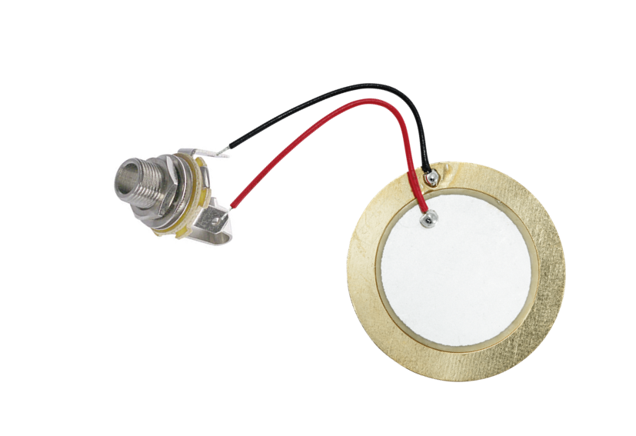

## BOM

Piezo 35 mm

Jack 6.5 female

## CAD model

This was designed in catia

