**Modbus**

**<https://www.alliedtelesis.com/sites/default/files/documents/feature-guides/modbus_feature_overview_guide.pdf>**

**<https://www.youtube.com/watch?v=gzevi1QuI4o>**

**<https://itexamanswers.net/1-2-2-5-packet-tracer-connecting-devices-to-build-iot-answers.html>**

**<https://www.youtube.com/playlist?list=PL0F7301169F983C40>**

-**The MODBUS protocol is a request-response protocol used in Supervisory Control And Data Acquisition (SCADA) systems for industrial automation devices.**

- communicate using a client /server model.

- **Ethernet (MODBUS TCP)**

-MODBUS is commonly used in industrial environments to monitor, gather, process, and transfer

real-time data between devices

-**MODBUS protocol is a request-response protocol.**

- A client can request the MODBUS server to perform an action and the server will respond with that action.

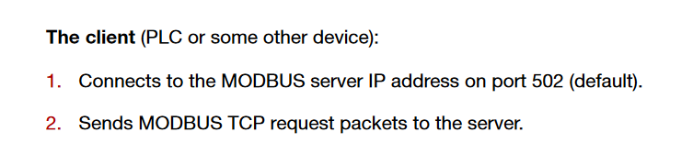

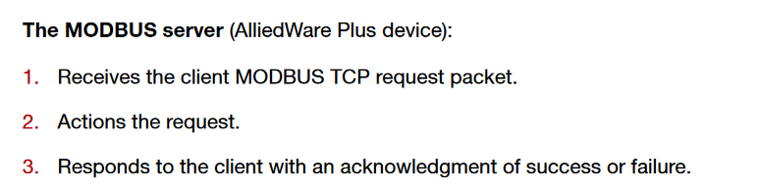

**The client can stay connected for as long as it needs to, making MODBUS requests.**

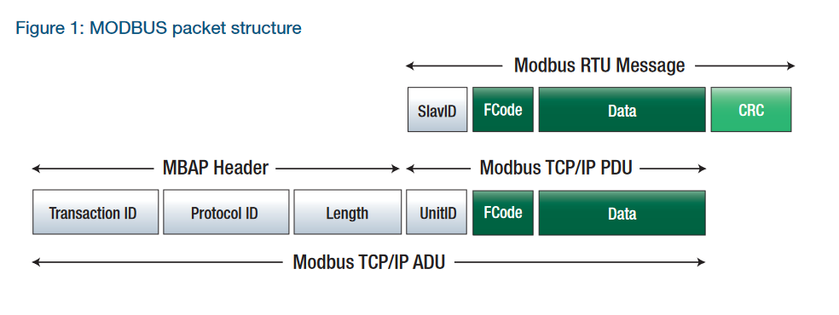

**TCP must establish a connection before transferring data, since it is a connection-based protocol**

**- In summary, the software in the client uses the MODBUS protocol to issue a request (function code) for the values in the specified addresses. The server replies with a response which contains the data. If the client doesn't issue a request, the server remains silent.**

**-Les données Modbus sont le plus souvent lues et écrites sous forme de « registres ». Les registres ont généralement une taille de 16 bits (1 mot).mais certains registres peuvent avoir une taille différente. Par exemple les « coil » qui sont des sorties binaires (0 ou 1) d’un serveur ont une taille de 1 bit.**

