Melanie Najera
Professor Haines
ECO 4422
December 6th, 2025

Econometrics Project
Introduction
With online consumer ratings playing an important role in shaping people's perceptions of a product, platforms such as Amazon have systems such as a star rating system to indicate consumer satisfaction. Of which, may potentially influence sellers’ pricing decisions. It raises a question for sellers of whether higher consumer ratings translate into the ability to charge higher and/or cheaper prices than the base listing. However, it’s not certain these ratings causally affect prices and understanding this relationship is important for both economists studying digital markets and publishers or sellers seeking optimal pricing strategies.
Background
Looking in depth at the publishing industry, there are several ways to discover and purchase novels- such as Books-a-Million and Barnes and Noble. One of the top companies as a marketplace is Amazon which includes a Top 50 bestselling books list that indicates public demand and market dynamics.
The purpose of this project is to focus on analyzing factors that impact the price of bestselling books on Amazon from 2009 to 2019. Utilizing the “Amazon Top 50 Bestselling Books 2009 – 2019” dataset provided by Kaggle, which record the top-selling books on a yearly basis. The study incorporates variables such as user ratings, number of reviews, publication year, author, and genre, to see potential effect on the price and listing. The features may reflect consumer preferences and pricing strategies.
However, the primary focus will be the effect Amazon user ratings have on physical book price while controlling the other factors. This will look for an understanding of whether higher rated books have a relationship with higher prices and if the perceived quality impacts the list pricing strategies on Amazon. On the other hand, to see if higher ratings are correlated with unobserved factors such as marketing.
User ratings in of itself is a key component throughout online marketplaces as a method for people to essentially score their experiences of buying or utilizing a product/service. It began being utilized in the mid-to-late 1990’s and was incorporated in the retail website itself- including Amazon. Not too long after, services were made available for the sole purpose of online ratings such as RateItAll. With it, users could go to one website and look in depth at what users were saying in regard to several companies and products. In the early 2000’s, user ratings became increasingly popular as they were not only directly incorporated by retailers but by third-party websites as well. It is a powerful marketing and informational tool for services to boast about how people enjoy a product or as a warning to others not to make a purchase. A primary, modern-day example for books is Goodreads. It was founded in 2007 and is owned by Amazon, containing a database of books and permits users to write and read reviews. Books sold on Amazon typically have both reviews made directly by those who purchased the item, but a Goodreads rating on the top of the listing for more information.
By exploring these relationships through applying econometric techniques, the project aims to identify causal impact of user ratings on book prices while accounting for potential confounding variables such as year and genre.

Dataset and Variables:
Name- Title of the Book
Author- Author of the Book
User Rating- Amazon User Rating
Reviews- Number of Reviews Written on Amazon
Price- Price of Book as of October 13th, 2020
Year- The Year(s) Ranked as Bestseller
Genre- Fiction or Non-Fiction
n-years_bestseller = Number of years the book appeared on the bestseller list
first_year = Fixed effect for the first year the book appeared on the bestseller list

Data
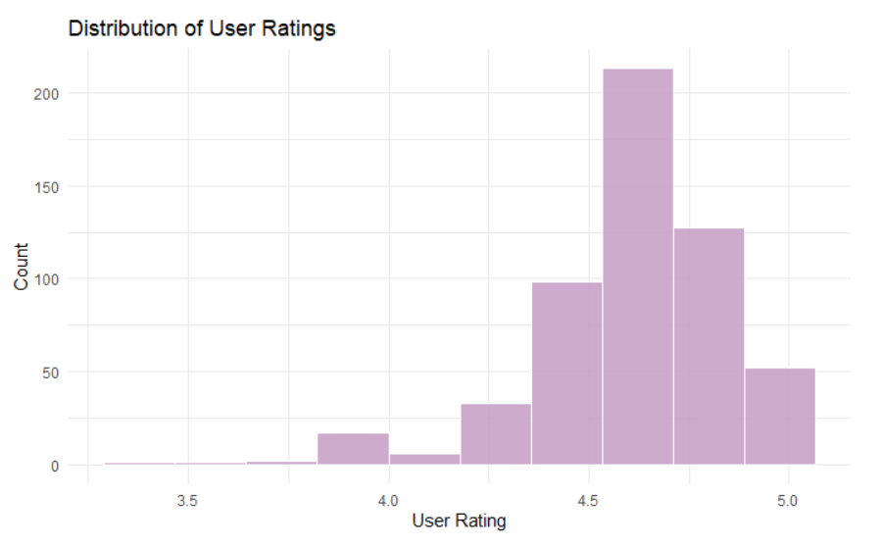
Figure 1. Distribution of User Ratings
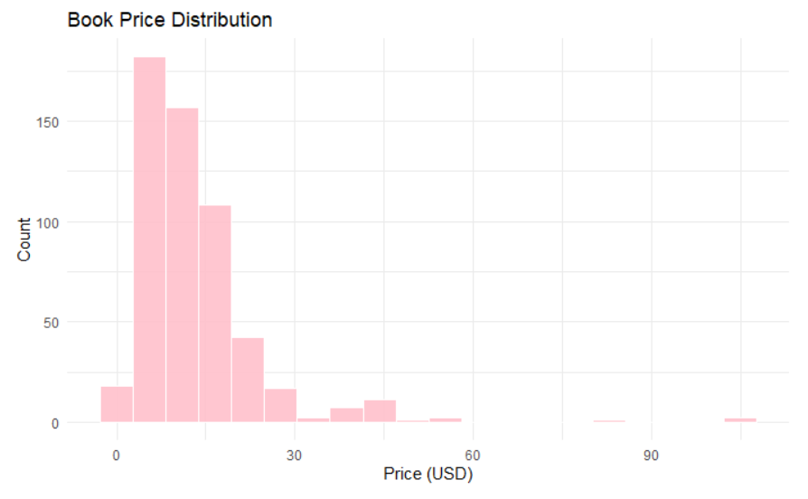
Figure 2. Book Price Distribution
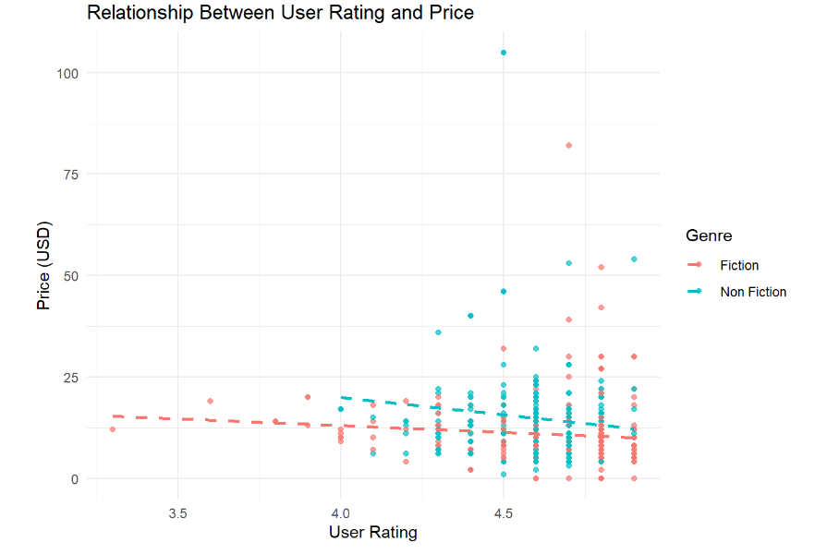
Figure 3. Relationship Between User Ratings and Price
The “Amazon Top 50 Bestselling Books 2009 – 2019” was provided by Sooter Saalu on Kaggle utilizing the bestsellers list on Amazon. It is composed of 550 observations and seven features that are composed of the title, author, rating score, number of reviews, price, genre, and year it was released.
As the data is composed of the top 50 bestsellers per their respective year, there may be books that consistently sold within that range for multiple years. To avoid double counting books, it is necessary to combine observations of a single title, which is indexed by the name and author, with a new variable that counts how many years the book is a bestseller. The observation becomes fixed at the first year the title is recorded in the top 50 list.
In terms of user ratings, it is generally high. The minimum rating for the books observed is 3.3 while the average rating is 4.6 and the median being 4.7, indicating strong consumer satisfaction. The review totals have an extremely high range with the minimum being 37 reviews and maximum of 87,841 reviews. This may be an indicator of certain books being an outlier with an outstanding amount as the median is 8,580 reviews. The books range from free to $105 but seem to average to about $11 - $13.
The initial findings of the correlations is that user ratings and price has a slightly negative score of -0.133. That of which demonstrate that higher ratings tend to be slightly cheaper on average.
Exploring the books themselves, they are separated on the basis of genre: fiction or non-fiction. Of the observations, 310 are non-fiction and the remaining 240 are fiction. The prices by genre leaned higher for non-fiction in comparison. Overall, the prices of books tends to fluctuate throughout the years.

Identification
There is a limitation within the dataset itself as it is composed of books that has specifically caught enough people’s attention and sold; with no information on prices of books that did poorly. Additionally, it is only the highest selling 50 out of the countless books sold. That of which may lead to results that cannot represent the book market on a broader scale as it is only capturing highly rated books. The sample data is inherently non-random. There is an issue of endogeneity, as there are omitted variables that are leading to a biased estimate.
Possible important factors such as a book’s sub-genre and only classifying a book on whether it is non-fiction or fiction, political clarifications, demographics (i.e. children’s books, young adult audiences), etc., being omitted factors which correlate with both ratings and price, may lead to OLS estimates of the rating effect being biased. There are potential issues with reverse causality, as price may influence user ratings in the sense of higher expectations or buyer composition for more expensive, or special, editions, creating simultaneity. Prices may also have a reverse causality with reviews as well (a disliked overpriced book leading to a stronger negative review, highly praised cheap book given a stronger positive review). To reiterate, sample selection is prevalent due to the data being limited to only 50 books composed of the highest selling.
To have a more in-depth understanding on how pricing itself works, demand theory is a “principle that emphasizes the relationship between consumer demand for goods and services and their prices” [6]. Demand theory explains that while other factors are held equal, the higher the price is for product, the less demand it will have and the more it is demanded, the higher the price (in relation to supply). The law of supply applies as a direct relationship between price and quantity. Together there is the law of supply and demand which is necessary to understand as it helps predict market conditions as well as determining pricing.
In terms of bookselling, an equilibrium price is determined, quantity is based on the available copies (supply) versus the demand of the people. A base price is composed of the costs it took to create the book, such as the materials of the page, ink used, and labor. Additionally, there are factors such as purchasing in bulk- which would lower the per-unit costs and permit a manufacturer to lower the price while still being able to make a profit. As each may vary by company, Gorham Printing will be utilized as a pricing tool as a baseline.
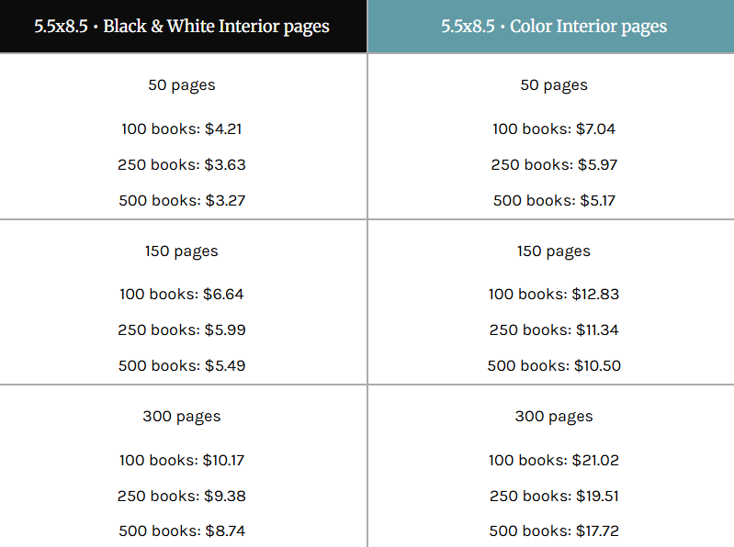
Figure 4. Costs to Print Books (Gorham Printing)
Looking at Figure 4, it refers to books 5.5 x 8.5 inches that are either printed in black and white or in color. What is important to note is that the smaller number of pages within the book are the cheapest in price and purchasing in bulk lowers the per-unit price of the book.
Taking into account the goal to estimate the causal effect while accounting for the challenges mentioned above, the control for the observable confounders are: genre, year, number of reviews. The initial model is written as:
$$Price_{i}= β_{0}+ β_{1}UserRating_{i}+ β_{2}Reviews_{i}+ β_{3}Genre_{i}+ β_{4}Year_{i}+ ε_{i}$$
- ${Price}_{i}$ = Price of Book $i$
- ${UserRating}_{i}$= Average Amazon User Rating
- ${Reviews}_{i}$= Number of Reviews
- ${Genre}_{i}$= Categorical variable (Fiction/Non-Fiction)
- ${Year}_{i}$= The Year(s) Ranked as Bestseller
- $ϵ_{i}$= Error term capturing unobserved factors

The issues that become prevalent are omitted variable bias, the repeat observations of books that appear on the bestseller list on different years, and time-specific impacts affecting book prices (such as changes in Amazon pricing or inflation). To adjust, the baseline model is:

Priceᵢ = β₀ + β₁·UserRatingᵢ + β₂·log(Reviewsᵢ + 1) + β₃·Genreᵢ + β₄·n_years_bestsellerᵢ + γ·first_yearᵢ + εᵢ

- ${\text{Price}}_{i}$ = Price of Book $i$
- ${\text{UserRating}}_{i}$= Average Amazon User Rating
- ${\text{Reviews}}_{i}$= Number of Reviews
- ${\text{Genre}}_{i}$= Categorical variable (Fiction/Non-Fiction)
- ${\text{Year}}_{i}$= The Year(s) Ranked as Bestseller
- ${\text{n_years_bestseller}}_{i}$= Number of years the book appeared on the bestseller list
- ${\text{first_year}}_{i}$= = Fixed effect for the first year the book appeared on the bestseller list
- $ϵ_{i}$= Error term capturing unobserved factors

This model demonstrates price as the dependent variable, and as price is a continuous numeric variable, ordinary least squares regression will be able to find the best-fit line as there may be a linear relationship. It will aid to estimate the marginal effect user ratings has on price while holding other factors constant and the other factors will reduce omitted variable bias. The adjustments account for the first year the book appeared in the best-selling list, combining multiple entries on the same book, a log transformation of reviews for extreme outliers, and the number of years a book was on the list to demonstrate its popularity.

Results
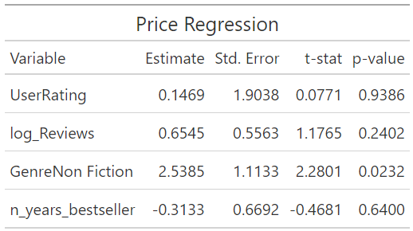
Table 1. Results from Regression Model
In terms of the user rating, a one-point increase in rating does not have any significant effect on price. That of which may indicate that higher ratings do not indicate higher book prices. Similarly, reviews does not seem to have an effect. As for genre, there is an average of $2.54 increase for nonfiction prices over fiction prices. Among the bestselling books, genre may have more impact on pricing rather than user ratings.

Analysis
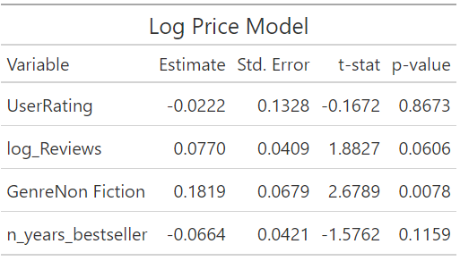
Table 2. Results from Log Price Model for Robustness
The regression results demonstrate that the user ratings do not have a statistical significance causal effect on book prices. Within the model, there is a one-point increase in user rating that is associated with only a $0.15 increase in price with a p = 0.94- indicating very little impact. Measuring popularity with a logged version of reviews did not have predictive power in terms of prices which indicate that, despite consumers leaving a varied number of reviews, it does not impact the pricing. The highest impact is genre with nonfiction books being $2.54 more expensive than fiction books. To reinforce the findings, re-estimating the model with log prices led to similar results with genre being significant and ratings not being impactful.
The model indicates that the prices for the bestselling books are rather inflexible, and may be more influenced by pricing conventions rather than changes in consumer evaluation. User ratings reflect the consumer’s satisfaction but do not aid as a price-setting resource for Amazon’s bestseller pricing strategies.

Conclusion
This study indicates that there is no consistent evidence that Amazon user ratings causally influence book prices. The findings suggest that while ratings may influence purchasing decisions, it is not sourced as a factor into price adjustments, likely due to publisher price-setting practices and Amazon’s standardized pricing norms. The only remaining factor that is used as a determinant of price differences across bestselling books is genre.
For future projects, it would be important to research data in relation to the cost of production of books themselves such as the printing methods and distribution expenses. Additionally, sampling books beyond the top 50 bestselling and source non-bestselling titles to form more broad ideas in regard to the publishing market. To gather information on Amazon’s book pricing strategies, there should be information on the base prices, the Amazon listed price, and potentially competitors’ prices to see if there are patterns such as Amazon matching a listed price from a competitor, when book prices are typically listed cheaper than base prices, etc.

Source:
https://www.kaggle.com/datasets/sootersaalu/amazon-top-50-bestselling-books-2009-2019
https://nudgenow.com/blogs/understanding-different-user-rating-systems-impact
https://results.shopperapproved.com/blog/the-history-and-evolution-of-online-reviews
https://reviewinc.com/2021/09/07/a-history-of-online-reviews
https://www.sciencedirect.com/topics/psychology/endogeneity
[6] https://www.investopedia.com/terms/d/demand_theory.asp
https://gorhamprinting.com/prices-book-printing/price-charts.html
https://www.mallickhossain.com/papers/BulkBuyingCogCosts.pdf
https://gorhamprinting.com/prices-book-printing/price-charts.html

