GPS Navigation System

Proposal

Southeastern Louisiana University

ET 494

Spring 2018

By: Dylan Landry, Jordan Melancon, and Miguel Rodriguez

Advisor: Dr. Koutsougeras

Professor: Dr. Koutsougeras

**Abstract**

The overall goal in this project is to implement a universally applicable GPS navigation system. This system should be able to work on any type of vehicle in an open environment. In this project, an app was developed that can read and write coordinates to and from the GPS module. We also, used basic circuitry to rewire and control the motors of a simple RC car. The idea is to combine these two elements and design what is essentially an autonomous vehicle.

**Introduction**

Last semester, we were successfully able to finish up the app and connect it to the Arduino via Bluetooth. The GPS module was also capable of gathering coordinates and we were able to send and receive coordinates through Bluetooth as well.

One of the main objectives for this semester is to take our GPS system and connect it to our RC car to interface the two to have an autonomous vehicle working in an open environment. To do this we will implement code to have full functionality of the RC car first. With this, we can setup the motions of the car based on the GPS coordinates sent to the Arduino. This means that based on where the GPS coordinates are located we can control the car if it needs to go left, right, forward, or reverse. After having our main goal accomplished we can then look at extra features of the car such as object detection and obstacle avoidance. This will involve the use of sensors for detecting objects near the car as it is moving along its current path. Also, once the car has come within a certain distance of the object we need to have the car perform some routine to avoid the object collision.

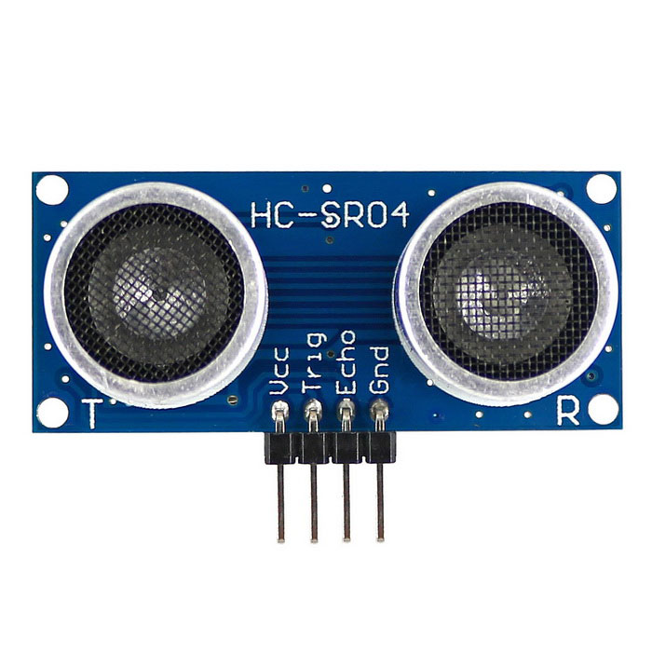**Parts List**

* Detection sensors
  + Ultrasonic distance sensor modules (HC-SR04)
    - Minimum Range (2 cm)
    - Maximum Range (4 m)

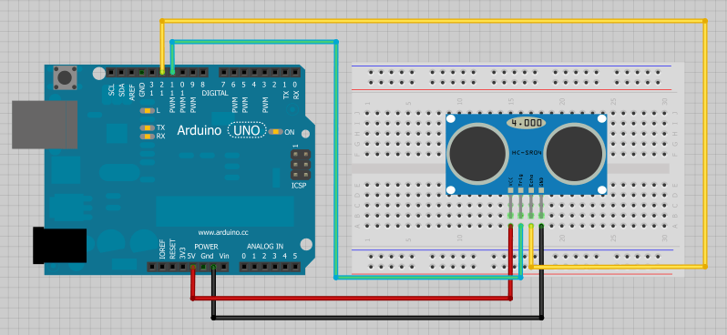*Figure 1: Ultrasonic sensor*

*Figure 2: Wiring of the Ultrasonic sensor*

**Deliverables**

* Fully combine GPS, app, and motor control
* Car should be able to travel from Point A to Point B without any obstacles
* Incorporate obstacle detection and avoidance

**Timeline**

* January - meet with our advisor and finalize semester plans; begin working on combining all elements of project
* February - work on coding GPS, app, and motors to work together
* March - be able to input coordinates and have car move on its own in open environment; begin working on object detection and avoidance
* April - coding and testing object detection and avoidance
* May - final testing and troubleshooting, present finished product

**Work Plan**

While last semester a lot of our project plans were more individually split, this semester we need to work as a whole to get our main objective completed which is getting the GPS system to interface with the RC car and control it. To do this we first need to finish having complete control over the car’s motors. Then we can begin to interface the two systems.

* **Implementing the GPS system with the RC Car**

First, we need to setup a parameter for the car to start moving only after it receives the GPS coordinates. Then, when the car has received the coordinates we need to be able to determine what way the car needs to be facing in order to go the correct direction. To do this we will implement a system that when the GPS coordinates have been received by the Arduino, have the car move forward a few feet in order to determine if it is going in the correct direction. After the car moves forward it can take its old location, current location, and the final destination coordinates, and compare the three coordinates to determine if it needs to readjust be it turning left or right, or moving forward or reverse. The car will then have the features to autocorrect itself to move autonomously. Once this goal is achieved, we can then focus on more added features to the car such as object detection, obstacle avoidance, and improving the app for the phone.

* **Object Detection and Obstacle Avoidance**

For object detection we need to attach sensor to the car to determine if there are obstacles in the way of the vehicle. We can assign multiple ultrasonic sensors to the car. This way if the car or an object gets within a certain distance of each other the car can correct itself. This leads into obstacle avoidance. When the car comes into the vicinity of an object we need to have multiple routines on how the car can correct itself based on which sensor on the car the object is located next to. For instance if the sensor on the front of the car comes in contact with an object it needs to stop the car, move in reverse, and turn left or right to avoid the object.

* **Improving the App**

As for improving the app, we would like to implement a system that would place multiple intermediate points along the way to the final destination. This would help with keeping the car on course, and improve its navigating capabilities. This needs further research but can most likely be done through the Google Maps API. We would also like to implement a master off switch on the app to stop the car from moving if we need to retrieve it. It would take placing a button on the app that would send a signal via Bluetooth to the Arduino to run a function to halt the car and stop the motors.

As a team we believe that having a great communication between each of us and our advisor is of great importance and it is important that we show our unity in solidarity to each other independently to any task that we have been assigned. This is how we are planning to tackle this project:

* Dylan - Interfacing the GPS system with the RC car to control it.
  + Setup if the Arduino could also be powered off of the RC cars battery. If not find an external power large enough to power the Arduino and components
  + Setup starting movement for the RC car when GPS coordinates are sent to determine the direction the car needs to go
  + Wiring up the GPS system and RC car components
  + Creating a system to detect the objects based on all of the sensors
* Jordan - Interfacing the GPS system with the RC car to control it.
  + Setup a routine to check if the car is still on course with the GPS coordinates
  + Improve the app to have multiple intermediate checkpoints based on the final destination
  + Create a master off switch to override all of the commands and stop the car
  + Creating routines for obstacle avoidance to correct the car to the right path
* Miguel - Interfacing the GPS system with the RC car to control it.
  + Expand and tune up the control for the two motors front and back.
  + Creating a way to control the speed of the car.
  + Implementing the ultrasonic distance sensor into the RC car system such as positioning and wiring.

**Conclusion**

Our goal by the end of this semester is to have a fully functional autonomous vehicle. To do this we need to first implement the GPS system, App, and RC car together to have everything communicating with each other. Then, we can proceed to make movements with the RC car based on the GPS coordinates set by the user, and sent to the car via Bluetooth. After the car is moving and functioning in an open environment, we can focus on getting it to work with sensors so that we can detect objects. Based off of where the said objects are we can then make routines for the car to correct itself to avoid the obstacles. Finally, we can then fine tune our system and improve the app so that we have multiple pathing points and a master off switch to stop the car if need be.

**References:**

* HC-SR04 Ultrasonic sensor

https://www.amazon.com/HC-SR04-Ultrasonic-Distance-Measuring-Sensor/dp/B00F167T2A

* Ultrasonic Sensor Wiring Diagram

https://create.arduino.cc/projecthub/SHAHIR_nasar/ultrasonic-sensor-d34f8b