Gaussian Study Guide
Gaussian probability connects uncertain voltage readings to receiver error rates. This guide develops the Gaussian distribution and Q function, binary decisions, averaging, and transformations, then applies them to filtered noise, envelopes, and sampled signals. Practical explanations accompany the mathematics; worked problems follow their relevant topics.

Contents
Gaussian Distribution and Q Function
Binary PAM Decision Error
Central Limit Theorem and Averaging
Transformations, Support, and Point Masses
Gaussian Variables and Linear Filtering
Gaussian Quadratures, Envelope, and Phase
Sampled Gaussian Signals and Prediction
Matched Filtering and Binary Decisions

Symbols
Symbol | Meaning
$X$, $x$ | A random variable and its value. $X\left(t\right)$ is a random process; a measured trace is one realization.
$f_{X}\left(x\right)$, $F_{X}\left(x\right)$ | Probability density and cumulative distribution, $F_{X}\left(x\right)=P\left(X≤x\right)$.
$μ_{X}$, $σ_{X}^{2}$ | Mean and variance; $σ_{X}$ is the standard deviation.
$Z$, $Q\left(z\right)$ | Standard Gaussian variable and its upper-tail probability.
$g\left(x\right)$, $c$, $d$ | Transformation; constant gain and DC offset in an affine transformation.
$R_{X}\left(τ\right)$, $C_{X}\left(τ\right)$ | Autocorrelation and autocovariance.
$R_{XY}\left(τ\right)$ | $E\{X\left(t+τ\right)Y\left(t\right)\}$: the first process carries the lag.
$S_{X}\left(f\right)$, $h\left(t\right)$, $H\left(f\right)$ | Power spectral density, impulse response, and frequency response; $f$ is in hertz.
$N_{0}/2$ | Two-sided white-noise spectral density.
$B$, $W$, $T_{s}$ | Bandwidths defined locally and the sampling interval.
$$sinc\left(u\right)=\frac{sin\left(πu\right)}{πu}, sinc\left(0\right)=1.$$

Gaussian Distribution and Q Function

Why we study a Gaussian distribution
A noisy receiver voltage can change every time it is measured, even when the transmitted symbol stays the same. A reading at one fixed instant is represented by a random variable. The complete uncertain waveform is a random process: each instant has a random variable, and one recorded waveform is a realization of that process.
Many small, approximately independent disturbances can combine into a nearly Gaussian voltage. This makes the Gaussian distribution useful for describing receiver noise and calculating the chance that a reading crosses a decision threshold. The central limit theorem explains this approximation; a mean and a variance alone do not prove that a variable is Gaussian.

The density and its parameters
Write
$$X∼N\left(μ_{X},σ_{X}^{2}\right), σ_{X}>0.$$
The first parameter is the mean; the second is the variance:
$$μ_{X}=E\{X\}, σ_{X}^{2}=E\{{\left(X−μ_{X}\right)}^{2}\}, σ_{X}=\sqrt{σ_{X}^{2}}.$$
The probability density is
$$f_{X}\left(x\right)=\frac{1}{\sqrt{2π} σ_{X}}exp​\left[−\frac{{\left(x−μ_{X}\right)}^{2}}{2σ_{X}^{2}}\right], x∈R.$$
The mean locates the centre of the symmetric bell shape. The standard deviation measures its spread in the same units as the voltage. Increasing $σ_{X}$ makes large deviations from the mean more likely. A density value is not a point probability: probabilities are areas under the curve.
$$P\left(a<X≤b\right)=\int_{a}^{b}{f_{X}}\left(x\right) dx, P\left(X=x\right)=0.$$
The mean-square value is
$$E\{X^{2}\}=σ_{X}^{2}+μ_{X}^{2}.$$
Thus a zero-mean noise voltage can have nonzero mean-square value and deliver power.

Standardization
Instead of integrating a different Gaussian density for every mean and variance, measure the reading in standard deviations from its mean:
$$Z=\frac{X−μ_{X}}{σ_{X}}∼N\left(0,1\right).$$
A threshold $c$ is therefore at the standardized distance $\left(c−μ_{X}\right)/σ_{X}$. This converts every Gaussian probability calculation into one involving the same standard normal curve.
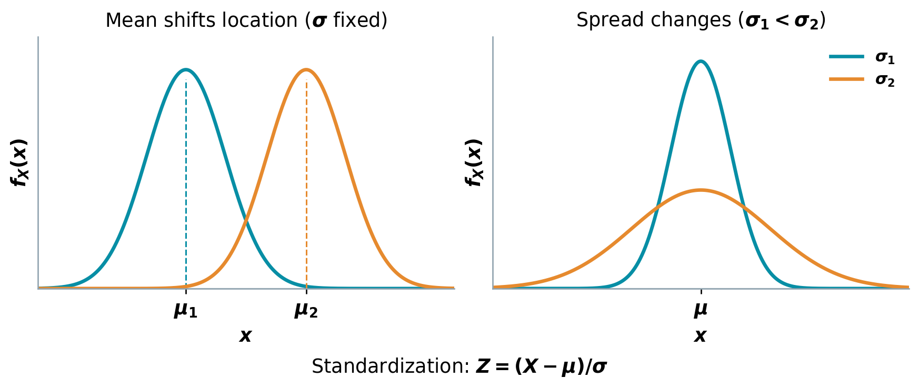
Gaussian location, spread, and standardization.

The Q function
The Q function is the upper-tail area of the standard Gaussian density:
$$Q\left(z\right)=\frac{1}{\sqrt{2π}}\int_{z}^{∞}{e^{−u^{2}/2}} du.$$
Its symmetry gives
$$Q\left(0\right)=\frac{1}{2}, Q\left(−z\right)=1−Q\left(z\right).$$
For $X∼N\left(μ_{X},σ_{X}^{2}\right)$,
$$P\left(X>c\right)=Q​\left(\frac{c−μ_{X}}{σ_{X}}\right),$$
$$P\left(X≤c\right)=F_{X}\left(c\right)=1−Q​\left(\frac{c−μ_{X}}{σ_{X}}\right).$$
For an interval, subtract the two upper tails:
$$P\left(a<X≤b\right)=Q​\left(\frac{a−μ_{X}}{σ_{X}}\right)−Q​\left(\frac{b−μ_{X}}{σ_{X}}\right).$$
For $k≥0$, symmetry also gives
$$P\left(\left|X−μ_{X}\right|>kσ_{X}\right)=2Q\left(k\right),$$
$$P\left(\left|X−μ_{X}\right|≤kσ_{X}\right)=1−2Q\left(k\right).$$
In a receiver, an error tail is the part of the voltage distribution lying beyond the wrong decision threshold. The Q function turns the threshold distance into that error probability. Larger positive distances give smaller tail areas.
Linear gains and voltage offsets change the Gaussian mean and spread; their distribution formulas are developed in the section on transformations.

Binary PAM Decision Error

A noisy amplitude decision
Binary pulse-amplitude modulation represents two symbols by opposite voltage levels. After receiving and sampling the signal, the receiver must decide which level was sent. Noise can move a positive level below the threshold or a negative level above it.
Let the transmitted symbol be
$$S∈\{+A,−A\}, A>0,$$
with equal probabilities. Model the received sample as
$$Y=S+N, N∼N\left(0,σ_{N}^{2}\right),$$
where the noise is independent of the transmitted symbol. For equal symbol probabilities and this symmetric noise model, the decision threshold is zero:
$$\hat{S}=\left\{\begin{matrix}+A, & Y≥0, \\ −A, & Y<0.\end{matrix}\right.$$
Conditional on the transmitted symbol, the received sample is Gaussian, centred at that symbol level. The two conditional distributions are separated by $2A$ and each has standard deviation $σ_{N}$. Without conditioning on the symbol, their equally weighted mixture is not generally a single Gaussian distribution.
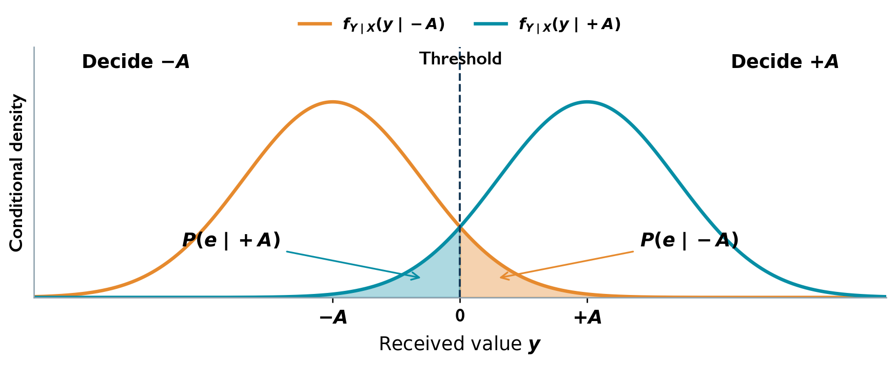
Zero-threshold PAM decision and Gaussian error tails.

Example: error probability for a zero-threshold receiver

Question
A binary PAM system transmits $+A$ and $−A$ with equal probabilities. The received sample is $Y=S+N$, where $N∼N\left(0,σ_{N}^{2}\right)$ is independent of $S$. Find the conditional error probability for each symbol and the average error probability when the threshold is zero.

Solution
After transmitting $+A$,
$$Y∣\left(S=+A\right)∼N\left(A,σ_{N}^{2}\right).$$
An error occurs when the received value is negative:
$$P\left(\text{error}∣S=+A\right)=P\left(Y<0∣S=+A\right)=P\left(N<−A\right).$$
Standardizing the noise,
$$P\left(\text{error}∣S=+A\right)=P​\left(\frac{N}{σ_{N}}<−\frac{A}{σ_{N}}\right)=1−Q​\left(−\frac{A}{σ_{N}}\right)=Q​\left(\frac{A}{σ_{N}}\right).$$
After transmitting $−A$, an error occurs on the positive side:
$$P\left(\text{error}∣S=−A\right)=P\left(N≥A\right)=Q​\left(\frac{A}{σ_{N}}\right).$$
Weighting the two conditional probabilities by their equal priors,
$$P_{e}=\frac{1}{2}P\left(\text{error}∣S=+A\right)+\frac{1}{2}P\left(\text{error}∣S=−A\right)=Q​\left(\frac{A}{σ_{N}}\right).$$
The ratio $A/σ_{N}$ measures how far the threshold lies from either symbol level in noise standard deviations. Increasing $A$, or reducing the noise spread, makes it less likely that a sample crosses to the wrong side.

Central Limit Theorem and Averaging

Why sums often look Gaussian
A receiver disturbance may be the combined effect of many small contributions. Even if the individual contributions are not Gaussian, their sum can approach a Gaussian distribution. This explains why the Gaussian model is useful for noise; it does not make every kind of noise Gaussian.
Let $X_{1},…,X_{n}$ be independent, identically distributed variables with common finite mean $μ_{X}$ and finite positive variance $σ_{X}^{2}$. For their sum,
$$Y_{n}=\sum_{k=1}^{n}{X_{k}},$$
$$E\{Y_{n}\}=nμ_{X}, Var\left(Y_{n}\right)=nσ_{X}^{2}.$$
The central limit theorem states that, as $n→∞$,
$$Z_{n}=\frac{Y_{n}−nμ_{X}}{σ_{X}\sqrt{n}}$$
approaches the standard Gaussian distribution $N\left(0,1\right)$. Consequently, for sufficiently large $n$ in a suitable application,
$$Y_{n} \text{is approximately} N\left(nμ_{X},nσ_{X}^{2}\right).$$
This is an approximation for non-Gaussian summands. If the independent summands are already Gaussian, their sum is exactly Gaussian for every $n$. The finite-variance and independence assumptions matter; the statement should not be applied simply because many terms are present.

Averaging repeated readings
Averaging is useful when the quantity of interest stays constant but independent measurement noise changes from reading to reading. The desired mean is preserved, while random fluctuations become smaller.
For the average
$$M_{n}=\frac{1}{n}\sum_{k=1}^{n}{X_{k}},$$
independence gives
$$E\{M_{n}\}=μ_{X}, Var\left(M_{n}\right)=\frac{σ_{X}^{2}}{n}, σ_{M_{n}}=\frac{σ_{X}}{\sqrt{n}}.$$
If the readings are independent Gaussian variables with a common law,
$$M_{n}∼N​\left(μ_{X},\frac{σ_{X}^{2}}{n}\right)$$
exactly. For non-Gaussian independent identically distributed readings, the corresponding Gaussian shape is a central-limit approximation for large $n$. Closely correlated readings do not generally provide the same variance reduction.

Example: Gaussian voltage and averaging

Question
A zero-mean Gaussian voltage has standard deviation $10$ V. Add a $5$ V offset. Find the probability of a positive reading, then find the probability that the average of two independent readings is positive.

Solution
Let $X∼N\left(0,100\right)$ and $Y=X+5$. The constant offset changes the mean and leaves the variance unchanged:
$$Y∼N\left(5,100\right).$$
Standardizing the zero threshold,
$$P\left(Y>0\right)=Q​\left(\frac{0−5}{10}\right)=1−Q\left(0.5\right)≈0.6915.$$
For two independent readings, let
$$M=\frac{Y_{1}+Y_{2}}{2}.$$
Their average is exactly Gaussian:
$$E\{M\}=5, Var\left(M\right)=\frac{100+100}{4}=50,$$
$$M∼N\left(5,50\right).$$
Therefore,
$$P\left(M>0\right)=Q​\left(−\frac{5}{\sqrt{50}}\right)=1−Q​\left(\frac{5}{\sqrt{50}}\right)≈0.7602.$$
Averaging keeps the $5$ V mean but reduces the standard deviation from $10$ V to $\sqrt{50}$ V. The probability of identifying the positive level therefore increases. This calculation uses the exact Gaussian averaging law; no large-sample approximation is needed.

Transformations, Support, and Point Masses

Why a transformation changes the distribution
A receiver may amplify a noisy voltage, add a DC offset, rectify it, or limit its amplitude. If the input reading is the random variable $X$, the device output is
$$Y=g\left(X\right).$$
The transformation changes both the output values that can occur and the probabilities attached to them. An amplifier spreads or compresses the range; a rectifier can send many different input readings to the same output value. For this reason, transforming a density formula alone is not enough: the output support and any point masses must also be identified.

Start with the output CDF
The event $Y≤y$ means that the input satisfies $g\left(X\right)≤y$. Therefore,
$$F_{Y}\left(y\right)=P\left(Y≤y\right)=P\left(g\left(X\right)≤y\right).$$
Find the input intervals satisfying the inequality, then add their probabilities. If $X$ has a density,
FYy={x:gx≤y}​fXx dx.
The integral automatically ignores input values outside the support because $f_{X}\left(x\right)=0$ there. The CDF method also works when part of the output law is discrete; an ordinary derivative describes only its continuous part.

A single inverse branch
Suppose $X$ has a density and $g$ is strictly monotone on its input support. With $h\left(y\right)=g^{−1}\left(y\right)$,
$$F_{Y}\left(y\right)=\left\{\begin{matrix}F_{X}\left(h\left(y\right)\right), & g\text{ increasing}, \\ 1−F_{X}\left(h\left(y\right)\right), & g\text{ decreasing}.\end{matrix}\right.$$
Where the inverse is differentiable,
$$\boxed{f_{Y}\left(y\right)=f_{X}\left(h\left(y\right)\right)\left|\frac{dh\left(y\right)}{dy}\right|.}$$
The derivative accounts for the change in interval width. Compressing an input interval into a narrower output interval increases the density there while preserving its probability. Its absolute value keeps the density nonnegative when the transformation reverses the input order.
Use this expression only for output values reached by the supported input. For a bounded input interval $\left[a,b\right]$ under $Y=cX+d$,
$$\text{output interval}=\left\{\begin{matrix}\left[ca+d, cb+d\right], & c>0, \\ \left[cb+d, ca+d\right], & c<0.\end{matrix}\right.$$
The density is zero outside the admissible output range. A decreasing transformation swaps the two interval endpoints.

Several inverse branches
Different input values can produce the same output. If $g\left(x_{i}\right)=y$ on locally invertible continuous branches, each admissible root contributes:
fY,conty=i​fXxig′xi, g′xi≠0.
Include only roots belonging to the input support and the corresponding branch. Summing contributions is necessary because the output cannot distinguish which input branch produced the reading.
A square-law detector. Squaring a signed voltage makes its output nonnegative. For $X∼N\left(0,σ_{X}^{2}\right)$ and $Y=X^{2}$, an output $y>0$ has two input roots, $\sqrt{y}$ and $−\sqrt{y}$:
$$\begin{matrix}f_{Y}\left(y\right) & =\frac{f_{X}\left(\sqrt{y}\right)+f_{X}\left(−\sqrt{y}\right)}{2\sqrt{y}} \\ & =\frac{e^{−y/\left(2σ_{X}^{2}\right)}}{σ_{X}\sqrt{2πy}}, y>0.\end{matrix}$$
The density is zero for $y<0$. The output is not Gaussian: it has lost the sign of the input and cannot be negative. At $y=0$, use the CDF or a limit rather than dividing by $g′\left(0\right)=0$. Here the density grows without bound as $y↓0$, but
$$P\left(Y=0\right)=P\left(X=0\right)=0.$$
A zero derivative at an isolated input point does not, by itself, create a point mass.

Constant branches and point masses
A constant branch maps an entire set of input values to one output value $y_{0}$. Define
$$A=\{x:g\left(x\right)=y_{0}\}.$$
Its total output mass is
$$\boxed{P\left(Y=y_{0}\right)=P\left(X∈A\right)=F_{Y}\left(y_{0}\right)−F_{Y}\left(y_{0}^{−}\right).}$$
The notation $F_{Y}\left(y_{0}^{−}\right)$ denotes the left limit,
$$F_{Y}\left(y_{0}^{−}\right)=\lim_{y↑y_{0}}F_{Y}\left(y\right).$$
A CDF jump is a probability at one exact output value. For a density-bearing input, the mass can be evaluated as PX∈A=A​fXx dx. It is positive only when the mapped set carries positive input probability. Retain the remaining continuous density separately; its integral need not equal one by itself.
If the output contains a continuous part and masses $p_{k}$ at values $y_{k}$, then
−∞∞fY,conty dy+k​pk=1.
The same law may be written using Dirac impulses:
fYy=fY,conty+k​pkδy−yk.
Here an impulse represents probability mass, rather than a finite density height.
A half-wave rectifier. For zero-mean Gaussian input and $Y=max\left(X,0\right)$, every negative reading becomes zero, whereas positive readings remain unchanged. Consequently,
$$P\left(Y=0\right)=\frac{1}{2}, f_{Y,cont}\left(y\right)=f_{X}\left(y\right), y>0.$$
The CDF is
$$F_{Y}\left(y\right)=\left\{\begin{matrix}0, & y<0, \\ F_{X}\left(y\right), & y≥0.\end{matrix}\right.$$
It jumps from $0$ to $1/2$ at zero. The positive continuous part has probability $1/2$; together, the mass and density account for all possible readings.

Amplifying and shifting Gaussian input
For $X∼N\left(μ_{X},σ_{X}^{2}\right)$ with $σ_{X}>0$, let
$$Y=cX+d, c≠0.$$
The inverse is $x=\left(y−d\right)/c$, so
$$\begin{matrix}f_{Y}\left(y\right) & =\frac{1}{\left|c\right|}f_{X}​\left(\frac{y−d}{c}\right) \\ & =\frac{1}{\sqrt{2πc^{2}σ_{X}^{2}}}exp​\left[−\frac{{\left(y−cμ_{X}−d\right)}^{2}}{2c^{2}σ_{X}^{2}}\right], y∈R.\end{matrix}$$
Therefore,
$$\boxed{Y∼N\left(cμ_{X}+d, c^{2}σ_{X}^{2}\right).}$$
The DC offset $d$ shifts the mean without changing the spread. The gain $c$ multiplies the standard deviation by $\left|c\right|$ and the variance by $c^{2}$. A negative gain reverses the voltage polarity, but the variance remains nonnegative. The Gaussian support remains all of $R$ for every nonzero gain.
If $c=0$, the output is always $d$:
$$P\left(Y=d\right)=1, F_{Y}\left(y\right)=\left\{\begin{matrix}0, & y<d, \\ 1, & y≥d.\end{matrix}\right.$$
This is a point mass, so the nonzero-gain density formula does not apply.

Worked Problems

A transformation producing both a point mass and a continuous density

Question
Let $X∼U\left[−2,2\right]$ and $Y=g\left(X\right)$, where
$$g\left(x\right)=\left\{\begin{matrix}−1, & −2≤x<0, \\ 2x/3, & 0≤x<3, \\ 2, & x≥3.\end{matrix}\right.$$
Find and sketch $F_{X}\left(x\right)$, $f_{Y}\left(y\right)$, and $F_{Y}\left(y\right)$.

Solution
Input distribution
$$f_{X}\left(x\right)=1/41_{\left(−2,2\right)}\left(x\right), \boxed{F_{X}\left(x\right)=\left\{\begin{matrix}0, & x<−2, \\ \left(x+2\right)/4, & −2≤x<2, \\ 1, & x≥2.\end{matrix}\right.}$$
Point mass and continuous density The input never reaches $x=3$, so no mass occurs at $y=2$.
$$\begin{matrix}P\left(Y=−1\right) & =P\left(X<0\right)=\frac{1}{2}, \\ f_{Y,cont}\left(y\right) & =f_{X}\left(3y/2\right)\left|\frac{dx}{dy}\right|=\frac{1}{4}\frac{3}{2}=\frac{3}{8}, 0<y<\frac{4}{3}.\end{matrix}$$
$$\boxed{f_{Y}\left(y\right)=\frac{1}{2}δ\left(y+1\right)+\frac{3}{8}1_{\left(0,4/3\right)}\left(y\right)}$$
The delta term denotes a probability mass, rather than a finite density height.
Output CDF
$$\boxed{F_{Y}\left(y\right)=\left\{\begin{matrix}0, & y<−1, \\ 1/2, & −1≤y<0, \\ 1/2+3/8y, & 0≤y<4/3, \\ 1, & y≥4/3.\end{matrix}\right.}$$
The CDF jumps by $1/2$ at $−1$, then increases linearly from $\left(0,1/2\right)$ to $\left(4/3,1\right)$.
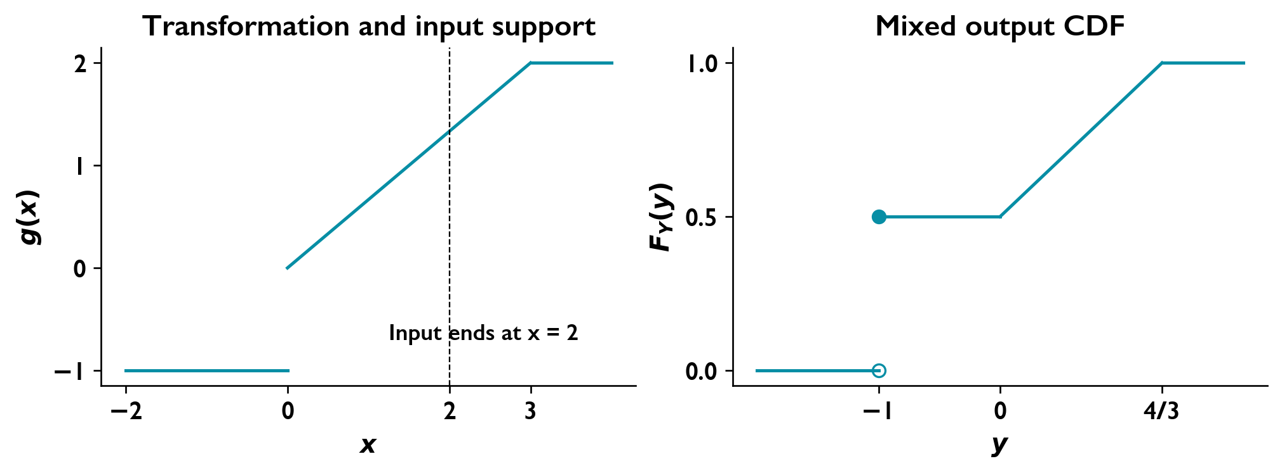
The constant negative branch creates an atom at y = −1; the output never reaches the saturation branch at y = 2.

A continuous law with a point mass

Question
A random voltage has generalized density
$$f_{X}\left(x\right)=k u\left(x+7\right)e^{−1.72\left(x+7\right)}+0.35δ\left(x−1\right),$$
where $u$ is the unit step and $δ$ is the Dirac impulse.
Determine the normalizing constant.
Obtain and sketch the CDF.
Calculate $P\left(X≤0.5\right)$, $P\left(X>3\right)$, and $P\left(0.5≤X≤3\right)$.

Solution
Continuous and discrete probability The impulse assigns $P\left(X=1\right)=0.35$; the continuous part must integrate to $0.65$.
$$1=k\int_{−7}^{∞}{e^{−1.72\left(x+7\right)}} dx+0.35=\frac{k}{1.72}+0.35.$$
$$\boxed{k=1.72\left(0.65\right)=1.118.}$$
Cumulative distribution
$$\boxed{F_{X}\left(x\right)=\left\{\begin{matrix}0, & x<−7, \\ 0.65\left[1−e^{−1.72\left(x+7\right)}\right], & −7≤x<1, \\ 0.65\left[1−e^{−1.72\left(x+7\right)}\right]+0.35, & x≥1.\end{matrix}\right.}$$
The CDF rises from zero at $−7$, jumps by $0.35$ at $1$, and approaches one asymptotically.
Requested probabilities There are no point masses at $0.5$ or $3$.
$$\boxed{P\left(X≤0.5\right)=0.65\left(1−e^{−12.9}\right)≈0.6499983763.}$$
$$\boxed{P\left(X>3\right)=0.65e^{−17.2}≈2.20317×{10}^{−8}.}$$
$$\begin{matrix}P\left(0.5≤X≤3\right) & =F_{X}\left(3\right)−F_{X}\left(0.5\right) \\ & =0.35+0.65\left(e^{−12.9}−e^{−17.2}\right).\end{matrix}$$
$$\boxed{P\left(0.5≤X≤3\right)≈0.3500016017.}$$
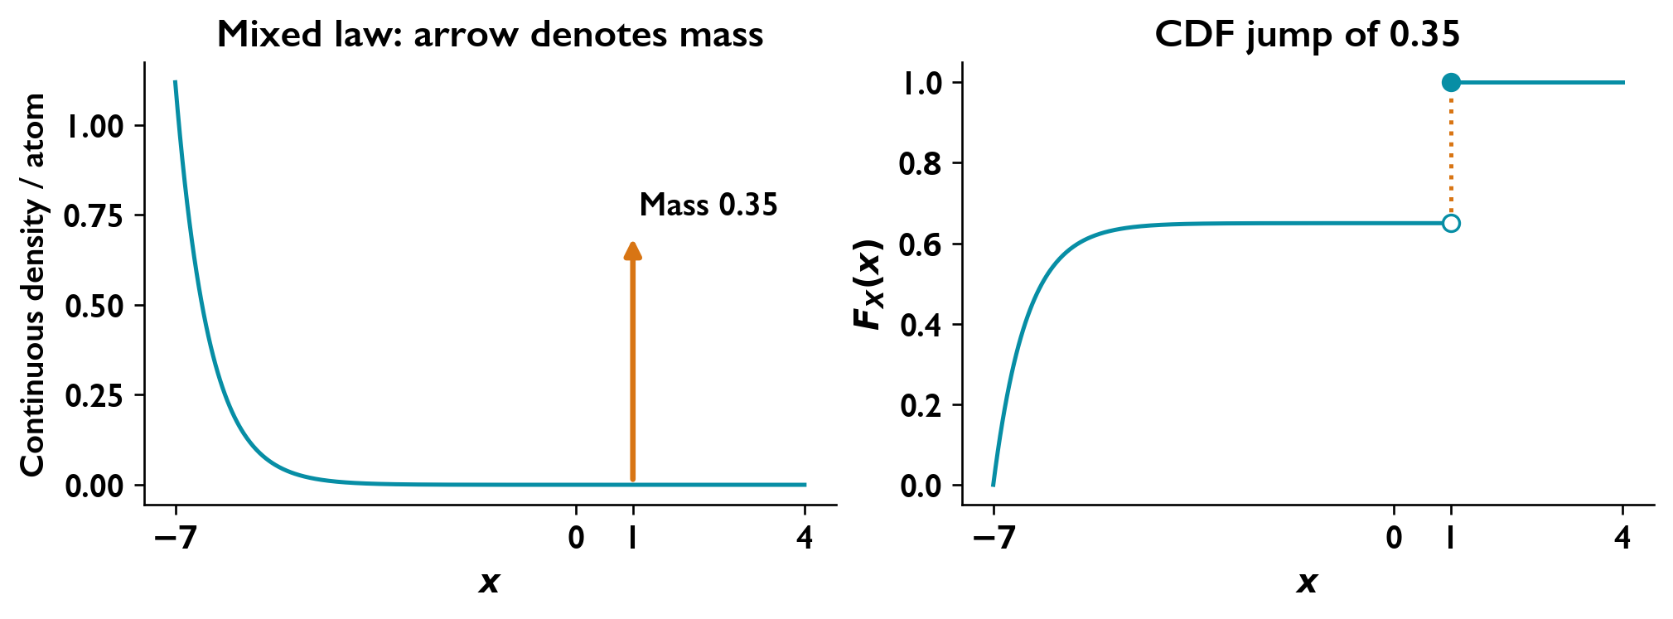
The arrow represents a probability mass of 0.35; it is not an ordinary finite density height.

Gaussian Variables and Linear Filtering
A receiver adds, subtracts, and filters voltages. These operations change the noise power, but Gaussian inputs remain Gaussian under linear processing when the inputs are jointly Gaussian. This lets us predict a receiver’s output distribution without predicting its particular noise waveform.

Linear combinations
For jointly Gaussian variables, any linear combination is Gaussian. With real constants $a_{i}$,
Y=i​aiXi+d,
μY=i​aiμi+d, σY2=i​j​aiajCovXi,Xj.
For independent Gaussian inputs, this reduces to
σY2=i​ai2σi2.
In particular, independent equal-variance noise branches satisfy
$$X_{1},X_{2}∼N\left(0,σ_{b}^{2}\right) ⇒ X_{1}−X_{2}∼N\left(0,2σ_{b}^{2}\right).$$
For a jointly Gaussian pair, zero covariance implies independence. Having two Gaussian marginal distributions alone does not establish joint Gaussianity. Independent variables have the product joint density
$$f_{X_{1},X_{2}}\left(x_{1},x_{2}\right)=f_{X_{1}}\left(x_{1}\right)f_{X_{2}}\left(x_{2}\right).$$

A Gaussian process is a family of possible waveforms
At a fixed time, $X\left(t\right)$ is a random variable; over time, it is a random process. One measured voltage trace is one realization. A Gaussian process has jointly Gaussian values at every finite collection of sampling times, so its mean and covariance determine these finite-dimensional distributions.
A noise waveform can be Gaussian while adjacent samples are correlated. Gaussian describes amplitude statistics; white describes a flat power spectrum. These properties answer different questions.

The effect of a linear filter
For a real WSS input and a deterministic real LTI filter,
$$Y\left(t\right)=h\left(t\right)*X\left(t\right), μ_{Y}=μ_{X}H\left(0\right).$$
Whenever the output has a finite second moment, a Gaussian input gives a Gaussian output. The filter changes its spectrum according to
$$\boxed{S_{Y}\left(f\right)={\left|H\left(f\right)\right|}^{2}S_{X}\left(f\right)}.$$
The autocorrelation and mean-square value follow from
$$R_{Y}\left(τ\right)=\int_{−∞}^{∞}{S_{Y}}\left(f\right)e^{j2πfτ} df,$$
$$P_{Y}=R_{Y}\left(0\right)=\int_{−∞}^{∞}{S_{Y}}\left(f\right) df, σ_{Y}^{2}=P_{Y}−μ_{Y}^{2}.$$
Using the convention $R_{XY}\left(τ\right)=E\{X\left(t+τ\right)Y\left(t\right)\}$,
$$S_{XY}\left(f\right)=S_{X}\left(f\right)H^{*}\left(f\right), S_{YX}\left(f\right)=S_{X}\left(f\right)H\left(f\right).$$
The output spectrum describes the admitted noise power; the cross spectrum also retains the filter’s phase.
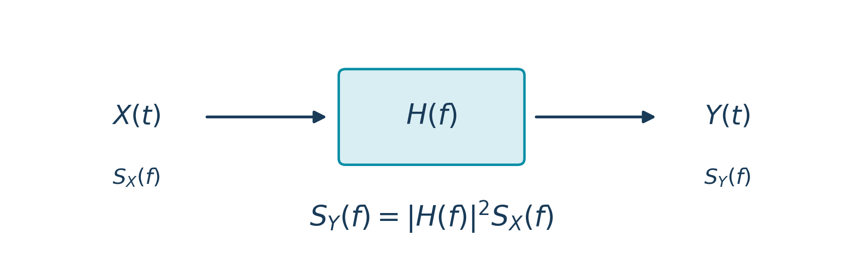
A linear filter shapes the input power spectrum.

Gaussian white noise after filtering
For zero-mean white Gaussian input with two-sided PSD $N_{0}/2$,
$$S_{Y}\left(f\right)=\frac{N_{0}}{2}{\left|H\left(f\right)\right|}^{2},$$
$$\boxed{σ_{Y}^{2}=\frac{N_{0}}{2}\int_{−∞}^{∞}{{\left|H\left(f\right)\right|}^{2}}df=\frac{N_{0}}{2}\int_{−∞}^{∞}{{\left|h\left(t\right)\right|}^{2}}dt}.$$
Thus the filter’s energy determines the variance of each output sample. The ideal unfiltered white-noise model has infinite total power; a finite-energy filter makes the output variance finite. Filtering generally makes the noise colored while preserving Gaussianity.
For measurement over a band $\left|f\right|≤B$,
$$P_{Y,B}=\int_{−B}^{B}{S_{Y}}\left(f\right) df.$$
This band power differs from the total output power unless the filter rejects every frequency outside the measurement band.

RC noise filtering
An RC low-pass filter smooths rapid voltage fluctuations. For $RC>0$,
$$H\left(f\right)=\frac{1}{1+j2πRCf},$$
$$S_{Y}\left(f\right)=\frac{N_{0}/2}{1+{\left(2πRCf\right)}^{2}}, R_{Y}\left(τ\right)=\frac{N_{0}}{4RC}e^{−\left|τ\right|/\left(RC\right)}.$$
Therefore each fixed-time output value has distribution
$$\boxed{Y\left(t\right)∼N​\left(0,\frac{N_{0}}{4RC}\right)}.$$
Increasing $RC$ reduces the output noise variance and increases the time over which samples remain correlated.
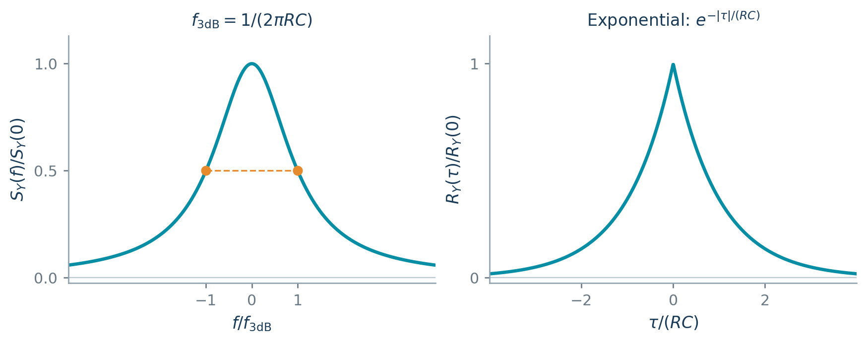
RC filtering produces a shaped spectrum and exponential noise correlation.

Worked Problems

Independent Gaussian branches and an estimation-error network

Question
Independent Gaussian white-noise processes $W_{1}\left(t\right)$ and $W_{2}\left(t\right)$ satisfy
$$R_{W_{i}}\left(τ\right)=\frac{η}{2}δ\left(τ\right).$$
Identical real LTI filters $h\left(t\right)$ produce $N_{1}\left(t\right)$ and $N_{2}\left(t\right)$. Define
$$N=N_{1}−N_{2}, ε=N_{1}−h_{o}*N.$$
Find:
The density of $N$ and the joint density of $N_{1},N_{2}$ at a fixed time.
$P\left(N>−1\right)$.
A simplified expression for $ε$.

Solution
Branch statistics Assume $η>0$ and $0<E_{h}<∞$.
$$E_{h}=\int_{−∞}^{∞}{{\left|h\left(u\right)\right|}^{2}}du, σ_{b}^{2}=\frac{ηE_{h}}{2}, S_{N_{i}}\left(f\right)=\frac{η}{2}{\left|H\left(f\right)\right|}^{2}.$$
The branch outputs are independent, zero-mean Gaussian processes.
Densities and probability
$$N∼N\left(0,ηE_{h}\right).$$
$$\boxed{f_{N}\left(n\right)=\frac{e^{−n^{2}/\left(2ηE_{h}\right)}}{\sqrt{2πηE_{h}}}}$$
$$\boxed{f_{N_{1}N_{2}}\left(n_{1},n_{2}\right)=\frac{1}{2πσ_{b}^{2}}exp\left[−\frac{n_{1}^{2}+n_{2}^{2}}{2σ_{b}^{2}}\right]}$$
$$\boxed{P\left(N>−1\right)=1−Q\left(\frac{1}{\sqrt{ηE_{h}}}\right)}$$
A numerical probability requires $ηE_{h}$.
Error network
$$\boxed{ε=\left(δ−h_{o}\right)*N_{1}+h_{o}*N_{2}}$$
$$S_{ε}\left(f\right)=\frac{η}{2}{\left|H\left(f\right)\right|}^{2}\left({\left|1−H_{o}\left(f\right)\right|}^{2}+{\left|H_{o}\left(f\right)\right|}^{2}\right).$$
Without a specified $H_{o}$, this is the general result. For minimum mean-square estimation,
$$H_{o}=\frac{S_{N_{1}N}}{S_{N}}=\frac{1}{2}, h_{o}=1/2δ,$$
$$\boxed{ε=\frac{N_{1}+N_{2}}{2}, Var\left(ε\right)=\frac{ηE_{h}}{4}}$$
If $ηE_{h}=0$, the outputs vanish in mean square, the joint law is a point mass at the origin, and $P\left(N>−1\right)=1$.

A Gaussian input through a first-order low-pass filter

Question
A zero-mean white Gaussian input has $S_{X}\left(f\right)=η/2$ and drives a filter with $h\left(t\right)=e^{−t}u\left(t\right)$.
Determine:
The output PSD, autocorrelation and mean-square value.
The input and output powers in the band $\left|f\right|≤B$, with positive low-pass edge $B={10}^{3} Hz$.
The percentage of total output power within that band and the output-to-input power percentage within the same band.

Solution
Frequency response and output PSD
$$\begin{matrix}H\left(f\right) & =\int_{0}^{∞}{e^{−t}}e^{−j2πft} dt=\frac{1}{1+j2πf}, \\ S_{Y}\left(f\right) & =\frac{η}{2}{\left|H\left(f\right)\right|}^{2}.\end{matrix}$$
Therefore,
$$\boxed{S_{Y}\left(f\right)=\frac{η}{2\left[1+{\left(2πf\right)}^{2}\right]}}.$$
Autocorrelation and mean square
The exponential Fourier pair gives
$$\boxed{R_{Y}\left(τ\right)=\frac{η}{4}e^{−\left|τ\right|}}, \boxed{E\{Y^{2}\left(t\right)\}=P_{Y,total}=\frac{η}{4}}.$$
Powers in the measurement band
$$\begin{matrix}P_{X,B} & =\int_{−B}^{B}{\frac{η}{2}} df=\boxed{ηB=1000η}, \\ P_{Y,B} & =\frac{η}{2}\int_{−B}^{B}{\frac{df}{1+{\left(2πf\right)}^{2}}}=\boxed{\frac{η}{2π}\tan^{−1}\left(2πB\right)}.\end{matrix}$$
Power percentages
At $B={10}^{3} Hz$,
$$\boxed{100\frac{P_{Y,B}}{P_{Y,total}}=100\frac{2}{π}\tan^{−1}\left(2πB\right)≈99.9899\%},$$
$$\boxed{100\frac{P_{Y,B}}{P_{X,B}}=100\frac{\tan^{−1}\left(2πB\right)}{2πB}≈0.0249975\%}.$$
The first ratio measures how much of the total filtered noise lies in the measurement band; the second compares output and input powers over that same band.

Gaussian Quadratures, Envelope, and Phase
Radio noise near a carrier can be described by two slowly varying components. These are the noise coordinates along cosine and sine carrier references. Their geometry shows how noise changes a received carrier’s strength and phase.

In-phase and quadrature components
Write zero-mean stationary Gaussian narrowband noise as
$$n\left(t\right)=n_{c}\left(t\right)cos\left(2πf_{c}t\right)−n_{s}\left(t\right)sin\left(2πf_{c}t\right).$$
At a fixed time, its standard quadrature components are jointly Gaussian with equal variance and zero covariance:
$$n_{c},n_{s}∼N\left(0,σ^{2}\right), E\{n_{c}n_{s}\}=0.$$
They are therefore independent at that time. Their common variance equals the bandpass noise power,
$$σ^{2}=P_{n}=\int_{−∞}^{∞}{S_{n}}\left(f\right)df,$$
and their same-time joint density is
$$f_{n_{c},n_{s}}\left(u,v\right)=\frac{1}{2πσ^{2}}exp​\left[−\frac{u^{2}+v^{2}}{2σ^{2}}\right].$$
The equal variances make this density circularly symmetric in the $\left(u,v\right)$ plane. Same-time independence does not imply independence between components at different times; carrier-centered spectral symmetry supplies the stronger process independence.

From Gaussian coordinates to envelope and phase
Define
$$R=\sqrt{n_{c}^{2}+n_{s}^{2}}, Θ=atan2\left(n_{s},n_{c}\right).$$
Then
$$n\left(t\right)=R\left(t\right)cos\left[2πf_{c}t+Θ\left(t\right)\right].$$
The envelope is a nonnegative magnitude, so its support is $r≥0$. Transforming $u=rcosθ$, $v=rsinθ$ contributes the Jacobian magnitude $r$:
$$f_{R,Θ}\left(r,θ\right)=\frac{r}{2πσ^{2}}e^{−r^{2}/\left(2σ^{2}\right)}, r≥0, −π<θ≤π.$$
The density factors into
$$\boxed{f_{R}\left(r\right)=\frac{r}{σ^{2}}e^{−r^{2}/\left(2σ^{2}\right)}, r≥0},$$
$$\boxed{f_{Θ}\left(θ\right)=\frac{1}{2π}, −π<θ≤π}.$$
Thus the noise envelope is Rayleigh, its phase is uniform, and they are independent at a fixed time. There is no preferred phase direction because the zero-mean Gaussian coordinate density is circularly symmetric. Although the coordinates are Gaussian, their nonnegative magnitude is not Gaussian.
Useful envelope moments are
$$E\{R\}=σ\sqrt{\frac{π}{2}}, E\{R^{2}\}=2σ^{2},$$
$$Var\left(R\right)=\left(2−\frac{π}{2}\right)σ^{2}.$$

Adding a deterministic carrier
For $x\left(t\right)=Acos\left(2πf_{c}t\right)$, addition of the noise gives
$$y\left(t\right)=\left[A+n_{c}\left(t\right)\right]cos\left(2πf_{c}t\right)−n_{s}\left(t\right)sin\left(2πf_{c}t\right).$$
Matching this with $ρ\left(t\right)cos\left[2πf_{c}t+θ\left(t\right)\right]$ yields
$$ρcosθ=A+n_{c}, ρsinθ=n_{s},$$
$$\boxed{ρ=\sqrt{{\left(A+n_{c}\right)}^{2}+n_{s}^{2}}}, \boxed{θ=atan2\left(n_{s},A+n_{c}\right)}.$$
The carrier shifts the Gaussian coordinate cloud by $A$ along the in-phase axis. The envelope is no longer Rayleigh for a nonzero carrier, and the phase need not be uniform. The two-argument arctangent selects the correct quadrant; phase is immaterial when the envelope vanishes.

Worked Problems

Envelope and phase of a carrier with narrowband noise

Question
A carrier $x\left(t\right)=Acos\left(2πf_{c}t\right)$ is added to narrowband noise
$$n\left(t\right)=n_{c}\left(t\right)cos\left(2πf_{c}t\right)−n_{s}\left(t\right)sin\left(2πf_{c}t\right).$$
Express $y\left(t\right)=x\left(t\right)+n\left(t\right)$ in the form
$$y\left(t\right)=ρ\left(t\right)cos\left[2πf_{c}t+θ\left(t\right)\right].$$

Solution
Combine the quadrature components
$$y\left(t\right)=\left[A+n_{c}\left(t\right)\right]cos\left(2πf_{c}t\right)−n_{s}\left(t\right)sin\left(2πf_{c}t\right).$$
Match the envelope–phase coefficients
Expanding $ρ\left(t\right)cos\left[2πf_{c}t+θ\left(t\right)\right]$ gives
$$\begin{matrix}ρ\left(t\right)cosθ\left(t\right) & =A+n_{c}\left(t\right), \\ ρ\left(t\right)sinθ\left(t\right) & =n_{s}\left(t\right).\end{matrix}$$
Hence
$$\boxed{ρ\left(t\right)=\sqrt{{\left[A+n_{c}\left(t\right)\right]}^{2}+n_{s}^{2}\left(t\right)}},$$
$$\boxed{θ\left(t\right)=atan2\left(n_{s}\left(t\right),A+n_{c}\left(t\right)\right)}.$$
The two-argument arctangent selects the correct quadrant. When $ρ\left(t\right)=0$, phase may be assigned arbitrarily.

Sampled Gaussian Signals and Prediction
A digital receiver measures an analogue waveform at successive instants. If nearby samples are correlated, the previous samples contain information about the next one. A predictor removes this predictable part, leaving a smaller error to encode or quantize.

From a spectrum to sampled statistics
For a real WSS Gaussian process sampled every $T_{s}$ seconds,
$$X\left[n\right]=X\left(nT_{s}\right), T_{s}=\frac{1}{f_{s}},$$
$$R_{X}\left(τ\right)=\int_{−∞}^{∞}{S_{X}}\left(f\right)e^{j2πfτ} df, r_{X}\left[k\right]=R_{X}\left(kT_{s}\right).$$
For zero mean,
$$Cov\left(X\left[i\right],X\left[j\right]\right)=r_{X}\left[i−j\right].$$
These quantities specify the joint Gaussian law of a sample vector. A spectrum does not supply the actual amplitudes of one measured realization.

Minimum mean-square prediction
For $r_{X}\left[0\right]>0$, consider a one-tap predictor
$$\hat{X}\left[n\right]=aX\left[n−1\right], D\left[n\right]=X\left[n\right]−aX\left[n−1\right].$$
The best coefficient makes the error orthogonal to the available sample:
$$E\{D\left[n\right]X\left[n−1\right]\}=r_{X}\left[1\right]−ar_{X}\left[0\right]=0.$$
Hence
$$\boxed{a=\frac{r_{X}\left[1\right]}{r_{X}\left[0\right]}}, \boxed{σ_{D}^{2}=r_{X}\left[0\right]−\frac{r_{X}^{2}\left[1\right]}{r_{X}\left[0\right]}}.$$
For an $M$-tap predictor, the corresponding orthogonality equations are
$$\sum_{j=1}^{M}{a_{j}}r_{X}\left[k−j\right]=r_{X}\left[k\right], k=1,…,M.$$
The zero covariance between the optimum error and the past samples also gives independence when the variables are jointly Gaussian. This is why the Gaussian assumption simplifies the prediction problem.

Exponential correlation
If
$$r_{X}\left[k\right]=σ_{X}^{2}ρ^{\left|k\right|}, \left|ρ\right|<1,$$
the optimum predictor from any finite number of past samples has
$$\boxed{a_{1}=ρ, a_{2}=a_{3}=⋯=0},$$
$$X\left[n\right]=ρX\left[n−1\right]+D\left[n\right], \boxed{σ_{D}^{2}=σ_{X}^{2}\left(1−ρ^{2}\right)}.$$
The innovations $D\left[n\right]$ are independent zero-mean Gaussian variables. The first previous sample already contains the predictive information provided by the more distant past under this covariance model.

Quantizing the prediction error
Use the stated Gaussian quantization model
$$P_{q}=\frac{2σ_{D}^{2}}{Q^{2}}.$$
Here $Q$ is the number of levels. This is a specified model for the exercise, rather than a formula for every Gaussian quantizer. To meet a maximum allowed noise power,
$$Q≥\sqrt{\frac{2σ_{D}^{2}}{P_{q,max}}}, \boxed{Q_{min}=\left\lceil \sqrt{\frac{2σ_{D}^{2}}{P_{q,max}}}\right\rceil }.$$
For binary coding,
$$b=⌈\log_{2}Q_{min}⌉, Q_{implemented}=2^{b}.$$
A smaller prediction-error variance needs fewer levels for the same distortion limit. The inequality must be checked before rounding: a value just above an integer requires the next integer.

Worked Problems

Prediction of a sampled Gaussian process

Question
A zero-mean Gaussian process has
$$S_{X}\left(f\right)=\frac{16}{1+{\left(16πf\right)}^{2}}, f_{s}=1 Hz.$$
A differential quantizer subtracts the predictor
$$\hat{X}\left[n\right]=a_{1}X\left[n−1\right]+a_{2}X\left[n−2\right]+a_{3}X\left[n−3\right].$$
For a Gaussian input of variance $σ^{2}$ and $Q$ quantization levels, the quantization-noise power is $2σ^{2}/Q^{2}$.
Find the number of levels required for noise power at most $4.32×{10}^{−4}$.
Determine the sampled-process values at $T_{s},2T_{s},3T_{s},4T_{s}$.

Solution
Correlation and optimum prediction Assume minimum mean-square prediction. With $T_{s}=1 s$,
$$R_{X}\left(τ\right)=e^{−\left|τ\right|/8}, ρ=e^{−1/8}=0.882496903, r_{X}\left[m\right]=ρ^{\left|m\right|}.$$
$$\left[\begin{matrix}1 & ρ & ρ^{2} \\ ρ & 1 & ρ \\ ρ^{2} & ρ & 1\end{matrix}\right]\left[\begin{matrix}a_{1} \\ a_{2} \\ a_{3}\end{matrix}\right]=\left[\begin{matrix}ρ \\ ρ^{2} \\ ρ^{3}\end{matrix}\right] ⇒ \boxed{a_{1}=ρ, a_{2}=a_{3}=0}.$$
$$X\left[n\right]=ρX\left[n−1\right]+D\left[n\right], \boxed{σ_{D}^{2}=1−e^{−1/4}=0.221199217}.$$
Quantization levels
$$\begin{matrix}\frac{2σ_{D}^{2}}{Q^{2}} & ≤4.32×{10}^{−4}, \\ Q & ≥\sqrt{\frac{2\left(1−e^{−1/4}\right)}{4.32×{10}^{−4}}}=32.0011007.\end{matrix}$$
$$\boxed{Q_{min}=33}$$
For $Q=32$, $P_{q}=4.3202972×{10}^{−4}$, just above the bound. If $Q$ must be a power of two, $\boxed{Q=64, b=6}$.
Sample statistics A PSD does not determine individual sample amplitudes. The available results are
$$E\{X\left[i\right]\}=0, Var\left(X\left[i\right]\right)=1, Cov\left(X\left[i\right],X\left[j\right]\right)=ρ^{\left|i−j\right|}, i,j∈\{1,2,3,4\}.$$
Given $X\left[0\right]$ and independent Gaussian innovations $D\left[k\right]$, actual samples follow from
$$X\left[n\right]=ρ^{n}X\left[0\right]+\sum_{k=1}^{n}{ρ^{n−k}}D\left[k\right].$$
The corresponding autocorrelation samples are
$$\begin{matrix}R_{X}\left(T_{s}\right) & =0.882497, & R_{X}\left(2T_{s}\right) & =0.778801, \\ R_{X}\left(3T_{s}\right) & =0.687289, & R_{X}\left(4T_{s}\right) & =0.606531.\end{matrix}$$

Matched Filtering and Binary Decisions
A receiver often has to recognize a known pulse buried in noise. A matched filter combines the pulse contributions so they reinforce one another at the sampling instant. The remaining noise at that instant is Gaussian, so its probability of crossing the decision threshold is evaluated with the $Q$ function.

Matching a known pulse
For a pulse $s\left(t\right)$ of energy
$$E_{s}=\int_{−∞}^{∞}{{\left|s\left(t\right)\right|}^{2}}dt,$$
and zero-mean additive white Gaussian noise with two-sided PSD $N_{0}/2$, the matched impulse response is
$$\boxed{h\left(t\right)=Ks^{*}\left(T−t\right)}, K≠0.$$
For a real pulse and real gain,
$$R_{s}\left(τ\right)=\int_{−∞}^{∞}{s}\left(u+τ\right)s\left(u\right)du,$$
$$y_{s}\left(t\right)=KR_{s}\left(t−T\right), y_{s}\left(T\right)=KE_{s}.$$
Time reversal aligns the entire pulse with the filter at $t=T$. Its output noise variance is
$$σ_{n,o}^{2}=\frac{N_{0}}{2}{\left|K\right|}^{2}E_{s},$$
so
$$\boxed{{SNR}_{max}=\frac{{\left|KE_{s}\right|}^{2}}{\left(N_{0}/2\right){\left|K\right|}^{2}E_{s}}=\frac{2E_{s}}{N_{0}}}.$$
Changing $K$ scales both signal and noise, leaving SNR unchanged. The matched filter maximizes the sampling-instant SNR for the given pulse in white noise; it does not remove the noise.

Gaussian tails become decision errors
For equiprobable bits in coherent, undistorted AWGN reception, the receiver compares a noisy decision statistic with its threshold. An error occurs when the Gaussian noise moves that statistic to the wrong side.
For binary PSK, whose two signals are antipodal,
$$\boxed{P_{e,BPSK}=Q​\left(\sqrt{\frac{2E_{b}}{N_{0}}}\right)}.$$
For coherent binary FSK with orthogonal equal-energy signals,
$$\boxed{P_{e,BFSK}=Q​\left(\sqrt{\frac{E_{b}}{N_{0}}}\right)}.$$
For a passband sinusoid of amplitude $A$ over a bit interval $T_{b}$, with the usual carrier-cycle energy approximation,
$$T_{b}=\frac{1}{R_{b}}, E_{b}≃\frac{A^{2}T_{b}}{2}.$$
Here $R_{b}$ is the bit rate. Orthogonal FSK requires the appropriate tone spacing over the observation interval; $ΔfT_{b}=1$ is a suitable envelope-model spacing. Coherent reception assumes the carrier reference needed for these formulas is available.
Increasing bit energy relative to noise density makes a threshold crossing less likely. At fixed signal power, increasing the bit rate reduces energy per bit and can therefore increase the error probability.

Rate and pulse-shaping bandwidth
The maximum bit rate cannot be inferred from channel bandwidth without a signaling and pulse-shaping assumption. For binary PSK with raised-cosine roll-off $α$ and positive-frequency lobe width $B$,
$$B=\left(1+α\right)R_{b}, R_{b}≤\frac{B}{1+α}.$$
Ideal zero roll-off gives $R_{b}≤B$. Rectangular pulses instead give the first-null approximation
$$B≃2R_{b}.$$
Their sidelobes extend beyond this interval. A filter that truncates these sidelobes can distort the waveform, so first-null bandwidth is an approximation rather than an exact distortion-free rate bound.

Worked Problems

Matched filtering of a flat-topped pulse

Question
The pulse is
$$s\left(t\right)=\left\{\begin{matrix}1, & 0≤t<1, \\ 2−t, & 1≤t<2, \\ 0, & \text{otherwise}.\end{matrix}\right.$$
The two-sided AWGN PSD is $\left(2/3\right)×{10}^{−3} W/Hz$.
Find and sketch a matched-filter impulse response and its signal output.
Find the time and magnitude of the maximum output.
Determine the maximum output SNR.

Solution
Matched impulse response Choose unit gain and sampling time $T=2$.
$$\boxed{h\left(t\right)=s\left(2−t\right)=\left\{\begin{matrix}t, & 0<t≤1, \\ 1, & 1<t≤2, \\ 0, & \text{otherwise}.\end{matrix}\right.}$$
Signal output Let $a=\left|t−2\right|$. Then $y_{s}\left(t\right)=R_{s}\left(t−2\right)$. For $0≤a≤1$,
$$R_{s}\left(a\right)=\int_{a}^{1}{d}u+\int_{1}^{1+a}{\left(2−u\right)}du+\int_{1+a}^{2}{\left(2−u\right)}\left(2−u+a\right)du.$$
For $1<a≤2$, $R_{s}\left(a\right)=\int_{a}^{2}{\left(2−u\right)}du$. Hence
$$\boxed{y_{s}\left(t\right)=\left\{\begin{matrix}4/3−1/2a−1/2a^{2}+1/6a^{3}, & 0≤a≤1, \\ 1/2{\left(2−a\right)}^{2}, & 1<a≤2, \\ 0, & a>2,\end{matrix}\right. a=\left|t−2\right|.}$$
The output is symmetric about $t=2$ and passes through
$$\left(t,y_{s}\right)=\left(0,0\right),\left(1,1/2\right),\left(2,4/3\right),\left(3,1/2\right),\left(4,0\right).$$
Peak and SNR
$$E_{s}=\int_{0}^{1}{d}t+\int_{1}^{2}{{\left(2−t\right)}^{2}}dt=\frac{4}{3}, \boxed{t_{max}=2, \left|y_{s}\left(t_{max}\right)\right|=\frac{4}{3}}.$$
$$\boxed{{SNR}_{max}=\frac{E_{s}}{N_{0}/2}=\frac{4/3}{\left(2/3\right){10}^{−3}}=2000≈33.01 dB}$$
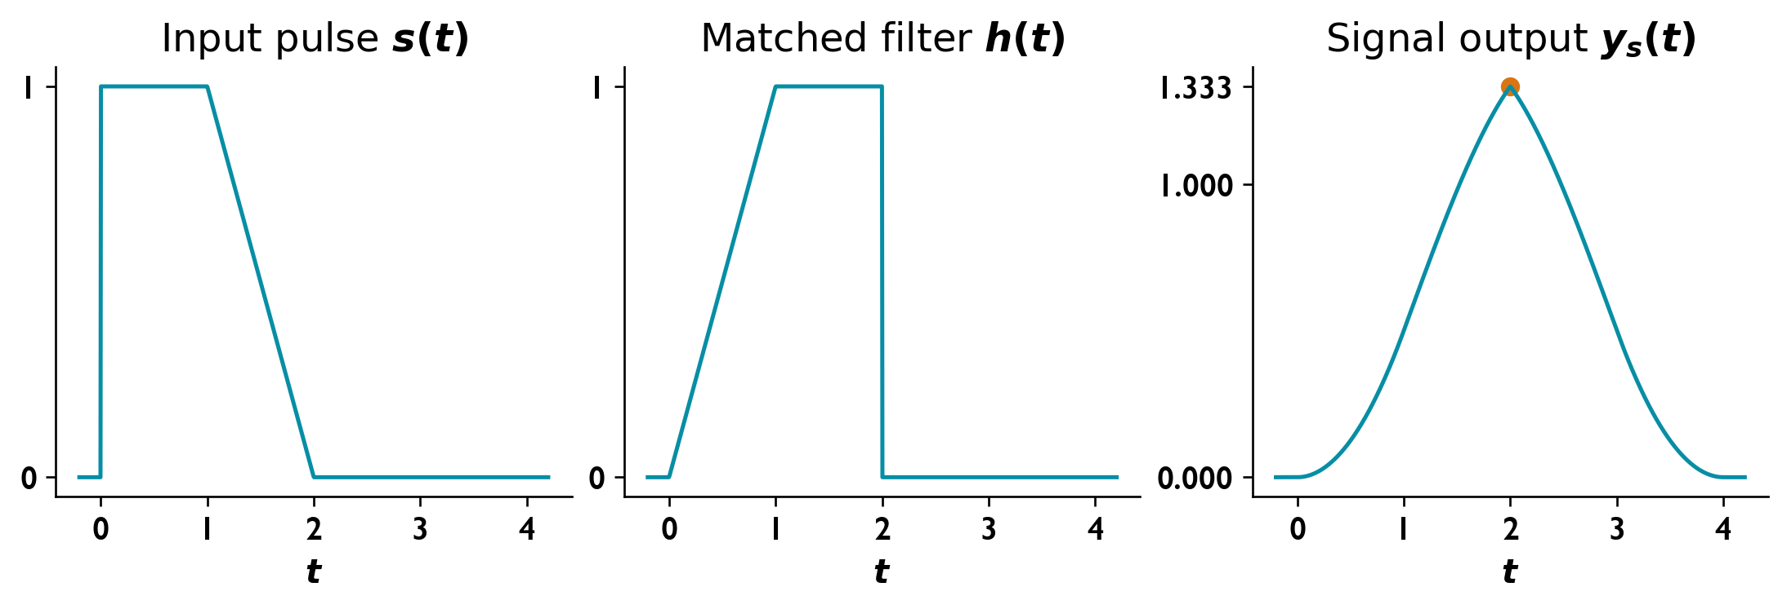
Input pulse, causal matched-filter response, and signal output with peak 4/3 at t = 2.

Coherent binary FSK and PSK error probabilities

Question
A unity-gain channel passes $500≤\left|f\right|≤1500 Hz$ and rejects all other frequencies. The amplitude-to-noise ratio is $A^{2}/η=8000$.
Find the coherent binary FSK error probability at $200 bit/s$ with tones at 1070 and 1270 Hz.
Determine the fastest PSK rate and its coherent error probability.

Solution
Assume equiprobable bits, two-sided AWGN PSD $η/2=N_{0}/2$, sinusoid amplitude $A$, and negligible distortion of the shaped signals.
Coherent FSK
$$\begin{matrix}T_{b} & =1/200=0.005 s, \\ \left(f_{2}−f_{1}\right)T_{b} & =200\left(0.005\right)=1, \\ \frac{E_{b}}{N_{0}} & ≃\frac{A^{2}T_{b}}{2η}=8000\frac{0.005}{2}=20.\end{matrix}$$
The spacing satisfies envelope-model orthogonality.
$$\boxed{P_{e,FSK}=Q\left(\sqrt{20}\right)=3.8721×{10}^{−6}}$$
Binary PSK with ideal Nyquist shaping A maximum rate requires a pulse-shaping and modulation-order assumption. For binary PSK with zero roll-off, the positive-lobe width $B=1000 Hz$ equals $R_{b}$.
$$\boxed{R_{b,max}=1000 bit/s}$$
$$\frac{E_{b}}{N_{0}}=\frac{A^{2}}{2ηR_{b}}=4,$$
$$\boxed{P_{e,BPSK}=Q\left(\sqrt{8}\right)=2.33887×{10}^{−3}}$$
For raised-cosine roll-off $α$, $R_{b,max}=B/\left(1+α\right)$.
Rectangular-pulse bandwidth approximation Using the first-null approximation $B≃2R_{b}$,
$$R_{b}≃500 bit/s, E_{b}/N_{0}=8,$$
$$\boxed{P_{e}≃Q\left(4\right)=3.16712×{10}^{−5}}$$
This assumes undistorted coherent detection. A brick-wall channel truncates rectangular-pulse sidelobes, so the approximation is not an exact distortion analysis. Higher-order PSK requires a specified order.

