Random Signals and Noise
A receiver observes a waveform carrying information together with noise. Probability describes this uncertainty; correlation and spectra describe how the waveform behaves across time and frequency. Filtering and detection use these descriptions to help recover the information.
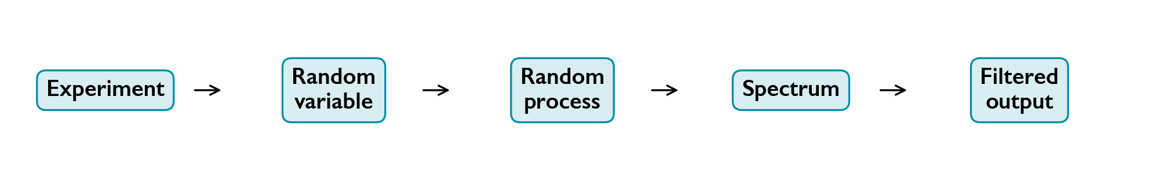
Probability, random signals, spectra and filtering.

Contents
Random Variables and Probability Laws
Moments and Transformations
Joint and Conditional Distributions
Random processes, stationarity and ergodicity
Autocorrelation, autocovariance and crosscorrelation
Power spectra, linear systems and random binary signals
Random Processes Through Linear Filters
White Noise, Filtered Noise, and Equivalent Bandwidth
Narrowband Noise and Its Quadrature Components
Modulation and noise
Sampling, quantization, and prediction
Matched filters and binary detection

Symbols
Symbol | Meaning
$X$, $x$ | Random variable and its value. $X\left(t\right)$ is a random process; $x\left(t\right)$ is a realization.
$f_{X}\left(x\right)$, $F_{X}\left(x\right)$ | Probability density and cumulative distribution.
$μ_{X}$, $σ_{X}^{2}$ | Mean and variance.
$R_{X}\left(τ\right)$, $C_{X}\left(τ\right)$ | Autocorrelation and autocovariance.
$R_{XY}\left(τ\right)$ | $E\{X\left(t+τ\right)Y\left(t\right)\}$: the first process carries the lag.
$S_{X}\left(f\right)$, $S_{XY}\left(f\right)$ | Power spectrum and cross spectrum; $f$ is in hertz.
$h\left(t\right)$, $H\left(f\right)$ | Impulse response and frequency response.
$N_{0}/2$ | Two-sided white-noise spectral density.
$B$, $W$ | Bandwidths defined locally. An ideal lowpass edge $B$ corresponds to full positive-lobe bandpass width $2B$ where stated.
$$sinc\left(u\right)=\frac{sin\left(πu\right)}{πu}, sinc\left(0\right)=1.$$

Random Variables and Probability Laws

Events and random variables
Even when a receiver repeats the same measurement, its voltage can vary because of noise. Probability describes this uncertainty and lets us predict how often a reading will cross a decision threshold. A random variable represents one such uncertain numerical reading; it does not mean that every possible value is equally likely.
A random experiment has an uncertain outcome. Its sample space $S$ contains all possible outcomes; an event $A$ is a subset of $S$.
$$P\left(S\right)=1, 0≤P\left(A\right)≤1,$$
$$P\left(A∪B\right)=P\left(A\right)+P\left(B\right), A∩B=⌀.$$
If $A$ occurs $n_{A}$ times in $n$ repeated trials, $n_{A}/n$ is its observed relative frequency.
For a fair die, $S=\{1,2,3,4,5,6\}$ and the even event is $A=\{2,4,6\}$, so $P\left(A\right)=3/6=1/2$.
A random variable assigns a real value to each outcome:
$$X:S→R, X\left(s_{k}\right)=x.$$
$X$ denotes the variable; $x$ denotes a possible value. A discrete variable has a finite or countable set of values. The continuous variables considered below possess probability densities.

Probability mass and cumulative distribution
The probability mass function (PMF) of a discrete variable is
pXxk=PX=xk, pXxk≥0, k​pXxk=1.
A Bernoulli variable has $P\left(X=1\right)=p$ and $P\left(X=0\right)=1−p$, where $0≤p≤1$.
The cumulative distribution function (CDF) is
$$F_{X}\left(x\right)=P\left(X≤x\right).$$
It is nondecreasing, lies in $\left[0,1\right]$, and satisfies
$$F_{X}\left(−∞\right)=0, F_{X}\left(+∞\right)=1, P\left(a<X≤b\right)=F_{X}\left(b\right)−F_{X}\left(a\right).$$
For a discrete variable, FXx=xk≤x​pXxk. A fair die has six masses of $1/6$, so its CDF increases by $1/6$ at each face value. A point mass is a CDF jump: $P\left(X=x_{0}\right)=F_{X}\left(x_{0}\right)−F_{X}\left(x_{0}^{−}\right)$, where $F_{X}\left(x_{0}^{−}\right)$ is the left limit. A mixed law retains both its point masses and its continuous density.
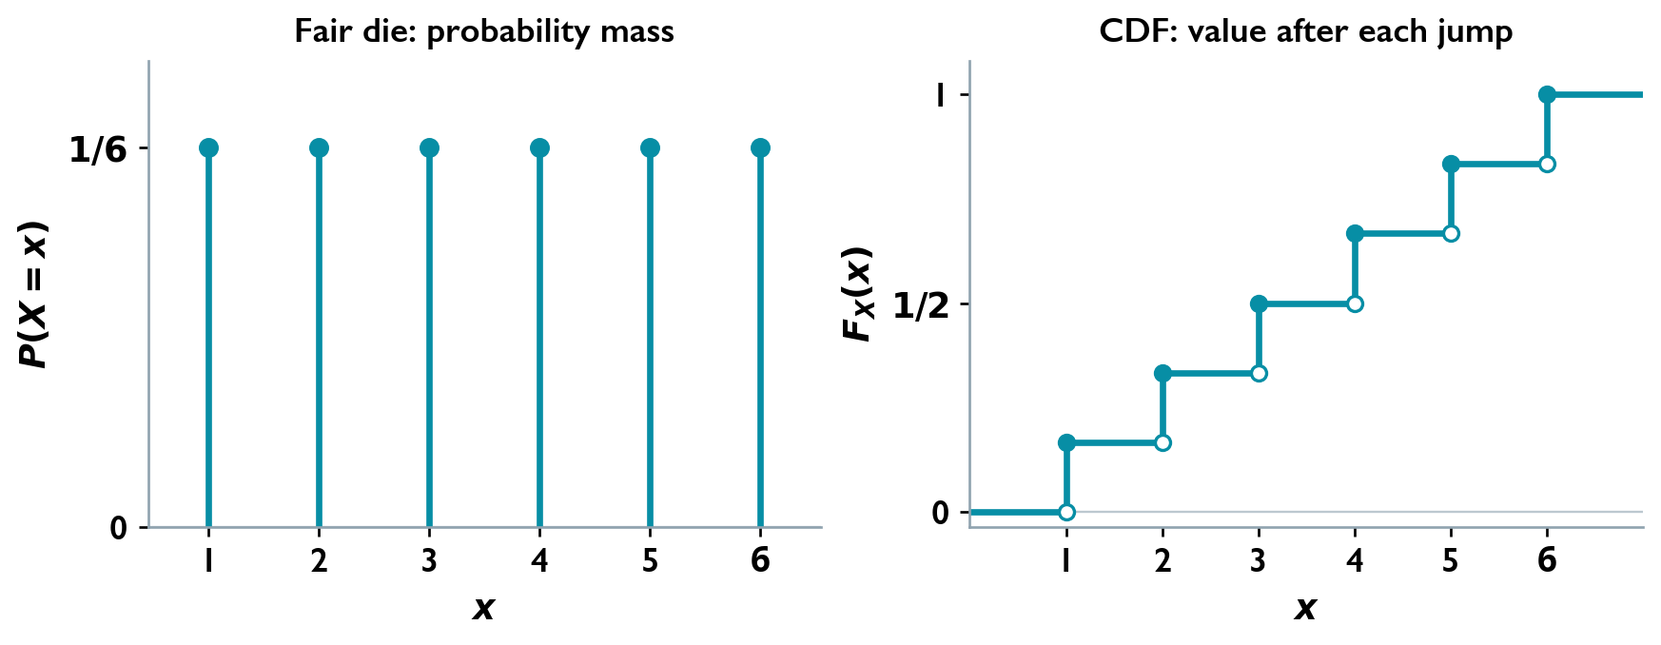
Probability masses and CDF of a fair die.

Probability density
A probability density function (PDF) satisfies
$$f_{X}\left(x\right)≥0, \int_{−∞}^{∞}{f_{X}}\left(x\right) dx=1,$$
$$F_{X}\left(x\right)=\int_{−∞}^{x}{f_{X}}\left(u\right) du, f_{X}\left(x\right)=\frac{dF_{X}\left(x\right)}{dx},$$
where the derivative exists. Thus
$$P\left(a<X≤b\right)=\int_{a}^{b}{f_{X}}\left(x\right) dx.$$
A density is not a point probability: $P\left(X=x\right)=0$. Its value may exceed one; its total area must equal one. A normalized histogram of repeated voltage measurements approximates this shape: intervals with more area occur more often. For a continuous reading, the probability of a finite voltage range matters, rather than the probability of one exact voltage.

Uniform distribution
For $X$ uniform on $\left[a,b\right]$, with $a<b$,
$$f_{X}\left(x\right)=\left\{\begin{matrix}\frac{1}{b−a}, & a≤x≤b, \\ 0, & \text{otherwise},\end{matrix}\right.$$
$$F_{X}\left(x\right)=\left\{\begin{matrix}0, & x<a, \\ \frac{x−a}{b−a}, & a≤x≤b, \\ 1, & x>b.\end{matrix}\right.$$
For $a≤c<d≤b$,
$$P\left(c<X≤d\right)=\frac{d−c}{b−a}.$$
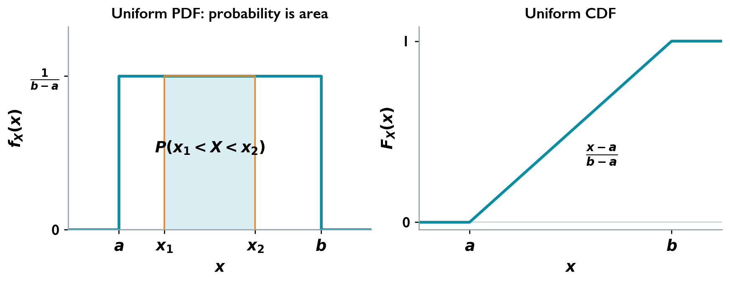
Uniform PDF and CDF; the shaded area is an interval probability.

Gaussian distribution and Q function
Gaussian noise is useful in receiver analysis because many small, approximately independent disturbances can combine into a nearly Gaussian voltage. The model must still suit the physical situation: knowing only a mean and a variance does not establish that a distribution is Gaussian.
A Gaussian variable $X∼N\left(μ_{X},σ_{X}^{2}\right)$ has mean $μ_{X}$, variance $σ_{X}^{2}$, standard deviation $σ_{X}>0$, and density
$$f_{X}\left(x\right)=\frac{1}{\sqrt{2π} σ_{X}}exp​\left[−\frac{{\left(x−μ_{X}\right)}^{2}}{2σ_{X}^{2}}\right], x∈R.$$
Standardization gives
$$Z=\frac{X−μ_{X}}{σ_{X}}∼N\left(0,1\right).$$
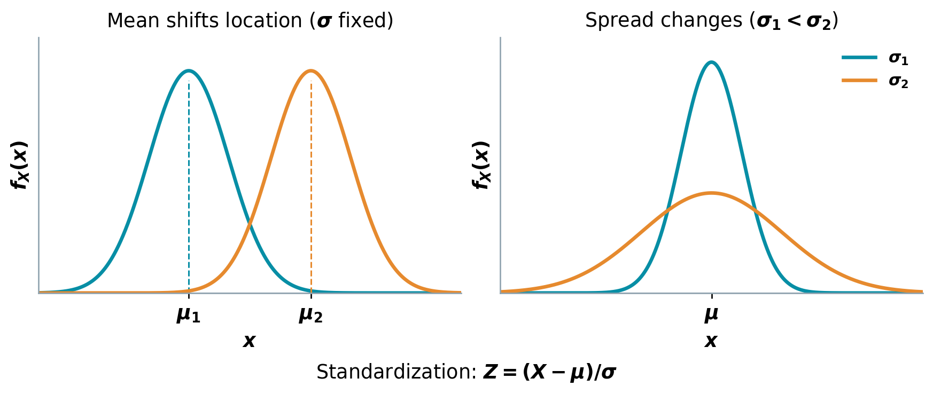
Gaussian location, spread, and standardization.
A receiver makes an error when noise pushes its measured value beyond the wrong side of a threshold. The Q function gives the probability in a Gaussian tail, so it converts a threshold distance measured in standard deviations into an error probability.
Define the standard Gaussian upper tail by
$$Q\left(z\right)=\frac{1}{\sqrt{2π}}\int_{z}^{∞}{e^{−u^{2}/2}} du.$$
Then
$$P\left(X>c\right)=Q​\left(\frac{c−μ_{X}}{σ_{X}}\right), Q\left(−z\right)=1−Q\left(z\right), Q\left(0\right)=\frac{1}{2}.$$

Example: binary PAM decision error

Question
Binary symbols use levels $+A$ and $−A$, where $A>0$. The received value is the transmitted level plus Gaussian noise $N∼N\left(0,σ_{N}^{2}\right)$, independent of the transmitted symbol. With decision threshold zero, find the error probability after transmitting $+A$.

Solution
Given $+A$, $Y=A+N∼N\left(A,σ_{N}^{2}\right)$, and an error occurs when $Y<0$:
$$P\left(\text{error}∣+A\right)=\int_{−∞}^{0}{\frac{e^{−{\left(y−A\right)}^{2}/\left(2σ_{N}^{2}\right)}}{\sqrt{2π} σ_{N}}} dy.$$
With $z=\left(y−A\right)/σ_{N}$ and Gaussian symmetry,
$$P\left(\text{error}∣+A\right)=P​\left(Z<−\frac{A}{σ_{N}}\right)=Q​\left(\frac{A}{σ_{N}}\right).$$
The conditional error after sending $−A$ is identical, so $P_{e}=Q\left(A/σ_{N}\right)$ for the symmetric binary model. Increasing the signal level relative to the noise spread moves the decision threshold farther into the tail and reduces errors.
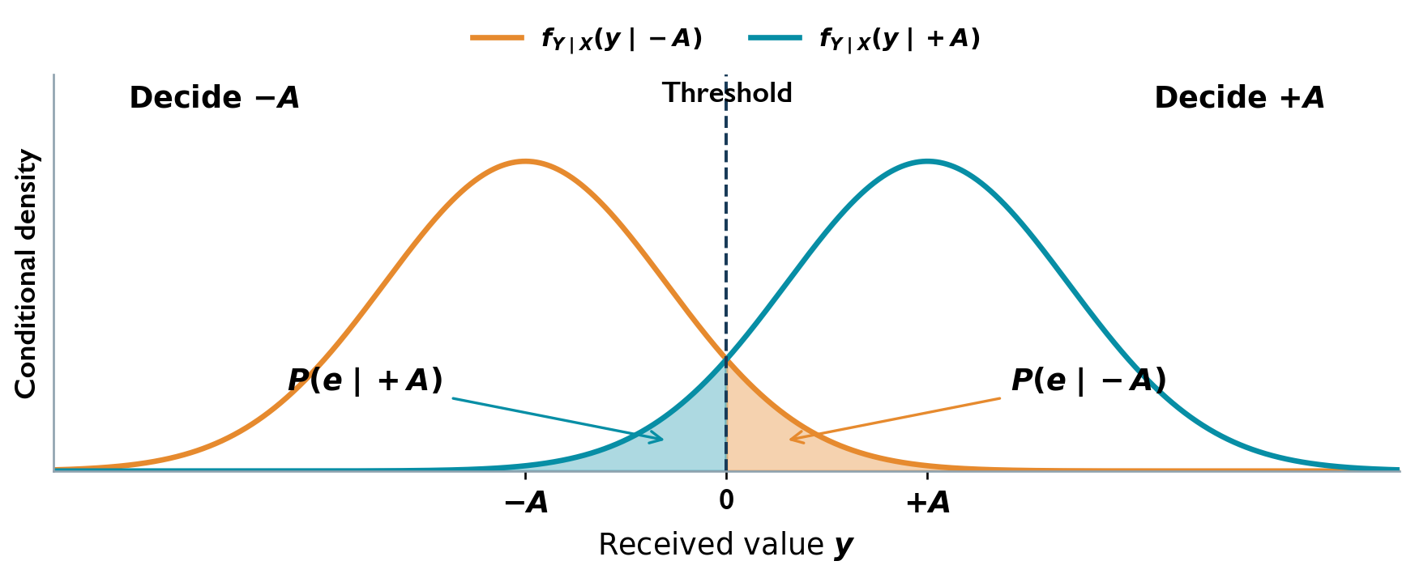
Zero-threshold PAM decision and Gaussian error tails.

Central limit theorem
Let $X_{1},…,X_{n}$ be independent identically distributed variables with common finite mean $μ_{X}$ and finite positive variance $σ_{X}^{2}$. For their sum,
$$Y_{n}=\sum_{k=1}^{n}{X_{k}}, E\{Y_{n}\}=nμ_{X}, σ_{Y_{n}}^{2}=nσ_{X}^{2}.$$
As $n→∞$, the distribution of
$$Z_{n}=\frac{Y_{n}−nμ_{X}}{σ_{X}\sqrt{n}}$$
approaches $N\left(0,1\right)$. This explains the Gaussian model for a sum of many small independent noise contributions. For finite $n$ it is an approximation; independent Gaussian summands give an exactly Gaussian sum.

Worked Problems

A cubic cumulative distribution

Question
A random variable $X$ has cumulative distribution
$$F_{X}\left(x\right)=\left\{\begin{matrix}0, & x<0, \\ Ax^{3}, & 0≤x≤10, \\ B, & x>10.\end{matrix}\right.$$
Determine $A$ and $B$, and obtain and sketch the density.

Solution
Normalization and right continuity
$$\lim_{x→∞}F_{X}\left(x\right)=B=1, F_{X}\left(10\right)=1000A=1.$$
$$\boxed{A={10}^{−3}, B=1.}$$
Density The CDF is continuous, so differentiating gives
$$\boxed{f_{X}\left(x\right)=\left\{\begin{matrix}3×{10}^{−3}x^{2}, & 0<x<10, \\ 0, & \text{otherwise}.\end{matrix}\right.}$$
Check and sketch
$$\int_{0}^{10}{3}×{10}^{−3}x^{2} dx={10}^{−3}{\left[x^{3}\right]}_{0}^{10}=1.$$
The density rises parabolically from zero to a limiting height of $0.3$ on $\left(0,10\right)$ and vanishes outside this interval.

Testing an exponential density

Question
Determine whether
$$g\left(x\right)=\left\{\begin{matrix}e^{−x/2}, & x≥0, \\ 0, & x<0\end{matrix}\right.$$
is a valid probability density.

Solution
Nonnegativity $g\left(x\right)≥0$ for every $x$.
Total area
$$\int_{−∞}^{∞}{g}\left(x\right) dx=\int_{0}^{∞}{e^{−x/2}} dx={\left[−2e^{−x/2}\right]}_{0}^{∞}=2≠1.$$
$$\boxed{g\text{ is not a normalized probability density.}}$$
The corresponding normalized density is
$$\boxed{f_{X}\left(x\right)=1/2e^{−x/2}u\left(x\right).}$$

Normalizing a symmetric exponential law

Question
Find $k$ such that
$$f_{X}\left(x\right)=ke^{−\left|x\right|}, −∞<x<∞,$$
is a probability density.

Solution
Normalization Since $e^{−\left|x\right|}>0$, require $k≥0$. Split at the origin:
$$1=k\int_{−∞}^{0}{e^{x}} dx+k\int_{0}^{∞}{e^{−x}} dx=k+k=2k.$$
$$\boxed{k=\frac{1}{2}, f_{X}\left(x\right)=\frac{1}{2}e^{−\left|x\right|}.}$$
By symmetry, each half-line has probability $1/2$.

A trapezoidal probability density

Question
Let
$$f_{X}\left(x\right)=\left\{\begin{matrix}ax, & 0≤x≤1, \\ a, & 1<x≤2, \\ a\left(3−x\right), & 2<x≤3, \\ 0, & \text{otherwise}.\end{matrix}\right.$$
Determine $a$, obtain and sketch the CDF, and calculate $P\left(X≤1.5\right)$.

Solution
Normalization
$$1=a\int_{0}^{1}{x} dx+a\int_{1}^{2}{d}x+a\int_{2}^{3}{\left(3−x\right)} dx=\frac{a}{2}+a+\frac{a}{2}=2a.$$
$$\boxed{a=\frac{1}{2}.}$$
Accumulated probability
$$\begin{matrix}F_{X}\left(x\right) & =\int_{0}^{x}{\frac{t}{2}} dt=\frac{x^{2}}{4}, & & 0≤x<1, \\ F_{X}\left(x\right) & =\frac{1}{4}+\int_{1}^{x}{\frac{1}{2}} dt=\frac{x}{2}−\frac{1}{4}, & & 1≤x<2, \\ F_{X}\left(x\right) & =1−\int_{x}^{3}{\frac{3−t}{2}} dt=1−\frac{{\left(3−x\right)}^{2}}{4}, & & 2≤x<3.\end{matrix}$$
$$\boxed{F_{X}\left(x\right)=\left\{\begin{matrix}0, & x<0, \\ x^{2}/4, & 0≤x<1, \\ x/2−1/4, & 1≤x<2, \\ 1−{\left(3−x\right)}^{2}/4, & 2≤x<3, \\ 1, & x≥3.\end{matrix}\right.}$$
The CDF is continuous and increases quadratically, linearly, then along a concave quadratic segment.
Requested probability
$$\boxed{P\left(X≤1.5\right)=F_{X}\left(1.5\right)=\frac{1.5}{2}−\frac{1}{4}=\frac{1}{2}.}$$
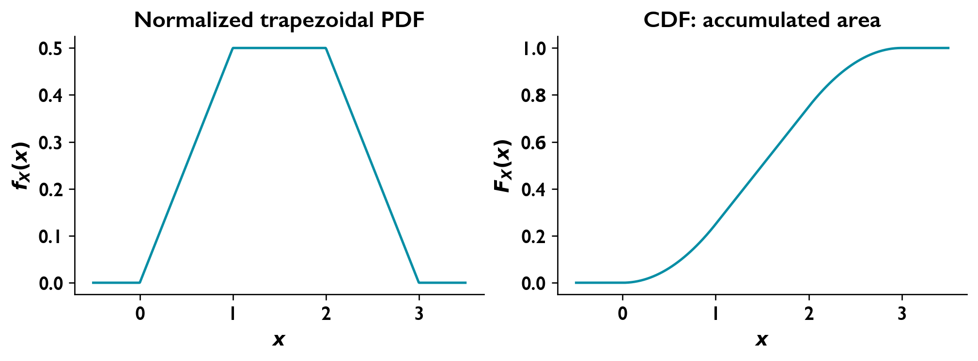
The normalized trapezoidal density and its accumulated probability.

Normalizing a two-level density

Question
A density is specified by
$$f_{X}\left(x\right)=\left\{\begin{matrix}k, & 0<x<1, \\ 1/3, & 1<x<2, \\ 0, & \text{otherwise}.\end{matrix}\right.$$
Determine $k$.

Solution
Total area
$$1=\int_{0}^{1}{k} dx+\int_{1}^{2}{\frac{1}{3}} dx=k+\frac{1}{3}.$$
$$\boxed{k=\frac{2}{3}.}$$
Both density levels are nonnegative.

A shifted exponential law with a point mass

Question
A random voltage has generalized density
$$f_{X}\left(x\right)=k u\left(x+7\right)e^{−1.72\left(x+7\right)}+0.35δ\left(x−1\right),$$
where $u$ is the unit step and $δ$ is the Dirac impulse.
Determine the normalizing constant.
Obtain and sketch the CDF.
Calculate $P\left(X≤0.5\right)$, $P\left(X>3\right)$, and $P\left(0.5≤X≤3\right)$.

Solution
Continuous and discrete probability The impulse assigns $P\left(X=1\right)=0.35$; the continuous part must integrate to $0.65$.
$$1=k\int_{−7}^{∞}{e^{−1.72\left(x+7\right)}} dx+0.35=\frac{k}{1.72}+0.35.$$
$$\boxed{k=1.72\left(0.65\right)=1.118.}$$
Cumulative distribution
$$\boxed{F_{X}\left(x\right)=\left\{\begin{matrix}0, & x<−7, \\ 0.65\left[1−e^{−1.72\left(x+7\right)}\right], & −7≤x<1, \\ 0.65\left[1−e^{−1.72\left(x+7\right)}\right]+0.35, & x≥1.\end{matrix}\right.}$$
The CDF rises from zero at $−7$, jumps by $0.35$ at $1$, and approaches one asymptotically.
Requested probabilities There are no point masses at $0.5$ or $3$.
$$\boxed{P\left(X≤0.5\right)=0.65\left(1−e^{−12.9}\right)≈0.6499983763.}$$
$$\boxed{P\left(X>3\right)=0.65e^{−17.2}≈2.20317×{10}^{−8}.}$$
$$\begin{matrix}P\left(0.5≤X≤3\right) & =F_{X}\left(3\right)−F_{X}\left(0.5\right) \\ & =0.35+0.65\left(e^{−12.9}−e^{−17.2}\right).\end{matrix}$$
$$\boxed{P\left(0.5≤X≤3\right)≈0.3500016017.}$$
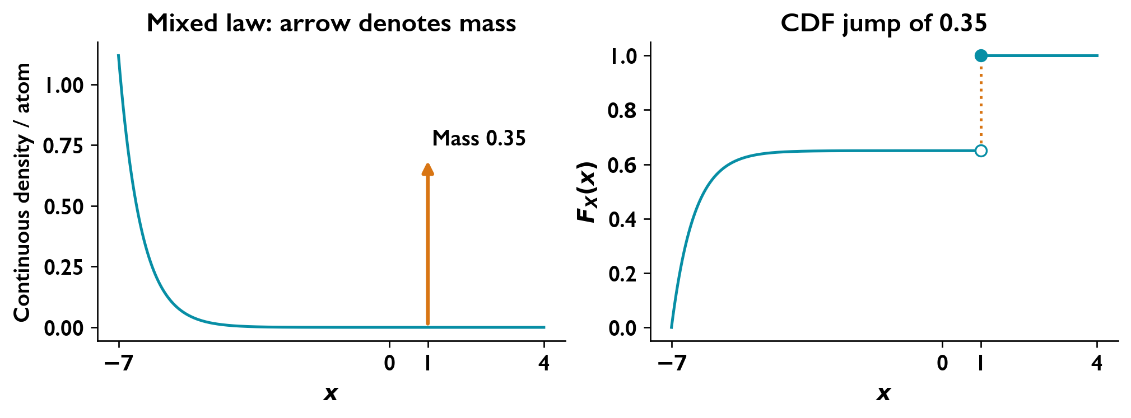
The arrow represents a probability mass of 0.35; it is not an ordinary finite density height.

Cumulative probabilities of an Erlang density

Question
A continuous random variable has density
$$f_{X}\left(x\right)=xe^{−x}u\left(x\right).$$
Obtain its CDF and calculate $P\left(X≤1\right)$, $P\left(1≤X≤2\right)$, and $P\left(X>2\right)$.

Solution
Cumulative distribution For $x≥0$, integration by parts gives
$$F_{X}\left(x\right)=\int_{0}^{x}{t}e^{−t} dt={\left[−\left(t+1\right)e^{−t}\right]}_{0}^{x}=1−\left(1+x\right)e^{−x}.$$
$$\boxed{F_{X}\left(x\right)=\left\{\begin{matrix}0, & x<0, \\ 1−\left(1+x\right)e^{−x}, & x≥0.\end{matrix}\right.}$$
Its limit at infinity is one, verifying normalization.
Requested probabilities
$$\boxed{P\left(X≤1\right)=1−\frac{2}{e}≈0.264241.}$$
$$\begin{matrix}P\left(1≤X≤2\right) & =F_{X}\left(2\right)−F_{X}\left(1\right) \\ & =\frac{2}{e}−\frac{3}{e^{2}}.\end{matrix}$$
$$\boxed{P\left(1≤X≤2\right)≈0.329753.}$$
$$\boxed{P\left(X>2\right)=1−F_{X}\left(2\right)=\frac{3}{e^{2}}≈0.406006.}$$

The cumulative distribution of a uniform variable

Question
For $a<b$, let
$$f_{X}\left(x\right)=\left\{\begin{matrix}1/\left(b−a\right), & a≤x≤b, \\ 0, & \text{otherwise}.\end{matrix}\right.$$
Obtain and sketch its CDF.

Solution
Integration over the support
$$F_{X}\left(x\right)=\int_{a}^{x}{\frac{1}{b−a}} dt=\frac{x−a}{b−a}, a≤x≤b.$$
No probability lies below $a$, and all probability has accumulated by $b$.
$$\boxed{F_{X}\left(x\right)=\left\{\begin{matrix}0, & x<a, \\ \left(x−a\right)/\left(b−a\right), & a≤x≤b, \\ 1, & x>b.\end{matrix}\right.}$$
The sketch is horizontal at zero, rises linearly from $\left(a,0\right)$ to $\left(b,1\right)$ with slope $1/\left(b−a\right)$, then remains at one.

Recovering a density from a sinusoidal CDF

Question
A random variable has CDF
$$F_{X}\left(x\right)=\left\{\begin{matrix}0, & x<0, \\ ksin\left(πx/40\right), & 0≤x≤10, \\ ksin\left(π/4\right), & x>10.\end{matrix}\right.$$
Determine $k$, obtain the density, and calculate $P\left(X≤4\right)$.

Solution
Normalization
$$\lim_{x→∞}F_{X}\left(x\right)=ksin\left(π/4\right)=1.$$
$$\boxed{k=\sqrt{2}.}$$
Differentiation The CDF is continuous at both support boundaries, so no point masses occur there.
$$\boxed{f_{X}\left(x\right)=\left\{\begin{matrix}\frac{\sqrt{2}π}{40}cos\left(πx/40\right), & 0<x<10, \\ 0, & \text{otherwise}.\end{matrix}\right.}$$
The density is nonnegative on its support, and
$$\int_{0}^{10}{f_{X}}\left(x\right) dx=\sqrt{2}sin\left(π/4\right)=1.$$
Requested probability
$$\boxed{P\left(X≤4\right)=\sqrt{2}sin\left(π/10\right)≈0.437016.}$$

Moments and Transformations

Mean, moments, and variance
A noise waveform changes from one reading to the next, but its average level and spread can remain stable. Moments summarize these features: the mean indicates an average bias, while the variance measures fluctuations about that bias. An expected value describes a probability-weighted average across measurements, rather than the value of each individual reading.
The mean is a probability-weighted average:
μX=E{X}=k​xkpXxk or μX=−∞∞xfXx dx.
For a function $g$,
E{gX}=k​gxkpXxk or E{gX}=−∞∞gxfXx dx.
The raw moment of order $n$ is $E\{X^{n}\}$. The first moment is the mean; the second is the mean-square value. For finite second moments,
$$σ_{X}^{2}=E\{{\left(X−μ_{X}\right)}^{2}\}=E\{X^{2}\}−μ_{X}^{2}, σ_{X}=\sqrt{σ_{X}^{2}}.$$
The RMS value is $\sqrt{E\{X^{2}\}}$. Mean square equals variance only for zero mean. For voltage across resistance $R$, average power is $E\{X^{2}\}/R$. Positive and negative noise voltages can average to zero while still delivering nonzero power, because squaring removes their signs.
For constants $c,d$,
$$E\{cX+d\}=cμ_{X}+d, Var\left(cX+d\right)=c^{2}σ_{X}^{2}.$$
For Bernoulli $X$, $X^{2}=X$, giving $μ_{X}=p$ and $σ_{X}^{2}=p\left(1−p\right)$.

Estimates from measurements
For $N$ independent identically distributed observations $x_{1},…,x_{N}$ with finite variance,
$${\hat{μ}}_{X}=\frac{1}{N}\sum_{n=1}^{N}{x_{n}},$$
$${\hat{σ}}_{X}^{2}=\frac{1}{N−1}\sum_{n=1}^{N}{{\left(x_{n}−{\hat{μ}}_{X}\right)}^{2}}, N>1.$$
These estimate the population mean and variance. The denominator $N−1$ makes the variance estimate unbiased under the stated conditions.

Transforming a variable
An amplifier changes the scale of a random voltage, and a DC offset shifts its average level. A transformation describes how the entire probability distribution changes when a device acts on its input; the output range changes along with the density.
For $Y=g\left(X\right)$, begin with
$$F_{Y}\left(y\right)=P\left(g\left(X\right)≤y\right).$$
Suppose $X$ has a density and $g$ is strictly monotone on its support, with inverse $h=g^{−1}$. Then
$$F_{Y}\left(y\right)=\left\{\begin{matrix}F_{X}\left(h\left(y\right)\right), & g\text{ increasing}, \\ 1−F_{X}\left(h\left(y\right)\right), & g\text{ decreasing}.\end{matrix}\right.$$
Where the inverse is differentiable,
$$f_{Y}\left(y\right)=f_{X}\left(h\left(y\right)\right)\left|\frac{dh\left(y\right)}{dy}\right|.$$
Transform the support as well as the formula. If several inverse branches occur, each admissible branch contributes density. A constant transformation branch can create a point mass. With $A=\{x:g\left(x\right)=y_{0}\}$, its total mass is $P\left(Y=y_{0}\right)=P\left(X∈A\right)=F_{Y}\left(y_{0}\right)−F_{Y}\left(y_{0}^{−}\right)$, where the superscript minus denotes the left limit. Retain the remaining continuous density separately. A Gaussian input under $Y=cX+d$, $c≠0$, gives
$$Y∼N\left(cμ_{X}+d,c^{2}σ_{X}^{2}\right).$$

Example: Gaussian voltage and averaging

Question
A zero-mean Gaussian voltage has standard deviation $10$ V. Add $5$ V. Find the probability of a positive reading and the probability that the average of two independent readings is positive.

Solution
Let $X∼N\left(0,100\right)$ and $Y=X+5$. Then
$$μ_{Y}=5, σ_{Y}^{2}=100,$$
$$P\left(Y>0\right)=Q​\left(\frac{0−5}{10}\right)=1−Q\left(0.5\right)≈0.6915.$$
For $M=\left(Y_{1}+Y_{2}\right)/2$, independence gives
$$μ_{M}=5, σ_{M}^{2}=\frac{100+100}{4}=50,$$
$$P\left(M>0\right)=Q​\left(−\frac{5}{\sqrt{50}}\right)=1−Q​\left(\frac{5}{\sqrt{50}}\right)≈0.7602.$$
Averaging independent readings preserves the positive offset while reducing the random spread. The result illustrates why repeated measurements can make a weak DC level easier to distinguish from noise; correlated readings do not generally give the same reduction.

Example: double-exponential density

Question
For $f_{X}\left(x\right)=ae^{−b\left|x\right|}$ on $R$, determine the constants required for a density, find its CDF, and evaluate $P\left(1<X<2\right)$.

Solution
Integrability requires $b>0$. Normalization gives
$$1=2a\int_{0}^{∞}{e^{−bx}} dx=\frac{2a}{b}, a=\frac{b}{2}.$$
Integrating separately on either side of zero gives
$$F_{X}\left(x\right)=\left\{\begin{matrix}\frac{1}{2}e^{bx}, & x<0, \\ 1−\frac{1}{2}e^{−bx}, & x≥0.\end{matrix}\right.$$
Thus
$$P\left(1<X<2\right)=F_{X}\left(2\right)−F_{X}\left(1\right)=\frac{1}{2}\left(e^{−b}−e^{−2b}\right).$$

Example: Rayleigh distribution
Unlike a signed voltage, a signal envelope is nonnegative. The Rayleigh distribution models the envelope of zero-mean narrowband Gaussian noise when its quadrature components are independent and have equal variance.

Question
For $b>0$, a Rayleigh variable has
$$f_{R}\left(r\right)=\left\{\begin{matrix}\frac{r}{b}e^{−r^{2}/\left(2b\right)}, & r>0, \\ 0, & \text{otherwise}.\end{matrix}\right.$$
Find its CDF, mean, mean square, and variance.

Solution
Integration gives
$$F_{R}\left(r\right)=\left\{\begin{matrix}0, & r<0, \\ 1−e^{−r^{2}/\left(2b\right)}, & r≥0.\end{matrix}\right.$$
Integration by parts reduces the mean to a Gaussian integral:
$$E\{R\}=\frac{1}{b}\int_{0}^{∞}{r^{2}}e^{−r^{2}/\left(2b\right)} dr=\int_{0}^{∞}{e^{−r^{2}/\left(2b\right)}} dr=\sqrt{\frac{bπ}{2}}.$$
With $u=r^{2}/\left(2b\right)$,
$$E\{R^{2}\}=\frac{1}{b}\int_{0}^{∞}{r^{3}}e^{−r^{2}/\left(2b\right)} dr=2b\int_{0}^{∞}{u}e^{−u} du=2b.$$
Therefore
$$σ_{R}^{2}=2b−\frac{bπ}{2}=b\left(2−\frac{π}{2}\right).$$

Worked Problems

A transformation producing both a discrete mass and a continuous density

Question
Let $X∼U\left[−2,2\right]$ and $Y=g\left(X\right)$, where
$$g\left(x\right)=\left\{\begin{matrix}−1, & −2≤x<0, \\ 2x/3, & 0≤x<3, \\ 2, & x≥3.\end{matrix}\right.$$
Find and sketch $F_{X}\left(x\right)$, $f_{Y}\left(y\right)$, and $F_{Y}\left(y\right)$.

Solution
Input distribution
$$f_{X}\left(x\right)=1/41_{\left(−2,2\right)}\left(x\right), \boxed{F_{X}\left(x\right)=\left\{\begin{matrix}0, & x<−2, \\ \left(x+2\right)/4, & −2≤x<2, \\ 1, & x≥2.\end{matrix}\right.}$$
Point mass and continuous density The input never reaches $x=3$, so no mass occurs at $y=2$.
$$\begin{matrix}P\left(Y=−1\right) & =P\left(X<0\right)=\frac{1}{2}, \\ f_{Y,cont}\left(y\right) & =f_{X}\left(3y/2\right)\left|\frac{dx}{dy}\right|=\frac{1}{4}\frac{3}{2}=\frac{3}{8}, 0<y<\frac{4}{3}.\end{matrix}$$
$$\boxed{f_{Y}\left(y\right)=\frac{1}{2}δ\left(y+1\right)+\frac{3}{8}1_{\left(0,4/3\right)}\left(y\right)}$$
The delta term denotes a probability mass, rather than a finite density height.
Output CDF
$$\boxed{F_{Y}\left(y\right)=\left\{\begin{matrix}0, & y<−1, \\ 1/2, & −1≤y<0, \\ 1/2+3/8y, & 0≤y<4/3, \\ 1, & y≥4/3.\end{matrix}\right.}$$
The CDF jumps by $1/2$ at $−1$, then increases linearly from $\left(0,1/2\right)$ to $\left(4/3,1\right)$.
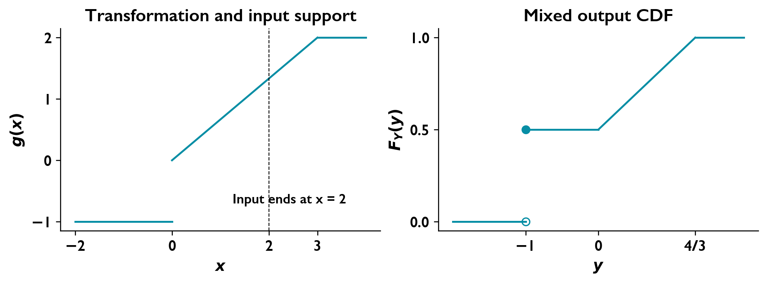
The constant negative branch creates an atom at y = −1; the output never reaches the saturation branch at y = 2.

Moments of a quadratic density

Question
A continuous random variable has density
$$f_{X}\left(x\right)=\left\{\begin{matrix}3×{10}^{−3}x^{2}, & 0≤x≤10, \\ 0, & \text{otherwise}.\end{matrix}\right.$$
Determine its mean, second raw moment, and variance.

Solution
Mean
$$μ_{X}=\int_{0}^{10}{x}\left(3×{10}^{−3}x^{2}\right) dx=3×{10}^{−3}{\left[\frac{x^{4}}{4}\right]}_{0}^{10}.$$
$$\boxed{μ_{X}=7.5.}$$
Second raw moment
$$E\{X^{2}\}=3×{10}^{−3}\int_{0}^{10}{x^{4}} dx=3×{10}^{−3}{\left[\frac{x^{5}}{5}\right]}_{0}^{10}.$$
$$\boxed{E\{X^{2}\}=60.}$$
Variance and standard deviation
$$σ_{X}^{2}=E\{X^{2}\}−μ_{X}^{2}=60−{\left(7.5\right)}^{2}.$$
$$\boxed{σ_{X}^{2}=3.75, σ_{X}=\sqrt{3.75}≈1.93649.}$$

Moments of an exponential random variable

Question
For $a>0$, let
$$f_{X}\left(x\right)=ae^{−ax}u\left(x\right).$$
Determine the mean, second raw moment, variance, and standard deviation.

Solution
Mean Integration by parts gives
$$μ_{X}=a\int_{0}^{∞}{x}e^{−ax} dx={\left[−xe^{−ax}\right]}_{0}^{∞}+\int_{0}^{∞}{e^{−ax}} dx.$$
$$\boxed{μ_{X}=\frac{1}{a}.}$$
Second raw moment
$$E\{X^{2}\}=a\int_{0}^{∞}{x^{2}}e^{−ax} dx={\left[−x^{2}e^{−ax}\right]}_{0}^{∞}+2\int_{0}^{∞}{x}e^{−ax} dx.$$
$$\boxed{E\{X^{2}\}=\frac{2}{a^{2}}.}$$
Variance and standard deviation
$$σ_{X}^{2}=\frac{2}{a^{2}}−{\left(\frac{1}{a}\right)}^{2}.$$
$$\boxed{σ_{X}^{2}=\frac{1}{a^{2}}, σ_{X}=\frac{1}{a}.}$$

Joint and Conditional Distributions

Joint density and marginal densities
Two receiver measurements may share a disturbance, so their separate distributions do not describe their full relationship. A joint distribution describes which pairs of readings are likely together. This matters when one measurement can help us interpret or predict another.
For variables $X,Y$,
$$F_{X,Y}\left(x,y\right)=P\left(X≤x, Y≤y\right).$$
When a joint density exists,
$$f_{X,Y}\left(x,y\right)=\frac{∂^{2}F_{X,Y}\left(x,y\right)}{∂x ∂y}, f_{X,Y}\left(x,y\right)≥0,$$
$$\int_{−∞}^{∞}{\int_{−∞}^{∞}{f_{X,Y}}}\left(x,y\right) dx dy=1.$$
The support is the region where the density is nonzero. For a region $D$,
PX,Y∈D=D​fX,Yx,y dx dy.
A marginal distribution describes one reading by itself, ignoring the value of the other. Integrate out the other variable to obtain a marginal density:
$$f_{X}\left(x\right)=\int_{−∞}^{∞}{f_{X,Y}}\left(x,y\right) dy, f_{Y}\left(y\right)=\int_{−∞}^{∞}{f_{X,Y}}\left(x,y\right) dx.$$

Conditional density and moments
After observing one measurement, we can update what we expect from the other. The conditional density is this updated description; its mean gives the expected unobserved reading and its variance describes how uncertain that reading remains.
For $f_{Y}\left(y\right)>0$,
$$f_{X∣Y}\left(x∣y\right)=\frac{f_{X,Y}\left(x,y\right)}{f_{Y}\left(y\right)}.$$
This is a normalized density in $x$, with the support restricted to the fixed value $y$. Similarly, $f_{Y∣X}\left(y∣x\right)=f_{X,Y}\left(x,y\right)/f_{X}\left(x\right)$ when $f_{X}\left(x\right)>0$.
The conditional mean and variance follow from that density:
$$μ_{X∣Y}\left(y\right)=E\{X∣Y=y\}=\int_{−∞}^{∞}{x}f_{X∣Y}\left(x∣y\right) dx,$$
$$σ_{X∣Y}^{2}\left(y\right)=\int_{−∞}^{∞}{x^{2}}f_{X∣Y}\left(x∣y\right) dx−μ_{X∣Y}{\left(y\right)}^{2}.$$
The same integral with $x^{n}$ gives the conditional moment of order $n$.

Independence and covariance
Independence means
$$P\left(X∈A,Y∈B\right)=P\left(X∈A\right)P\left(Y∈B\right).$$
For density-bearing pairs, equivalently,
$$f_{X,Y}\left(x,y\right)=f_{X}\left(x\right)f_{Y}\left(y\right), F_{X,Y}\left(x,y\right)=F_{X}\left(x\right)F_{Y}\left(y\right).$$
Under independence, the conditional density equals its marginal density.
For an integrable function $g$,
$$E\{g\left(X,Y\right)\}=\int_{−∞}^{∞}{\int_{−∞}^{∞}{g}}\left(x,y\right)f_{X,Y}\left(x,y\right) dx dy.$$
Covariance indicates whether deviations from the two means tend to occur in the same or opposite directions. It measures this particular type of relationship, rather than every possible dependence. In particular,
$$Cov\left(X,Y\right)=E\{\left(X−μ_{X}\right)\left(Y−μ_{Y}\right)\}=E\{XY\}−μ_{X}μ_{Y}.$$
For $σ_{X},σ_{Y}>0$, the correlation coefficient is
$$ρ_{X,Y}=\frac{Cov\left(X,Y\right)}{σ_{X}σ_{Y}}.$$
Independent variables with finite second moments are uncorrelated. Zero covariance does not generally imply independence. It does imply independence for a jointly Gaussian pair; Gaussian marginal densities alone are insufficient.

Example: sine and cosine of a uniform angle

Question
Let $Z$ be uniform on $\left[0,2π\right]$, with $X=sinZ$ and $Y=cosZ$. Find their marginal densities. Are they uncorrelated? Are they independent?

Solution
For $−1<x<1$, the sine map has two inverse branches. Each has derivative magnitude $\sqrt{1−x^{2}}$ in the forward map, so
$$f_{X}\left(x\right)=\frac{2}{2π\sqrt{1−x^{2}}}=\frac{1}{π\sqrt{1−x^{2}}}.$$
The cosine map gives the same form:
$$f_{Y}\left(y\right)=\frac{1}{π\sqrt{1−y^{2}}}, −1<y<1.$$
Both densities are zero outside their stated intervals. Over one full cycle,
$$μ_{X}=μ_{Y}=0,$$
$$E\{XY\}=\frac{1}{2π}\int_{0}^{2π}{sin}zcosz dz=\frac{1}{4π}\int_{0}^{2π}{sin}\left(2z\right) dz=0.$$
Thus $Cov\left(X,Y\right)=0$. Nevertheless,
$$X^{2}+Y^{2}=1,$$
so knowing $X$ restricts $Y$: they are dependent. Their joint law lies on a circle and has no ordinary density over the plane. A shared random phase can therefore link two components even when their covariance is zero.

Example: a joint density on a triangular support

Question
Let
$$f_{X,Y}\left(x,y\right)=\left\{\begin{matrix}Ke^{−x−y}, & x≥y≥0, \\ 0, & \text{otherwise}.\end{matrix}\right.$$
Find $K$, the marginal and conditional densities, independence, covariance, and correlation coefficient.

Solution
Normalization gives
$$1=K\int_{0}^{∞}{\int_{y}^{∞}{e^{−x−y}}} dx dy=\frac{K}{2}, K=2.$$
The marginal densities are
$$f_{X}\left(x\right)=\int_{0}^{x}{2}e^{−x−y} dy=2e^{−x}\left(1−e^{−x}\right), x≥0,$$
$$f_{Y}\left(y\right)=\int_{y}^{∞}{2}e^{−x−y} dx=2e^{−2y}, y≥0.$$
Both are zero for negative arguments. The joint support prevents factorization, so the variables are dependent. Conditioning gives
$$f_{X∣Y}\left(x∣y\right)=e^{−\left(x−y\right)}, x≥y, y≥0,$$
and zero for $x<y$. With $u=x−y$,
$$μ_{X∣Y}\left(y\right)=\int_{0}^{∞}{\left(y+u\right)}e^{−u} du=y+1,$$
$$σ_{X∣Y}^{2}\left(y\right)=\int_{0}^{∞}{u^{2}}e^{−u} du−1^{2}=1.$$
Integrating the marginal densities yields
$$μ_{X}=\frac{3}{2}, E\{X^{2}\}=\frac{7}{2}, σ_{X}^{2}=\frac{5}{4},$$
$$μ_{Y}=\frac{1}{2}, E\{Y^{2}\}=\frac{1}{2}, σ_{Y}^{2}=\frac{1}{4}.$$
Finally,
$$E\{XY\}=\int_{0}^{∞}{y}\left(y+1\right) 2e^{−2y} dy=1,$$
$$Cov\left(X,Y\right)=1−\frac{3}{2}⋅\frac{1}{2}=\frac{1}{4}, ρ_{X,Y}=\frac{1/4}{\sqrt{5/4}\sqrt{1/4}}=\frac{1}{\sqrt{5}}.$$

Worked Problems

Normalization and marginals on a curved support

Question
The joint density is
$$f_{XY}\left(x,y\right)=\left\{\begin{matrix}k\left(1+2xy\right), & 0<x≤1, 0<x^{2}<y≤x+0.5≤1, \\ 0, & \text{otherwise}.\end{matrix}\right.$$
Find:
The normalization constant $k$.
The marginal densities $f_{X}\left(x\right)$ and $f_{Y}\left(y\right)$.

Solution
Support
$$x+1/2≤1 ⇒ D=\{\left(x,y\right):0<x≤1/2, x^{2}<y≤x+1/2\}.$$
Normalization
$$\begin{matrix}1 & =k\int_{0}^{1/2}{\int_{x^{2}}^{x+1/2}{\left(1+2xy\right)}} dy dx \\ & =k\int_{0}^{1/2}{\left(1/2+5/4x+x^{3}−x^{5}\right)}dx=k\frac{161}{384}.\end{matrix}$$
$$\boxed{k=\frac{384}{161}}$$
Marginal of $X$
$$\boxed{f_{X}\left(x\right)=\left\{\begin{matrix}\frac{384}{161}\left(1/2+5/4x+x^{3}−x^{5}\right), & 0<x<1/2, \\ 0, & \text{otherwise}.\end{matrix}\right.}$$
Marginal of $Y$ For fixed $y$, let $ℓ=max\left(0,y−1/2\right)$ and $u=min\left(1/2,\sqrt{y}\right)$.
$$f_{Y}\left(y\right)=k\int_{ℓ}^{u}{\left(1+2xy\right)} dx=k{\left[x+yx^{2}\right]}_{ℓ}^{u}.$$
$$\boxed{f_{Y}\left(y\right)=\frac{384}{161}\left\{\begin{matrix}\sqrt{y}+y^{2}, & 0<y<1/4, \\ 1/2+1/4y, & 1/4≤y<1/2, \\ 1−y+y^{2}−y^{3}, & 1/2≤y<1, \\ 0, & \text{otherwise}.\end{matrix}\right.}$$
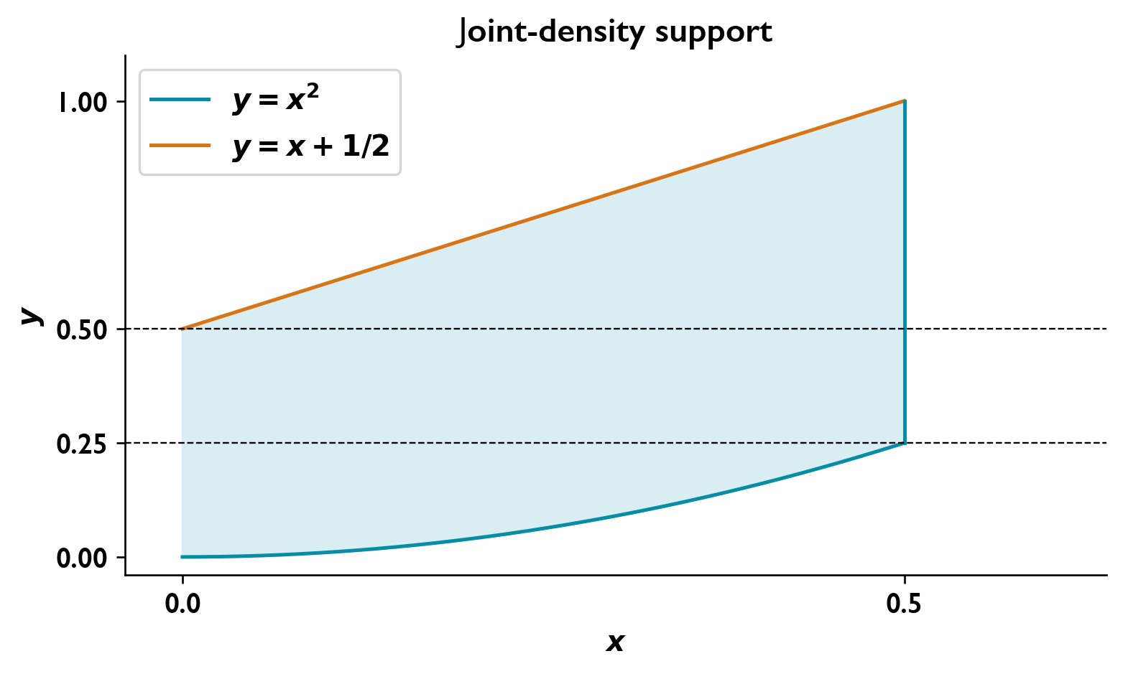
The curved support fixes the marginal integration limits. Horizontal boundary changes occur at y = 1/4 and y = 1/2.

A joint density on a triangular strip

Question
The joint density is
$$f_{XY}\left(x,y\right)=\left\{\begin{matrix}kx, & 1≤x+y≤2, x,y≥0, \\ 0, & \text{otherwise}.\end{matrix}\right.$$
Find $k$, $f_{X}\left(x\right)$, and $f_{Y}\left(y\right)$.

Solution
Normalization Set $s=x+y$; the Jacobian is one.
$$1=k\int_{1}^{2}{\int_{0}^{s}{x}} dx ds=\frac{k}{2}\int_{1}^{2}{s^{2}}ds=\frac{7k}{6}, \boxed{k=\frac{6}{7}}.$$
Marginal of $X$
$$f_{X}\left(x\right)=kx\int_{max\left(0,1−x\right)}^{2−x}{d}y.$$
$$\boxed{f_{X}\left(x\right)=\left\{\begin{matrix}\frac{6}{7}x, & 0≤x≤1, \\ \frac{6}{7}x\left(2−x\right), & 1<x≤2, \\ 0, & \text{otherwise}.\end{matrix}\right.}$$
Marginal of $Y$
$$f_{Y}\left(y\right)=k\int_{max\left(0,1−y\right)}^{2−y}{x} dx.$$
$$\boxed{f_{Y}\left(y\right)=\left\{\begin{matrix}\frac{3}{7}\left(3−2y\right), & 0≤y≤1, \\ \frac{3}{7}{\left(2−y\right)}^{2}, & 1<y≤2, \\ 0, & \text{otherwise}.\end{matrix}\right.}$$

A joint exponential density on an ordered support

Question
Two continuous random variables have joint density
$$f_{X,Y}\left(x,y\right)=\left\{\begin{matrix}ke^{−\left(x+y\right)}, & x>y>0, \\ 0, & \text{otherwise}.\end{matrix}\right.$$
Determine $k$ and both marginal densities.
Determine whether $X$ and $Y$ are independent.
Obtain $f_{X∣Y}\left(x∣y\right)$.

Solution
Normalization
$$1=\int_{0}^{∞}{\int_{y}^{∞}{k}}e^{−\left(x+y\right)} dx dy=k\int_{0}^{∞}{e^{−2y}} dy=\frac{k}{2}.$$
$$\boxed{k=2.}$$
Marginal densities For fixed $x>0$, the support requires $0<y<x$:
$$f_{X}\left(x\right)=\int_{0}^{x}{2}e^{−x−y} dy=2e^{−x}\left(1−e^{−x}\right).$$
For fixed $y>0$, the support requires $x>y$:
$$f_{Y}\left(y\right)=\int_{y}^{∞}{2}e^{−x−y} dx=2e^{−2y}.$$
$$\boxed{f_{X}\left(x\right)=2e^{−x}\left(1−e^{−x}\right)u\left(x\right), f_{Y}\left(y\right)=2e^{−2y}u\left(y\right).}$$
Independence For $0<x<y$, both marginals are positive but the joint density is zero. Therefore it cannot factor as $f_{X}\left(x\right)f_{Y}\left(y\right)$.
$$\boxed{X\text{ and }Y\text{ are dependent.}}$$
Conditional density For $y>0$,
$$f_{X∣Y}\left(x∣y\right)=\frac{2e^{−x−y}}{2e^{−2y}}=e^{−\left(x−y\right)}, x>y.$$
$$\boxed{f_{X∣Y}\left(x∣y\right)=\left\{\begin{matrix}e^{−\left(x−y\right)}, & x>y, \\ 0, & x≤y.\end{matrix}\right. y>0.}$$
Its integral over $\left(y,∞\right)$ equals one.

An exponential conditional law with a random rate

Question
Let
$$f_{X,Y}\left(x,y\right)=ye^{−y\left(x+1\right)}u\left(x\right)u\left(y\right).$$
Obtain $f_{Y}\left(y\right)$, determine whether the variables are independent, and find $f_{X∣Y}\left(x∣y\right)$.

Solution
Marginal density of $Y$ For $y>0$,
$$f_{Y}\left(y\right)=\int_{0}^{∞}{y}e^{−y\left(x+1\right)} dx=ye^{−y}\int_{0}^{∞}{e^{−yx}} dx=e^{−y}.$$
$$\boxed{f_{Y}\left(y\right)=e^{−y}u\left(y\right).}$$
Independence For $x≥0$,
$$f_{X}\left(x\right)=\int_{0}^{∞}{y}e^{−\left(x+1\right)y} dy=\frac{1}{{\left(x+1\right)}^{2}}.$$
On the positive quadrant,
$$f_{X}\left(x\right)f_{Y}\left(y\right)=\frac{e^{−y}}{{\left(x+1\right)}^{2}}≠ye^{−y\left(x+1\right)}.$$
$$\boxed{X\text{ and }Y\text{ are dependent.}}$$
Conditional density For $y>0$,
$$f_{X∣Y}\left(x∣y\right)=\frac{ye^{−y\left(x+1\right)}}{e^{−y}}=ye^{−yx}, x≥0.$$
$$\boxed{f_{X∣Y}\left(x∣y\right)=\left\{\begin{matrix}ye^{−yx}, & x≥0, \\ 0, & x<0.\end{matrix}\right. y>0.}$$
Normalization follows from $\int_{0}^{∞}{y}e^{−yx} dx=1$. The conditional rate depends on $y$.

Conditional statistics on a curved joint support

Question
Let $X$ and $Y$ have joint density
$$f_{X,Y}\left(x,y\right)=\left\{\begin{matrix}6xy, & 0≤x≤1, 0≤y≤\sqrt{x}, \\ 0, & \text{otherwise}.\end{matrix}\right.$$
Determine:
Both marginal densities and whether $X$ and $Y$ are independent.
The conditional density $f_{X∣Y}\left(x∣y\right)$.
The conditional mean and variance of $X$ given $Y=y$.
The joint support in the $\left(x,y\right)$ plane and the cross moment $E\{XY\}$.

Solution
Support and normalization
The same region can be written as
$$\boxed{D=\{\left(x,y\right):0≤y≤1, y^{2}≤x≤1\}}.$$
The support lies between $y=0$ and $y=\sqrt{x}$ for $0≤x≤1$:
$$\int_{0}^{1}{\int_{0}^{\sqrt{x}}{6}}xy dy dx=\int_{0}^{1}{3}x^{2} dx=1.$$
Marginal densities
$$\begin{matrix}f_{X}\left(x\right) & =\int_{0}^{\sqrt{x}}{6}xy dy=3x^{2}, & & 0≤x≤1, \\ f_{Y}\left(y\right) & =\int_{y^{2}}^{1}{6}xy dx=3y\left(1−y^{4}\right), & & 0≤y≤1.\end{matrix}$$
Both densities are zero outside their stated supports. Thus
$$\boxed{f_{X}\left(x\right)=3x^{2}1_{\left[0,1\right]}\left(x\right)}, \boxed{f_{Y}\left(y\right)=3y\left(1−y^{4}\right)1_{\left[0,1\right]}\left(y\right)}.$$
The joint density is zero for $x<y^{2}$, whereas $f_{X}\left(x\right)f_{Y}\left(y\right)$ is positive at interior points in that region. Therefore $\boxed{X\text{ and }Y\text{ are dependent}}$.
Conditional density
For $0<y<1$,
$$\boxed{f_{X∣Y}\left(x∣y\right)=\left\{\begin{matrix}\frac{2x}{1−y^{4}}, & y^{2}≤x≤1, \\ 0, & \text{otherwise}.\end{matrix}\right.}$$
Conditional moments
$$\begin{matrix}E\{X∣Y=y\} & =\frac{2}{1−y^{4}}\int_{y^{2}}^{1}{x^{2}} dx=\frac{2\left(1−y^{6}\right)}{3\left(1−y^{4}\right)}, \\ E\{X^{2}∣Y=y\} & =\frac{2}{1−y^{4}}\int_{y^{2}}^{1}{x^{3}} dx=\frac{1+y^{4}}{2}.\end{matrix}$$
Hence
$$\boxed{E\{X∣Y=y\}=\frac{2\left(1+y^{2}+y^{4}\right)}{3\left(1+y^{2}\right)}},$$
$$\boxed{Var\left(X∣Y=y\right)=\frac{1+y^{4}}{2}−{\left[\frac{2\left(1+y^{2}+y^{4}\right)}{3\left(1+y^{2}\right)}\right]}^{2}}.$$
The density ratio is defined for $0<y<1$. Its continuous limits give mean $2/3$ and variance $1/18$ as $y→0$, and mean 1 and variance 0 as $y→1$.
Cross moment
$$\begin{matrix}E\{XY\} & =\int_{0}^{1}{\int_{0}^{\sqrt{x}}{6}}x^{2}y^{2} dy dx \\ & =2\int_{0}^{1}{x^{7/2}} dx=\boxed{\frac{4}{9}}.\end{matrix}$$
These are scalar random variables; their joint density determines $E\{XY\}$, not a temporal correlation at an unspecified lag.
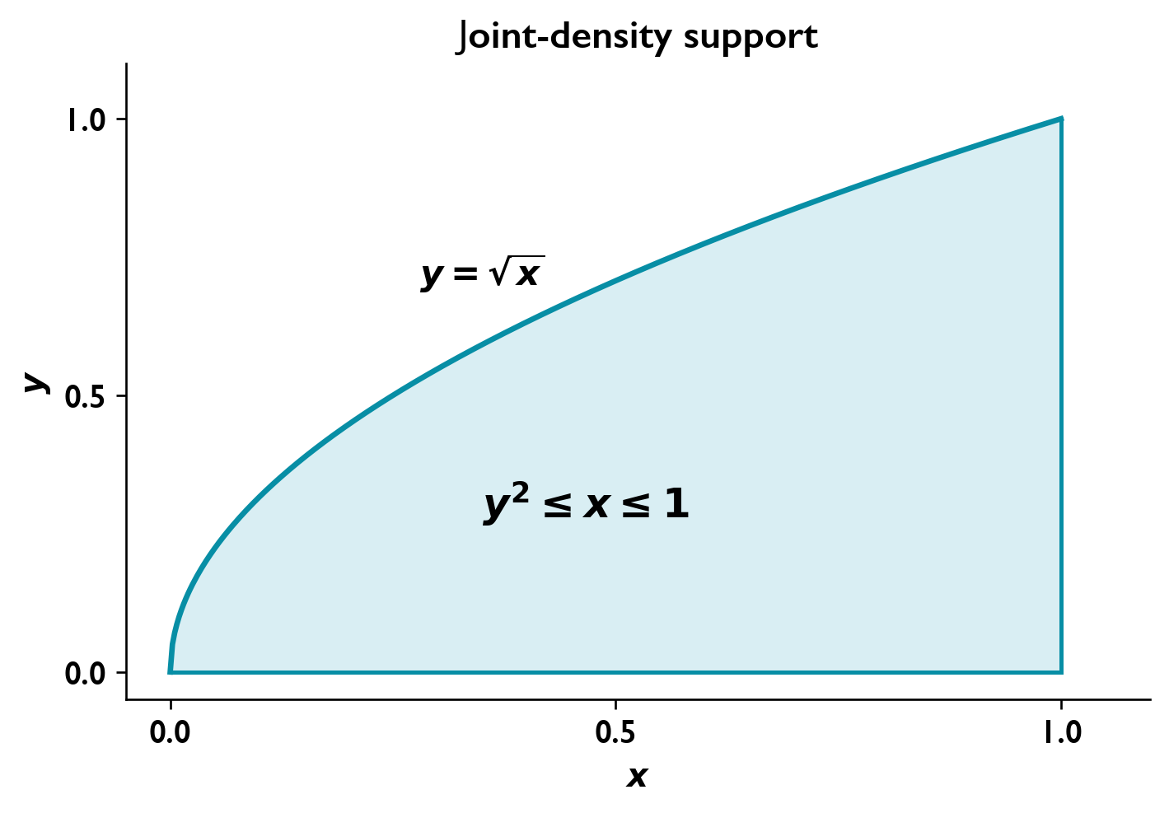
The joint support is bounded by y = sqrt(x), y = 0 and x = 1.

Random processes, stationarity and ergodicity

The process and its ensemble
A communication receiver observes a waveform determined by transmitted symbols and noise. Before reception, those symbols and the exact noise waveform are uncertain, so we model the received signal as a random process. This model describes the possible waveforms and lets us calculate their average power and statistical behavior. A fully specified test tone can instead be a deterministic signal.
A random process assigns a waveform to each outcome $s$ of an experiment:
$$X\left(t,s\right), x_{k}\left(t\right)=X\left(t,s_{k}\right).$$
Here $t$ is time, and $x_{k}\left(t\right)$ is one sample function, or realization: the particular trace observed during one transmission. The collection of possible realizations is the ensemble. Fixing the outcome gives a waveform; fixing the time gives a random variable $X\left(t_{0}\right)$, whose value can differ across repeated transmissions.
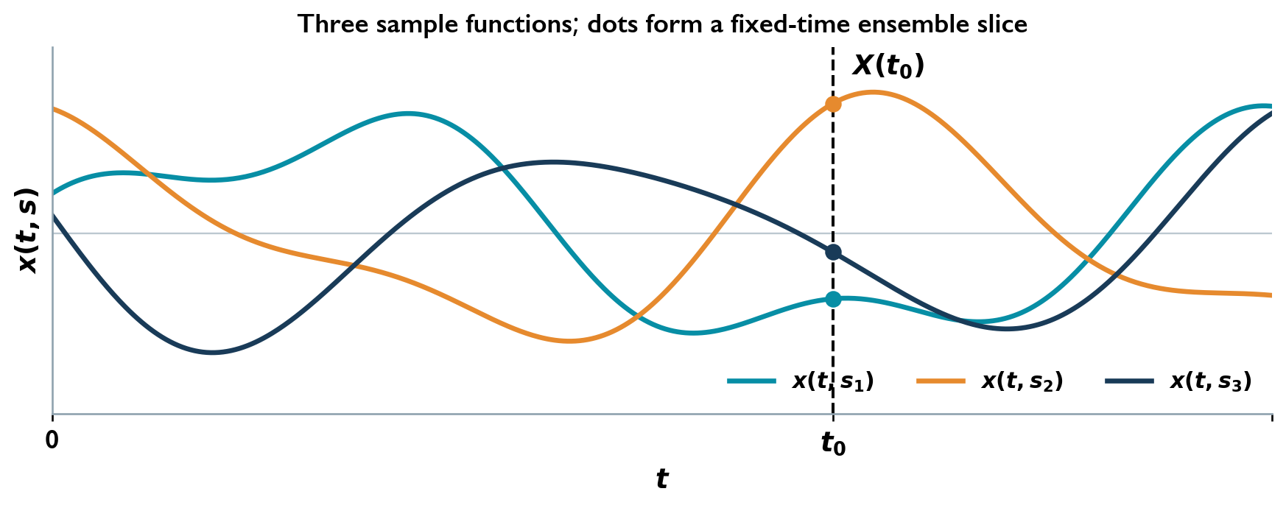
Realizations of a process. The vertical slice selects the random variable at one fixed time.
At a fixed time, the ensemble mean averages the amplitudes across possible realizations. It is a deterministic function of time. If a density exists,
$$μ_{X}\left(t\right)=E\{X\left(t\right)\}=\int_{−∞}^{∞}{x}f_{X\left(t\right)}\left(x\right) dx.$$
Different realizations need not be independent merely because they belong to the same ensemble. Independence is an additional assumption about how observations or experiments are obtained.

What stationarity requires
Stationarity lets us use the same statistical description at different observation times. In a receiver, it is often an approximation over an interval during which operating conditions remain stable; switching a transmitter on or changing its power can invalidate that approximation. The mathematical stationarity conditions below are exact conditions on the model.
First-order stationarity means that the one-time probability law is unchanged by a time shift $h$:
$$F_{X\left(t+h\right)}\left(x\right)=F_{X\left(t\right)}\left(x\right) \text{for every }t,h,x.$$
When the mean exists, it is therefore constant. A constant mean alone does not establish this equality.
Strict-sense stationarity requires the joint law of every finite collection $X\left(t_{1}\right),…,X\left(t_{n}\right)$ to remain unchanged when all times are shifted by the same $h$. It concerns all joint probability laws, rather than only a one-time density.
For a real process with finite second moments, wide-sense stationarity (WSS) requires
$$E\{X\left(t\right)\}=μ_{X}=\text{constant}, R_{X}\left(t_{1},t_{2}\right)=E\{X\left(t_{1}\right)X\left(t_{2}\right)\}=R_{X}\left(t_{2}−t_{1}\right).$$
Writing $τ=t_{2}−t_{1}$ gives $R_{X}\left(τ\right)=E\{X\left(t\right)X\left(t+τ\right)\}$. Strict-sense stationarity with finite second moments implies WSS. WSS alone does not establish strict-sense stationarity.

Ensemble averages and time averages
An ensemble average compares realizations at fixed times. In practice, a receiver or measuring instrument often has one long waveform record rather than access to all possible realizations. Ergodicity explains when averages from that record can recover the ensemble statistics. A time average follows one realization over an observation duration $L$:
$$\overline{x_{k}}=\lim_{L→∞}\frac{1}{L}\int_{−L/2}^{L/2}{x_{k}}\left(t\right) dt.$$
In the almost-sure interpretation used here, mean ergodicity means that this limit equals $μ_{X}$ for almost every realization. Correlation ergodicity means, for the lag under consideration,
$$R_{X}\left(τ\right)=\lim_{L→∞}\frac{1}{L}\int_{−L/2}^{L/2}{x_{k}}\left(t\right)x_{k}\left(t+τ\right) dt.$$
The limits must exist. Ergodicity is specified for the statistic being recovered; WSS by itself does not justify replacing an ensemble expectation by a time average. A finite observation gives an estimate, so a short record need not accurately reproduce the ensemble result.
With a normalized resistive load, mean square represents average power:
$$P_{X}=E\{X^{2}\left(t\right)\}=μ_{X}^{2}+σ_{X}^{2}.$$
The deterministic mean contributes power $μ_{X}^{2}$, while the centered fluctuation has power $σ_{X}^{2}$. Total RMS is $\sqrt{μ_{X}^{2}+σ_{X}^{2}}$; fluctuation RMS is $σ_{X}$. These powers coincide with DC and AC power, respectively, when the centered process has no random constant component. For a voltage across resistance $r$, divide the mean-square voltage by $r$ to obtain power in watts.

Example: Random phase

Question
Is $X\left(t\right)=Acos\left(2πf_{c}t+Θ\right)$ stationary when $A$ and $f_{c}≠0$ are constants and $Θ∼U[0,2π)$?

Solution
A time shift replaces $Θ$ by $Θ+2πf_{c}h$, taken modulo $2π$. This phase is still uniform. Because the same phase shift applies to every observed time, all finite-dimensional joint laws remain unchanged: the process is strictly stationary.
$$μ_{X}\left(t\right)=\frac{A}{2π}\int_{0}^{2π}{cos}\left(2πf_{c}t+θ\right) dθ=0.$$
Its correlation, derived below, is $R_{X}\left(τ\right)={A^{2}}/2cos\left(2πf_{c}τ\right)$, so it is also WSS. Integrating one sinusoidal realization over a growing interval gives time mean zero and the same time correlation; it is ergodic for these two statistics.

Example: Random amplitude

Question
Is $X\left(t\right)=Acos\left(2πf_{c}t\right)$ strictly stationary if $A∼U\left[0,1\right]$ and $f_{c}≠0$?

Solution
Since $E\{A\}=1/2$,
$$μ_{X}\left(t\right)=\frac{1}{2}cos\left(2πf_{c}t\right).$$
The mean varies with absolute time. The process is neither strictly stationary nor WSS. A random amplitude with fixed phase therefore behaves differently from a fixed amplitude with uniform random phase.

Example: Random frequency

Question
Show that $X\left(t\right)=sin\left(2πWt\right)$ is nonstationary when $W∼U\left[0,B\right]$ and $B>0$ hertz.

Solution
For $t≠0$,
$$μ_{X}\left(t\right)=\frac{1}{B}\int_{0}^{B}{sin}\left(2πwt\right) dw=\frac{1−cos\left(2πBt\right)}{2πBt}.$$
At $t=0$, the mean is zero, also the limit of this expression. The mean is not constant, which rules out both forms of stationarity.

Example: A Gaussian amplitude through an integrator

Question
Let $X\left(t\right)=Acos\left(2πf_{c}t\right)$, where $A∼N\left(0,σ_{A}^{2}\right)$, $σ_{A}^{2}>0$ and $f_{c}≠0$. Find the law of $Y\left(t_{k}\right)$ for
$$Y\left(t\right)=\int_{0}^{t}{X}\left(u\right) du,$$
and determine whether $Y\left(t\right)$ is stationary.

Solution
Direct integration gives
$$Y\left(t\right)=\frac{Asin\left(2πf_{c}t\right)}{2πf_{c}}.$$
At a fixed time $t_{k}$, define $K_{k}=sin\left(2πf_{c}t_{k}\right)/\left(2πf_{c}\right)$. Then
$$E\{Y\left(t_{k}\right)\}=0, σ_{Y}^{2}\left(t_{k}\right)=K_{k}^{2}σ_{A}^{2}.$$
For $K_{k}≠0$, the output is Gaussian with density
$$f_{Y\left(t_{k}\right)}\left(y\right)=\frac{1}{\sqrt{2π} \left|K_{k}\right|σ_{A}}exp​\left(−\frac{y^{2}}{2K_{k}^{2}σ_{A}^{2}}\right).$$
If $K_{k}=0$, the output is identically zero and its law is a point mass at zero. The variance changes with time, so the process is neither WSS nor strictly stationary, despite its constant zero mean.

Autocorrelation, autocovariance and crosscorrelation

Energy signals and random processes
A waveform has a time structure: nearby samples may carry related values, and that relationship can weaken or reverse as their separation grows. Autocorrelation measures this structure by comparing a signal with a delayed copy. For a centered random process, it describes how fluctuations at one time relate to fluctuations later, helping us assess memory and the usefulness of earlier samples in prediction.
For a real deterministic signal $x\left(t\right)$ of finite energy,
$$E_{x}=\int_{−∞}^{∞}{x^{2}}\left(t\right) dt<∞, R_{x}\left(τ\right)=\int_{−∞}^{∞}{x}\left(t\right)x\left(t+τ\right) dt.$$
The correlation integrates the overlap between the signal and a shifted copy. At zero lag, $R_{x}\left(0\right)=E_{x}$: this is energy, not time-averaged power.
For a real random process, use an ensemble expectation:
$$R_{X}\left(t_{1},t_{2}\right)=E\{X\left(t_{1}\right)X\left(t_{2}\right)\}.$$
Only after verifying WSS may it be reduced to
$$R_{X}\left(τ\right)=E\{X\left(t\right)X\left(t+τ\right)\}, R_{X}\left(0\right)=E\{X^{2}\left(t\right)\}=P_{X}.$$
For a correlation-ergodic process, the corresponding time integral must be divided by its observation duration before taking the infinite-duration limit. The deterministic energy integral has no such normalization.

Removing the mean
A constant signal offset can create correlation even when the fluctuations themselves have no time dependence. Autocovariance removes this mean contribution and measures the correlation of deviations from the mean:
$$C_{X}\left(t_{1},t_{2}\right)=E\{\left[X\left(t_{1}\right)−μ_{X}\left(t_{1}\right)\right]\left[X\left(t_{2}\right)−μ_{X}\left(t_{2}\right)\right]\}$$
$$=R_{X}\left(t_{1},t_{2}\right)−μ_{X}\left(t_{1}\right)μ_{X}\left(t_{2}\right).$$
For WSS,
$$C_{X}\left(τ\right)=R_{X}\left(τ\right)−μ_{X}^{2}, C_{X}\left(0\right)=σ_{X}^{2}.$$
Thus correlation and covariance coincide for a zero-mean process. Values at two times are uncorrelated when their covariance is zero. Independence implies zero covariance when the moments exist; the converse requires extra assumptions, such as joint Gaussianity.

Conditions every autocorrelation must satisfy
For real WSS processes with finite average power,
$$R_{X}\left(0\right)≥0, R_{X}\left(−τ\right)=R_{X}\left(τ\right), \left|R_{X}\left(τ\right)\right|≤R_{X}\left(0\right).$$
The magnitude bound follows without assuming a positive correlation. Expanding a nonnegative mean square gives
$$0≤E\{{\left[X\left(t+τ\right)±X\left(t\right)\right]}^{2}\}=2R_{X}\left(0\right)±2R_{X}\left(τ\right).$$
Hence $−R_{X}\left(0\right)≤R_{X}\left(τ\right)≤R_{X}\left(0\right)$. The same symmetry and magnitude bound hold for finite-energy $R_{x}$, with energy at the origin.
These are necessary checks, not a complete validity test. A proposed WSS autocorrelation must also have a nonnegative power spectrum. A negative value of $R_{X}\left(τ\right)$ at a nonzero lag is allowed; a negative spectral power density is not.
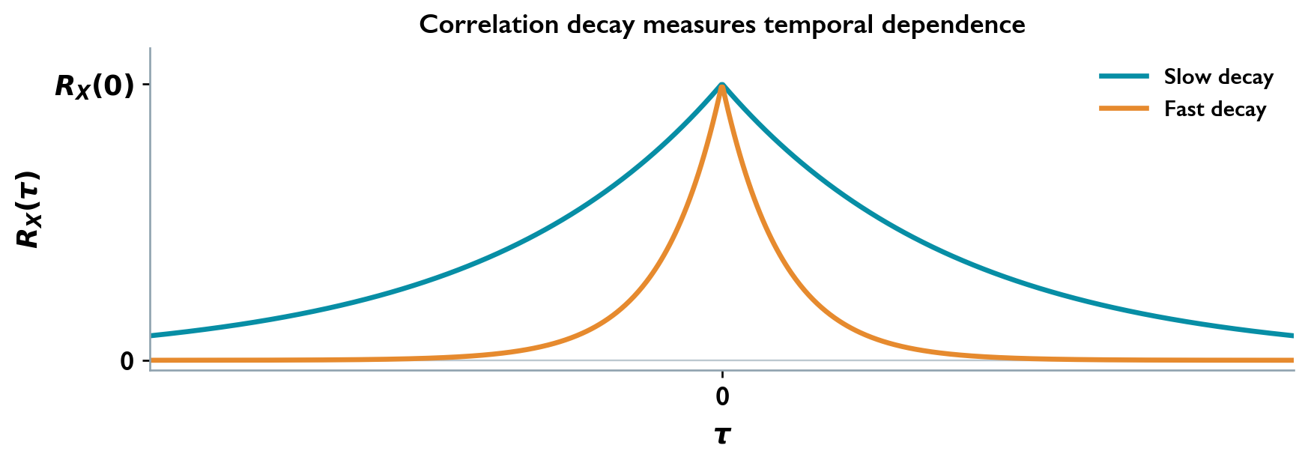
Normalized broad and narrow autocorrelation peaks. The broader peak retains correlation over larger time separations.
Slowly varying fluctuations, such as the output of a low-pass noise filter with a small cutoff frequency, often have a broad correlation peak: samples separated by a small delay still tend to vary together. Rapid fluctuations can have a narrow peak, so their correlation can weaken over shorter delays. This does not imply that every correlation decays monotonically or tends to zero: a sinusoidal component produces a persistent oscillation.

Example: Correlation of a random-phase sinusoid

Question
Find $R_{X}\left(τ\right)$ for $X\left(t\right)=Acos\left(2πf_{c}t+Θ\right)$ with fixed $A,f_{c}$ and $Θ∼U[0,2π)$.

Solution
Apply $cosαcosβ=1/2\left[cos\left(α−β\right)+cos\left(α+β\right)\right]$:
$$R_{X}\left(τ\right)=\frac{A^{2}}{2}cos\left(2πf_{c}τ\right)+\frac{A^{2}}{2}E\{cos\left(4πf_{c}t+2πf_{c}τ+2Θ\right)\}.$$
The second term averages to zero over the uniform phase. Therefore
$$R_{X}\left(τ\right)=\frac{A^{2}}{2}cos\left(2πf_{c}τ\right), P_{X}=\frac{A^{2}}{2}.$$
It is even, depends only on lag, and attains its greatest magnitude at zero and at other integer half-period lags.

Example: DC and sinusoidal components in noise

Question
How do a deterministic DC offset and an independent random-phase sinusoid affect correlation?

Solution
If $X\left(t\right)=a+N\left(t\right)$, where $a$ is constant and $N$ is zero-mean WSS noise, expansion gives
$$R_{X}\left(τ\right)=a^{2}+aE\{N\left(t\right)\}+aE\{N\left(t+τ\right)\}+R_{N}\left(τ\right)=a^{2}+R_{N}\left(τ\right).$$
No independence assumption is needed for the constant $a$. If instead $X\left(t\right)=Acos\left(2πf_{0}t+Θ\right)+N\left(t\right)$ and the uniform phase is independent of the noise, the cross terms vanish and
$$R_{X}\left(τ\right)=\frac{A^{2}}{2}cos\left(2πf_{0}τ\right)+R_{N}\left(τ\right).$$

Example: A finite pulse and a random time shift

Question
Find the energy correlation of $x\left(t\right)=Ap_{T}\left(t\right)$, where $p_{T}\left(t\right)=1$ on $0≤t<T$ and zero elsewhere. Does a single uniformly shifted pulse automatically become WSS?

Solution
The overlap length is $T−\left|τ\right|$ for $\left|τ\right|≤T$, and zero otherwise:
$$R_{x}\left(τ\right)=\left\{\begin{matrix}A^{2}\left(T−\left|τ\right|\right), & \left|τ\right|≤T, \\ 0, & \left|τ\right|>T.\end{matrix}\right.$$
The zero-lag value is $A^{2}T$, the pulse energy.
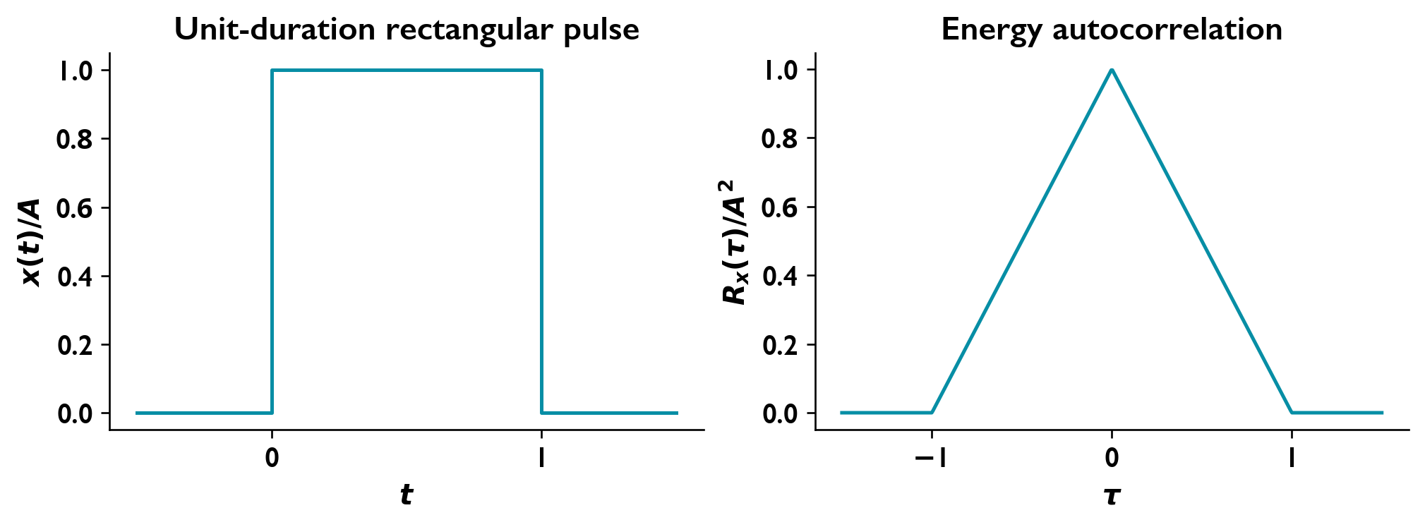
The pulse and its energy correlation for unit duration. The peak is the signal energy.
For a random shift $U∼U[0,T)$, take $X\left(t\right)=Ap_{T}\left(t+U\right)$ with $A≠0$. Then $R_{X}\left(0,0\right)=A^{2}$ but $R_{X}\left(T,T\right)=0$. The mean square depends on absolute time, so this single finite pulse is not WSS. Its energy correlation must not be relabeled as a stationary process correlation.

Crosscorrelation and the lag convention
Crosscorrelation compares two waveforms as one is shifted relative to the other. A receiver can compare a known transmitted pulse with its delayed received copy to estimate the propagation delay: their overlap is greatest when the shift aligns them. The sign of that shift depends on which waveform carries the lag, so the convention must be fixed first.
For two real jointly WSS processes, put the lag on the first process:
$$R_{XY}\left(τ\right)=E\{X\left(t+τ\right)Y\left(t\right)\}, R_{YX}\left(τ\right)=E\{Y\left(t+τ\right)X\left(t\right)\}.$$
Joint WSS means that the individual means are constant and all auto- and crosscorrelations depend only on time differences. Individual WSS alone does not establish this joint property. Reversing the order reflects the lag axis:
$$R_{XY}\left(τ\right)=R_{YX}\left(−τ\right).$$
Crosscorrelation need not be even or peak at zero. Crosscovariance is $C_{XY}\left(τ\right)=R_{XY}\left(τ\right)−μ_{X}μ_{Y}$.
The matching deterministic energy definition is
$$R_{xy}\left(τ\right)=\int_{−∞}^{∞}{x}\left(t+τ\right)y\left(t\right) dt,$$
with $R_{xy}\left(τ\right)=R_{yx}\left(−τ\right)$. The order must be fixed before identifying the sign of a delay.
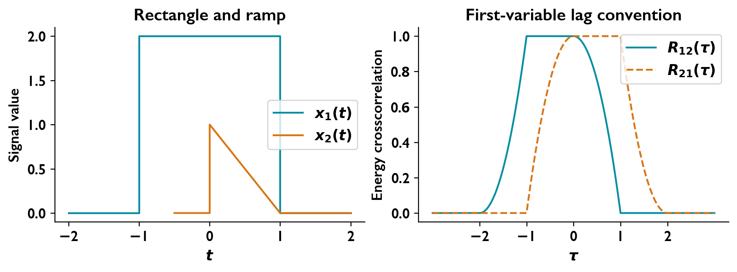
Energy crosscorrelations of a rectangle and ramp. Exchanging the two signals reflects the lag axis.

Worked Problems

Energy autocorrelation of a rectangular pulse

Question
A real deterministic pulse is
$$x\left(t\right)=\left\{\begin{matrix}A, & 0≤t≤1, \\ 0, & \text{otherwise}.\end{matrix}\right.$$
Obtain and sketch its energy autocorrelation,
$$R_{x}\left(τ\right)=\int_{−∞}^{∞}{x}\left(t+τ\right)x\left(t\right) dt.$$

Solution
Overlap intervals The factors are simultaneously nonzero on the intersection of $\left[0,1\right]$ and $\left[−τ,1−τ\right]$.
For $0≤τ≤1$,
$$R_{x}\left(τ\right)=\int_{0}^{1−τ}{A^{2}} dt=A^{2}\left(1−τ\right).$$
For $−1≤τ≤0$,
$$R_{x}\left(τ\right)=\int_{−τ}^{1}{A^{2}} dt=A^{2}\left(1+τ\right).$$
For $\left|τ\right|>1$, there is no overlap.
Autocorrelation
$$\boxed{R_{x}\left(τ\right)=\left\{\begin{matrix}A^{2}\left(1−\left|τ\right|\right), & \left|τ\right|≤1, \\ 0, & \left|τ\right|>1.\end{matrix}\right.}$$
The graph is triangular and even, with peak $A^{2}$ and zeros at $τ=±1$.
Zero-lag energy
$$\boxed{R_{x}\left(0\right)=E_{x}=\int_{0}^{1}{A^{2}} dt=A^{2}.}$$
Overlap of a unit-duration pulse produces its triangular energy autocorrelation.

Crosscorrelation of a rectangular pulse and a ramp

Question
Let
$$x_{1}\left(t\right)=\left\{\begin{matrix}2, & −1≤t≤1, \\ 0, & \text{otherwise},\end{matrix}\right. x_{2}\left(t\right)=\left\{\begin{matrix}1−t, & 0≤t≤1, \\ 0, & \text{otherwise}.\end{matrix}\right.$$
Obtain and sketch the energy crosscorrelations
$$R_{12}\left(τ\right)=\int_{−∞}^{∞}{x_{1}}\left(t+τ\right)x_{2}\left(t\right) dt,$$
$$R_{21}\left(τ\right)=\int_{−∞}^{∞}{x_{2}}\left(t+τ\right)x_{1}\left(t\right) dt.$$

Solution
Overlap geometry For $R_{12}$, intersect the ramp interval $\left[0,1\right]$ with the shifted rectangle interval $\left[−1−τ,1−τ\right]$. The integrand is $2\left(1−t\right)$ on the intersection.
Partial and full overlaps
$$\begin{matrix}R_{12}\left(τ\right) & =2\int_{−1−τ}^{1}{\left(1−t\right)} dt={\left(τ+2\right)}^{2}, & & −2≤τ<−1, \\ R_{12}\left(τ\right) & =2\int_{0}^{1}{\left(1−t\right)} dt=1, & & −1≤τ≤0, \\ R_{12}\left(τ\right) & =2\int_{0}^{1−τ}{\left(1−t\right)} dt=1−τ^{2}, & & 0<τ≤1.\end{matrix}$$
Outside $\left[−2,1\right]$, there is no overlap.
Forward-order crosscorrelation
$$\boxed{R_{12}\left(τ\right)=\left\{\begin{matrix}{\left(τ+2\right)}^{2}, & −2≤τ<−1, \\ 1, & −1≤τ≤0, \\ 1−τ^{2}, & 0<τ≤1, \\ 0, & \text{otherwise}.\end{matrix}\right.}$$
Reverse-order crosscorrelation For real signals, $R_{21}\left(τ\right)=R_{12}\left(−τ\right)$.
$$\boxed{R_{21}\left(τ\right)=\left\{\begin{matrix}1−τ^{2}, & −1≤τ<0, \\ 1, & 0≤τ≤1, \\ {\left(2−τ\right)}^{2}, & 1<τ≤2, \\ 0, & \text{otherwise}.\end{matrix}\right.}$$
The two graphs are reflections about zero lag. Each has maximum one and continuous joins between adjacent pieces.
Crosscorrelation order is defined by shifting the first signal. Reversal reflects the lag axis.

Testing proposed autocorrelation functions

Question
Determine whether each function can be the autocorrelation of a real WSS process with finite second moment.
$r_{1}\left(τ\right)=sin\left(2πf_{0}τ\right)$, where $f_{0}≠0$.
$r_{2}\left(τ\right)=τ^{2}$.
The piecewise function
$$r_{3}\left(τ\right)=\left\{\begin{matrix}1−\left|τ\right|, & \left|τ\right|≤1, \\ 1+\left|τ\right|, & \left|τ\right|>1.\end{matrix}\right.$$

Solution
Necessary conditions A real WSS autocorrelation must satisfy
$$R\left(−τ\right)=R\left(τ\right), \left|R\left(τ\right)\right|≤R\left(0\right).$$
Sine candidate $r_{1}$ is odd and nonzero, so it is not even. Also $r_{1}\left(0\right)=0$ while $r_{1}$ is nonzero at some lags.
$$\boxed{r_{1}\text{ is invalid.}}$$
Quadratic candidate Although $r_{2}$ is even,
$$r_{2}\left(0\right)=0, r_{2}\left(1\right)=1>r_{2}\left(0\right).$$
$$\boxed{r_{2}\text{ is invalid.}}$$
Piecewise candidate The function is even but violates the zero-lag bound:
$$r_{3}\left(0\right)=1, r_{3}\left(2\right)=3>r_{3}\left(0\right).$$
$$\boxed{r_{3}\text{ is invalid.}}$$

Power spectra, linear systems and random binary signals

Finite observation and power spectrum
A time-domain waveform shows how a signal changes during one observation. A power spectral density (PSD) shows how its average power is distributed over frequency, even when the individual waveform is unpredictable. This helps us choose a transmission bandwidth and determine which parts of a signal or noise a receiver filter will pass. Autocorrelation and PSD describe the same second-order behavior in the time-lag and frequency domains, respectively.
Observe a process over $\left[−T,T\right]$ and define its finite-window transform:
$$Ξ_{T}\left(f\right)=\int_{−T}^{T}{X}\left(t\right)e^{−j2πft} dt.$$
Its power spectrum is
$$S_{X}\left(f\right)=\lim_{T→∞}\frac{E\{{\left|Ξ_{T}\left(f\right)\right|}^{2}\}}{2T},$$
when the limit exists. Spectral delta lines are interpreted by their weights.

Correlation and spectrum
For a real WSS process, autocorrelation and the two-sided power spectral density form a Fourier pair:
$$S_{X}\left(f\right)=\int_{−∞}^{∞}{R_{X}}\left(τ\right)e^{−j2πfτ} dτ,$$
$$R_{X}\left(τ\right)=\int_{−∞}^{∞}{S_{X}}\left(f\right)e^{j2πfτ} df.$$
Here $f$ is frequency in hertz, $τ$ is time lag, and $j=\sqrt{−1}$. The spectrum distributes mean-square power over frequency:
$$P_{X}=R_{X}\left(0\right)=\int_{−∞}^{∞}{S_{X}}\left(f\right) df, S_{X}\left(f\right)≥0, S_{X}\left(−f\right)=S_{X}\left(f\right).$$
The area under the PSD over a frequency interval gives the mean-square power in that interval. Thus a filter can reduce noise by rejecting frequencies outside the useful signal band. With amplitude in volts, the spectral units are $V^{2}/Hz$; for a normalized load they can be expressed as watts per hertz. When the integral exists, $S_{X}\left(0\right)=∫R_{X}\left(τ\right) dτ$.
For a deterministic finite-energy signal, the corresponding Fourier transform of $R_{x}\left(τ\right)$ is the energy spectral density $ψ_{x}\left(f\right)={\left|ξ_{x}\left(f\right)\right|}^{2}$, where $ξ_{x}\left(f\right)=∫x\left(t\right)e^{−j2πft} dt$. Its spectral area is energy. It is not the PSD of a WSS random process.

DC and sinusoidal lines
A constant offset concentrates its power at zero frequency, whereas a sinusoidal component concentrates power at its oscillation frequency and the matching negative frequency in a two-sided spectrum. These concentrated components appear as spectral lines.
Writing $X\left(t\right)=μ_{X}+\tilde{X}\left(t\right)$ with a zero-mean WSS fluctuation gives
$$R_{X}\left(τ\right)=μ_{X}^{2}+C_{X}\left(τ\right), S_{X}\left(f\right)=μ_{X}^{2}δ\left(f\right)+S_{\tilde{X}}\left(f\right).$$
The deterministic mean contributes a spectral line at zero. A delta line is characterized by its area or weight, not by an ordinary finite height. A DC line can also contain power from a random constant component; its weight alone does not determine the mean.
For the fixed-amplitude random-phase sinusoid,
$$R_{X}\left(τ\right)=\frac{A^{2}}{2}cos\left(2πf_{c}τ\right), S_{X}\left(f\right)=\frac{A^{2}}{4}\left[δ\left(f−f_{c}\right)+δ\left(f+f_{c}\right)\right].$$
Each line carries power $A^{2}/4$, giving total power $A^{2}/2$.
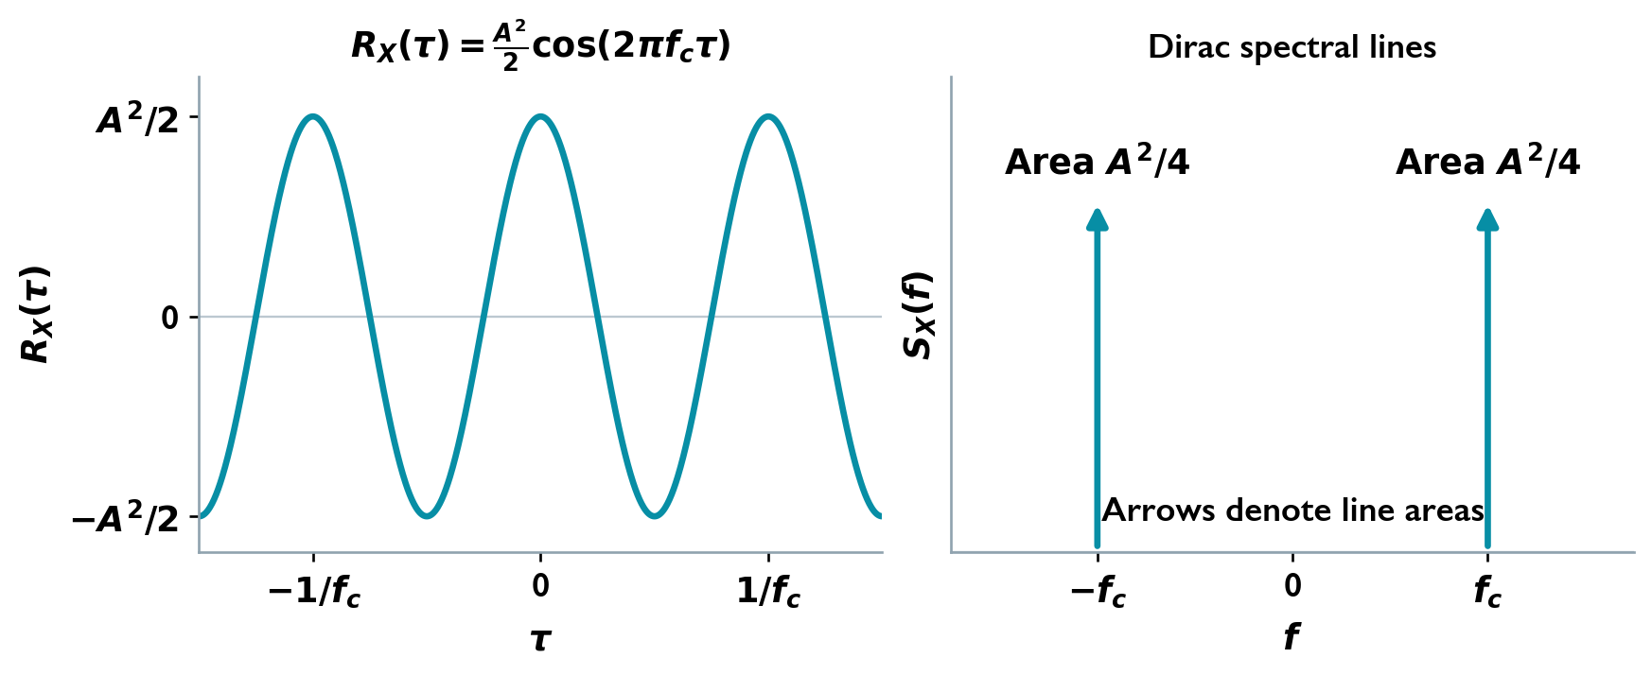
Cosine correlation and the two spectral lines. Arrow labels indicate delta weights.

Example: Triangular correlation and triangular spectrum

Question
Transform a triangular correlation, and then find the correlation corresponding to a triangular PSD.

Solution
Define the dimensionless functions
$$Λ\left(u\right)=\left\{\begin{matrix}1−\left|u\right|, & \left|u\right|≤1, \\ 0, & \left|u\right|>1,\end{matrix}\right. sinc\left(u\right)=\frac{sin\left(πu\right)}{πu}, sinc\left(0\right)=1.$$
For a zero-mean process and time width $T>0$,
$$R_{X}\left(τ\right)=σ^{2}Λ\left(τ/T\right) ⇔ S_{X}\left(f\right)=σ^{2}T{sinc}^{2}\left(fT\right).$$
For a frequency width $f_{0}>0$ and peak spectral density $s_{0}$,
$$S_{X}\left(f\right)=s_{0}Λ\left(f/f_{0}\right) ⇔ R_{X}\left(τ\right)=s_{0}f_{0}{sinc}^{2}\left(f_{0}τ\right).$$
The zero-lag values agree with the spectral areas: $σ^{2}$ for the first pair and $s_{0}f_{0}$ for the second. A triangle in one domain becomes a squared sinc in the other; the scale factor follows the integration variable.

Example: A triangular PSD with a DC line

Question
For $S_{X}\left(f\right)=s_{0}Λ\left(f/f_{0}\right)+p_{0}δ\left(f\right)$, find correlation, DC and AC powers, and sampling intervals giving uncorrelated samples. Interpret the line as a deterministic mean contribution.

Solution
The inverse transform gives
$$R_{X}\left(τ\right)=s_{0}f_{0}{sinc}^{2}\left(f_{0}τ\right)+p_{0}.$$
Thus $μ_{X}^{2}=p_{0}$, $P_{DC}=p_{0}$, $P_{AC}=s_{0}f_{0}$, and $P_{X}=p_{0}+s_{0}f_{0}$. The stated numerical unit-height, unit-line case is obtained with $s_{0}=1$ and $p_{0}=1$ in the relevant units.
After subtracting the mean contribution,
$$C_{X}\left(τ\right)=s_{0}f_{0}{sinc}^{2}\left(f_{0}τ\right).$$
Consequently $C_{X}\left(kT_{s}\right)=0$ for every nonzero integer $k$ if
$$T_{s}=\frac{m}{f_{0}}, f_{s}=\frac{f_{0}}{m}, m=1,2,….$$
These samples are uncorrelated, although $R_{X}\left(kT_{s}\right)=p_{0}$ rather than zero. They need not be independent without joint Gaussianity. If the line were a random constant component instead, this covariance conclusion would require its mean and variance to be specified.

Cross spectra
With $R_{XY}\left(τ\right)=E\{X\left(t+τ\right)Y\left(t\right)\}$, define
$$S_{XY}\left(f\right)=\int_{−∞}^{∞}{R_{XY}}\left(τ\right)e^{−j2πfτ} dτ,$$
$$R_{XY}\left(τ\right)=\int_{−∞}^{∞}{S_{XY}}\left(f\right)e^{j2πfτ} df.$$
For real jointly WSS processes,
$$S_{XY}\left(f\right)=S_{YX}\left(−f\right)=S_{YX}^{*}\left(f\right).$$
A cross spectrum describes how two processes are related at each frequency. Comparing a filter input with its output, for example, reveals a frequency-dependent relationship that can include a phase shift. It may therefore be complex and is not required to be nonnegative. Its integral gives the zero-lag crosscorrelation, $R_{XY}\left(0\right)=E\{X\left(t\right)Y\left(t\right)\}$.

A random bipolar binary sequence
A digital transmitter converts successive data symbols into voltage pulses. Before the data are known, the possible pulse sequences form an ensemble of random waveforms. Holding each symbol for a longer time changes both how long nearby samples remain related and how widely the signal power spreads in frequency.
Let independent equiprobable symbols $A_{k}∈\{−1,+1\}$ be held for duration $T$. Randomize the timing origin uniformly over $[0,T)$, independently of the symbols, so no absolute time is privileged. Then $E\{X\left(t\right)\}=0$ and $P_{X}=1$.
For $\left|τ\right|≤T$, the probability that two observations belong to the same symbol is $1−\left|τ\right|/T$. The same-symbol product is one; different symbols have expected product zero. Hence
$$R_{X}\left(τ\right)=\left\{\begin{matrix}1−\left|τ\right|/T, & \left|τ\right|≤T, \\ 0, & \left|τ\right|>T,\end{matrix}\right. S_{X}\left(f\right)=T{sinc}^{2}\left(fT\right).$$
For symbols $±A$, both expressions are multiplied by $A^{2}$.
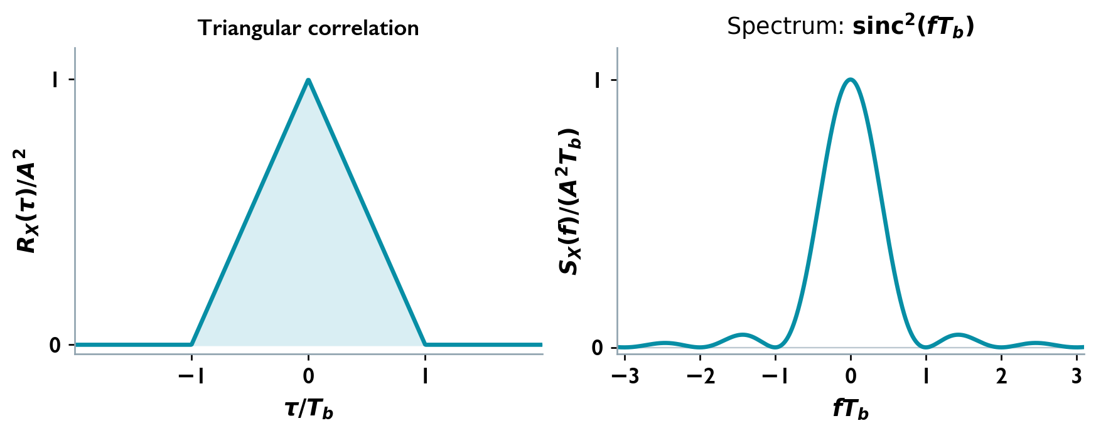
Binary correlation and PSD for two symbol durations, using shared axis scales.
The bit rate is $R_{b}=1/T$. First spectral zeros occur at $f=±1/T=±R_{b}$, so the null-to-null main-lobe width is $2R_{b}$. A longer symbol produces broader correlation and a narrower main lobe; a shorter symbol reverses this relation. This connects faster data transmission to a wider signal spectrum and helps explain why a channel bandwidth limits the symbol rates it can carry without substantial pulse distortion. The squared-sinc sidelobes continue outside the main lobe, so this width is not a strict finite spectral support.

Worked Problems

Power spectrum of the sum of two processes

Question
Let $X\left(t\right)$ and $Y\left(t\right)$ be zero-mean WSS processes, and define $Z\left(t\right)=X\left(t\right)+Y\left(t\right)$. Assume joint WSS for the general spectral calculation.
Determine $S_{Z}\left(f\right)$ in terms of the auto and cross spectra.
Simplify the result when $X\left(t\right)$ and $Y\left(t\right)$ are independent.

Solution
Expand the autocorrelation
Using $R_{XY}\left(τ\right)=E\{X\left(t+τ\right)Y\left(t\right)\}$,
$$\begin{matrix}R_{Z}\left(τ\right) & =E\{\left[X\left(t+τ\right)+Y\left(t+τ\right)\right]\left[X\left(t\right)+Y\left(t\right)\right]\} \\ & =R_{X}\left(τ\right)+R_{Y}\left(τ\right)+R_{XY}\left(τ\right)+R_{YX}\left(τ\right).\end{matrix}$$
Take the Fourier transform
Since $S_{YX}\left(f\right)=S_{XY}^{*}\left(f\right)$,
$$\boxed{S_{Z}\left(f\right)=S_{X}\left(f\right)+S_{Y}\left(f\right)+2ReS_{XY}\left(f\right)}.$$
Independent processes
Independence and zero means give $R_{XY}\left(τ\right)=0$ at every lag. Therefore,
$$\boxed{S_{Z}\left(f\right)=S_{X}\left(f\right)+S_{Y}\left(f\right)}.$$
The same simplification holds for processes with zero cross-correlation at every lag.

A spectral null produced by delayed-symbol subtraction

Question
An i.i.d. sequence $\{α_{n}\}$ takes values $−1$ and $+1$ with equal probability. For real $K$, define
$$β_{n}=α_{n}+Kα_{n−3}, X\left(t\right)=\sum_{n=−∞}^{∞}{β_{n}}g\left(t−nT\right).$$
Determine $K$ if the power spectrum has a null at $f=1/\left(3T\right)$. Assume $G\left(1/\left(3T\right)\right)≠0$, where $G\left(f\right)$ is the Fourier transform of $g\left(t\right)$.

Solution
Symbol correlation
The original symbols have zero mean and unit variance, so
$$R_{α}\left[k\right]=δ\left[k\right],$$
where $δ\left[k\right]$ is the Kronecker delta. Expanding the filtered-symbol product gives
$$R_{β}\left[k\right]=\left(1+K^{2}\right)δ\left[k\right]+Kδ\left[k−3\right]+Kδ\left[k+3\right].$$
Spectral factor
$$\begin{matrix}Φ_{β}\left(f\right) & =\sum_{k=−∞}^{∞}{R_{β}}\left[k\right]e^{−j2πfkT} \\ & =1+K^{2}+2Kcos\left(6πfT\right).\end{matrix}$$
The fixed-clock pulse train has the period-averaged PSD
$${\overline{S}}_{X}\left(f\right)=\frac{{\left|G\left(f\right)\right|}^{2}}{T}Φ_{β}\left(f\right).$$
The same expression is the WSS PSD when an independent uniform timing offset over $[0,T)$ is included.
Apply the null condition
At $f=1/\left(3T\right)$,
$$Φ_{β}\left(\frac{1}{3T}\right)=1+K^{2}+2K={\left(1+K\right)}^{2}.$$
Because the pulse spectrum is nonzero there,
$${\left(1+K\right)}^{2}=0 ⇒ \boxed{K=−1}.$$
If $G\left(1/\left(3T\right)\right)=0$, that null alone would impose no restriction on $K$.

Random Processes Through Linear Filters
A receiver filter acts on both the useful signal and the noise accompanying it. Although the input waveform is random, the same filter acts on every possible realization, so its output statistics can be predicted. A low-pass filter suppresses high-frequency fluctuations; a bandpass filter selects frequencies around a carrier. Reducing the passband can lower noise power, but a passband that is too narrow also removes useful signal content and distorts the message.

Convolution, mean, and correlation
Let a real WSS process $X\left(t\right)$ pass through a real LTI filter with impulse response $h\left(t\right)$ and frequency response $H\left(f\right)$. For an output with finite second moment,
$$Y\left(t\right)=h\left(t\right)*X\left(t\right)=\int_{−∞}^{∞}{h}\left(u\right)X\left(t−u\right) du.$$
Taking the expectation inside the integral gives
$$μ_{Y}=\int_{−∞}^{∞}{h}\left(u\right)μ_{X} du=μ_{X}H\left(0\right).$$
The output mean depends on the filter’s DC gain. A zero-mean input therefore gives a zero-mean output.
Expanding the expected product of two output values gives
$$\begin{matrix}R_{Y}\left(τ\right) & =E\{Y\left(t+τ\right)Y\left(t\right)\} \\ & =∬h\left(u\right)h\left(v\right)R_{X}\left(τ−u+v\right) du dv \\ & =R_{X}\left(τ\right)*h\left(τ\right)*h\left(−τ\right).\end{matrix}$$
The mean is constant and the correlation depends only on lag, so the output is WSS under the stated existence condition. For Gaussian input, the output is also Gaussian.

Power spectra and input–output correlation
The Fourier transform converts the correlation convolution into
$$\boxed{S_{Y}\left(f\right)={\left|H\left(f\right)\right|}^{2}S_{X}\left(f\right)}.$$
The squared magnitude is the power gain. At each frequency, the filter multiplies the input power density by this gain; integrating the result gives the total power reaching the next receiver stage. The output mean square and variance are
$$P_{Y}=R_{Y}\left(0\right)=\int_{−∞}^{∞}{{\left|H\left(f\right)\right|}^{2}}S_{X}\left(f\right) df, σ_{Y}^{2}=P_{Y}−μ_{Y}^{2}.$$
Use the cross-correlation convention
$$R_{XY}\left(τ\right)=E\{X\left(t+τ\right)Y\left(t\right)\}.$$
Then
$$\begin{matrix}R_{XY}\left(τ\right) & =∫h\left(u\right)R_{X}\left(τ+u\right) du=R_{X}\left(τ\right)*h\left(−τ\right), \\ R_{YX}\left(τ\right) & =R_{XY}\left(−τ\right)=R_{X}\left(τ\right)*h\left(τ\right).\end{matrix}$$
Their cross spectra are
$$S_{XY}\left(f\right)=S_{X}\left(f\right)H^{*}\left(f\right), S_{YX}\left(f\right)=S_{X}\left(f\right)H\left(f\right).$$
The output PSD retains the magnitude of the filter response; the cross spectrum also retains its phase. Output power alone therefore cannot describe how the filter shifts a waveform in time or phase.
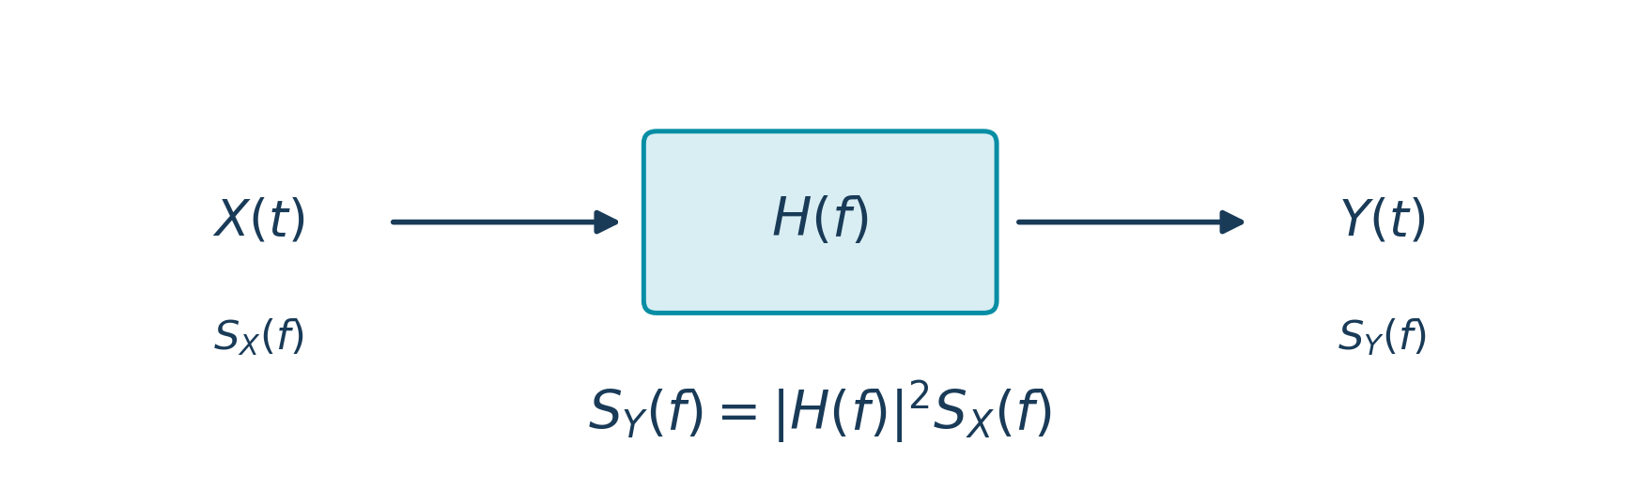
Input and output power spectra of an LTI filter.

Example: Cascaded filters

Question
A WSS process passes through two real filters: $X→H_{1}→V→H_{2}→Y$. Find the intermediate and final spectra and correlations.

Solution
The equivalent response is
$$H_{eq}\left(f\right)=H_{1}\left(f\right)H_{2}\left(f\right), h_{eq}=h_{1}*h_{2}.$$
Consequently,
$$S_{V}\left(f\right)={\left|H_{1}\left(f\right)\right|}^{2}S_{X}\left(f\right),$$
$$S_{Y}\left(f\right)={\left|H_{2}\left(f\right)\right|}^{2}S_{V}\left(f\right)={\left|H_{1}\left(f\right)H_{2}\left(f\right)\right|}^{2}S_{X}\left(f\right).$$
In the time domain,
$$R_{V}=R_{X}*h_{1}\left(τ\right)*h_{1}\left(−τ\right),$$
$$R_{Y}=R_{X}*h_{eq}\left(τ\right)*h_{eq}\left(−τ\right).$$
The intermediate process remains the output of the first filter; it is not a new independent input.

Example: A random-phase sinusoid through an RC filter

Question
Let $X\left(t\right)=Acos\left(2πf_{0}t+Θ\right)$, where $Θ$ is uniform on $[0,2π)$, and let
$$H\left(f\right)=\frac{1}{1+j2πRCf}.$$
Find the output autocorrelation and power.

Solution
The input has zero mean and
$$S_{X}\left(f\right)=\frac{A^{2}}{4}\left[δ\left(f−f_{0}\right)+δ\left(f+f_{0}\right)\right].$$
Evaluate the power gain at the two spectral lines:
$$S_{Y}\left(f\right)=\frac{A^{2}}{4\left[1+{\left(2πRCf_{0}\right)}^{2}\right]}\left[δ\left(f−f_{0}\right)+δ\left(f+f_{0}\right)\right].$$
Inverse transformation gives
$$R_{Y}\left(τ\right)=\frac{A^{2}}{2\left[1+{\left(2πRCf_{0}\right)}^{2}\right]}cos\left(2πf_{0}τ\right).$$
Thus
$$P_{Y}=R_{Y}\left(0\right)=\frac{A^{2}}{2\left[1+{\left(2πRCf_{0}\right)}^{2}\right]}.$$
The filter changes amplitude and phase, while the autocorrelation reflects the amplitude change.

Worked Problems

Independent Gaussian noise branches and an estimation-error network

Question
Independent Gaussian white-noise processes $W_{1}\left(t\right)$ and $W_{2}\left(t\right)$ satisfy
$$R_{W_{i}}\left(τ\right)=\frac{η}{2}δ\left(τ\right).$$
Identical real LTI filters $h\left(t\right)$ produce $N_{1}\left(t\right)$ and $N_{2}\left(t\right)$. Define
$$N=N_{1}−N_{2}, ε=N_{1}−h_{o}*N.$$
Find:
The density of $N$ and the joint density of $N_{1},N_{2}$ at a fixed time.
$P\left(N>−1\right)$.
A simplified expression for $ε$.

Solution
Branch statistics Assume $η>0$ and $0<E_{h}<∞$.
$$E_{h}=\int_{−∞}^{∞}{{\left|h\left(u\right)\right|}^{2}}du, σ_{b}^{2}=\frac{ηE_{h}}{2}, S_{N_{i}}\left(f\right)=\frac{η}{2}{\left|H\left(f\right)\right|}^{2}.$$
The branch outputs are independent, zero-mean Gaussian processes.
Densities and probability
$$N∼N\left(0,ηE_{h}\right).$$
$$\boxed{f_{N}\left(n\right)=\frac{e^{−n^{2}/\left(2ηE_{h}\right)}}{\sqrt{2πηE_{h}}}}$$
$$\boxed{f_{N_{1}N_{2}}\left(n_{1},n_{2}\right)=\frac{1}{2πσ_{b}^{2}}exp\left[−\frac{n_{1}^{2}+n_{2}^{2}}{2σ_{b}^{2}}\right]}$$
$$\boxed{P\left(N>−1\right)=1−Q\left(\frac{1}{\sqrt{ηE_{h}}}\right)}$$
A numerical probability requires $ηE_{h}$.
Error network
$$\boxed{ε=\left(δ−h_{o}\right)*N_{1}+h_{o}*N_{2}}$$
$$S_{ε}\left(f\right)=\frac{η}{2}{\left|H\left(f\right)\right|}^{2}\left({\left|1−H_{o}\left(f\right)\right|}^{2}+{\left|H_{o}\left(f\right)\right|}^{2}\right).$$
Without a specified $H_{o}$, this is the general result. For minimum mean-square estimation,
$$H_{o}=\frac{S_{N_{1}N}}{S_{N}}=\frac{1}{2}, h_{o}=1/2δ,$$
$$\boxed{ε=\frac{N_{1}+N_{2}}{2}, Var\left(ε\right)=\frac{ηE_{h}}{4}}$$
If $ηE_{h}=0$, the outputs vanish in mean square, the joint law is a point mass at the origin, and $P\left(N>−1\right)=1$.

Output autocorrelation of a rectangular LTI filter

Question
A WSS input has
$$R_{X}\left(τ\right)=\left\{\begin{matrix}1−\left|τ\right|, & \left|τ\right|≤1, \\ 0, & \text{otherwise}.\end{matrix}\right.$$
For $h\left(t\right)=u\left(t\right)−u\left(t−1\right)$, use convolution to find $R_{Y}\left(τ\right)$.

Solution
Correlation convolution
$$\begin{matrix}R_{Y} & =R_{X}*h*\tilde{h}, \tilde{h}\left(t\right)=h\left(−t\right), \\ h*\tilde{h} & =Λ, Λ\left(τ\right)=max\left(1−\left|τ\right|,0\right), \\ R_{Y} & =Λ*Λ.\end{matrix}$$
Overlap integral
$$R_{Y}\left(τ\right)=\int_{−1}^{1}{\left(1−\left|v\right|\right)}max\left(1−\left|τ−v\right|,0\right) dv.$$
Set $a=\left|τ\right|$ and split at the changes of sign inside the overlap:
$$\boxed{R_{Y}\left(τ\right)=\left\{\begin{matrix}\frac{2}{3}−a^{2}+\frac{1}{2}a^{3}, & 0≤a≤1, \\ \frac{1}{6}{\left(2−a\right)}^{3}, & 1<a≤2, \\ 0, & a>2,\end{matrix}\right. a=\left|τ\right|.}$$
$$\boxed{P_{Y}=R_{Y}\left(0\right)=\frac{2}{3}}$$
At $\left|τ\right|=1$, both branches equal $1/6$.

Autocorrelation and spectrum of a shifted difference

Question
A real WSS process $X\left(t\right)$ is transformed according to
$$Y\left(t\right)=X\left(t+a\right)−X\left(t−a\right).$$
Determine:
The autocorrelation $R_{Y}\left(τ\right)$ in terms of $R_{X}\left(τ\right)$.
The PSD $S_{Y}\left(f\right)$ in terms of $S_{X}\left(f\right)$.

Solution
Expand the autocorrelation
The output mean is zero. With $R_{X}\left(τ\right)=E\{X\left(t+τ\right)X\left(t\right)\}$,
$$\begin{matrix}R_{Y}\left(τ\right) & =E\{\left[X\left(t+τ+a\right)−X\left(t+τ−a\right)\right]\left[X\left(t+a\right)−X\left(t−a\right)\right]\} \\ & =2R_{X}\left(τ\right)−R_{X}\left(τ−2a\right)−R_{X}\left(τ+2a\right).\end{matrix}$$
Thus
$$\boxed{R_{Y}\left(τ\right)=2R_{X}\left(τ\right)−R_{X}\left(τ−2a\right)−R_{X}\left(τ+2a\right)}.$$
Find the transfer function
$$H\left(f\right)=e^{j2πfa}−e^{−j2πfa}=2jsin\left(2πfa\right).$$
Consequently,
$$\boxed{S_{Y}\left(f\right)=4\sin^{2}\left(2πfa\right)S_{X}\left(f\right)}.$$
Zero-lag check
Evenness of $R_{X}$ gives
$$\boxed{P_{Y}=R_{Y}\left(0\right)=2\left[R_{X}\left(0\right)−R_{X}\left(2a\right)\right]}.$$

White Noise, Filtered Noise, and Equivalent Bandwidth
Noise in a receiver comes partly from thermal agitation in its electronic components. Its exact waveform cannot be predicted, but its average power within the receiver’s bandwidth can be estimated. A flat spectrum is a useful approximation when the noise density changes little over the operating band. This makes it possible to calculate how much noise a filter admits without knowing a particular noise waveform.

The white-noise model
Zero-mean ideal white noise has a constant two-sided power spectral density:
$$S_{W}\left(f\right)=\frac{N_{0}}{2}, −∞<f<∞.$$
Its autocorrelation is the inverse Fourier transform:
$$\boxed{R_{W}\left(τ\right)=\frac{N_{0}}{2}δ\left(τ\right)}.$$
The model has no correlation at nonzero lag. Its total ideal power is infinite, so finite noise power is evaluated after bandwidth limitation rather than by assigning a finite variance to an ideal unfiltered point value. Whiteness specifies the spectrum: equal frequency intervals contain equal average noise power. Gaussianity describes the amplitude probability distribution and is useful when many small noise contributions combine. These are separate properties: Gaussian noise can be colored, and white noise need not be Gaussian.
When the density represents available thermal-noise power,
$$N_{0}=kT, S_{W}\left(f\right)=\frac{kT}{2} W/Hz,$$
where $k≈1.38×{10}^{−23} J/K$ and $T$ is absolute temperature in kelvin. The negative and positive frequencies each contribute half the available power. Real receiver bandwidths are finite, so the infinite-band idealization does not imply infinite measured noise power. An ideal low-pass bandwidth $B$ therefore admits $kTB$. This available-power convention does not by itself specify a resistor’s voltage-noise density.

Filtering the spectrum
For white noise passing through a filter,
$$S_{Y}\left(f\right)=\frac{N_{0}}{2}{\left|H\left(f\right)\right|}^{2},$$
$$P_{Y}=\frac{N_{0}}{2}\int_{−∞}^{∞}{{\left|H\left(f\right)\right|}^{2}} df.$$
The integral must be finite for finite output noise power. The filter shapes the flat input spectrum into colored noise: some frequency ranges now carry more noise power than others. Gaussian white input gives Gaussian output.

Example: Ideal low-pass filtering

Question
White Gaussian noise with PSD $N_{0}/2$ passes through a unity-gain ideal filter with passband $\left[−B,B\right]$, where $B>0$. Find its output PSD, autocorrelation, and power.

Solution
The output PSD is
$$S_{Y}\left(f\right)=\left\{\begin{matrix}N_{0}/2, & \left|f\right|≤B, \\ 0, & \left|f\right|>B.\end{matrix}\right.$$
Using $sinc\left(u\right)=sin\left(πu\right)/\left(πu\right)$, with $sinc\left(0\right)=1$,
$$\begin{matrix}R_{Y}\left(τ\right) & =\frac{N_{0}}{2}\int_{−B}^{B}{e^{j2πfτ}} df \\ & =N_{0}Bsinc\left(2Bτ\right).\end{matrix}$$
Therefore,
$$\boxed{P_{Y}=σ_{Y}^{2}=N_{0}B}.$$
Bandwidth limitation also spreads the correlation over time: nearby output samples can resemble one another because the filter averages contributions from overlapping input intervals. Its correlation zeros occur at $τ=m/\left(2B\right)$ for nonzero integers $m$. Distinct Gaussian samples on that grid are independent; at other separations, they are generally correlated.
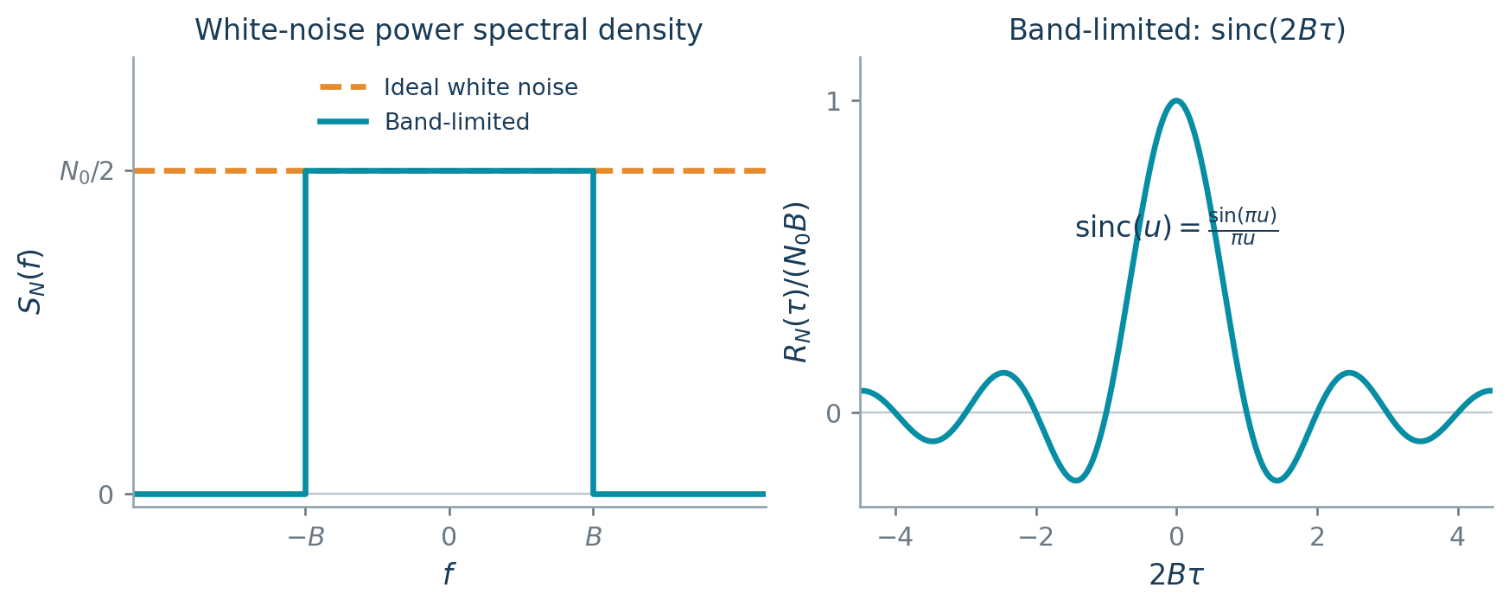
White-noise PSD and the finite-bandwidth output correlation.

Example: RC filtering

Question
White Gaussian noise passes through an RC low-pass filter. Find the output spectrum, power, and autocorrelation.

Solution
For $RC>0$,
$$H\left(f\right)=\frac{1}{1+j2πRCf}, f_{3dB}=\frac{1}{2πRC}.$$
Hence
$$S_{Y}\left(f\right)=\frac{N_{0}/2}{1+{\left(2πRCf\right)}^{2}}.$$
Substitute $u=2πRCf$ in the power integral:
$$\begin{matrix}P_{Y} & =N_{0}\int_{0}^{∞}{\frac{df}{1+{\left(2πRCf\right)}^{2}}} \\ & =\frac{N_{0}}{2πRC}\int_{0}^{∞}{\frac{du}{1+u^{2}}} \\ & =\frac{N_{0}}{4RC}=\frac{π}{2}N_{0}f_{3dB}.\end{matrix}$$
The corresponding correlation is
$$\boxed{R_{Y}\left(τ\right)=\frac{N_{0}}{4RC}e^{−\left|τ\right|/\left(RC\right)}}.$$
Its zero-lag value confirms the same power. Increasing $RC$ lowers the noise power and broadens the correlation in time.
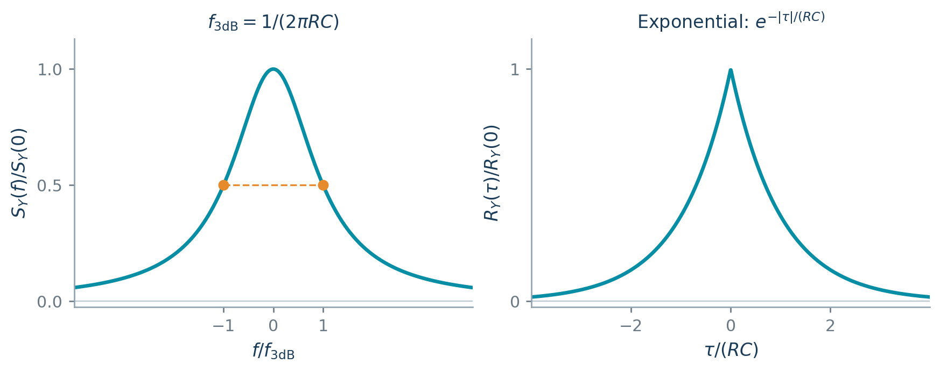
RC noise spectrum and exponential correlation.

Noise-equivalent bandwidth
Let $g=\max_{f}{\left|H\left(f\right)\right|}^{2}>0$ be the reference power gain of a real filter. Define its one-sided noise-equivalent bandwidth by
$$B_{N}=\frac{1}{g}\int_{0}^{∞}{{\left|H\left(f\right)\right|}^{2}} df=\frac{1}{2g}\int_{−∞}^{∞}{{\left|H\left(f\right)\right|}^{2}} df.$$
An ideal rectangle of height $g$ and positive-frequency width $B_{N}$ has the same area as the squared-gain curve. Therefore,
$$\boxed{P_{Y}=N_{0}gB_{N}}.$$
For the RC filter, $g=1$, giving
$$B_{N}=\int_{0}^{∞}{\frac{df}{1+{\left(2πRCf\right)}^{2}}}=\frac{1}{4RC}=\frac{π}{2}f_{3dB}.$$
The 3-dB frequency marks one point on the response; equivalent bandwidth measures its area. Filters with the same 3-dB frequency can therefore admit different noise powers. Equivalent bandwidth provides a direct comparison by replacing each actual response with an ideal rectangle that admits the same white-noise power.
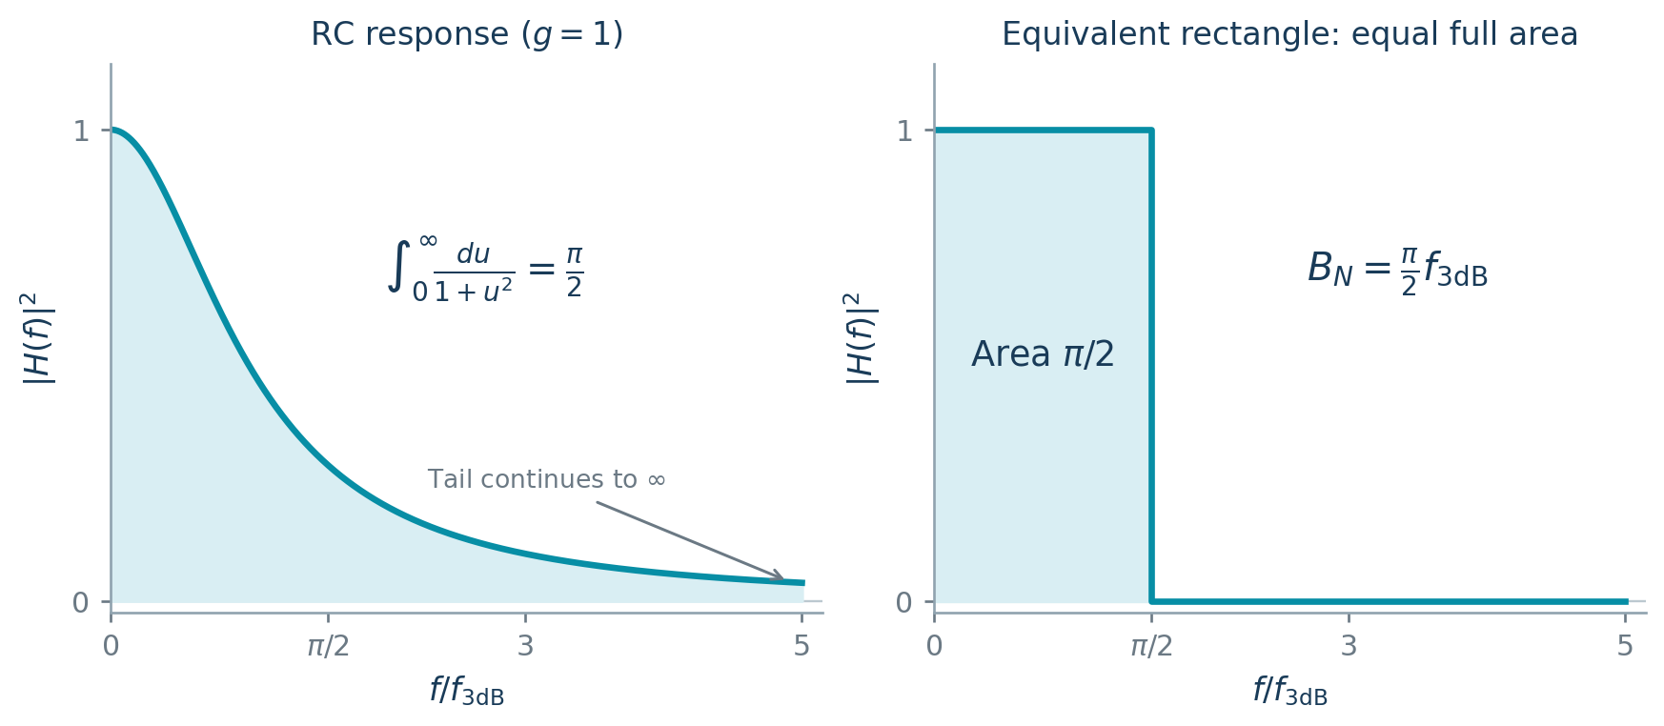
Equal positive-frequency areas define the equivalent bandwidth.

Worked Problems

White noise through a first-order low-pass filter

Question
Zero-mean white noise $N_{i}\left(t\right)$ has
$$R_{N_{i}}\left(τ\right)=\frac{N_{0}}{2}δ\left(τ\right).$$
It drives a filter with
$$H\left(ω\right)=\frac{1}{1+jω/ω_{0}}, ω_{0}>0, ω=2πf.$$
Determine:
The impulse response.
The output-noise autocorrelation.
Both orders of input–output cross-correlation.
The output noise power.

Solution
Impulse response
$$H\left(ω\right)=\frac{ω_{0}}{ω_{0}+jω} ⇒ \boxed{h\left(t\right)=ω_{0}e^{−ω_{0}t}u\left(t\right)}.$$
Output spectrum and autocorrelation
$$\begin{matrix}S_{N_{o}}\left(f\right) & =\frac{N_{0}}{2}{\left|H\left(f\right)\right|}^{2} \\ & =\frac{N_{0}ω_{0}^{2}}{2\left[ω_{0}^{2}+{\left(2πf\right)}^{2}\right]}.\end{matrix}$$
Using $e^{−a\left|τ\right|}↔2a/\left[a^{2}+{\left(2πf\right)}^{2}\right]$,
$$\boxed{R_{N_{o}}\left(τ\right)=\frac{N_{0}ω_{0}}{4}e^{−ω_{0}\left|τ\right|}}.$$
Input–output cross-correlations
With $R_{XY}\left(τ\right)=E\{X\left(t+τ\right)Y\left(t\right)\}$,
$$\begin{matrix}R_{N_{i}N_{o}}\left(τ\right) & =\int_{−∞}^{∞}{h}\left(v\right)R_{N_{i}}\left(τ+v\right) dv \\ & =\frac{N_{0}}{2}h\left(−τ\right).\end{matrix}$$
Therefore,
$$\boxed{R_{N_{i}N_{o}}\left(τ\right)=\frac{N_{0}ω_{0}}{2}e^{ω_{0}τ}u\left(−τ\right)},$$
$$\boxed{R_{N_{o}N_{i}}\left(τ\right)=\frac{N_{0}ω_{0}}{2}e^{−ω_{0}τ}u\left(τ\right)}.$$
Output noise power
The output mean is zero, so
$$\boxed{P_{N_{o}}=R_{N_{o}}\left(0\right)=\frac{N_{0}ω_{0}}{4}}.$$

Autocorrelation of ideal low-pass filtered white noise

Question
White noise has two-sided PSD $N_{0}/2$ and passes through
$$H\left(f\right)=\left\{\begin{matrix}1, & \left|f\right|≤B, \\ 0, & \text{otherwise},\end{matrix}\right. B>0.$$
Determine the output-noise autocorrelation.

Solution
Output spectrum
$$S_{N_{o}}\left(f\right)=\frac{N_{0}}{2}rect\left(\frac{f}{2B}\right).$$
Inverse Fourier transform
$$\begin{matrix}R_{N_{o}}\left(τ\right) & =\frac{N_{0}}{2}\int_{−B}^{B}{e^{j2πfτ}} df \\ & =\frac{N_{0}sin\left(2πBτ\right)}{2πτ}.\end{matrix}$$
With $sinc\left(x\right)=sin\left(πx\right)/\left(πx\right)$ and its continuous value at zero,
$$\boxed{R_{N_{o}}\left(τ\right)=N_{0}Bsinc\left(2Bτ\right)}.$$
Zero-lag check
$$\boxed{P_{N_{o}}=R_{N_{o}}\left(0\right)=N_{0}B}.$$
The first nonzero-lag zeros are $τ=±1/\left(2B\right)$.

Band-pass filtering of triangular-spectrum noise

Question
Zero-mean noise has the two-sided PSD
$$S_{N_{i}}\left(f\right)=\left\{\begin{matrix}{10}^{−8}\left(1−\frac{\left|f\right|}{{10}^{8}}\right), & \left|f\right|<{10}^{8} Hz, \\ 0, & \text{otherwise}.\end{matrix}\right.$$
A unity-gain ideal band-pass filter has a positive-frequency passband of width $2 MHz$ centered at $50 MHz$, and a mirrored negative-frequency passband.
Determine:
The output PSD.
The input and output noise powers.

Solution
Identify the passbands
The positive-frequency edges are $49 MHz$ and $51 MHz$. Therefore,
$$\boxed{S_{N_{o}}\left(f\right)=\left\{\begin{matrix}{10}^{−8}\left(1−\frac{\left|f\right|}{{10}^{8}}\right), & 49×{10}^{6}≤\left|f\right|≤51×{10}^{6}, \\ 0, & \text{otherwise}.\end{matrix}\right.}$$
Input power
$$P_{N_{i}}=2×{10}^{−8}\int_{0}^{{10}^{8}}{\left(1−\frac{f}{{10}^{8}}\right)}df=\boxed{1}.$$
Output power
$$\begin{matrix}P_{N_{o}} & =2×{10}^{−8}\int_{49×{10}^{6}}^{51×{10}^{6}}{\left(1−\frac{f}{{10}^{8}}\right)}df \\ & =2×{10}^{−8}{\left[f−\frac{f^{2}}{2×{10}^{8}}\right]}_{49×{10}^{6}}^{51×{10}^{6}} \\ & =\boxed{0.02}.\end{matrix}$$
Thus $\boxed{100P_{N_{o}}/P_{N_{i}}=2\%}$. If the PSD is in $W/Hz$, the powers are in watts.

Triangular-spectrum noise through a ramp-gain filter

Question
Zero-mean noise has the two-sided PSD
$$S_{N_{i}}\left(f\right)=\left\{\begin{matrix}{10}^{−8}\left(1−\frac{\left|f\right|}{{10}^{8}}\right), & \left|f\right|<{10}^{8} Hz, \\ 0, & \text{otherwise}.\end{matrix}\right.$$
The filter has
$${\left|H\left(f\right)\right|}^{2}=\left\{\begin{matrix}\left|f\right|−49×{10}^{6}, & 49×{10}^{6}≤\left|f\right|≤51×{10}^{6}, \\ 0, & \text{otherwise}.\end{matrix}\right.$$
Evaluate $f$ numerically in hertz and use the specified gain without normalization.
Determine:
The output PSD.
The output noise power.
The output-to-input power ratio.

Solution
Output spectrum
$$\boxed{S_{N_{o}}\left(f\right)=\left\{\begin{matrix}{10}^{−8}\left(1−\frac{\left|f\right|}{{10}^{8}}\right)\left(\left|f\right|−49×{10}^{6}\right), & 49×{10}^{6}≤\left|f\right|≤51×{10}^{6}, \\ 0, & \text{otherwise}.\end{matrix}\right.}$$
Integrate both passbands
Set $a=49×{10}^{6}$, $L=2×{10}^{6}$ and $u=f−a$. Then
$$\begin{matrix}P_{N_{o}} & =2×{10}^{−8}\int_{0}^{L}{\left(0.51−\frac{u}{{10}^{8}}\right)}u du \\ & =2×{10}^{−8}\left[\frac{0.51L^{2}}{2}−\frac{L^{3}}{3×{10}^{8}}\right] \\ & =\boxed{\frac{59600}{3}≈1.98667×{10}^{4}}.\end{matrix}$$
Power ratio
The input triangular spectrum has area $P_{N_{i}}=1$. Hence
$$\boxed{\frac{P_{N_{o}}}{P_{N_{i}}}=\frac{59600}{3}}, \boxed{100\frac{P_{N_{o}}}{P_{N_{i}}}≈1.98667×{10}^{6}\%}.$$
The specified maximum squared gain is $2×{10}^{6}$. Powers are in watts when the input PSD is in $W/Hz$.

Autocorrelation of ideal band-pass filtered white noise

Question
White noise with two-sided PSD $N_{0}/2$ passes through an ideal band-pass filter. Its magnitude is $K$ on each interval $\left|f−f_{c}\right|≤B$ and $\left|f+f_{c}\right|≤B$, and zero elsewhere, with $f_{c}>B>0$.
Determine the output-noise autocorrelation.

Solution
Output spectrum
Each passband has width $2B$:
$$S_{N_{o}}\left(f\right)=\frac{K^{2}N_{0}}{2}\left[rect\left(\frac{f−f_{c}}{2B}\right)+rect\left(\frac{f+f_{c}}{2B}\right)\right].$$
Inverse Fourier transform
Using the rectangular-spectrum transform and frequency translation,
$$\begin{matrix}R_{N_{o}}\left(τ\right) & =K^{2}N_{0}Bsinc\left(2Bτ\right)\left(e^{j2πf_{c}τ}+e^{−j2πf_{c}τ}\right) \\ & =2K^{2}N_{0}Bsinc\left(2Bτ\right)cos\left(2πf_{c}τ\right).\end{matrix}$$
Therefore,
$$\boxed{R_{N_{o}}\left(τ\right)=2K^{2}N_{0}Bsinc\left(2Bτ\right)cos\left(2πf_{c}τ\right)}.$$
Here $sinc\left(x\right)=sin\left(πx\right)/\left(πx\right)$, with $sinc\left(0\right)=1$.
Power check
$$\boxed{P_{N_{o}}=R_{N_{o}}\left(0\right)=2K^{2}N_{0}B}.$$

First-order filtering with a 10 rad/s cutoff

Question
White noise has $R_{X}\left(τ\right)=\left(N_{0}/2\right)δ\left(τ\right)$ and drives
$$H\left(ω\right)=\frac{1}{1+jω/10}, ω=2πf.$$
Determine:
The impulse response.
The output-noise autocorrelation.

Solution
Impulse response
$$H\left(ω\right)=\frac{10}{10+jω} ⇒ \boxed{h\left(t\right)=10e^{−10t}u\left(t\right)}.$$
Output spectrum
$$S_{Y}\left(f\right)=\frac{N_{0}}{2}{\left|H\left(f\right)\right|}^{2}=\frac{N_{0}}{2}\frac{100}{100+{\left(2πf\right)}^{2}}.$$
Output autocorrelation
Using $e^{−a\left|τ\right|}↔2a/\left[a^{2}+{\left(2πf\right)}^{2}\right]$ with $a=10$,
$$\boxed{R_{Y}\left(τ\right)=\frac{5N_{0}}{2}e^{−10\left|τ\right|}}.$$
The output power is $\boxed{P_{Y}=5N_{0}/2}$, and the cutoff frequency is $10/\left(2π\right) Hz$.

Finite-band powers after first-order noise filtering

Question
A zero-mean white Gaussian input has $S_{X}\left(f\right)=η/2$ and drives a filter with $h\left(t\right)=e^{−t}u\left(t\right)$.
Determine:
The output PSD, autocorrelation and mean-square value.
The input and output powers in the band $\left|f\right|≤B$, with positive low-pass edge $B={10}^{3} Hz$.
The percentage of total output power within that band and the output-to-input power percentage within the same band.

Solution
Frequency response and output PSD
$$\begin{matrix}H\left(f\right) & =\int_{0}^{∞}{e^{−t}}e^{−j2πft} dt=\frac{1}{1+j2πf}, \\ S_{Y}\left(f\right) & =\frac{η}{2}{\left|H\left(f\right)\right|}^{2}.\end{matrix}$$
Therefore,
$$\boxed{S_{Y}\left(f\right)=\frac{η}{2\left[1+{\left(2πf\right)}^{2}\right]}}.$$
Autocorrelation and mean square
The exponential Fourier pair gives
$$\boxed{R_{Y}\left(τ\right)=\frac{η}{4}e^{−\left|τ\right|}}, \boxed{E\{Y^{2}\left(t\right)\}=P_{Y,total}=\frac{η}{4}}.$$
Powers in the measurement band
$$\begin{matrix}P_{X,B} & =\int_{−B}^{B}{\frac{η}{2}} df=\boxed{ηB=1000η}, \\ P_{Y,B} & =\frac{η}{2}\int_{−B}^{B}{\frac{df}{1+{\left(2πf\right)}^{2}}}=\boxed{\frac{η}{2π}\tan^{−1}\left(2πB\right)}.\end{matrix}$$
Power percentages
At $B={10}^{3} Hz$,
$$\boxed{100\frac{P_{Y,B}}{P_{Y,total}}=100\frac{2}{π}\tan^{−1}\left(2πB\right)≈99.9899\%},$$
$$\boxed{100\frac{P_{Y,B}}{P_{X,B}}=100\frac{\tan^{−1}\left(2πB\right)}{2πB}≈0.0249975\%}.$$
The first ratio measures how much of the total filtered noise lies in the measurement band; the second compares output and input powers over that same band.

Narrowband Noise and Its Quadrature Components
A radio receiver selects a narrow band around the carrier, so the noise reaching its detector is also concentrated in that band. Its waveform oscillates rapidly at approximately the carrier frequency while its amplitude and phase vary more slowly. Describing those slow variations makes the noise easier to analyze than following every carrier cycle. The quadrature representation also connects directly to the two carrier references used by an I/Q receiver.

A time-domain approximation
A real zero-mean stationary Gaussian narrowband process has mirrored spectral lobes near $±f_{c}$, with bandwidth small compared with $f_{c}$. Consider first a rectangular spectral pair of height $S_{0}$, each lobe having full width $Δf$ and center $±f_{c}$. Then
$$R_{Y}\left(τ\right)=2S_{0}Δf sinc\left(Δfτ\right)cos\left(2πf_{c}τ\right).$$
For $\left|τ\right|≪1/Δf$,
$$R_{Y}\left(τ\right)≈2S_{0}Δfcos\left(2πf_{c}τ\right).$$
This correlation is reproduced by
$$\tilde{Y}\left(t\right)=Acos\left(2πf_{c}t\right)+Bsin\left(2πf_{c}t\right),$$
where $A,B$ are independent zero-mean Gaussian variables with
$$E\{A^{2}\}=E\{B^{2}\}=2S_{0}Δf.$$
A general narrowband spectrum can be divided into thin spectral pairs. With pair centers $±f_{m}$ and width $Δf$,
Yt≈m​Amcos2πfmt+Bmsin2πfmt,
$$E\{A_{m}^{2}\}=E\{B_{m}^{2}\}=2S_{Y}\left(f_{m}\right)Δf.$$
Coefficients from different pairs are uncorrelated and jointly Gaussian. The resulting mean square is the spectral-area approximation
E{Y2t}≈m​2SYfmΔf.

In-phase and quadrature representation
The same noise can be written using slowly varying baseband components:
$$\boxed{Y\left(t\right)=Y_{c}\left(t\right)cos\left(2πf_{c}t\right)−Y_{s}\left(t\right)sin\left(2πf_{c}t\right)}.$$
$Y_{c}$ is the in-phase component and $Y_{s}$ the quadrature component. They are the noise coordinates along cosine and sine carrier references, separating the fast carrier oscillation from the slower noise variations. For zero-mean stationary Gaussian bandpass noise, they are zero-mean, low-pass, jointly stationary Gaussian processes.
Translate the positive lobe left by $f_{c}$ and the negative lobe right by $f_{c}$, then add:
$$S_{Y_{c}}\left(f\right)=S_{Y_{s}}\left(f\right)=S_{Y}\left(f+f_{c}\right)+S_{Y}\left(f−f_{c}\right),$$
within the retained baseband support. With
$$R_{Y_{c}Y_{s}}\left(τ\right)=E\{Y_{c}\left(t+τ\right)Y_{s}\left(t\right)\},$$
the cross spectra are
$$S_{Y_{c}Y_{s}}\left(f\right)=j\left[S_{Y}\left(f+f_{c}\right)−S_{Y}\left(f−f_{c}\right)\right],$$
$$S_{Y_{s}Y_{c}}\left(f\right)=S_{Y_{c}Y_{s}}^{*}\left(f\right).$$
Their imaginary, odd shape gives $R_{Y_{c}Y_{s}}\left(0\right)=0$. The component powers satisfy
$$\boxed{P_{Y_{c}}=P_{Y_{s}}=P_{Y}=\int_{−∞}^{∞}{S_{Y}}\left(f\right) df}.$$
For real components,
$$R_{Y}\left(τ\right)=R_{Y_{c}}\left(τ\right)cos\left(2πf_{c}τ\right)+R_{Y_{c}Y_{s}}\left(τ\right)sin\left(2πf_{c}τ\right).$$
Symmetry about the carrier means that equal offsets above and below it carry matching noise densities. If the lobes are symmetric about the chosen carrier, the cross spectrum vanishes at every frequency. The components are then independent Gaussian processes, and $R_{Y}=R_{Y_{c}}cos\left(2πf_{c}τ\right)$. Without that symmetry, the same-time pair remains independent, but different-time component values can be correlated.

Example: Symmetric bandpass white noise

Question
White Gaussian noise of PSD $N_{0}/2$ passes through a unity-gain filter with positive passband $\left[f_{c}−B,f_{c}+B\right]$ and its negative-frequency mirror, where $0<B≪f_{c}$. Find the noise and component spectra, correlations, and powers.

Solution
Each lobe has full width $2B$, so
$$P_{Y}=2\left(2B\frac{N_{0}}{2}\right)=2N_{0}B.$$
The translated lobes coincide at baseband:
$$S_{Y_{c}}\left(f\right)=S_{Y_{s}}\left(f\right)=\left\{\begin{matrix}N_{0}, & \left|f\right|≤B, \\ 0, & \left|f\right|>B.\end{matrix}\right.$$
Thus
$$R_{Y_{c}}\left(τ\right)=R_{Y_{s}}\left(τ\right)=2N_{0}Bsinc\left(2Bτ\right),$$
$$R_{Y}\left(τ\right)=2N_{0}Bsinc\left(2Bτ\right)cos\left(2πf_{c}τ\right),$$
$$P_{Y_{c}}=P_{Y_{s}}=P_{Y}=2N_{0}B.$$
Each component has the same power as the bandpass process. Sinusoidal reconstruction contributes a factor one-half to each component’s power.

Example: An asymmetric triangular spectrum

Question
A zero-mean Gaussian process has a positive triangular lobe with vertices $\left(4,0\right),\left(5,1\right),\left(7,0\right)$, with frequency in hertz, and a reflected negative lobe. Find the component spectra at reference carrier $f_{c}=5$ Hz and the same-time joint density.

Solution
The total spectral area is
$$P_{Y}=2\left[\frac{1}{2}\left(7−4\right)\right]=3.$$
Adding the two translated shapes gives
$$S_{Y_{c}}\left(f\right)=S_{Y_{s}}\left(f\right)=\left\{\begin{matrix}2−\frac{3}{2}\left|f\right|, & \left|f\right|≤1, \\ 1−\frac{1}{2}\left|f\right|, & 1<\left|f\right|≤2, \\ 0, & \left|f\right|>2.\end{matrix}\right.$$
The peak is two, and each component spectrum has area three. At a common time, the Gaussian pair has zero covariance and variances three:
$$f_{Y_{c},Y_{s}}\left(u,v\right)=\frac{1}{6π}exp​\left[−\frac{u^{2}+v^{2}}{6}\right].$$
The spectrum’s asymmetry affects unequal-time cross-correlation, while the same-time pair is independent.
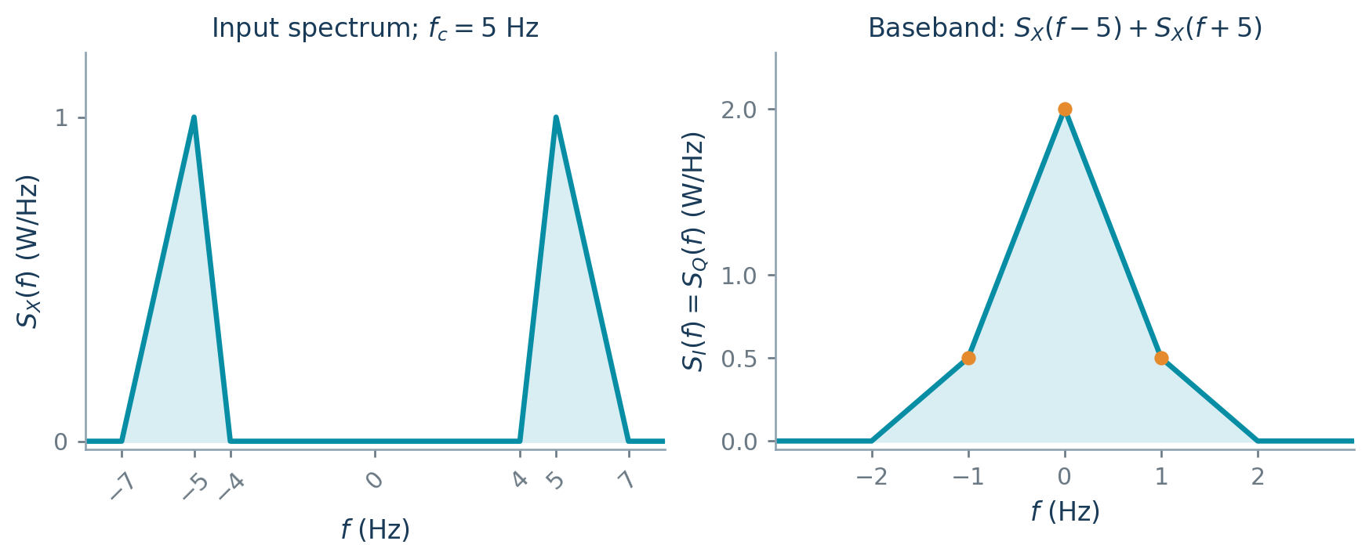
A bandpass triangle and its shifted-and-added component spectrum.

Envelope and phase
The envelope measures the instantaneous strength of the narrowband noise, and the phase locates its oscillation relative to the carrier reference. When this noise is added to a received signal, its quadrature components perturb the signal’s amplitude and phase, affecting the detector output.
Define
$$R\left(t\right)=\sqrt{Y_{c}^{2}\left(t\right)+Y_{s}^{2}\left(t\right)}, Θ\left(t\right)=atan2\left(Y_{s}\left(t\right),Y_{c}\left(t\right)\right).$$
Then
$$Y\left(t\right)=R\left(t\right)cos\left[2πf_{c}t+Θ\left(t\right)\right].$$
At a fixed time, write $σ^{2}=P_{Y}>0$. The independent Gaussian components have joint density
$$f_{Y_{c},Y_{s}}\left(u,v\right)=\frac{1}{2πσ^{2}}exp​\left[−\frac{u^{2}+v^{2}}{2σ^{2}}\right].$$
Substitute $u=rcosθ$, $v=rsinθ$ with Jacobian magnitude $r$:
$$f_{R,Θ}\left(r,θ\right)=\frac{r}{2πσ^{2}}e^{−r^{2}/\left(2σ^{2}\right)}, r≥0, −π<θ≤π.$$
It factors into the Rayleigh envelope density and uniform phase density:
$$f_{R}\left(r\right)=\frac{r}{σ^{2}}e^{−r^{2}/\left(2σ^{2}\right)}, r≥0, f_{Θ}\left(θ\right)=\frac{1}{2π}.$$
The envelope and phase are independent at a fixed time. Their useful envelope moments are
$$E\{R\}=σ\sqrt{\frac{π}{2}}, E\{R^{2}\}=2σ^{2}, Var\left(R\right)=\left(2−\frac{π}{2}\right)σ^{2}.$$

Worked Problems

Envelope and phase of a carrier plus narrowband noise

Question
A carrier $x\left(t\right)=Acos\left(2πf_{c}t\right)$ is added to narrowband noise
$$n\left(t\right)=n_{c}\left(t\right)cos\left(2πf_{c}t\right)−n_{s}\left(t\right)sin\left(2πf_{c}t\right).$$
Express $y\left(t\right)=x\left(t\right)+n\left(t\right)$ in the form
$$y\left(t\right)=ρ\left(t\right)cos\left[2πf_{c}t+θ\left(t\right)\right].$$

Solution
Combine the quadrature components
$$y\left(t\right)=\left[A+n_{c}\left(t\right)\right]cos\left(2πf_{c}t\right)−n_{s}\left(t\right)sin\left(2πf_{c}t\right).$$
Match the envelope–phase coefficients
Expanding $ρ\left(t\right)cos\left[2πf_{c}t+θ\left(t\right)\right]$ gives
$$\begin{matrix}ρ\left(t\right)cosθ\left(t\right) & =A+n_{c}\left(t\right), \\ ρ\left(t\right)sinθ\left(t\right) & =n_{s}\left(t\right).\end{matrix}$$
Hence
$$\boxed{ρ\left(t\right)=\sqrt{{\left[A+n_{c}\left(t\right)\right]}^{2}+n_{s}^{2}\left(t\right)}},$$
$$\boxed{θ\left(t\right)=atan2\left(n_{s}\left(t\right),A+n_{c}\left(t\right)\right)}.$$
The two-argument arctangent selects the correct quadrant. When $ρ\left(t\right)=0$, phase may be assigned arbitrarily.

I/Q spectra of asymmetric triangular-band noise

Question
The PSD $S_{n}\left(f\right)$ has a positive-frequency triangular lobe supported on $4≤f≤7 Hz$, with height 1 at $f=5 Hz$. It rises linearly from zero at 4 Hz and falls linearly to zero at 7 Hz. The negative-frequency lobe is its mirror.
Use $f_{c}=5 Hz$ and
$$n\left(t\right)=n_{c}\left(t\right)cos\left(2πf_{c}t\right)−n_{s}\left(t\right)sin\left(2πf_{c}t\right).$$
Determine:
The in-phase and quadrature PSDs.
Both cross-spectral densities, using $R_{XY}\left(τ\right)=E\{X\left(t+τ\right)Y\left(t\right)\}$.

Solution
Express the band-pass spectrum
$$T\left(f\right)=\left\{\begin{matrix}f−4, & 4≤f≤5, \\ \frac{7−f}{2}, & 5≤f≤7, \\ 0, & \text{otherwise},\end{matrix}\right. S_{n}\left(f\right)=T\left(f\right)+T\left(−f\right).$$
Translate and add the lobes
$$S_{n_{c}}\left(f\right)=S_{n_{s}}\left(f\right)=S_{n}\left(f+5\right)+S_{n}\left(f−5\right).$$
For $r=\left|f\right|$, with $f$ in hertz,
$$\boxed{S_{n_{c}}\left(f\right)=S_{n_{s}}\left(f\right)=\left\{\begin{matrix}2−\frac{3}{2}r, & 0≤r≤1, \\ 1−\frac{1}{2}r, & 1<r≤2, \\ 0, & r>2.\end{matrix}\right.}$$
Cross spectra
$$\begin{matrix}S_{n_{c}n_{s}}\left(f\right) & =j\left[S_{n}\left(f+5\right)−S_{n}\left(f−5\right)\right], \\ S_{n_{s}n_{c}}\left(f\right) & =S_{n_{c}n_{s}}^{*}\left(f\right).\end{matrix}$$
Define
$$q\left(r\right)=\left\{\begin{matrix}\frac{r}{2}, & 0≤r≤1, \\ 1−\frac{r}{2}, & 1<r≤2, \\ 0, & r>2.\end{matrix}\right.$$
The explicit answers are
$$\boxed{S_{n_{c}n_{s}}\left(f\right)=jsgn\left(f\right)q\left(\left|f\right|\right)}, \boxed{S_{n_{s}n_{c}}\left(f\right)=−jsgn\left(f\right)q\left(\left|f\right|\right)}.$$
Power and covariance checks
$$\begin{matrix}P_{n_{c}}=P_{n_{s}} & =2\left[\int_{0}^{1}{\left(2−\frac{3}{2}r\right)}dr+\int_{1}^{2}{\left(1−\frac{1}{2}r\right)}dr\right] \\ & =\boxed{3}.\end{matrix}$$
The imaginary odd cross spectrum integrates to zero, so $C_{n_{c}n_{s}}\left(0\right)=0$. It is not identically zero, so unequal-time cross-correlation can remain.

I/Q spectra with three carrier choices

Question
Zero-mean white noise has two-sided PSD $N_{0}/2$ and passes through a filter with
$${\left|H\left(f\right)\right|}^{2}=\left\{\begin{matrix}\frac{1}{2}, & 10≤\left|f\right|/{10}^{3}<12, \\ 1, & 12≤\left|f\right|/{10}^{3}≤14, \\ 0, & \text{otherwise},\end{matrix}\right.$$
where $f$ is in hertz.
Determine:
The output PSD and total noise power.
The I/Q PSDs and both cross spectra for $f_{c}=10,12,14 kHz$.
Use $n=n_{c}cos\left(2πf_{c}t\right)−n_{s}sin\left(2πf_{c}t\right)$ and $R_{XY}\left(τ\right)=E\{X\left(t+τ\right)Y\left(t\right)\}$.

Solution
Output PSD and power
$$\boxed{S_{n}\left(f\right)=\left\{\begin{matrix}\frac{N_{0}}{4}, & 10≤\left|f\right|/{10}^{3}<12, \\ \frac{N_{0}}{2}, & 12≤\left|f\right|/{10}^{3}≤14, \\ 0, & \text{otherwise}.\end{matrix}\right.}$$
Both lobes contribute, with each subband width equal to $2000 Hz$:
$$\boxed{P_{n}=2\left[\frac{N_{0}}{4}\left(2000\right)+\frac{N_{0}}{2}\left(2000\right)\right]=3000N_{0}}.$$
Shifted-spectrum formulas
Let $S_{I}\left(f\right)=S_{n_{c}}\left(f\right)=S_{n_{s}}\left(f\right)$ and $r=\left|f\right|/{10}^{3}$. Then
$$\begin{matrix}S_{I}\left(f\right) & =S_{n}\left(f+f_{c}\right)+S_{n}\left(f−f_{c}\right), \\ S_{n_{c}n_{s}}\left(f\right) & =j\left[S_{n}\left(f+f_{c}\right)−S_{n}\left(f−f_{c}\right)\right], \\ S_{n_{s}n_{c}}\left(f\right) & =S_{n_{c}n_{s}}^{*}\left(f\right).\end{matrix}$$
Carrier $f_{c}=10 kHz$
$$\boxed{S_{I}\left(f\right)=\left\{\begin{matrix}\frac{N_{0}}{4}, & 0<r<2, \\ \frac{N_{0}}{2}, & 2<r<4, \\ 0, & r>4,\end{matrix}\right.}$$
$$\boxed{S_{n_{c}n_{s}}\left(f\right)=jsgn\left(f\right)S_{I}\left(f\right)}.$$
Carrier $f_{c}=12 kHz$
$$\boxed{S_{I}\left(f\right)=\left\{\begin{matrix}\frac{3N_{0}}{4}, & r<2, \\ 0, & r>2,\end{matrix}\right.}$$
$$\boxed{S_{n_{c}n_{s}}\left(f\right)=\left\{\begin{matrix}jsgn\left(f\right)\frac{N_{0}}{4}, & 0<r<2, \\ 0, & r>2.\end{matrix}\right.}$$
Carrier $f_{c}=14 kHz$
$$\boxed{S_{I}\left(f\right)=\left\{\begin{matrix}\frac{N_{0}}{2}, & 0<r<2, \\ \frac{N_{0}}{4}, & 2<r<4, \\ 0, & r>4,\end{matrix}\right.}$$
$$\boxed{S_{n_{c}n_{s}}\left(f\right)=−jsgn\left(f\right)S_{I}\left(f\right)}.$$
For every carrier, $S_{n_{s}n_{c}}=S_{n_{c}n_{s}}^{*}$ and each component power is $3000N_{0}$. Values at isolated spectral breakpoints do not affect these powers.
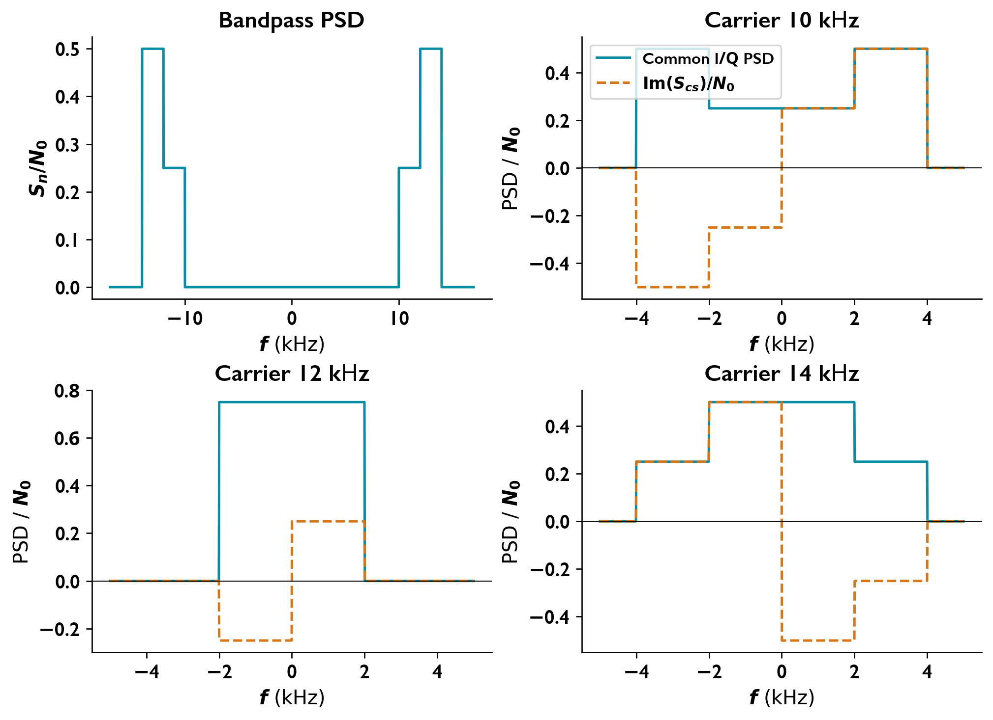
Frequency axes are in kHz. The dashed orange curve is the imaginary cross spectrum under the stated first-variable lag convention.

Modulation and noise
A radio transmitter uses modulation to let a high-frequency carrier carry a lower-frequency message, such as speech. The receiver selects the carrier band and then recovers the message.
Sinusoidal power and AM sidebands For a unit resistance, a sinusoid of amplitude $A$ has power $A^{2}/2$.
$$\begin{matrix}s_{AM}\left(t\right) & =A_{c}\left[1+μcos\left(2πf_{m}t\right)\right]cos\left(2πf_{c}t\right), \\ s_{AM}\left(t\right) & =A_{c}cos\left(2πf_{c}t\right)+\frac{A_{c}μ}{2}cos\left[2π\left(f_{c}+f_{m}\right)t\right]+\frac{A_{c}μ}{2}cos\left[2π\left(f_{c}−f_{m}\right)t\right], \\ P_{AM} & =\frac{A_{c}^{2}}{2}\left(1+\frac{μ^{2}}{2}\right).\end{matrix}$$
The two sidebands place the message tone on either side of the carrier. After filtering, multiply each sinusoidal amplitude by its filter gain before calculating power. For DSB-SC,
$$s\left(t\right)=A_{c}m\left(t\right)cos\left(2πf_{c}t\right), P_{s}=\frac{A_{c}^{2}P_{m}}{2}.$$
Filtered and coherently translated noise A receiver filter admits both the desired signal and noise within its passband, so increasing the admitted bandwidth can increase noise power. Let $N_{0}/2$ be the two-sided white-noise PSD.
$$S_{n}\left(f\right)=\frac{N_{0}}{2}{\left|H\left(f\right)\right|}^{2}, P_{n}=\int_{−∞}^{∞}{S_{n}}\left(f\right)df.$$
For multiplication by $A_{L}cos\left(2πf_{c}t\right)$ followed by a lowpass filter, let $κ=A_{L}/2$. For separated passbands,
$$S_{n,o}\left(f\right)=κ^{2}\left[S_{n}\left(f−f_{c}\right)+S_{n}\left(f+f_{c}\right)\right]$$
within the output passband. Ideal DSB-SC reception gives $m_{o}\left(t\right)=κA_{c}m\left(t\right)$. For AM, remove carrier-generated DC when finding message SNR.
$$SNR=\frac{P_{s}}{P_{n}}, {SNR}_{dB}=10\log_{10}\left(SNR\right).$$
SNR compares useful signal power with the noise power that competes with it at the same point in the receiver.
FM bandwidth, power, and threshold Increasing the frequency deviation can improve the recovered message SNR above threshold, but it also requires a wider transmission band. Assume a unit-peak message, ideal above-threshold reception, and no pre-emphasis or de-emphasis.
$$β=\frac{Δf}{W}, B_{T}≃2\left(β+1\right)W,$$
$${SNR}_{o}=\frac{3β^{2}P_{m}P_{r}}{N_{0}W}, P_{r}=P_{T}{10}^{−L/10}.$$
Here $W$ is the message bandwidth, $P_{m}$ its mean-square value, and $L$ the channel power loss in decibels. If the threshold ratio is ten,
$$P_{n,BP}=N_{0}B_{T}, \frac{P_{r}}{N_{0}B_{T}}≥10.$$

Worked Problems

AM signal and noise through a nonuniform bandpass filter

Question
A carrier with $A_{c}=10 mV$ and $f_{c}=90 kHz$ is 50% amplitude modulated by a $750 Hz$ sinusoid. The two-sided noise PSD is $η/2={10}^{−3} W/Hz$.
The filter magnitude is even; on the positive-frequency lobe,
$$\left|H\left(f\right)\right|=\left\{\begin{matrix}1, & 89.5≤f≤90.5 kHz, \\ 0.5, & 89≤f<89.5 kHz \text{or} 90.5<f≤91 kHz, \\ 0, & \text{otherwise}.\end{matrix}\right.$$
The output is multiplied by $2cos\left(2πf_{c}t\right)$ and passed through an ideal LPF with bandwidth $1 kHz$.
Find the demodulator input SNR and the recovered-message output SNR.

Solution
Assume coherent phase at the carrier and sidebands, and a unit resistance.
Input signal and noise With $μ=0.5$, each sideband initially has amplitude $A_{c}μ/2$. The carrier gain is one; the sideband gains are $1/2$.
$$\begin{matrix}P_{s,i} & =\frac{A_{c}^{2}}{2}+2\frac{1}{2}{\left(\frac{A_{c}μ}{4}\right)}^{2}=5.15625×{10}^{−5} W, \\ ∫{\left|H\left(f\right)\right|}^{2}df & =2\left[1000+2\left(500\right){\left(0.5\right)}^{2}\right]=2500 Hz, \\ P_{n,i} & ={10}^{−3}\left(2500\right)=2.5 W.\end{matrix}$$
$$\boxed{{SNR}_{i}=2.0625×{10}^{−5}≈−46.86 dB}$$
Recovered message
$$s_{o}\left(t\right)=A_{c}+\frac{A_{c}μ}{2}cos\left(2πf_{m}t\right), P_{m,o}=\frac{1}{2}{\left(\frac{A_{c}μ}{2}\right)}^{2}=3.125×{10}^{−6} W.$$
Exclude the carrier-generated DC term from message power.
Output noise
$$S_{n,o}\left(f\right)=\frac{η}{2}\left[{\left|H\left(f−f_{c}\right)\right|}^{2}+{\left|H\left(f+f_{c}\right)\right|}^{2}\right].$$
$$S_{n,o}\left(f\right)=\left\{\begin{matrix}2×{10}^{−3}, & \left|f\right|≤500, \\ 0.5×{10}^{−3}, & 500<\left|f\right|≤1000, \\ 0, & \text{otherwise}.\end{matrix}\right.$$
$$P_{n,o}=\left(2×{10}^{−3}\right)\left(1000\right)+\left(0.5×{10}^{−3}\right)\left(1000\right)=2.5 W.$$
$$\boxed{{SNR}_{o}=1.25×{10}^{−6}≈−59.03 dB}$$
If DC is included, $\left(A_{c}^{2}+P_{m,o}\right)/P_{n,o}=4.125×{10}^{−5}$.

FM power, Carson bandwidth, and threshold limitation

Question
An audio signal has $W=15 kHz$, average power $P_{m}=1/6$, and peak magnitude one. FM transmission experiences 60 dB power loss and two-sided AWGN PSD $η/2={10}^{−12} W/Hz$. The required output SNR is at least 40 dB.
Find the bandwidth and transmitter power for deviation ratio $β=5$.
Find the maximum deviation ratio and bandwidth when the carrier power must be at least ten times the channel noise power.

Solution
Assume ideal above-threshold FM without pre-emphasis or de-emphasis. Let $N_{0}=η=2×{10}^{−12}$.
Bandwidth and power
$$\boxed{B_{T}≃2\left(β+1\right)W=180 kHz}$$
$$\begin{matrix}{SNR}_{o} & =\frac{3β^{2}P_{m}P_{r}}{N_{0}W}={10}^{4}, \\ P_{r} & =\frac{{10}^{4}\left(2×{10}^{−12}\right)\left(15000\right)}{3\left(25\right)\left(1/6\right)}=2.4×{10}^{−5} W, \\ P_{T} & ={10}^{6}P_{r}.\end{matrix}$$
$$\boxed{P_{T}=24 W}$$
Here $N_{0}B_{T}=3.6×{10}^{−7} W$ and $P_{r}/\left(N_{0}B_{T}\right)=66.67>10$.
Threshold at fixed transmitter power Keep $P_{T}=24 W$.
$$\begin{matrix}\frac{P_{r}}{N_{0}B_{T}} & ≥10, \\ B_{T} & ≤\frac{P_{r}}{10N_{0}}=1.2×{10}^{6} Hz, \\ β & ≤\frac{1.2×{10}^{6}}{2\left(15000\right)}−1.\end{matrix}$$
$$\boxed{β_{max}=39, B_{T,max}=1.2 MHz}$$
These are boundary values; strictly remaining above threshold requires a smaller bandwidth.
Power retuned for each deviation ratio If power is instead minimized anew at each $β$ while maintaining 40 dB output SNR,
$$P_{r}=\frac{6×{10}^{−4}}{β^{2}}, P_{r}≥6×{10}^{−7}\left(β+1\right).$$
$$β^{2}\left(β+1\right)≤1000.$$
$$\boxed{β_{max}=9.67753, B_{T}=320.326 kHz}$$

Minimum FM transmitter power under a channel bandwidth limit

Question
A normalized message has bandwidth $W=5 kHz$ and power $P_{m}=0.5$. The channel has bandwidth $60 kHz$, 40 dB power attenuation, and two-sided noise PSD ${10}^{−9} W/Hz$.
For FM without pre-emphasis or de-emphasis, find the minimum transmitter power and deviation ratio needed for at least 40 dB output SNR.

Solution
Assume unit peak message magnitude and ideal above-threshold FM.
Maximum deviation
$$2\left(β+1\right)\left(5000\right)≤60000 ⇒ β≤5.$$
Since required power is proportional to $1/β^{2}$,
$$\boxed{β=5, Δf=25 kHz}$$
Minimum power The two-sided density gives $N_{0}=2×{10}^{−9}$.
$$\begin{matrix}{SNR}_{o} & =\frac{3β^{2}P_{m}P_{r}}{N_{0}W}={10}^{4}, \\ P_{r,min} & =\frac{{10}^{4}\left(2×{10}^{−9}\right)\left(5000\right)}{3\left(25\right)\left(0.5\right)}=2.66667×{10}^{−3} W, \\ P_{T,min} & ={10}^{4}P_{r,min}.\end{matrix}$$
$$\boxed{P_{T,min}=26.667 W}$$
The predetection ratio is
$$\frac{P_{r}}{N_{0}B_{T}}=\frac{2.66667×{10}^{−3}}{\left(2×{10}^{−9}\right)\left(60000\right)}=22.22,$$
above a ten-to-one threshold criterion.

DSB-SC filtering and coherent-detection SNR

Question
The transmitted signal is
$$s\left(t\right)=10\left[3cos\left(2π{10}^{2}t\right)+2cos\left(2π{10}^{4}t\right)\right]cos\left(π{10}^{8}t\right).$$
White noise has two-sided PSD $N_{0}/2=2×{10}^{−6} W/Hz$. A unity-gain ideal band-pass filter is centered at the carrier and has full positive-frequency passband width $10 kHz$, with the mirrored negative-frequency passband.
Determine:
The modulation type.
The SNR at the band-pass filter output.
The in-phase noise PSD and average power.
The SNR after coherent detection with multiplier $2cos\left(2πf_{c}t\right)$ and low-pass edge $5 kHz$.
Use a unit-resistance power normalization.

Solution
Carrier frequency and passed signal
The modulation is double-sideband suppressed carrier, with
$$f_{c}=\frac{{10}^{8}}{2}=5×{10}^{7} Hz.$$
The positive passband edges are $f_{c}±B$, with $B=5000 Hz$. The 100 Hz tone passes; the 10 kHz tone is rejected. Therefore,
$$s_{o}\left(t\right)=30cos\left(2π100t\right)cos\left(2πf_{c}t\right).$$
Its mean-square power is
$$\boxed{P_{s}={30}^{2}\left(\frac{1}{2}\right)\left(\frac{1}{2}\right)=225 W}.$$
Band-pass noise and SNR
The combined width of both passbands is $4B$:
$$\boxed{P_{n}=\frac{N_{0}}{2}\left(4B\right)=0.04 W}.$$
Hence
$$\boxed{{SNR}_{BPF}=\frac{225}{0.04}=5625≈37.50 dB}.$$
In-phase noise
For $n=n_{c}cos\left(2πf_{c}t\right)−n_{s}sin\left(2πf_{c}t\right)$,
$$\boxed{S_{n_{c}}\left(f\right)=\left\{\begin{matrix}4×{10}^{−6} W/Hz, & \left|f\right|≤5000 Hz, \\ 0, & \text{otherwise}.\end{matrix}\right.}$$
$$\boxed{P_{n_{c}}=\int_{−5000}^{5000}{4}×{10}^{−6} df=0.04 W}.$$
Coherent detector output
Mixing by $2cos\left(2πf_{c}t\right)$ and retaining $\left|f\right|≤5000 Hz$ gives
$$y_{d}\left(t\right)=30cos\left(2π100t\right)+n_{c}\left(t\right).$$
Thus
$$P_{s,d}=\frac{{30}^{2}}{2}=450 W, P_{n,d}=0.04 W,$$
$$\boxed{{SNR}_{d}=\frac{450}{0.04}=11250≈40.51 dB}.$$
For a narrower detector edge $B_{d}$, with $100≤B_{d}≤5000 Hz$, the signal power remains 450 W and the noise power becomes $2N_{0}B_{d}$.
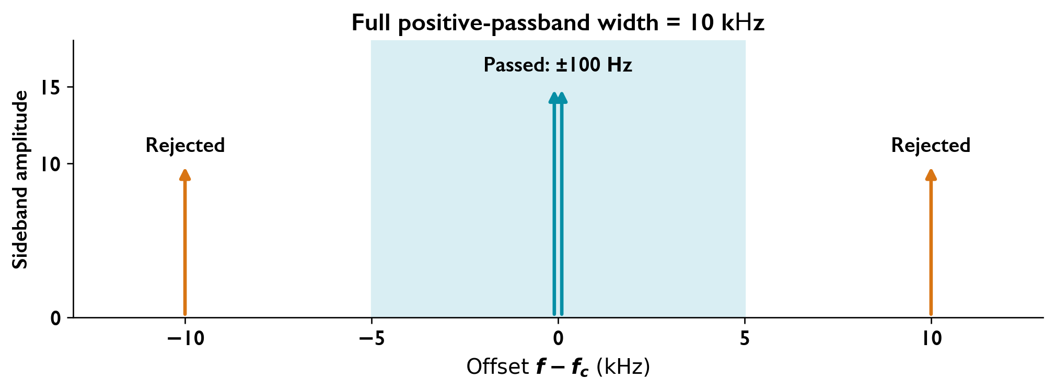
Positive-frequency sidebands relative to the carrier. The reflected negative-frequency band also contributes noise power.

Sampling, quantization, and prediction
A digital receiver first measures an analogue voltage waveform at regularly spaced instants. These measurements form a sequence that can be stored, transmitted, or processed digitally.
Samples and correlation
$$X\left[n\right]=X\left(nT_{s}\right), T_{s}=\frac{1}{f_{s}}, r_{X}\left[k\right]=R_{X}\left(kT_{s}\right).$$
A PSD specifies sample statistics; it does not specify individual random sample amplitudes.
Exact quantization powers A quantizer replaces each sample by one of a finite set of levels that can be represented by bits. The difference between the original value and its chosen level is quantization error; its mean-square value measures the distortion. Let bin $B_{i}$ have reconstruction level $q_{i}$.
pi=Bi​fXxdx,PX=∫x2fXxdx,Pq=i​Bi​x−qi2fXxdx,Pout=i​qi2pi, SQNR=PXPq.
For a uniform input over the complete operating range and uniform bins without overload,
$$Δ=\frac{2A}{Q}, P_{q}=\frac{Δ^{2}}{12}.$$
For a nonuniform density, use the bin integrals rather than assuming a uniform error. A valid density must be nonnegative and integrate to one.
Minimum mean-square prediction When successive samples are correlated, past samples help estimate the next value. Quantizing the smaller prediction error instead of the full sample can reduce distortion for a given number of levels, or reduce the number of levels needed for a specified distortion. For a real zero-mean WSS sequence,
$$\hat{X}\left[n\right]=aX\left[n−1\right], D\left[n\right]=X\left[n\right]−\hat{X}\left[n\right].$$
Orthogonality gives
$$a=\frac{r_{X}\left[1\right]}{r_{X}\left[0\right]}, σ_{D}^{2}=r_{X}\left[0\right]−\frac{r_{X}{\left[1\right]}^{2}}{r_{X}\left[0\right]}.$$
If $r_{X}\left[k\right]=σ_{X}^{2}ρ^{\left|k\right|}$, a longer optimum predictor needs only its first tap:
$$a_{1}=ρ, a_{2}=a_{3}=0, σ_{D}^{2}=σ_{X}^{2}\left(1−ρ^{2}\right).$$
For a Gaussian sequence, the innovations are independent Gaussian variables.
Differential quantization levels Under the specified Gaussian quantization model,
$$P_{q}=\frac{2σ_{D}^{2}}{Q^{2}}, Q_{min}=\left\lceil \sqrt{\frac{2σ_{D}^{2}}{P_{q,max}}}\right\rceil .$$
For binary coding, $b=⌈\log_{2}Q_{min}⌉$ and the implemented number of levels is $2^{b}$.

Worked Problems

Prediction of a sampled Gaussian process and differential quantization

Question
A zero-mean Gaussian process has
$$S_{X}\left(f\right)=\frac{16}{1+{\left(16πf\right)}^{2}}, f_{s}=1 Hz.$$
A differential quantizer subtracts the predictor
$$\hat{X}\left[n\right]=a_{1}X\left[n−1\right]+a_{2}X\left[n−2\right]+a_{3}X\left[n−3\right].$$
For a Gaussian input of variance $σ^{2}$ and $Q$ quantization levels, the quantization-noise power is $2σ^{2}/Q^{2}$.
Find the number of levels required for noise power at most $4.32×{10}^{−4}$.
Determine the sampled-process values at $T_{s},2T_{s},3T_{s},4T_{s}$.

Solution
Correlation and optimum prediction Assume minimum mean-square prediction. With $T_{s}=1 s$,
$$R_{X}\left(τ\right)=e^{−\left|τ\right|/8}, ρ=e^{−1/8}=0.882496903, r_{X}\left[m\right]=ρ^{\left|m\right|}.$$
$$\left[\begin{matrix}1 & ρ & ρ^{2} \\ ρ & 1 & ρ \\ ρ^{2} & ρ & 1\end{matrix}\right]\left[\begin{matrix}a_{1} \\ a_{2} \\ a_{3}\end{matrix}\right]=\left[\begin{matrix}ρ \\ ρ^{2} \\ ρ^{3}\end{matrix}\right] ⇒ \boxed{a_{1}=ρ, a_{2}=a_{3}=0}.$$
$$X\left[n\right]=ρX\left[n−1\right]+D\left[n\right], \boxed{σ_{D}^{2}=1−e^{−1/4}=0.221199217}.$$
Quantization levels
$$\begin{matrix}\frac{2σ_{D}^{2}}{Q^{2}} & ≤4.32×{10}^{−4}, \\ Q & ≥\sqrt{\frac{2\left(1−e^{−1/4}\right)}{4.32×{10}^{−4}}}=32.0011007.\end{matrix}$$
$$\boxed{Q_{min}=33}$$
For $Q=32$, $P_{q}=4.3202972×{10}^{−4}$, just above the bound. If $Q$ must be a power of two, $\boxed{Q=64, b=6}$.
Sample statistics A PSD does not determine individual sample amplitudes. The available results are
$$E\{X\left[i\right]\}=0, Var\left(X\left[i\right]\right)=1, Cov\left(X\left[i\right],X\left[j\right]\right)=ρ^{\left|i−j\right|}, i,j∈\{1,2,3,4\}.$$
Given $X\left[0\right]$ and independent Gaussian innovations $D\left[k\right]$, actual samples follow from
$$X\left[n\right]=ρ^{n}X\left[0\right]+\sum_{k=1}^{n}{ρ^{n−k}}D\left[k\right].$$
The corresponding autocorrelation samples are
$$\begin{matrix}R_{X}\left(T_{s}\right) & =0.882497, & R_{X}\left(2T_{s}\right) & =0.778801, \\ R_{X}\left(3T_{s}\right) & =0.687289, & R_{X}\left(4T_{s}\right) & =0.606531.\end{matrix}$$

Exact quantization powers for uniform and parabolic inputs

Question
A midrise quantizer has thresholds $−2,0,2$, reconstruction levels $−3,−1,1,3$, and input range $\left[−4,4\right]$:
$$q\left(x\right)=\left\{\begin{matrix}−3, & −4≤x<−2, \\ −1, & −2≤x<0, \\ 1, & 0≤x<2, \\ 3, & 2≤x≤4.\end{matrix}\right.$$
For a uniform input on $\left[−4,4\right]$, find quantization-noise power and SQNR.
For $f_{X}\left(x\right)=A\left(1−x^{2}/c\right)$ on $\left|x\right|≤4$, zero otherwise, find the normalization, quantization-noise power, and quantized-signal power when the density is valid. The positive denominator is uncertain: test $c=10$ and give the $c=16$ results conditionally, together with the general valid model.

Solution
Uniform input
$$Δ=2, P_{X}=\frac{4^{2}}{3}=\frac{16}{3}, \boxed{P_{q}=\frac{Δ^{2}}{12}=\frac{1}{3}}.$$
$$\boxed{SQNR=\frac{16/3}{1/3}=16≈12.04 dB}$$
Validity and normalization For $c=10$, $1−x^{2}/10$ changes sign on the stated support. No nonzero $A$ makes it a density. For positive $c$, validity requires $c≥16$.
$$1=A\int_{−4}^{4}{\left(1−\frac{x^{2}}{c}\right)}dx=A\left(8−\frac{128}{3c}\right), \boxed{A=\frac{3c}{8\left(3c−16\right)}}.$$
Exact noise power
$$\begin{matrix}P_{q}=2A[ & \int_{0}^{2}{{\left(x−1\right)}^{2}}\left(1−\frac{x^{2}}{c}\right)dx \\ & +\int_{2}^{4}{{\left(x−3\right)}^{2}}\left(1−\frac{x^{2}}{c}\right)dx].\end{matrix}$$
$$\boxed{P_{q}=\frac{5c−28}{5\left(3c−16\right)}}$$
Quantized-signal power
$$\begin{matrix}P_{1} & =P\left(0<X<2\right)=\frac{3c−4}{4\left(3c−16\right)}, \\ P_{2} & =P\left(2<X<4\right)=\frac{3c−28}{4\left(3c−16\right)}.\end{matrix}$$
$$\boxed{E\{q{\left(X\right)}^{2}\}=2\left(P_{1}+9P_{2}\right)=\frac{15c−128}{3c−16}}$$
Conditional model $c=16$
$$\boxed{A=\frac{3}{16}, P_{q}=\frac{13}{40}=0.325, E\{q{\left(X\right)}^{2}\}=\frac{7}{2}=3.5}$$
Here $P_{1}=11/32$, $P_{2}=5/32$, and $E\{X^{2}\}=16/5=3.2$. Exact quantization error can be correlated with $X$, so subtracting noise power from input power does not give output power.

Matched filters and binary detection
A receiver must often detect a known pulse hidden in noise. A matched filter aligns its response with the pulse shape so that the signal contributions combine at the chosen sampling time, giving the largest output SNR in white Gaussian noise.
Matched filter For a known pulse $s\left(t\right)$ in two-sided AWGN with PSD $N_{0}/2$,
$$E_{s}=∫{\left|s\left(t\right)\right|}^{2}dt, h\left(t\right)=Ks^{*}\left(T−t\right).$$
For a real pulse,
$$y_{s}\left(t\right)=KR_{s}\left(t−T\right), y_{s}\left(T\right)=KE_{s}.$$
$$σ_{n,o}^{2}=\frac{N_{0}}{2}{\left|K\right|}^{2}E_{s}, \boxed{{SNR}_{max}=\frac{2E_{s}}{N_{0}}}.$$
The gain $K≠0$ changes amplitude but not SNR.
Coherent binary error probabilities The receiver uses the noisy output to choose a transmitted bit, and the error probability tells us how often that choice will be wrong. Let $T_{b}=1/R_{b}$ and $E_{b}≃A^{2}T_{b}/2$ for a passband sinusoid of amplitude $A$.
$$Q\left(x\right)=\frac{1}{\sqrt{2π}}\int_{x}^{∞}{e^{−u^{2}/2}}du.$$
For equiprobable, undistorted signaling,
$$P_{e,BFSK}=Q​\left(\sqrt{\frac{E_{b}}{N_{0}}}\right), P_{e,BPSK}=Q​\left(\sqrt{\frac{2E_{b}}{N_{0}}}\right).$$
The BFSK formula requires orthogonal signaling; $ΔfT_{b}=1$ is a suitable envelope-model spacing.
PSK bandwidth assumptions For binary PSK and positive-lobe channel width $B$,
$$B=\left(1+α\right)R_{b}$$
with raised-cosine roll-off $α$. Rectangular pulses instead give the first-null approximation $B≃2R_{b}$; their sidelobes extend beyond this interval.
MAP detection with Laplace noise A decision threshold separates observations assigned to the two possible signal levels, balancing the two kinds of wrong decision. If one level occurs more often, its larger prior probability shifts the threshold in its favour to minimize the average error probability. For polar levels $±A$, priors $p_{+},p_{−}$, and $f_{N}\left(n\right)=\frac{λ}{2}e^{−λ\left|n\right|}$, decide $+A$ if
$$λ\left(\left|v+A\right|−\left|v−A\right|\right)>ln\frac{p_{−}}{p_{+}}.$$
If $\left|ln\left(p_{−}/p_{+}\right)\right|<2λA$,
$$γ=\frac{1}{2λ}ln\frac{p_{−}}{p_{+}}, P_{e}=\sqrt{p_{+}p_{−}} e^{−λA}.$$
The average signal power is $A^{2}$ and the noise variance is $2/λ^{2}$, so
$$SNR=\frac{{\left(λA\right)}^{2}}{2}.$$

Worked Problems

Matched filter for a flat-topped, linearly falling pulse

Question
The pulse is
$$s\left(t\right)=\left\{\begin{matrix}1, & 0≤t<1, \\ 2−t, & 1≤t<2, \\ 0, & \text{otherwise}.\end{matrix}\right.$$
The two-sided AWGN PSD is $\left(2/3\right)×{10}^{−3} W/Hz$.
Find and sketch a matched-filter impulse response and its signal output.
Find the time and magnitude of the maximum output.
Determine the maximum output SNR.

Solution
Matched impulse response Choose unit gain and sampling time $T=2$.
$$\boxed{h\left(t\right)=s\left(2−t\right)=\left\{\begin{matrix}t, & 0<t≤1, \\ 1, & 1<t≤2, \\ 0, & \text{otherwise}.\end{matrix}\right.}$$
Signal output Let $a=\left|t−2\right|$. Then $y_{s}\left(t\right)=R_{s}\left(t−2\right)$. For $0≤a≤1$,
$$R_{s}\left(a\right)=\int_{a}^{1}{d}u+\int_{1}^{1+a}{\left(2−u\right)}du+\int_{1+a}^{2}{\left(2−u\right)}\left(2−u+a\right)du.$$
For $1<a≤2$, $R_{s}\left(a\right)=\int_{a}^{2}{\left(2−u\right)}du$. Hence
$$\boxed{y_{s}\left(t\right)=\left\{\begin{matrix}4/3−1/2a−1/2a^{2}+1/6a^{3}, & 0≤a≤1, \\ 1/2{\left(2−a\right)}^{2}, & 1<a≤2, \\ 0, & a>2,\end{matrix}\right. a=\left|t−2\right|.}$$
The output is symmetric about $t=2$ and passes through
$$\left(t,y_{s}\right)=\left(0,0\right),\left(1,1/2\right),\left(2,4/3\right),\left(3,1/2\right),\left(4,0\right).$$
Peak and SNR
$$E_{s}=\int_{0}^{1}{d}t+\int_{1}^{2}{{\left(2−t\right)}^{2}}dt=\frac{4}{3}, \boxed{t_{max}=2, \left|y_{s}\left(t_{max}\right)\right|=\frac{4}{3}}.$$
$$\boxed{{SNR}_{max}=\frac{E_{s}}{N_{0}/2}=\frac{4/3}{\left(2/3\right){10}^{−3}}=2000≈33.01 dB}$$
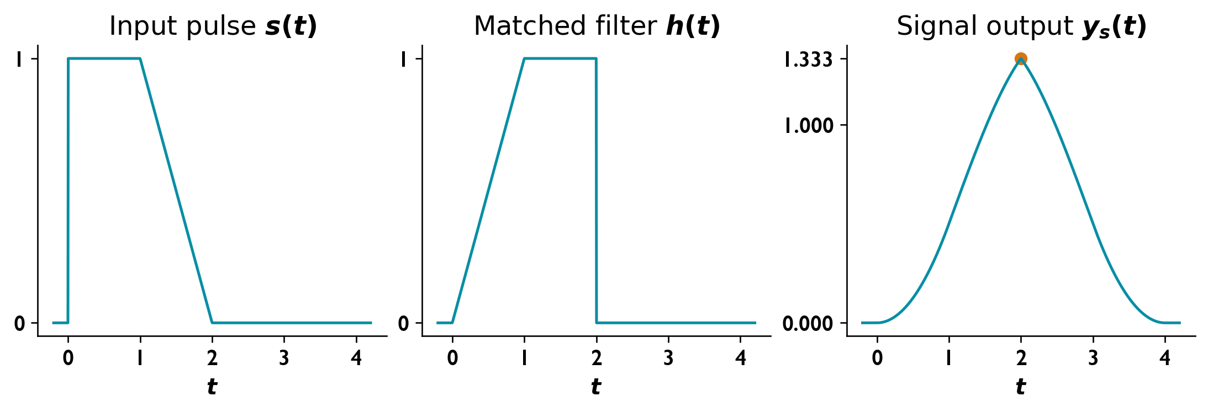
Input pulse, causal matched-filter response, and signal output with peak 4/3 at t = 2.

Coherent FSK and PSK over a finite bandpass channel

Question
A unity-gain channel passes $500≤\left|f\right|≤1500 Hz$ and rejects all other frequencies. The amplitude-to-noise ratio is $A^{2}/η=8000$.
Find the coherent binary FSK error probability at $200 bit/s$ with tones at 1070 and 1270 Hz.
Determine the fastest PSK rate and its coherent error probability.

Solution
Assume equiprobable bits, two-sided AWGN PSD $η/2=N_{0}/2$, sinusoid amplitude $A$, and negligible distortion of the shaped signals.
Coherent FSK
$$\begin{matrix}T_{b} & =1/200=0.005 s, \\ \left(f_{2}−f_{1}\right)T_{b} & =200\left(0.005\right)=1, \\ \frac{E_{b}}{N_{0}} & ≃\frac{A^{2}T_{b}}{2η}=8000\frac{0.005}{2}=20.\end{matrix}$$
The spacing satisfies envelope-model orthogonality.
$$\boxed{P_{e,FSK}=Q\left(\sqrt{20}\right)=3.8721×{10}^{−6}}$$
Binary PSK with ideal Nyquist shaping A maximum rate requires a pulse-shaping and modulation-order assumption. For binary PSK with zero roll-off, the positive-lobe width $B=1000 Hz$ equals $R_{b}$.
$$\boxed{R_{b,max}=1000 bit/s}$$
$$\frac{E_{b}}{N_{0}}=\frac{A^{2}}{2ηR_{b}}=4,$$
$$\boxed{P_{e,BPSK}=Q\left(\sqrt{8}\right)=2.33887×{10}^{−3}}$$
For raised-cosine roll-off $α$, $R_{b,max}=B/\left(1+α\right)$.
Rectangular-pulse bandwidth approximation Using the first-null approximation $B≃2R_{b}$,
$$R_{b}≃500 bit/s, E_{b}/N_{0}=8,$$
$$\boxed{P_{e}≃Q\left(4\right)=3.16712×{10}^{−5}}$$
This assumes undistorted coherent detection. A brick-wall channel truncates rectangular-pulse sidelobes, so the approximation is not an exact distortion analysis. Higher-order PSK requires a specified order.

MAP detection of polar data in Laplace noise

Question
At a binary receiver’s sampling instant,
$$V_{0}\left(T_{b}\right)=s_{0}\left(T_{b}\right)+N_{0}\left(T_{b}\right), f_{N}\left(n\right)=\frac{λ}{2}e^{−λ\left|n\right|}.$$
The polar levels are $+A$ for bit one and $−A$ for bit zero, with probabilities 0.25 and 0.75. Find the average SNR required for $P_{e}={10}^{−4}$ using the optimum threshold.

Solution
MAP threshold Decide $+A$ when
$$\frac{f_{V|+}\left(v\right)}{f_{V|−}\left(v\right)}=exp\{λ\left(\left|v+A\right|−\left|v−A\right|\right)\}>3.$$
Within $−A<v<A$, the log ratio is $2λv$, giving
$$\boxed{γ=\frac{ln3}{2λ}, +A \text{if }v>γ}.$$
The interior condition is $λA>\left(ln3\right)/2$.
Error probability
$$\begin{matrix}P_{e} & =\frac{1}{8}e^{−λ\left(A−γ\right)}+\frac{3}{8}e^{−λ\left(A+γ\right)} \\ & =\frac{\sqrt{3}}{4}e^{−λA}.\end{matrix}$$
$$λA=ln\left(\frac{\sqrt{3}}{4×{10}^{−4}}\right)=8.37335216.$$
This satisfies the interior condition.
Average SNR
$$P_{s}=A^{2}, σ_{N}^{2}=\frac{2}{λ^{2}},$$
$$\boxed{SNR=\frac{{\left(λA\right)}^{2}}{2}=35.0565≈15.45 dB}.$$

