Requirements: three executables
- index and search the MS MACRO dataset - preprocessed and can use parsing libraries
- all data produced by first and second executable should be written to files on disk

- parse data + create sorted files of index postings in an intermediate format
  - create a complete search disk on disk, consisting of actual inverted lists
  - the lexicon storing for each terms where the corresponding inverted list is located
  - a page table allowing you to convert document IDs back into document names (such as URLS)
  - if needed additional files storing meta information for the index, such as last document ID in each block and the block sizes
  - total index should consist of a small number of files, 3-5 – DO NOT create a file for each inverted list or for groups of inverted lists
    - inverted lists should be stored in a blocked, binary and compressed format
- merge the files into a final compressed inverted index
  - use the inverted index API framework to access inverted lists
  - which hides issues such as list decompression and file access and caching from the higher-level query processing algorithms
  - implement methods for opening and closing an inverted list
  - implement methods for forward seeking in a compressed inverted list
  - implement methods for retrieving frequencies or impact scores
  - SHOULD NOT decompress inverted lists immediately after loading them from disk
    - do a traversal on the still compressed lists
    - local decompression is performed inside the seek operations on a lower level as needed
  - recommended to compress doc IDs and frequencies using varbyte encoding
    - if using quantized impact scores, a fixed 8 bit format for each score may be more appropriate
    - may use other compression methods such as Simple9, PEF, etc.
    - may reuse open source code for compressing a posting or single block – but NOT for doing higher level operations such as forward seeks
    - DO NOT use generic file compression techniques such as gzip or bzip2 to compress inverted lists
  - recommended to assign docIDs in the order in which the pages are parsed
    - don’t use any term IDs during indexing, but can make own choices
    - input data is mostly in english, may also include text from other character sets
      - indexer should not fail, and you may just ignore such text
- allow user to input queries that returns a rank list of results based on BM25 ranking function
  - when query processor starts running, it may read some of the files into main memory and place them into suitable data structures
    - SHOULD NOT load all inverted lists into main memory
    - may choose to support index caching, either static or dynamic, by placing a subset of the inverted lists into a fixed-size cache (Ex. few hundred MB) but this is optional
  - given a user query, find the query terms in the lexicon
  - fetch the corresponding inverted lists from disk by performing a seek to the starting position of the list inside the file
  - traverse the compressed inverted lists in a DAAT (document at a time) fashion
  - return the ten highest scoring results according to the BM25 ranking function
  - implement conjunctive and disjunctive qwerty processing
  - each index posting should store a docID and either the frequency or a quantized impact score, but should not store positional information
  - after answering a query, the query processor should wait for the next input query
  - for each query there should be a choice of disjunctive and conjunctive query mode
  - query processor may accept queries and return results using a simple command line interface
    - EXTRA CREDIT: make it browser-accessible
    - EXTRA CREDIT: return query-dependent snippets as part of the result page, using a suitable algorithm for selecting good snippets from the result pages
      - would also have to store the indexed passages in a suitable format (indexed by offsets or in mysql) so you can run snippet algorithm on the top passages

Deliverables:
- well commented program source
- 10-15 page paper explaining:
  - what the program can do
  - how to run the program
  - how it works internally
  - how long it takes on the provided data set
  - how large the resulting index files are
  - what limitations it has
  - what major functions and modules are
  - paper should be readable to a generic computer scientist who knows what an inverted index is but otherwise does not know much about search engines
Simple Search System | Sara Anurag Somani & Si Yue Jiang

Background: How a Search Engine Finds Passages
Reading all 2.9 GB for every query would be far too slow, so a search engine does the slow work once, ahead of time, and builds an inverted index. Like the index at the back of a textbook, it lists for every word the passages that contain it, and a query only looks up the lists of its own words.
Overview: Our system is a small search engine for the MS MARCO passage collection: 8,841,823 short passages in one 2.9 GB file, collection.tsv. A user types a few words, picks AND or OR mode, and gets back the 10 most relevant passages, ranked with BM25. The system is three separate programs. Each one writes its results to files on disk, and the next program reads those files.
Report Structure: The report starts with the background section, which explains the main ideas and important terms. It is then split into three parts, one for each program: the parser, the merger and the query processor. Parser.cpp, Merger.cpp and query_processer.cpp give a quick summary, how it works step by step, flowchart, its output files including the time taken to run each file, the design choices with the reasons behind them and limitations.
Program | What is required and should do | Reads | Writes
parser.cpp | Splits every passage into words and writes sorted postings in chunks | collection.tsv | temp_0.csv … temp_n.csv, pagetable.csv, stats.csv
merger.cpp | Joins the chunks into one compressed inverted index | the temp files | index.bin, lexicon.txt, blockmeta.txt
query_processor.cpp | Answers queries with the top 10 passages by BM25 | the index files, pagetable.csv, stats.csv | results on screen

Important Terms
Term | Meaning
docID | the number of a passage: 0 for the first one read, then 1, 2, …
posting | (docID, frequency): "this word appears in this passage this many times"
inverted list | all the postings of one word, sorted by docID
lexicon | the table that says where each word's list is stored
page table | the table from docID to passage ID and passage length
temp file | a sorted chunk of postings written by the parser
block | up to 128 postings of one list, compressed together
gap | the difference between a docID and the previous one in the list
var-byte | compression that uses fewer bytes for smaller numbers

Parser.cpp
The parser reads collection.tsv once, from top to bottom and turns 8841823 passages into sorted temp files of postings. It does not hold more than 750000 passages worth of postings into memory.
How it works:
- Read one passage: std::getline reads one line of the collection.tsv at a time so that the file is streamed and not loaded as a whole.
- Split the DocIDs and the text: Each line is DocID<TAB>text, a line with no tab is skipped. Everything before the first tab is the DocID, everything after is the text.
- Tokenise: Each letter or digit is kept and lowercased so that every other character becomes a space. Characters are cast to unsigned char first so bytes from other languages become separators instead of crashing the program. A std::stringstream then splits the cleaned text on spaces.
- Count Terms: A small std::map (passage_terms) counts how often each term appears in this passage. Word_count counts every word in a passage. Passage_terms[word]++ counts the frequency of each word in the passage.
- Store postings: The DocID is a counter example 0,1,2…., in the order passages are being read. For each term, the posting (DocID, frequency) is appended to an in-memory buffer, inverted_index, a std::map from term to its list of postings. A row (docID,word_count) goes to the pagetable.csv.
- Buffer every 750000 passages: When the counter reaches a multiple of 750000, the whole buffer is written to temp_N.csv, one (term,DocID,frequency) row per posting until the buffer is cleared.
- Finish: After the last line, what remains in the buffer becomes the last temp file and stats.csv gets the number of DocIDs and average passage length.
Flowchart:
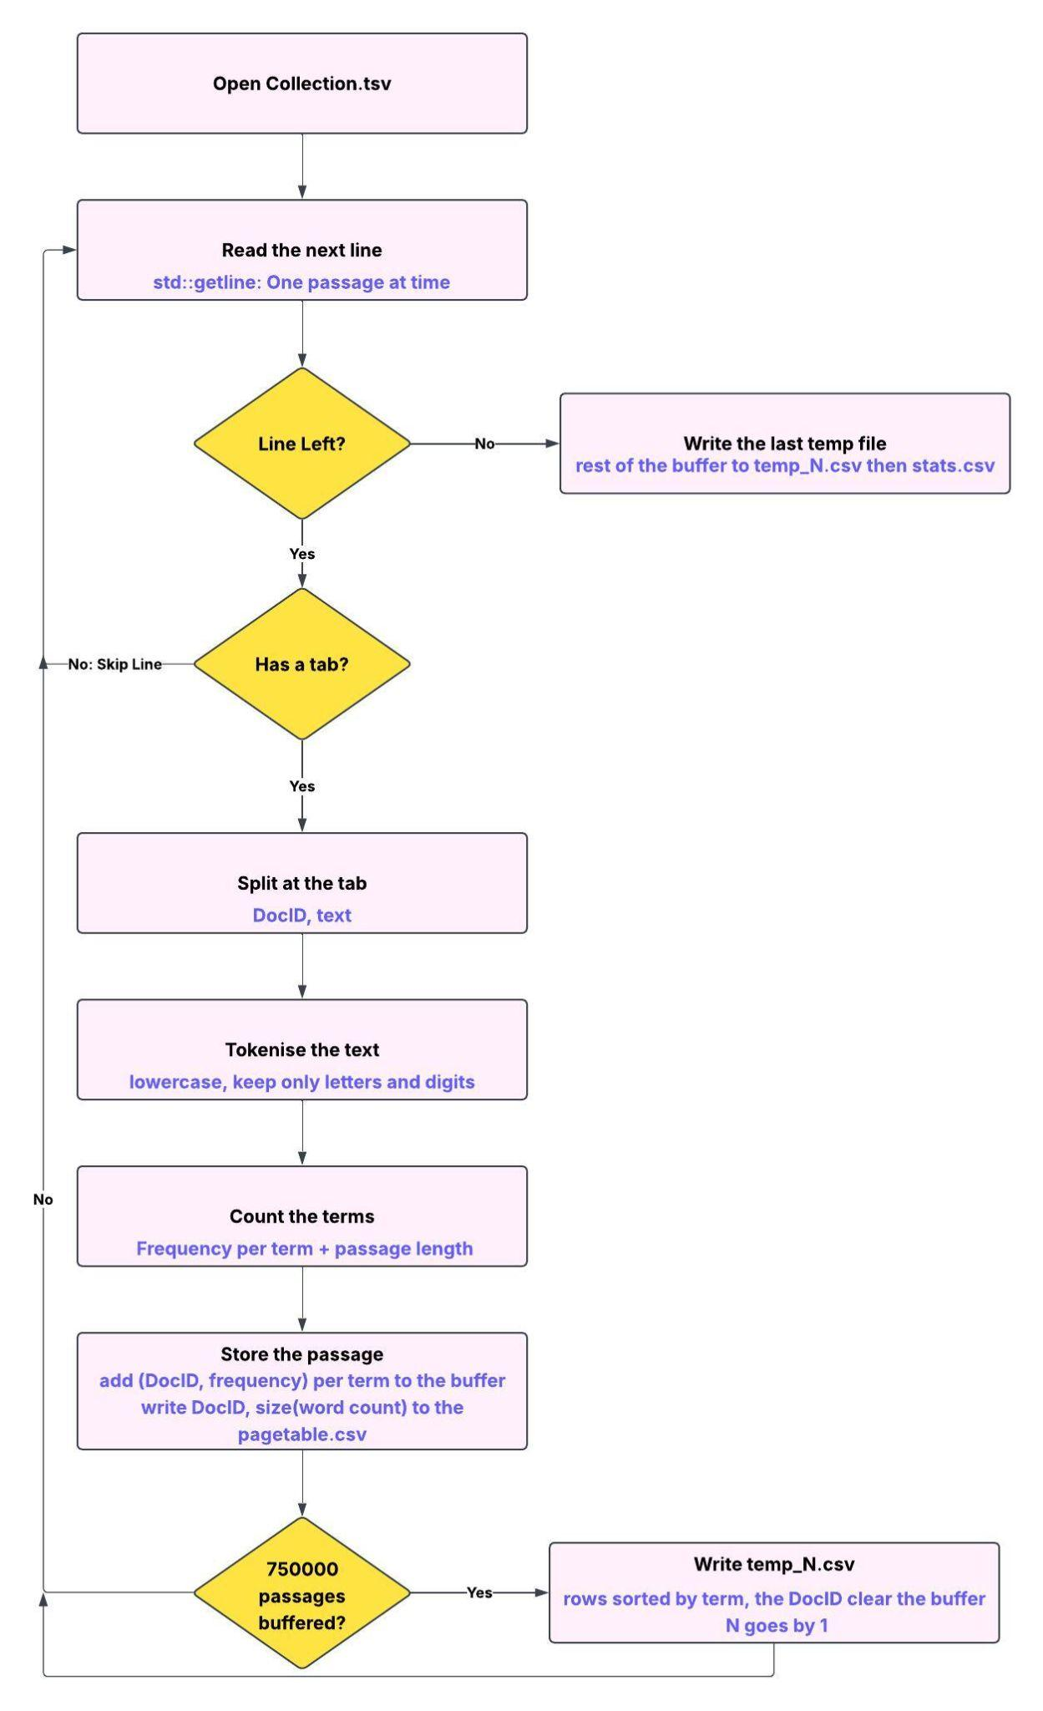

Output Files:
File | What does it hold | Read By
Temp_0 to Temp_11.csv  (Total: 12 temp files) | Term, DocID, Frequency | merger.cpp
pagetable.csv | DocID, word_count | Query-processor.cpp: DocID and length required for BM25
stats.csv | Number of DocIDs, average passage length | Query-processor.cpp: number of DocID and avgdl required for BM25
Extra Notes:
We measured run time with std::chrono::steady_clock, printing the time for each temp file and the total parser time.

Time taken to run the parser: 1137.27 seconds
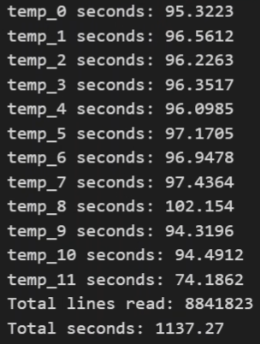
Decision Choices & Explainations
Temp files(building towards the index) : The full index is too big to fit in memory, so we build it in chunks, as in Lecture 2. We kept 750000 passages' worth of postings in memory, wrote them to a temp file, cleared the memory and repeated. The merger joins the pieces later.
A map for the buffer: We used std::map because it kept the words in alphabetical order by itself and made it quick to find a word and add to it. So every temp file comes out already sorted, with no extra sorting step.
DocID = the order we read the passages. The first passage is 0, the next is 1, and so on. In MS MARCO this is the same as the passage ID, so we never have to translate between the two. Words stay as words, with no term IDs.
A simple tokenizer: We keep only letters and numbers and make them lowercase; everything else becomes a space. We cast each character to unsigned char so that non-English characters don't crash the program. There is no stemming and no stopword removal, so every word can be searched.
Passage length counts every word: Repeats count too, so "dog dog cat" has length 3. This is what BM25 needs, and the instructor confirmed it.
Buffer 750000: This is big enough to need only 12 temp files and small enough to fit in a laptop's memory. A smaller batch uses less memory but makes more temp files.

Limitations
- It’s a bit slow: It takes about 20 minutes, because it does everything step by step on one core and uses data structures that are easy to use but not the fastest.
- Its word splitting is basic: It only understands English letters and numbers, splits words like “it’s” and “e-mail”, treats “run” and “running” as different words, and keeps every number as a word.
- DocIDs only match passage IDs if no line is skipped: That never happens in MS MARCO, but it could in other data.
- It doesn’t use memory limit: It saves to disk every 750,000 passages, not when memory gets full. That works here because the passages are short, but it could run out of memory on bigger documents or a weaker computer.
- It doesn’t clean up old temp files: Leftovers from an earlier run can confuse the merger.
Merger.cpp
The merger reads all the temp files together and joins them into the final index: one compressed list per word in index.bin, lexicon.txt and blockmeta.txt, which say where each list and each block is. It keeps only one row from each temp file and one word's postings in memory at a time.
How it works:
- Open all temp files: It opens temp_0.csv, temp_1.csv, … until one is missing, skips the heading and reads the first row of each. Each open file is a TempFile: the file, its current row (term, docID, frequency) and a done flag. We used struct so that when opening each file, it will remember the 5 important things.
- Read a row: readNext reads the next line of one temp file, such as apple,19,10. It finds the two commas with find, cuts out the three pieces with substr, and turns the docID and frequency into numbers with stoi. When the file has no lines left, it sets done to true.
- Pick the next word: smallestTerm looks at the current word of every file that is not finished and returns the smallest one, A to Z.
- Collect its postings: It goes through the temp files in order, temp_0 first. While a file's current word is this word, its docID and frequency are added to two lists, docIDs and freqs, and readNext moves that file to its next row. temp_0 holds the lowest docIDs, temp_1 the next ones and so on, so the docIDs come out sorted without any comparison.
- Compress and write: writeList cuts the lists into blocks of 128 postings. In each block, docIDs are stored as gaps and every number is encoded var-byte. All of a block's docIDs are written to index.bin first, then all of its frequencies.
- Record where it is: Each block adds one line to blockmeta.txt, and each word adds one line to lexicon.txt
- Repeat until every temp file is done, then print the number of words and the total time.
Flowchart:
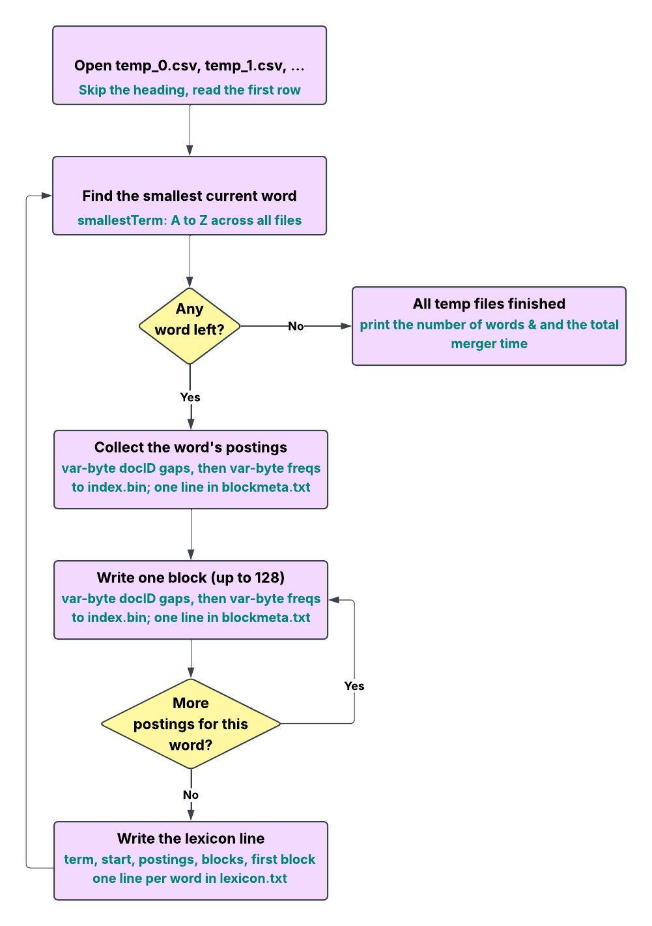
Var-byte encoding
A normal int always takes 4 bytes, even for a small number like 8. Var-byte (variable-byte) encoding uses only as many bytes as a number needs. Each byte holds 7 bits of the number, and its top bit is a flag that says whether more bytes follow.
Split the number into pieces of 0–127:
where each piece is
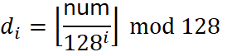
Then each byte is:
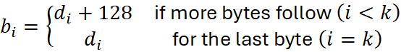
Number of bytes:
Bytes | Numbers that fit
1 | 0 to 127
2 | 128 to 16383
3 | 16384 to 2,097151
4 | 2097152 to 268435455
Example:
Step | docID part | frequency part
Postings | 19, 27, 39 | 10, 3, 128
Stored as | 19, 8, 12 (gaps) | 10, 3, 128 (no gaps)
Bytes written (var-byte) | [19] [8] [12] | [10] [3] [128] [1]
Size | 3 bytes | 4 bytes (128 needs 2)

Output files:
Files | What does it hold | What does the query processor use it for | File size
Index.bin | Compressed Doc IDs and Frequency | read a word's postings | 788 MB
lexicon.txt | term  start  num_postings num_blocks first_block | find a word's list; num_postings is the document frequency BM25 needs | 44.9 MB
blockmeta.txt | last_docID docID_bytes freq_bytes, one line per block | skip blocks and know how many bytes to read | 62.2 MB

Extra Notes: We measured run time with std::chrono::steady_clock, printing the time for the total merger time.

Time taken to run the merger : 338.806 seconds
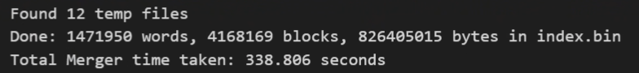
Design Choices & Explanation:
Merge all temp files in one pass: This is the second phase of the merge sort. Each temp file is read once, top to bottom, and only its current row is in memory.
A simple loop instead of a heap: With 12 temp files, checking each file's current word is fast enough and easy to follow. A heap would only pay off with many more files.
Blocks of 128 postings: The query processor can skip a whole block by looking at its last docID, and only decompresses the block it needs.
DocIDs and frequencies not interleaved: Each block stores all its docIDs, then all its frequencies, so the query processor can decode the docIDs alone and the frequencies are decoded only for passages that get scored.
Gaps for docIDs, not for frequencies: DocIDs always go up, so their gaps are small positive numbers. Frequencies go up and down, and most are already small.
Var-byte compression: It is simple, byte-aligned and recommended by the assignment so no gzip is used.
Lexicon and block info as text: They are easy to check by eye and small next to index.bin. A binary format would load faster.
find and substr to split each row: readNext runs once for every row of every temp file, hundreds of millions of times. Our first version built a new stringstream for each row; splitting at the commas with find, substr and stoi gave the same output about 2.7 times faster in our test.
Limitations:
- Reading the text files is slow: It has to read and split hundreds of millions of text rows and turn text into numbers which takes about 5.6 minutes since the temp files are not binary.
- Picking the next word is a simple scan: For every word, it checks all the 12 temp files one by one. With hundreds of files, it could get slow so a heap would scale better.
- It runs on one core, start to finish: It doesn’t split the work to go faster.
Query-Processor.cpp
Allow user to input queries that returns a rank list of results based on BM25 ranking function
- Load Output Files into Memory: This step takes around 5-10 seconds. Passage_count and avg_doc_length are pulled from stats.csv to be used in BM2_ranking. Entries from lexicon.txt are loaded and stored into an unordered_map (for O(1) lookup) of lexicon_data used by the PostingReader to locate a term in index.bin. Entries from blockmeta.txt are loaded and stored into a vector (index for each term is stored in lexicon_data) of block_meta. This is used to traverse the encoded blocks in index.bin. Word_counts from pagetable.csv are stored in a vector (where the index correlates with the docID).
- Query Loop: Prompt user for disjunctive or conjunctive query, exit the loop if they input something else. Prompt the user for a query, then normalize the query to match the tokenization that occurs in parser.cpp. Then parse the query, storing it in an unordered set to remove duplicate terms. For each term, retrieve the lexicon data and create a PostingReader via search_setup. Move onto the next query if the term_data vector is empty, as there are no searchable terms. Otherwise, set each reader to its first posting and call either disjunctive_search or conjunctive_search. Only call conjunctive_search if the number of query_terms is equal to the number of terms we are able to pull from the lexicon into term_data. The top query results are stored in a minheap with a size of 10. When the number of elements in top_results exceeds 10 and the score is greater than the lowest score, the result with the lowest score (top) is popped off of the heap, and replaced with the new result.
- BM25 Ranking: Calculates the individual score of a term utilizing:
  - k1 = 1.2: controls term frequency saturation – how quickly the score increases when a query word appears multiple times in a document (k = 0 turns it off, k = lower value if subsequent appearances should have little impact, k = higher value if subsequent appearance should still have some impact)
  - b = 0.75: strength of document length normalization – how much a document’s length relative to the average document length affects its relevancy score (b=0 for no penalties, b=1 for heavy penalties)
  - term frequency (f_{d,t}): the number of times a term occurs in the document – BM25 rewards higher term frequency but with diminishing returns
  - document length (|d|): the number of terms in the document – BM25 penalizes longer document lengths
  - document frequency / number of postings (f_t): number of documents a term appears in – BM25 penalizes common words
  - document / passage count (N): total number of passages in the corpus
  - average document length (|d|_avg): used to determine which passages are lengthy
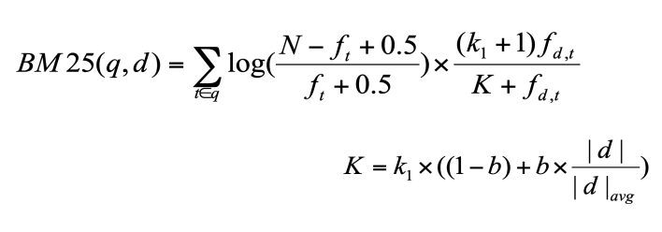
- PostingReader: Iterate through a term’s postings, loading blocks from index, storing the docIDs and freqs to calculate BM25 scores.
- Load Block: Loads one block of a term’s posting list into memory, decodes the docIDs and stashes the freq bytes for later decoding.
- Decode DocID: Get the docID of the previous block, 0 if it is the starting block. While the doc_pos has not reached the freq block region, varbyte_decode the current docID gap and add to the prev_doc_id to get the true docID. The positions are updated within the varbyte_decode via reference. Finally, store the true docID in the docIDs vector.
- VarByte Decode: This is used to decode the docID and freq blocks. Get the current byte from bytes using pos as an index. Take the lower seven bits using 127 as a mask. Shift num to match its actual value. Then combine result and num_shifted to get the accumulated result. Increase the shift by 7 for the next byte read and advance the position. Continue while the continuation bit (8th bit) is 1, using 128 as a mask. Once it is decoded, return the result.
- Next: Move to the next posting in the block, and move to the next block if the current block is exhausted – used mainly during a disjunctive query and when a docIDs match is found during a conjunctive query.
- Seek: Move to the first posting with docID greater than or equal to target, and return true if found – While the block_index is less than the num_blocks in that term, scan through the blocks linearly. Retrieve the metadata for the block from block_metadatas, indexing using the term’s first_block + block_index. If the last_docID of the block is below the target, move to the next block. Otherwise, load the current block. Iterate through the block until the docID is greater than target, and store the number of varbytes traversed to find the corresponding freq via skip_varbyte.
- Skip VarByte: Advance position past one varbyte without computing the value – While the continuation bit is 1, continue to the next byte. Once it hits a 0, increment the position one last time to reach the end of the value.
- Disjunctive Search: While there is a valid reader, continue to iterate through the postings document by document. This is achieved by keeping track of the minimum docID amongst all of the readers, calculating the total score for the docID across all terms present in the document by adding individual term score via BM25_ranking, then adding the score to top_results if the score is greater than the current minimum score.
- Conjunctive Search: While all readers are valid (if one term runs out of postings, then the loop ends – the effect is similar to traversing across the postings of the least common term), set target as the max docID out of all the readers. Have each reader seek for this target docID. If any of the readers fail their seek, there are no more postings with a docID equal to or greater than the target, and there are no more eligible postings. Therefore there are no other documents that could contain all of the terms, ending the search. If any of the readers jump past the target, the target doesn’t contain all of the terms, so there is no match and the search continues with a new target. If all of the docID match the target, then we find the total score of the document. Then move each reader to the next posting, and end the search if any reader runs out of them.
Limitations:
- Slow Disjunctive Queries on Common Terms: Searching for many common terms such as the, a, are, there may slow down query speed. To improve speed, a Top-K algorithm such as MaxScore can be used to get the correct top-k results without evaluating all docs in the union. This is done by storing the maximum impact score for each term’s posting list.
- Linear Scan: Currently PostingReader iterates through postings one by one, checking the max docID, then scanning the docIDs one by one and comparing against the target. A more efficient form of forward skipping, galloping can be used, which skips blocks in powers of two until exceeding the target docID, then performing a binary search in the region from the previous docID and the current blocks max_docID.
- Index and DocID Assumption: For example, the word count vector assumes that the page table is ordered in ascending order, and therefore the index correlates to the docID. If docID weren’t strictly sequential and began at 0, there may be issues with indexing.
- No Snippets: Since snippets for each passage are not being stored, search results are displayed with just docID and score. To check the accuracy of the results, you would need to check collection.tsv.

Flowchart:
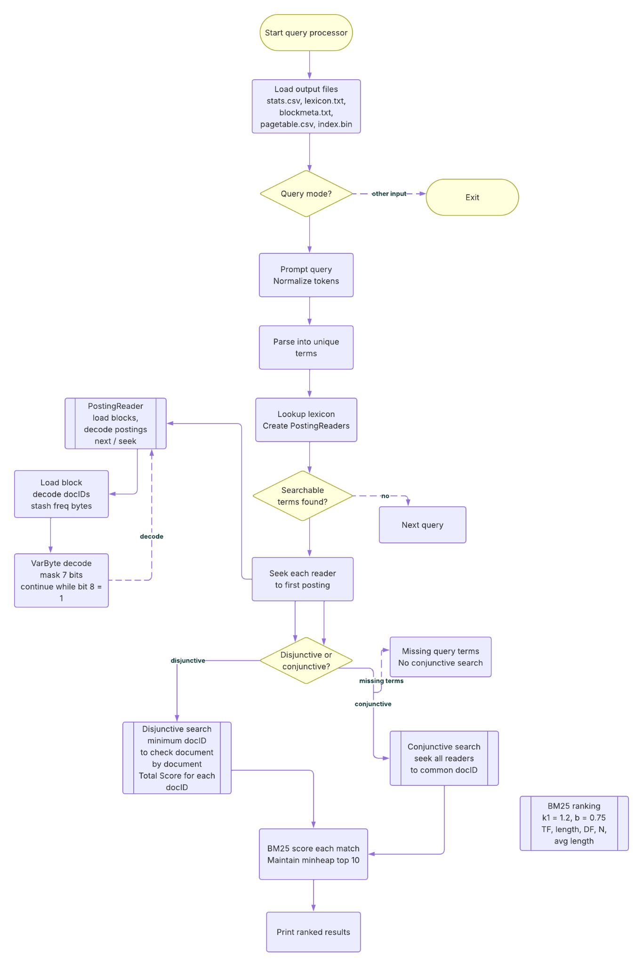

Outputs during the run of the query_processor (DEMO)

Index loaded by the query_processor:
Item | Count
Terms in the lexicon | 1471950
Blocks in blockmeta.txt | 4168169
Passages in the page table | 8841823

Test Queries
# | Query | Mode | Results shown | Top docID | Top score
Q1 | armadillo | OR | 10 | 3634360 | 19.7174
Q2 | armadillo | AND | 10 | 3634360 | 19.7174
Q3 | a cat | OR | 10 | 2377709 | 11.9479
Q4 | the a there was are cat | OR | 10 | 5466551 | 15.9914
Q5 | the big apple new york city empire state | AND | 7 | 2592775 | 38.2426
Q6 | apple orange banana pineapple grape the quick brown fox jumped over the lazy dog | OR | 10 | 7031064 | 55.7416

Top 10 results, doc ID(score)
Rank | Q1: armadillo (OR) | Q2: armadillo (AND) | Q3: a cat (OR) | Q4: the a there was are cat (OR) | Q5: the big apple new york city empire state (AND) | Q6: apple orange … lazy dog (OR)
1 | 3634360 (19.7174) | 3634360 (19.7174) | 2377709 (11.9479) | 5466551 (15.9914) | 2592775 (38.2426) | 7031064 (55.7416)
2 | 2650578 (19.3124) | 2650578 (19.3124) | 6563098 (11.9297) | 992063 (15.9701) | 65845 (32.7221) | 8613146 (54.5771)
3 | 1024240 (18.7351) | 1024240 (18.7351) | 2377710 (11.9116) | 992069 (15.7625) | 3226265 (32.1163) | 7031065 (54.3139)
4 | 2624406 (18.5965) | 2624406 (18.5965) | 2051043 (11.8864) | 2267639 (14.4981) | 5947055 (31.9007) | 1187041 (45.0278)
5 | 3070814 (18.4491) | 3070814 (18.4491) | 5466551 (11.7647) | 8458272 (14.3956) | 8811275 (26.4089) | 2272186 (40.9698)
6 | 7205580 (18.3865) | 7205577 (18.3865) | 1407162 (11.6832) | 6721231 (14.3040) | 3061811 (23.8154) | 1448441 (37.0262)
7 | 7205577 (18.3865) | 7205580 (18.3865) | 2051048 (11.6031) | 4841372 (14.1514) | 3061812 (23.5069) | 5480350 (34.4719)
8 | 1954534 (18.2117) | 1954534 (18.2117) | 7796811 (11.5422) | 5635778 (14.0944) | — | 4214272 (33.7880)
9 | 1024238 (18.1612) | 1024238 (18.1612) | 342509 (11.5155) | 5774494 (13.9833) | — | 6464015 (33.4397)
10 | 4247667 (17.9413) | 4247667 (17.9413) | 527509 (11.4971) | 99339 (13.8308) | — | 1671879 (33.1149)

