Sugarbush Site Suitability in Ojibwe Ceded Territory of Northern Wisconsin

Sheamus Johnson, Melanie Kohls, Emily Pettit

University of Wisconsin-Madison

GEOG578 Final Project Proposal

Spring 2018

Table of Contents

1. Capstone Statement................................................2
2. Background.................................................2
3. Methodology...............................................4
4. Results and Analysis................................... ?
5. Conclusion.................................................. ?
6. Bibliography............................................... ?

*Capstone Statement / Project Goals*

The Ojibwe people maintain usufruct rights on public lands, including the right to tap sugar maples for syrup and sugar, in ceded territories of Wisconsin. Maple sugar plays an invaluable spiritual and cultural role in the Ojibwe economy, and knowing the locations of ideal sugarbush stands would allow the Ojibwe to further utilize this resource. Thus, we plan to conduct a site suitability analysis using climatic, habitat, and socioeconomic factors to locate optimal sugarbush sites in Ojibwe ceded territories of northern Wisconsin.

*Introduction & Background*

Our objectives are to locate tappable, profitable stands of sugar maples in Ojibwe ceded territory (as defined by the treaties of 1837 and 1842), within the Wisconsin state boundary. In the U.S., the Ojibwe currently spread across Wisconsin, Minnesota, Michigan, Montana, and North Dakota (Roy 2018). In Canada, as the second-largest First Nations population, they make up a significant portion of the populace. Our Wisconsin-focused model will serve as a starting point for finding optimal maple sugarbushes; eventually, we can expand the model to find sugarbushes throughout Ojibwe territory.

The Ojibwe people were tapping sugar maples long before European settlers arrived in the United States. Families returned to the same sugarbush (stand of sugar maples) spring after spring. To the Ojibwe (and other native tribes) sap is not just sap; it is a precious gift signaling the end of winter – the Ojibwe word for spring, *ziig-wan*, incorporates the idea of sap starting to flow from the maple trees (Erickson 2006). Maple sugar and (more commonly today) maple syrup play an integral role in Ojibwe culture.

Beyond culture, maple products contribute substantially to the Ojibwe economy. Families who produce more syrup than they need can sell to stores, or directly to friends and neighbors (Science Museum of Minnesota, 2018). In 1866, the Keweenaw Bay Indian Community sold 453,252 pounds of maple sugar to Mackinack Indian agents (Wyckoff 1999). That requires tapping 151,804 trees and boiling down 2,266,260 gallons of sap. And as maple products have gained mass appeal, more and more sellers aim to increase their yearly production. But finding a sugarbush takes time (hence their generational aspect in Ojibwe culture). Most of Wisconsin’s sugar maples remain a truly “untapped” resource. Our model uses environmental and socioeconomic parameters to find the sugarbushes of the next generation.

We already know the ideal growing conditions for a maple sugarbush (Brown et al. 2015; Tirmenstein 2018; Farrell 2012; Stults et al. 2016; United States Forest Service 2018). These climatic, soil, and elevation characteristics make up one set of layers of our optimization model. Road networks and access make up the second set. Finally, we know the current spread of sugar maples across Wisconsin. By overlaying all of these layers, we can select out just the areas that would support a profitable, sustainable sugarbush.

*Methodology*

Sugar maples are capable of growing in a wide range of conditions, which made it necessary to differentiate between the many variables that affect sugar maple growth and distribution. Our analysis relied on multi-criteria decision making (Brown et al. 2015) and weighted sum analysis to produce a site suitability output map that incorporated both environmental and socioeconomic factors. Our input data layers fit into two categories: climate data and landscape data (Table 1). We identified these data layers after reviewing the literature on sugarbush sites and sugar maple growing conditions (Brown et al. 2015; Tirmenstein 2018; Farrell 2012; Stults et al. 2016; United States Forest Service 2018). Each layer was imported into QGIS 2.18 and clipped to the study area boundary of the ceded territory.

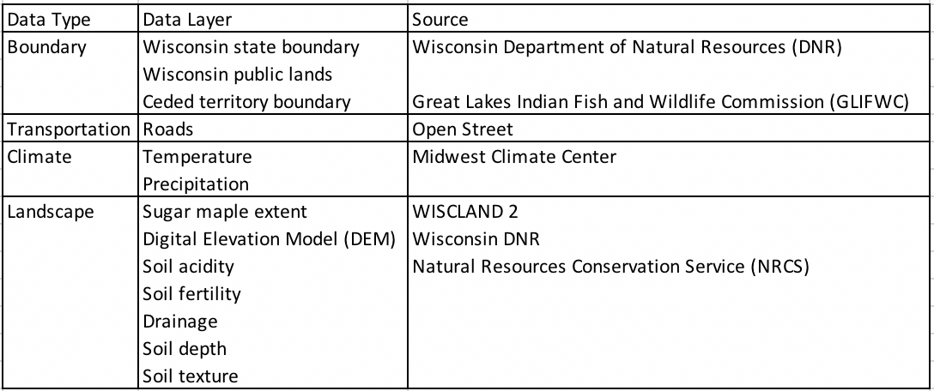

Table 1: *Input data layers*

To create the site suitability map we performed a weighted sum analysis of the raster data layers that required ranking each data layer (Table 2) before multiplying them by an established weight representing their influence on the analysis. We ranked the two climatic variables (temperature and precipitation) and the six landscape raster layers pertaining to soil characteristics (soil acidity, soil fertility, depth to bedrock, drainage, slope, and soil texture) on a 1-5 scale, with a rank of 1 representing the ideal (best) conditions for sugar maples and a rank of 5 representing the least ideal (worst) conditions (Brown et al. 2015).

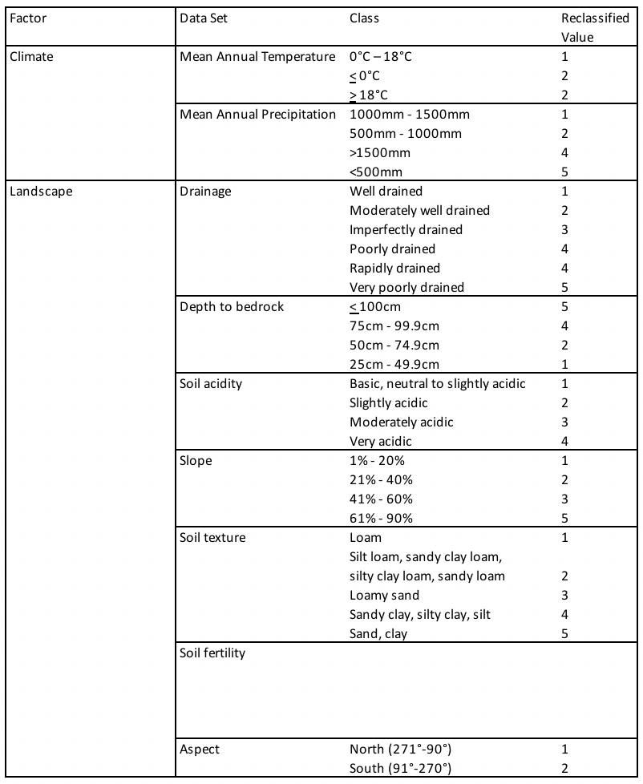

Table 2: *Fuzzy scoring rankings of data layer variables*

The entire study area, due to its smaller spatial extent, falls within sugar maples’ preferred ranges for the two climatic variables of mean annual temperature (0°C-18°C) and mean annual precipitation (1000mm-1500mm). Those two identified ranges were each assigned a rank value of 1 (ideal). Though sugar maples can grow outside of the 0°C-18°C temperature range, we decided to rank all temperatures beyond the preferred range as less ideal to represent the increased stress the trees would be under in those conditions (United States Forest Service 2018). We used similar reasoning for the mean annual temperature variable: 1000mm-1500mm represents the ideal precipitation range, though sugar maples can grow with more or less. Areas receiving >1500mm or <500mm of precipitation were scored as 4 (less ideal) because the trees would experience significant stress under those conditions. Research shows that sugar maples prefer to grow in areas with "low drought stress," but may still be able to survive if other variables are suitable (United States Forest Service 2018; Tirmenstien 2018; Stults 2016).

The soil layers are a significant component in this analysis because, though sugar maples can grow in a variety of conditions, the soil conditions and their modification of climate variables such as precipitation are the key factor dictating sugar maple health (Brown et al. 2015; United States Forest Service 2018). The Natural Resources Conservation Service (NRCS) classifies soil drainage in qualitative categories that matched with our review of the literature to produce our rankings of "well drained" as 1 (ideal) and "very poorly drained" as 5 (least ideal) (NRCS 2018; Brown et al 2015; Tirmenstien 2018; Stults 2016). For the depth to bedrock variable we ranked deeper soils (25-49.9cm) as 1 (ideal) and shallow soils (</= 100cm) as 5 (least ideal) because sugar maples grow best in deep soils that allow the development of extensive root networks (Brown et al. 2015; Stults et. al 2016; Tirmenstien 2018). Soil acidity was ranked so that basic, neutral to slightly acidic soil was ideal and very acidic was least ideal, since sugar maples can grow in soils with pH values ranging from 3.7 to 7.3 but grow best "where soil pH ranges 5.5 to 7.3" (Tirmenstien 2018; Brown 2015).

Soil texture is another variable for which sugar maples have a wide tolerance range, though they tend to prefer "loamy soils" above other varieties (Brown et al. 2015). We chose to group the soil categories based on similar component structures, with pure loam ranked 1 and pure sand and clay ranked 5. The mixed soil types (e.g. silt loam, loamy sand, silty clay) were ranked progressively lower in suitability as the texture shifted to more extreme soil types that would impact the soils' ability to meet other criteria preferred by the sugar maples (e.g. drainage, fertility) (Stults et al. 2016; Tirmenstien 2018; United States Forest Service 2018).

Sugar maples can grow on a range of slopes given that other variables are ideal, and our ranking reflects this with less slope (1-20%) ranked 1 and sharp slopes (61-90%) ranked 5 (Brown et al. 2015). Somewhat in conjunction with slope is the aspect, or direction the slope is facing. Sugar maples prefer north-facing slopes because the microclimate is cooler in the Summer (Stults et. al 2016; Brown et al. 2015). South-facing slopes are less ideal during summer months but are better for late Winter/early Spring due to their increased sun exposure that helps with early season growth (United States Forest Service 2018). We defined a North-facing slope as any slope oriented 271°-90°, and gave it a ranking of 1, while South-facing slopes were those oriented 91°-270° and ranked 2.

--soil fertility?—

(Bal et al. 2015)

It was necessary to weight each layer according to its importance or influence in the analysis to represent the greater local influence of the landscape variables on sugar maple distribution (Table 3).

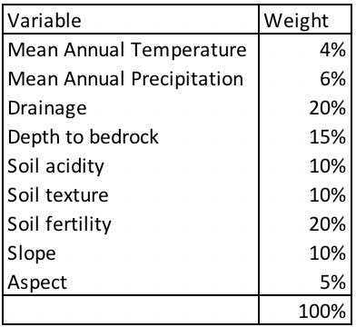

Table 3: *Weighted variable layers for weighted sum analysis*

Our weighting scheme developed out of our review of the literature that highlighted the importance of drainage (weighted 20%) and soil fertility (20%) to the health of sugar maples (Brown et al. 2015; Bal et al. 2015). Depth to bedrock was weighted next highest (15%) due to the importance of root growth on tree health (Brown et al. 2015; Tirmenstien 2018; Stults et al. 2016). Slope, soil acidity, and soil texture were all ranked the same weight (10%) due to their influence on drainage and soil fertility. Mean annual precipitation earned a higher weight (6%) than aspect (5%) and mean annual temperature (4%) because of the relationship of precipitation with drainage and soil fertility, and the explicit need for “low drought stress” (Stults et al. 2016; Tirmenstien 2018). Both climatic variables were given low weights because the climatic conditions were the same throughout the study area and thus had less influence on growing conditions than the localized landscape variables. Aspect was weighted slightly more than temperature due to its relationship with temperature and lack of direct influence on drainage. Temperature was the variable with the widest value range in our analysis and thus had least impact on our study area.

For the distance-to-road component of this model we performed a fixed buffer analysis on the road data layer using a 1600km (1 mile) buffer width based on our review of the literature (Farrell 2012). The output layer, when overlaid on the site suitability analysis output, helped to identify those sugarbush sites within tolerance distance for travel to and from roads.

--will we overlay the WISCLAND 2 layer with our weighted sum output, or will we incorporate that in the analysis like the buffer result?—

Need to clip site suitability output to the public lands within the ceded territory (since those are the areas where the Ojibwe have usufruct rights).

Converted WISCLAND 2 data layer of sugar maple extent from an ArcLayer to a shapefile for use in QGIS (Trent University link)

Bibliography

Bal T.L., Storer A.J., Jurgensen M.F., Doskey P.V., Amacher M.C. (2015). *Nutrient Stress Predisposes and Contributes to Sugar Maple Dieback Across Its Northern Range: A Review*. Forestry 88: 64-83. DOI: 10.1093/forestry/cpu051.

Brown L.J., Lamhonwah D., Murphy B.L. (2015). *Projecting a Spatial Shift of Ontario’s Sugar Maple Habitat in Response to Climate Change: A GIS Approach*. The Canadian Geographer 59(3): 369-381. DOI: 10.1111/cag.12197

Farrell, M. (2012). *Estimating the Maple Syrup Production Potential of American Forests: An Enhanced Estimate that Accounts for Density and Accessibility of Tappable Maple Trees.* Agroforest Systems87: 631-641. DOI: 10.1007/s10457-012-9584-7.

Keller, R.H. (1989). *America’s Native Sweet: Chippewa Treaties and the Right to Harvest Maple Sugar.* American Indian Quarterly 13 (2): 117-135. DOI: 10.2307/1184054.

Loriene, R. (2018). “Countries and Their Cultures: Ojibwa.” <http://www.everyculture.com/multi/Le-Pa/Ojibwa.html>. Accessed 4 March 2018.

Stults M., Petersen S., Bell J., Baule W., Nasser E., Gibbons E., Fougerat M. (2016). *Climate Change Vulnerability Assessment and Adaptation Plan: 1854 Ceded territory including the Bois Forte, Fond du Lac, and Grand Portage Reservations. Duluth, MN: 1854 Ceded Territory.* <http://www.1854treatyauthority.org/images/ClimateAdaptationPlan_Final-July_2016-optimized(1).pdf>. Accessed March 4, 2018.

Tirmenstein, D.A. (1991). *Acer saccharum.* In: Fire Effects Information System, [Online]. U.S. Department of Agriculture, Forest Service, Rocky Mountain Research Station, Fire Sciences Laboratory (Producer). <http://www.fs.fed.us/database/feis/>. Accessed March 4, 2018.

United States Forest Service Northern Research Station. “Sugar Maple (*Acer saccharum*).” <https://www.fs.fed.us/nrs/atlas/tree/niche_318.html>. Accessed March 4, 2018.

Wyckoff, L.M. (1999). *Annual Reports from the Mackinac Indian Agency, 1833-1888*. <http://www.academia.edu/14147162/Annual_Reports_from_the_Mackinac_Indian_Agency_1833-1888>. Accessed March 4, 2018.

<https://www.trentu.ca/library/sites/default/files/documents/OverlayAnalysis_10_2.pdf>