ggplot Customization with National Park Visitation Data (Solution)

2024-02-26

# Solution

Download as R Script

[Exercise Without Solutions](Intro-to-DPLYR-NP.qmd)

## Load National Park Visitation data

np_data <- read.csv("https://raw.githubusercontent.com/melaniewalsh/Neat-Datasets/main/1979-2022-National-Park-Visits-By-State.csv",  
 stringsAsFactors = FALSE)

View the np_data dataframe by clicking on the spreadsheet icon in the Global Environment

## Load libraries

library("dplyr")  
library("stringr")  
library("ggplot2")  
library("scales")

* How have visits to a particular National Park changed over time?
* What is the most interesting period of change?

# Exercise 1

First, filter the dataframe for a park of your choice. Then, pick a National Park that you haven’t worked with yet, and filter the data for only that park.

my_parks_df <- np_data %>%   
 filter(ParkName == "Mount Rainier NP")  
  
head(my_parks_df)

| ParkName | Region | State | Year | RecreationVisits |
| --- | --- | --- | --- | --- |
| Mount Rainier NP | Pacific West | WA | 1979 | 1516703 |
| Mount Rainier NP | Pacific West | WA | 1980 | 1268256 |
| Mount Rainier NP | Pacific West | WA | 1981 | 1233671 |
| Mount Rainier NP | Pacific West | WA | 1982 | 1007300 |
| Mount Rainier NP | Pacific West | WA | 1983 | 1106306 |
| Mount Rainier NP | Pacific West | WA | 1984 | 1152411 |

# Exercise 2

Now, make a line plot that shows the number of visits per year to that park from 1979 to 2022.

### 2a.

Choose a color for the line.

### 2b.

Give the plot a title that also functions as a kind of “headline” for the most interesting story of the plot.

### 2c.

Change the x-axis ticks so that they increase 5 years at a time.

### 2d.

Change the y-axis tick labels so that they abbreviate millions to M and thousands to K.

ggplot(my_parks_df) +  
 geom_line(aes(  
 x = Year,  
 y = RecreationVisits  
 ),  
 color = "green") +  
 scale_x_continuous(  
 breaks = seq(from = 1980, to = 2020, by = 5),  
 ) +  
 scale_y_continuous(labels = label_number(scale_cut = cut_short_scale()),  
 limits = c(0, 2000000)) +  
 labs(title = "Visits to Mt. Rainier Are Surprisingly Stable")

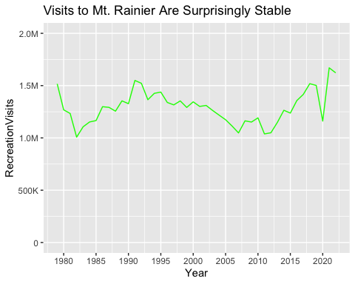

## Exercise 3

Now, create a plot that zooms in on the most interesting time period for this particular National Park.

### 3a.

Change the x-axis limits so that it only shows the most interesting years.

### 3b.

Come up with a new title that describes this time period.

ggplot(my_parks_df) +  
 geom_line(aes(  
 x = Year,  
 y = RecreationVisits  
 ),  
 color = "green") +  
 scale_x_continuous(  
 breaks = seq(from = 1980, to = 2020, by = 5),   
 limits = c(2005, 2023),  
 ) +  
 scale_y_continuous(labels = label_number(scale_cut = cut_short_scale()),  
 limits = c(0, 2000000)) +  
 labs(title = "After a COVID Dip, Mt. Rainier Visits Are Higher Than Ever")

