Spring Derivative

Deriving the derivatives of Hooke’s law is just a matter of first finding a couple basic derivatives and then using the standard rules to complete the formulas. For deriving what we really need, it’s actually enough to initially think of the 3D spring as a single 3tuple (v). The math is so simple. I tried to provide a maple worksheet that included all of this, but I found that hard to get maple to express the equations in the intuitively most pleasing way. So, I’m just using MS Word here instead.

Derivative of some function wrt a vector
Since it isn’t covered in first year calculus we mention some simple concepts about doing derivatives with 3D vectors. The following is the general derivative of a function f() with respect to a vector:
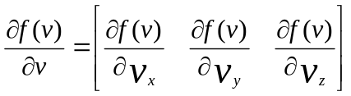
So if the function f produces a scalar the derivative in this case becomes a vector. Should f() produces a vector then the resulting derivative is a matrix etc. In tensor-speak, the rank is increased by one. Other than that everything else is just simple first year calculus.

Note that I’m just using v in the mathematical equations here so it reinforces the idea that it’s a vector. I also just assume 3D (x,y,z space) since that’s the most common application. Therefore I chose not to use x as the state vector since people might get confused with that and the x in x,y,z.

Derivative of the Magnitude

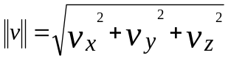

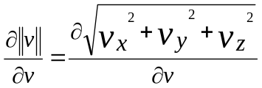

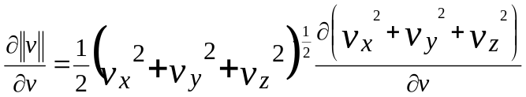

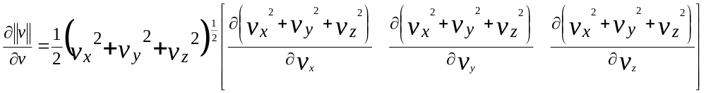

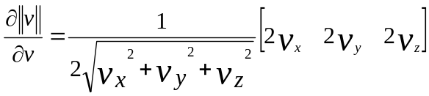

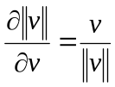

The result should be immediately recognized. It’s the unit length vector in the direction of v. What does this mean? Think of the equation as:

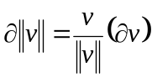

This clearly shows how a change in v will affect the magnitude. The difference it will make to the magnitude is what is meant by the symbols on the left hand side of the equation. The change in v (delta v) is the thing we moved to the right hand side. The answer is the dot product of that little change you make with the unit length vector along v. The change in magnitude in the neighborhood will be proportional to the change in v if you happen to move parallel (in the direction of) v or –v. If you adjust the vector moving orthogonal to its direction of motion, then the magnitude won’t change – at least not significantly until the 2nd derivative has something to say about it. The length of v doesn’t matter - just its direction does.

Hopefully this example explains why the increase in rank is necessary. While the magnitude of a vector is just a scalar, the first derivative of this function is a vector. Remember we are taking the derivative wrt a vector. Other derivatives such as taking the derivative wrt a scalar such as time do not increase rank. For example, position, velocity and acceleration all have the same rank and dimension.

Derivative of the Direction Vector

The normalized or unit length “direction” of a vector is:

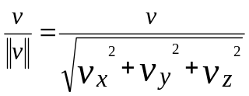

The derivative of this direction with respect to the vector itself is:

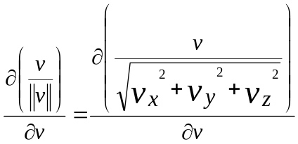

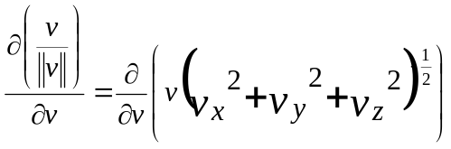

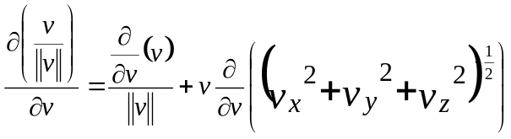

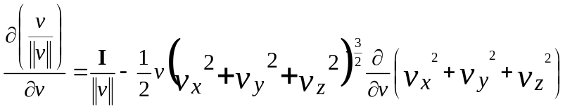

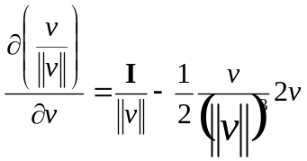

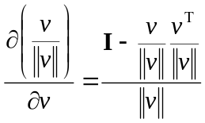

The ‘I’ stands for the identity matrix. The other term in the subtraction is the outerproduct of the normalized vector with itself. The matrix in the numerator may look familiar. It projects a vector onto the plane with normal ‘v’. In other words, it removes any contribution along the direction of ‘v’. The resulting formula is intuitive since any change along the direction of v would have no affect in the direction. Only changes orthogonal to it would. Furthermore, given a small modification to v, the resulting change in direction is inversely proportional to the length of v. So it makes sense that the whole thing is divided by the magnitude of v.

Application to Spring Force - Hooke’s Law
Pretend that we have a spring with one endpoint fixed at the origin and the other endpoint is at v. The force exerted by the spring:

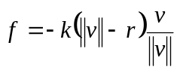

Using what we’ve shown previously along with some basic rules of calculus we end up with:

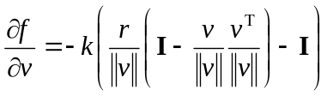

Sorry for not including some more substeps, but I’m getting tired of MS Word’s equation editor. Also note that this doesn’t include the damping. That term is mentioned later after we introduce time derivatives and velocity.

Time Derivative
If v represents a position then how that position changes over time is its velocity. This is often expressed as:
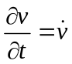

How does velocity of a moving point affect its absolute distance from the origin?

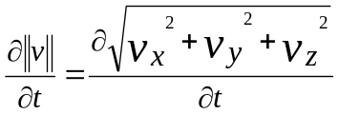

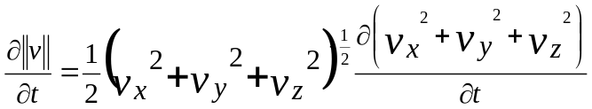

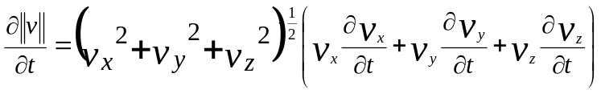

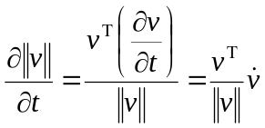

The result is the dot product of the unit length direction vector and the velocity.

Velocity Derivative

In one place we will need to take the derivative of a force with respect to velocity. This only applies to damping. Hooke’s law otherwise isn’t sensitive to velocity.

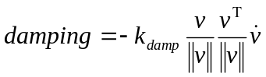

Again we see the familiar tensor that projects the velocity onto the direction. The needed derivative is simply:

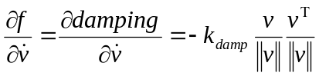

This is what you plug into the corresponding df/dv term in Baraff’s equation 6.

Keeping the System Symmetric
Systems of equations are easier to solve when you have a symmetric matrix. As suggested by Baraff and Witkin, we can achieve this by dropping a term from the derivative of damping force with respect to the spring endpoint positions. So, even though it’s not accurate, just pretend:

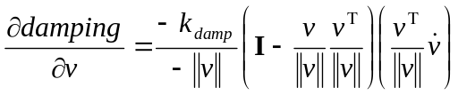

This term is added with the derivative of the spring force (f).

Generalizing to Springs with non-origin Endpoints

To fit with our spring network with many point masses, each spring will not be described by a single vector v, but rather two endpoints xi and xj or just a and b. The equations are really the same. Specifically if v=a-b then:

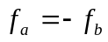

and therefore

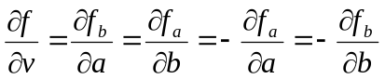

S Melax, 2006

