**Get Started**

Summary

Set Environment

Install SSH Client on Your PC Download NetLogo to HPC

Run Experiment

Set Model BahaviorSpace

Revise and Run create_xmls.sh

Revise and Run submit_jobarray.slurm

Merge CSV Results Other Notes

**Cheat Sheet**

# **G et Started**

## **Summary**

The main idea is to run NetLogo's [BehavorSpace](http://ccl.northwestern.edu/netlogo/docs/behaviorspace.html#advanced) in ["headless" mode](http://ccl.northwestern.edu/netlogo/docs/behaviorspace.html#running-from-the-command-line). Experiments in BehaviorSpace is split into a number of separate simulations, each of which is submitted to HPC as a separate job and run in parallel.

Four steps are required to run NetLogo models on HPC:

1. Install an [SSH](https://en.wikipedia.org/wiki/Secure_Shell) client to connect HPC (For Mac OS users, this is not required).
2. Download NetLogo software and unzip it to your project directory on HPC.
3. Add an experiment in the BahaviorSpace of your NetLogo model.
4. Make a copy of the templates in this repository, revise and run your model.

Steps 1 and 2 are to set up work environment, and are only need to be done once.

## **Set Environment**

### **Install SSH Client on Your PC**

This part is only required for Windows users. Mac (OS X) already has an SSH client built-in, so Mac users can skip this step.

1. Install an SSH client such as [PuTTY](http://www.putty.org/), [Bitvise](https://www.bitvise.com/ssh-client-download), or [MobaXTerm](http://mobaxterm.mobatek.net/download-home-edition.html). Here we use [Bitvise SSH Client](https://www.bitvise.com/ssh-client-download) as an example.
2. Set up Bitvise SSH client

Tab **[Login]**: Set **Host** as spartan.hpc.unimelb.edu.au (change here to use the host by your institute), **Port** as 22 , **Username** as your username , **Initial method** as password , **Password** as your password.

Tab **[Options]**: Tick **Open Terminal** and **Open SFTP**.

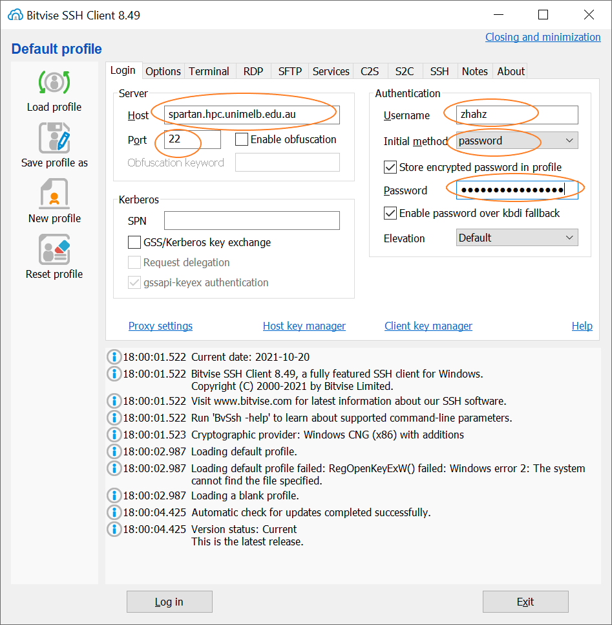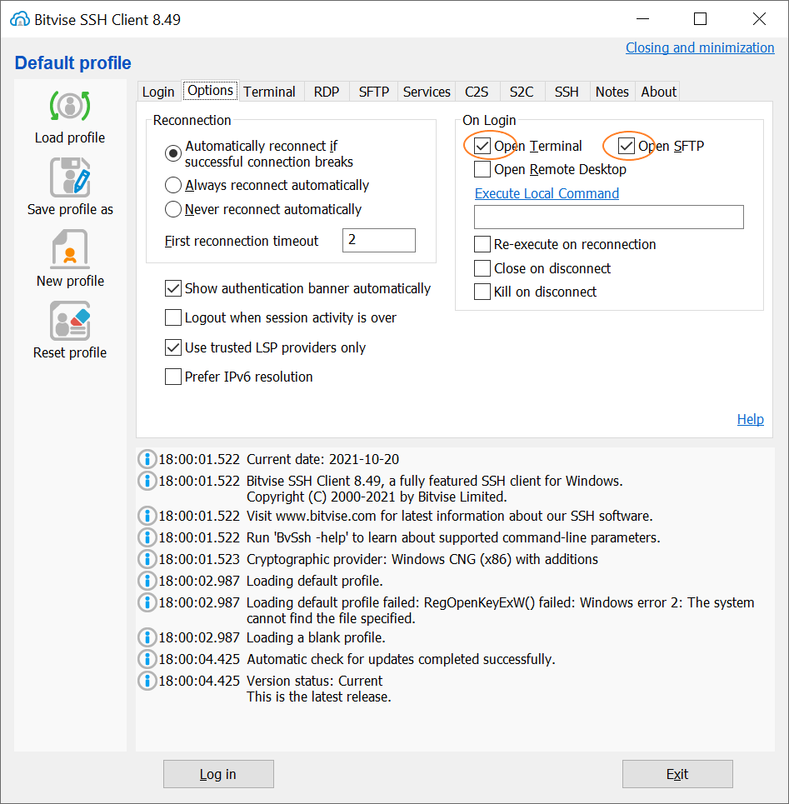

1. Save profile

Click [**Save profile**] on the left panel, so that next time you do not need to type all these settings.

1. Log in Spartan

Click [**Log in**] button at the bottom, type your password and click [**OK**] to login. This should open a command prompt window and a SFTP window.

The command prompt is where you type and run your scripts. The SFTP window provides a graphical user interface where you can create/copy/delete files and folders, upload files to Spartan by dragging a file from left to right, and download files to your laptop by dragging files from right to left.

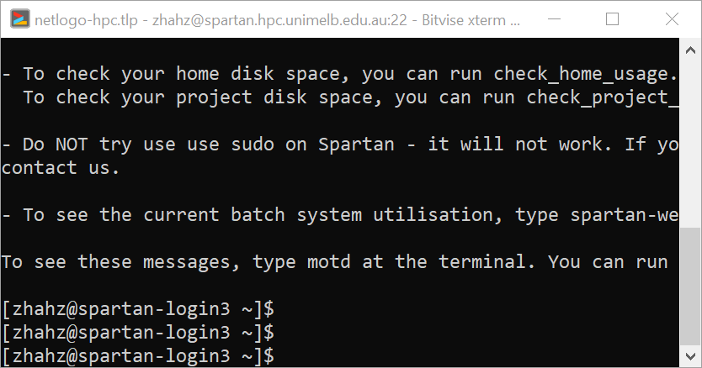

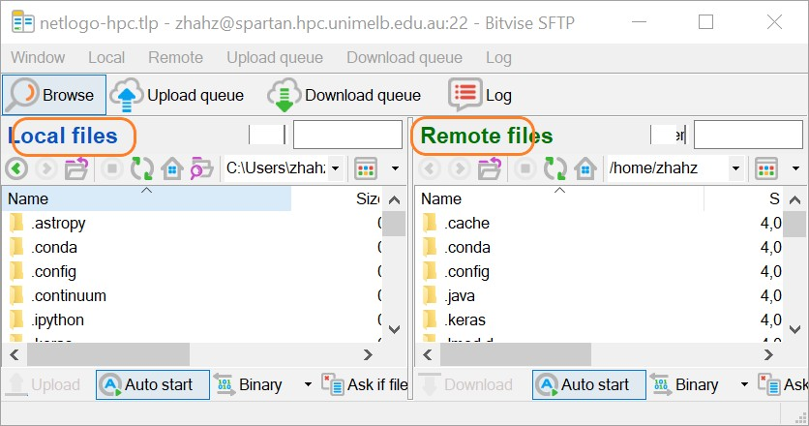

### **Download NetLogo to HPC**

In this example, we download NetLogo to this folder

/data/gpfs/projects/punim1439/workflow/netlogo_hpc . In SFTP window, right click mouse and Create Folder netlogo_hpc.

Then, in command line,

* 1. Run

cd /data/gpfs/projects/punim1439/workflow/netlogo_hpc

to change current directory to /data/gpfs/projects/punim1439/workflow/netlogo_hpc .

* 1. Run

wget https://ccl.northwestern.edu/netlogo/6.2.0/NetLogo-6.2.0-64.tgz

to download NetLogo installation file to current directory.

* 1. Run

tar -xzf NetLogo-6.2.0-64.tgz

to install (unzip) NetLogo to current directory.

Click **Refresh**, and you should be able to see the NetLogo 6.2.0 folder.

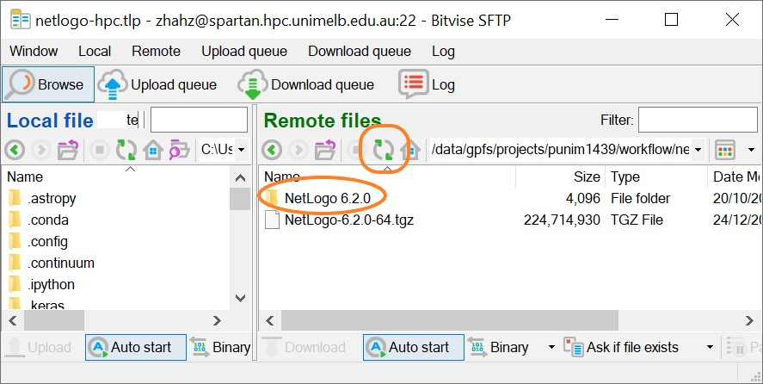

💡**Tips**:

Copy and paste in command prompt: **Right Click** mouse🖱 in command prompt to paste content from clipboard.

Press up arrow key⬆ and down arrow key ⬇ in keyboard to recall command history.

## **Run Experiment**

### **Set Model BahaviorSpace**

1. We used a

Wolf_Sheep_Predation.nlogo

model as an example.

This model is adjusted on top of a NetLogo sample model NetLogo 6.2.0/app/models/Sample Models/Biology/Wolf Sheep Predation.nlogo. We created an HPC_Experiment in the BahaviorSpace, added a global variable repetitions with 100 values, and removed user-message "The sheep have inherited the earth".

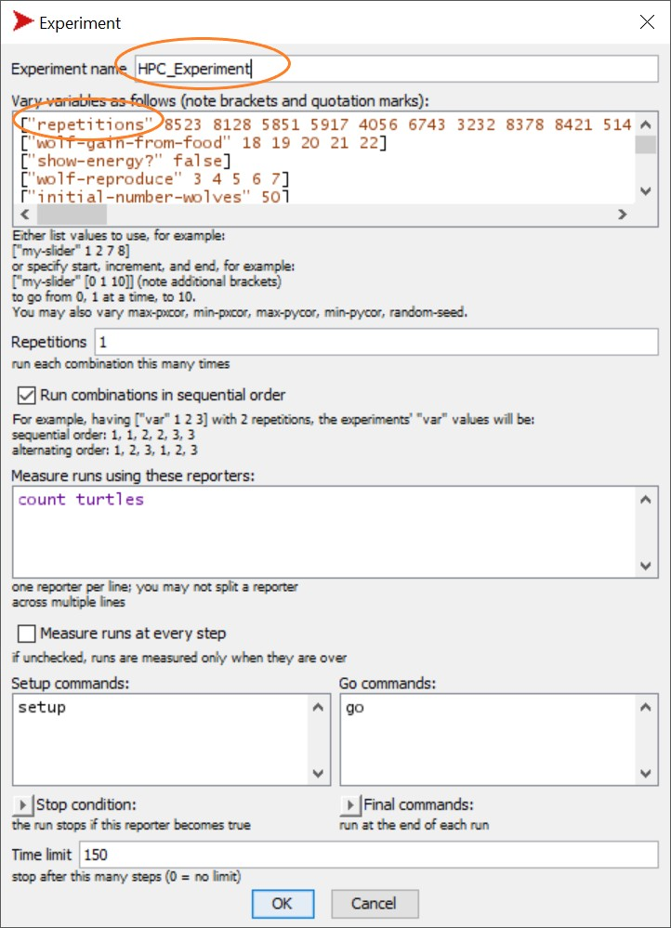

1. Upload Wolf_Sheep_Predation.nlogo , HPC folder.

create_xmls.sh

and to

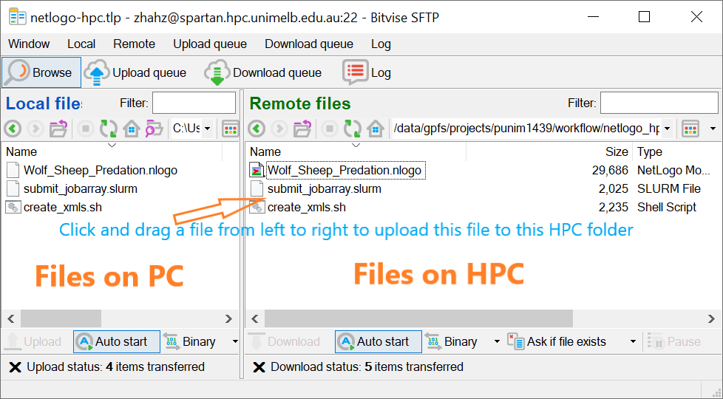

💡**Tips**:

If your model is on GitHub, clone the repo (for example

https://github.com/JTHooker/COVIDModel ) directly to HPC using:

git clone https://github.com/JTHooker/COVIDModel

### **Revise and Run**

create_xmls.sh

1. Edit

create_xmls.sh

(using text editor notepad++, notepad, etc.)

BEHAVIORSPACE_NAME= 'HPC_Experiment'

submit_jobarray.slurm

NETLOGO_MODEL= '/data/gpfs/projects/punim1439/workflow/netlogo_hpc/Wolf_S

heep_Predation/Wolf_Sheep_Predation.nlogo'

1. End of Line (EOL) Conversion

From Bitvise command line, change directory to Wolf_Sheep_Predation :

cd /data/gpfs/projects/punim1439/workflow/netlogo_hpc/Wolf_Sheep_Predation

Then, run

sed -i.bak 's/\r$//g' create_xmls.sh

to convert Windows (CR LF) line ending to Unix (LF)

1. Run

bash create_xmls.sh

From Bitvise command line, run

bash create_xmls.sh

to create xmls folder and 100 xml files under this folder.

💡**Tips**:

MS-Windows to Unix like operation systems are using different End of Line (EOL).

If you want to see line ending in Notepad++, click menu **View > Show Symbol > Show All Characters**, then you will see Windows has line ending with invisible characters **CRLF**, while Unix has **LF**. Click menu **Edit > EOL Conversion > Unix (LF)** to convert MS-Windows to Unix EOL, as HPC is using Unix like operation systems.

Command did the same thing, using string editor

sed -i.bak 's/\r$//g' create_xmls.sh

to convert EOL of create_xmls.sh to Unix removing all **CR**, and the original file is backed up

as submit_jobarray.slurm.bak .

### **Revise and Run**

submit_jobarray.slurm

1. Edit

submit_jobarray.slurm

(using text editor notepad++, notepad, etc.).

are script directive for Spartan. This script creates a job array of **100** jobs. Each job requires **1** computer node and **8** CPU cores on **snowy** cluster for a maximum wall time of **2** hours. When all jobs are ended, an email notification will be sent to –mail-

#SBATCH

#SBATCH

--mail-type

user. In

directive, --qos , -A , --job-name , --mail-user ,

are

optional, and can be deleted.

BASE_FOLDER: current directory of submit_jobarray.slurm , and the upper directory of

xmls folder.

NETLOGO_SH: file path of netlogo-headless.sh under NetLogo 6.2.0 directory.

NETLOGO_MODEL: file path of Wolf_Sheep_Predation.nlogo OUTPUT_FOLDER: name of output folder.

1. End of Line (EOL) Conversion From Bitvise command line, run

sed -i.bak 's/\r$//g' submit_jobarray.slurm

1. Run

sbatch submit_jobarray.slurm

sbatch submit_jobarray.slurm

to submit 100 jobs to Spartan. You will receive an email when the computation ends.

💡**Tips**:

Run username.

squeue -u yourusername

to see current jobs, replacing

with your

yourusername

Run scancel -n wolf_sheep_predation to cancel a job, replacing

wolf_sheep_predation with the value after

SBATCH --job-name=

submit_jobarray.slurm ).

Run spartan-weather to see usage of all partitions (optional). Run clear to clear screen.

Run exit to quite command line.

1. Move all slurm_*.out files to slurm folder (optional) When all jobs finished, run

(file

cd /data/gpfs/projects/punim1439/workflow/netlogo_hpc/Wolf_Sheep_Predation mkdir -p slurms

mv ./slurm-*.out ./slurms/

to create a folder slurms, and move all slurm-*.out files to slurms folder.

### **Merge CSV Results**

cd

/data/gpfs/projects/punim1439/workflow/netlogo_hpc/Wolf_Sheep_Predation/outputs

awk '(NR < 8) || (FNR > 7)' *_table_*.csv > MergedResults.csv

This will create a file as the final output file.

MergedResults.csv

## **Other Notes**

1.



cd

Change directory command is to avoid always typing the absolute path when running script files.

cd /data/gpfs/projects/punim1439/workflow/netlogo_hpc/Wolf_Sheep_Predation

bash create_xmls.sh

sbatch submit_jobarray.slurm

cd outputs

awk '(NR < 8) || (FNR > 7)' *_table_*.csv > MergedResults.csv

is the same as using

bash

/data/gpfs/projects/punim1439/workflow/netlogo_hpc/Wolf_Sheep_Predation/crea te_xmls.sh

sbatch

/data/gpfs/projects/punim1439/workflow/netlogo_hpc/Wolf_Sheep_Predation/subm it_jobarray.slurm

awk '(NR < 8) || (FNR > 7)'

/data/gpfs/projects/punim1439/workflow/netlogo_hpc/Wolf_Sheep_Predation/outp uts/*_table_*.csv >

/data/gpfs/projects/punim1439/workflow/netlogo_hpc/Wolf_Sheep_Predation/outp uts/MergedResults.csv

1. In command prompt, put file path or directory path in example



“ ”

if filename includes space, for

cd “/data/gpfs/projects/punim1439/workflow/netlogo_hpc/NetLogo 6.2.0”

1. Bitvise

Click **[New terminal console]** to open a new command window. Click **[New SFTP window]** to open a new SFTP window. Set the **Initial directory** in Tab **[SFTP]** and Save profile, to specify initial directories for your new SFTP windows.

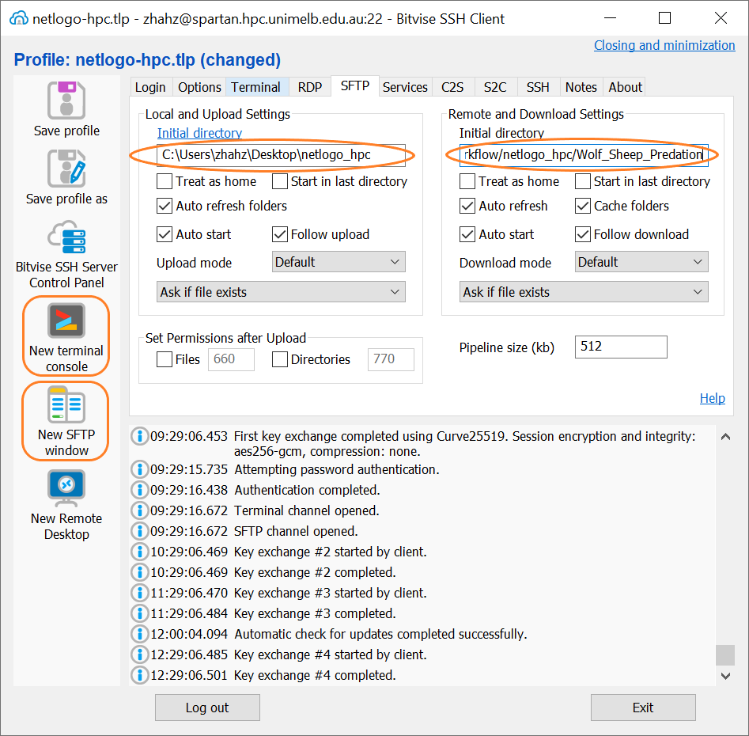

1. NetLogo RAM

To run models that require large memory, you need to change NetLogo's RAM of Java virtual machine (JVM).

Make a copy of netlogo-headless.sh (e.g. netlogo-headless-10g.sh)

cd "/data/gpfs/projects/punim1439/workflow/netlogo_hpc/NetLogo 6.2.0" cp netlogo-headless.sh netlogo-headless-10g.sh

Edit netlogo-headless-10g.sh : Line 15, Change **-Xmx10240m** to **-Xmx10g** to increase 1GB RAM to 10GB RAM.

JVM_OPTS=(-Xmx10g -XX:+UseParallelGC -Dfile.encoding=UTF-8)

Notes: You can either edit

netlogo-headless-10g.sh

line on command prompt by running

using any text editors, or edit in

nano netlogo-headless-10g.sh

After editing, press <Ctrl+X> to exit, type <Y> to save changes, then press <Enter> to overwrite file.

1. NetLogo extensions

If your model requires an extension which is not a default extention of NetLogo software, the extension should be copied to the same folder of the NetLogo model or can be placed in the extension’s folder in the NetLogo extensions directory. Refer [here](https://ccl.northwestern.edu/netlogo/docs/extensions.html) for where to find extensions.

For example, we can copy rngs folder from

C:\Program Files\NetLogo

on our laptop to

6.2.0\app\extensions\.bundled\rngs

/data/gpfs/projects/punim1439/workflow/netlogo_hpc/NetLogo 6.2.0/app/extensions/.bundled/rngs on HPC.

1. Single run

If your experiment only has **one run** that cannot be split (Note the of

HPC_Experiment

has 100 runs), or you just want to run your model by submitting one job to HPC, then you can simply save the following script as

Wolf_Sheep_Predation.nlogo

(ℹuse Unix EOL), and run

submit_single_job.slurm

sbatch submit_single_job.slurm

after you Set Model BahaviorSpace You do not need to run Revise and Run

Revise and Run submit_jobarray.slurm

create_xmls.sh ,

and Merg

CSV Results.

# -- file submit_single_job.slurm --

#!/bin/bash

#SBATCH --nodes=1

#SBATCH --partition interactive

#SBATCH --time 1:00:00

#SBATCH --cpus-per-task=8

module load java

cd "/data/gpfs/projects/punim1439/workflow/netlogo_hpc/Wolf_Sheep_Predation" "/data/gpfs/projects/punim1439/workflow/netlogo_hpc/NetLogo 6.2.0/netlogo- headless.sh" \

--model "Wolf_Sheep_Predation.nlogo" \

--experiment "HPC_Experiment" \

--table "output_file.csv"

You can also run NetLogo headless mode on Windows PC (if JAVA_HOME has been set or system PATH has included java.exe), using

cd "C:\Users\zhahz\Desktop\netlogo_hpc"

"C:\Program Files\NetLogo 6.2.0\netlogo-headless.bat" ^

--model "Wolf_Sheep_Predation.nlogo" ^

--experiment "HPC_Experiment" ^

--table "output_file.csv"

# **Cheat Sheet**

# change work directory

cd /data/gpfs/projects/punim1439/workflow/netlogo_hpc/Wolf_Sheep_Predation

# create experiments

sed -i.bak 's/\r$//g' create_xmls.sh bash create_xmls.sh

# check which partition has more available CPUs spartan-weather

# submit jobs

sed -i.bak 's/\r$//g' submit_jobarray.slurm sbatch submit_jobarray.slurm

# check job status squeue -u yourusername

# clean log files mkdir slurms

mv ./slurm-*.out ./slurms/

# merge results cd outputs

awk '(NR < 8) || (FNR > 7)' *_table_*.csv > MergedResults.csv

# cancel job

scancel -n wolf_sheep_predation