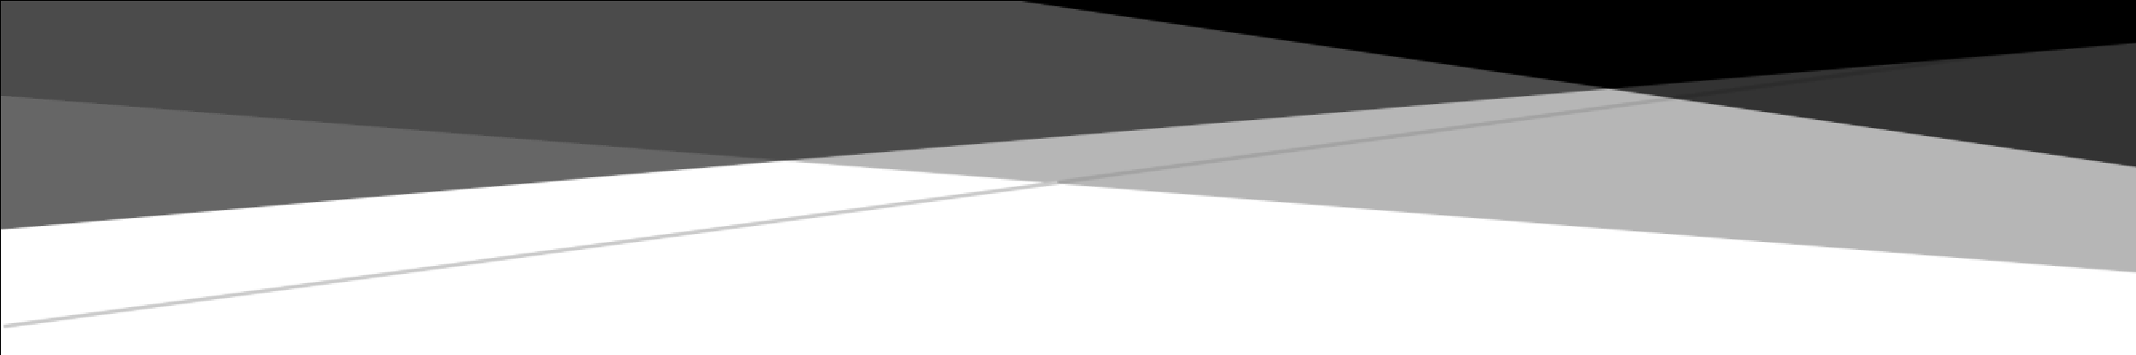

**High Level Design**

**Wafer Fault Detection Application**

# Document Version Control

|  |  |  |  |
| --- | --- | --- | --- |
| **Date Issued** | **Version** | **Description** | **Author** |
| 28/03/2023 | 1 | Initial HLD - V1.0 | Melbin Biju |
|  |  |  |  |
|  |  |  |  |

# Abstract

The goal of the wafer fault detection project is to build a machine learning model that can predict whether a wafer needs to be replaced or not based on the inputs from various sensors. The project involves preparing and analyzing the data, engineering relevant features, selecting and training a suitable classification algorithm, tuning its hyper parameters, and deploying the model in the production environment. The model's performance is evaluated using different evaluation metrics, and its interpretability is ensured to provide insights into the factors that contribute to the fault detection. The successful implementation of the model can improve the quality of wafer sensors and reduce the cost of manufacturing.

# Table of Contents

1. Introduction
   1. Purpose of the document…………………………………………………………………4
   2. Objective of HLD………………………………………………………………………………4
   3. Scope of HLD……………………………………………………………………………………4

1. System Overview
   1. Product prospective………………………………………………………………………….5
   2. Problem statement……………………………………………………………………………5
   3. Proposed solution……………………………………………………………………………..5
   4. Technical requirements……………………………………………………………………..5
   5. Data requirements…………………………………………………………………………….6
   6. Tools used…………………………………………………………………………………………6
   7. Constraints………………………………………………………………………………………...6

1. Design Flow
   1. Process flow………………………………………………………………………………………7
   2. Event log…………………………………………………………………………………………...7
   3. Error handling……………………………………………………………………………………8

1. Performance
   1. Re-usability……………………………………………………………………………………….8
   2. Application compatibility………………………………………………………………….8
   3. Resource utilization…………………………………………………………………………..8
   4. Deployment………………………………………………………………………………………8

1. Conclusion………………………………………………………………………………………………......9

# 1. Introduction

This document will be used for documenting High-level designs of project.

## 1.1 Purpose of the Document

The purpose of this plan is to

* Identify different design approaches.
* Identify core modules/sub-systems of the system and sub-system boundary.
* Identify the best suitable technology for various sub-systems.
* Identify areas that need R&D.
* Identify third party components required in the system.
* Identify components, state, life cycle, and communication mechanisms between different sub-systems, and also identify the external interface.
* Identify various usage scenarios.

## 1.2 Objective of HLD

1. To provide an overview of the entire system.
2. To provide a module-wise breakup of the entire system.
3. To provide introduction and high level working of every module involved.

**1.3 Scope of HLD**

This HLD covers all areas of system

# 2. System Overview

## 2.1 Product Prospective

The Wafer fault detection prediction problem using classification-based Machine Learning algorithms.

## 2.2 Problem statement

To build a classification methodology to predict the quality of wafer sensors based on the given training data.

The inputs of various sensors for different wafers have been provided. In [electronics,](https://en.wikipedia.org/wiki/Electronics) a wafer (also called a slice or substrate) is a thin slice of [semiconductor](https://en.wikipedia.org/wiki/Semiconductor) used for the [fabrication](https://en.wikipedia.org/wiki/Semiconductor_device_fabrication) of [integrated circuits.](https://en.wikipedia.org/wiki/Integrated_circuit) The goal is to build a machine learning model which predicts whether a wafer needs to be replaced or not (i.e. whether it is working or not) based on the inputs from various sensors. There are two classes: +1 and -1.

* +1 means that the wafer is in a working condition and it doesn’t need to be replaced.
* -1 means that the wafer is faulty and it needs to be replaced.

## 2.3 Proposed Solution

The solution here is a classification based Machine Learning model. We perform data preprocessing on the given data, do feature engineering and group it into different clusters. We choose best model from each cluster and whenever test data comes, first it finds suitable cluster, then it selects the proposed model for that cluster to predict the results.

## 2.4 Technical Requirements

We are trying to predict good wafers and bad wafers according to the provided dataset. For that, in this project we are going to use different technologies. Here are some requirements for this project.

* Model should be exposed through API or User Interface, so that anyone can test model.
* Model should be deployed on cloud (Azure, AWS, GCP).
* Database should be integrated in this project for any kind of user input

## 2.5 Data Requirements

Data Requirements completely depend on our problem.

* For training and testing the model, we get list of csv files from the training batch files and testing batch files.
* From user we are getting the input path of training batch files and testing batch files so that we can access datasets with ease.

## 2.6 Tools Used

* VSCode is used as IDE.
* For visualization of the plots, Matplotlib, Seaborn are used.
* AWS is used for deployment of the model.
* SQLite is used to retrieve, insert, delete, and update the database.
* Front end development is done using HTML/CSS, JavaScript.
* Flask is used for backend development and for API development.
* GitHub is used as version control system.

## 2.7 Constraints

The wafer fault detection system must be user friendly, errors free and users should not be required to know any of the back end working.

# 3. Design Flow

## 3.1 Process Flow

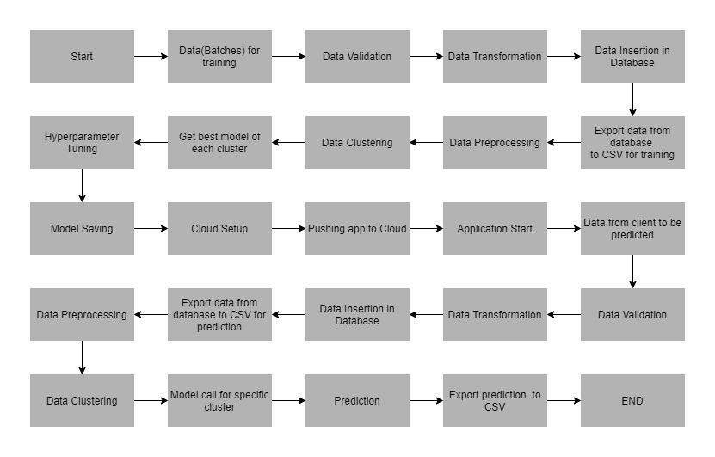

## 3.2 Event Log

In this Project we are logging every process so that the user will know what process is running internally. Step-By-Step Description:

* We defined logging for every function, class.
* By logging we can monitor every insertion, every flow of data in database.
* By logging we monitor every step which may create problem or every step which is important in file system.
* We have designed logging in such a way that system should not hang even after so many logging's, so that we can easily debug issues which may arises during process flow.

## 3.4 Error Handling / Exception Handling

We have designed this project in such a way that, at any step if error occur then our application should not terminate rather it should catch that error and display that error with proper explanation as to what went wrong during process flow

# 4. Performance

We perform prediction in order to understand whether we need to replace wafer or not. The successful implementation of the model can improve the quality of wafer sensors and reduce the use of resources. Also, model retraining is very important to improve performance.

## 4.1 Re-usability

We have done programming of this project in such a way that it should be reusable. So that anyone can add and contribute without facing any problems.

## 4.2 Application Compatibility

The different module of this project is using Python as an interface between them. Each module have its own job to perform and it is the job of the Python to ensure the proper transfer of information.

## 4.3 Resource Utilization

In this project, when any task is performed, it will likely that the task will use all the processing power available in that particular system until it’s job finished.

**4.4 Deployment** we have deployed this on cloud using AWS.

# 5. Conclusion

The use of wafer fault detection model helps to understand which all wafers are good and bad. If some are bad, it can be suggested for the replacement. By predicting in this way, we can avoid the manual checking of each wafers which is costly and time consuming, so company can invest money on other areas without bothered about the wafer replacement.