

Wafer Fault Detection Project

Wireframe Documentation

# Home Page

We get this homepage. Here, enter path of the folder containing list of training files in this form and submit it. Training of the model is started as you click on the submit button.

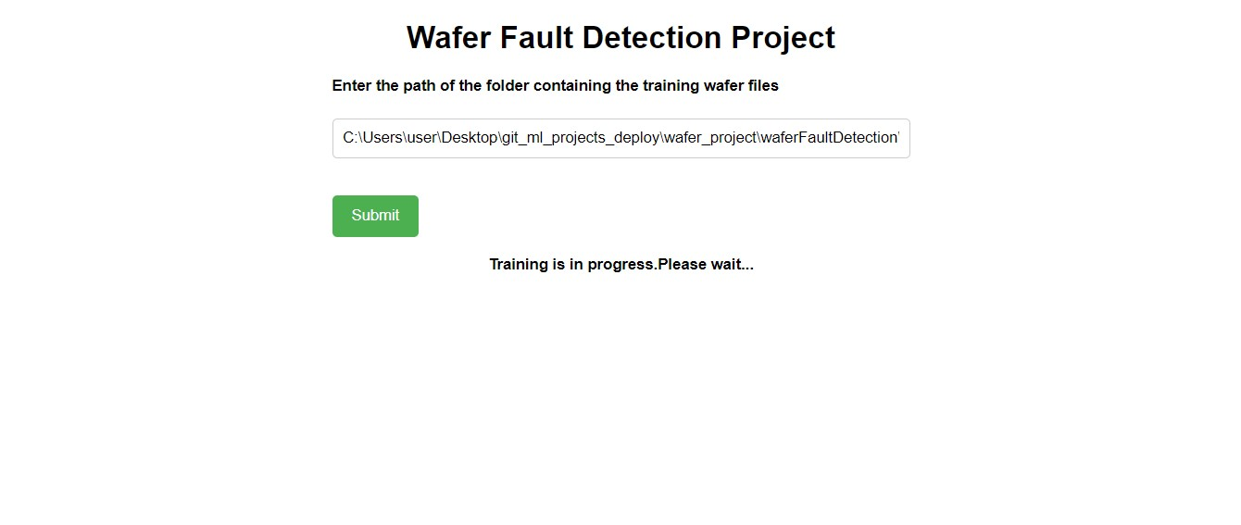

Prediction Page

After completion of the model training, you will get the message “Training is Successful ” . Now we need to enter the path of folder containing prediction files to predict using model. Prediction process become started after you click on this submit button.

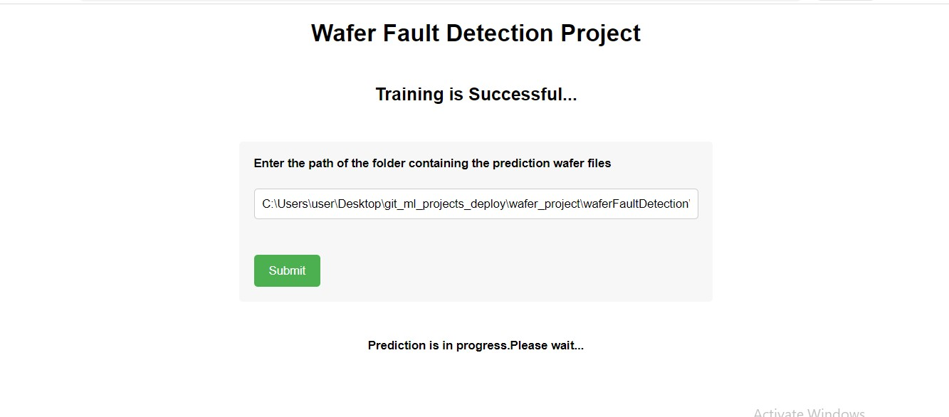

# Results Page

This is the last page that we get here. Here we can see some of the prediction samples whether wafer is faulty or not.

