Quantic: Proposed Architecture for Sales
Oct 17, 2026 · @Mel Boulos

Bottom line
- Quantic gets a modern architecture at about today's credit burn: 90-day hot tier, full history in a shadow store, Analytics inside the cluster.
- Funded by consolidation, not new spend: the unused Columnar instance and an oversized Index tier pay for Analytics and dedicated Eventing.
- Proven on our own Capella cluster, at half Quantic's scale, with Quantic's data model.
- Opens the AIDP / MCP conversation: AI agents answer operational and historical questions safely, already demo-ready.
- Commit sizing: should reflect current consumption (~22.5K credits/mo today) plus a few transition months.

Why it matters to Quantic
Today Quantic ages data out to control cost, so the questions merchants and Quantic care most about stop being answerable.
- Who they serve: a cloud, processor-agnostic POS for independent restaurants, cafés, bars and food trucks, sold largely through resellers.
- How data arrives: iOS, Android and web POS apps sync through Couchbase Mobile; commChannel is the merchant and the sync channel (to confirm with Quantic).
- Today: every document type shares one _default collection, told apart by a docType field, and older data is aged out.
- What gets lost: year-over-year sales, seasonal and holiday patterns, menu trends, and early warning that a merchant is about to churn.
- The fix: keep recent data fast and small, keep years of history affordably, and make both answerable in plain English.

What we tested
We rebuilt Quantic's POS data model on Capella (17 collections, 225 merchants, 3 years) and ran their real queries plus a demo set.
- TTL works per document: each hot doc expires exactly 90 days after it was created, not 90 days after load. This avoids an "expiry storm" after migration.
- Eventing copy is exact: in a sample, 408 of 408 history copies were identical to the hot doc and carried no TTL. It backfilled about 12.4M docs in minutes, with 0 failures.
- Analytics keeps up: history is ingested within seconds of the copy.
- Query alone gives wrong answers on old data: after the 90-day cutoff, a churn report on Query showed merchants up 1–2%. Analytics on history showed them down 20%, and ran 30% faster.
- Recent lookups are unaffected: Quantic's own queries return the same rows at the same speed.
- Found a gap in Quantic's Eventing filter: isClosed === 1 alone silently skips record types without that field (transactionDetail). Fixed in our design.
- Realistic data: the synthetic dataset follows Quantic's production document shapes field for field, built from 14 sample documents Quantic provided; no real IDs or menus are reused.

Today vs. proposed (qdb-us)
The new layout runs at about 5% fewer credits than today, before a disk increase for Quantic's 4 KB documents.
Service | Today | Proposed | Why
Data | 3 × 8 vCPU/64 GB, 3.8 TB | 3 × 8/64, 6 TB recommended | Hot bucket (90-day TTL) + shadow bucket (full history, no TTL)
Index | 4 × 16 vCPU/128 GB | 2 × 8/64 | Indexes only cover 90 days of data
Query | Shared with Eventing | 2 × 8/64, dedicated | Recent, selective queries only
Eventing | Shared with Query | 2 × 8/16, dedicated | Copy path never competes with user queries
Analytics | None in cluster | 4 × 8/32, ~1.1 TB each | History, reporting and AI agents
App Services | 3 × 8/16 | Unchanged | Scale up briefly for cutover
Credits/mo, cluster | 11,651 | 10,954 | Actual vs. Capella estimator
Credits/mo, App Services | 2,657 | 2,657 | Unchanged
Credits/mo, total | 14,308 | 13,611 | About −5%
The proposed figures use 1.5 TB per Data node and 800 GB per Analytics node. The recommended disk sizes add a small amount to price.
Index design: no docType filters (the collection is the type), partial indexes on the state that defines a sale, covering indexes for common aggregates, no primary indexes, and large indexes built deferred and partitioned. 18 indexes cover every customer and demo query.

The good news: consolidation pays for it
Quantic already pays for the capacity the new design needs; it is just in the wrong places.
- Repurpose the unused Columnar instance: quanticanalytics (2 × 8/64) shows 0 buckets and 0 documents. Its spend, about 2K credits/mo, moves into in-cluster Analytics.
- Right-size the Index tier: 4 × 16/128 shrinks to 2 × 8/64 once the old _default indexes are dropped. That funds Analytics nodes 3–4, dedicated Eventing and a separate Query tier.
- One cluster instead of two: one set of links, one security model, one bill, one place for AI agents to connect.
- Framing: in Capella this moves spend, not servers. We retire Columnar and resize service groups; nothing is physically moved.
- Magma keeps history affordable: Couchbase reports Magma runs at as little as 1% memory-to-data, holds up to 10 TB per node, and lowers total cost of ownership by up to 10× versus Couchstore. History is written once and read in scans, so memory is the cost that matters.

AI Data Plane (AIDP): the upside
The AI Data Plane turns Quantic's operational data into something anyone can question in plain English, without a data warehouse, ETL or a BI team, and it runs on the same consolidated cluster.

What AIDP is
- One governed layer between Quantic's live data and AI assistants: the hot tier for what is happening now, the history store for everything that happened, both reachable through read-only MCP servers.
- No copies, no pipelines: the AI reads the same data the POS writes, seconds old, not last night's extract.
- Guardrails built in: read-only access, a routing rule that sends older questions to Analytics, and per-query limits.

Why it matters
For | Value | Example question
Quantic leadership | Decisions from data Quantic already owns, in minutes instead of a report request | "Which merchants are at risk, and how much revenue is at stake?"
Quantic product and sales | A new, sellable insights product for merchants, built on cross-merchant data only a platform has | "How does my store compare to similar restaurants in my state?"
Merchants | Answers about menu, labor, voids and seasonality without exporting spreadsheets | "Why did salmon sales stop at Fishtown last week?"
Quantic support and success | Faster root cause on merchant tickets: the assistant traces a problem across collections | "Why was this location's week flat?"
Engineering | No warehouse to build or keep in sync; one security model; the index advisor on the same connection | "Is the query you just ran using a good index?"
- The moat: years of transaction history across hundreds of merchants is data no single restaurant and no competitor without it can match. AIDP is what turns that history from a cost into a product.
- The economics: it reuses the Analytics capacity funded by consolidation (Columnar budget plus a smaller Index tier), so the AI capability arrives without a new platform line item.
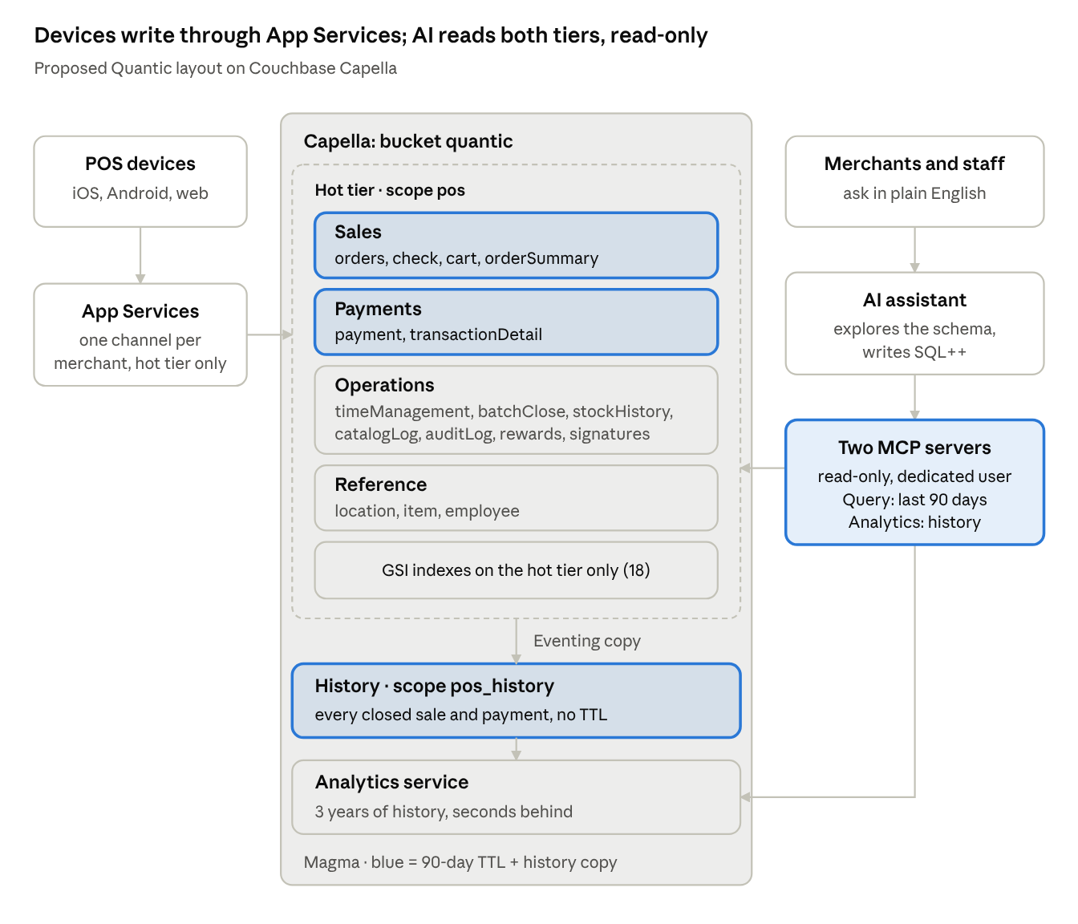
AI data plane · write path left, AI read path right
Devices write and sync only the hot tier; the assistant reaches both tiers through two read-only MCP servers and picks the engine by time range.

How it works and how it is governed
- Two read-only MCP servers, already built and demo-ready: one for operational queries (Query service), one for history (Analytics).
- Built-in routing guardrail: questions older than 90 days go to Analytics automatically, so agents never return the wrong numbers we found on Query.
- Demo story: "Which merchants are at churn risk?" Analytics answers correctly in seconds; Query alone would have hidden a 20% decline.
- Why it matters for Quantic: merchant insights, support agents and reporting from the same cluster, with no new data pipeline.
- Expansion path: AI use cases grow on capacity Quantic already owns.
- Proven in an earlier run: asked why a flagship location had a flat week, the assistant traced it in six queries to one menu item out of stock for four days.
- Two independent safeguards: a dedicated read-only database user, and the MCP server's read-only mode, which blocks writes and index or collection changes.
- Path to production: one shared MCP server (Streamable HTTP with OAuth) so access is granted centrally and every query is logged; covering indexes, no primary indexes and query time-outs keep AI queries cheap.
- Before merchants use it: Couchbase permissions stop at the collection, so per-merchant scoping needs a thin service that injects the merchant filter.

Rollout
The higher spend is limited to the migration months; steady state comes in at about today's burn.
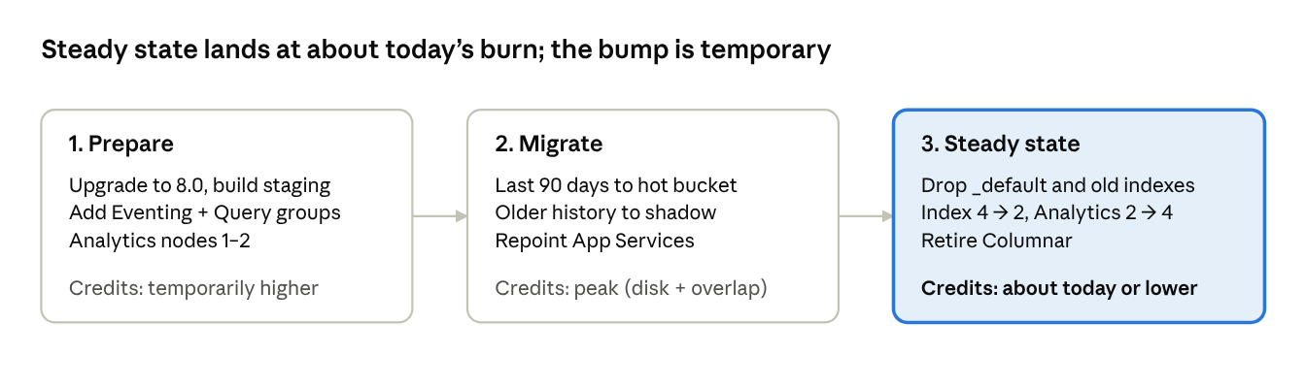
rollout · 3 phases
What to watch
- Transition months: new service groups run alongside the 4 large Index nodes until _default is dropped.
- Analytics on day one: the full history lands at cutover, so nodes 1–2 need large disks until nodes 3–4 arrive.
- Staging is required: today's dev cluster (1 Basic node) cannot run Eventing and Analytics.
- Backup (about 11% of spend) grows with the shadow store.
- Sync layer: App Services / Sync Gateway must write to named collections; confirm Quantic's version early, since an upgrade would be phase one.
- Load from in-region: a laptop loads about 1.5–3K docs/s, limited by upload bandwidth; the migration and any bulk load should run from a VM in the cluster's region.
- Migration tooling exists: a route_by_DocType Eventing function already splits _default into collections by document type.

Open questions for Quantic
These firm up the sizing; none blocks the architecture.
- How many documents are created per day? This sets the hot-tier size.
- What do the 4 Index nodes serve today? Our view shows no GSI indexes on the main bucket.
- How long can devices stay offline? This sets the tombstone purge window.
- Which record types have no isClosed field, and what does their Eventing filter check today?
- Is the 8.0 upgrade on their roadmap? We validated on 8.0; production runs 7.6.9.
- What is the full list of document types, with counts? We have 14 sample types; the samples reference more (customer, gift card, tax class).
- What retention should each history collection keep? For example, signatures 6–12 months, change logs 24 months, sales and payments 36 months or longer.
- Which Sync Gateway / App Services version runs in production? (Couchbase Server is 7.6.9.)
- What do serviceAreaType 2 and 3 mean, and how are voids, refunds and third-party payments recorded?
- Do location, item and employee documents exist under those names? Our shapes for them are assumed.

Appendix: the demo dataset
A synthetic copy of Quantic's POS data model: 225 restaurant merchants, 506 locations and 28.2M orders over 3 years (Oct 18, 2023 to Oct 16, 2026), about 262M documents in 17 collections. Numbers illustrate the model, not Quantic's business.
- Merchants: QSR 27%, casual 24%, café 16%, pizzeria 11%, Mexican 9%, bar 8%, Asian 4%, food truck 1%.
- Locations: 506, of which 464 are still active; 81K employees; 6.5K menu items.
- Growth: orders by year 4.5% (2023, partial) / 26.5% / 34.4% / 34.7% (2026 to date).
- Mix: 68% iOS POS, 23% Android, 10% web; 82% card, 16% cash; online and delivery rising from 9% to 15.5%.

Relationships
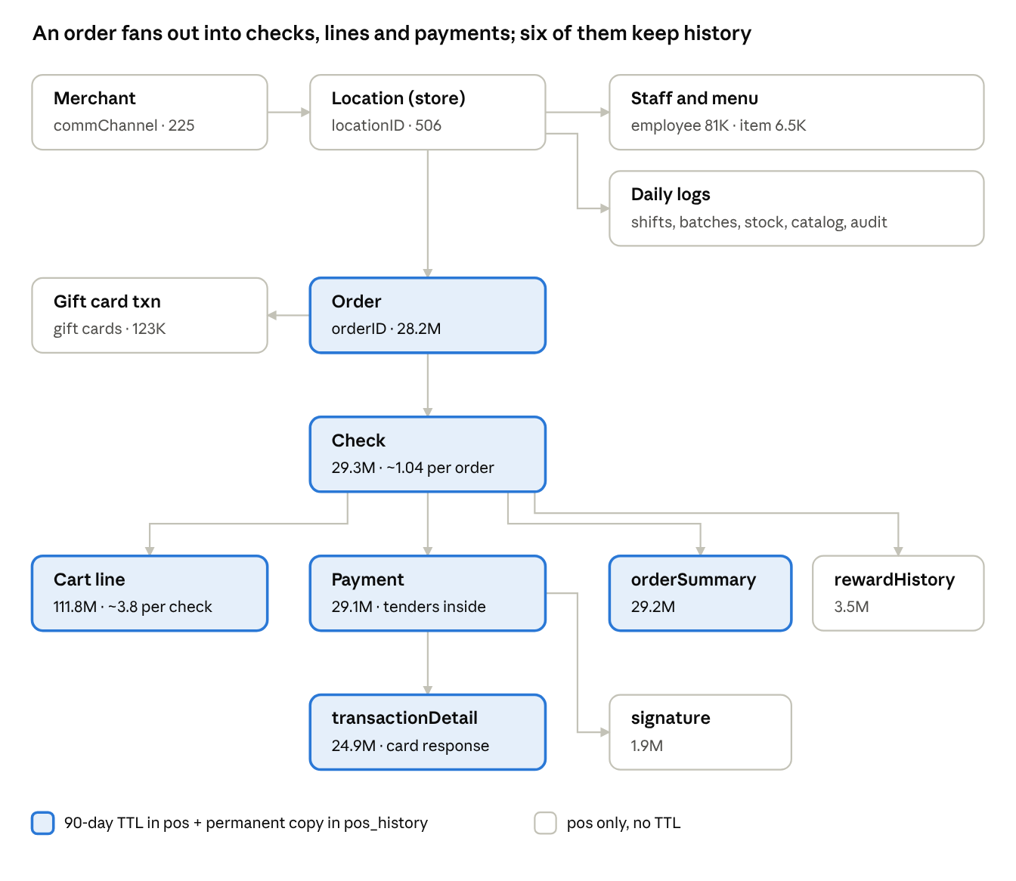
data model · 17 collections, counts at full load
Arrows read "one to many". Cart lines also point to the menu item they sold (itemID).

Collections
Collection | One document is | Key | Links to | Docs (full load) | Tier
cart | One line item on a check | cartID | checkID, orderID, itemID, locationID | 111.8M | Hot (TTL) + history
check | One guest check within an order | checkID | orderID, locationID | 29.3M | Hot (TTL) + history
orderSummary | Receipt view of a paid check, line items embedded | orderSummaryID | checkID, orderID, paymentID | 29.2M | Hot (TTL) + history
payment | Settlement of a check; tenders in transactionList[] | paymentID | checkID, orderID | 29.1M | Hot (TTL) + history
orders | Order header (ticket) | orderID | locationID, commChannel | 28.2M | Hot (TTL) + history
transactionDetail | Card processor response | transactionID | orderID, checkID | 24.9M | Hot (TTL) + history
rewardHistory | Loyalty points earned on a check | rewardHistoryID | checkID, customerID | 3.5M | Hot, no TTL
timeManagement | One employee shift | timeID | empID, locationID | 2.2M | Hot, no TTL
signature | Card signature on a transaction | — | checkID, transactionID | 1.9M | Hot, no TTL
batchClose | End-of-day card batch | batchCloseID | locationID | 1.1M | Hot, no TTL
stockHistory | Inventory receipt for an item | stockHistoryID | itemID, locationID | 170K | Hot, no TTL
giftTransactionDetail | Gift card transaction | transactionID | giftCardID, orderID | 123K | Hot, no TTL
employee | Staff member at a location | empID | locationID, roleID | 81K | Reference, no TTL
catalogLog | Menu change (price, 86'd, restock) | logID | masterItemID, locationID | 9K | Hot, no TTL
item | Menu item at a location | itemID | catID, locationID | 6.5K | Reference, no TTL
location | Merchant parent row or a store | locationID | commChannel, parentLocationID | 506 | Reference, no TTL
auditLog | Configuration change | auditLogID | locationID | <1K | Hot, no TTL

Which process fills what
Only the six transaction collections expire; they reach Analytics through the history store, while collections that never expire are linked to Analytics directly.
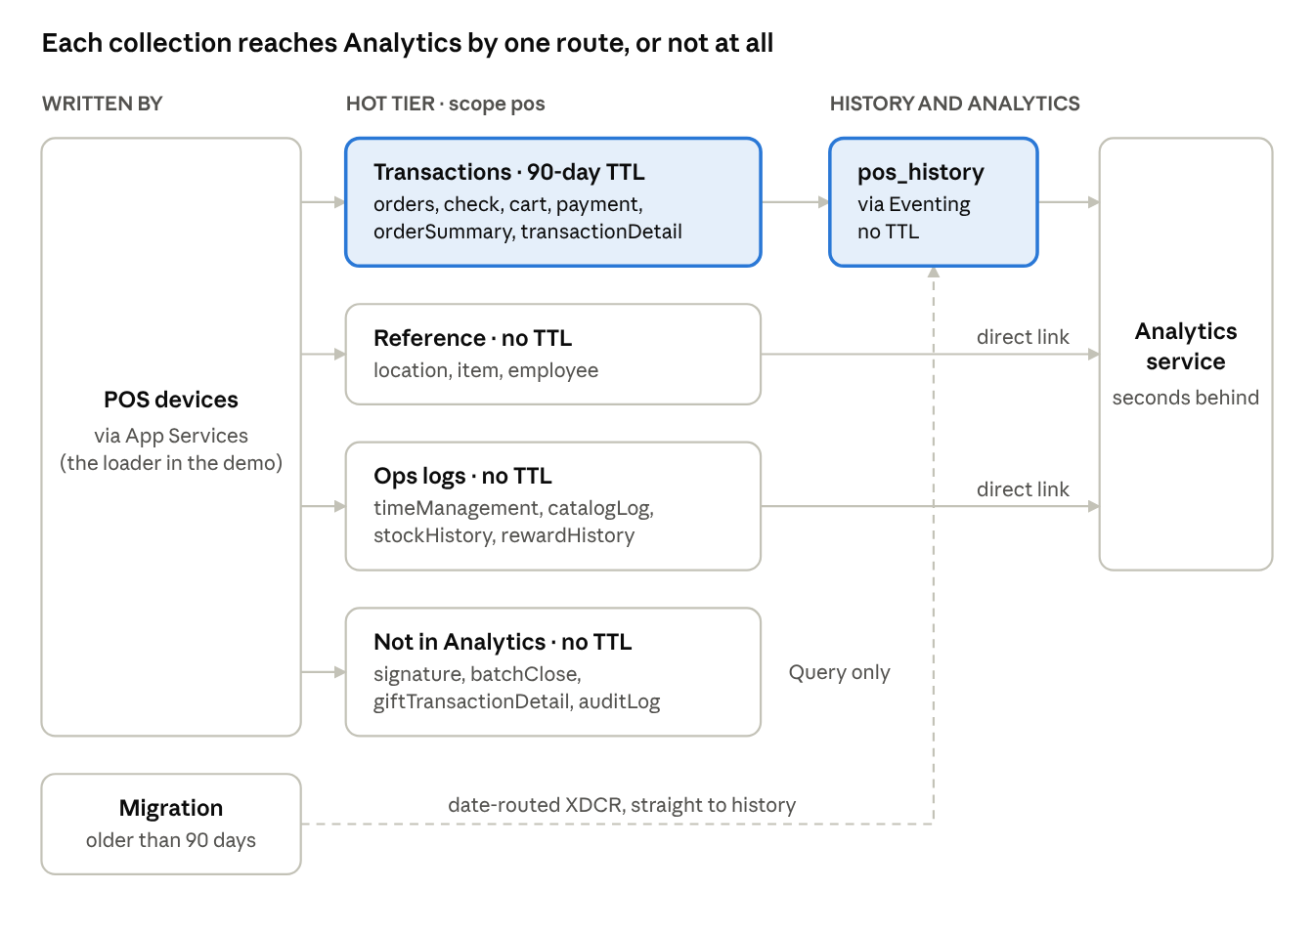
data flow · which process fills each collection
Collection | Written by | In pos (hot) | In pos_history | In Analytics
orders, check, cart, payment, orderSummary, transactionDetail | Devices via App Services | 90-day TTL (collection maxTTL) | Closed records, copied by Eventing; older history by the migration | Yes, from pos_history
location, item, employee | Devices and the merchant portal | No TTL | — | Yes, direct link
timeManagement, catalogLog, stockHistory, rewardHistory | Devices and the merchant portal | No TTL | — | Yes, direct link
batchClose, giftTransactionDetail, auditLog | Devices and the merchant portal | No TTL | — | No (Query only)
signature | Devices | No TTL (retention to agree, 6–12 months proposed) | — | No (images, no analytic value)
Rule: a collection with no TTL can be linked to Analytics directly; one with a TTL must be copied to the history store first, or Analytics would mirror its expirations.

Conventions
- Merchant = commChannel; its name is on the parent location row (parentLocationID = "").
- Keys are docType:UUID; the same key is used in pos and pos_history.
- Sales = paid cart lines, subTotal - totalDiscount. Channel = serviceAreaType (1 dine-in, 2 takeout, 3 delivery, 4 online).
- Tenders in payment.transactionList[]: paymentType, transactionType, gateWay (cardConnect ~85% of merchants, dejavoo ~15%).
- Cost: cart.cog is a static unit cost (theoretical food cost). Times are epoch ms, UTC.

Planted stories
Story | Where | When | What the data shows
Void hotspot | Ember & Oak, King of Prussia | Server hired ~Aug 3, 2026 | ~12% of his lines voided vs ~2% for others
Salmon outage | Ember & Oak, Fishtown | ~Oct 7–10, 2026 | Sales stop; menu log shows it 86'd, then restocked
New item launch | Ember & Oak | ~Sep 19, 2026 | Nashville Hot Chicken Sandwich ramps ~4×
Seasonal LTO | Ember & Oak | Sep 15 – Nov 30 yearly | Pumpkin Cheesecake, 3 seasons
Declining item | Ember & Oak | 3 years | Quinoa Power Bowl falls from 1.8× to 0.35×
Delivery surge | Ember & Oak, Pittsburgh | Last ~6 months | Delivery ramps to ~3.2×
New store | Ember & Oak, Brooklyn | Opened ~May 20, 2026 | Store ramping from zero
Churned merchants | ~10% of others | Random dates | Orders stop; location inactive
Holiday spikes | All, by concept | Every year | Super Bowl wings 2.5×, Cinco margaritas 2.2×, Valentine's desserts ~1.7×; Christmas closed

