API Controls

## Understanding the Updates

Google notified primary admins on June 19th, 2023, announcing new API Controls, changes in behavior for users under 18 regarding their access to third-party apps, and a requirement to review and confirm access settings to third-party apps by Oct. 23rd, 2023.

|  |
| --- |
| Takeaway |
| Google is making domains go to an OAuth App “Trusted List” for under 18 before Oct. 23rd, 2023 or students will lose access to OAuth apps. Read the [full email](https://collab.amplifiedit.com/topic/2881-%F0%9F%9A%A8-primary-admin-email-action-required-access-to-third-party-applications-is-changing-for-users-designated-as-under-18-%F0%9F%9A%A8-61923) |

### Immediate Impact

Previously accessed apps should not be affected until October 23rd. Google has “configured” previously accessed apps from under 18 as limited.

|  |
| --- |
| Note |
| This is why you are seeing a lot more “configured apps” |

Any “new” app can not be accessed by under 18 and the user can “Request” the app.

|  |
| --- |
| Note |
| This is why you’re seeing requests (from students) |

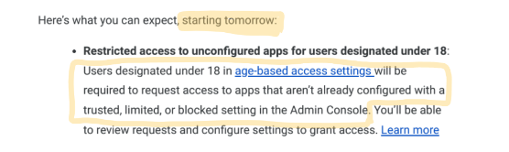

“It’s like Google did the “Stop the bleed” approach for students for you.”

*- Melissa Benson*