CNC SHIELD V3

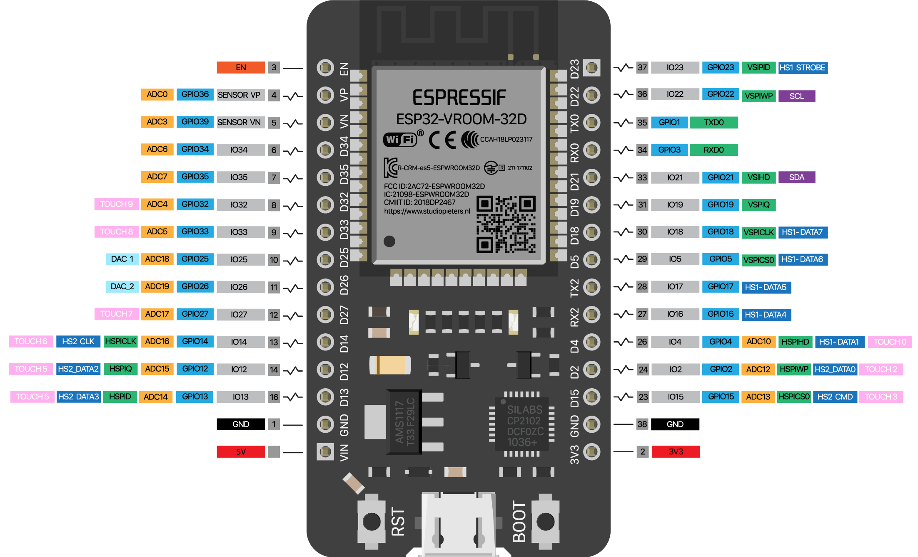
FUNCTION | ESP32 BOARD
X_STEP_PIN | GPIO_NUM_26
X_DIRECTION_PIN | GPIO_NUM_16
Y_STEP_PIN | GPIO_NUM_25
Y_DIRECTION_PIN | GPIO_NUM_27
Z_STEP_PIN | GPIO_NUM_17
Z_DIRECTION_PIN | GPIO_NUM_14
DISABLE_MOTORS | GPIO_NUM_13

SD CARD READER PINOUT

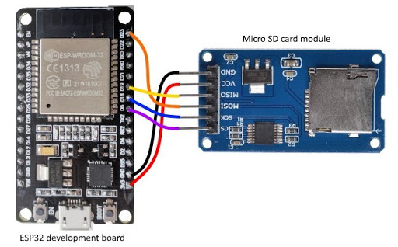

ESP32 BOARD | MICRO SD SHIELD
GPIO_NUM_5 | CS
GPIO_NUM_18 | SCK
GPIO_NUM_19 | MISO
GPIO_NUM_23 | MOSI

