**HOME PAGE**

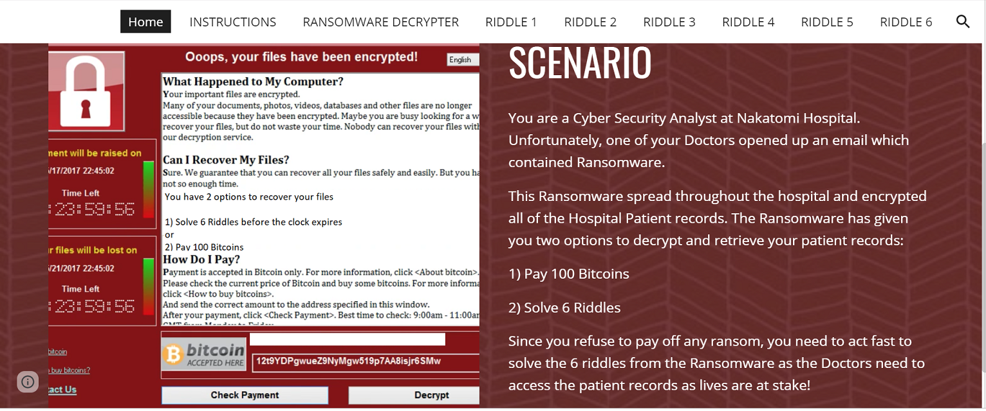

**Instructions:**

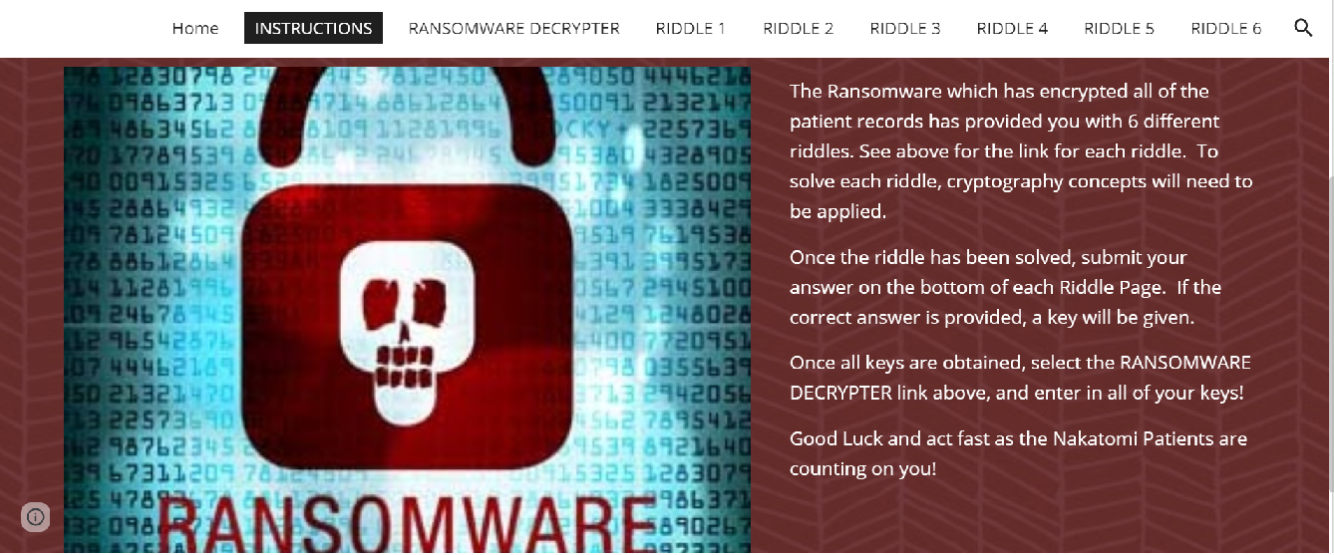

**RIDDLE 1:**

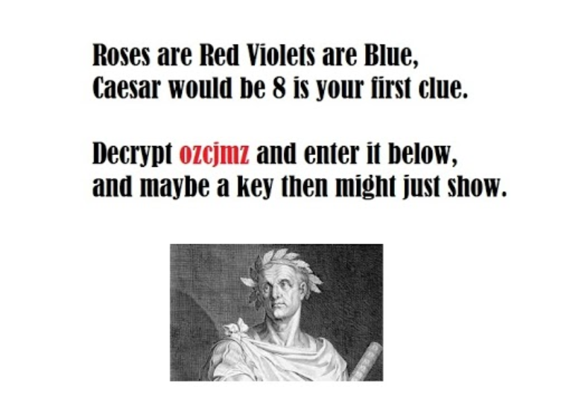

**RIDDLE 2:**

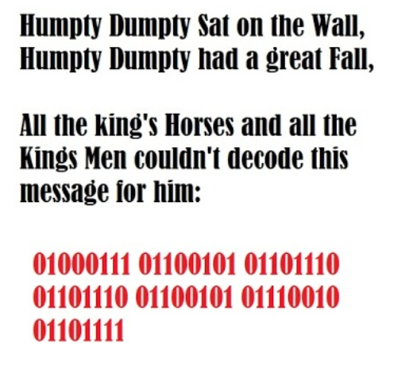

**RIDDLE 3:**

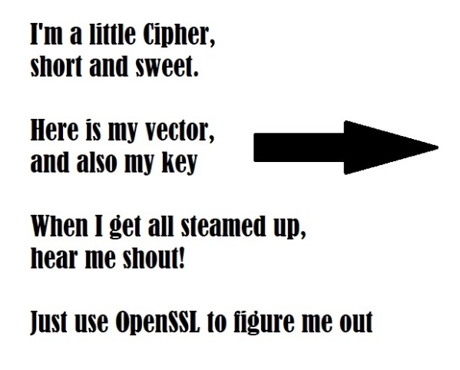

**Cipher Text:**

4qMOIvwEGXzvkMvRE2bNbg

**Key:**

5284A3B154D99487D9D8D8508461A478C7BEB67081A64AD9A15147906E8E8564

**IV (Initialization Vector):**

1907C5E255F7FC9A6B47B0E789847AED

**OpenSSL Options:**

* -pbkdf2
* -nosalt
* -aes-256-cbc
* base64

**RIDDLE 4:**

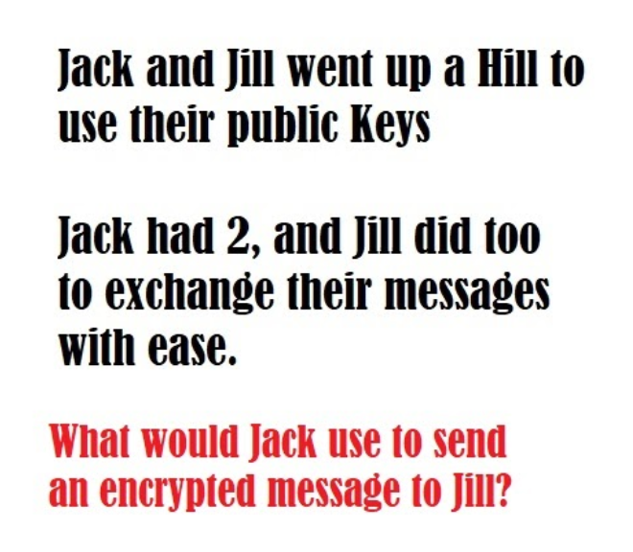

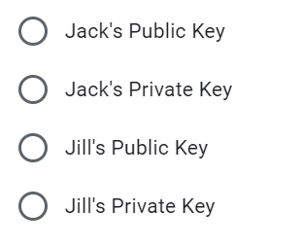

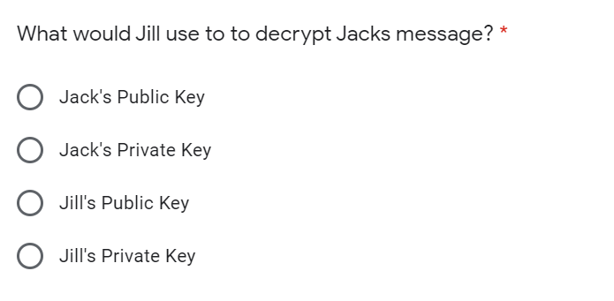

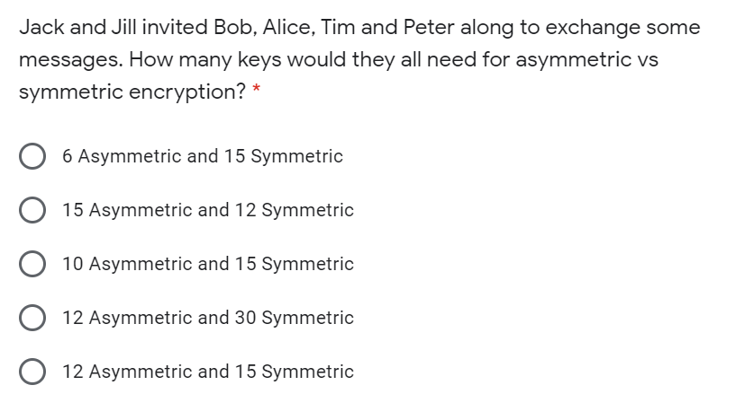

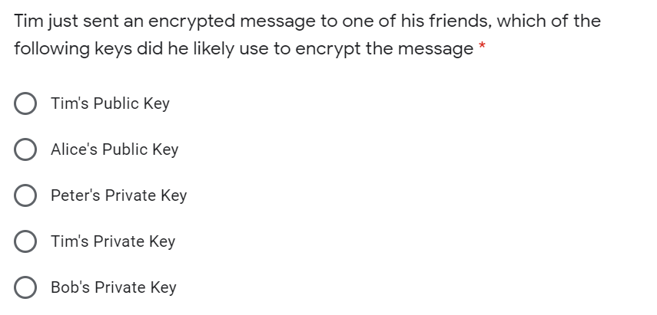

**RIDDLE 5:**

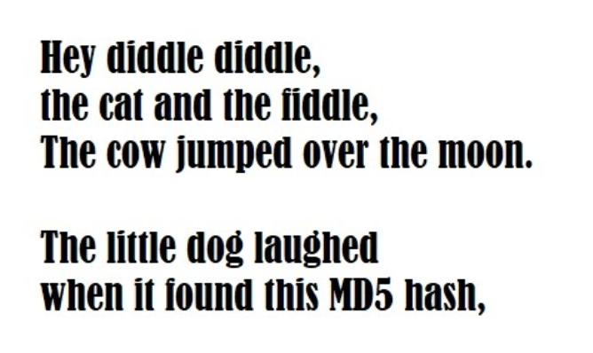

**Hash:**

3b75cdd826a16f5bba0076690f644dc7

**RIDDLE 6:**

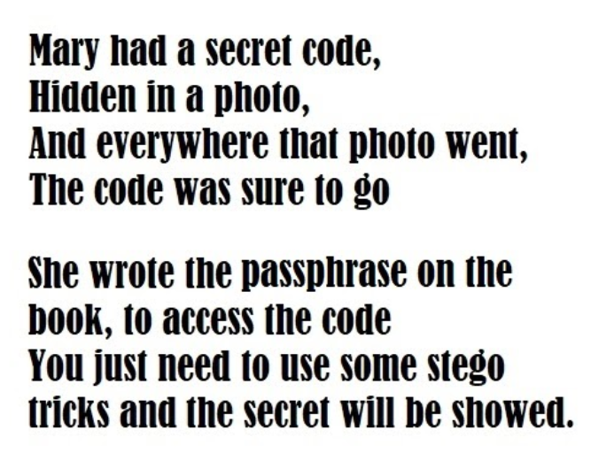

**Image Link: https://drive.google.com/file/d/1m9ykscnTGzgkkVet9wmiBCYsbhzbrKR9/view**