GLOBAL WARMING

For the project, our data analysis will be about global warming. Since the global warming is a crucial issue for our survival it is important to see data that cause it.

Global warming is a popular issue since it becomes more dangerous every day. Therefore, there are lots of studies, researchers and data about this issue. It is not caused just because of natural reasons, it also happens because of political, social etc. factors. The combination of the all the reasons in datasets is important for observe it in wide angle and increase awareness and hopefully step up for doing something to prevent it.

For instance, one of the biggest reason of the climate change is the rise of CO2 emission. There are lots of data about how much C02 emissions increased in years. The graph below is taken from  <https://climate.nasa.gov/evidence/>shows that how much atmospheric C02 increased through years.

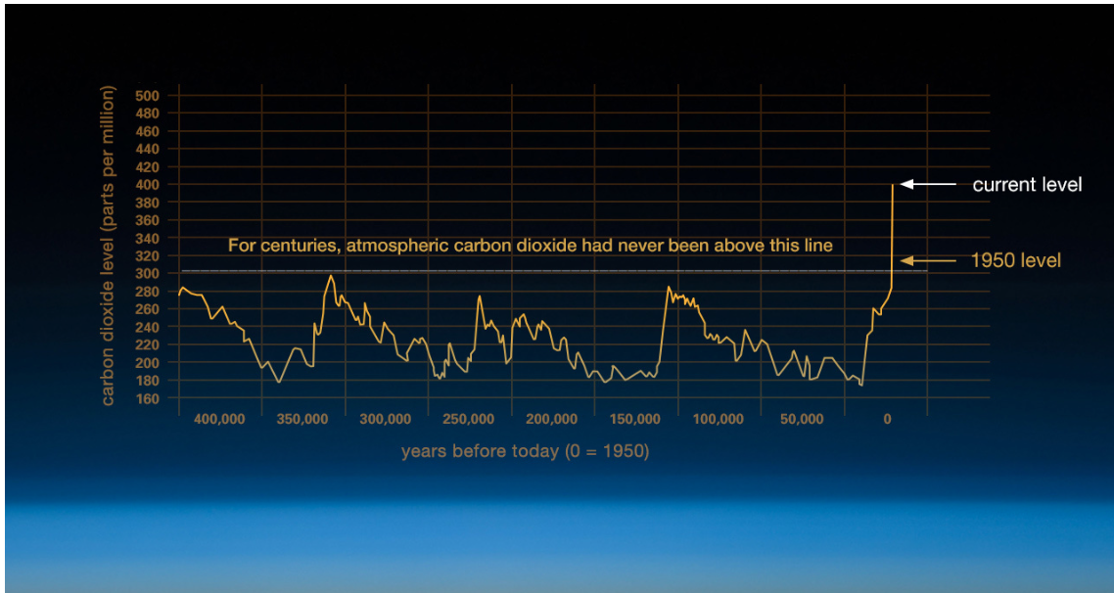

Each country has a contribution to climate change, some more than others. For our project, we will discuss that how countries affect climate change, which factors are coming to the forefront.  Do less developed countries affect climate change more than developed countries?  If they are what are the causes for it?

For instance, According to 2011 data compiled by the Netherlands Environmental Assessment Agency, the top 10 CO2 emitters are;

1. China: 9697 million tons (MT) or 28.6%
2. US: 5420 MT or 16.0%
3. India: 1967 MT or 5.8%
4. Russia: 1829 MT or 5.4%
5. Japan: 1243 MT or 3.7%
6. Germany: 810 MT 2.4%
7. South Korea: 609 MT or 1.7%
8. Canada: 555 MT or 1.6%
9. Indonesia: 490 MT or 1.4%
10. Saudi Arabia: 464 MT or 1.4%

We will examine why these countries are emitting this much amount of CO2, what are reasons for these countries to be in top 10 CO2 emitters?

Another example that below is taken from IPCC (intergovernmental panel on climate change) research, which shows the sea level also ocean and land temperature changes through years.

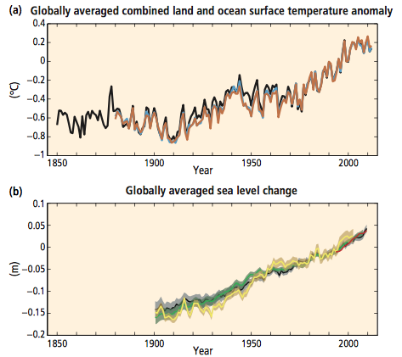

We will use accurate data sources for our project. Links of the some of the data sources is below;

<https://www.ipcc.ch>

<https://climate.nasa.gov/evidence/>

<http://data.worldbank.org/topic/climate-change>

Group members:

HATICE MELDA AKTEPE 18075

ASLI DEMIR 14193

Link for our blog

cs210globalwarming.wordpress.com