**DB**

create table knigi ( knigi_id int primary key , zaglavia varchar(13), avtor varchar(13), cena varchar(5), tematica_ID int references tematica, knigarnici_ID int references knigarnici );

create table tematica ( tematica_ID int primary key , tematica varchar(60) ) ;

create table klienti ( klient_ID int primary key, ime varchar(20), adres varchar(20), telefon varchar(8), knigarnici_ID int references knigarnici);

**create table knigarnitzi ( knigarnitci_ID int primary key, ime varchar(20), adres varchar(20)**

**);**

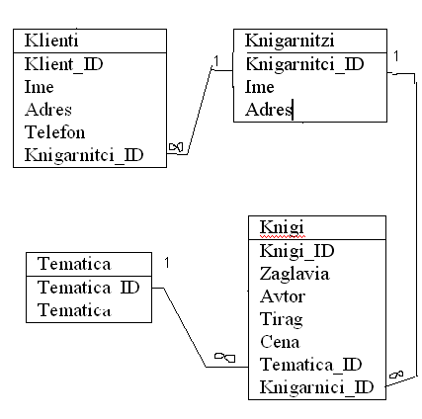

**php**

**insert into knigi values ('1','Burqta na veka','** **Stephen King, '15,90','','');**

**insert into knigi values ('2','Kudjo','** **Stephen King', '14,90','','');**

**insert into knigi values ('3','Kralqt v julto,'Robert Chambers, '15,90','','');**

**insert into knigi values ('4','Ostani','** **Harlan Coben', '15,90','','');**