


DOKUZ EYLUL UNIVERSITY

FACULTY OF ENGINEERING

PROJECT REPORT
for
CME 4403 Term Project

Prepared by Melda Karadağ
2014510048
Table of Contents

CHAPTER ONE
INTRODUCTION
This report explains the project of training the real data set with two different machine learning models. My data set is MAGIC Gamma Telescope Data Set. The number of instances in my data set is 19020. It has 11 attributes. There aren't any missing value. Target value is categoric and feature values are continuous. Since there is no missing value, no data cleaning has been done. I trained my data set using K nearest neighbors and Decision Trees machine learning models.

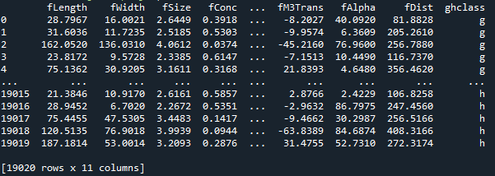
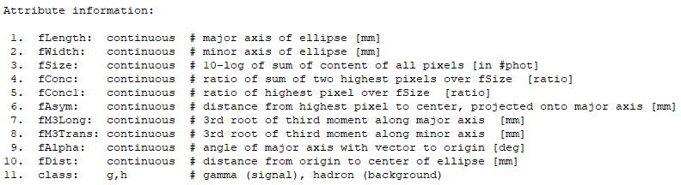

CHAPTER TWO
Machıne learnıng models

K nearest neighbors and decision tree machine learning models have been worked with.
K Nearest Neighbor
K nearest neighbors is a simple algorithm that stores all available cases and classifies new cases based on a similarity measure (e.g., distance functions). A case is classified by a majority vote of its neighbors, with the case being assigned to the class most common amongst its K nearest neighbors measured by a distance function. If K = 1, then the case is simply assigned to the class of its nearest neighbor. In project there is a function that works for kNN algorithm. Algorithm works with range of k between 1 to 25. Algorithm pick the k acoording to highest accuracy value, Also it calculates Log Loss and ROC AUC by does cross validation values for eack k value. For the best k value creates the confusion matrix and classification report.
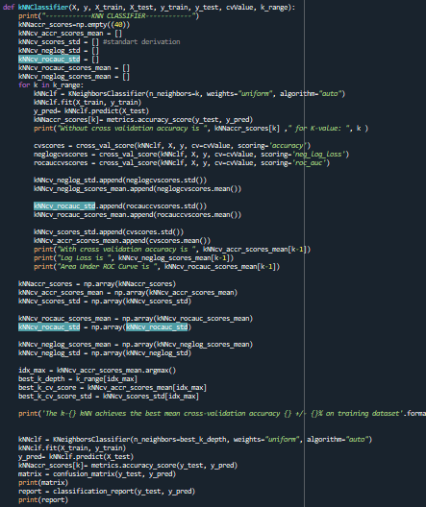
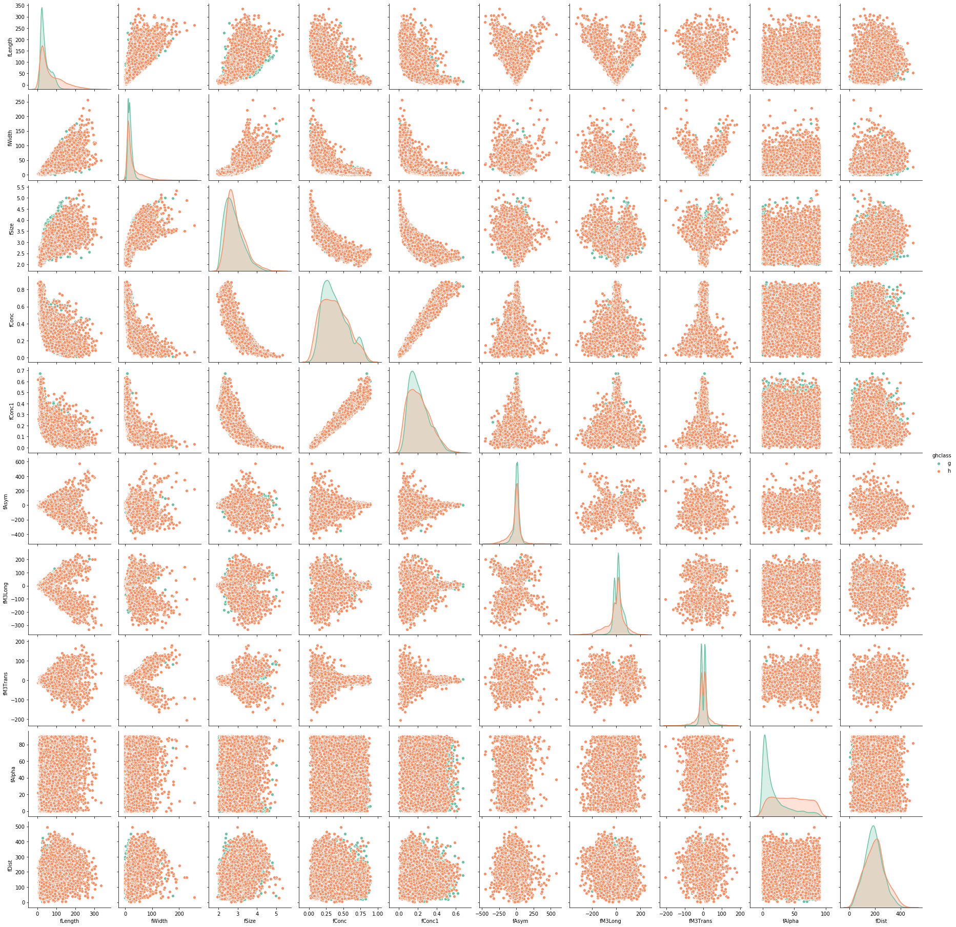
Here are plots that when we combine each feature together, the results are target class, pink ones are gamma, blue ones are hadron signals.

Decision Tree
A tree has many analogies in real life, and turns out that it has influenced a wide area of machine learning, covering both classification and regression. In decision analysis, a decision tree can be used to visually and explicitly represent decisions and decision making. As the name goes, it uses a tree-like model of decisions. Though a commonly used tool in data mining for deriving a strategy to reach a particular goal, its also widely used in machine learning.
In the project there is one decision tree function that finds best depth of tree, calculate accuracy, log loss and ROC AUC values bycross validation. For the best depth value creates the confusion matrix and classification report. Also shows the tree.
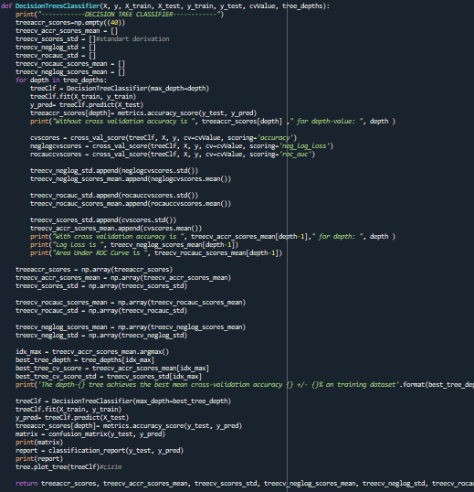
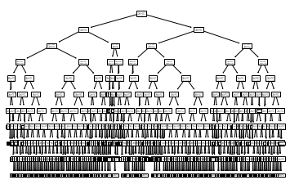

Decision tree figure of MAGIC Gamma Telescope Data Set.

CHAPTER THREE
Test results
K range between 1 to 25 all values of accuracy, log loss and ROC AUC by cross validation is shown when we run the project with 10 value cross-validation.
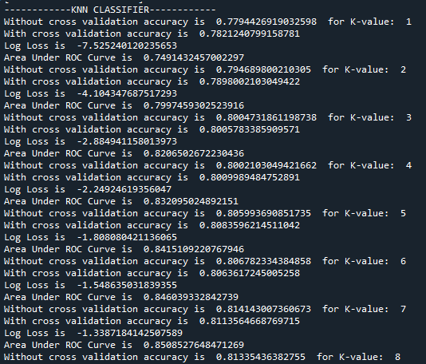

Depth range between 1 to 25 all values of accuracy, log loss and ROC AUC by cross validation is shown when we run the project.
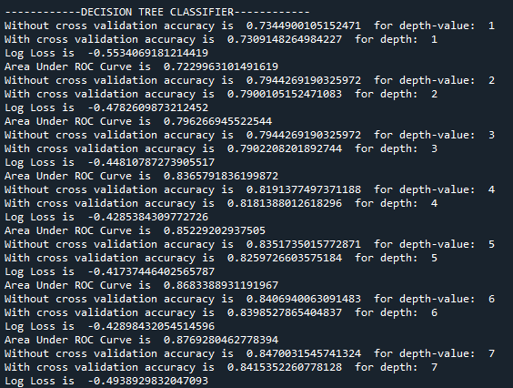
For the best k and depth values of accuracy, roc auc and log loss is shown below. Acoording to different cross validation values are shown below.
CV = 5
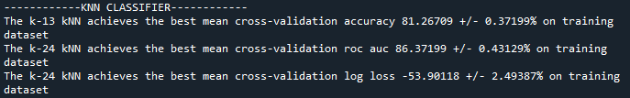
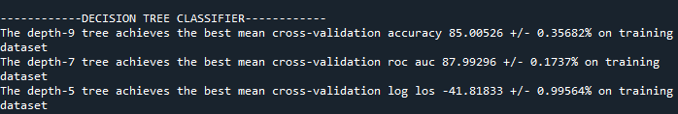
CV = 10
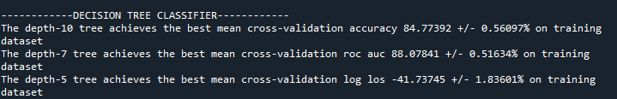
CV = 20
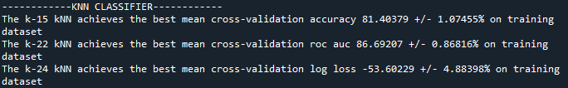

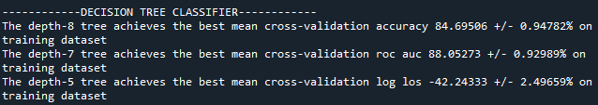
CV = 40
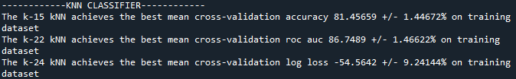

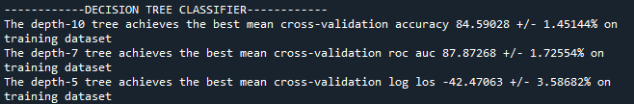
Confusion matrix and classification reports by different test size values are shown below.
Test size = 0.10 for kNN
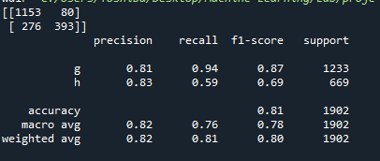

Test size = 0.10 for decision tree
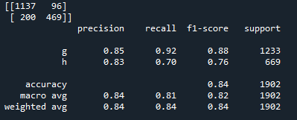

Test size = 0.20 for kNN
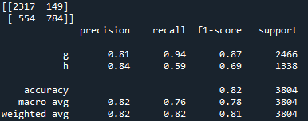

Test size = 0.20 for decision tree
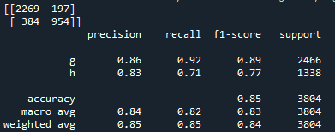

Test size = 0.30 for kNN
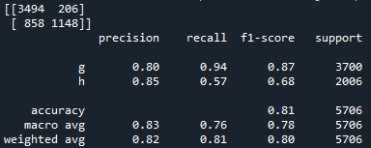

Test size = 0.30 for decision tree
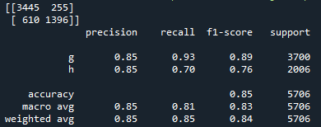

Test size = 0.40 for kNN
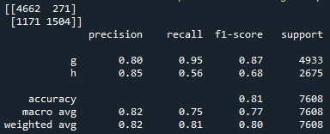

Test size = 0.40 for decision tree
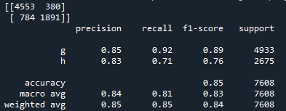

Test size = 0.50 for kNN
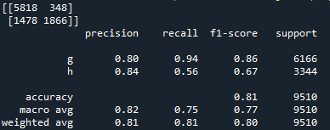

Test size = 0.50 for decision tree
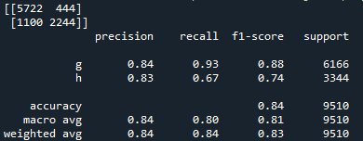

As we see above, 0.20 test size and cross validation value as 10 have the best fit. Also haowever it chnages by evaluation metrics, best depth value for decision tree is 8 and best k value for kNN is 14.

Accuracy plot on kNN for k-Value on training data
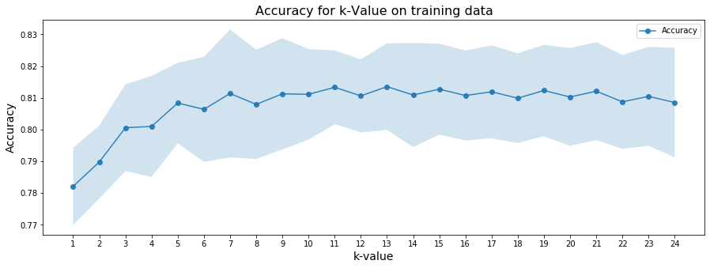
Accuracy plot on decision tree for depths on training data
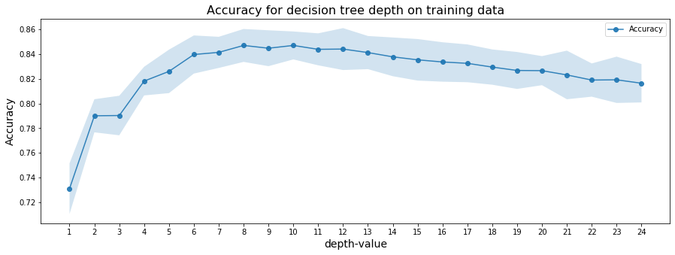

Log Loss plot on kNN for k-Value on training data
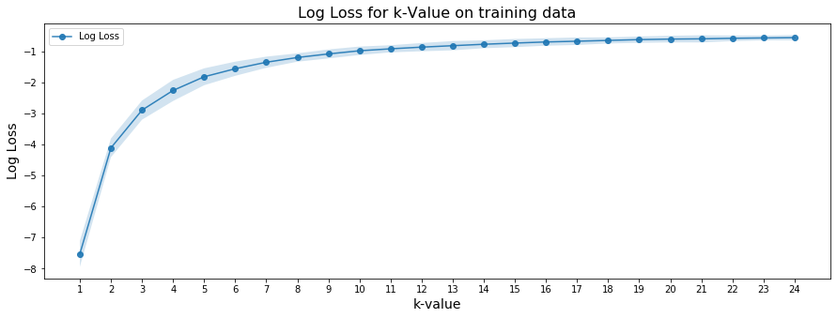

Log Loss plot on decision tree for depths on training data
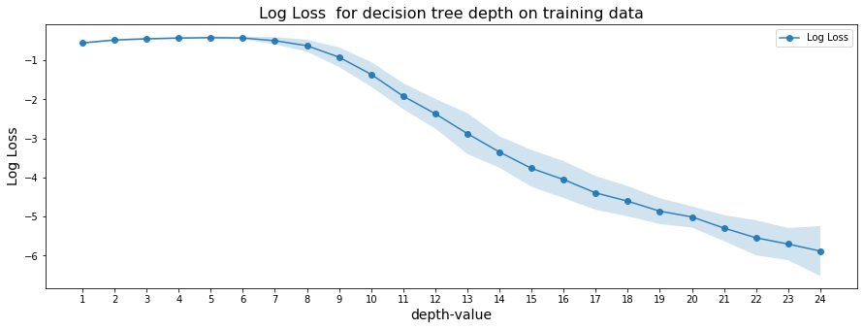

Area Under ROC Curve plot on kNN for k-Value on training data
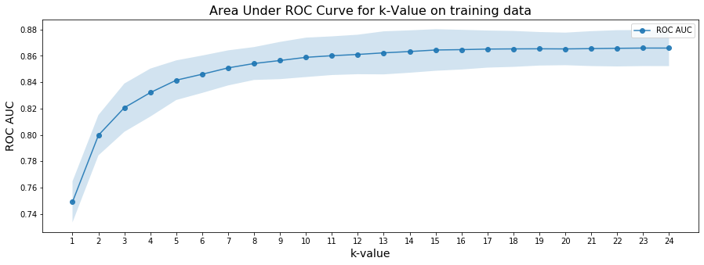

Area Under ROC Curve plot on decision tree for depths on training data
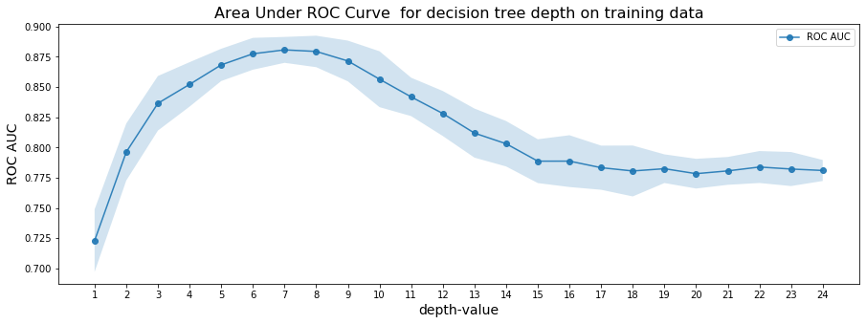

REFERENCES

http://archive.ics.uci.edu/ml/datasets/MAGIC+Gamma+Telescope
https://towardsdatascience.com/which-machine-learning-model-to-use-db5fdf37f3dd
https://medium.com/@svanillasun/how-to-deal-with-cross-validation-based-on-knn-algorithm-compute-auc-based-on-naive-bayes-ff4b8284cff4
https://gist.github.com/chalg/c1a7d707c10d496bb3139719b6aff258
https://medium.com/@randerson112358/python-decision-tree-classifier-example-d73bc3aeca6
https://medium.com/pursuitnotes/decision-tree-classification-in-9-steps-with-python-600c85ef56de
https://www.kaggle.com/amolbhivarkar/knn-for-classification-using-scikit-learn

