**DOKUZ EYLUL UNIVERSITY**

**ENGINEERING FACULTY**

**DEPARTMENT OF COMPUTER ENGINEERING**

**CME4408**

**INTRODUCTION TO NATURAL LANGUAGE PROCESSING**

**ASSIGNMENT-2**

**MED ALGORITHM**

**By**

**2014510048 – Melda Karadağ**

**Lecturers**

**Asst.Prof.Dr. Özlem Aktaş**

**1. Part One**

**1.1 Definition of Algorithm**

Within the scope of this assignment, we were asked to select the most similar words after scanning the data in a source which named “tr_dictionary.txt” for an input received from the user and present it with a simple interface. We are expected to use the MED algorithm to perform this process.

Two functions named "editDistance" and "min" have been developed to perform these operations. The minimum function is used to compare the neighboring indexes of the current location while navigating in the two-dimensional matrix and select the smallest value to write to that index. The "editDistance" function is used to display this returned string value on the interface in "label3", by navigating through the two-dimensional array it receives and performing the appropriate minimum edit distance operation based on the minimum values. The "runtime" output value, which passes from the entered inputt until the corpus is scanned and the result is obtained, is performed in this function. This runtime result is presented to the user in "label4".

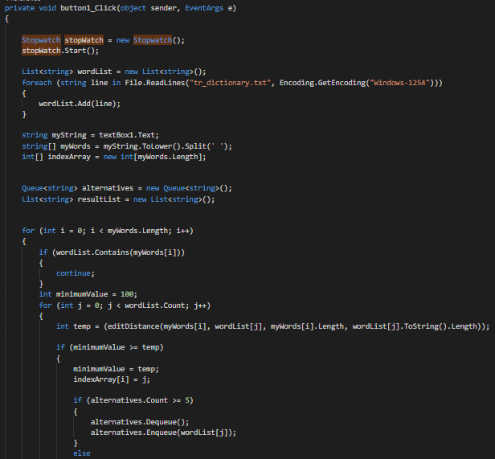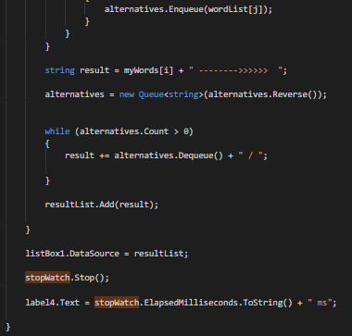

**1.2 Test Results**

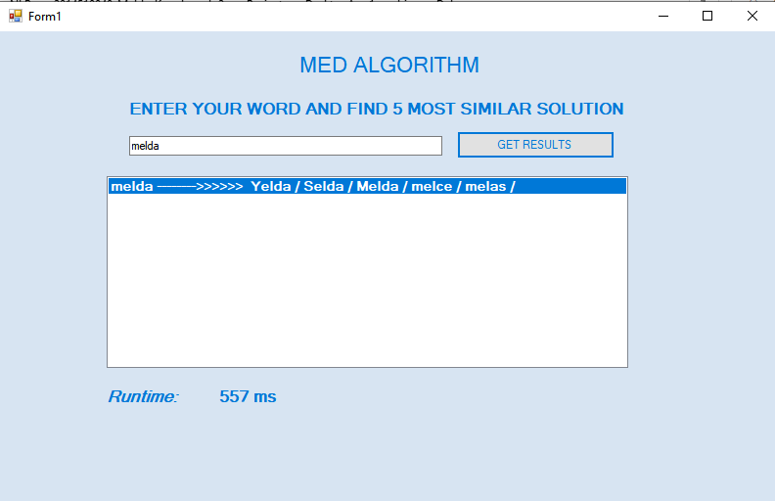

The nearest 5 results “yelda, selda, melda, melce, melas” for "melda" and the runtime value is “557 ms” are as shown above.

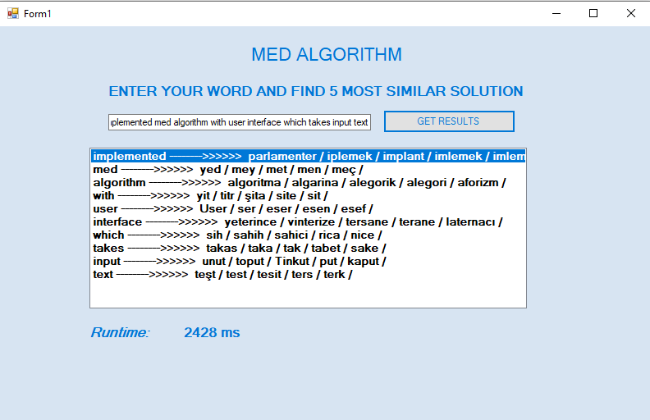

The results containing the nearest 5 values ​​for 10 string values ​​in the text "implemented med algorithm with user interface which takes input text" are listed and the total runtime value is as shown above.

**2. Part Two**

**2.1 Definition of Algorithm**

With the scope of this part we are asked to calculate a MED value of two words which is taken by user,show the steps in a table and write the operations’ names needed to transform.

I create one more different project for this part which is also C#. This project does not have interface, I can see the result from command window. It is one page project. It includes two function except main function. One function which is “editDistance” creates MED matrix, MED value, insert, remove, replace values. Other function which is ”min” helps to editDistance function to calculate and update insert, remove, replace values and find a min value of the matrix. Main function calculates running time, takes two input words from user and call the editDistance faunction.

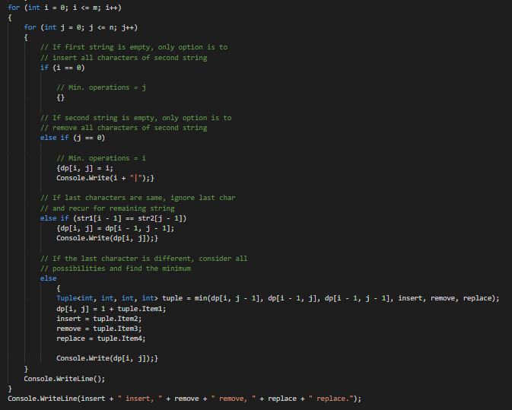

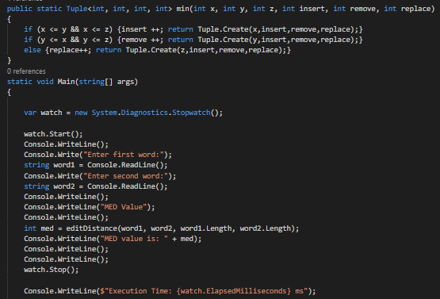

**2.2 Test Results**

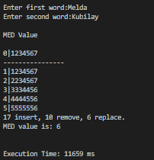Like it is shown in left, program takes two word from user, than show MED calculation matrix, number of insert, remove, replace values, MED value and total runing time.

**REFERENCE**

https://www.csharpstar.com/csharp-string-distance-algorithm/