Michael Elder

Dr. Kelley

CS 215

9/11/2022

Assignment 2.2

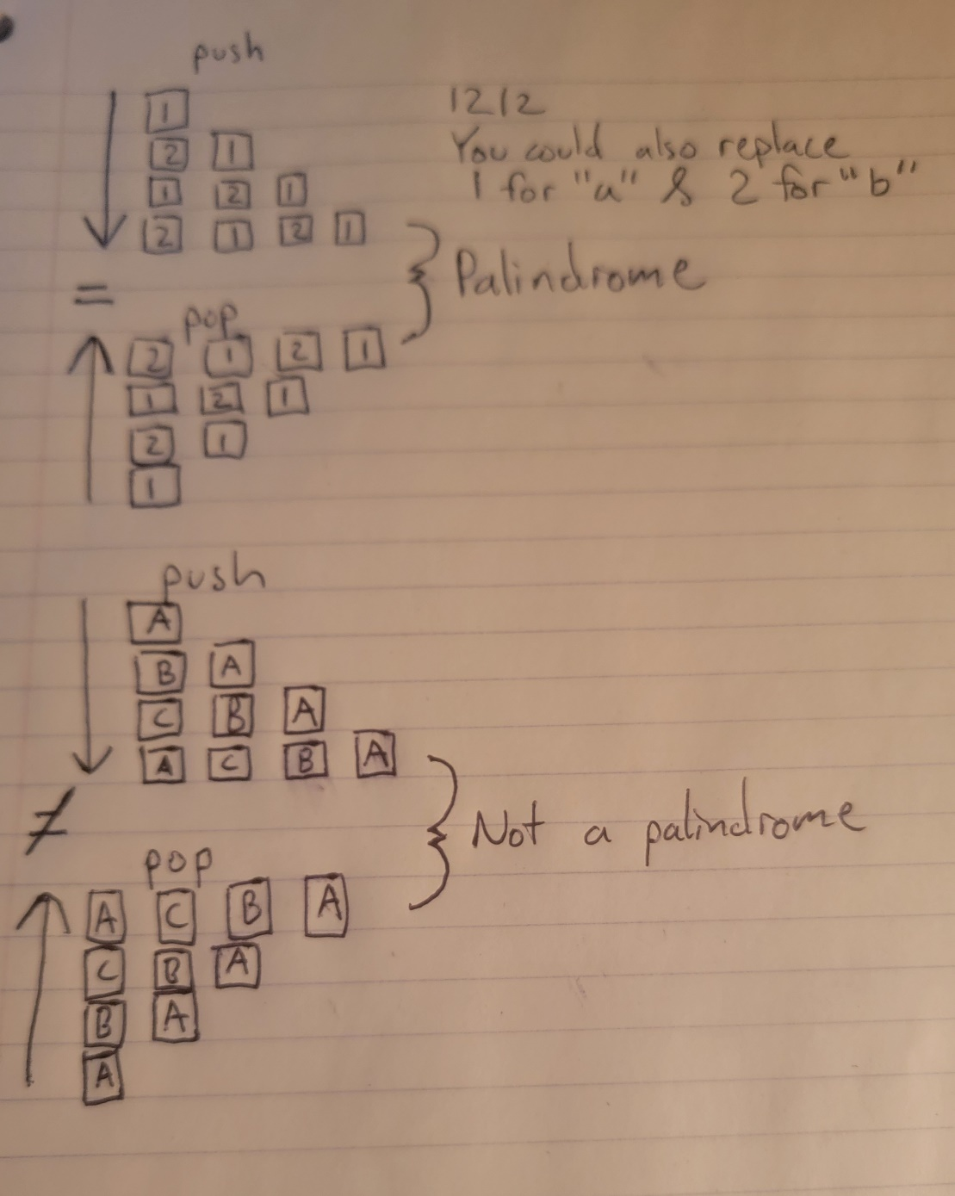

1. What is the basic operation in your code?

**for** (**int** count = 0; count < str1.length(); count++) {

stack.push(str1.charAt(count)); }

1. What input determines how many times the basic operation takes place?

Str1(The String that you get from the user.)

1. Express the number of times the basic operation occurs in terms of n. What does n represent?

N represents the number of characters in the string that is inputted from the user

1. What is the computational complexity of the code in terms of Big O? Explain why.

O(n) because the String that the user puts in can vary in size, so it iterates a different number of times based on your entered String.

5. Explain how a stack data structure differs from a bag data structure. Explain how you used the stack in your code to solve the palindrome problem.

The bag data structure stores its items in a random order and the stack data structure stores its items in a last-in, first-out. I asked the user to input a string and then saved it to the str1 variable. Then, I added the characters to the stack. Once added, I removed the characters of the string and saved the output to the palindrome variable. Removing the characters with the pop method reverses the String. Lastly, I compare the str1 to the palindrome. If the two variables are equal, it prints that it is a palindrome and if not, it says it isn’t palindrome.