Wolfram solve partially elastic collision:

a = m1
b = v1
c = m2
d = v2
f = v1’
h = v2’
i = ΔE

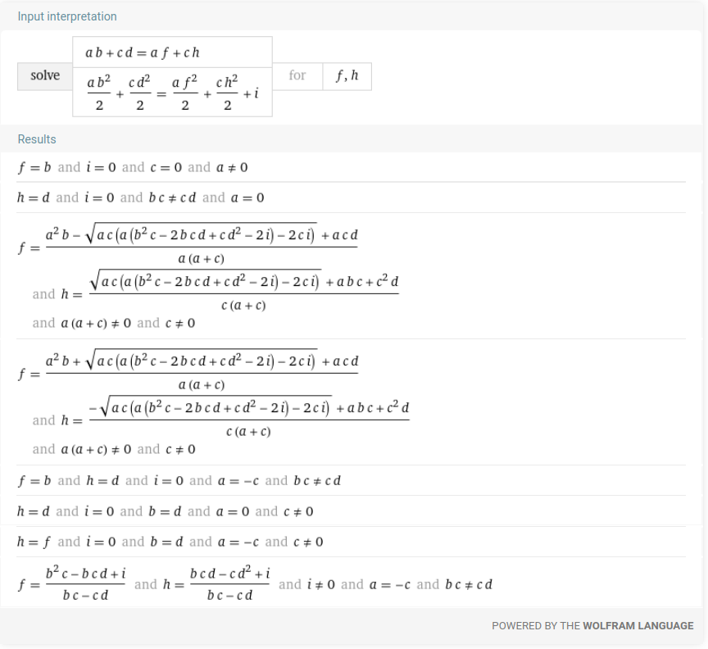

Recall equation:
https://www.wolframalpha.com/input?i2d=true&i=solve+a+*+b+%2B+c*d+%3D+a+*+f+%2B+c+*+h+and+Divide%5Ba+*+Power%5Bb%2C2%5D%2C2%5D%2BDivide%5Bc*Power%5Bd%2C2%5D%2C2%5D%3DDivide%5Ba+*+Power%5Bf%2C2%5D%2C2%5D%2BDivide%5Bc+*+Power%5Bh%2C2%5D%2C2%5D%2Bi+for+f+and

