Integration Flow Implementation Document

Project: EAI

Component: ICE-ADP

Status: DRAFT

Document version: 0.1

CONFIDENTIAL

Distribution List

| From | Date | Phone/Fax/Email |
| --- | --- | --- |
| Marco Mele |  | marco.mele@catenate.com |
|  |  |  |

| To | Action* | Due Date | Phone/Fax/Email |
| --- | --- | --- | --- |
| Rene Michel | Review |  |  |
|  |  |  |  |
|  |  |  |  |
|  |  |  |  |

* Action Types: Approve, Review, Inform, File, Action Required, Attend Meeting, Other (please specify)

Version History

| Ver. No. | Ver. Date | Revised By | Description | Reviewer | Status |
| --- | --- | --- | --- | --- | --- |
| 0.1 | 9/11/2017 |  | Initial Draft |  |  |
|  |  |  |  |  |  |
|  |  |  |  |  |  |
|  |  |  |  |  |  |
|  |  |  |  |  |  |
|  |  |  |  |  |  |

# Contents

1 Contents 3

2 Overview 4

2.1 Purpose of this Document 4

2.2 Introduction 4

2.2.1 Business Background 4

2.3 Document References 4

3 Sub System Compendium 5

3.1 Implementation Details 6

3.2 Provider Services 7

3.3 Configuration Values 8

3.4 Base Global Variables 8

3.5 EMS Configuration 10

4 Releases 11

5 Error Handling 11

5.1 System Errors 11

5.2 Business and Validation Errors 11

5.3 Error Queues 11

6 Error Codes 12

7 Unit Test 15

8 Attachments 16

# Overview

## Purpose of this Document

The purpose of this document is to describe the ICE-ADP sub system with its interfaces, configuration variables and connection to other systems. The intention is to provide sufficient information so that the infra team and operational team has all required information to configure, deploy (maintain) and operate an EAI application. It does not describe the signature of the interface. This can be found in the corresponding IFDD, which also contains some implementation details.

This document will be handed over to the infra team once the development is completed and unit tested.

## Introduction

### Business Background

The Tibco BusinessWorks ICE-ADP Adapter connects the MAX system to ICE.

ICE-ADP component expose the service Work into the ESB. It contains two operations: getWorkDetails and createSkeletonWork. Only the operation getWorkDetails is implemented for now.

## Document References

For a detailed description of the interfaces check the following documents

|  |  |  |
| --- | --- | --- |
| Reference ID | Document | Filename |
| [1] | Integration Flow Design Document | IFDD C2 Work Info ICE Service 009.docx |
| [2] | Interface Contract  C2 (ICE-EAI) | 2014-01-28_Interface Contract _C2_ICE_to_EAI v0.4 |

# Sub System Compendium

The system compendium shows which systems are interacting. The following figure explains the overall sequence between the involved systems.



The service Work is exposed on a SOAP/JMS binding. The communication use a queue (Work001.q.sync) configured on a store with access mode Asynch, the jms acknowledge mode is configured as AUTO and the jms delivery mode is configured as NON_PERSISTENT.

Figure 1: Component Diagram for ICE-ADP

|  |  |  |  |
| --- | --- | --- | --- |
| ID | | Interface | Description |
| IF1 | | Interface ICE-ADP | This interface send/receives work details data between MAX and ICE systems. |
|  | IF1a | getWorkDetails | This operation is used to get work details from MAX System. It’s an asynchoronous call, any errors are logged by Tibco logging via the errorhandler from the core package. |
|  | IF1b | IAC9361 | This service is used to get detailed work data form ICE System. It’s a synchoronous call, any errors are logged by Tibco logging via the errorhandler from the core package.  Validation error are published on a specific queue for business exception. |
|  |  |  |  |

## Implementation Details

Towards the MAX system communication is SOAP/JMS, towards ICE an ICE API named IAC9631 is called as a synchronous Webservice with an ice-work-key and will supply MAX with the requested work details.

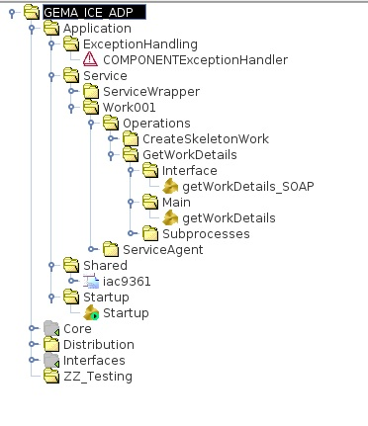

Figure 2: Project tree

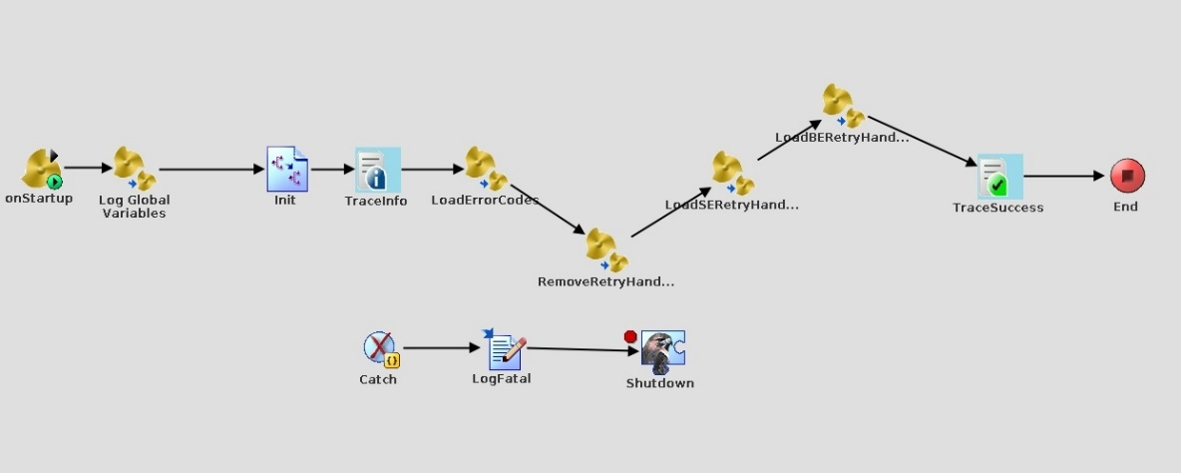

Figure 3: Startup process

This process started onStartup sets the environment in order to work properly.

## Provider Services

The ServiceAgent calls the Interface Process getWorkDetails_Soap (pic below) that handles any errors, get the context and calls the Main process getWrokDetails.



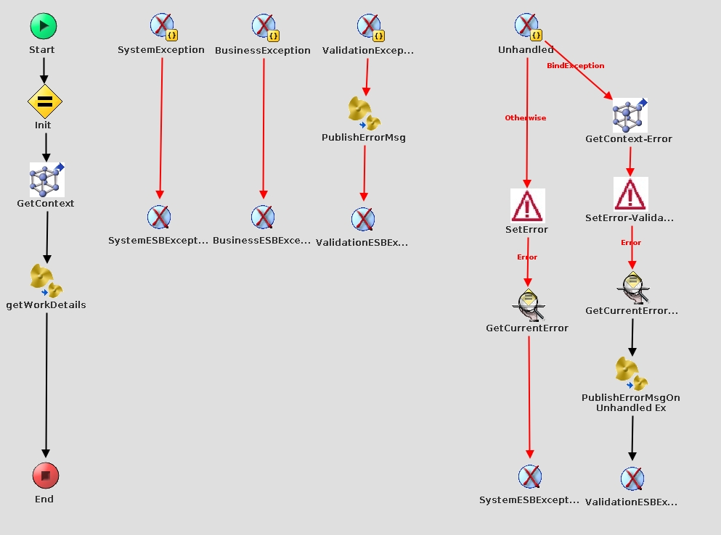

Figure 4: Interface Process - getWorkDetails_soap

The Main Process getWorkDetails maps the request, calls the ICE API named IAC9631 and retrieves the detailed works information. The response from IAC9631 is checked for any errors in data.



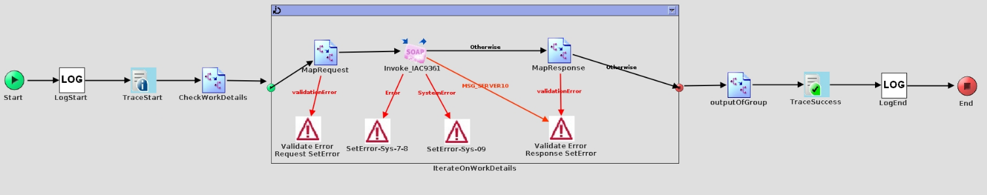

Figure 6: Main Process - getWorkDetails

# Configuration Values

Within the TIBCO BusinessWorks implementation a number of configurable parameter are defined. The names of those parameters are Global Variables. With the TIBCO AppManage tool Global Variables can be exported to an XML based deployment descriptor. Before the application is deployed those variables have to be adjusted to the relevant environments.

In the following section the relevant Global Variables are listed and described. In the deployment descriptor many other variables are found, but they are constant values and must not be touched or the global variables are TIBCO BusinessWorks defaults variables and are not used.

# Base Global Variables

The Base Global variables describe configuration parameters that are valid for every EAI sub system.

|  |  |  |
| --- | --- | --- |
| Variable | Description | Example/Predefined setting |
| AppInfo/AppHome | Each EAI subsystem has its own runtime directory where start and stop scripts, deployments scripts, error codes csv file etc. are located. Especially the error codes and configuration files are loaded within the startup of an engine. In case of wrong configuration the engine does not start. | /opt/workspace/gema_ice_adp/repo/  / GEMA_ICE_ADP |
| AppInfo/AppName | Is used in different scenarios within the TIBCO BusinessWorks implementation, for example as part of a JMS client Id or within logging and tracing | GEMA_ICE_ADP |
| Core/Connection/  EMS/JNDIContextURL | The JNDI URL to the main ESB EMS. | tibjmsnaming://localhost:17222 |
| Core/Connection/  EMS/JNDIPassword | The JNDI password to connect to EMS. | admin123 |
| Core/Connection/  EMS/JNDIUserName | The JNDI username to connect to EMS. | admin |
| Core/Logging/LogLevel | The log level of this application. | I (Information) |
|  |  |  |

The following global variables are related to TIBCO BusinessWorks Process Monitoring. For this a dedicated EMS instance is running, which needs to be addressed with the following Global Variables:

|  |  |  |
| --- | --- | --- |
| Variable | Description | Example/Predefined setting |
| Destinations/Work001/Work | queue | Work001.q.sync |
| ICE_ADP/Service/JmsDeliveryMode | Jms Delivery Mode of the Service Exposed (Work001) | “NON_PERSISTENT” |
| ICE_ADP/Service/Publisher/DeliveryMode | JMS Delivery Mode of the validation error publisher | “NON_PERSISTENT” |
| ICE_ADP/Service/Publisher/JmsExpiration | Jms Expiration of the validation error messages | 0 |
| ICE_ADP/Service/Publisher/Priority | Priority of the validation error messages | 4 |
| ICE_ADP/BW_GLOBAL_TRUSTED_CA | Certificate folder | /opt/workspace/ |
| ICE_ADP/Backend/ICE/URL | Web Service URL | http://services.iceaccess.com//wsa800/IAC9361 |
| ICE_ADP/Backend/ICE/Timeout |  | 0 |
| ICE_ADP/Backend/ICE/_langcode |  | EN |
| ICE_ADP/Backend/ICE/shwnatchar |  | Y |
| ICE_ADP/Backend/ICE/userid |  | GEMA |
| ICE_ADP/Backend/ICE/Usernumber |  | 0 |
| Core/Connection/EMS/Max_Session | NOT USED due to the current configuration of the Ack Mode of the SOAP/JMS service exposed: AUTO. | 10 |
| ICE_ADP/BW_GLOBAL_TRUSTED_CA_STORE | Standard BW GV for certificates folder | /opt/tibco/certs |

## EMS Configuration

The “Ems_configuration.sh” file makes a connection to ems server and creates queues and factories mandatory for the project calling the “Ems_configuration.txt” file.

The “Ems_configuration_delete.sh deletes all the queues and factories created in the above step calling the “Ems_configuration_delete.txt” files.

See attachment chapter.

# Releases

TBD

# Error Handling

## System Errors

System error is thrown in case of technical or infrastructure problems. For example if MAX is unavailable. For synchronous request/reply the SOAP fault SystemESBException is returned back to service consumer. The service consumer is responsible for retry.

## Business and Validation Errors

Business Errors are thrown in case of functional error, for example if wrong data is sent or some other inconsistencies.

Validation Errors are throws in case the send request does to match to service provider’s schema. For synchronous request/reply the SOAP fault BusinessESBException or ValidationESBException is returned back to service consumer.

Only in case of validation errors, the initial message is published in the error queue.

## Error Queues

|  |  |
| --- | --- |
| Error Queue | Error Queue Type |
| Work001.q.sync.BE | Business |
|  |  |

# Error Codes

|  |  |  |  |  |
| --- | --- | --- | --- | --- |
| V | ErrorCode | ErrorType | ErrorMessage | Operational Guide |
| 1.0 | ESB000001 | System | Unhandled system exception. Please see ErrorInformation for further info or contact system support | Further Analyzing by Application Support needed. Inform Development Team. Log-Extracts helpful. |
| 1.0 | ESB000002 | Validation | Binding Exception. SOAP request could not be validated against WSDL | Further Analyzing by Application Support needed. Inform Development Team. Log-Extracts helpful. |
| 1.0 | ESB000003 | System | Error Codes could not be loaded. Check ErrorInformation for details. | $APP_HOME/errorcodes/esberrorcodes/*.csv not existing or in wrong format  Check Files in directory, if format is valid |
| 1.0 | ESB000004 | System | Backend Error Codes could not be loaded. Check ErrorInformation for details. | $APP_HOME/errorcodes/BackendMapping.xml  or  $APP_HOME/errorcodes/backendmapping/*.csv  not existing or in wrong format  Check Files in directory, if format is valid |
| 1.0 | ESB000005 | Business | Given ESB ErrorCode could not be found. Check ErrorInformation for details | Given Errorcode is not configured in $APP_HOME/errorcodes/esberrorcodes/*.csv  Check with Development-Team |
| 1.0 | ESB000006 | Business | Given Backend ErrorCode could not be found. Check ErrorInformation for details | Given BackendErrorcode is not configured in $APP_HOME/errorcodes/backendmapping/*.csv  Check with Development-Team |
| 1.0 | ESB000007 | System | HttpException | HTTP Error 4xx – request message in wrong format -> check with Development Team  HTTP Error 5xx – Server could not process request -> check with BackendSystem (Provider of HTTP-Service e.g. ICE) |
| 1.0 | ESB000008 | System | HttpClientException | HTTP-Service on Backend might not be available -> check with BackendSystem |
| 1.0 | ESB000009 | System | HttpServerException | Service provider reported internal error -> check with operational support of corresponding Backend system |
| 1.0 | ESB000010 | System | HttpCommunicationException | Communication problem Client/Server; probably wrong method invocation implemented -> check with Development Team |
| 1.0 | ESB000011 | System | HttpResponseException | Client no longer reachable -> should be handled in client, inform operational team of specific client (e.g. MAX-Dialog) |
| 1.0 | ESB000012 | System | ActivityTimedOutException | Implementation is handling this error in automated retry-framework -> Check with BackendSystem why Timeout occurs (if frequently occurring) |
| 1.0 | ESB000013 | System | JMSMessageCreateException | Wrong implementation -> check with Development Team |
| 1.0 | ESB000014 | System | JMSReceiveException | EMS Server probably offline, or queue/topic not existing -> check status of EMS instance |
| 1.0 | ESB000015 | System | JMSSendException | EMS Server probably offline, or queue/topic not existing -> check status of EMS instance |
| 1.0 | ESB000016 | System | JMSSessionCreateException | Further analyzing according to error message needed -> check with Development Team |
| 1.0 | ESB000017 | System | Unknown Communication Problem | Further analyzing according to error message needed -> check with Development Team |
| 1.0 | ESB000018 | System | The Configuration file could not be loaded. Check ErrorInformation for details. | given File in $APP_HOME/config/BERetryHandlerConfiguration.xml is not existing or not valid -> check File for layout issues |
| 1.0 | ESB000019 | Validation | Unable to parse the traceIdentifier. Check ErrorInformation for details. | Wrong implementation of service consumer -> contact Development Team of consuming service (e.g. Max-Dialog) |
| 1.0 | ESB000020 | System | Routing element is not found for the requested URI | Service consumer try to call operation which is not configured in gema_http_gateway/config/ RoutingElement.xml -> check with DevelopmentTeam of ServiceConsumer and ConfigurationManager EAI |
| 1.0 | ESB000021 | System | GatewayTimeOutException. | Service Consumer should handle this error (e.g. retry) -> further analyze needed, if timeout is occurring frequently (probably BW-component or BackendSystem offline) |
| 1.0 | ESB000022 | Business | Process Name does not exists | Wrong configuration in $APP_HOME/config/SERetryHandlerConfiguration.xml  or  $APP_HOME/config/BERetryHandlerConfiguration.xml  Check with Development-Team |
| 1.0 | ESB000023 | System | Error while removing the lock files. | Error occurs only on Engine-Startup -> make sure engine is started with correct user & permissions of $APP_HOME/locks/* are set correct (TIBCO);  probably Engine is started more than once -> check Unix process list |
| 1.0 | ESB000024 | System | Error in loading the configuration file. | given File in $APP_HOME/config/SERetryHandlerConfiguration.xml is not existing or not valid -> check File for layout issues |

Adapter specific error codes:

|  |  |  |  |  |
| --- | --- | --- | --- | --- |
| V | ErrorCode | ErrorType | ErrorMessage | Operational Guide |
| 1.0 | ICE000007 | System | ICE Web Service IAC9361 cannot be reached | Contact ICE Administrator |
| 1.0 | ICE000008 | System | Request timed out | Contact ICE Administrator |
| 1.0 | ICE000009 | System | /IAC9361Response/return/_ IACRETMSGS/_MSGSEVER= 99 | Contact ICE Administrator |
| 1.0 | ICE000010 | Validation | ICE mapping value not found in lookup structure | The input data didn’t match the ICE parameters after mapping in Tibco, check the transformed data and change the input data if necessary |
| 1.0 | ICE000011 | Validation | /IAC9361Response/return/_IACRETMSG S/_MSGSEVER= 10 |  |

# Unit Test

In the table below the list of unit test performed:

|  |  |  |
| --- | --- | --- |
| # | Name | Description |
| 1 | One iceWorkKey | The request contains 1 iceWorkKey. The response is valid. |
| 2 | One iceWorkKey – MSGSERVER=10 | The request contains 1 iceWorkKey. The ICE response contains the parameter MSG_SERVER=30. The response is provided with the status NOT FOUND |
| 3 | One iceWorkKey - _IAC9361L3 missing | The request contains 1 iceWorkKey. The ICE response does not contains the structure _ IAC9361L3. |
| 4 | One iceWorkKey - _IAC9361L1 missing | The request contains 1 iceWorkKey. The ICE response does not contains the structure _ IAC9361L1. A valid response is provided. |
| 5 | One iceWorkKey - _IAC9361L2 missing | The request contains 1 iceWorkKey. The ICE response does not contains the structure _ IAC9361L2. A valid response is provided. |
| 6 | One iceWorkKey - _IAC9361L3 empty | The request contains 1 iceWorkKey. The ICE response contains the structure _ IAC9361L3 empty. Validation Error raised. The initial message is published on the Business Error Queue. |
| 7 | One iceWorkKey - _IAC9361L3 missing | The request contains 1 iceWorkKey. The ICE response does not contains the structure _ IAC9361L3. A valid response is provided |
| 8 | One iceWorkKey - _IAC9361L4 missing | The request contains 1 iceWorkKey. The ICE response does not contains the structure _ IAC9361L4. A valid response is provided |
| 9 | One iceWorkKey – MSGSERVER=10 | The request contains 1 iceWorkKey. The ICE response contains the parameter MSG_SERVER=10. A Validation exception is raised. The initial message is published on the Business Error Queue. |
| 10 | One iceWorkKey – MSGSERVER=99 | The request contains 1 iceWorkKey. The ICE response contains the parameter MSG_SERVER=99. A System exception is raised |
| 11 | Timeout | The component receive a timeout exception trying to contact ICE. A System Exception is raised. |
| 12 | Connection issue | The component receive a connection exception trying to contact ICE. A System Exception is raised. |
| 13 | Multiple iceWorkKey | The request contains multiple iceWorkKey in input. A valid response is provided |
| 14 | Multiple iceWorkKey – 1 in error | The request contains multiple iceWorkKey in input. ICE raise an exception for one of them. An exception is raised. The log message contains the iceWorkKey (from the input) in error. |

# Attachments

EMS Configuration file



EMS Configuration script

