Mele Winn

February 21, 2021

Foundations Databases and SQL Programming

Assignment06

https://github.com/melewinn/DBFoundations

Views, Functions, and Stored Procedures

## Introduction

In this paper, I will explain when one would use a SQL View. Then, I will explain the differences and similarities between a View, Function, and Stored Procedure.

## SQL View

A SQL View creates a ‘table’ out of a saved query. Views provide a layer of abstraction which contribute to a more secure database. End users are only allowed to see a subset of data that the database owner permits the end user to see.

## Views, Functions, and Stored Procedures

Views and Functions use similar syntax in the query. However, the key difference is that Functions can accept parameters, while Views cannot. Stored procedures also utilize similar syntax as Views and Functions. However, instead of using the ‘Select’ statement for Views and Functions, you ‘Execute’ the Stored Procedure (Figure 1). You can also have many statements such as Insert, Delete, and Update statements in Stored Procedures.

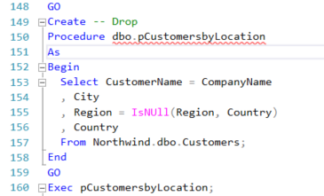

Figure 1: SQL query with Stored Procedure

## Summary

Views, Functions, and Stored Procedures are various ways to store code in a database file. Since functions are more complex than views and provide similar functionality, it is best practice to use views. Lastly, due to the flexibility that is allowed by Stored Procedures, this method is most used for complex reporting purposes.