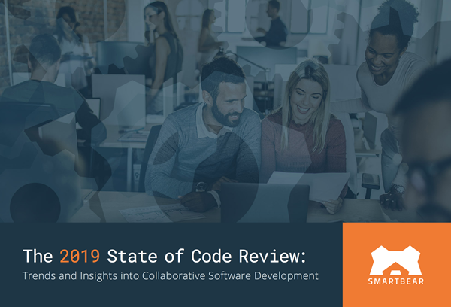

This is the 6th Annual State of Code Review report, designed to document and analyze the code review practices common across software development. We highlight the most prevalent trends relative to prior years and surface the top best practices.

This report includes insights from 1100 software developers, testers, IT/operations professionals, and business leaders representing more than 35 different industries.

**The following report covers topics like:**

* Perceptions on Code Quality
* Approaches to Code Review
* Code Review Tools and Decision Making
* Actionable Recommendations for Your Team
* "What Makes for a Great Code Review?"

[Download the Report](https://smartbear.com/resources/ebooks/the-state-of-code-review-2019/)