**Data Center Scheduling Optimization Problem**

Data Science Track

**Prepared by**

Farid Ahmed Farid

Mohamed Ahmed Abdo Elhamamsy

Mohamed Abdelghani Mohamed

**Under supervision of:**

Dr. Basma Mostafa

Contents

Business Problem 3

Business Objectives 3

Decision Variable: 3

Constraints: 4

Demand Constraints 4

Max Supply Per Rack Constraints 4

Binary Constraint 5

Objective Function: 5

Classification with respect to the Optimization model 5

Continuous Optimization 5

Constrained Optimization 5

One Objective 5

Deterministic Optimization 5

Assumptions & Approximations 6

Racks Specs 6

System Implementation using JuMP/Julia 7

Model Validation 8

### Business Problem

As a cloud provider organization, there is a necessity to set up a schedule for turning the hardware on or off to minimize power and cooling cost, in addition to minimizing greenhouse gas emission which leads to a fundamental tradeoff between performance and energy usage while supplying a variant demand over time.

### Business Objectives

* **Who:** IT solution Architects, Finance department, R&D department.
* **What:** Put a switch on/off schedule for the data center racks.
* **Why:** Minimizing the power and cooling cost in addition to greenhouse gas emission cost

### Decision Variable:

xjk: The contribution of the kth cluster in the jth period.

Note that an assumption that each rack must be OFF for two periods a day Was made.

|  |  |  |  |  |  |  |
| --- | --- | --- | --- | --- | --- | --- |
| Supply | X1 | X2 | X3 | X4 | X5 | X6 |
| T1 | x11 | X12 | X13 | x14 | x15 | x16 |
| T2 | x21 | x22 | X23 | X24 | x25 | x26 |
| T3 | x31 | x32 | x33 | X34 | X35 | x36 |
| T4 | x41 | x42 | x43 | x44 | x45 | x46 |
| T5 | x51 | x52 | x53 | x54 | x55 | X56 |
| T6 | x61 | X62 | x63 | x64 | x65 | x66 |

|  |  |
| --- | --- |
| Periods | Demand  GB/4hrs |
| T1 | 30000 |
| T2 | 30000 |
| T3 | 40000 |
| T4 | 40000 |
| T5 | 35000 |
| T6 | 35000 |

### Constraints:

## Demand Constraints

The total contribution of all racks at each period must be equal to the demand in the same period.

* **∑i6=1**x1i*pi = 30000
* **∑i6=2**x2i*pi = 30000
* **∑i6=3**x3i*pi = 40000
* **∑i6=4**x4i*pi = 40000
* **∑i6=5**x5i*pi = 35000
* **∑i6=6**x6i*pi = 35000

## Max Supply Per Rack Constraints

The total contribution of a given rack throughout the period must be less than or equal to the max supply the rack can contribute with, in any given period. Each rack has to be put out of service two periods a day for maintenance.

|  |  |  |  |  |  |  |
| --- | --- | --- | --- | --- | --- | --- |
|  | C1 | C2 | C3 | C4 | C5 | C6 |
| Max Supply GB/period | 7500 | 7500 | 5000 | 10000 | 10000 | 15000 |

* **∑j6=1∑i6=1**xij <= 4

## Binary Constraint

xjk = {0,1}, ∀ j, k Є {1,2,3,4,5,6}

### Objective Function:

* ∑k6= 1 ∑j6= 1 xjk * ck (Minimize)

Where Ck is the combined cost of the kthrack per GB per period.

|  |  |  |  |  |  |  |
| --- | --- | --- | --- | --- | --- | --- |
| Cost+CO2 | C1 | C2 | C3 | C4 | C5 | C6 |
| On Cost + CO2 $/Period | 29.475 | 29.475 | 14.3 | 50.2 | 57 | 106.2 |

### Classification with respect to the Optimization model

## Discrete Optimization

 An xjk can take 0 or 1 resembling ON and OFF states of the machine.

## Constrained Optimization

The optimization model is constrained by the imposed business constraints.

## One Objective

The model has one and only one objective which is to minimize the total combination cost considering the cost of providing the service plus the equivalent CO2 emissions costs.

## Deterministic Optimization

The model uses a Deterministic approach to find the optimal solution, in Other words, the objective function is convex leading the search Algorithm to reach a global optimum.

### Assumptions & Approximations

* Any XJK variables can take 0 or 1.
* Demand is covered within six periods throughout the day, four hours each, for instance, T1 period demand is 7500 GB/4hr.
* Each rack must be OFF for at least two periods a day.
* Demand is the transfer rate in MB/S.
* Each rack consists of a different number of devices, for instance routers, servers, and firewalls.
* Each rack can serve a different max transfer rate, for example, c1 can serve up to 100MB/s.

One $/GB costs differently for each rack, for instance, c1 rock has 15.225 $/GB.

* Each rack contributes differently into the Co2 emission cost, for instance C3 costs 10.3 $/GB for 6gm Co2 emission.

### Racks Specs

**Rack 1, 2 (7500GB/4h):**

Rack 1 can serve 100MB/s, 6GB/m.

2 UPS systems

router

firewall

2 switches

30 workstations

**Rack 3 (7500GB/4h):**

1 UPS systems

router

firewall

1 switch

15 workstations

**Rack 4 (10000GB/4h):**

3 UPS systems

2 routers

firewall

3 switches

45 workstations

**Rack 5 (10000GB/4h):**

4 UPS systems

2 routers

firewall

4 switches

60 workstations

**Rack 6 (15000GB/4h):**

5 UPS systems

2 routers

firewall

5 switches

75 workstations

### System Implementation using JuMP/Julia and Excel

* Source Code is available in another file with the name Cloud Provider.

**Solution of the model using Julia**

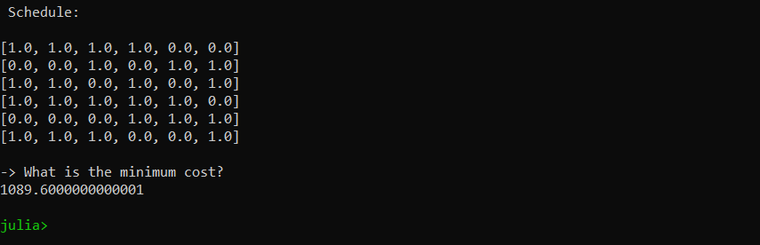

**Solution of the model using Excel**

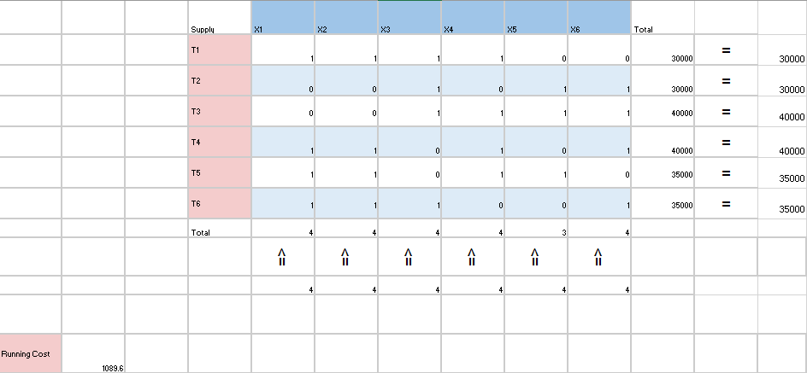

### Model Validation

The model has provided quite good results that make sense, for instance: -

* The total supply across each period is typically equal to the demand.
* The model has met all the constraints set, for example, the racks supply doesn’t exceed its maximum threshold of working periods per day.
* The result of the running cost provided by the model according to the inputs provided is very reasonable.