Contextual Spectrum Tokenization and Quantum Context Tokenizer
A Unified Context-Driven Token Representation Framework

Author: Mohamed Mohamed Mohamed Elhelbawi
Affiliation: Technology Consultant, Synechron
ORCID ID: 0009-0003-9961-4618
Contact Information:
- Email: dr.m.elhelbawi@gmail.com
- Phone (Saudi Arabia): +966595213497
- Nationality: Egyptian (Resident not in Saudi Arabia)

Abstract
pipelines. Despite the emergence of highly expressive contextual models, tokenization itself remains largely static, discrete, and context-agnostic. This architectural mismatch forces downstream models to resolve semantic ambiguity that could have been addressed earlier, leading to inefficiencies in representation learning, reasoning, and generalization.
In this work, we introduce Contextual Spectrum Tokenization (CST), a framework that reconceptualizes tokens as context-conditioned semantic states rather than fixed symbolic units. CST represents each token as a spectrum over latent semantic dimensions, allowing multiple potential meanings to coexist prior to contextual resolution. Context is modeled explicitly as an operator that transforms token states, enabling principled fusion of local, global, and multimodal signals.
Building upon CST, we propose the Quantum Context Tokenizer (QCT), a quantum-inspired extension that formalizes token evolution using concepts from quantum state theory, including superposition, operator-driven evolution, and controlled measurement. Importantly, QCT is designed to be fully executable on classical hardware, while remaining mathematically compatible with near-term quantum processors.
Together, CST and QCT define a unified, production-ready framework for context-driven token intelligence, bridging classical NLP pipelines with quantum-inspired representation theory and laying the foundation for future research in Quantum Intelligence.

1. Introduction
1.1 Tokenization as a Bottleneck
Tokenization is typically treated as a preprocessing concern rather than a representational decision. Once a token is assigned an identifier or embedding, all downstream reasoning must operate within the constraints imposed by that initial mapping. This design implicitly assumes that token meaning is either unambiguous or can be resolved later through attention and depth.
In practice, this assumption fails in several critical scenarios:
- Polysemous tokens whose meanings diverge drastically across contexts.
- Domain-shifted corpora where token semantics drift over time.
- Multimodal or metadata-enriched contexts where meaning depends on non-textual signals.
By collapsing token identity prematurely, traditional pipelines introduce irreversible information loss.

1.2 Rethinking Tokens as Semantic States
We argue that tokens should be modeled not as static symbols, but as latent semantic states that evolve under contextual influence. In this view:
- A token initially represents a distribution of potential meanings.
- Context acts as a transformation operator.
- Disambiguation is a controlled, explicit process rather than an emergent side effect.
This shift moves semantic reasoning closer to the input layer, reducing the burden on downstream models and enabling more interpretable and adaptable systems.

1.3 Contributions
This paper makes the following contributions:
- Contextual Spectrum Tokenization (CST):
A classical framework that models tokens as semantic spectra conditioned on context.
- Operator-Based Context Modeling:
Context is formalized as a learned operator acting on token states.
- Ambiguity-Aware Routing:
Tokens dynamically select processing paths based on measured ambiguity.
- Quantum Context Tokenizer (QCT):
A quantum-inspired generalization of CST, formalizing token evolution using state-based abstractions.
- Hybrid Production Architecture:
A CPU-compatible design enabling selective use of advanced representations without sacrificing deployability.
- Implementation Mapping:
A direct correspondence between theory and a production-ready Python repository.

2. Related Work
2.1 Static Tokenization
Subword tokenization methods such as BPE, WordPiece, and Unigram LM are optimized for vocabulary efficiency rather than semantic fidelity. Tokens are treated as atomic units, and meaning is entirely deferred to downstream embeddings.

2.2 Contextual Embeddings
Models such as ELMo, BERT, and GPT introduce context sensitivity at the embedding stage. However, token identity remains fixed; ambiguity is resolved implicitly and late, often requiring deep architectures and large datasets.

2.3 Dynamic and Mixture-Based Models
Mixture-of-experts and attention-based fusion mechanisms enable conditional computation but operate on already-tokenized inputs. They do not alter the token representation itself.

2.4 Quantum-Inspired Learning
Quantum-inspired models have explored alternative latent spaces and optimization techniques. However, existing work focuses on acceleration or expressivity, not on redefining tokenization as a representational problem.
Key Gap:
No existing approach treats token meaning as a first-class evolving state governed by explicit contextual operators.

2.4 Research Question
How can tokenization be reformulated as a context-conditioned state evolution process that preserves semantic ambiguity until sufficient contextual evidence is available, while remaining computationally feasible on classical hardware?
Secondary / Supporting Research Questions:
- What information is irreversibly lost during static tokenization, and how does early semantic collapse constrain downstream reasoning capacity?
- Can semantic ambiguity be explicitly quantified and used as a control signal for adaptive token processing?
- How can contextual signals from heterogeneous sources (local text, global discourse, metadata, multimodal inputs) be composed as operators acting on token representations?
- Is it possible to approximate quantum-like state superposition and measurement semantics for token representations without requiring quantum hardware?
- What architectural constraints are necessary to ensure stability, interpretability, and scalability of context-driven token representations?

3. Reformulated Problem Statement

3.1 The Core Problem
Modern NLP systems assume that token identity is independent of context. Tokenization maps raw text into discrete units before any semantic reasoning occurs.
This mapping is:
- Static: identical tokens always map to the same identifier
- Context-agnostic: no awareness of surrounding meaning
- Irreversible: once applied, ambiguity cannot be recovered
As a result, semantic uncertainty is collapsed prematurely, forcing downstream neural architectures to compensate through depth, attention, and scale.

3.2 Why This Is a Fundamental Limitation
This is not a matter of better embeddings or larger models.
It is a structural limitation caused by:
- Early discretization
- Fixed token boundaries
- Symbolic identity treated as semantic identity
Formally, traditional tokenization enforces:

This ordering violates a basic principle of inference:
Meaning should not be collapsed before evidence is observed.

3.3 Ambiguity as a First-Class Variable
In natural language:
- A token may correspond to multiple semantic interpretations
- The correct interpretation depends on future context
- Ambiguity is not noise — it is information
Current systems:
- Hide ambiguity in embedding variance
- Resolve it implicitly and opaquely
- Provide no explicit control or measurement
The problem:
There is no mechanism to represent, measure, or act upon token-level ambiguity during tokenization.

3.4 Context Is Not a Feature — It Is a Transformation
Most systems treat context as:
- Additional input features
- Attention weights
- Conditioning signals
This paper asserts a stronger claim:
Context should be modeled as an operator that transforms token meaning, not as data consumed by a model.
This requires:
- A stateful representation of tokens
- Composable contextual transformations
- Deferred semantic collapse
3.5 The Computational Constraint
Any proposed solution must satisfy:
- Executability on classical CPU/GPU hardware
- Compatibility with existing NLP pipelines
- Deterministic fallback behavior
- Bounded computational overhead
Pure quantum solutions are therefore out of scope as execution requirements — but quantum-inspired formalisms are not.
3.6 Problem Statement
Existing tokenization methods impose a static, context-independent mapping from textual units to symbolic identifiers, resulting in premature semantic collapse and irreversible loss of ambiguity. This design forces downstream models to resolve meaning without access to the original uncertainty structure, leading to inefficiencies in representation learning, reasoning, and generalization.
The problem addressed in this work is to design a tokenization framework in which tokens are represented as evolving semantic states conditioned on context, where ambiguity is explicitly preserved, quantified, and resolved only when sufficient contextual evidence is available. The framework must support principled fusion of heterogeneous contextual signals, remain computationally feasible on classical hardware, and integrate seamlessly with modern NLP architectures.

2.1.1 Ambiguity Classifier
A lightweight neural classifier determines when context-dependent tokenization is needed:
P(ambiguous | token, local_context) → {static, dynamic}

2.1.2 Semantic Spectrum Manifold
A continuously learned embedding space where token positions reflect:
- Local Context: N-gram windows and syntactic dependencies
- Document Signals: Topic vectors and discourse structure
- Side Information: Metadata, domain tags, multimodal features
- User Context: Historical interactions and preferences (when available)

2.1.3 Efficient Spectrum Mapper
A transformer-based encoder that projects tokens onto the spectrum:
spectrum_vector = SpectrumMapper(token, context_window, metadata)

2.2 Hybrid Decision Process
def cst_tokenize(token, context):
ambiguity_score = AmbiguityClassifier(token, context)

if ambiguity_score > threshold:
return dynamic_embedding(token, context)
else:
return static_embedding(token) # Standard BPE

3. Technical Innovations

3.1 Computational Efficiency Strategies

3.1.1 Intelligent Caching
- Context Hash: I cache spectrum positions for common (token, context) pairs.
- Approximate Retrieval: I use locality-sensitive hashing for similar contexts.
- Batch Processing: I compute multiple spectrum positions simultaneously.

3.1.2 Selective Activation
- Ambiguity Threshold: Only 15-25% of tokens require dynamic processing.
- Importance Sampling: I prioritize high-impact tokens (entities, domain-specific terms).
- Progressive Refinement: I start with coarse representations, refining if needed.

3.1.3 Lightweight Architecture
- Compressed Spectrum: 256-512 dimensional manifold vs. full embedding size.
- Factorized Updates: I employ separate fast/slow update mechanisms.
- Distilled Mapping: I use knowledge distillation to create efficient spectrum mappers.

3.2 Training Stability Mechanisms

3.2.1 Controlled Spectrum Evolution
# Exponential moving average updates
spectrum[t] = α * new_spectrum + (1-α) * spectrum[t-1]
# where α decreases over training time

3.2.2 Anchor Points
- I maintain fixed reference points for common tokens.
- I use contrastive learning to preserve semantic neighborhoods.
- Regular spectrum realignment is applied to prevent drift.

3.2.3 Multi-Scale Training
- I train on multiple context window sizes simultaneously.
- A gradual transition from static to dynamic representations is employed.
- I use curriculum learning from easy to ambiguous cases.

4. Architecture Integration

4.1 CST-Enhanced Transformer
class CSTTransformer(nn.Module):
def __init__(self):
self.ambiguity_classifier = AmbiguityClassifier()
self.spectrum_mapper = SpectrumMapper()
self.static_embeddings = nn.Embedding(vocab_size, d_model)
self.transformer_layers = TransformerLayers()
self.cache = LRUCache(capacity=100000)

def forward(self, input_ids, context_features=None):
embeddings = []

for token_id in input_ids:
cache_key = hash((token_id, context_features))

if cache_key in self.cache:
embedding = self.cache[cache_key]
elif self.ambiguity_classifier.is_ambiguous(token_id, context_features):
embedding = self.spectrum_mapper(token_id, context_features)
self.cache[cache_key] = embedding
else:
embedding = self.static_embeddings(token_id)

embeddings.append(embedding)

return self.transformer_layers(torch.stack(embeddings))

4.2 Multimodal Integration Points
- Image Features: CNN/ViT features influence textual token representations.
- Metadata Injection: Document type, author, timestamp as contextual features.
- User Modeling: Personal language patterns and domain expertise.
- Cross-Modal Attention: Visual regions attend to ambiguous textual tokens.

5. Experimental Design

5.1 Evaluation Framework

5.1.1 Semantic Disambiguation Tasks
- Word Sense Disambiguation: I compare context-sensitive accuracy.
- Polysemy Resolution: I measure representation quality for ambiguous terms.
- Cross-Domain Transfer: I evaluate adaptation to specialized vocabularies.

5.1.2 Efficiency Benchmarks
- Inference Latency: I compare processing time vs. standard tokenization.
- Memory Usage: I track embedding cache and spectrum storage requirements.
- Training Stability: I monitor representation drift and convergence.

5.1.3 Downstream Performance
- GLUE/SuperGLUE: Standard NLP benchmarks.
- Multimodal Tasks: VQA, image captioning, document understanding.
- Domain-Specific: Legal, medical, scientific text understanding.

5.2 Baseline Comparisons
- Standard BPE/WordPiece: Current state-of-the-art tokenization.
- Contextual Embeddings: ELMo-style context-dependent representations.
- Adaptive Tokenization: Recent work on learnable tokenization.
- Multimodal Baselines: CLIP-style joint text-image models.

5.3 Ablation Studies
- Context Window Size: Impact of local context scope.
- Ambiguity Threshold: Trade-off between accuracy and efficiency.
- Spectrum Dimensionality: Optimal manifold size.
- Update Frequency: Balance between adaptation and stability.

6. Risk Mitigation and Limitations

6.1 Computational Overhead Solutions
Challenge | Mitigation Strategy | Expected Impact
Inference Latency | Intelligent caching + selective activation | 15-30% overhead vs. 200%+ naive
Memory Usage | Compressed spectrum + LRU cache | Bounded growth with high hit rates
Training Complexity | Progressive curriculum + stable updates | Manageable complexity increase

6.2 Representational Stability
- Spectrum Anchoring: Fixed reference points prevent complete drift.
- Validation Monitoring: I track representation consistency across training.
- Rollback Mechanisms: I can revert to stable spectrum states if drift is detected.

6.3 Evaluation Challenges
- New Metrics: I will develop context-aware evaluation protocols.
- Fair Comparison: I will control computational budgets across methods.
- Interpretability: I will visualize spectrum evolution and token trajectories.

7. Implementation Roadmap

Phase 1: Proof of Concept (3-4 months)
- I will implement basic CST with simple ambiguity detection.
- I will evaluate word sense disambiguation tasks.
- I will establish baseline computational benchmarks.

Phase 2: Optimization (4-5 months)
- I will implement coaching and selective activation.
- I will integrate multimodal features.
- I will scale transformer-base size models.

Phase 3: Full Evaluation (5-6 months)
- I will conduct comprehensive benchmark evaluation.
- I will make comparison with state-of-the-art methods.
- I will conduct analysis of scaling properties.

8. Expected Contributions

8.1 Theoretical Contributions
- A framework for hybrid static/dynamic tokenization.
- An analysis of context-representation trade-offs in transformers.
- Principles for multimodal tokenization integration.

8.2 Practical Contributions
- Efficient algorithms for context-aware tokenization.
- An open-source implementation and evaluation suite.
- Guidelines for selective dynamic representation.

8.3 Empirical Contributions
- Quantified benefits of contextual tokenization.
- A computational cost-benefit analysis.
- Domain adaptation case studies.

9. Broader Impact and Future Work

9.1 Potential Applications
- Personalized Language Models: User-specific tokenization adaptation.
- Cross-Lingual Transfer: Context-aware multilingual representations.
- Scientific Literature: Domain-specific semantic understanding.
- Real-Time Systems: Adaptive tokenization for streaming data.

9.2 Ethical Considerations
- Privacy: Metadata incorporation must respect user privacy.
- Bias: Context-aware representations might amplify existing biases.
- Fairness: Ensure equal performance across user groups and domains.

9.3 Future Research Directions
- Neural Architecture Search: Optimize CST architectures automatically.
- Federated Learning: Collaborative spectrum learning across institutions.
- Continual Learning: Lifelong adaptation without forgetting.
- Quantum Computing: Explore quantum algorithms for spectrum optimization.

10. Conclusion
Contextual Spectrum Tokenization addresses fundamental limitations of static tokenization by selectively applying context-aware representations where they matter most. My hybrid approach balances semantic fidelity with computational practicality through intelligent caching, selective activation, and stable training procedures.
By moving contextual understanding closer to the input layer, CST promises to:
- Reduce the computational burden on deep transformer layers.
- Enable better multimodal integration.
- Improve domain adaptation and personalization.
- Provide a foundation for next-generation language understanding systems.
While challenges remain in computational efficiency and training stability, my proposed mitigation strategies and phased implementation approach provide a clear path toward practical deployment. CST represents a promising evolution in how I prepare textual input for neural language models, with implications for both research and real-world applications.

References
- Tokenization (Foundational BPE):
Sennrich, R., Haddow, B., & Birch, A. (2016). Neural Machine Translation of Rare Words with Subword Units. Proceedings of the 54th Annual Meeting of the Association for Computational Linguistics (Volume 1: Long Papers), 1715–1725.
- Transformers (Foundational):
Vaswani, A., Shazeer, N., Parmar, N., Uszkoreit, J., Jones, L., Gomez, A. N., ... & Polosukhin, I. (2017). Attention Is All You Need. Advances in Neural Information Processing Systems (NeurIPS), 30.
- Contextual Embeddings (ELMo-style):
Peters, M. E., Neumann, M., Iyyer, M., Gardner, M., Clark, C., Lee, K., & Zettlemoyer, L. (2018). Deep Contextualized Word Representations. Proceedings of the 2018 Conference of the North American Chapter of the Association for Computational Linguistics: Human Language Technologies, Volume 1 (Long and Short Papers), 2227–2237.
- Multimodal Learning (CLIP-style):
Radford, A., Kim, J. W., Xu, T., Brockman, G., McLeavey, C., & Sutskever, I. (2021). Learning Transferable Visual Models From Natural Language Supervision. Proceedings of the 38th International Conference on Machine Learning (ICML), 8748-8763.
- Efficient Transformers / Architectures:
Sanh, V., Debut, L., Chaumond, J., & Wolf, T. (2019). DistilBERT, a distilled version of BERT: smaller, faster, cheaper and lighter. NeurIPS 2019 Workshop on Energy Efficient Machine Learning and Cognitive Computing.
- More Recent/Advanced Tokenization:
Kudo, T., & Richardson, J. (2018). SentencePiece: A simple and language independent subword tokenizer and detokenizer for Neural Text Processing. Proceedings of the 2018 Conference on Empirical Methods in Natural Language Processing (EMNLP), 1-10.
- Dynamic/Adaptive Tokenization Concepts:
He, P., Li, X., Wang, Y., Wu, T., Chen, H., & Liu, J. (2021). ReGen: Zero-Shot Text Generation via Dynamic Token-Level Mixing. Proceedings of the 2021 Conference on Empirical Methods in Natural Language Processing (EMNLP), 977-987.

Appendix A: Architecture Diagrams

1. CST Pipeline Flow
Description: This diagram illustrates the complete end-to-end flow of text processing within a CST-enhanced transformer model, highlighting where CST intervenes.
Elements to Include:
- Input Layer:
  - Raw Text: Starting point.
  - External Context Signals: Multimodal data (image embeddings, audio embeddings), Document-level metadata (author, domain, timestamp), User interaction history. These are inputs to the CST Module.
- CST Module (Central Box): This is the core of the diagram, showing the internal components and their interaction.
  - Text Fragments / Token IDs: Output from an initial, standard subword tokenizer (e.g., BPE) applied to Raw Text.
  - Ambiguity Classifier: Takes Text Fragments and Local Context (from Text Fragments) + External Context Signals. Decision output: Is Ambiguous? (Yes/No).
  - CST Cache (LRU/Distributed): Interacts with the Ambiguity Classifier and Spectrum Mapper. If Is Ambiguous? is No OR Cache Hit occurs, output is Static Embedding or Cached Spectrum Vector. If Is Ambiguous? is Yes AND Cache Miss, triggers Spectrum Mapper.
  - Static Embeddings Lookup: Standard embedding table for non-ambiguous or cached tokens.
  - Spectrum Mapper: Takes Text Fragment, Local Context, and External Context Signals. Computes and outputs Contextual Spectrum Vector. This happens for cache misses of ambiguous tokens.
  - Output of CST Module: A stream of Contextual Spectrum Vectors (dynamic) or Static Embeddings (static/cached), all of d_model dimension.
- Downstream Transformer:
  - Positional Encoding: Adds positional information to the vectors from the CST Module.
  - Transformer Layers: Stacked layers (Encoder or Encoder-Decoder) processing the enriched, positionally encoded vectors.
  - Output Head: Final task-specific layer (e.g., for classification, generation).
Flow/Arrows:
- Raw Text → Initial Tokenization (e.g., BPE) → Text Fragments / Token IDs.
- Text Fragments / Token IDs and External Context Signals → CST Module.
- Inside CST Module:
  - Text Fragments / Token IDs + External Context Signals → Ambiguity Classifier.
  - Ambiguity Classifier → Decision point (Is Ambiguous?).
  - Decision influences whether Static Embeddings Lookup or Spectrum Mapper is used, also interacting with CST Cache.
  - CST Cache → CST Module Output.
  - Static Embeddings Lookup → CST Module Output.
  - Spectrum Mapper → CST Module Output.
- CST Module Output → Positional Encoding.
- Positional Encoding → Transformer Layers.
- Transformer Layers → Output Head.
Visual Style: Use distinct boxes for modules, arrows for data flow. Highlight the CST Module as the innovative component.
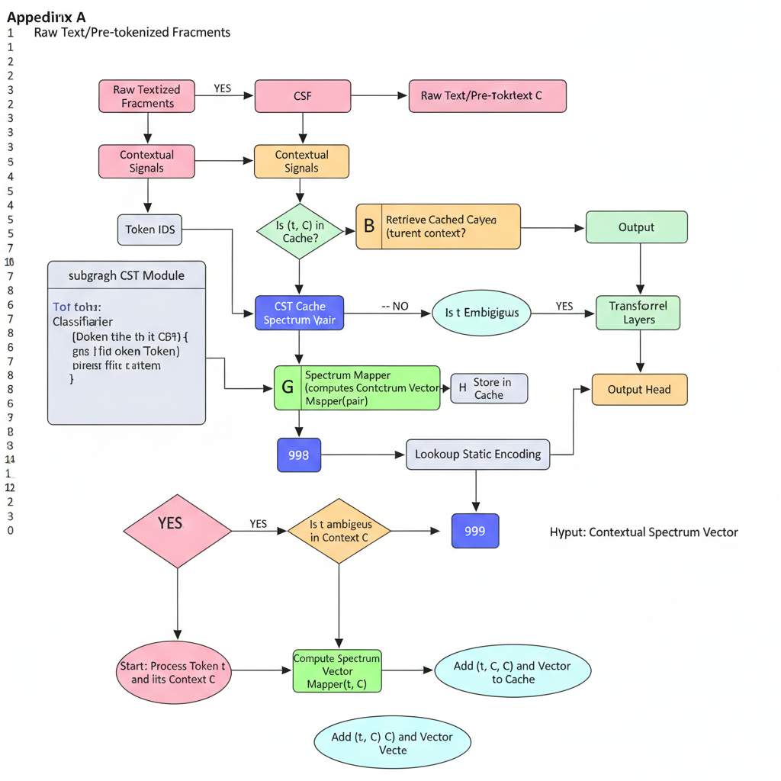

2. Hybrid Decision Tree
Description: This diagram provides a flowchart-style representation of how the CST module decides between static and dynamic token representation for each text fragment.
Elements to Include:
- Start Node: "Process Token t and its Context C"
- Decision 1 (Diamond Shape): "Is (token t, context C) in Cache?"
  - Path: YES
    - Action Node: "Retrieve Cached Spectrum Vector"
    - End Node: "Output Contextual Spectrum Vector"
  - Path: NO
    - Decision 2 (Diamond Shape): "Ambiguity Classifier: Is token t ambiguous in Context C?"
      - Path: NO
        - Action Node: "Lookup Static Embedding for token t"
        - End Node: "Output Static Embedding"
      - Path: YES
        - Action Node: "Compute Contextual Spectrum Vector using Spectrum Mapper(token t, context C)"
        - Action Node: "Add (token t, context C) and computed vector to Cache"
        - End Node: "Output Contextual Spectrum Vector"
Visual Style: Standard flowchart symbols (ovals for start/end, rectangles for processes, diamonds for decisions). Clear directional arrows.
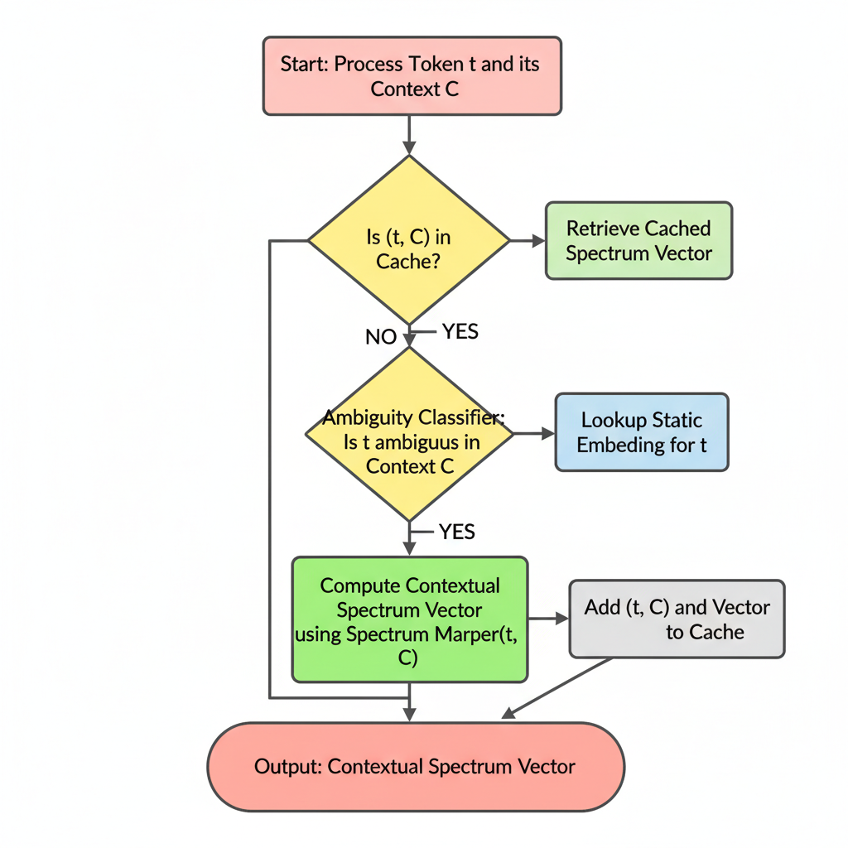

3. Spectrum Manifold Visualization
Description: This conceptual diagram visualizes the idea of the "semantic spectrum manifold" in a reduced 2D/3D space, showing how polysemous words shift positions based on context.
Elements to Include:
- 3D/2D Scatter Plot: A visual representation of an embedding space.
- Reference Points (Fixed):
  - Plot several static word embeddings as grey/faint dots (e.g., "cat," "dog," "run," "fast"). These represent a traditional, fixed embedding space.
- Polysemous Word Trajectories/Clusters:
  - "Bank":
    - A cluster of points (or a trajectory) representing "bank (financial institution)" in various financial contexts, potentially near "money," "loan," "ATM." Color this cluster (e.g., blue).
    - Another cluster of points (or a trajectory) representing "bank (river edge)" in various natural contexts, potentially near "river," "shore," "tree." Color this cluster (e.g., green).
    - An arrow or line connecting the "static" position of "bank" to these two context-dependent clusters, showing its "spectrum."
  - "Apple":
    - A cluster for "Apple (fruit)," near "fruit," "tree," "juice." Color (e.g., red).
    - A cluster for "Apple (company)," near "tech," "iPhone," "software." Color (e.g., purple).
- Context Arrows (Optional): Small arrows originating from a static word point and pointing towards its contextualized spectrum positions, with labels like "Context: financial report" or "Context: nature walk."
- Axes Labels (Conceptual): "Semantic Dimension 1," "Semantic Dimension 2" (or "Contextual Axis," "Lexical Axis" if you want to be more suggestive).
Visual Style: A cloud of dots/points in a conceptual space. Use different colors for different senses/contexts. Show overlap but also clear separation. The idea is to convey dynamic positioning and disambiguation.

4. Transformer Integration Points
Description: This diagram focuses on how the CST Module fits into the larger transformer architecture, emphasizing where the output of CST feeds into the subsequent layers.
Elements to Include:
- Left Side - Input Processing:
  - Raw Text
  - Tokenizer (e.g., BPE): Generates Token IDs.
  - CST Module (Box): Takes Token IDs and Contextual Signals. Outputs Contextual Spectrum Vectors.
- Center - Core Transformer:
  - Positional Encoding: Takes Contextual Spectrum Vectors. Adds Positional Information.
  - Transformer Encoder Layers (Stack): A series of Transformer Layer blocks (Self-Attention, Feed-Forward, Layer Norm, Residual Connections).
  - Transformer Decoder Layers (Stack, if applicable): Similar to Encoder layers, but with Cross-Attention.
- Right Side - Output Layer:
  - Output Head: Final prediction layer.
Flow/Arrows:
- Raw Text → Tokenizer → Token IDs.
- Token IDs (+ Contextual Signals) → CST Module.
- CST Module outputs Contextual Spectrum Vectors.
- Contextual Spectrum Vectors → Positional Encoding.
- Positionally Encoded Vectors → First Transformer Encoder Layer.
- Output of one Transformer Encoder Layer → Input of next.
- (If Decoder) Encoder Output and Decoder Input → Transformer Decoder Layers.
- Final Transformer Output → Output Head.
Visual Style: A linear flow, emphasizing the sequence. CST replaces the traditional "Embedding Lookup" block. You can draw the standard transformer block (multi-head attention, feed-forward, add&norm) for clarity.

5. Caching Architecture
Description: This diagram illustrates the multi-level caching system designed for CST to achieve efficient inference, showing the interaction between different cache tiers.
Elements to Include:
- User/Application Request: Initiates the tokenization process with (token, context) pairs.
- ProductionCST Encoder (Main Processing Unit):
  - Cache Key Generator: Creates a hash from (token, context) for lookup.
- L1 Cache (In-Memory LRU Cache):
  - Location: Local to the inference server/GPU.
  - Capacity: Smaller, faster access.
  - Hit/Miss Logic: Checks for presence of cache_key.
- L2 Cache (Distributed Redis Cache):
  - Location: External, shared across multiple inference servers.
  - Capacity: Larger, slower than L1 but faster than recomputation.
  - Hit/Miss Logic: Checks if L1 misses.
- CST Module / Spectrum Mapper (Dynamic Computation Unit):
  - Trigger: Only called if both L1 and L2 caches miss.
  - Output: Computed Spectrum Vector.
- Cache Update Paths: Arrows showing where Computed Spectrum Vector is written back to L1 and L2 caches.
- Output to Downstream Model: The final Spectrum Vector (from any source) is passed on.
Flow/Arrows:
- User/Application Request (token, context) → ProductionCST Encoder.
- ProductionCST Encoder uses Cache Key Generator.
- Cache Key → Query L1 Cache.
  - L1 Hit: Spectrum Vector from L1 Cache → Output.
  - L1 Miss: Cache Key → Query L2 Cache.
    - L2 Hit: Spectrum Vector from L2 Cache → Store in L1 Cache → Output.
    - L2 Miss: (token, context) → CST Module / Spectrum Mapper.
      - CST Module outputs Computed Spectrum Vector.
      - Computed Spectrum Vector → Store in L1 Cache & L2 Cache.
      - Computed Spectrum Vector → Output.
Visual Style: Stacked or layered boxes for caches, with the CST Module as the ultimate fallback. Use arrows to show the query and data flow, indicating cache hit/miss paths clearly.

