Statistical Modeling and Graphing
Enter Your Name
2025-12-11
Machine: MELAW - Windows 10 x64
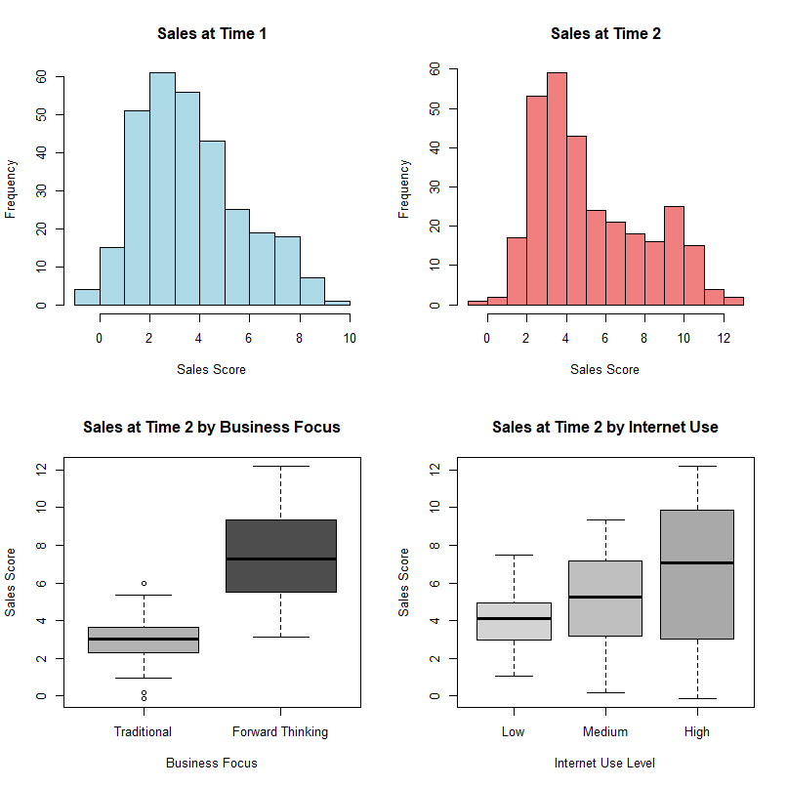
Citation: Trends in Internet-based business-to-business marketing
Abstract: The Internet is changing the transactional paradigms under which businesses-to-business marketers operate. Business-to-business marketers that take advantage of the operational efficiencies and effectiveness that emerge from utilizing the Internet in transactions are out performing firms that utilize traditional transactional processes. As an example, Dell computers, by utilizing business-to-business processes that take advantage of the Internet, has gained the largest market share in the PC business when compared to traditional manufacturers such as Compaq. This paper first examines the genesis of the Internet movement in business-to-business markets. The long-term impact of the increase of business-to-business utilization of the Internet on the marketing theory and marketing process is then discussed. Finally, managerial implications and directions for future research are highlighted.
Dataset includes:
1) Business marketing focus - traditional or forward thinking.
2) Internet use - low, medium, or high levels of business marketing use on the internet.
3) Time _ 1 - sales scores at the first measurement time.
4) Time _ 2 - sales scores at the second measurement time
On all of these questions, be sure to include a coherent label for the X and Y axes. You should change them to be “professional looking” (i.e. Proper Case, explain the variable listed, and could be printed in a journal). The following will be assessed:
1) Is it readable?
2) Is X-axis labeled appropriately?
3) Is Y-axis labeled appropriately?
4) Is it the right graph?
5) Do the labels in the legend look appropriate?
6) Are there error bars when appropriate?
We won’t grade for color of bars or background color, but you should consider that these things are usually printed in black/white - so be sure you know how to change those values as well as get rid of that grey background.
Please note that each subpoint (i.e. a, b) indicates a different chart.
# Load required libraries
library(rio)
library(ggplot2)
# Load the lab dataset
labdata <- import("05_data.csv")
# Display structure of the data
str(labdata)
## 'data.frame': 300 obs. of 5 variables:
## $ id : chr "S001" "S002" "S003" "S004" ...
## $ biz_focus: chr "forward" "forward" "forward" "forward" ...
## $ internet : chr "high" "high" "high" "high" ...
## $ time.1 : num 7.54 7.57 5.93 6.77 7.62 ...
## $ time.2 : num 9.71 10.24 9.18 10.5 8.69 ...
# Summary statistics
summary(labdata)
## id biz_focus internet time.1
## Length:300 Length:300 Length:300 Min. :-0.6805
## Class :character Class :character Class :character 1st Qu.: 2.0516
## Mode :character Mode :character Mode :character Median : 3.3273
## Mean : 3.6253
## 3rd Qu.: 4.7821
## Max. : 9.9014
## time.2
## Min. :-0.1169
## 1st Qu.: 3.0242
## Median : 4.4151
## Mean : 5.2299
## 3rd Qu.: 7.2588
## Max. :12.1847
# Check first few rows
head(labdata)
## id biz_focus internet time.1 time.2
## 1 S001 forward high 7.544619 9.711458
## 2 S002 forward high 7.566022 10.237006
## 3 S003 forward high 5.930514 9.183059
## 4 S004 forward high 6.773251 10.495166
## 5 S005 forward high 7.621748 8.689356
## 6 S006 forward high 8.107049 10.265340
# Factor the categorical variables
labdata$biz_focus <- factor(labdata$biz_focus,
levels = c("traditional", "forward"),
labels = c("Traditional", "Forward Thinking"))
labdata$internet <- factor(labdata$internet,
levels = c("low", "medium", "high"),
labels = c("Low", "Medium", "High"))
# Verify factoring
table(labdata$biz_focus)
##
## Traditional Forward Thinking
## 150 150
table(labdata$internet)
##
## Low Medium High
## 100 100 100
# Create cleanup theme for professional graphs
cleanup <- theme(panel.grid.major = element_blank(),
panel.grid.minor = element_blank(),
panel.background = element_blank(),
axis.line.x = element_line(color = 'black'),
axis.line.y = element_line(color = 'black'),
legend.key = element_rect(fill = 'white'),
text = element_text(size = 15))
- Make a simple histogram using ggplot:
  - Sales at time 1
  - Sales at time 2
- Make a bar chart with two independent variables:
  - Business focus, internet, DV: sales at time 2
- Make a bar chart with two independent variables:
  - Time (time 1, time 2), Business focus, DV: is sales from time 1 and 2
- Make a simple line graph:
  - Time (time 1, time 2), DV: is sales from time 1 and 2
- Make a simple scatterplot:
  - Sales at Time 1, Time 2
- Make a grouped scatterplot:
  - Sales at time 1 and 2, Business focus

