Assessing extinction dynamics in changing metacommunities: a case study of the Guadalquivir river basin

Introduction
Mediterranean river basins, home to a significant number of endemic fish species facing conservation challenges, are among the most vulnerable types of dendritic metacommunities (Smith & Darwall, 2006; Reyjol et al., 2007). The structure and colonization/extinction dynamics of fish metacommunities are naturally constrained by the connectivity within their habitats, shaped by both local and regional factors (Brown & Swan 2010). These indigenous species are increasingly threatened by factors such as reservoir-induced connectivity reduction, increased pollution, habitat loss, and a surge in invasive species, which pose significant threats to freshwater ecosystems globally (Valerio et al. 2022).

Mediterranean rivers' vulnerability to climate change (Jarić et al. 2018) is exacerbated by their species-poor communities and periods of natural drought/flood (Gasith & Resh, 1999). Increasingly intense summer heat is compounding the fragmentation of fish populations, which naturally isolate into pools during the drought (Bernardo et al., 2003, Maghallaes et al., 2007). Although native species have adapted to these fluctuations, escalating climate change poses an unprecedented threat. The region has already experienced a 1.5ᵒC increase in summer temperatures, outpacing global rates by 20% (Ali et al., 2022). Predictions suggest that droughts will worsen, potentially leading to complete dry-outs of headwater streams. In a scenario where temperatures rise by 3ᵒC, there is projected to be a 12% reduction in expected mean rainfall (XIth IPCC Report, Ali et al., 2022). These conditions increase the risk of local extinction, with uncertain impacts on the metacommunity.
Despite these mounting threats, the primary drivers of extinction risks in these communities remain uncertain, particularly regarding the combined effects of multiple threats. To prevent catastrophic biodiversity loss in Mediterranean fish communities, it is essential to understand how extinction risk will varies across the basin under these compounded threats. It is essential not only to recognize the threats that have the most significant impact but also to consider how the interaction of multiple threats could magnify extinction risks in certain areas.
Thus, it is critical to develop robust, data-driven simulation tools that can identify and monitor at-risk regions. Such tools will inform targeted conservation efforts, including exotic species management, creation of refuge zones for native and endemic species' range expansion, and designation of priority areas for heightened protection and monitoring.

Aims

Our research aims to address these gaps through the following objectives:

- What are the extinction risk levels in the Guadalquivir River basin under the current threat scenario?
Using a large empirical metacommunity dataset (Fig. 1), we will model the probability of species extinction. Our approach will incorporate empirical data, taking into account the unique disturbances within each watershed, such as the prevalence of exotic species, dam presence, and land use patterns. We will then compare the findings with a 'null model' scenario, which instead uses longitudinal 'slices' across the whole basin.
- How will extinction risk change with increased threat levels?
We intend to study the influence of exotic species and climate change-driven desiccation on the range dynamics and extinction risk of native and endemic species.
- What tools can we provide to predict extinction risks and assess resilience under different scenarios in Mediterranean basins?
We aim to develop a spatially-explicit modeling tool to enable practitioners and stakeholders to predict extinction risks and assess the resilience of various freshwater fish populations under different drought and anthropogenic impact scenarios in the Guadalquivir and other Mediterranean basins. This tool will have a user-friendly interface, with the possibility of being adapted for use in other Mediterranean watersheds.

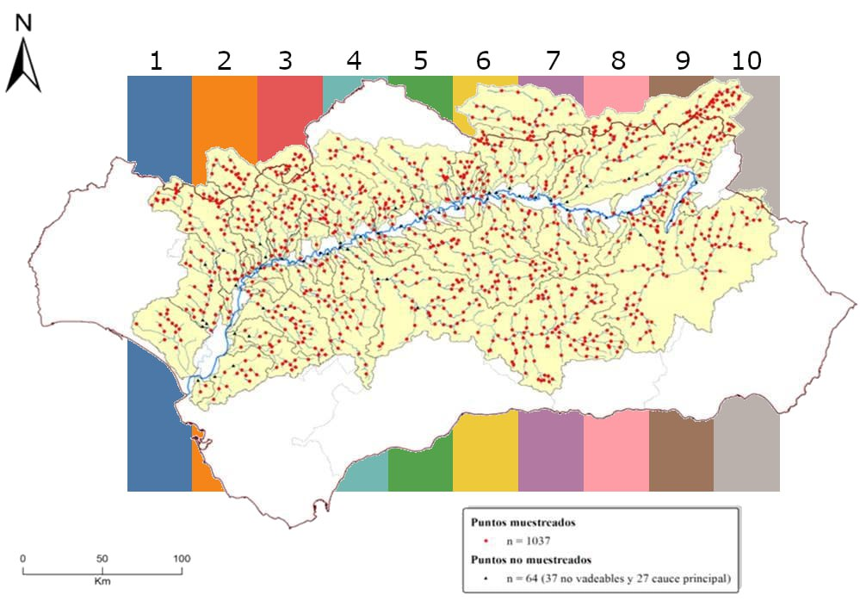
Figure 1: Sampled sites in the Guadalquivir basin (red). Colored stripes in the background represent the selected

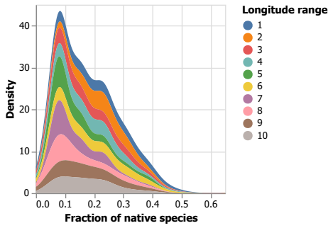
Figure 2: Density plot as a function of the fraction of native species (x-axis) following vertical stripes in Figure 1.

Methods
To achieve these aims, we will employ the following methodologies:

Extinction probability curves
Using an existing database of fish communities, habitat characteristics, and river connectivity in the Guadalquivir river basin, we will model extinction probability curves influenced by different disturbance regimes.
- This will be a two-step approach:

- Random spatial longitudinal slices along the basin will be used to examine the extinction patterns (Figure 2).
- Each watershed will be used to set the limits for the curves' extent.

By comparing these two patterns, we aim to understand if there are significant differences in extinction patterns.
When comparing the spatial slices vs. watershed approach, patterns of greater intra-watershed variability vs. general variability might emerge.

- We will calculate the extinction probability curves under the influence of different disturbances by:

- Developing a map detailing the ratio of native to exotic species, following the SICA map.
- Generating profiles of native species proportions across the Guadalquivir basin using spatial slices (Figure 2).
- Calculating the extinction probability curves using both the "spatial slices" and watershed methods to define curve limits.
- Comparing the extinction probabilities and identify “cold spots” – regions with a notably high extinction probability. Preliminary analyses suggest local native extinction peaks at around 10% for all random longitudinal slices (Figure 2).

Global change scenarios
Using existing data, we will conduct dynamic simulations to model the extinction probability of multiple species assemblages under different scenarios. These scenarios will encompass a range of factors, including:
- Dendritic fragmentation: We will assess the impact of fragmentation due to connectivity changes and the creation of reservoirs.
- Exotic species dynamics: Our model will simulate responses of native and endemic species to exotic species invasions, considering factors such as competition and predation.

- Climate change effects: We will account for increased drought and desiccation, reduction in channel width, and habitat loss, all of which are projected effects of climate change.

- Anthropogenic land-use changes: Our simulations will consider the gradient of anthropic uses as derived from the CCA and the specific sensitivity of each species to these disturbances.

Platform for knowledge transfer
The progress of our research will be tracked via a git repository with a final interface that visualizes all steps of the results. This software will form the core product for reporting and will facilitate efficient knowledge transfer during the project's timeline.

Budget and timeline
The project is planned to run from the fall 2023 until fall 2024 (1 year). This timeline includes the dedicated involvement of a data scientist for the entire year. Their role will encompass developing and implementing the simulation model, running and evaluating the robustness of various scenarios, and creating a user-friendly software interface that facilitates efficient knowledge transfer.

Item | Description | Number | Cost | Total (EUR) | Observations
Computer scientist | Developing codes in Julia comp. language | 6 months | Hours | 15k
Computer scientist | Maintenance git repository | Full year | Hours | 3k
Computer scientist | Interface for knowledge transfer | 4 months | Hours | 10k
Computer scientist | Simulations, numerical analysis, robustness scenarios | 5 months | Hours | 12k
Data analysis | Data analytics, pattern detection, robustness | 5 months | Hours | 12k
Modeling | Server setup, parallel computing | 2 months | Hours | 1k
TOTAL |  | 1 year | Total hours | 53k

Objective/activity | Month
 | 1 | 2 | 3 | 4 | 5 | 6 | 7 | 8 | 9 | 10 | 11 | 12
Random and watershed patterns
Global change scenarios
Numerical analysis
Robustness
Interface knowledge transfer
Generate predictions scenarios
Robustness analysis
Writing manuscript and reporting

References
Ali, E., Cramer, W., Carnicer, J., Georgopoulou, E., Hilmi, N.J.M., Le Cozannet, G. et al. (2022). Cross-Chapter Paper 4: Mediterranean Region. In: H.O. Pörtner, D.C. Roberts, M. Tignor, E.S. Poloczanska, K. Mintenbeck, A. Alegría, M. Craig, S. et al. (Eds.). Climate Change 2022: Impacts, Adaptation and Vulnerability. Contribution of Working Group II to the Sixth Assessment Report of the Intergovernmental Panel on Climate Change, Cambridge, UK and New York, NY, USA, Cambridge University Press, pp. 2233–2272. doi:10.1017/9781009325844.021.
Brown, B.L. and Swan, C.M. (2010), Dendritic network structure constrains metacommunity properties in riverine ecosystems. Journal of Animal Ecology, 79: 571-580. https://doi.org/10.1111/j.1365-2656.2010.01668.x
Bernardo, J.M., Ilhéu, M., Matono, P. & Costa, A.M. (2003). Interannual variation of fish assemblage structure in a Mediterranean river: Implications of streamflow on the dominance of native or exotic species. River Research and Applications, 19, 1–12.
Gasith, A. & Resh, V.H. (1999) Streams in Mediterranean climate regions: Abiotic influences and biotic responses to predictable seasonal events. Annual Review of Ecology and Systematics, 30, 51–81.
Jarić I, Lennox RJ, Kalinkat G, CvijanovićG, Radinger J. Susceptibility of European freshwater fish to climate change: Species profiling based on life‐history and environmental characteristics. Glob ChangeBiol. 2019;25:448–458.https://doi.org/10.1111/gcb.14518458
Magalhães, M.F., Beja, P., Schlosser, I.J. & Collares-Pereira, M.J. (2007). Effects of multi-year droughts on fish assemblages of seasonally drying Mediterranean streams. Freshwater Biology, 52, 1494–1510.
Reyjol, Y., Hugueny, B., Pont, D., Bianco, P.G., Beier, U., Caiola, N. et al. (2007). Patterns in species richness and endemism of European freshwater fish. Global Ecology and Biogeography, 16, 65–75. doi:10.1111/j.1466-8238.2006.00264.x
Smith, K. G., & Darwall, W. R. (Eds.) (2006). The status and distribution of freshwater fish endemic to the Mediterranean Basin (Vol. 1). IUCN. Gland, Switzerland and Cambridge, UK.
Valerio, C., Baquero, R. A., Gómez Nicola, G., Garrido, A., & De Stefano, L. (2022). Shedding light on the decline of Iberian freshwater fish species over the period 1980–2020. Freshwater Biology, 67, 169 0 – 17 0 7. https://doi.org/10.1111/fwb.13963

