Proposal
Extinction dynamics in changing metacommunities: Guadalquivir river basin as a case study

Introduction
The structure and colonization/extinction dynamics of fish metacommunities are naturally constrained by connectivity within the dendritic (river) networks they inhabit, with both local and regional aspects playing roles to shape assemblages and at a given stream point (Brown & Swan 2010). Mediterranean river basins are vulnerable ecosystems with a high proportion of endemic fish species of high conservation concern (Smith & Darwall, 2006; Reyjol et al., 2007) and are currently under pressure from multiple threats: reduced connectivity due to reservoirs, increased pollution and habitat loss, recent increases in exotic invasive species, etc (Valerio et al. 2022).
In addition, Mediterranean rivers are especially sensitive to climate change because they have species poor communities and are under natural drought/flood regimes (Gasith & Resh, 1999). During the summer drought, fish communities become isolated in pools in upstream reaches, resulting in temporally naturally fragmented populations (Bernardo et al., 2003, Maghallaes et al., 2007). Native species are naturally adapted to this fluctuating water regime and populations recover with the autumn rains.
Climate change has already increased summer temperatures in the area by 1.5ᵒC degrees at rates 20% above global means (Ali et al., 2022). Predictions suggest that drought periods will become longer and more intense, and headwater streams may dry out completely in the near future (projected reduction of 12% of expected mean rainfall under a 3ᵒC temperature raise scenario XIth IPCC Report, Ali et al., 2022). Given the highly susceptibility of Mediterranean species to these changes (Jarić et al. 2018), this will increase local extinction risk, with unknown consequences at the metacommunity level.
In order to avoid the catastrophic depletion of diversity in Mediterranean fish communities, it is essential to study how extinction risk will vary across the different parts of the basin in response to these multiple threats. It is important to identify which threats are having the greatest effect, but also what the implications are of having multiple threats acting in synergy on the extinction risk in different areas. This would allow us to identify those areas most at risk so areas in need of enhanced monitoring/protection can be identified and management/mitigation measures can be implemented (eg. exotic species eradication, obstacle removal etc.).

Aims
- What are the extinction risk levels in the Guadalquivir River basin under the current threat scenario?
Using a large fish metacommunity dataset from the Guadalquivir basin, we will model how extinction probability using empirical data of each watershed with its current intrinsic disturbances (eg. amount of exotics, dams, land uses etc) compares to a “null model” scenario based on longitudinal “slices” across the whole basin.
- How will extinction risk change with increased threat levels?
We will test how potential increases in exotic species, climate change-driven desiccation and anthropogenic impacts may influence extinction risk under different scenarios.
- Finally, we aim to provide a spatially-explicit modelling tool that will allow practitioners and stakeholders to predict extinction risks in the Guadalquivir and other Mediterranean basins and assess the potential resilience of different freshwater fish populations under different drought and anthropogenic impact scenarios. This tool will have a user-friendly interface, with the possibility of being adapted for use in other Mediterranean watersheds.

Data and empirical patterns
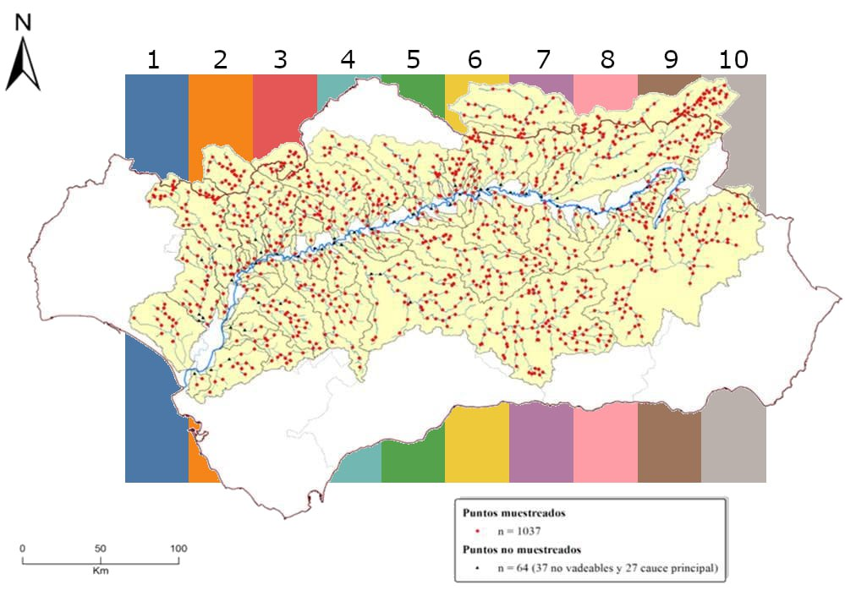

Figure 1: Sampled sites in the Guadalquivir basin (red). Colored stripes in the background represent the selected
sampled sites for the density plot in Figure 2.

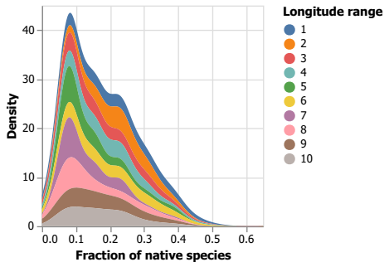

Figure 2: Density plot as a function of the fraction of native species (x-axis) following vertical stripes in Figure 1.

Extinction probability curves
Using an existing database of fish communities, habitat characteristics and connectivity of rivers of the Guadalquivir river basin, we will model extinction probability curves under the influence of different disturbance regimes. We will use a 2-tier approach:
- Using random spatial longitudinal slices along the basin (Figure 2)
- Using each watershed as limits for the curves’ extent.
Extinction patterns will be compared between these two patterns, do they differ significantly in extinction patterns? When comparing the spatial slices vs. watershed approach, patterns of greater intra-watershed variability vs. general variability might emerge.
Calculation of extinction probability curves under the influence of different disturbances.
- Map of proportion of natives and exotics – Natives/Exotics ratio following SICA map.
- Proportion of natives profiles across Guadalquivir basin - spatial slices (Figure 2).
- Probability of extinction curves will be made comparing “spatial slices” and the watershed as a curve limit.
- Comparison of extinction probability. Local native extinction peaks around 10% for all random longitudinal slices (Figure 2). Are there specific cold spots, i.e., areas in the basin with high extinction probability?

Global change scenarios
We will use the existing data to run dynamic simulations of extinction probability in multiple species assemblages under different scenarios of connectivity (fragmentation driven by reservoirs/fish ladders), influx of exotic species, anthropogenic land uses and climate change, e.g., more severe droughts gradient with elevation. The modeling of multivariate disturbance regimes will follow:
- Dendritic fragmentation accounting for connectivity and reservoirs
- Dynamics of exotic species and responses to invasion by endemic and native species
- Climate change driven by increased drought, desiccation, narrower channel width, and habitat loss.
- Increases in anthrop
- ogenic land use changes. We will use gradient of anthropic uses from CCA combined with the “sensibility” of each species to this type of disturbance.

Platform for knowledge transfer
The overall research will be tracked via a git repository with a final interface ready to visualize all the steps of the results, i.e., extinction probability maps as well as population size-distribution under varying global change scenarios. The software will be the core product for the reporting for optimizing knowledge transfer to practice and management during the period of the project, i.e., results from the reports will be generated via this interface.

Budget and timeline
The project is planned to run from the fall 2023 until fall 2024 (1 year). It includes 1 year of a computer scientist to develop, implement, run, explore the robustness of the scenarios and the development of the software interface for knowledge transfer.

Item | Description | Number | Cost | Total (EUR) | Observations
Computer scientist | Developing codes in Julia comp. language | 6 months | Hours | 15k
Computer scientist | Maintenance git repository | Full year | Hours | 3k
Computer scientist | Interface for knowledge transfer | 4 months | Hours | 10k
Computer scientist | Simulations, numerical analysis, robustness scenarios | 5 months | Hours | 12k
Data analysis | Data analytics, pattern detection, robustness | 5 months | Hours | 12k
Modeling | Server setup, parallel computing | 2 months | Hours | 1k
TOTAL |  | 1 year | Total hours | 53k

Objective/activity | Month
 | 1 | 2 | 3 | 4 | 5 | 6 | 7 | 8 | 9 | 10 | 11 | 12
Random and watershed patterns
Global change scenarios
Numerical analysis
Robustness
Interface knowledge transfer
Generate predictions scenarios
Robustness analysis
Writing manuscript and reporting

References
Ali, E., Cramer, W., Carnicer, J., Georgopoulou, E., Hilmi, N.J.M., Le Cozannet, G. et al. (2022). Cross-Chapter Paper 4: Mediterranean Region. In: H.O. Pörtner, D.C. Roberts, M. Tignor, E.S. Poloczanska, K. Mintenbeck, A. Alegría, M. Craig, S. et al. (Eds.). Climate Change 2022: Impacts, Adaptation and Vulnerability. Contribution of Working Group II to the Sixth Assessment Report of the Intergovernmental Panel on Climate Change, Cambridge, UK and New York, NY, USA, Cambridge University Press, pp. 2233–2272. doi:10.1017/9781009325844.021.
Brown, B.L. and Swan, C.M. (2010), Dendritic network structure constrains metacommunity properties in riverine ecosystems. Journal of Animal Ecology, 79: 571-580. https://doi.org/10.1111/j.1365-2656.2010.01668.x
Bernardo, J.M., Ilhéu, M., Matono, P. & Costa, A.M. (2003). Interannual variation of fish assemblage structure in a Mediterranean river: Implications of streamflow on the dominance of native or exotic species. River Research and Applications, 19, 1–12.
Gasith, A. & Resh, V.H. (1999) Streams in Mediterranean climate regions: Abiotic influences and biotic responses to predictable seasonal events. Annual Review of Ecology and Systematics, 30, 51–81.
Jarić I, Lennox RJ, Kalinkat G, CvijanovićG, Radinger J. Susceptibility of European freshwater fish to climate change: Species profiling based on life‐history and environmental characteristics. Glob ChangeBiol. 2019;25:448–458.https://doi.org/10.1111/gcb.14518458
Magalhães, M.F., Beja, P., Schlosser, I.J. & Collares-Pereira, M.J. (2007). Effects of multi-year droughts on fish assemblages of seasonally drying Mediterranean streams. Freshwater Biology, 52, 1494–1510.
Reyjol, Y., Hugueny, B., Pont, D., Bianco, P.G., Beier, U., Caiola, N. et al. (2007). Patterns in species richness and endemism of European freshwater fish. Global Ecology and Biogeography, 16, 65–75. doi:10.1111/j.1466-8238.2006.00264.x
Smith, K. G., & Darwall, W. R. (Eds.) (2006). The status and distribution of freshwater fish endemic to the Mediterranean Basin (Vol. 1). IUCN. Gland, Switzerland and Cambridge, UK.
Valerio, C., Baquero, R. A., Gómez Nicola, G., Garrido, A., & De Stefano, L. (2022). Shedding light on the decline of Iberian freshwater fish species over the period 1980–2020. Freshwater Biology, 67, 169 0 – 17 0 7. https://doi.org/10.1111/fwb.13963

