Proposal
Extinction dynamics in changing metacommunities: Guadalquivir river basin as a case study

Introduction
Mediterranean basins are vulnerable ecosystems with a high proportion of native and endemic species which are of high conservation concern. They are the most vulnerable/delicate “version” of dendritic metacommunities. Most native and endemic species occupy narrow ranges and are under multiple threats, including fragmentation, habitat loss, warming, droughts, and exotic species, which have been recognized as one of the key threats in freshwater ecosystems worldwide.
Mediterranean rivers are especially sensitive to climate change because they have species poor communities and a natural period of drought/desiccation. Climate change predictions suggest drying of upper reaches is becoming more frequent with the increasing risk of local species extinctions with unknown consequences at the metacommunity level for ecosystem functions. There are a limited number of studies addressing extinction risk in large freshwater basins under Mediterranean conditions. There is also uncertainty about the main mechanisms and their combination that might be driving extinction risk in these communities. Studies addressing the effect of multiple threats on species extinctions simultaneously are even more rare. Data driven simulation tools are needed to identify areas at risk. In this way, management measures can be more efficiently implemented, e.g., exotic spp eradication/management, buffering areas to allow for range expansions of native and endemic species and selection of areas of enhanced monitoring/protection.

Aims
- Using large empirical metacommunity dataset (Figure 1), we will model extinction risk varying with topography across the basin (intermediate disturbance – altitudinal trends). We will model several threats simultaneously, exotic species, fragmentation (reservoirs) and anthropogenic land uses as the main constraints to species persistence.
- We will combine exotic species and climate change-driven desiccation as factors influencing native and endemic species range dynamics and extinction risk (Figure 2).
- We will provide a user-friendly tool accounting for spatially-explicit modeling allowing practitioners and stakeholders to explore extinction risks scenarios in the Guadalquivir and other Mediterranean basins.

Methods

Data and empirical patterns
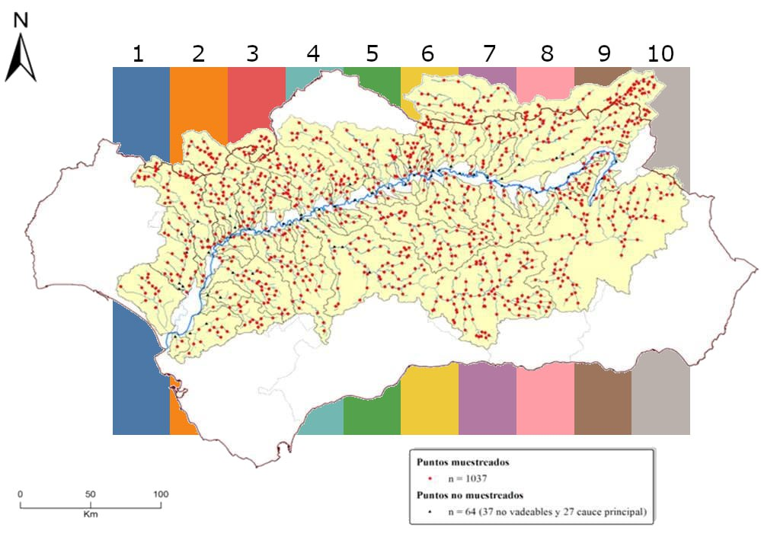

Figure 1: Sampled sites in the Guadalquivir basin (red). Colored stripes in the background represent the selected
sampled sites for the density plot in Figure 2.

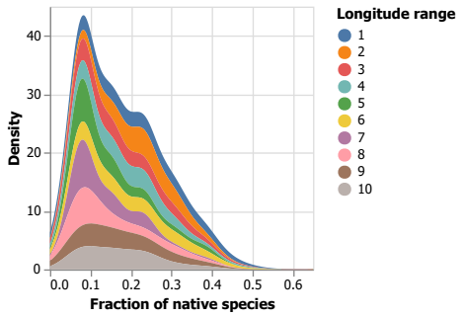

Figure 2: Density plot as a function of the fraction of native species (x-axis) following vertical stripes in Figure 1.

Extinction probability curves
Using an existing database of fish communities, habitat characteristics and connectivity of rivers of the Guadalquivir river basin, we will model extinction probability curves under the influence of different disturbance regimes. We will use a 2-tier approach:
- Using random spatial longitudinal slices along the basin (Figure 2)
- Using each watershed as limits for the curves’ extent.
Extinction patterns will be compared between these two patterns, do they differ significantly in extinction patterns? When comparing the spatial slices vs. watershed approach, patterns of greater intra-watershed variability vs. general variability might emerge.
Calculation of extinction probability curves under the influence of different disturbances.
- Map of proportion of natives and exotics – Natives/Exotics ratio following SICA map.
- Proportion of natives profiles across Guadalquivir basin - spatial slices (Figure 2).
- Probability of extinction curves will be made comparing “spatial slices” and the watershed as a curve limit.
- Comparison of extinction probability. Local native extinction peaks around 10% for all random longitudinal slices (Figure 2). Are there specific cold spots, i.e., areas in the basin with high extinction probability?

Global change scenarios
We will use the existing data to run dynamic simulations of extinction probability in multiple species assemblages under different scenarios of connectivity (fragmentation driven by reservoirs/fish ladders), influx of exotic species, anthropogenic land uses and climate change, e.g., more severe droughts gradient with elevation. The modeling of multivariate disturbance regimes will follow:
- Dendritic fragmentation accounting for connectivity and reservoirs
- Dynamics of exotic species and responses to invasion by endemic and native species
- Climate change driven by increased drought, desiccation, narrower channel width, and habitat loss.
- Increases in anthrop
- ogenic land use changes. We will use gradient of anthropic uses from CCA combined with the “sensibility” of each species to this type of disturbance.

Platform for knowledge transfer
The overall research will be tracked via a git repository with a final interface ready to visualize all the steps of the results, i.e., extinction probability maps as well as population size-distribution under varying global change scenarios. The software will be the core product for the reporting for optimizing knowledge transfer to practice and management during the period of the project, i.e., results from the reports will be generated via this interface.

Budget and timeline
The project is planned to run from the fall 2023 until fall 2024 (1 year). It includes 1 year of a computer scientist to develop, implement, run, explore the robustness of the scenarios and the development of the software interface for knowledge transfer.

Item | Description | Number | Cost | Total (EUR) | Observations
Computer scientist | Developing codes in Julia comp. language | 6 months | Hours | 15k
Computer scientist | Maintenance git repository | Full year | Hours | 3k
Computer scientist | Interface for knowledge transfer | 4 months | Hours | 10k
Computer scientist | Simulations, numerical analysis, robustness scenarios | 5 months | Hours | 12k
Data analysis | Data analytics, pattern detection, robustness | 5 months | Hours | 12k
Modeling | Server setup, parallel computing | 2 months | Hours | 1k
TOTAL |  | 1 year | Total hours | 53k

Objective/activity | Month
 | 1 | 2 | 3 | 4 | 5 | 6 | 7 | 8 | 9 | 10 | 11 | 12
Random and watershed patterns
Global change scenarios
Numerical analysis
Robustness
Interface knowledge transfer
Generate predictions scenarios
Robustness analysis
Writing manuscript and reporting

