**CST 350: Activity 1**

Michael Melichar

CST 350: Programming in C# III

Brandon Bass

3/19/23

**Modified HTML of the Contact Page**

*This demonstrates inserting highlighted text into a portion of the contact page.*

**Variables at Breakpoint on Contact Page**

*This demonstrates using a breakpoint to view variables at various stages of code execution.*

**Summary of Key Concepts**

When editing the HTML of an ASP.NET application, it is important to understand the overall structure of the application's pages and how they are generated dynamically by the server-side code. ASP.NET applications use server controls to generate HTML, which can make editing the HTML more complex than in traditional static websites. One useful technique for debugging and troubleshooting issues in the HTML is to use breakpoints in the server-side code. Breakpoints allow you to pause the execution of the code at a specific point and inspect the current state of the application, including the generated HTML. By using breakpoints strategically, you can more easily understand how the server-side code is generating the HTML and troubleshoot any issues that arise.

**Sitemap for Login and Registration Project**

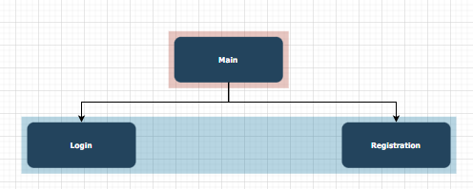

**Login Page Wireframe**

**Registration Page Wireframe**

**UML Diagram**

