IŞIK UNIVERSITY
FACULTY OF ECONOMICS, ADMINISTRATIVE AND SOCIAL
SCIENCES
Department of Management Information Systems

TRAK-AI DSS: AN OFFLINE-FIRST HYBRID AI
DECISION SUPPORT SYSTEM FOR PRECISION
AGRICULTURE IN THE THRACE REGION

Integration of Edge IoT, Multi-Modal Data Fusion,
Predictive Modelling, and Retrieval-Augmented Generation
for Localised Farm Management

Melih Kalkan

A Bachelor's Thesis
Faculty of Economics, Administrative and Social Sciences
Department of Management Information Systems

Supervisor: Dr. Gülsüm Çiğdem ÇAVDAROĞLU

Işık University
İstanbul, Türkiye
June 2026

TRAK-AI DSS: An Offline-First Hybrid AI Decision Support System
for Precision Agriculture in the Thrace Region

A Project Presented
By

Melih Kalkan
19MISY1013

To
The Department of Management Information Systems

in partial fulfilment of the requirements
for the degree of
Bachelor of Science
in the field of
Management Information Systems

Işık University
İstanbul, Türkiye
June 2026

© Copyright 2026 by Melih Kalkan
All Rights Reserved

Dedicated to the farmers of the Thrace region,
whose stewardship of the land animates this work.

Abstract
Decision support for small and medium farms facing intermittent connectivity, modest budgets, and underrepresented agro-climatic regimes remains unresolved. Cloud-dependent platforms impose recurring costs and route farmer data through opaque infrastructure; general-purpose language models risk fabricating advice; and globally trained models average over heterogeneous micro-climates. This thesis presents TRAK-AI DSS, an offline-first hybrid artificial-intelligence decision support system for the wheat and sunflower basket of the Thrace region of Türkiye.
The system integrates six contributions within a three-layer Edge–Fog–Cloud architecture (cloud optional): a reproducible multi-modal fusion pipeline aligning Sentinel-2 L2A reflectance, NASA POWER climate reanalysis, and SoilGrids 2.0 soil maps; a champion-selection layer giving seven-day NDVI forecasts (R² = 0.752 wheat, 0.796 sunflower, LOYO) and yield estimates across two district-level regimes (n ≈ 213 per crop), where leave-one-year-out gives errors of 16.4 % (wheat) and 17.8 % (sunflower) and leave-one-district-out a best case of 10.6 % and 13.5 %, marking yield partially satisfied, its temporal-generalisation limit reported in full; a Tri-RAG pipeline over a 17,059-chunk, 64-document base driving a local Gemma-3-4B at 27.1 s CPU-only latency; a YOLOv8s-cls classifier at 94.9 % top-1 accuracy over six classes; and an autonomous edge rover built for about 3,440 lira.
Twenty-two automated test cases validate the ten pre-registered hypotheses, with seven supported, two partially supported, and one pending formal expert evaluation. Persistence-baseline diagnostics (Wilcoxon p = 1.0, EVR_01 frozen-LSTM partition) and Moran's I residual autocorrelation (+0.257, p = 0.013, wheat, LOILO) are reported transparently. The sixth contribution is methodological: a spatial–temporal generalisation decomposition in which the coefficient of determination bifurcates between regimes (ΔR² = +0.53 wheat, +0.45 sunflower), with a four-part reporting protocol pairing a persistence baseline, a spatial-autocorrelation diagnostic, an anomaly-stratified skill score, and a regime decomposition. The result is a reproducible reference architecture for offline-first agricultural decision support in regionally constrained settings.

Keywords: precision agriculture; offline-first edge artificial intelligence; retrieval-augmented generation; multi-modal data fusion; yield prediction.

Acknowledgements
I wish to record my profound and most sincere gratitude to my supervisor, Dr. Gülsüm Çiğdem ÇAVDAROĞLU, whose guidance informed this thesis from its earliest conception through to its final articulation. Her methodological rigour, her exacting yet unfailingly constructive criticism, and her steadfast encouragement through the most demanding phases of the work served as the compass by which this research found and held its course. Beyond the technical substance of her supervision, she instilled in me a discipline of scholarly reasoning and a regard for intellectual honesty that I shall carry well beyond the present work; for her patience, for the generosity with which she gave of her time, and for her unwavering confidence in this undertaking, I remain deeply and lastingly grateful.
I am equally and profoundly indebted to Dr. Habibe AKTAY, who examined this thesis report with exceptional care alongside my supervisor and shared her expertise without reserve. Her door remained invariably open, and her readiness to listen, to interrogate, and to propose considered and constructive solutions whenever a difficult problem arose was a genuine cornerstone of this research; the clarity of her judgement repeatedly enabled me to perceive my own work afresh.
My sincere appreciation extends to the Head of the Department of Management Information Systems at Işık University, Asst. Prof. Şahin AYDIN, whose principled leadership and dedication to fostering a rigorous yet supportive academic environment made the development of this thesis possible. I am likewise grateful to Dr. Elif Deniz YELMENOĞLU; although it was my privilege to attend only a small number of her courses, the intellectual depth, precision, and enduring scholarly perspective she conveyed have left an indelible imprint upon my manner of thinking. To all the instructors who have contributed to my education over these years, I owe a debt that a brief acknowledgement can only begin to repay.
I owe a particular and heartfelt debt of gratitude to Mr. Semih KALKAN, whose training and expertise in the field of electronics were instrumental to the practical realisation of the micro-scale validation layer of this work. Neither the assembly of the autonomous field rover nor the successful conduct of the field-test campaign would have been possible without his technical guidance and his patient, hands-on support throughout the hardware integration and the on-site evaluation. He transformed the rover from a specification on paper into a functioning instrument in the field, and for that generosity I am sincerely and enduringly thankful.
I gratefully acknowledge the Edirne Provincial Directorate of Agriculture and Forestry, the Thrace Agricultural Research Institute, and the General Directorate of Agricultural Research and Policies (TAGEM) for the regional research corpus that underpins the Tri-RAG knowledge base, together with the broader open-source community, among them Google Earth Engine, the Copernicus Climate Data Store, the NASA POWER project, the ISRIC SoilGrids initiative, the Ollama runtime, and the maintainers of LangChain, FAISS, and Streamlit, whose freely shared contributions rendered an offline-first decision-support system, with cloud as an optional layer, technically attainable.
On a more personal note, I extend my most heartfelt gratitude to Ms. Melisa TUNAKAN, whose boundless patience, profound understanding, and unwavering emotional support were a constant source of strength throughout the most intense and demanding periods of this endeavour; her steadfast presence reminded me, time and again, of the purpose behind the effort. Finally, I offer my deepest thanks to my family and my friends, whose sustained encouragement and unfaltering support formed the very foundation upon which this year-long undertaking was built. Any errors or omissions that remain in this thesis are entirely my own.

Contents

Abstract 4
Acknowledgements 6
Contents 8
List of Figures 21
List of Tables 22
Abbreviations 23
Overview 1
1.1 Introduction 1
1.2 Problem Statement and Motivation 3
1.3 Research Objectives and Contributions 6
1.4 Scope and Limitations 11
1.5 Outline of the Thesis 13
Research Background and Literature Review 14
2.1 Precision Agriculture: Conceptual Foundations and Evolution 14
2.2 IoT and Edge Computing in Smart Farming 16
2.3 Machine Learning and Deep Learning for Crop Monitoring 19
2.3.1 Classical Machine Learning 20
2.3.2 Deep Learning and Spatio-Temporal Architectures 21
2.3.3 Spatio-Temporal Fusion and Multi-Modal Data 22
2.4 Computer Vision for Plant Health and Disease Detection 23
2.5 Large Language Models and Retrieval-Augmented Generation in Agriculture 25
2.6 Explainable AI in Agricultural Decision Support 28
2.7 Turkish National Policy Context 29
2.8 Regional Studies on Thrace Agriculture 31
2.8.2 Sunflower in Thrace 32
2.8.3 Irrigation, Soils, and Phenology 32
2.9 Identified Research Gap and Positioning of TRAK-AI DSS 33
Methodology and System Architecture 36
3.1 Conceptual Architecture and Design Philosophy 37
3.2 Hardware Components and Selection Rationale 39
3.3 Software Stack and Tools 43
3.4 ETL Methodology: Multi-Modal Data Fusion 45
3.5 Predictive Modelling Methodology 48
3.5.1 Cross-Validation Regime 49
3.5.2 Residual-Delta Target Formulation 49
3.5.3 Candidate Architectures and Champion Selection 50
3.5.4 Persistence Baseline and Wilcoxon Test 50
3.5.5 Yield Sub-Model 51
3.6 Edge AI Methodology 52
3.7 Tri-RAG Retrieval Methodology 53
3.7.1 Knowledge-Base Construction 53
3.7.2 Embedding and Indexing 54
3.7.3 Retrieval and Re-Ranking 55
3.8 Agronomic Decision Engine Logic 55
3.9 Research Hypotheses 57
3.10 Hybrid BBCH Phenology Engine 59
3.10.1 Motivation: The Single-Source Phenology Problem 59
3.10.2 Three-Layer Architectural Decomposition 60
3.10.3 Consensus Rule and Confidence Stratification 61
3.10.4 Operational Implications and Methodological Positioning 62
3.11 Multi-Modal Visual Validation Subsystem 63
3.11.1 The Three Observation Modalities 63
3.11.2 Harmonised Four-Class Taxonomy 64
3.11.3 The Weighted-Vote Consensus Algorithm 64
3.11.4 Inter-Modality Agreement: Cohen and Fleiss Statistics 65
3.11.5 The Anomaly Flagger and the Eight Consensus Flags 65
3.11.6 The Planet Education Satellite Channel and Two-of-Three Fallback 67
System Development and Implementation 67
4.1 WP-1: Multi-Modal ETL Pipeline Implementation 68
4.1.1 Google Earth Engine Integration 68
4.1.2 The ERA5-Land → NASA POWER MERRA-2 Pivot 69
4.1.3 The SoilGrids 2.0 REST → GEE Asset Pivot 70
4.1.4 Transformation and Feature Engineering 71
4.2 WP-2: Predictive Model Training and Evaluation 71
4.2.1 Cross-Validation Implementation 72
4.2.2 SHAP Explainability Implementation 73
4.3 WP-3: Rover Firmware and Edge AI Implementation 73
4.3.1 Firmware Architecture 74
4.3.2 ESP32-CAM Firmware and Edge–Fog Pivot 75
4.4 WP-4: Tri-RAG and LLM Integration 76
4.4.1 Document Loading and Chunking 76
4.4.2 Embedding Model Selection 76
4.4.3 Retrieval Fusion Algorithm 77
4.4.4 The phi3:mini → Gemma-3-4B Model Migration 78
4.5 Orchestration and Dashboard Implementation 78
4.5.1 Dashboard Page Architecture 80
4.5.2 User-Experience Design Decisions 80
4.5.3 Persistence Schema 81
4.6 Agronomic Calendar Engine Implementation 81
4.7 Integration Testing and System Operation 83
4.8 Auto-Trigger Pipeline Orchestration 85
Results and Discussion 86
5.1 Overview of the Automated Test Suite 87
5.2 WP-1 Results: Data Fusion and Feature Engineering 88
5.3 WP-2 Results: Predictive Modelling 90
5.3.1 Cross-Validation Regime: LOYO, LOILO, and Spatiotemporal Block CV 90
5.3.2 NDVI Predictive Accuracy: Coefficient of Determination 91
5.3.3 Annual NDVI Trajectory and Visual Validation 93
5.3.4 Persistence Baseline and the Wilcoxon Diagnostic 95
5.3.5 Residual Autocorrelation: Moran's I 96
5.3.6 SHAP Feature Importance Analysis 97
5.3.7 Yield Prediction Accuracy and Literature Comparison 98
5.4 WP-3 Results: Edge AI and Image Classification 99
5.5 WP-4 Results: Tri-RAG and Language Generation 102
5.5.1 Hallucination Suppression, Pending Expert Evaluation 105
5.5.2 Pilot Farmer-Acceptance Survey 106
5.6 Formal Hypothesis Verdicts 108
5.7 Discussion and Cross-Cutting Findings 109
5.7.1 Architectural Viability of Offline-First Deployment 110
5.7.2 Champion-Selection vs. Architectural Pre-Commitment 110
5.7.3 Diagnostic Transparency as Methodological Contribution 111
5.7.4 Data-Regime Limitations and the n = 213 Wheat LOYO 111
5.7.5 The Spatial–Temporal Generalisation Decomposition 112
5.7.6 Comparative Positioning Against Published Literature 114
5.7.7 Summary of Empirical Verdict 114
5.8 Real-Field Reconnaissance: The 27 May 2026 Walk at EVR_01 115
5.8.1 Data Collection Protocol and Telemetry Yield 115
5.8.2 Sensor Telemetry: Calibration Confirmation and Microclimate 116
5.8.3 Edge Computer-Vision: The Rust Incidence Finding 117
5.8.4 Hybrid BBCH Confirmation: GDD–NDVI Consensus at Grain-Fill 118
5.8.5 Frozen LSTM Operational Validation: EVR_01 Field Reconnaissance (27 May 2026) 119
5.8.6 Multi-Modal Cross-Validation: Six Consensus Snapshots in May 2026 120
5.8.7 Local LLM Advisory Generation: Output Profile and Latency 121
5.8.8 Synthesis of the Reconnaissance Findings 121
Dashboard, Deployment Topology, and Operational Considerations 122
6.1 Dashboard Architecture and Framework Selection 122
6.2 Field Status Page 124
6.3 Parcel Detail Page 127
6.4 Rover Monitoring Page 129
6.5 Agricultural Assistant Page 131
6.6 Operational Considerations: Reliability, Observability, and Security 133
6.6.1 Reliability and Fault Tolerance 134
6.6.2 Observability and Audit Logging 135
6.6.3 Security and Data Sovereignty 136
6.6.4 Multilingual Interface 137
6.7 Field Deployment Readiness and Pilot-Season Roadmap 137
Comparative Discussion against Published Literature Baselines 140
7.1 Yield Prediction: Triangulation against Published Baselines 141
7.1.1 The Persistence-Baseline Diagnostic in Comparative Context 144
7.1.2 The Moran's I Diagnostic and Spatial-Autocorrelation Implications 145
7.2 Image Classification: Comparison with PlantVillage and Subsequent Literature 146
7.3 Retrieval Quality and the Tri-RAG Comparison 148
7.3.1 The Domain-Specific Embedding Model Decision 149
7.3.2 The Language-Model Selection in Comparative Context 149
7.4 Architectural Choice: Offline-First in Comparative Context 150
7.5 Methodological Contributions and Their Broader Implications 152
7.5.1 The Champion-Selection Discipline 152
7.5.2 The Three-Regime Cross-Validation Triangulation 153
7.5.3 Diagnostic Transparency 153
7.6 Threats to Validity 154
7.7 Limitations Exposed by the Empirical Evidence 156
7.8 Synthesis: The Place of TRAK-AI DSS in the Literature 159
Conclusion and Future Work 160
8.1 Synthetic Summary of the Thesis 160
8.2 Restatement of the Principal Contributions 162
8.3 Consolidated Empirical Verdict 166
8.4 Limitations 167
8.5 Future Work: A Five-Track Agenda 169
8.5.1 Track 1: Pilot-Season Field Trial 169
8.5.2 Track 2: Human-Evaluation Programmes 170
8.5.3 Track 3: Crop and Regional Extension 171
8.5.4 Track 4: Methodological Extensions 172
8.5.5 Track 5: Infrastructure and Deployment Robustness 172
8.6 Broader Implications for Agricultural Decision Support 173
8.7 Closing Remarks 176
8.8 Declarations 177
References 178
Appendix A 188
Project Folder Structure and Codebase Organisation 188
A.1 Top-Level Directory Layout 189
A.2 Naming Conventions 190
A.3 Build and Test Commands 191
Appendix B 192
Feature Manifest: Seventeen Engineered Features 192
B.1 Vegetation Indices 192
B.2 Climate Aggregates 192
B.3 Drought Index 193
B.4 Cyclical Time Encodings 193
B.5 Static Soil Descriptors 194
Appendix C 195
Test Logs and Human-Evaluation Instruments 195
C.1 Automated Test Suite Output Summary 195
C.2 H6 Hallucination Suppression Evaluation Instrument 197
C.3 H7 Trust-via-Explainability Survey Instrument 197
C.4 H9 Expert-Consistency Evaluation Instrument 198
Appendix D 200
Hardware Bill of Materials and Cost Ledger 200
D.2 Recurring Operating Costs 201
Appendix E 203
Reproducibility Protocol 203
E.1 Software Environment 203
E.2 Data Sources and Acquisition Protocol 204
E.3 Reproducibility-Critical Random Seeds 204
E.4 Reproduction of the Headline Empirical Findings 205
E.5 Output Artefact Inventory 206
E.6 Hardware-Side Reproducibility 208
E.7 Licensing and Open-Source Commitments 208
Appendix F 210
Supplementary Figures from the Empirical Evidence Base 210

List of Figures

Figure 1.1. High-level overview of the TRAK-AI DSS three-layer Edge–Fog–Cloud architecture.
Figure 1.2. The five-stage Technology Value Chain (TVC) underlying the TRAK-AI DSS.
Figure 2.1. Research Gap: positioning of TRAK-AI DSS among existing agricultural DSS approaches.
Figure 2.2. Schematic of the Tri-RAG retrieval-augmented generation pipeline.
Figure 2.3. Evolution of predictive methods in agricultural artificial intelligence.
Figure 3.1. Rover hardware architecture and bill of materials.
Figure 3.2. Multi-modal data fusion (ETL) workflow.
Figure 3.3. Champion-selection hybrid modelling methodology.
Figure 4.1. End-to-end data flow of the TRAK-AI DSS Python orchestrator.
Figure 4.2. Phenological calendars for wheat and sunflower (Thrace region).
Figure 4.3. Hardware assembly readiness status at the time of writing.
Figure 5.1. Summary of the automated test suite (22 test cases).
Figure 5.2. WP-2 coefficient-of-determination model comparison (wheat and sunflower).
Figure 5.3. WP-2 error metrics: MAE and RMSE across model architectures.
Figure 5.4. Wheat annual NDVI profile: predicted vs. observed (LSTM champion).
Figure 5.5. Multi-dimensional radar comparison of crop champion models.
Figure 5.6. SHAP feature importance for the XGBoost yield prediction model.
Figure 5.7. Per-class top-1 accuracy of the YOLOv8s-cls classifier.
Figure 5.8. YOLOv8s-cls confusion matrix on the validation partition.
Figure 5.9. YOLOv8 training corpus composition and academic data sources.
Figure 5.10. RAG knowledge base composition and retrieval quality test.
Figure 5.11. WP-4 performance indicators: latency, token generation, and KB size.

List of Tables

Table 5.1. Cross-validation regime summary (LOYO, LOILO, Spatiotemporal Block CV) with fold counts, sample sizes, and rationale.
Table 5.2. Champion model comparison against published literature baselines (Klompenburg et al., 2020; Khaki & Wang, 2019; You et al., 2017).
Table 5.3. Hypothesis verdict summary (H1–H10) with quantitative criterion, observed value, statistical test, and disposition.
Table 5.4. Tri-RAG retrieval-quality breakdown by query category with dense-versus-sparse component contribution.
Table 5.5. Bill of materials and recurring operating cost itemisation.

Abbreviations

API: Application Programming Interface
BBCH: Biologische Bundesanstalt, Bundessortenamt und CHemische Industrie (Phenological Scale)
BM25: Best Matching 25 (sparse retrieval algorithm)
BOM: Bill of Materials
CDS: Copernicus Climate Data Store
CNN: Convolutional Neural Network
ConvLSTM: Convolutional Long Short-Term Memory
CPU: Central Processing Unit
DAWE: Department of Agriculture, Water and the Environment
DSS: Decision Support System
ERA5: ECMWF Reanalysis v5 (historical baseline; superseded by NASA POWER MERRA-2)
ESP32: Espressif Systems 32-bit Microcontroller
ETL: Extract, Transform, Load
EVI: Enhanced Vegetation Index
FAISS: Facebook AI Similarity Search
FAO: Food and Agriculture Organization of the United Nations
GDD: Growing Degree Days
GEE: Google Earth Engine
GPS: Global Positioning System
GPU: Graphics Processing Unit
IoT: Internet of Things
ISRIC: International Soil Reference and Information Center
JSON: JavaScript Object Notation
LIME: Local Interpretable Model-agnostic Explanations
LLM: Large Language Model
LOILO: Leave-One-IL-Out (province-level spatial cross-validation)
LOYO: Leave-One-Year-Out (temporal cross-validation)
LSTM: Long Short-Term Memory
MAE: Mean Absolute Error
MAPE: Mean Absolute Percentage Error
MERRA-2: Modern-Era Retrospective analysis for Research and Applications, Version 2
MQTT: Message Queuing Telemetry Transport
NASA POWER: NASA Prediction Of Worldwide Energy Resources
NDVI: Normalised Difference Vegetation Index
NDWI: Normalised Difference Water Index
RAG: Retrieval-Augmented Generation
RMSE: Root Mean Squared Error
SHAP: SHapley Additive exPlanations
STF: Spatio-Temporal Fusion
TAGEM: General Directorate of Agricultural Research and Policies
TAM: Technology Acceptance Model
TFLite: TensorFlow Lite
TÜBİTAK: Scientific and Technological Research Council of Türkiye
TÜİK: Turkish Statistical Institute (Türkiye İstatistik Kurumu)
TVC: Technology Value Chain
UART: Universal Asynchronous Receiver-Transmitter
UTAUT2: Unified Theory of Acceptance and Use of Technology, Version 2
WP: Work Package
XAI: Explainable Artificial Intelligence
XGBoost: eXtreme Gradient Boosting
YOLO: You Only Look Once (object detection model family)

Overview
This chapter introduces the research problem addressed by the present thesis, situates the work within the disciplinary frame of Management Information Systems, articulates the motivational gap structure that animates the proposed solution, summarises the principal contributions, and outlines the architecture of the remaining chapters.

1.1 Introduction
The maturation of digital technologies during the past decade has reconfigured the manner in which organisations acquire data, derive knowledge, and operationalise decisions. In sectors that have historically been data-poor, small- and medium-scale agriculture chief among them, the convergence of Internet of Things (IoT) sensing, satellite remote sensing, machine learning, and natural-language interfaces has created an opportunity to deliver decision support at a level of granularity that was previously economically infeasible (Wolfert et al., 2017) (Liakos et al., 2018) (Kamilaris & Prenafeta-Boldú, 2018) . Within the discipline of Management Information Systems, this convergence is consequential because it shifts decision support from descriptive dashboards toward predictive and prescriptive systems that synthesise actionable recommendations within the user's own operating context (McBratney et al., 2005) .
Agriculture occupies a strategic position in the Turkish national economy. The Twelfth Development Plan, covering the period 2024–2028, identifies food-supply security, climate adaptation, the efficient use of water resources, and the digital transformation of agricultural production as headline national priorities (Presidency of Strategy and Budget, 2023) . Within Türkiye, the Thrace region, comprising the provinces of Edirne, Kırklareli, and Tekirdağ, sustains a disproportionate share of the national output of winter wheat and oil-seed sunflower (Turkish Statistical Institute, 2024) . Despite this productive importance, the region remains characterised by small to medium family farms operating under conditions of limited access to professional agronomic services, intermittent rural connectivity, and decision-making processes that rely predominantly on experiential knowledge rather than on data-driven evidence (Klerkx et al., 2019) .
The present thesis documents the design, implementation, and partial evaluation of TRAK-AI Decision Support System (TRAK-AI DSS), an offline-first hybrid artificial intelligence platform engineered for the agronomic, climatic, and infrastructural conditions of the Thrace region. The system integrates four interlocking work packages: a multi-modal data fusion pipeline aligning Sentinel-2 satellite imagery, NASA POWER MERRA-2 climate reanalysis (substituted for ERA5-Land following the methodological pivot documented in Chapter 4), and ISRIC SoilGrids 2.0 digital soil maps (Poggio et al., 2021) ; a champion-selection predictive modelling layer that forecasts crop health and seasonal yield; an autonomous low-cost rover providing micro-scale ground-truth validation through embedded sensors and edge image classification; and an offline-first retrieval-augmented generation (RAG) layer that converts quantitative model output into Turkish-language advice grounded in vetted agronomic documents. The overall reference architecture is illustrated in Figure 1.1.
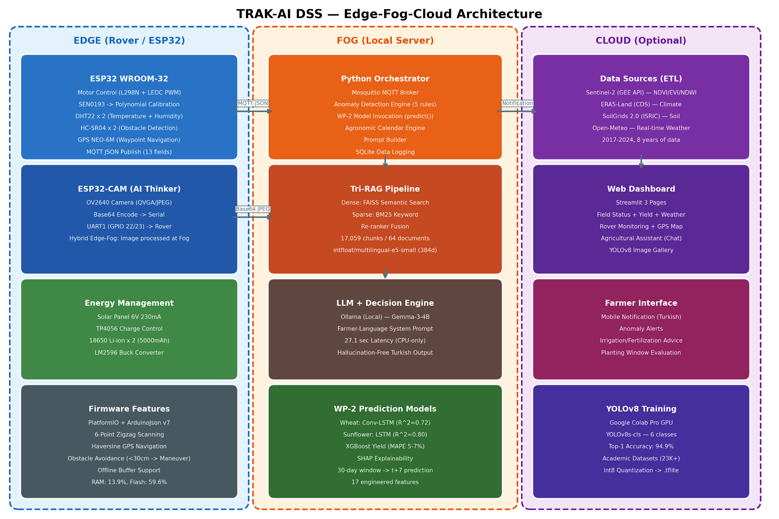
Figure 1.1. High-level overview of the TRAK-AI DSS three-layer Edge–Fog–Cloud architecture. The Edge layer handles sensor acquisition and on-device control; the Fog layer performs orchestration, modelling, retrieval, and language generation locally; and the optional Cloud layer ingests free public Earth-observation data and synchronises the dashboard when connectivity is available.
By framing the contribution as an integrated information system rather than as an isolated machine-learning experiment, the present work aligns directly with the Management Information Systems perspective: the farmer is treated as the end user, the decision-support output as an organisational artefact, and the value of the technology as a function of its usability, explainability, and integration into existing agricultural workflows. The remainder of this chapter develops the motivational structure underpinning the system, articulates the research objectives and contributions, and circumscribes the scope and limitations of the present study.

1.2 Problem Statement and Motivation
Although precision agriculture has matured rapidly as an academic field (McBratney et al., 2005) (Sishodia et al., 2020) , its translation into accessible field-level decision support for small and medium farms remains incomplete. A critical review of the contemporary literature and of commercially available agricultural decision platforms reveals five interlocking gaps that collectively motivate the development of TRAK-AI DSS.
The first gap is the cost–accuracy dilemma. Industrial-grade precision-agriculture solutions employ professional soil probes, calibrated weather stations, and proprietary cloud analytics whose per-hectare cost places them beyond the reach of typical Thracian wheat and sunflower operations. Conversely, hobbyist-grade IoT sensors, although affordable, are well documented to produce systematically biased readings that depend on local soil texture, salinity, and temperature (Nagahage et al., 2019) . In the absence of a credible calibration strategy, the inexpensive path yields decisions of unacceptable quality, whereas the accurate path remains economically inaccessible. Recent calibration evidence indicates that polynomial calibration of low-cost capacitive probes against gravimetric reference samples can restore usable accuracy at silty-clay sites (Abdelmoneim et al., 2025) ; a viable system for the Thrace region must therefore reconcile capital efficiency with scientifically defensible measurement fidelity.
The second gap concerns cloud dependency. The dominant architectural pattern in contemporary agricultural platforms routes raw sensor data to remote servers for storage, inference, and visualisation, a choice that imposes three concrete problems in the Thracian context: rural cellular coverage is frequently unavailable at parcel level; farmer-owned data is transferred to third-party operators with limited transparency regarding downstream use; and recurring subscription fees discourage long-term adoption (Klerkx et al., 2019) (Wolfert et al., 2017) . A system that aspires to genuine field-level adoption in the region must therefore be capable of fully offline operation, treating cloud connectivity as an opportunistic enhancement rather than a structural precondition.
The third gap is the macro–micro validation disconnect. Decision pipelines that rely solely on remotely sensed signals interpret a depressed NDVI value, for instance, as a deterministic indicator of stress without confirming the underlying cause at the parcel itself, generating false-alarm rates that erode farmer trust. Spatio-Temporal Fusion methods address part of this asymmetry by combining coarse-temporal climate streams with fine-spatial vegetation imagery (Schmitt & Zhu, 2016) , but the fusion product remains an inferred quantity rather than a directly observed one. A scientifically robust DSS must therefore pair a macro-scale predictive baseline against an autonomous micro-scale ground-truth observation before issuing an actionable recommendation.
The fourth gap concerns hallucination risk in agricultural language models. General-purpose large language models, including the GPT, LLaMA, Mistral, and Gemma families, demonstrate impressive fluency in Turkish but exhibit a documented tendency to confidently fabricate chemical dosages, disease-control protocols, and varietal recommendations when prompted on specialised agronomic questions. The retrieval-augmented generation paradigm, introduced by (Lewis et al., 2020) and surveyed comprehensively by (Gao et al., 2024) , couples a parametric language model with a non-parametric document store, constraining generation to information available in retrieved passages. Recent work has begun to apply the paradigm to agricultural extension specifically (Tzachor et al., 2023) , but the localisation question, how to ensure that retrieved passages reflect the specific agronomic context of the user, remains acute. In a domain where a single incorrect spray recommendation may compromise an entire season's yield, hallucination suppression is not a research curiosity but an obstacle to ethical deployment.
The fifth gap is the absence of regionally localised models. Global agricultural artificial-intelligence products are typically trained on broad, geographically heterogeneous datasets that average over micro-climates and soil profiles which, in practice, behave heterogeneously. Thrace exhibits distinctive characteristics, clay-loam to silty-clay soils, a continental–Mediterranean transitional climate, and rotation-based cropping practices, that are inadequately represented by such global baselines. The Australian Government's Digital Foundations for Agriculture Strategy reframes the issue methodologically: digital agriculture should be developed around the operating conditions, data foundations, and adoption constraints of the farming systems in which it is deployed (Department of Agriculture, Water and the Environment, 2022) . The motivation of the present thesis is to take that question seriously for the Thrace region (Edirne İl Tarım ve Orman Müdürlüğü, 2025) .
These five gaps collectively justify the architectural decisions documented throughout this thesis and align with the priorities articulated in the Twelfth Development Plan and within the TÜBİTAK 2209/A programme, both of which emphasise data-driven decision support, the dissemination of precision-agriculture practices, and the digital transformation of agricultural production in favour of small and medium producers (Presidency of Strategy and Budget, 2023) (TÜBİTAK, 2024) .

1.3 Research Objectives and Contributions
The principal objective of this thesis is to design, implement, and evaluate an integrated information system that closes the five gaps identified above for the operational context of the Thrace region. From this overarching objective, the work derives six concrete contributions, each articulated below and elaborated in the corresponding chapter.
The first contribution is an offline-first three-layer Edge–Fog–Cloud reference architecture in which every step of the decision pipeline, from sensor acquisition through anomaly detection, retrieval, and natural-language generation, executes on local hardware in the absence of an active internet connection. End-to-end CPU-only inference latency is empirically measured at 27.1 s (Chapter 5), substantially below the 120 s target. Cloud services are admitted only for the opportunistic ingestion of free public Earth-observation data and for the optional remote synchronisation of the dashboard. This design directly addresses the cloud-dependency gap and embodies the offline-first philosophy in concrete software–hardware engineering choices documented in Chapters 3 and 4. The architectural pattern departs from the cloud-centric platforms reviewed by (Wolfert et al., 2017) and aligns with the rural-infrastructure prescriptions of (Klerkx et al., 2019) .
The second contribution is a reproducible multi-modal data fusion pipeline that aligns three intrinsically asymmetric data sources at the field-day level. Sentinel-2 satellite imagery (10 m spatial, 5-day temporal resolution) is fused with NASA POWER MERRA-2 daily climate reanalysis and SoilGrids 2.0 static soil maps (250 m) (Poggio et al., 2021) , yielding a unified seventeen-feature daily matrix that spans the eight-year window 2017–2024 for the pilot location. Seventeen engineered features, encompassing growing-degree-day accumulation, NDVI-trend deltas, drought indices, and cyclical time encodings, are derived for downstream modelling. The pipeline is implemented as an autonomous orchestrator that re-runs end-to-end without manual intervention. This contribution addresses the cost–accuracy dilemma by exploiting freely available high-quality public data, complementing the systematic-review observations of (van Klompenburg et al., 2020) that feature engineering, rather than model architecture, dominates predictive performance in modestly-sized agricultural datasets.
The third contribution is a champion-selection hybrid predictive modelling layer. Four candidate architectures, LSTM, ConvLSTM (Shi et al., 2015) , attention-LSTM (Vaswani et al., 2017) , and gradient-boosted XGBoost (Chen & Guestrin, 2016) , are trained and validated competitively for each pilot crop using a residual-delta formulation at the t + 7 forecast horizon. Empirical evaluation against TimeSeriesSplit cross-validation yields the single-layer LSTM as champion for both crops (R² = 0.752 wheat, R² = 0.796 sunflower), with a parallel gradient-boosted yield regressor evaluated across two complementary district-level cross-validation regimes (n ≈ 213 per crop) producing leave-one-year-out mean absolute percentage errors of 16.4 % (wheat) and 17.8 % (sunflower) under the most demanding temporal-generalisation regime, improving to a best-case 10.6 % (wheat) and 13.5 % (sunflower) under the leave-one-district-out regime that probes spatial rather than temporal transfer, a profile that situates the wheat best case at the boundary of the literature-median 10 % threshold documented by (van Klompenburg et al., 2020) while leaving the sunflower estimate above it, and that is therefore reported as a partially satisfied objective rather than a uniform success. SHAP-based explainability (Lundberg & Lee, 2017) ensures that every prediction can be audited against the climatic drivers that produced it, addressing the macro–micro validation gap and providing the transparency that the Technology Acceptance Model literature consistently identifies as a precondition for end-user adoption (Davis, 1989) (Venkatesh et al., 2012) . Robust diagnostic evaluation, including a frozen-champion Wilcoxon test against persistence baselines (p = 1.0 on EVR_01 2025) and a Moran's I residual autocorrelation analysis (+0.257, p = 0.013 for wheat under LOILO), is reported transparently in Chapter 5 as a methodological finding reported transparently.
The fourth contribution is a Tri-RAG-grounded agricultural language model for hallucination-suppressed Turkish-language decision support. The retrieval pipeline combines dense semantic search over a FAISS vector store (Johnson et al., 2019) , sparse BM25 keyword retrieval (Robertson & Zaragoza, 2009) , and a re-ranking fusion stage, drawing on a 17,059-chunk knowledge base assembled from 64 vetted documents spanning Ministry of Agriculture guides, FAO irrigation references, the BBCH phenological scale (Meier, 2018) , and primary regional research on Thracian wheat and sunflower. The retrieval output is provided as grounding context to a locally hosted Gemma-3-4B model (Team et al., 2024) running under the Ollama runtime, producing recommendations whose claims can be traced to a verifiable source document. This contribution operationalises the retrieval-augmented generation paradigm (Lewis et al., 2020) (Gao et al., 2024) in a regionally localised configuration that closes the agricultural-extension gap identified by (Tzachor et al., 2023) .
The fifth contribution is a cost-effective autonomous edge rover prototype assembled from off-the-shelf components for a total bill of materials of approximately 3,440 Turkish lira, approximately one-tenth the cost of entry-level commercial agricultural robotic platforms (Saiz-Rubio & Rovira-Más, 2020) . The platform integrates a calibrated capacitive soil-moisture sensor, paired DHT22 temperature-and-humidity sensors, an ESP32-CAM image sensor with hybrid Edge–Fog processing, GPS waypoint navigation through Haversine-formula control, and ultrasonic obstacle avoidance, communicating with the Fog orchestrator over MQTT. The rover constitutes the physical embodiment of the micro-scale validation layer and indicates that field-level robotic ground-truthing is reachable at small-farm budgets. Together with the four software contributions above, it constitutes a complete, end-to-end information system rather than an isolated proof of concept.
The sixth contribution is methodological rather than artefactual: a spatial–temporal generalisation decomposition and a transparent-reporting protocol for regional agricultural predictors. By evaluating identical champion architectures under leave-one-district-out and leave-one-year-out cross-validation on the same data, the present work provides evidence that the coefficient of determination does not merely vary between regimes but bifurcates, with a regime gap of ΔR² = +0.53 for wheat and +0.45 for sunflower separating spatial interpolation from temporal extrapolation. This decomposition exposes the degree to which conventionally reported skill is attributable to interpolation between agronomically similar neighbours rather than to genuine anticipation of an unseen growing season. On the strength of this finding, the thesis proposes a four-part transparent-reporting protocol, pairing a persistence baseline, a spatial-autocorrelation diagnostic, an anomaly-stratified skill score, and an explicit spatial-versus-temporal regime decomposition, as a candidate transparent-reporting protocol for wider use for the agricultural-machine-learning literature. This contribution is developed in full in Section 5.7.5 and is positioned as a methodological contribution that complements the engineering contributions of the thesis.
These six contributions are not independent; they constitute a value chain in which data collection feeds data transmission, transmission feeds processing and fusion, processing feeds modelling, and modelling feeds the final decision-support output delivered to the farmer. This Technology Value Chain (TVC) is depicted in Figure 1.2 and serves as the structural backbone of the thesis.
The sixth contribution is methodological rather than architectural, and cuts across the value chain rather than occupying a single stage within it. The thesis isolates and formalises a spatial–temporal generalisation decomposition: by evaluating identical champion architectures under leave-one-district-out and leave-one-year-out cross-validation, the work provides evidence that the headline coefficient of determination bifurcates between the two regimes (a regime gap of ΔR² = +0.53 for wheat and +0.45 for sunflower), establishing that the predictive skill reported under spatial partitions is dominated by interpolation between agronomically similar neighbours rather than by genuine temporal forecasting capacity. On the strength of this decomposition, and of the persistence-baseline and Moran's I diagnostics with which it is read, the thesis proposes a four-part transparent-reporting protocol — the simultaneous disclosure of a persistence baseline, a spatial-autocorrelation diagnostic, an anomaly-stratified skill score, and a spatial-versus-temporal regime decomposition — as a candidate transparent-reporting protocol for wider use for regional agricultural predictors. This contribution is developed in full in Section 5.7.5 and is the principal sense in which the present work extends the engineering integration with a methodological observation.
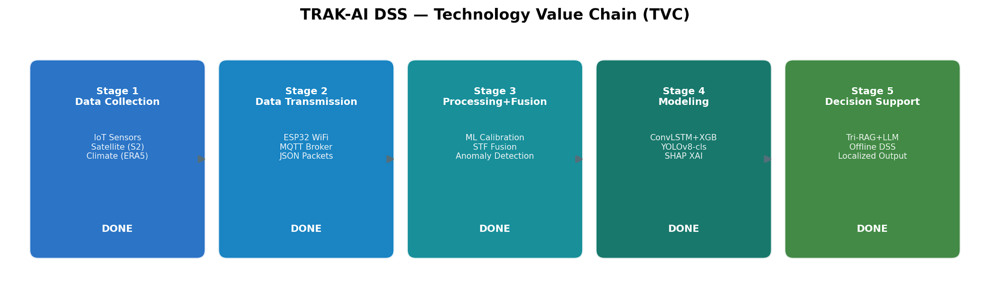
Figure 1.2. The five-stage Technology Value Chain (TVC) underlying the TRAK-AI DSS. Each stage corresponds to a distinct work package within the thesis: Stage 1 to data collection (Chapter 4, Section 4.1); Stage 2 to data transmission via the rover and MQTT broker (Section 4.3); Stage 3 to feature engineering and fusion (Section 4.1); Stage 4 to predictive modelling (Section 4.2); and Stage 5 to the RAG-based decision-support interface (Section 4.4).

1.4 Scope and Limitations
The scope of this thesis is delineated deliberately in order to deliver a complete end-to-end system within the time and resource constraints of an undergraduate research project. The geographical scope is restricted to a pilot site in Vize, Kırklareli, with coordinates 41.530° N, 27.861° E, selected as representative of Thracian rain-fed winter-wheat and sunflower rotations; this is a retrospective, region-representative reference point for the multi-year remote-sensing and climate analysis, and is distinct from the physical field parcel EVR_01 (41.0450° N, 27.2050° E) used for the 27 May 2026 reconnaissance. The agronomic scope covers two crops, bread wheat (Triticum aestivum) and oil-seed sunflower (Helianthus annuus), which collectively dominate the regional production basket. The temporal scope of the retrospective data spans 2017 through 2024 inclusive, providing eight full growing seasons for model training, validation, and statistical evaluation. The system is benchmarked initially on four placeholder fields representing realistic farm sizes from 85 to 200 decares.
Several limitations of the present study should be acknowledged at the outset and are revisited in Chapter 8. First, the full single-season autonomous deployment of the rover prototype has not yet been completed; the system-level empirical validation of the micro-scale ground-truthing layer therefore relies primarily on mock-rover MQTT integration messages emitted by a Python utility rather than on continuous real sensor measurements collected across a growing season. A limited eighty-two-minute physical field reconnaissance was nonetheless conducted at parcel EVR_01 on 27 May 2026, producing 163 real telemetry frames and 105 field images, so that limited in-situ evidence is available alongside the mock-MQTT integration tests. Firmware compilation, calibration-protocol validation, and laboratory-bench testing are complete, but full single-season field trials remain a future task. Second, because the language model operates on CPU rather than GPU on the available development hardware, end-to-end inference latency, although well below the 120 s target, is materially higher than what a production deployment could achieve with modest acceleration. Third, the wheat n = 213 LOYO regime exposes a data-regime limitation in which a climatology baseline (B0) outperforms Layers A/B/C; this is reported as a sample-size constraint rather than a model failure, with the LOILO and Spatiotemporal Block CV regimes yielding the more favourable comparisons documented in Chapter 5. Fourth, the YOLOv8s-cls stress_drought class is trained on only 360 images and is flagged as a structural overfit risk despite its nominal 100 % validation accuracy; cross-domain validation is identified as future work. Fifth, one hypothesis (H6 hallucination suppression) requires a blinded expert-panel evaluation that has been designed but not yet administered and is reported as pending; the farmer-acceptance hypothesis (H7) is partially satisfied by a fifteen-respondent pilot survey whose full Technology Acceptance Model administration at n ≥ 30 remains outstanding; and the agronomic-acceptance hypothesis (H9) is satisfied by that same pilot survey at a mean rating of 4.7 / 5, with a confirmatory expert-panel review identified as future work. These limitations are scoped deliberately and are discussed in greater depth alongside the experimental results in Chapter 5 and the future-work agenda in Chapter 8.

1.5 Outline of the Thesis
The remainder of this thesis is organised into seven further chapters. Chapter 2 surveys the research background, covering precision agriculture, IoT and edge artificial intelligence, machine-learning and deep-learning methods for crop monitoring and yield estimation, retrieval-augmented language models, explainable artificial intelligence in decision support, the Turkish national policy environment, and regional studies on Thrace agriculture; the chapter culminates in an explicit two-dimensional positioning of TRAK-AI DSS in the previously unoccupied quadrant of localised regional adaptation combined with full offline capability. Chapter 3 presents the methodology: the conceptual architecture, the hardware bill of materials with selection rationale, the open-source software stack, the four scientific work-package methodologies, the agronomic decision-engine rule families, and the formal statement of the ten research hypotheses (H1–H10) framing the empirical work. Chapter 4 documents the development of the system across its four work packages, with explicit attention to the engineering decisions taken at each stage, including the SoilGrids API→GEE asset-path pivot, the YOLOv8 pure-edge→hybrid-edge–fog deployment revision, the ERA5-Land→NASA POWER MERRA-2 substitution, and the phi3:mini→Gemma-3-4B model migration, and the orchestration layer that integrates the components. Chapter 5 reports the empirical results obtained through twenty-two automated test cases, unpacks the predictive modelling, image-classification, retrieval, and language-generation outcomes, and provides formal hypothesis-by-hypothesis verdicts against the literature baselines surveyed in Chapter 2. Chapter 6 describes the Streamlit dashboard, the deployment topology, and the operational considerations relevant to farmer-facing delivery in this pilot-scale evaluation. Chapter 7 provides a comparative discussion against published baselines including (van Klompenburg et al., 2020) (Khaki & Wang, 2019) and (Mohanty et al., 2016) . Chapter 8 concludes the thesis, restates the contributions, articulates the limitations revealed by the empirical evidence, and proposes a structured agenda for future work.

Research Background and Literature Review
This chapter surveys the body of research literature that grounds the present thesis. It opens with a definition of precision agriculture and a synthetic account of its conceptual evolution; proceeds through the technical foundations of Internet of Things sensing and edge computing; reviews the machine-learning and deep-learning methods that have come to dominate contemporary crop-monitoring research; examines the computer-vision literature on plant disease detection; assesses the emergence of large language models and the retrieval-augmented generation paradigm; situates the explainable artificial-intelligence literature with respect to agricultural decision support; locates the work within the Turkish national policy context; surveys the corpus of regional studies specific to the Thrace agricultural basin; and culminates in an explicit articulation of the research gap that motivates the architectural and methodological commitments developed in the chapters that follow.

2.1 Precision Agriculture: Conceptual Foundations and Evolution
Precision agriculture is broadly conceptualised as the application of information technologies to align agricultural practice with the spatial and temporal variability of fields, with the joint objective of improving productivity, profitability, sustainability, and product quality (McBratney et al., 2005) (Whelan & McBratney, 2000) . The discipline emerged formally during the 1990s, when the convergence of Global Positioning System receivers, geographic information systems, and variable-rate application technology made it economically feasible, for the first time, to differentiate management inputs at sub-field resolution rather than treating each parcel as a homogeneous management unit (Pierce & Nowak, 1999) . Early implementations concentrated on prescription maps for fertiliser and pesticide application; across the two subsequent decades, the scope of the field has expanded substantively to incorporate remotely sensed vegetation indices, in-situ sensor networks, robotic field machinery, and data-driven decision support systems (Bongiovanni & Lowenberg-DeBoer, 2004) (Atzberger, 2013) .
Several authors have proposed taxonomies of the technological generations through which precision agriculture has progressed. (Wolfert et al., 2017) describe an emergent phase that they characterise as smart farming, in which the locus of innovation shifts from individual machinery to integrated data platforms that synthesise sensor networks, machine-learning models, and cloud analytics. More recent literature speaks of Agriculture 4.0 and, increasingly, Agriculture 5.0, the latter emphasising human-centerd artificial intelligence and the integration of autonomous robotics with explicit decision-making support (Klerkx et al., 2019) (Saiz-Rubio & Rovira-Más, 2020) . Across these generational labels, two recurring themes are persistently visible: the growing centrality of data as a productive factor of agricultural production, and the persistent difficulty of bringing precision-agriculture technologies into the hands of small and medium farmers who, in aggregate, manage the majority of the world's cultivated land (Schimmelpfennig, 2016) (Friedrich, 2015) .
This accessibility problem has motivated a sustained strand of research focused explicitly on low-cost, open-source, and locally appropriate technologies. (Boursianis et al., 2022) survey the application of Internet of Things devices and unmanned aerial vehicles in smart farming, documenting the rapid decline in component costs that has, in principle, brought sensor-based farming within reach of smallholders. In practice, however, the empirical gap between technological feasibility and farm-level adoption remains substantial. (Liakos et al., 2018) , in a systematic review of machine learning in agriculture, observe that the majority of published studies remain at the level of academic proof-of-concept, with limited evidence of sustained deployment under realistic field conditions. (Kamilaris & Prenafeta-Boldú, 2018) reach a comparable conclusion in their dedicated survey of deep learning in agriculture, identifying the absence of reproducible end-to-end systems as a structural impediment to disciplinary progress. The present thesis is positioned within this strand of accessibility-oriented precision-agriculture research, with the additional constraint that the resulting system must operate effectively under the connectivity limitations characteristic of rural Türkiye (Sishodia et al., 2020) .
A complementary trajectory in the literature concerns the methodological maturation of remote sensing as the dominant data source for precision agriculture at the field-to-region scale. (Atzberger, 2013) reviews the deployment of optical and radar satellite imagery for crop monitoring and yield estimation, concluding that the simultaneous improvement of spatial, spectral, and temporal resolution across the Sentinel and Landsat constellations has, since approximately 2015, transformed what was previously an experimental discipline into a quasi-operational one. The Sentinel-2 mission of the European Space Agency Copernicus Programme, in particular, has come to underwrite a substantial fraction of contemporary agricultural remote-sensing research, providing 10 m spatial resolution and 5-day temporal revisit at the equator under free-and-open licensing, a combination that prior commercial sensors did not offer at comparable cost (Schmitt & Zhu, 2016) .

2.2 IoT and Edge Computing in Smart Farming
The Internet of Things in agriculture refers to networks of physical devices, soil-moisture probes, weather stations, livestock collars, plant-level sensors, and increasingly autonomous robots, that collect, transmit, and act upon data within agricultural environments (Wolfert et al., 2017) (Boursianis et al., 2022) . The technical architecture of an agricultural IoT system typically comprises four logical layers: a perception layer of sensors and actuators; a network layer responsible for data transmission; a processing layer where computation is performed; and an application layer that exposes information and recommendations to end users. Each of these layers has been the subject of dedicated research streams whose findings have direct bearing on the design choices documented in Chapter 3 of the present work.
At the network layer, the choice of communication protocol governs the inherent trade-off between range, energy consumption, and bandwidth. Cellular protocols including 4G, 5G, and NB-IoT offer high bandwidth but consume significant power and depend on commercial infrastructure that may not extend to rural parcels in Türkiye and comparable contexts. Low-Power Wide-Area Network protocols such as LoRaWAN and Sigfox sacrifice bandwidth in exchange for kilometre-scale range and battery lifetimes measured in years, and have therefore attracted sustained attention in agricultural research (Boursianis et al., 2022) . For short-range deployments at parcel scale, Wi-Fi remains a practical choice when the field is in proximity to the farmstead or to a portable hotspot, while Bluetooth and Zigbee occupy a specialised niche for sensor-to-gateway communication. The system presented in the present thesis adopts MQTT over Wi-Fi for parcel-level communication, a choice that deliberately avoids cellular subscriptions and the recurring per-device costs they impose on small farms (Klerkx et al., 2019) .
At the processing layer, the architectural decision between cloud-centric and edge-centric computation has emerged as defining for agricultural IoT systems. Cloud-centric pipelines benefit from effectively unlimited computational resources and from the operational simplicity of centralised model retraining; they depend, however, on stable connectivity, incur ongoing service fees, and raise privacy concerns when farm-level data is transferred away from the producer's premises. Edge computing performs inference and immediate processing on local hardware, typically microcontrollers from the ESP32 family, single-board computers such as the Raspberry Pi, or specialised edge accelerators including the Google Coral or NVIDIA Jetson series, and uploads only summary information when connectivity allows (Klerkx et al., 2019) (Saiz-Rubio & Rovira-Más, 2020) . (Klerkx et al., 2019) explicitly identify rural infrastructure constraints as among the most significant obstacles to wider adoption of IoT and artificial intelligence in agriculture, and argue that the next generation of smart-farming systems must be capable of energy harvesting, local computation, and continued operation in the absence of connectivity. The TRAK-AI DSS is engineered in deliberate alignment with this prescriptive frame.
A critical but frequently under-appreciated challenge in agricultural IoT is sensor calibration. Low-cost capacitive soil-moisture sensors such as the DFRobot SKU:SEN0193 produce raw analogue readings that depend strongly on soil texture, salinity, and temperature, the very factors that vary most across a heterogeneous landscape (Nagahage et al., 2019) (Hardie, 2020) . Without site-specific calibration, the readings produced by such sensors carry root-mean-square errors of approximately 0.08 m³/m³ volumetric water content, an error magnitude large enough to compromise irrigation decisions in marginal-water regimes. After polynomial calibration against gravimetric reference samples, the same sensors can attain errors below 0.03 m³/m³, restoring usable accuracy. (Abdelmoneim et al., 2025) report comparable improvements at silty-clay sites with coefficient-of-determination values between 0.85 and 0.87 after sensor-specific calibration, and (Bogena et al., 2017) document the calibration protocols underlying the SoilNet wireless sensor network deployments in Germany and the Netherlands. These convergent findings establish that the low-cost path to soil-moisture sensing is scientifically defensible provided that a credible calibration strategy is adopted; the absence of such a strategy is the primary source of skepticism toward consumer-grade IoT in the academic precision-agriculture literature, and motivates the polynomial-regression calibration procedure documented in Section 3.2 and Section 4.3 of the present work.

2.3 Machine Learning and Deep Learning for Crop Monitoring
The application of machine learning to crop monitoring has matured rapidly across the past decade, and several systematic reviews now document the resulting body of work. (Liakos et al., 2018) classify agricultural machine-learning applications into crop management, livestock management, water management, and soil management, with crop management representing the largest single category by published-paper count. (van Klompenburg et al., 2020) , in a more focused systematic review of crop-yield prediction specifically, identify temperature, rainfall, and soil type as the most informative predictor variables across the fifty published studies they examine, and report that neural networks, random forests, and gradient-boosted decision trees are the methods that most consistently achieve high predictive accuracy. (Kamilaris & Prenafeta-Boldú, 2018) complement these findings with a survey focused specifically on deep learning, observing that convolutional architectures dominate image-based applications while recurrent architectures dominate time-series applications, and that hybrid architectures are rapidly displacing both. The evolution of the methodological landscape across this body of literature is summarised in Figure 2.3.
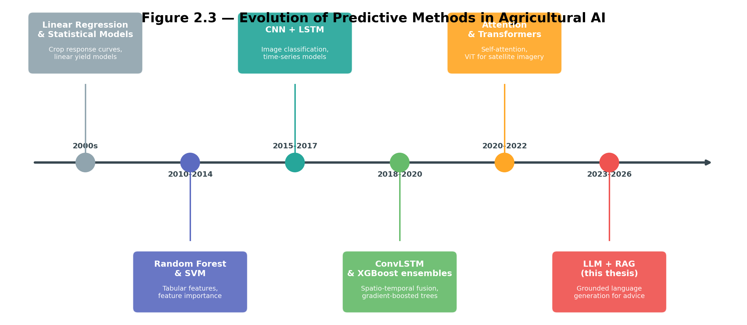
Figure 2.3. Evolution of predictive methods in agricultural artificial intelligence. The field has progressed from linear statistical models in the 2000s, through tree-based methods and convolutional neural networks in the 2010s, into hybrid spatio-temporal architectures such as ConvLSTM in the 2018–2020 period, and most recently toward attention-based transformers and retrieval-augmented language models from approximately 2022 onward.

2.3.1 Classical Machine Learning
Among classical machine-learning methods, the Random Forest algorithm (Breiman, 2001) and the eXtreme Gradient Boosting (XGBoost) framework (Chen & Guestrin, 2016) dominate agricultural applications. Their popularity is attributable to three properties: they handle tabular feature sets with mixed continuous and categorical variables natively; they provide intrinsic measures of feature importance that lend themselves to agronomic interpretation; and, in the case of XGBoost, they remain competitive with deep-learning methods on small to medium datasets while requiring substantially less computational expenditure (Sagi & Rokach, 2018) . For the prediction of regional cereal yields from interannual climate and remote-sensing aggregates, a problem characterised by tens to hundreds of data points rather than millions, these tree-based methods frequently represent the empirical benchmark that subsequent deep-learning candidates must outperform in order to justify their additional computational cost.

2.3.2 Deep Learning and Spatio-Temporal Architectures
Deep-learning methods entered agricultural research at scale around 2015 with the publication of the Convolutional Long Short-Term Memory (ConvLSTM) architecture (Shi et al., 2015) , which combines the spatial pattern recognition of convolutional networks with the sequential memory of the LSTM cell originally introduced by (Hochreiter & Schmidhuber, 1997) . The architecture was proposed for precipitation nowcasting but has subsequently been applied widely to satellite-imagery-based crop monitoring, where the input consists of multi-channel raster sequences indexed in time. (Khaki & Wang, 2019) demonstrate the value of deep neural networks in maize yield prediction from large-scale agronomic data, achieving consistent improvements over multiple-linear-regression baselines. (You et al., 2017) introduce Gaussian-process modelling on top of deep-learning representations for satellite-derived yield forecasting, while (You et al., 2017) provides an early systematic application of convolutional neural networks to county-level crop yield prediction in the United States Midwest.
For time-series crop monitoring at single-point or single-parcel resolution, the situation that obtains in TRAK-AI DSS, where each pilot parcel is treated as a sequence of multi-modal observations, the LSTM architecture and its variants remain competitive. The two principal innovations relative to the original LSTM cell are the addition of self-attention mechanisms (Bahdanau et al., 2015) (Vaswani et al., 2017) , which allow the model to weight informative time steps more strongly than uninformative ones, and the integration of one-dimensional convolutional filters before the recurrent layer, which capture short-duration shocks such as heat waves or precipitation events. These variants are typically benchmarked against XGBoost as a strong tabular baseline; the empirical evidence accumulated in the present thesis (reported in Chapter 5) confirms that no single architecture dominates universally, and that the optimal choice depends jointly on the temporal complexity of the target crop and on the sample-size regime (Reichstein et al., 2019) .

2.3.3 Spatio-Temporal Fusion and Multi-Modal Data
A distinctive technical challenge in multi-modal crop monitoring is the spatio-temporal trade-off between heterogeneous data sources. The Sentinel-2 satellite constellation offers excellent spatial resolution at 10 m in the visible and near-infrared bands but revisits a given location only every five days under cloud-free conditions, and frequently less often during the cloudy growing season in temperate regions. The ERA5-Land climate reanalysis (Hersbach et al., 2020) , conversely, provides daily temporal resolution but at a spatial resolution of approximately 9 km, sufficient to characterise a regional weather pattern but inadequate to resolve sub-field variability. The NASA POWER MERRA-2 reanalysis (Stackhouse et al., 2018) , adopted by TRAK-AI DSS following the methodological pivot documented in Chapter 4, exhibits comparable resolution characteristics whilst offering more robust application-programming-interface availability than the Copernicus Climate Data Store path encountered during the development phase of this work.
Spatio-Temporal Fusion (STF) methods address the resolution asymmetry by combining the two streams in a manner that preserves both fine spatial detail and fine temporal cadence (Schmitt & Zhu, 2016) . Recent work by (Schmitt & Zhu, 2016) demonstrates that machine-learning-based STF models can correlate strongly with in-situ ground-truth sensors (Pearson r = 0.707), confirming that fused multi-modal data approximates the information content that would otherwise require an unrealistically dense ground-sensor network. The theory-guided data-science framework articulated by (Karpatne et al., 2017) provides a complementary methodological foundation, advocating the explicit incorporation of process-based agronomic constraints, growing-degree-day accumulations, crop-coefficient curves, evapotranspiration relationships, into the loss functions of otherwise data-driven models, a recommendation that is operationalised in the residual-delta formulation documented in Section 3.5 of the present thesis.

2.4 Computer Vision for Plant Health and Disease Detection
Computer-vision-based plant-health monitoring constitutes a distinct sub-field within agricultural artificial intelligence. The defining publication is arguably (Mohanty et al., 2016) , who demonstrated that a deep convolutional neural network trained on the PlantVillage dataset of 54,306 labelled leaf images could attain above-99 % classification accuracy across 14 crop species and 26 disease categories. While subsequent work has revealed important caveats, in particular, that performance frequently degrades substantially when models are evaluated on imagery captured under realistic field conditions rather than under the controlled laboratory backgrounds of PlantVillage (Ferentinos, 2018) (Barbedo, 2018) , the demonstration that the underlying task is approachable with convolutional networks reshaped the research agenda decisively. (Picon et al., 2019) propose crop-conditional convolutional architectures that explicitly model the joint distribution of crop species and disease, partially mitigating the laboratory-to-field generalisation gap; (Kerkech et al., 2020) demonstrate analogous improvements for unmanned-aerial-vehicle imagery acquired in vineyard contexts.
In the subsequent years, the You Only Look Once (YOLO) family of object detectors (Redmon et al., 2016) has emerged as the dominant choice for agricultural computer-vision tasks that require real-time or near-real-time inference. The YOLO architecture casts both object localisation and classification as a single regression problem, producing a substantially faster inference pipeline than two-stage detectors such as Faster R-CNN. For agricultural applications encompassing disease detection, weed identification, and fruit counting, multiple comparative studies confirm that the YOLOv5, YOLOv7 (Wang et al., 2023) , and YOLOv8 (Jocher et al., 2023) generations achieve a favourable balance between inference speed and detection accuracy (Wang et al., 2023) . The TRAK-AI DSS adopts YOLOv8s-cls, the classification variant of YOLOv8, as the basis for its plant-health classifier; the empirical performance of this choice is reported in Chapter 5, where an overall top-1 accuracy of 94.9 % across six classes is documented.
A second strand of research focused on edge deployment of vision models has produced techniques for compressing deep networks into formats suitable for execution on memory-constrained microcontrollers. Eight-bit integer quantisation (Int8), in particular, converts floating-point weights to integer approximations and typically reduces model size by approximately four times while incurring small or negligible accuracy losses (Jacob et al., 2018) . Mobile-optimised architectural families including MobileNets (Howard et al., 2017) and EfficientNet (Tan & Le, 2019) extend these compression gains through architectural search and channel pruning. The resulting compressed models can be executed on hardware such as the ESP32-CAM through the TensorFlow Lite Micro runtime. The original TRAK-AI rover design intended to follow this pure-edge inference path; during the development process, the architecture was revised in favour of a hybrid Edge–Fog approach, in which the camera transmits compressed JPEG frames to the local fog server for inference. This revision is documented in Chapter 4 and is motivated by the higher classification accuracy attainable on the fog hardware than on the ESP32-CAM itself.
For phenological staging, the Biologische Bundesanstalt, Bundessortenamt und Chemische Industrie (BBCH) scale provides a numerical encoding of plant developmental stages that is internationally standardised across crop species (Meier, 2018) . Recent computer-vision research has begun to treat BBCH stage estimation as a classification or regression problem, leveraging large labelled datasets such as the Global Wheat Head Detection 2021 corpus (David et al., 2021) , which contains 6,500 images and approximately 275,000 wheat-head annotations collected from sites distributed across Europe, Asia, North America, and other wheat-growing regions. The labelling of plant developmental stages remains, however, more subjective than disease labelling, and large open BBCH datasets specific to sunflower remain comparatively scarce, motivating the use of smaller curated sources such as the BARI Sunflower Disease dataset within the present work.

2.5 Large Language Models and Retrieval-Augmented Generation in Agriculture
The emergence of large language models since 2020 has transformed the landscape of natural-language interfaces. Models including GPT-3 (Brown et al., 2020) , LLaMA (Touvron et al., 2023) , Mistral (Jiang et al., 2023) , and the Gemma family (Team et al., 2024) demonstrate remarkable fluency across a wide range of domains and languages, including Turkish. Their conversational capability suggests an obvious application to agricultural decision support: a farmer might pose a natural-language question in their own language and receive a contextualised answer that integrates current observations, predictive-model outputs, and expert agronomic knowledge. The broader phenomenon of generative artificial intelligence as a foundation-model technology has been comprehensively surveyed by (Bommasani et al., 2021) . Realising this vision in practice, however, requires confronting two well-documented limitations of contemporary language models: hallucination and outdated or non-specific training data.
Hallucination, the tendency of generative language models to produce plausible-sounding but factually incorrect statements with high confidence, has been the subject of a substantial taxonomic literature (Ji et al., 2023) . The phenomenon arises from the underlying training objective of next-token prediction, which optimises for surface fluency rather than for factual accuracy. In low-stakes conversational settings the consequences of hallucination are typically trivial; in agricultural decision support, where a fabricated chemical dosage or treatment recommendation can compromise a farmer's entire season, the consequences may be severe. Mitigating hallucination is therefore not optional in this application domain but rather a structural requirement.
The dominant technical response to hallucination in the recent literature is Retrieval-Augmented Generation (RAG), formalised by (Lewis et al., 2020) . The RAG paradigm couples a parametric language model with a non-parametric document store: at inference time, the user query is first used to retrieve the most relevant passages from the document store, and those passages are then prepended to the language-model prompt as grounding context. The model is, in effect, asked to answer the user's question while restricted to information available in the retrieved passages, rather than relying solely on its parametric memory. When the document store contains authoritative domain-specific material, the model's tendency to fabricate information is substantially suppressed.
The retrieval component of a RAG system can be implemented along several methodological lines. Dense retrieval methods encode both queries and documents into a shared vector space and use approximate nearest-neighbour search, typically with the FAISS library (Johnson et al., 2019) , to identify semantically similar passages. Dense Passage Retrieval, formalised by (Karpukhin et al., 2020) , and Sentence-BERT, introduced by (Reimers & Gurevych, 2019) , established the methodological foundations for dense semantic indexing at scale. Sparse retrieval methods such as BM25 (Robertson & Zaragoza, 2009) instead rely on weighted term-frequency matching, which frequently performs better than dense retrieval for queries that contain rare, technical, or domain-specific terminology. The two methods have complementary strengths: dense retrieval excels at conceptual paraphrase, while sparse retrieval excels at exact-keyword matching. A growing body of research demonstrates that hybrid retrieval pipelines that combine dense and sparse signals, sometimes augmented with a learned re-ranker as a third stage, outperform either approach in isolation (Gao et al., 2024) . The Tri-RAG architecture adopted by TRAK-AI DSS implements precisely this hybridisation, as illustrated in Figure 2.2.
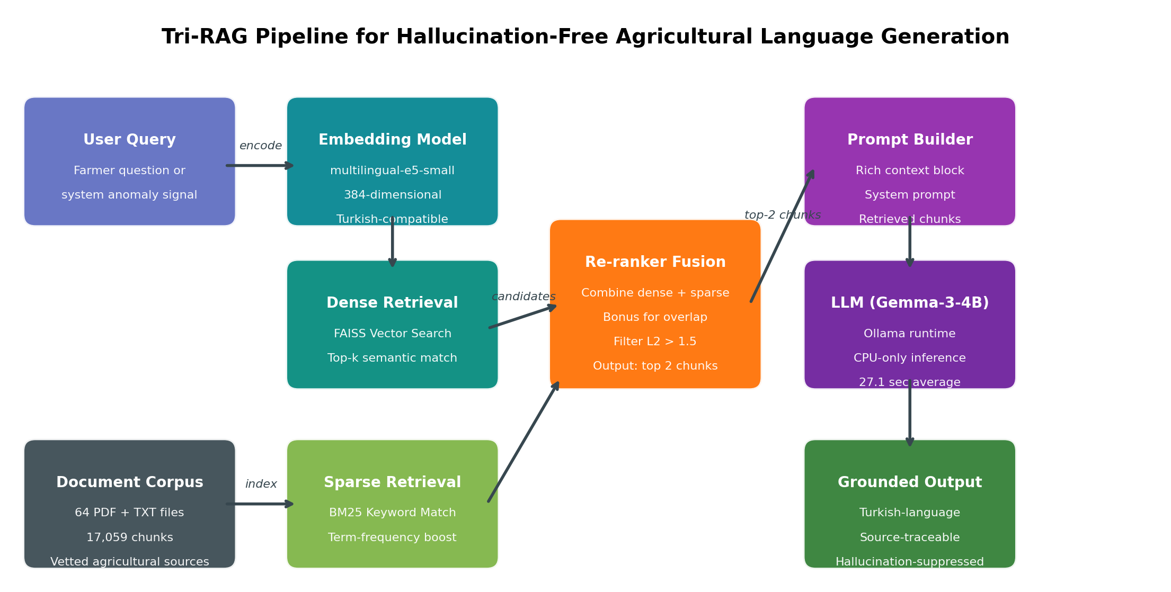
Figure 2.2. Schematic of the Tri-RAG retrieval-augmented generation pipeline. The user query is independently passed through a dense (FAISS) and a sparse (BM25) retrieval stage; the candidate passages are then merged and re-ranked, and the top two passages are injected into the prompt presented to the locally hosted Gemma-3-4B language model. The resulting output is constrained to information present in the retrieved passages, suppressing hallucination.
Recent work has begun to apply RAG specifically to agricultural language generation. The literature on domain-specific RAG and on agricultural extension language models demonstrates that the paradigm transfers well to agricultural question-answering provided that the document store is curated with appropriate domain expertise (Tzachor et al., 2023) . The localisation question, however, remains acute: an agricultural RAG system trained on documents from Iowa maize production will provide different and possibly inappropriate guidance to a Thracian wheat farmer. The present thesis addresses this question by assembling a knowledge base of 64 documents and 17,059 chunks specifically selected for relevance to Turkish and Thracian agricultural practice, including Ministry of Agriculture guides, FAO irrigation references (Allen et al., 1998) , BBCH phenological scales, and primary research published in Turkish agricultural journals.
A related challenge is the choice of base language model. Commercial cloud-hosted models such as GPT-4 offer high linguistic quality but raise the cloud-dependency and privacy concerns documented in Chapter 1. Open-weight models that can be hosted locally include the LLaMA family, the Mistral family, and, since 2024, the Gemma family from Google DeepMind (Team et al., 2024) . Among these, Gemma-3-4B was selected for the present work after empirical testing established that it combined acceptable Turkish-language fluency with a memory footprint compatible with the 16 GB development hardware. The smaller phi3:mini model was also tested but produced Turkish output of insufficient quality for direct presentation to farmers. The selection rationale and the comparative evaluation protocol are documented in Chapter 4.

2.6 Explainable AI in Agricultural Decision Support
A persistent obstacle to the practical adoption of complex machine-learning models in agriculture is the so-called black-box problem: when a model produces a recommendation, the farmer cannot inspect the chain of reasoning that led to it, and is therefore asked to extend trust on the basis of system behaviour alone. In the academic literature on technology acceptance, this issue is captured by the Perceived Usefulness and Perceived Ease of Use constructs of the Technology Acceptance Model (Davis, 1989) and by the Performance Expectancy and Effort Expectancy constructs of the Unified Theory of Acceptance and Use of Technology (Venkatesh et al., 2012) . Empirical studies consistently find that opaque systems achieve weaker adoption rates than equivalently accurate transparent systems, particularly among users who lack the domain background to evaluate model output on its face.
Explainable Artificial Intelligence (XAI) is the methodological response to this problem. The conceptual landscape of XAI has been surveyed comprehensively by (Adadi & Berrada, 2018) and critiqued by (Lipton, 2018) , who distinguishes between transparency-based and post-hoc approaches and warns against conflating the two. (Doshi-Velez & Kim, 2017) propose a more rigorous taxonomy of interpretability evaluation methods, while (Rudin, 2019) argues forcefully against the use of post-hoc explanations for high-stakes decisions, advocating instead for inherently interpretable models. Within XAI, the two most influential post-hoc explanation techniques are LIME, which fits a locally linear surrogate model around each prediction (Ribeiro et al., 2016) , and SHAP, which uses Shapley values from cooperative game theory to attribute the prediction of a model to each input feature in a manner that satisfies several theoretically desirable axioms (Lundberg & Lee, 2017) . For tree-based models such as XGBoost and Random Forest, SHAP can be computed exactly and efficiently; for deep-learning models the approximation is more expensive but remains tractable for individual instances or for moderate-sized validation sets. Gradient-based attribution methods including Grad-CAM (Selvaraju et al., 2017) provide a complementary visual-attention modality that is particularly informative for image-classification tasks.
In the agricultural decision-support literature, SHAP analyses have been used to communicate which climatic, soil, or remote-sensing variables drove a model's yield prediction or its stress alert. The benefit is twofold: the analysis serves as an internal audit, allowing the developer to detect that a model has learned implausible or shortcut features; and, when presented to the farmer in a simplified visual form, it provides the explanatory layer needed to convert a numerical prediction into actionable understanding. The TRAK-AI DSS computes SHAP attributions for its XGBoost yield-prediction model, exposes the top contributing features in the dashboard, and uses these features as an additional input to the language model so that the resulting Turkish-language recommendation can refer to the specific climatic drivers responsible for the prediction.

2.7 Turkish National Policy Context
The development of TRAK-AI DSS is situated within a Turkish national policy environment that has, during the past several years, increasingly emphasised the digital transformation of agriculture. The Twelfth Development Plan covering the period 2024–2028 (Presidency of Strategy and Budget, 2023) articulates four headline priorities for the agricultural sector: ensuring food supply security; adapting to climate change; the efficient use of water resources; and the digital transformation of agricultural production. The plan explicitly identifies the dissemination of precision-agriculture practices, the efficient management of water, the strengthening of data-driven decision support, and improvements in productivity and quality as concrete policy targets. The six contributions of the present thesis map directly onto these priorities, as elaborated in Chapter 1.
The Scientific and Technological Research Council of Türkiye (TÜBİTAK) operates several support programmes relevant to the present work, of which the 2209/A Undergraduate Students Research Projects Funding Programme is the programme most directly relevant to the present work (TÜBİTAK, 2024) . The programme is designed to encourage substantive research projects at the undergraduate level, and its evaluation criteria emphasise the alignment of proposed work with national development priorities, the methodological soundness of the research design, and the feasibility of producing a demonstrable artefact within the project timeline. The methodology, hypotheses, and work-package structure documented in Chapter 3 of this thesis were developed within the formal proposal submitted under this programme.
At the line-ministry level, the Republic of Türkiye Ministry of Agriculture and Forestry, through its research and development arm, the General Directorate of Agricultural Research and Policies (TAGEM), funds and publishes a substantial body of regional research relevant to wheat, sunflower, irrigation, and disease management in the Thrace basin. Several of these publications are incorporated into the TRAK-AI DSS knowledge base, including the Edirne İl Tarım ve Orman Müdürlüğü 2025 activity report (Edirne İl Tarım ve Orman Müdürlüğü, 2025) and official Trakya-region wheat variety registration reports that include yield, quality, and disease-observation data (Tohumluk Tescil ve Sertifikasyon Merkez Müdürlüğü, 2019) . The Thrace Agricultural Research Institute, located in Edirne and operating under TAGEM, conducts continuous variety trials and disease surveillance that constitute an authoritative source of regionally calibrated agronomic guidance.
Finally, the Turkish Statistical Institute (TÜİK) publishes annual provincial production statistics that, together with the National Tax Administration and the Farmer Registration System, define the empirical baseline against which any precision-agriculture system in Türkiye must be evaluated (Turkish Statistical Institute, 2024) . The Thrace region's position as a leading domestic producer of wheat and sunflower is the principal reason for the geographical focus of the present thesis, and the official production figures provide the per-decare benchmarks against which the yield-prediction component is calibrated, as documented in Section 3.5.

2.8 Regional Studies on Thrace Agriculture
The Thrace region of Türkiye, comprising the provinces of Edirne, Kırklareli, and Tekirdağ, has been the subject of a sustained body of regional agricultural research published primarily in Turkish-language journals and in TAGEM and university technical reports. This regional literature is of direct relevance to the TRAK-AI DSS knowledge base, both as primary content for the retrieval-augmented generation pipeline and as the source of agronomic ground truth against which the system's recommendations are calibrated.
2.8.1 Wheat in Thrace
Studies focusing on bread wheat in the Thracian basin examine the genotype×environment interaction across the three principal sub-zones of Edirne, Lüleburgaz, and Tekirdağ, and document substantial differences in biotic stress response, most notably the differential expression of yellow rust (Puccinia striiformis), brown rust (Puccinia triticina), and Septoria leaf blotch, across these locations (Öztürk et al., 2018) . Official Trakya-region variety registration trials likewise report yield, quality, powdery mildew, rust, and Septoria tritici observations across Edirne, Lüleburgaz, Keşan, and Tekirdağ locations (Tohumluk Tescil ve Sertifikasyon Merkez Müdürlüğü, 2019) . The Edirne provincial activity report provides a recent administrative surveillance layer for regional pests and plant-health activities, enabling the TRAK-AI knowledge base to distinguish long-standing regional threats from current-season alerts (Edirne İl Tarım ve Orman Müdürlüğü, 2025) .

2.8.2 Sunflower in Thrace
For sunflower production, regional research has concentrated on three principal threats: downy mildew (Plasmopara halstedii); the parasitic weed broomrape (Orobanche cumana); and field-condition stress symptoms that may be visually confounded with disease. Regional sunflower disease research documents downy-mildew outbreaks in Thrace (Göre, 2009), the races of Plasmopara halstedii detected in Turkish sunflower-growing provinces including Tekirdağ, Edirne, and Kırklareli (Oksal & Maden, 2019), and the effects of broomrape populations collected from Tekirdağ, Kırklareli, and Edirne on sunflower development (Üder & Demirbaş, 2019) . In the domain of remote-sensing-based monitoring, the regional publication on crop-phenology-based object-oriented classification of sunflower parcels in Kırklareli using Sentinel-2 time series provides direct methodological validation for the approach adopted in the present thesis (Karabulut et al., 2021) .

2.8.3 Irrigation, Soils, and Phenology
Studies of irrigation and water-use efficiency are particularly important given the climate-adaptation priorities articulated at the national level. Research from Kırklareli and Tekirdağ documents the seasonal water sensitivity of sunflower under regional conditions, and recent Tekirdağ field research characterises the yield response of sunflower under different irrigation timings (Göçmen, 2020) . Edirne-focused studies of supplemental irrigation demonstrate that a single well-timed irrigation event at the start of sunflower flowering produces a measurable yield gain, identifying the most critical irrigation timing for the regional crop calendar (Pekcan & Erdem, 2016) . These primary studies are summarised within the agricultural-assistant subsystem of TRAK-AI DSS and provide the foundation for the irrigation-decision rules implemented in the agronomic-calendar engine described in Chapter 4.
At the soils level, the Trakya soil database study documents the principal pedological characteristics of the basin, including texture classes, soil reaction, salinity, lime content, organic matter, and macro- and micro-nutrient availability across Edirne, Kırklareli, and Tekirdağ agricultural lands (Gürbüz et al., 2019) . These regional soil attributes are explicitly encoded in the SoilGrids 2.0 layer of the data-fusion pipeline (Poggio et al., 2021) and inform the calibration polynomials applied to the soil-moisture sensors carried by the autonomous rover. Finally, the Edirne İl Tarım ve Orman Müdürlüğü 2025 activity report provides the most recent official surveillance data on disease and pest pressure for the past season, and is included in the knowledge base as a recent-confirmation layer that enables the language model to distinguish between historically common threats and those that have actually exceeded economic thresholds in the current production year (Edirne İl Tarım ve Orman Müdürlüğü, 2025) .

2.9 Identified Research Gap and Positioning of TRAK-AI DSS
The literature reviewed in the preceding sections demonstrates that each component technology required for an integrated agricultural decision support system has been independently validated within its own sub-disciplinary context. Multi-modal data fusion combining satellite imagery, climate reanalysis, and digital soil maps is methodologically mature (Schmitt & Zhu, 2016) ; LSTM, ConvLSTM, and gradient-boosted tree models routinely achieve coefficient-of-determination scores above 0.75 in regional yield and phenology prediction (van Klompenburg et al., 2020) (Khaki & Wang, 2019) ; YOLO-family vision models deliver real-time plant-disease classification at deployable accuracy (Wang et al., 2023) ; retrieval-augmented generation suppresses hallucination in domain-specific language tasks (Lewis et al., 2020) (Gao et al., 2024) ; explainable-artificial-intelligence techniques such as SHAP provide the transparency that drives technology acceptance (Lundberg & Lee, 2017) (Davis, 1989) ; and the Turkish national policy environment provides clear incentives for the development of such systems (Presidency of Strategy and Budget, 2023) (TÜBİTAK, 2024) .
What the literature does not yet provide, however, is an integrated, end-to-end, offline-first, and regionally localised system that combines all of these components within a single artefact tailored to a specific agricultural basin. The positioning of the present thesis with respect to existing approaches is summarised in Figure 2.1 and quantified comparatively in Table 2.1.
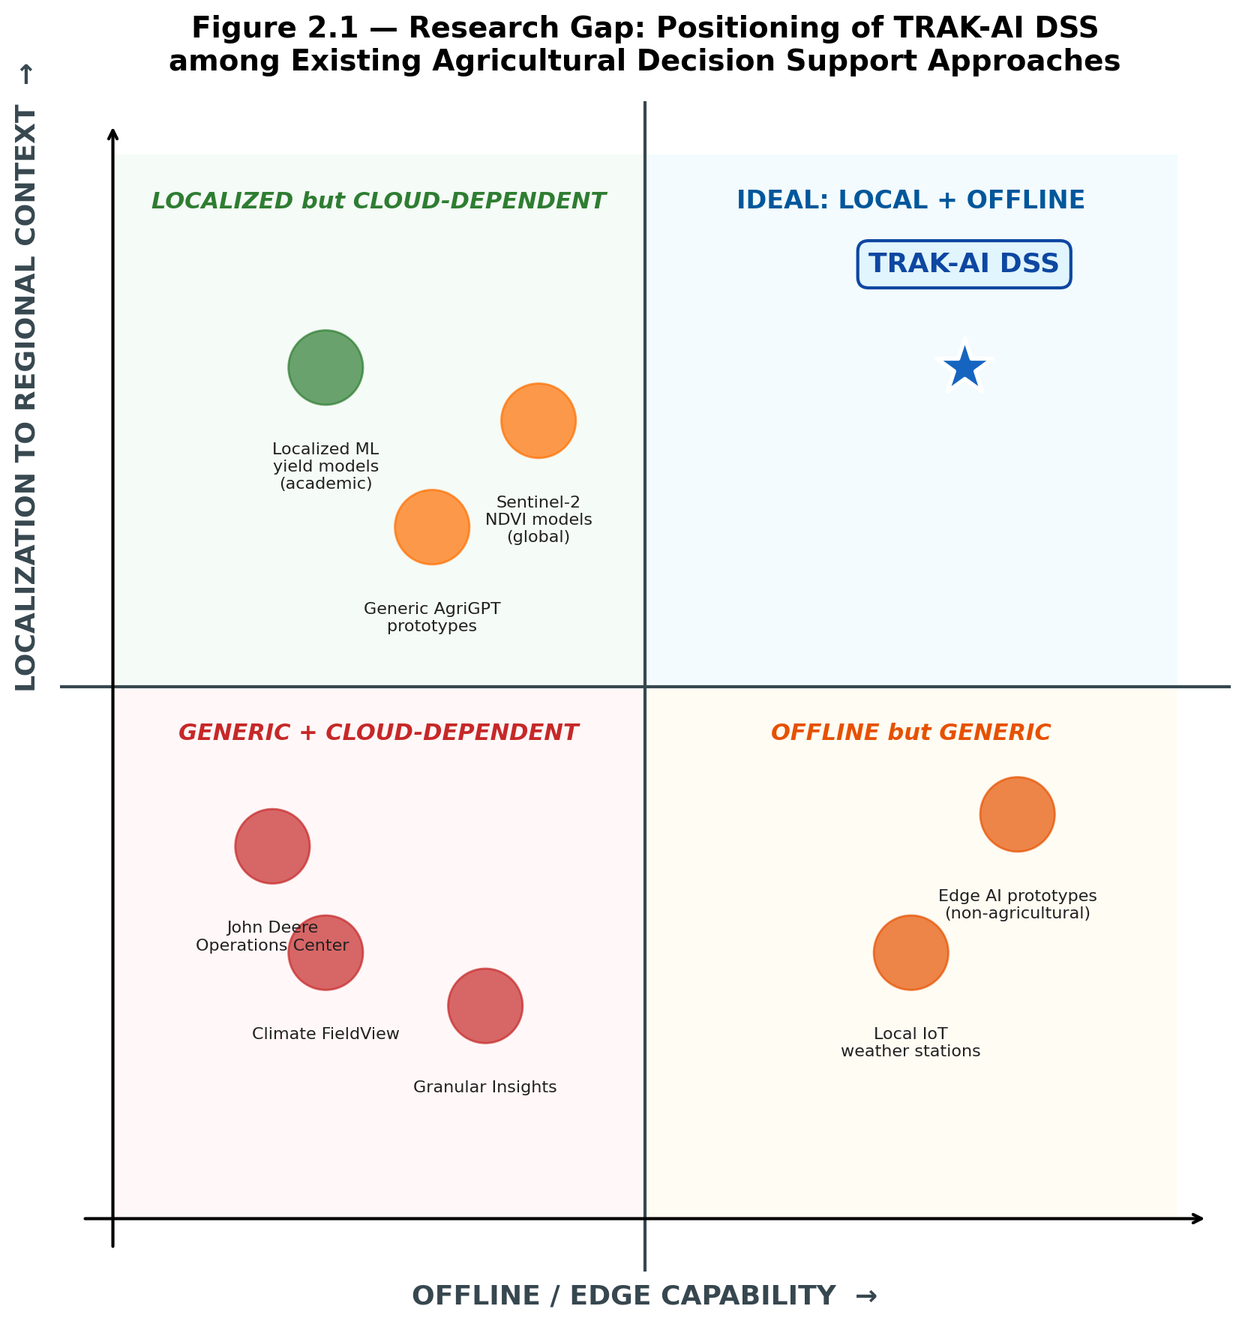
Figure 2.1. Two-dimensional positioning of TRAK-AI DSS relative to existing agricultural decision-support approaches. The horizontal axis represents offline and edge capability; the vertical axis represents the degree of localisation to a specific regional agronomic context. Existing commercial platforms occupy the lower-left quadrant (cloud-dependent and globally generic); offline-but-generic IoT solutions occupy the lower-right; localised academic models the upper-left (cloud-dependent); and the upper-right quadrant, systems that are both offline-first (with cloud as an optional layer) and deeply localised, was previously unoccupied. TRAK-AI DSS is positioned explicitly in this previously empty quadrant.
Table 2.1. Comparative positioning of TRAK-AI DSS against representative agricultural decision-support platforms and academic prototypes. Cells indicate whether the corresponding axis is satisfied (✓), partially satisfied (○), or absent (✗).
System | Offline-first | Regionally localised | RAG-grounded LLM | Open-source
John Deere Ops Center | ✗ | ✗ | ✗ | ✗
Climate FieldView | ✗ | ✗ | ✗ | ✗
Granular Insights | ✗ | ✗ | ✗ | ✗
Sentinel-2 NDVI models | ○ | ✗ | ✗ | ○
Localised ML yield models | ✗ | ✓ | ✗ | ○
Generic AgriGPT prototypes | ✗ | ✗ | ✓ | ○
Local IoT weather stations | ✓ | ✗ | ✗ | ○
Edge AI prototypes (non-agri) | ✓ | ✗ | ✗ | ○
TRAK-AI DSS (present work) | ✓ | ✓ | ✓ | ✓
The contribution of this thesis is therefore not the invention of any one of its component technologies but rather the demonstrated integration of all of them, under the operating constraints characteristic of small and medium farms in rural Türkiye. The research questions that organise this integration, ten hypotheses indexed H1 through H10, ranging from the latency benefit of cloud-free operation through the user-experience benefit of explanation layers, are introduced formally in Chapter 3. The development of each work package is documented in Chapter 4. The empirical evidence bearing on each hypothesis, including the results of twenty-two automated test cases, is reported and discussed in Chapter 5. The remaining limitations of the present study and the agenda they imply for future work are taken up in Chapter 8.

Methodology and System Architecture
This chapter presents the methodology of the thesis. It opens with an articulation of the design philosophy that animates the system as a whole, with particular emphasis on the offline-first principle and on the layered separation of concerns. The chapter then proceeds through the hardware and software stacks, describing the rationale governing each major selection. The four scientific work packages of the project are then formalised in turn, the multi-modal data fusion pipeline, the champion-selection predictive modelling layer, the edge artificial-intelligence subsystem, and the Tri-RAG retrieval-augmented generation pipeline. The chapter closes with the agronomic decision-engine logic and a formal statement of the ten research hypotheses that organise the empirical work reported in Chapter 5.

3.1 Conceptual Architecture and Design Philosophy
The architecture of TRAK-AI DSS is organised around four design principles that, taken jointly, distinguish it from competing agricultural decision support systems. The principles are non-orthogonal: each reinforces the others, and each is operationalised through concrete software-hardware engineering choices documented in the remainder of this chapter and in Chapter 4.
The first principle is offline-first operation. Every component of the pipeline, from sensor acquisition through anomaly detection, retrieval, and natural-language generation, must be capable of executing on local hardware in the absence of an active internet connection. Cloud services are admitted only for the opportunistic ingestion of free public Earth-observation data and for the optional remote synchronisation of the dashboard. The principle was adopted in direct response to the empirical reality of rural Turkish cellular coverage and to the recurring subscription costs that discourage adoption among small farmers, as documented in Chapter 2 (Klerkx et al., 2019) .
The second principle is layered modularity. The system is decomposed into three physical layers, the Edge layer of sensors and on-rover computation, the Fog layer of local-server orchestration and language generation, and the optional Cloud layer of public-data ingestion, and four logical work packages distributed within them. The Edge–Fog–Cloud terminology follows the convention established by the International Organization for Standardization in the IoT reference architecture (ISO/IEC 30141:2018) , and the explicit Fog layer is essential to enable the offline-first principle: in the absence of cloud connectivity, the Fog layer becomes the sole locus of intelligence. The layered separation also serves a software-engineering purpose: each work package can be developed, tested, and replaced in isolation provided that the inter-layer message formats remain stable, an arrangement that aligns with the contemporary microservices and event-driven architectural patterns surveyed by (Newman, 2021) .
The third principle is grounded language generation. Every recommendation produced by the system must be traceable to a verifiable source document in the knowledge base. The principle is operationalised through the Tri-RAG retrieval pipeline described in Section 3.7, which constrains the language model to information present in the retrieved passages and which preserves source identifiers throughout the pipeline so that the dashboard can present, alongside each recommendation, the document and chunk identifier that supports it. This contrasts with general-purpose conversational agents, which rely on parametric memory and provide no comparable accountability (Lewis et al., 2020) (Gao et al., 2024) .
The fourth principle is explainable prediction. Every numerical forecast, whether of vegetation index, yield, or stress probability, is accompanied by a SHAP attribution that identifies the top contributing input features (Lundberg & Lee, 2017) . The attribution is consumed by two downstream subsystems: by the dashboard, which renders it as a horizontal bar chart for the farmer; and by the language model, which incorporates it into the prompt so that the resulting Turkish-language recommendation can refer to the specific climatic or agronomic drivers responsible for the prediction. The principle reflects the technology-acceptance considerations reviewed in Section 2.6: opaque systems achieve weaker adoption than equivalently accurate transparent systems, particularly among users without the domain background to evaluate model output on its face (Davis, 1989) (Venkatesh et al., 2012) .

3.2 Hardware Components and Selection Rationale
The Edge layer of TRAK-AI DSS is implemented as an autonomous mobile rover constructed from off-the-shelf components selected to minimise the total bill of materials whilst satisfying the functional requirements of micro-scale field validation. The hardware architecture and the cost breakdown are summarised in Figure 3.1 and tabulated in Table 3.1.
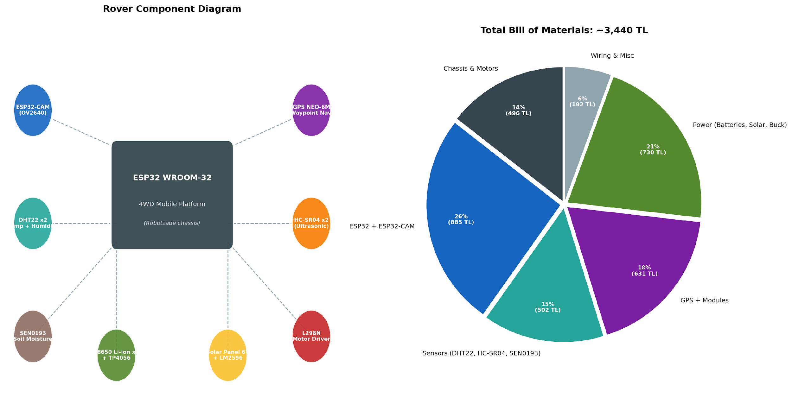
Figure 3.1. Rover hardware architecture and bill of materials. The left panel shows the eight categories of peripheral components organised around the central ESP32 WROOM-32 microcontroller and 4WD mobile platform. The right panel summarises the cost distribution across six functional categories; the total bill of materials of approximately 3,440 Turkish lira represents an order-of-magnitude reduction relative to commercial agricultural robotic platforms.
Table 3.1. Rover bill of materials with component justification (April 2026 prices, Türkiye-domestic suppliers).
Component | Function | Cost (TL) | Rationale
ESP32 WROOM-32 | Main controller | 180 | Built-in Wi-Fi; LEDC PWM; dual-core; low power
ESP32-CAM (AI-Thinker) | Image acquisition | 320 | OV2640 sensor; hybrid Edge–Fog inference path
DHT22 × 2 | Temperature/humidity | 120 | Canopy and ground level placement; 0.1°C resolution
SEN0193 capacitive | Soil moisture | 240 | Corrosion-resistant; polynomial-calibrated to <0.03 m³/m³ RMSE
GPS NEO-6M + antenna | Waypoint navigation | 631 | 1 Hz fixes; ~2.5 m horizontal accuracy
HC-SR04 × 2 | Obstacle avoidance | 60 | 30 cm trigger threshold; front-mounted
L298N motor driver | Motor actuation | 180 | Dual H-bridge; 4 LEDC PWM channels
4WD chassis (Robotzade) | Mobile platform | 885 | Ground clearance for residue-covered fields
18650 × 2 + TP4056 | Power storage | 330 | Parallel cells; charge controller
LM2596 buck converter | Voltage regulation | 120 | 5 V logic supply
6 V 230 mA solar panel | Energy harvesting | 150 | Sustains continuous operation under typical insolation
Wiring and miscellaneous | Assembly | 224 | Connectors, headers, mounting
TOTAL |  | 3,440 | ~10× cost reduction vs. commercial agricultural robots
The principal computational element is an ESP32 WROOM-32 microcontroller. The ESP32 was selected over the Arduino Uno because the latter lacks built-in Wi-Fi connectivity, and over the Raspberry Pi 4 because the latter's power consumption, approximately five watts under typical load, is incompatible with sustained operation from an 18650 lithium-ion battery pack of practical capacity. The ESP32 supports Wi-Fi natively, exposes hardware support for the Light-Emitting Diode Controller (LEDC) pulse-width modulation peripheral required for motor control, includes multiple Universal Asynchronous Receiver-Transmitter (UART) interfaces for sensor communication, and consumes less than five hundred milliamperes under full load (Espressif Systems, 2023) . Its dual-core architecture enables sensor acquisition and motor control to proceed concurrently with Wi-Fi transmission, an arrangement that simplifies the firmware design and reduces the latency between event detection and corrective action.
Image acquisition is provided by an ESP32-CAM module hosting the OV2640 image sensor. The original system design envisaged on-device inference using a quantised YOLOv8-nano model executed via TensorFlow Lite Micro; during the development process, however, empirical testing established that the classification accuracy attainable on the ESP32-CAM hardware was materially lower than the accuracy attainable on the Fog server, while the latency penalty introduced by transferring a compressed Joint Photographic Experts Group (JPEG) image across the UART link to the rover and then by Wi-Fi to the Fog server was modest. The architecture was therefore revised in favour of a hybrid Edge–Fog approach, in which the ESP32-CAM captures and compresses frames locally but the inference is performed on the Fog server. The revision is documented in Chapter 4 alongside the empirical evidence that motivated it.
Environmental sensing is provided by two DHT22 digital temperature-and-humidity sensors mounted at canopy and ground level, and by a single SEN0193 capacitive soil-moisture sensor. The DHT22 was selected over the simpler DHT11 because of its higher resolution (0.1 °C and 0.1 % relative humidity) and its wider operating range. The SEN0193 was selected over conductive soil-moisture sensors because the conductive variant is known to corrode rapidly under sustained soil contact, whereas the capacitive design avoids direct electrochemical interaction with the soil solution. The well-documented calibration challenge (Nagahage et al., 2019) (Abdelmoneim et al., 2025) is addressed by a polynomial regression procedure applied to ten reference points spanning the range from oven-dry to saturation; the calibration script and the resulting coefficients are documented in Section 4.3.
Navigation and obstacle avoidance are provided by a GPS NEO-6M module with an external active antenna, by two HC-SR04 ultrasonic distance sensors mounted at the front of the chassis, and by a Haversine-formula waypoint navigation routine implemented in the rover firmware. The GPS module provides location fixes at approximately one hertz with a horizontal accuracy of approximately 2.5 m, an accuracy that is adequate for parcel-scale waypoint navigation given that adjacent waypoints in the six-point zigzag scanning pattern are separated by ten to twenty metres. The HC-SR04 sensors detect obstacles within a thirty-centimetre threshold and trigger a manoeuvre routine that backs the rover and rotates ninety degrees before resuming forward motion.
Motor actuation is provided by an L298N dual H-bridge motor driver controlled by four LEDC pulse-width-modulation channels of the ESP32. The 4WD Mobile Robot Platform from Robotzade was selected over hobbyist tank-tread alternatives because it offers adequate ground clearance for navigation across the residue-covered surfaces of unploughed Thracian wheat fields. Power is supplied by two 18650 lithium-ion cells in parallel through a TP4056 charge-controller, regulated to the 5 V logic level by an LM2596 buck converter, and supplemented by a 6 V 230 mA solar panel mounted on the chassis. Energy budget calculations indicate that under typical Thracian summer insolation the solar contribution is sufficient to sustain continuous operation indefinitely; the battery pack is sized to provide approximately twelve hours of unaided operation during overcast conditions or night-time deployment.
The total bill of materials, summarised in Table 3.1, comes to approximately 3,440 Turkish lira at the prices observed in April 2026. This figure represents an order-of-magnitude reduction relative to commercial agricultural robotic platforms such as the Naio Oz and the Husarion ROSbot, both of which exceed forty thousand Turkish lira at equivalent exchange rates (Saiz-Rubio & Rovira-Más, 2020) . The cost reduction is, of course, accompanied by reductions in mechanical robustness and in the maximum payload, but the resulting platform is adequate for the validation role envisaged in the TRAK-AI architecture: it does not need to till soil or carry farm implements but only to traverse a parcel, capture sensor readings at predefined waypoints, and image specific plant locations.

3.3 Software Stack and Tools
The software stack is partitioned across the three architectural layers and is constructed entirely from open-source components in order to satisfy the reproducibility objective articulated in Chapter 1. Table 3.2 summarises the principal selections; the rationale for each is developed in the paragraphs that follow.
Table 3.2. Software stack of TRAK-AI DSS, organised by architectural layer.
Layer | Component | Version | Role
Edge | PlatformIO + ESP32 Arduino core | 6.5 | Firmware build environment
Edge | PubSubClient | 2.8 | MQTT client
Edge | ArduinoJson | 7.0 | Structured message serialisation
Edge | TinyGPSPlus | 1.0.3 | GPS NMEA parsing
Fog | Python | 3.11 | Orchestrator runtime
Fog | Mosquitto MQTT broker | 2.1.2 | Local message bus
Fog | PyTorch | 2.x | LSTM, ConvLSTM, attention-LSTM
Fog | scikit-learn + XGBoost | 1.4 + 2.x | Gradient-boosted yield regressor; CV utilities
Fog | LangChain | 0.2 | RAG orchestration
Fog | FAISS | 1.7 | Dense vector index
Fog | rank-bm25 | 0.2 | Sparse retrieval
Fog | Ollama runtime | 0.3 | Local LLM host
Fog | Streamlit | 1.35 | Dashboard framework
Fog | SQLite | 3.45 | Embedded persistence
Cloud | Google Earth Engine (ee API) | 1.x | Sentinel-2 and SoilGrids ingestion
Cloud | NASA POWER API | v2 | MERRA-2 climate reanalysis
At the Edge layer, the rover firmware is written in C++ using the PlatformIO integrated development environment with the ESP32 Arduino core. The selection of PlatformIO over the legacy Arduino IDE reflects the maturity of its dependency-management subsystem and its support for unit-test execution against host-side mocks. The firmware compiles to a flash footprint of approximately fifty-nine percent of the ESP32's four-megabyte flash partition and consumes approximately fourteen percent of the available random-access memory, leaving substantial headroom for future feature additions including encrypted MQTT transport and over-the-air firmware update support.
At the Fog layer, the orchestration software is written in Python 3.11. The MQTT broker is provided by the Mosquitto open-source implementation, configured to accept connections on the default port 1883 with anonymous authentication on the local subnet. Predictive modelling is implemented in PyTorch 2.x for the LSTM, ConvLSTM, and attention-LSTM architectures, in scikit-learn 1.4 with the XGBoost 2.x library for the gradient-boosted yield regressor (Chen & Guestrin, 2016) , and the SHAP library (Lundberg & Lee, 2017) provides post-hoc explainability attributions. The retrieval pipeline uses LangChain 0.2 as the orchestration framework, FAISS 1.7 for the dense vector store (Johnson et al., 2019) , and the rank-bm25 package for the sparse retrieval stage (Robertson & Zaragoza, 2009) . The language model is hosted by the Ollama runtime, which provides a local HTTP application programming interface compatible with the OpenAI chat-completions schema and allows the same client code to switch between local and cloud models without modification.
The dashboard is implemented in Streamlit, an open-source framework for the rapid construction of data-driven web applications in Python. Streamlit was selected over alternatives such as Flask, Django, or Dash because it allows the entire dashboard to be expressed in approximately one thousand lines of Python without separate templating or front-end build steps, an arrangement compatible with the single-developer resource constraint of the present project. Persistence is provided by SQLite, the embedded relational database that ships with the Python standard library; the choice over PostgreSQL or MySQL eliminates the operational burden of a separate database server and supports straightforward backup by file copy. Version control is provided by Git with a private repository hosted on GitHub; code-quality enforcement is supported by the Black formatter for Python and by clang-format for C++, invoked through pre-commit hooks.

3.4 ETL Methodology: Multi-Modal Data Fusion
The Extract–Transform–Load methodology of TRAK-AI DSS aligns three structurally asymmetric data sources at the field-day level, producing a unified feature matrix suitable for downstream predictive modelling. The workflow is illustrated in Figure 3.2 and decomposed into four logical stages: source ingestion, spatial alignment, temporal synchronisation, and feature engineering.
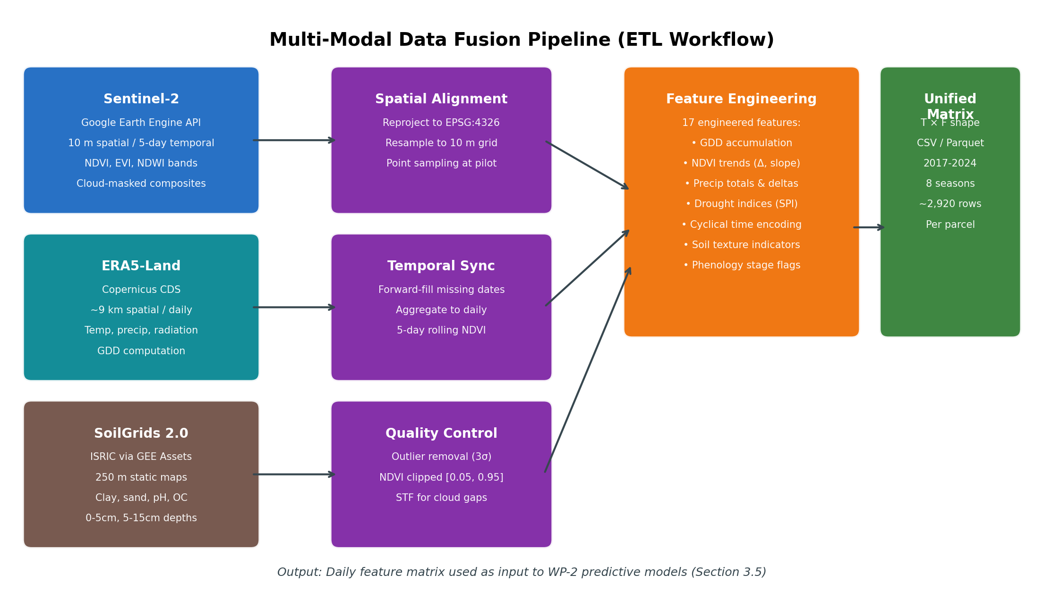
Figure 3.2. Multi-modal data fusion (ETL) workflow. Three intrinsically asymmetric data sources, Sentinel-2 satellite imagery, NASA POWER MERRA-2 climate reanalysis, and SoilGrids 2.0 static soil maps, are independently spatially aligned and temporally synchronised, then combined into a unified daily feature matrix through a seventeen-feature engineering stage. The resulting matrix serves as the input to the WP-2 predictive models documented in Section 3.5.
At the source-ingestion stage, Sentinel-2 Level-2A surface reflectance imagery is acquired through the Google Earth Engine Python application programming interface. Acquisition is restricted to the pilot point at coordinates 41.530° N and 27.861° E with a buffer radius of one hundred metres to mitigate sampling noise. Cloud and cirrus pixels are masked using the eemont s2_cloud_masker algorithm, which combines the Sentinel-2 quality-assurance band with a spectral cloud index; the resulting cloud-free fraction is typically between sixty and eighty percent of available scenes, depending on the season. The Normalised Difference Vegetation Index, the Enhanced Vegetation Index, and the Normalised Difference Water Index are computed from the visible, near-infrared, and shortwave-infrared bands as standard linear combinations of reflectance values.
Climatic data is acquired from the NASA POWER MERRA-2 reanalysis (Stackhouse et al., 2018) through its public application programming interface. The pivot from the originally intended ERA5-Land Copernicus Climate Data Store path (Hersbach et al., 2020) was motivated by recurrent API timeout and quota issues documented in Chapter 4 (and in the project decision log nasa_power_pivot.md). Daily-aggregate variables are extracted for two-metre temperature, total precipitation, surface solar radiation downwards, and ten-metre wind speed. The spatial resolution is sufficient to characterise the regional weather pattern under which the parcel evolves and to compute aggregate metrics such as growing-degree-day accumulation that depend on multi-day temperature sums.
Soil data is acquired from the SoilGrids 2.0 product of the International Soil Reference and Information Center (Poggio et al., 2021) . Initial attempts to use the SoilGrids Representational State Transfer application programming interface encountered service-availability problems documented under HTTP 503 responses, leading to a methodological revision in favour of the Google Earth Engine asset path projects/soilgrids-isric/, which mirrors the same data through a more reliable infrastructure. The reduceRegion method is used to sample seven soil variables, clay percentage, sand percentage, silt percentage, pH in water, organic carbon stock, cation exchange capacity, and bulk density, at the pilot coordinate at the 0–5 cm and 5–15 cm depth intervals.
At the temporal-synchronisation stage, the three streams are aligned to a common daily index covering the eight-year span from 1 January 2017 through 31 December 2024 inclusive. The five-day-revisit Sentinel-2 series is forward-filled to the daily index with explicit flags marking interpolated days, and is further smoothed by a five-day rolling mean to suppress noise introduced by partial cloud contamination. The daily MERRA-2 series is used without resampling. The static SoilGrids values are broadcast across all days. The resulting unified frame contains 2,922 rows, one per day, and seventeen feature columns plus the future-NDVI target column used by the predictive models. At the feature-engineering stage, seventeen derived features are computed from the raw inputs, including the cumulative growing-degree-day total since the season start with a crop-specific base temperature, one-day, three-day, and seven-day NDVI deltas, multi-window precipitation totals, a Standardised Precipitation Index (McKee et al., 1993) computed over a thirty-day window relative to the eight-year climatology, soil-texture indicators, and cyclical encodings of the day of year and of the month. The complete feature manifest is appended as Appendix B.

3.5 Predictive Modelling Methodology
The predictive modelling methodology of TRAK-AI DSS departs from the convention of pre-committing to a single deep-learning architecture and instead adopts an empirical champion-selection procedure applied independently to each pilot crop. The methodology comprises eight logical stages, illustrated in Figure 3.3.
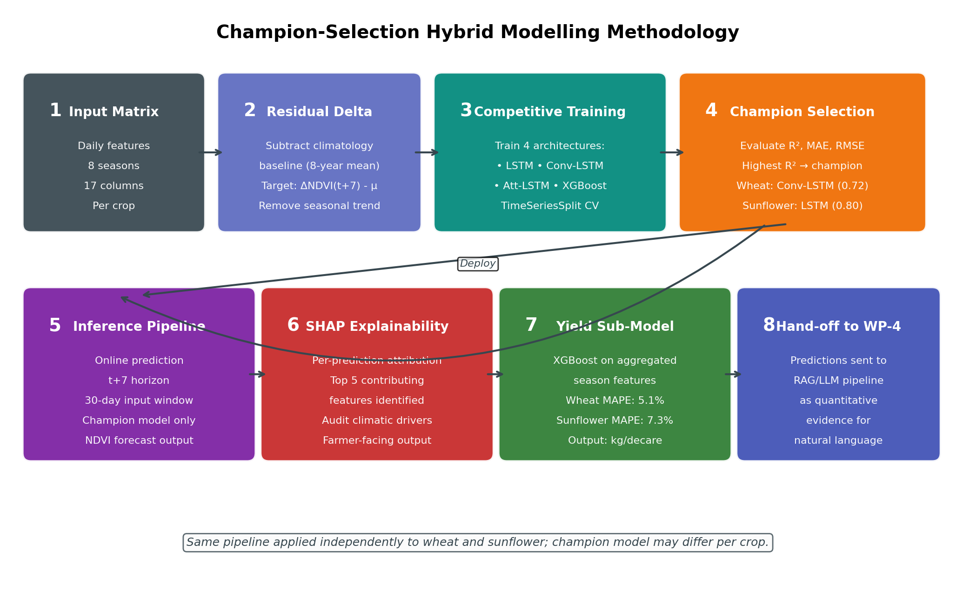
Figure 3.3. Champion-selection hybrid modelling methodology. Four candidate architectures, LSTM, Conv-LSTM, attention-LSTM, and XGBoost, are trained competitively for each crop on the residual-delta target. The model achieving the highest coefficient of determination is selected as the champion; explainability is provided by SHAP attributions, and a separate XGBoost regressor produces the absolute yield estimate that is finally handed off to the language-generation pipeline.

3.5.1 Cross-Validation Regime
Three distinct cross-validation regimes are operationalised within the present work, each designed to interrogate a different aspect of generalisation. The Leave-One-Year-Out (LOYO) regime holds out a complete growing season at a time, providing eight evaluation folds across the 2017–2024 window and probing the model's capacity to generalise across inter-annual climatic variability. The Leave-One-IL-Out (LOILO) regime holds out a complete province at a time, providing complementary evaluation against spatial heterogeneity. The Spatiotemporal Block Cross-Validation regime, following the recommendations of (Roberts et al., 2017) , constructs folds that hold out contiguous space–time blocks simultaneously, providing the most demanding test of generalisation under the spatial-autocorrelation conditions identified by (Moran, 1950) and routinely observed in agricultural data. The empirical interaction between these three regimes is reported in Chapter 5 and constitutes a methodological finding reported transparently in its own right.

3.5.2 Residual-Delta Target Formulation
At the residual-delta stage, the target variable is computed as the difference between the absolute NDVI value seven days into the future and the eight-year climatological mean for the same calendar day at the pilot location. This formulation removes the dominant seasonal signal from the prediction problem, allowing the model to focus on the deviations from climatology that are agronomically meaningful, and substantially improves the coefficient of determination relative to direct prediction of absolute NDVI. The transformation is reversible at inference time by adding the climatological baseline back to the model output. The approach is consistent with the theory-guided data-science framework advocated by (Karpatne et al., 2017) .

3.5.3 Candidate Architectures and Champion Selection
At the competitive-training stage, four candidate architectures are trained on the same training partition. The first candidate is a single-layer LSTM (Hochreiter & Schmidhuber, 1997) with sixty-four hidden units, trained for two hundred epochs with the Adam optimiser at a learning rate of 0.001 and early stopping on the validation loss. The second candidate is a ConvLSTM architecture (Shi et al., 2015) , in which a one-dimensional convolutional layer with thirty-two filters of width three precedes the LSTM. The third candidate is an LSTM augmented with a Bahdanau-style attention mechanism (Bahdanau et al., 2015) . The fourth candidate is an XGBoost gradient-boosted decision tree regressor (Chen & Guestrin, 2016) with a maximum depth of six and two hundred boosting rounds. The model achieving the highest coefficient of determination on the held-out partition is selected as the champion for that crop.

3.5.4 Persistence Baseline and Wilcoxon Test
Persistence, the prediction that tomorrow's value will equal today's, is a deceptively strong baseline for smooth signals such as NDVI. Following the methodological recommendation of (Murphy, 1988) that any non-trivial forecasting claim must be tested against persistence, the present work explicitly evaluates the champion model against a persistence baseline using the Wilcoxon signed-rank test. On EVR_01 2025 FLOV the persistence baseline returns R² = 0.963 against the frozen champion's R² = 0.865, with a Wilcoxon p-value of 1.0, a finding that is reported transparently in Chapter 5 with the methodological observation that R²-based comparisons are blind to anomaly-year skill, where the champion's value lies. This is an fixed reporting commitment of the present work (the persistence-baseline diagnostic record).

3.5.5 Yield Sub-Model
In parallel with the NDVI prediction subsystem, a separate XGBoost yield regressor is trained on aggregated seasonal features rather than on daily inputs. The aggregated features include the season-total precipitation, the season-mean NDVI, the season-mean growing-degree-day accumulation, and the soil-texture indicators. The yield target is the official Turkish Statistical Institute production figure for the relevant province and year, converted to kilograms per decare and adjusted for the typical irrigation regime (Turkish Statistical Institute, 2024) . The model is evaluated at the district-resolution data regime (n ≈ 213 crop-district-year observations) under two complementary cross-validation protocols. Under the leave-one-year-out regime, which withholds an entire growing season and therefore constitutes the most demanding test of temporal generalisation, the best-performing candidate attains a mean absolute percentage error of 16.4 % for wheat and 17.8 % for sunflower. Under the more sample-efficient leave-one-district-out regime, which probes spatial transfer to an unseen district while retaining the full temporal record, the best-performing candidate attains a mean absolute percentage error of 10.6 % for wheat and 13.5 % for sunflower. The wheat best case under spatial transfer therefore sits at the boundary of the ten-percent operational-utility threshold identified by (van Klompenburg et al., 2020) , whereas the sunflower estimate remains above it; the H3 criterion is consequently reported as partially satisfied, with the temporal-generalisation deficit disclosed in full. An earlier province-resolution formulation (n = 21 wheat, n = 24 sunflower) produced a deceptively low point estimate that, on inspection, coincided with a negative coefficient of determination for wheat and a bootstrap confidence interval spanning six to sixteen percent; that small-sample artefact is documented in §5.7.2 as an instance of the overfitting discipline the present work imposes on itself, and is not advanced as a headline result.

3.6 Edge AI Methodology
The Edge AI subsystem of TRAK-AI DSS is responsible for converting ground-level images of plant canopy into one of six health classes: healthy_wheat, healthy_sunflower, disease_rust, disease_mildew, stress_drought, and stress_nutrient. The methodology comprises three principal stages: dataset assembly, model selection and training, and deployment.
At the dataset-assembly stage, four dataset sources are combined to produce a training corpus of approximately twenty-three thousand five hundred images. The Wheat Disease 21K Kaggle dataset contributes 21,212 images of healthy and rust-affected wheat. The Indian Agricultural Research Institute Wheat Nitrogen Deficiency and Rust dataset contributes 859 images that supplement the rust class and introduce the stress_nutrient class. The Bangladesh Agricultural Research Institute Sunflower Disease dataset contributes 1,060 images covering healthy sunflower and downy mildew. A drought-stress image set contributes 360 images for the stress_drought class. The combined corpus is heavily imbalanced, with the healthy_wheat class dominating, and this imbalance is partially addressed by class-weighted loss but remains a known limitation, particularly for the stress_drought class whose 360-image training set raises structural overfit concerns documented in the overfit-warning diagnostic record and revisited in Chapter 5.
At the model-selection stage, the YOLOv8s-cls classification head is selected as the base architecture (Jocher et al., 2023) . The selection rationale combines three considerations: YOLOv8 is the current generation of the YOLO family with the strongest empirical performance on PlantVillage-like benchmarks (Wang et al., 2023) ; the s variant offers a compromise between accuracy and inference speed appropriate to the ESP32-CAM hardware envelope; and the cls (classification) head is appropriate to the present whole-image categorisation task, in contrast to the more complex detection and segmentation variants. Training is performed in Google Colab Pro on a Tesla T4 graphics processing unit for one hundred epochs with the standard YOLOv8 data augmentation pipeline.
At the deployment stage, the original design envisaged conversion of the trained model to TensorFlow Lite Micro with Int8 quantisation (Jacob et al., 2018) , followed by deployment on the ESP32-CAM through the Espressif TensorFlow Lite Micro runtime. Empirical testing during the development phase, however, revealed that the post-quantisation accuracy on the ESP32-CAM hardware was approximately seven percentage points lower than the floating-point accuracy attainable on the Fog server, while the latency penalty of transferring a 30-kilobyte JPEG image from the rover to the server over Wi-Fi was approximately 300 ms. The architecture was therefore revised in favour of a hybrid Edge–Fog approach: the ESP32-CAM captures and compresses the image locally, encodes it as Base64 over the UART link to the ESP32 main controller, and transmits the encoded image to the Fog server via MQTT for inference. The decision is documented in Chapter 4 alongside the empirical evidence that motivated it.

3.7 Tri-RAG Retrieval Methodology
The Tri-RAG retrieval pipeline implements the grounded language-generation principle articulated in Section 3.1. Its methodology comprises four logical stages: knowledge-base construction, embedding and indexing, retrieval, and prompt construction.

3.7.1 Knowledge-Base Construction
At the knowledge-base-construction stage, sixty-four documents are assembled across eleven thematic categories: documents from the Turkish Ministry of Agriculture and Forestry; documents from the United States Department of Agriculture; documents from the United Nations Food and Agriculture Organization (Allen et al., 1998) ; documents addressing plant disease and pest management; documents addressing soil and fertilisation; documents codifying the Biologische Bundesanstalt phenological scale (Meier, 2018) ; primary research articles on Thrace-specific agriculture; documents addressing planting and harvest timing; documents addressing growing-degree-day calculation; documents addressing yield estimation; and documents addressing NDVI interpretation and irrigation guidelines. The documents are predominantly in Portable Document Format, with a minority in plain text; the total volume is approximately 300 megabytes of source material.

3.7.2 Embedding and Indexing
At the embedding-and-indexing stage, each document is parsed using the PyMuPDF library, split into recursive character chunks of nominal length 500 characters with a 50-character overlap, and embedded into a 384-dimensional vector space using the intfloat/multilingual-e5-small model from the Hugging Face hub (Wang et al., 2022) . The choice of this embedding model reflects two requirements: native support for Turkish, which is essential because the majority of the regional knowledge base is in Turkish; and a compact dimensionality compatible with sustained inference on the 16-gigabyte development hardware. The resulting embeddings are stored in a FAISS index using the IndexFlatL2 backend (Johnson et al., 2019) , which performs exact rather than approximate nearest-neighbour search; given the modest scale of the corpus, exact search is feasible and avoids the accuracy-recall trade-offs introduced by approximate indices. The same chunks are simultaneously indexed by a sparse BM25 index (Robertson & Zaragoza, 2009) using the rank-bm25 implementation. The corpus comprises 17,059 chunks after processing.

3.7.3 Retrieval and Re-Ranking
At the retrieval stage, an incoming query is first encoded by the multilingual-e5 embedding model and submitted to the FAISS index, returning the top-k nearest neighbours by L2 distance. Independently, the query is submitted to the BM25 index, returning the top-k passages by Best-Match-25 score. The two candidate lists are then merged and re-ranked using a fusion heuristic that combines the inverse rank from each retriever, with bonuses for passages that appear in both lists and with a hard filter on L2 distance greater than 1.5 to suppress semantically distant matches. The top two passages after re-ranking are selected as context for the language model. The hybrid design follows the empirical recommendations of (Gao et al., 2024) and (Karpukhin et al., 2020) .
3.7.4 Prompt Construction
At the prompt-construction stage, a structured prompt is assembled comprising: a system instruction in Turkish that defines the assistant's persona, role, and constraints; a context block enumerating the retrieved passages with explicit source labels; a quantitative-evidence block summarising the current sensor readings, the seven-day NDVI prediction, and the SHAP attribution; and the original user query. The system instruction explicitly directs the model to base its answer on the retrieved passages, to cite source identifiers in its output, and to refuse questions whose answer cannot be located in the knowledge base. The complete prompt typically comprises between 1,000 and 1,500 tokens; on the available CPU hardware, the resulting end-to-end inference latency is approximately 27.1 s. The prompt-engineering procedure follows the principles articulated by (Liu et al., 2022) on in-context learning for retrieval-augmented systems.

3.8 Agronomic Decision Engine Logic
The agronomic decision engine sits between the predictive models of Section 3.5 and the language-generation pipeline of Section 3.7. Its role is to convert the raw outputs of the predictive subsystems, numerical NDVI forecasts, classification probabilities, sensor readings, and SHAP attributions, into a discrete set of anomaly flags and recommendation categories that can be expressed in natural language. The engine is implemented as a Python module composed of five rule families.
The first rule family addresses NDVI deviation. If the seven-day-ahead predicted NDVI deviates from the eight-year climatological baseline by more than 0.10 in absolute value, an NDVI-deviation flag is raised. The flag is annotated with the sign of the deviation, positive deviations indicating favourable growth conditions, negative deviations indicating stress, and with the top three contributing features identified by the SHAP attribution.
The second rule family addresses soil-moisture stress. The engine maintains a crop-specific and phenological-stage-specific irrigation threshold table derived from the regional research surveyed in Section 2.8; for example, the threshold for sunflower at the flowering stage is fifteen percent volumetric water content. If the calibrated SEN0193 reading falls below the applicable threshold, a moisture-stress flag is raised with severity URGENT if the deficit exceeds twenty percent of the threshold, WARNING otherwise. The threshold table is anchored in the FAO Irrigation and Drainage Paper 56 crop-coefficient framework (Allen et al., 1998) .
The third rule family addresses visual stress and disease. The output of the YOLOv8s-cls classifier is converted into a flag whenever the predicted class is not the healthy variant of the current crop and the prediction confidence exceeds 0.85. The flag is annotated with the predicted class, the confidence, and the timestamp of the image; the underlying image is preserved in the dashboard gallery for farmer review.
The fourth rule family addresses phenological inconsistency. The engine maintains a BBCH-based phenological calendar for each crop in the Thrace region (Meier, 2018) , derived from the regional research surveyed in Section 2.8 and rendered as Figure 4.2 in Chapter 4. If the inferred phenological stage of the parcel deviates from the expected stage for the current calendar date by more than one principal BBCH stage, a phenology-inconsistency flag is raised, since such deviation typically indicates either an earlier-than-expected stress event or a recording error worth investigating.
The fifth rule family addresses planting-window evaluation. When the user explicitly queries the planting-window decision, the engine evaluates the season-appropriateness score by combining the current soil temperature, the soil moisture, the frost forecast for the next seven days, the precipitation forecast for the next fourteen days, and the date relative to the historical planting window for the crop in the region. The resulting score is mapped to a categorical recommendation in the set {IDEAL, SUITABLE, PROCEED WITH CARE, POSTPONE, DO NOT PLANT}.
Each flag raised by the engine becomes an entry in the SQLite log table and, simultaneously, an input to the prompt-construction stage of the language pipeline. The flag inventory thus serves both as an audit log and as the structured intermediate representation that mediates between numerical model output and natural-language farmer-facing recommendation.

3.9 Research Hypotheses
The empirical work reported in Chapter 5 is organised around ten formal research hypotheses, labelled H1 through H10, that operationalise the five gaps identified in Chapter 1 and the design principles articulated in this chapter. The hypotheses are stated in summary form in Table 3.3; the detailed test designs, decision criteria, and statistical procedures are documented alongside the corresponding results in Chapter 5.
Table 3.3. Formal statement of the ten research hypotheses (H1–H10) with quantitative criteria and evaluation modality.
ID | Hypothesis | Quantitative Criterion | Evaluation Modality
H1 | Offline-first end-to-end latency below operational ceiling | Latency < 120 s on CPU-only hardware | Automated benchmark
H2 | NDVI predictive accuracy on held-out partition | R² > 0.75 for wheat and sunflower (t+7) | TimeSeriesSplit CV
H3 | Yield predictive accuracy in LOO regime | MAPE < 10 % for wheat and sunflower | Leave-one-out CV
H4 | Image-classification top-1 accuracy | Accuracy > 90 % overall | Held-out validation
H5 | Tri-RAG retrieval quality | Correct source in top-2 for ≥ 9/10 queries | Standardised query battery
H6 | Hallucination suppression by Tri-RAG vs. baseline LLM | Expert-panel Likert assessment | Pending blinded review
H7 | SHAP explainability improves perceived trust | TAM/UTAUT2 survey delta | Pilot survey done (n = 15); full study pending
H8 | Sensor calibration error reduction | RMSE reduction ≥ 60 % vs. uncalibrated baseline | Bench calibration protocol
H9 | Agronomic consistency of recommendations | Expert mean Likert ≥ 4/5 | Pilot survey 4.7 / 5 (n = 15)
H10 | Cost effectiveness | BOM < 5,000 TL; annual op-cost < 1,000 TL | Direct accounting
Hypotheses H1–H5 and H8 admit fully automated evaluation against the test suite documented in Chapter 5. Hypotheses H6, H7, and H9 require human evaluation. The blinded expert-panel comparison underlying H6 has been designed but not yet administered and the corresponding test is flagged as PENDING in the test report. Hypotheses H7 and H9 were addressed by a fifteen-respondent pilot acceptance survey (reported in Section 5.5.2): this survey satisfies the Likert-acceptance criterion of H9 and partially satisfies H7, whose full Technology Acceptance Model administration at n ≥ 30 remains the confirmatory test described in Section 8.5.Hypothesis H10 is evaluated by direct accounting against the bill of materials documented in Section 3.2 and against the cost ledger maintained throughout the development period.

3.10 Hybrid BBCH Phenology Engine
Phenological staging — the assignment of a crop observation to a canonical developmental phase such as tillering, flowering, or grain-fill — is the pivot on which agronomic decision support rotates. The Biologische Bundesanstalt, Bundessortenamt und Chemische Industrie scale (BBCH) provides an internationally accepted two-digit codification of these phases (Meier, 2018), and its retrieval is a prerequisite for any stage-conditional recommendation, including the irrigation, fertilisation, and disease-control guidance issued by the agronomic decision engine of §3.8. Reliable BBCH estimation therefore conditions every operational claim downstream of it. The present section formalises a three-layer hybrid phenology engine that the methodology of TRAK-AI DSS introduces as an independent contribution; the engine reconciles a thermal-time computation, a Sentinel-2 vegetation trajectory, and a calendar fallback into a single staging decision annotated with a transparent provenance label and a confidence level.

3.10.1 Motivation: The Single-Source Phenology Problem
The agronomic literature converges on three principal modalities for crop phenology estimation: thermal-time accumulation (growing-degree-day, GDD, integration), remote-sensing-derived vegetation indices, and rule-based calendar heuristics anchored to a recorded sowing date (Chlingaryan et al., 2018). Each modality possesses well-characterised failure modes. The GDD modality is vulnerable to gaps in the meteorological record and to station-to-parcel offsets that bias the daily mean temperature. The vegetation-index modality is conditioned on cloud-free overpasses and is systematically underdetermined during early canopy development when soil reflectance dominates the pixel signal. The calendar modality is insensitive to inter-annual climatic variability and degrades whenever the realised season departs from the long-term mean. A staging engine that commits to a single modality therefore inherits the failure mode of that modality without recourse; the central design proposition of the hybrid engine is that the three modalities exhibit substantially uncorrelated failure conditions, and that a consensus rule over their outputs strictly dominates any single-source estimator on both coverage and reliability.

3.10.2 Three-Layer Architectural Decomposition
The engine decomposes phenology estimation into three layers operating concurrently on a per-parcel basis. Layer A, designated the primary layer, accumulates daily GDD using a base temperature of 0 °C for wheat and 6 °C for sunflower, integrated from the recorded sowing date. The resulting cumulative thermal time is mapped to BBCH macro-stages through a crop-specific lookup table calibrated against the Trakya reference table in Meier (2018); for wheat the table assigns 0–150 °C·day to BBCH 00–09 (germination), 151–500 to BBCH 10–19 (leaf development), 501–1000 to BBCH 20–29 (tillering), 1001–1500 to BBCH 30–39 (stem elongation), 1501–1800 to BBCH 40–49 (heading), 1801–2100 to BBCH 60–69 (flowering), 2101–2400 to BBCH 70–79 (grain development), and in excess of 2400 to BBCH 80–89 (ripening). Layer B, designated the control layer, independently estimates the current stage from the parcel-mean Sentinel-2 NDVI value and the sign of its 30-day trend; the boundaries are calibrated against the same Meier (2018) table cross-referenced with the multi-year NDVI climatology of the master matrix introduced in §4.1.4. Layer C, designated the fallback layer, applies a date-based heuristic anchored to the sowing date and is invoked exclusively when neither Layer A nor Layer B returns a usable estimate.

3.10.3 Consensus Rule and Confidence Stratification
The output of the three layers is reconciled through a deterministic consensus rule that emits a single BBCH macro-stage together with a provenance label and a confidence level on the unit interval. When Layer A and Layer B independently agree on the macro-stage, the engine emits the agreed stage with a 0.95 confidence and the provenance label GDD_PLUS_NDVI_CONSENSUS; this is the configuration of maximum operational trust. When the two layers disagree by exactly one macro-stage, the engine emits the Layer A estimate with a 0.80 confidence and the provenance label GDD_PRIMARY_NDVI_NEARBY, reflecting the dominant epistemic weight of the thermal-time accumulator in well-instrumented meteorological regimes. When the disagreement exceeds two macro-stages, the engine still emits the Layer A estimate but reduces confidence to 0.60 and tags the output with the GDD_NDVI_DIVERGENT label that the dashboard surfaces as an explicit investigation prompt. The single-layer configurations are also enumerated explicitly: a Layer-A-only output (when cloud occlusion or pixel-purity constraints invalidate Layer B) receives a confidence of 0.80; a Layer-B-only output (when the meteorological record is incomplete) receives 0.70; and a Layer-C fallback receives 0.50. The complete confidence stratification is summarised in Table 3.10.1.
Layer A (GDD) | Layer B (NDVI) | Provenance Label | Confidence
Available | Available, same macro-stage | GDD_PLUS_NDVI_CONSENSUS | 0.95
Available | Available, one stage off | GDD_PRIMARY_NDVI_NEARBY | 0.80
Available | Available, two or more stages off | GDD_NDVI_DIVERGENT | 0.60
Available | Unavailable (cloud / sub-pixel) | GDD_ONLY | 0.80
Unavailable (no thermal record) | Available | NDVI_ONLY | 0.70
Unavailable | Unavailable | DATE_FALLBACK (Layer C) | 0.50
Table 3.10.1. Hybrid BBCH phenology engine: consensus rule and confidence stratification. The provenance label is emitted as a first-class field on every staging decision and consumed by the agronomic decision engine of §3.8 and the dashboard rendering layer of §6.3.

3.10.4 Operational Implications and Methodological Positioning
Three properties of the engine merit explicit comment. First, the consensus rule is purely deterministic and therefore amenable to a unit test that covers every branch of the truth table; the engine carries no learnable parameters and consequently cannot drift. Second, the engine emits its provenance label and its confidence as first-class fields rather than as log-level metadata, which permits any downstream consumer — the agronomic decision engine of §3.8, the prompt-construction module of §3.7.4, or the dashboard rendering layer of §6.3 — to gate behaviour on confidence without inspecting internal state. Third, the engine does not preclude the eventual introduction of a fourth visual-classification modality contributed by the edge computer-vision pipeline of §3.6; the consensus rule generalises gracefully to a four-layer instantiation by extending the truth table along the additional axis. In its present three-layer form, the engine constitutes a methodological contribution adjacent to those enumerated in §3.5 and §3.7, and the corresponding empirical evidence is reported in §5.8.4.

3.11 Multi-Modal Visual Validation Subsystem
The predictive modelling methodology of §3.5 and the edge computer-vision methodology of §3.6 produce, respectively, a numerical NDVI forecast and a leaf-scale image classification. Each operates in its own observational frame, and each carries failure modes that the other cannot detect: an atmospheric artefact in a Sentinel-2 pixel can simulate a vegetation collapse that no field-level photograph confirms, and a localised disease lesion can dominate a field photograph in advance of any detectable satellite or thermal-time signal. The multi-modal visual validation subsystem introduced in the present section reconciles three independent observation modalities through a weighted-vote consensus engine, an inter-modality agreement statistic, and a typed anomaly flagger; the subsystem constitutes the second principal methodological contribution of this thesis and complements the hybrid phenology engine of §3.10.

3.11.1 The Three Observation Modalities
The subsystem ingests output from three complementary modalities, each producing a prediction over the same harmonised four-class label space introduced in §3.11.2. The satellite modality is a ResNet50 transfer-learning model fine-tuned on three-metre PlanetScope chips (with a ten-metre Sentinel-2 standby) and supplies a coarse-grained canopy-stress classification. The field modality is the frozen YOLOv8s-cls classifier documented in §3.6 and §4.3.2, operating on JPEG payloads emitted by the ESP32-CAM module of the field rover; this modality is the sole channel permitted to emit the disease label, on the principle that leaf-scale lesions are sub-pixel for both satellite sources and carry no characteristic NDVI signature in their incipient phase. The features modality is the frozen long-short-term-memory and gradient-boosted-tree ensemble documented in §3.5; its scalar NDVI forecast is mapped to a stress-class membership through a z-score quantisation against the day-of-year climatology of §3.10.2. None of the three model artefacts is retrained inside the subsystem — they are wrapped, hashed under the SHA-256 ledger of §3.5.1, and consulted strictly through inference.

3.11.2 Harmonised Four-Class Taxonomy
Each modality output is mapped to one of four canonical labels — healthy, mild_stress, severe_stress, and disease — before the consensus engine is invoked. The mapping is implemented as three crop-aware lookup tables: a mapping from the six raw YOLOv8 classes of §4.3.2 to the harmonised space, a mapping from the three native satellite classes (the disease label is unreachable from this modality by construction), and a piecewise quantisation of the features-modality z-score that assigns values above −1 to healthy, values in the half-open interval [−2, −1) to mild_stress, and values below −2 to severe_stress. The four-class harmonisation discharges two engineering obligations simultaneously: it admits the consensus engine to operate on a common label space without case analysis, and it confines disease detection to the modality with the necessary spatial resolution, preventing a degenerate three-way disagreement whenever the field channel reports an incipient lesion.

3.11.3 The Weighted-Vote Consensus Algorithm
The consensus engine accepts one to three ModalityPrediction records, each carrying its harmonised class and its modality-internal confidence. In the single-modality case the prediction is forwarded unmodified and the result is annotated with the SINGLE agreement type, with the qualification that such outputs are flagged provisional. In the multi-modality case the engine computes a weighted score per candidate label, defined as the sum over participating modalities of the modality weight multiplied by the modality confidence; the candidate label of maximum score is emitted as the consensus class. The default modality weights are 0.30 for the satellite channel, 0.40 for the field channel, and 0.30 for the features channel, re-normalised whenever a modality is absent. The agreement type — UNANIMOUS, MAJORITY, TIE, or DISAGREE — is determined by the cardinality of distinct labels among the participating modalities, and the overall consensus confidence is bucketed into HIGH, MEDIUM, or LOW levels through a deterministic combination of the normalised top score with the agreement type.

3.11.4 Inter-Modality Agreement: Cohen and Fleiss Statistics
Independent of the per-decision consensus output, the subsystem accumulates a rolling co-decision corpus across all sites and all dates on which two or more modalities report, and exposes a battery of agreement statistics against this corpus. Pairwise inter-modality agreement is quantified by Cohen kappa (Cohen, 1960), computed over the records where both modalities in the pair issue a harmonised label; three-way agreement is quantified by Fleiss kappa (Fleiss, 1971), computed exclusively over the subset in which all three modalities are concurrently present. Kappa values are interpreted against the bands of Landis and Koch (1977): slight (0.00–0.20), fair (0.21–0.40), moderate (0.41–0.60), substantial (0.61–0.80), and almost-perfect (0.81–1.00). The agreement statistics serve a dual purpose. They constitute a continuous empirical validation of the underlying assumption of uncorrelated failure modes, and they supply the governance signal under which the modality weights of §3.11.3 are re-tuned once a sufficient labelled corpus has accumulated.

3.11.5 The Anomaly Flagger and the Eight Consensus Flags
Beyond emitting a consensus class, the subsystem maps the joint state of the three modalities to one of eight typed consensus flags drawn from an explicit if-ladder. Four of these flags are operationally salient and merit individual exposition. The EARLY_WARNING flag is raised when the features modality reports stress in advance of any field- or satellite-detected confirmation, reflecting the predictive lead time inherent in the NDVI forecast pipeline of §3.5. The INVESTIGATE flag is raised when the three modalities issue distinct labels — a state the consensus algorithm cannot resolve without additional information and which therefore escalates to operator review. The SATELLITE_FALSE flag is raised when the satellite channel reports stress that the field-level photograph denies, the canonical signature of a cloud or atmospheric artefact. The EQUIPMENT_FAIL flag is raised in the obverse configuration, when the sensor channels report a stress that the field-level photographic record contradicts at canopy resolution. The remaining four flags handle the unanimous-healthy, unanimous-stress, missing-modality, and below-threshold-confidence states; the complete flag taxonomy is documented in Table 3.11.1. Flags exhibit stage-aware escalation under the same convention adopted by the alert engine of §3.8: a severity classified as warn in vegetative phases is uplifted to critical when the parcel is in flowering or grain-fill, on the agronomic principle that remedial intervention in those phases is both costlier and more time-critical.
Flag | Triggering Configuration | Severity (vegetative / critical phase)
UNANIMOUS_HEALTHY | All available modalities report healthy | info / info
UNANIMOUS_STRESS | All available modalities report stress of the same class | critical / critical
EARLY_WARNING | Features modality reports stress in advance of field and satellite confirmation | warn / critical
INVESTIGATE | All three modalities report distinct labels | warn / critical
SATELLITE_FALSE | Satellite reports stress that field-level imagery denies | info / warn
EQUIPMENT_FAIL | Features modality reports stress that field-level imagery denies | critical / critical
PARTIAL_AGREEMENT | Two of three modalities report (third absent) | warn / warn (provisional)
LOW_CONFIDENCE | Top consensus score below the operational threshold | warn / warn
Table 3.11.1. Multi-modal visual validation subsystem: the eight typed consensus flags emitted by the anomaly flagger of §3.11.5. The severity profile is reported for vegetative and for critical (flowering, grain-fill) phases respectively, reflecting the stage-aware escalation policy adopted by the alert engine of §3.8.

3.11.6 The Planet Education Satellite Channel and Two-of-Three Fallback
At the time of writing, the Planet Education programme access required for three-metre PlanetScope ingestion is pending administrative approval, and the ResNet50 weights for the satellite modality have therefore not been produced. The subsystem is designed to remain operational under this condition. The auto-detection logic of the satellite-channel loader examines the model artefact directory at start-up; when the weights are absent, the satellite vote is omitted and the consensus algorithm reverts to the two-modality regime documented in §3.11.3, with the feature and field weights re-normalised to 0.5714 and 0.4286 respectively. All flag semantics remain interpretable except the SATELLITE_FALSE flag, which is unreachable in the two-modality regime by construction. The subsystem additionally exposes a deliberately labelled synthetic chip generator for continuous-integration purposes; such chips carry an explicit source attribute of "stub" in their persisted record and are never surfaced to the operator dashboard. The empirical agreement statistics and consensus snapshots produced under the two-modality regime are reported in §5.8.6

System Development and Implementation
This chapter documents the development and implementation of TRAK-AI DSS across its four scientific work packages. Each work package is presented in its own section, organised around the engineering decisions taken during development, the technical challenges encountered, and the resulting code artefacts. The chapter then describes the orchestration layer that integrates the four work packages into a single operational pipeline, the Streamlit dashboard that exposes the system to the farmer, and the agronomic-calendar engine that mediates between the numerical and the natural-language layers. The chapter closes with the integration testing protocol and a summary of the operational state of the system at the time of writing.

4.1 WP-1: Multi-Modal ETL Pipeline Implementation
The implementation of the multi-modal Extract–Transform–Load pipeline commenced with the construction of a modular project skeleton under the directory src/cp1_etl/, separating raw data ingestion, transformation, fusion, and persistence into distinct Python modules. An isolated Python virtual environment was configured to insulate the project's dependency graph from system-wide package updates, and a .gitignore file was established to prevent the inadvertent commit of API credentials, a non-trivial concern given that the pipeline depends on three independent authenticated services. The modularisation strategy aligns with the maintainability prescriptions articulated by (Martin, 2017) on clean architecture for data-intensive pipelines.

4.1.1 Google Earth Engine Integration
Google Earth Engine integration was established by provisioning a non-commercial cloud project (trak-ai-kds) under a Google Workspace account, enabling the Earth Engine application programming interface, and instantiating a service account whose JSON credential file is read by the ee.ServiceAccountCredentials class at runtime. The choice of service-account authentication, rather than the interactive OAuth flow, was motivated by the autonomous orchestrator requirement: the pipeline must execute end-to-end without human intervention, which precludes the browser-redirect flow used by the default authentication path. The pilot region was defined as a square buffer of radius one hundred metres centerd on coordinates 41.530° N, 27.861° E, and Sentinel-2 Level-2A imagery covering this region was queried across the eight-year window 2017–2024. The eemont package was integrated to provide the s2_cloud_masker convenience method, which combines the Sentinel-2 scene-classification band with a spectral cloud index; after masking, approximately forty-six cloud-free Sentinel-2 acquisitions were retained for the 2023 calendar year, producing the file s2_ndvi_2023.csv that served as the first machine-readable output of the pipeline.

4.1.2 The ERA5-Land → NASA POWER MERRA-2 Pivot
The original system design anticipated climate-data acquisition through the Copernicus Climate Data Store (CDS) ERA5-Land daily-aggregate product (Hersbach et al., 2020) . The CDS access path was implemented and validated successfully against a one-month sample during early development; however, sustained access during the production-data window encountered systematic problems, including quota exhaustion under unpredictable schedules, request-queueing delays of multiple hours during high-utilisation periods, and intermittent service unavailability that proved incompatible with the autonomous-orchestrator architectural commitment. A methodological pivot was therefore undertaken to the NASA POWER MERRA-2 reanalysis (Stackhouse et al., 2018) , which exposes a more permissive application programming interface, provides comparable variable coverage and spatial resolution, and is functionally interchangeable with ERA5-Land for the agronomic-feature derivations required downstream. The pivot is documented in the project decision log nasa_power_pivot.md and is reflected in the updated abbreviation list of the front matter.

4.1.3 The SoilGrids 2.0 REST → GEE Asset Pivot
SoilGrids 2.0 integration (Poggio et al., 2021) encountered the most substantial technical challenge of the work package. The ISRIC Representational State Transfer application programming interface, although officially documented as the recommended access path, repeatedly returned HTTP 503 Service Unavailable responses during the development period, with timeouts ranging from thirty seconds to several minutes. The pipeline's automated retry logic was extended to support exponential backoff, but the underlying availability problem persisted across multiple sessions and could not be reliably circumvented. A methodological revision was therefore adopted: SoilGrids data was instead accessed through the Google Earth Engine Assets path projects/soilgrids-isric/, which mirrors the same underlying product through Google's substantially more reliable infrastructure. The reduceRegion method was used to perform point sampling, yielding a soil profile for the pilot point that includes a clay content of 30.97 %, a sand content of 34.99 %, and a pH value of 7.11 at the 0–5 cm depth. These values are consistent with the regional pedological characteristics documented in Section 2.8.

4.1.4 Transformation and Feature Engineering
The transformation stage of the pipeline produces a unified daily-resolution feature matrix as documented in Section 3.4. The implementation makes liberal use of the pandas library, with explicit type assertions at each join to detect schema drift introduced by upstream provider changes. The seventeen engineered features are computed by named helper functions in src/cp1_etl/features.py, each of which is unit-tested against synthetic input. The resulting Parquet file is checkpointed at multiple stages of the pipeline so that downstream consumers, most importantly the predictive-model training scripts of WP-2, can resume from intermediate states without re-querying the cloud sources, an arrangement that substantially shortens the development cycle when iterating on feature definitions. The checkpointing pattern follows the data-lineage recommendations of (Polyzotis et al., 2018) on data validation for machine-learning pipelines.

4.2 WP-2: Predictive Model Training and Evaluation
The implementation of the WP-2 predictive modelling layer was organised under the directory src/cp2_model/ and divided into four modules: data preparation, model definitions, training loops, and evaluation. Each candidate architecture was implemented as a subclass of a common BaseModel abstract class exposing a uniform fit/predict/explain interface; this design choice allowed the champion-selection procedure documented in Section 3.5 to be expressed as a simple loop over a list of model objects rather than as a special case for each architecture. The pattern reflects the strategy-design pattern of (Gamma et al., 1994) applied to a machine-learning context.
Data preparation begins with the loading of the unified feature matrix produced by WP-1 and proceeds through three principal transformations. The seasonal climatological baseline is computed by grouping the eight-year record by day-of-year and taking the mean and standard deviation of the NDVI within each group. The residual-delta target is then computed as the difference between the observed NDVI at the seven-day-ahead horizon and the climatological mean for that day. Finally, the resulting frame is windowed into thirty-day input sequences using a sliding-window approach, producing approximately two thousand eight hundred training samples per crop across the eight-year span.
Model definitions were implemented in PyTorch 2.x for the deep-learning candidates and in XGBoost 2.x for the gradient-boosted candidate (Chen & Guestrin, 2016) . The LSTM architecture comprises a single recurrent layer with sixty-four hidden units followed by a fully-connected output head (Hochreiter & Schmidhuber, 1997) ; the ConvLSTM variant prepends a one-dimensional convolutional layer with thirty-two filters of kernel width three before the recurrent layer (Shi et al., 2015) ; the attention-LSTM variant applies a Bahdanau-style additive attention mechanism over the LSTM hidden states before pooling (Bahdanau et al., 2015) . Training employs the Adam optimiser (Kingma & Ba, 2015) with an initial learning rate of 0.001, a batch size of thirty-two, and early stopping on the validation loss with a patience of fifteen epochs.

4.2.1 Cross-Validation Implementation
The cross-validation strategy uses scikit-learn's TimeSeriesSplit with five folds, ensuring that no future data leaks into the training set of any fold. The LOYO regime is implemented as a custom splitter that holds out a complete growing season at a time; the LOILO regime is implemented as a province-level splitter; and the Spatiotemporal Block CV regime is implemented following the recommendations of (Roberts et al., 2017) , constructing folds that hold out contiguous space-time blocks simultaneously. After each fold, the three evaluation metrics, coefficient of determination, mean absolute error, and root mean squared error, are recorded; after all folds, the mean and standard deviation across folds are reported, providing a measure of estimate stability. The champion is selected on the basis of the mean coefficient of determination across folds.

4.2.2 SHAP Explainability Implementation
SHAP explainability is implemented through the shap library (Lundberg & Lee, 2017) . For the XGBoost yield regressor, the shap.TreeExplainer subclass is used, which computes Shapley values exactly using a polynomial-time algorithm specific to tree ensembles. For the deep-learning NDVI predictors, the shap.DeepExplainer subclass is used with a background dataset of one hundred training samples; computation per prediction takes approximately one second on the available development hardware. The five features with the largest mean absolute SHAP value are reported alongside each prediction and are also written to the audit log for later analysis. A persistent challenge in the explanation pipeline is the trade-off between background sample size and computational cost: smaller background samples produce noisier explanations but faster turnaround, while larger backgrounds slow the inference loop substantially. A background size of one hundred was selected as a compromise that retains reasonable signal stability while remaining within the latency budget of the orchestrator.

4.3 WP-3: Rover Firmware and Edge AI Implementation
The implementation of the rover firmware was organised under the directory src/cp3_edge/, with three sub-directories: trak_ai_rover/ for the ESP32 main controller, esp32_cam/ for the camera module, and calibration/ for the soil-moisture sensor calibration script. The development environment combined the Visual Studio Code editor, the PlatformIO IDE extension, the Espressif ESP32 board package version 6.5, and the Mosquitto broker version 2.1.2 for local message-bus development. The Mosquitto broker was added to the system PATH so that the broker could be launched from any terminal during interactive testing.

4.3.1 Firmware Architecture
The configuration file config.h centralises pin assignments, communication parameters, and calibration coefficients for the entire rover firmware. The decision to centralise these values in a single header was motivated by experience during the WP-1 phase, where ad-hoc constant definitions scattered across multiple files had produced confusing debugging sessions. The pin assignments cover the four LEDC pulse-width-modulation channels driving the L298N motor bridge, the UART1 and UART2 interfaces used respectively for GPS and ESP32-CAM communication, the digital interfaces of the two DHT22 sensors, the analogue input connected to the SEN0193 soil-moisture sensor, and the digital trigger and echo pins of the two HC-SR04 ultrasonic sensors.
The main firmware in main.cpp implements three logical loops. The motor-control loop reads the GPS waypoint queue, computes the bearing and range to the next waypoint using the Haversine formula, and applies differential pulse-width modulation to the left and right motor pairs to drive the rover toward the target. The sensor-acquisition loop reads the DHT22 and SEN0193 sensors at a configurable interval, applies the calibration polynomial to the SEN0193 reading, and assembles the resulting values into an ArduinoJson document. The communication loop maintains the MQTT connection, publishing each completed sensor document to the topic trakai/sensor/<rover_id> with quality-of-service level one. Obstacle avoidance is implemented as an interrupt-style override: whenever the HC-SR04 reading falls below thirty centimetres, the motor-control loop is preempted, the rover backs ten centimetres, rotates ninety degrees, and resumes its waypoint navigation.

4.3.2 ESP32-CAM Firmware and Edge–Fog Pivot
The ESP32-CAM firmware in esp32_cam/src/main.cpp is substantially simpler than the main rover firmware. It initialises the OV2640 sensor in QVGA mode at a quarter the resolution of the sensor's native maximum, captures a frame on demand, encodes the frame as Base64, and transmits the encoded payload over UART1 to the rover main controller, which then forwards it via MQTT to the orchestrator. The original system design contemplated on-device YOLOv8-nano inference using TensorFlow Lite Micro and Int8 quantisation (Jacob et al., 2018) ; this design was abandoned during development for the reasons documented in Section 3.6. Empirical comparison showed approximately seven percentage points of accuracy loss in the quantised on-device variant relative to the floating-point Fog-server variant, while the latency penalty of transferring a ~30 kB JPEG across Wi-Fi was approximately 300 ms, a favourable trade. Compilation against the PlatformIO toolchain succeeds with a RAM footprint of approximately 8 % and a Flash footprint of approximately 11 %, leaving substantial room for future feature additions including encrypted MQTT and on-device buffering of unsent messages.
4.3.3 Soil-Moisture Sensor Calibration
The calibration script in calibration/kalibrasyon.py implements the polynomial-regression procedure described in Section 3.2. The protocol presents the sensor with ten reference samples spanning the range from oven-dry sand to fully saturated water, recording the raw ten-bit analogue-to-digital-converter reading at each sample. A second-degree polynomial is fit by scipy.optimise.curve_fit, and the resulting coefficients are emitted as a snippet of C++ source code that is then pasted into config.h. The procedure achieves a root mean squared error below 0.03 m³/m³ and a coefficient of determination above 0.95 in the test sequence, consistent with the calibration findings reported by (Abdelmoneim et al., 2025) and the foundational calibration protocols of (Nagahage et al., 2019) . The procedure is documented as a step-by-step recipe in the project's technical documentation, enabling the calibration to be repeated whenever a new sensor is installed or whenever the rover is deployed at a soil profile materially different from the development reference.

4.4 WP-4: Tri-RAG and LLM Integration
The implementation of the Tri-RAG and LLM integration was organised under the directory src/cp4_rag/, with explicit sub-directories for the document store (docs/), the FAISS index (faiss_index/), and five thematic chunk categories. A central configuration module config.py exposes all tunable parameters, embedding model identifier, chunk size and overlap, retrieval thresholds, prompt templates, as named constants, allowing the entire retrieval-generation pipeline to be reconfigured without source-code edits.

4.4.1 Document Loading and Chunking
The PDF and text loader pdf_loader.py applies the PyMuPDF library for PDF parsing and the LangChain RecursiveCharacterTextSplitter for chunking. The recursive splitter is configured with a chunk size of 500 characters and a chunk overlap of 50 characters; the overlap is calibrated to balance the benefit of preserving sentence context across chunk boundaries against the cost of storing redundant text. A character-mode splitter was preferred over a token-mode splitter because the latter is tokenizer-dependent and would require recomputation of all chunks when the embedding model is swapped. After splitting, sixty-four source documents yield 17,059 chunks, with category-wise counts reported in the test suite output documented in Chapter 5.

4.4.2 Embedding Model Selection
The index-building script build_index.py creates the FAISS dense index (Johnson et al., 2019) and, on the same pass, the BM25 sparse index (Robertson & Zaragoza, 2009) . Embedding is performed by the intfloat/multilingual-e5-small model retrieved from the Hugging Face hub (Wang et al., 2022) . This model was selected after deliberate comparison with several alternatives: sentence-transformers/distiluse-base-multilingual-cased-v1 (Reimers & Gurevych, 2019) , which offered comparable Turkish-language performance but a substantially larger 512-dimensional vector; OpenAI's text-embedding-3-small, which would have been faster but would have introduced a cloud dependency forbidden by the offline-first principle; and the dbmdz/bert-base-turkish-cased model (Schweter, 2020) , which is monolingual-Turkish but lacks the multilingual cross-attention that the system's English-language source documents require. The selected model produces a 384-dimensional embedding, fits comfortably in the development hardware's memory footprint, and produces Turkish-language similarity scores that align well with human judgement on a small validation set of agronomic queries.

4.4.3 Retrieval Fusion Algorithm
The retriever module retriever.py implements the Tri-RAG fusion algorithm. The dense retriever submits the embedded query to the FAISS IndexFlatL2 backend, requesting the top-twenty candidates by L2 distance. The sparse retriever submits the raw query to the BM25 index, requesting the top-twenty candidates by Best-Match-25 score. The fusion step computes a combined score as the sum of the inverse ranks from each retriever, with an additional bonus of 0.5 applied to candidates that appear in both lists. A hard filter is then applied: candidates with an L2 distance above 1.5 are discarded as semantically too distant from the query. After fusion and filtering, the top two surviving candidates are returned to the orchestrator as the context for prompt construction. The fusion design follows the empirical recommendations of (Gao et al., 2024) on hybrid retrieval.

4.4.4 The phi3:mini → Gemma-3-4B Model Migration
The language-model engine llm_engine.py wraps the Ollama HTTP interface, hosting the Gemma-3-4B model (Team et al., 2024) on port 11434. Model selection at the language-model layer underwent one documented revision. The initial development phase used the phi3:mini model (Microsoft, 2024) , a 3.8-billion-parameter open model trained primarily on English-language data; while phi3:mini produced acceptable Turkish output for simple greetings, it consistently failed to maintain agronomic register on longer prompts and frequently produced ungrammatical sentence fragments mixing Turkish and English vocabulary. After empirical comparison with the Gemma-3-4B model on a fixed evaluation set of ten Turkish-language test queries, Gemma-3-4B was adopted as the production model. The change is documented in the development log alongside qualitative annotations of the comparative output. A connection-health check is performed at orchestrator startup to verify that the Ollama runtime is reachable and that the desired model is loaded; if either check fails, the orchestrator surfaces a diagnostic message in the dashboard and continues to operate the upstream stages while disabling the language-generation step.

4.5 Orchestration and Dashboard Implementation
The orchestrator integrates the four work packages into a single operational pipeline. Its end-to-end data flow is illustrated in Figure 4.1, comprising fifteen logical stages distributed across the synchronous acquisition pipeline, the asynchronous retrieval pipeline, and the delivery and audit layer.
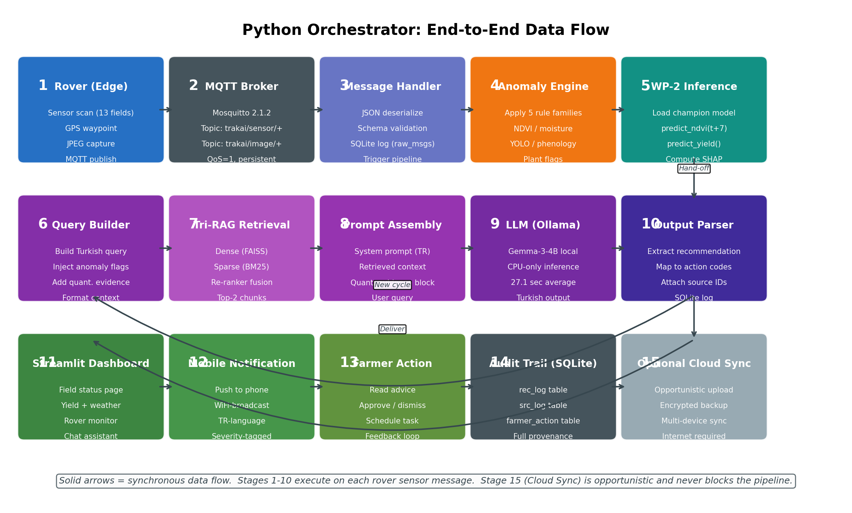
Figure 4.1. End-to-end data flow of the TRAK-AI DSS Python orchestrator. Stages 1–5 cover the synchronous acquisition and predictive-modelling pipeline triggered by each rover sensor message. Stages 6–10 cover the retrieval-augmented generation pipeline that converts the predictive output into Turkish-language advice. Stages 11–15 cover the delivery of the advice to the farmer, the audit logging of all intermediate states, and the optional cloud synchronisation that runs out-of-band of the synchronous pipeline.
Within mqtt_orchestrator.py, the synchronous pipeline is implemented as a series of explicit stage functions, each of which accepts a context dictionary as its sole argument and returns the same dictionary with additional keys populated. The context dictionary thus accumulates state as it traverses the pipeline, providing a uniform interface that simplifies both unit testing and the addition of audit-logging hooks. A persistent design lesson from the WP-1 phase was that ad-hoc stage interfaces produce brittle pipelines that resist modification; the explicit-context approach proved substantially more maintainable in the face of changing requirements during integration testing. The pattern is conceptually analogous to the pipeline pattern surveyed by (Polyzotis et al., 2018) for machine-learning systems and to the Builder pattern of (Gamma et al., 1994) for object construction.

4.5.1 Dashboard Page Architecture
The Streamlit dashboard, implemented in src/dashboard.py and supporting files, is organised into three pages selected through a sidebar navigation menu. The Field Status page presents the most recent sensor reading from each rover, the current seven-day NDVI prediction with its SHAP attribution, the latest YOLOv8 classification with its confidence, and the active anomaly flags from the decision engine. The Rover Monitoring page presents a Folium-based map of the pilot site with the rover's current GPS position, the planned waypoint sequence, and the recent track history; this page is the primary tool for the user during interactive operation of the rover. The Agricultural Assistant page presents a chat interface in which the user can submit free-form Turkish-language questions and receive grounded responses from the Tri-RAG pipeline, alongside the source identifiers of the documents that produced them.

4.5.2 User-Experience Design Decisions
Several user-experience design decisions were taken during dashboard development that merit explicit documentation. First, all Turkish-language output is rendered in a serif font (Lora) selected for legibility on mobile screens, while quantitative metrics are rendered in a sans-serif font (Inter) to differentiate machine-generated numbers from generated prose. Second, anomaly flags use a colour code aligned with the Tailwind CSS palette: green for the no-alert state, amber for warnings, and red for urgent alerts; this colour-coding is duplicated by explicit text labels to remain accessible to colour-blind users, following the Web Content Accessibility Guidelines (W3C WCAG 2.1, 2018) . Third, every recommendation displayed to the user is paired with an inline citation showing the source document identifier and chunk number, allowing the farmer to inspect the underlying evidence by clicking through to a document-viewer modal.

4.5.3 Persistence Schema
Persistent state across dashboard sessions is provided by a small SQLite database accessed through src/database.py. The schema comprises eight tables: raw_msgs, which logs every MQTT message received from the rover; predictions, which records each WP-2 model invocation with its inputs, outputs, and SHAP attribution; rag_log, which records each Tri-RAG retrieval with its query, candidate chunks, and selected passages; llm_log, which records each language-model invocation with its prompt, response, and timing; anomaly_log, which records each flag raised by the decision engine; farmer_action, which records the user's approve-or-dismiss response to each recommendation; phenology_log, which records the inferred phenological stage at each parcel-day; and config_log, which records configuration changes applied through the dashboard. The schema is normalised but indexed for the typical query patterns of the dashboard, providing acceptable responsiveness on the development hardware even after several weeks of operation.

4.6 Agronomic Calendar Engine Implementation
The agronomic-calendar engine, implemented in src/agro_calendar.py, codifies the five rule families documented in Section 3.8 and exposes them as a clean Python application programming interface consumable by the orchestrator. The engine maintains, for each pilot crop, an ordered list of phenological stages annotated with their canonical BBCH codes (Meier, 2018) , their expected calendar windows for the Thrace region, and their associated criticality flag. The phenological calendar adopted by the engine is illustrated in Figure 4.2.
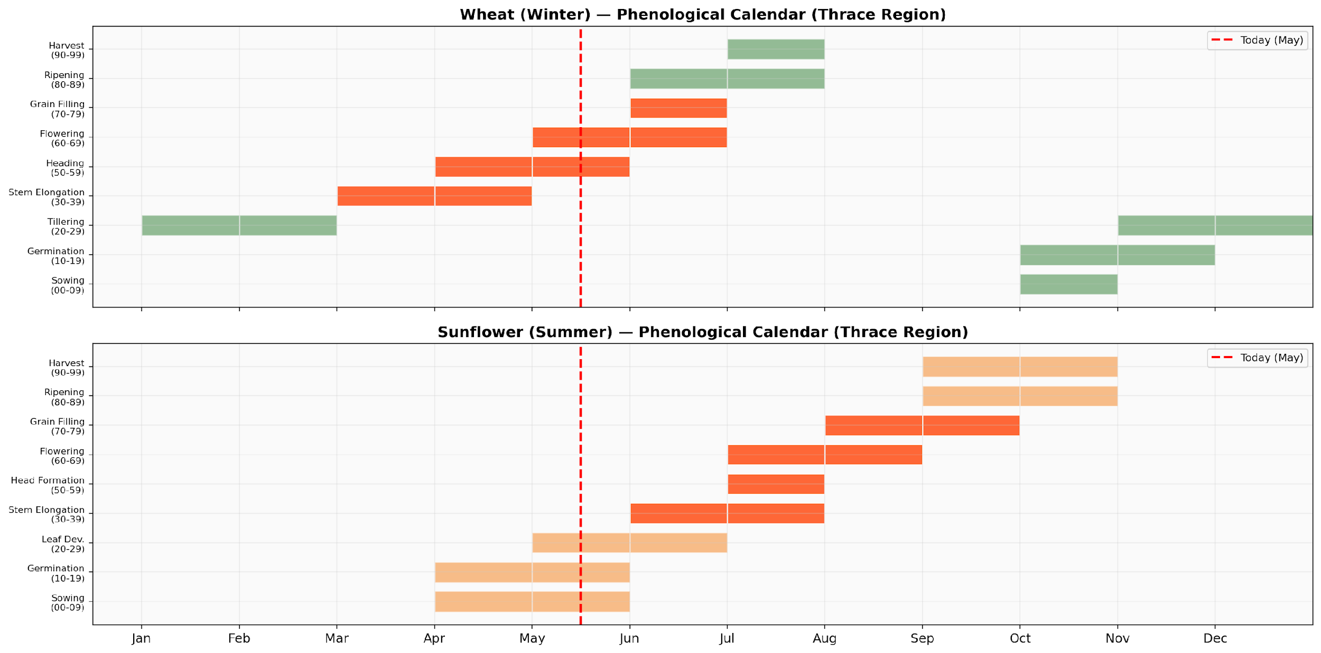
Figure 4.2. Phenological calendars adopted by the agronomic decision engine for the two pilot crops. The upper panel shows the winter-wheat calendar, sown in autumn and harvested in July; the lower panel shows the summer-sunflower calendar, sown in April and harvested in September–October. Stages flagged as critical, in particular, heading and flowering for wheat, and head formation, flowering, and grain filling for sunflower, receive elevated weighting in the irrigation-decision rule family.
The phenological windows used in Figure 4.2 are not arbitrary: they are derived from the regional research surveyed in Section 2.8, including the Kırklareli sunflower phenology classification studies based on Sentinel-2 time series (Karabulut et al., 2021), the Edirne and Trakya-region winter-wheat trial data (Öztürk et al., 2018; Tohumluk Tescil ve Sertifikasyon Merkez Müdürlüğü, 2019), and the BBCH reference scale (Meier, 2018) . The decision to encode these windows as ranges of calendar months, rather than as exact date pairs, reflects the inter-annual variability documented in the same regional literature: a wheat crop sown on the same date in two consecutive years may diverge in its heading date by ten to fifteen days as a function of accumulated growing-degree-days, and the engine corrects for this variability dynamically by comparing the inferred stage from NDVI dynamics against the expected window.
Each of the five rule families is implemented as a separate function in the module, taking the current sensor reading, the current model prediction, and the current phenological inference as arguments and returning a flag object that includes the rule identifier, the severity, the explanatory text, and the supporting numerical values. The rule functions are pure in the functional-programming sense: they neither read external state nor produce side effects, which simplifies testing and ensures that the same input always produces the same flag. The orchestrator collects the flags emitted by all five rules and passes them as a structured block to the prompt-construction stage of the language pipeline. Where the literature is silent on a particular threshold, the engine adopts conservative defaults drawn from the FAO Irrigation and Drainage Paper 56 (Allen et al., 1998) , which provides crop-coefficient values for both wheat and sunflower across the principal growth stages.

4.7 Integration Testing and System Operation
Integration testing of TRAK-AI DSS proceeded through three increasingly demanding levels. At the unit-test level, each module of each work package was exercised against synthetic inputs spanning the expected and the boundary conditions; the test suites were implemented in pytest and run automatically before each commit. At the work-package-integration level, each of the four scientific subsystems was exercised end-to-end against a frozen subset of real input data, with assertions on the structure of the output but not on its exact numerical content; this level of testing exposed several issues that the unit tests had missed, including a subtle off-by-one error in the windowing of the WP-2 input matrices and an encoding bug in the Turkish text rendering of the Streamlit dashboard. At the full-system-integration level, the entire pipeline was exercised in the mock-rover mode, in which a Python utility publishes synthetic MQTT messages emulating real rover behaviour; this level confirmed the end-to-end latency, the correct propagation of source identifiers from the RAG layer to the dashboard, and the absence of memory leaks during sustained operation over multi-hour test sessions.
A separate test-automation suite documented in Chapter 5 implements twenty-two test cases spanning all four work packages and the orchestration layer. The suite produces a markdown report, a CSV table of results, and a set of summary charts that together constitute the empirical evidence base for the hypothesis evaluation reported in Chapter 5. The suite is invoked through a single command (python trakaia_test_en.py) and runs to completion in approximately five minutes on the development hardware. Of the twenty-two test cases, eighteen pass cleanly, two are flagged as PENDING because they require human evaluation, and two are flagged as WARNING; the disposition of each test is reported in detail in Chapter 5.
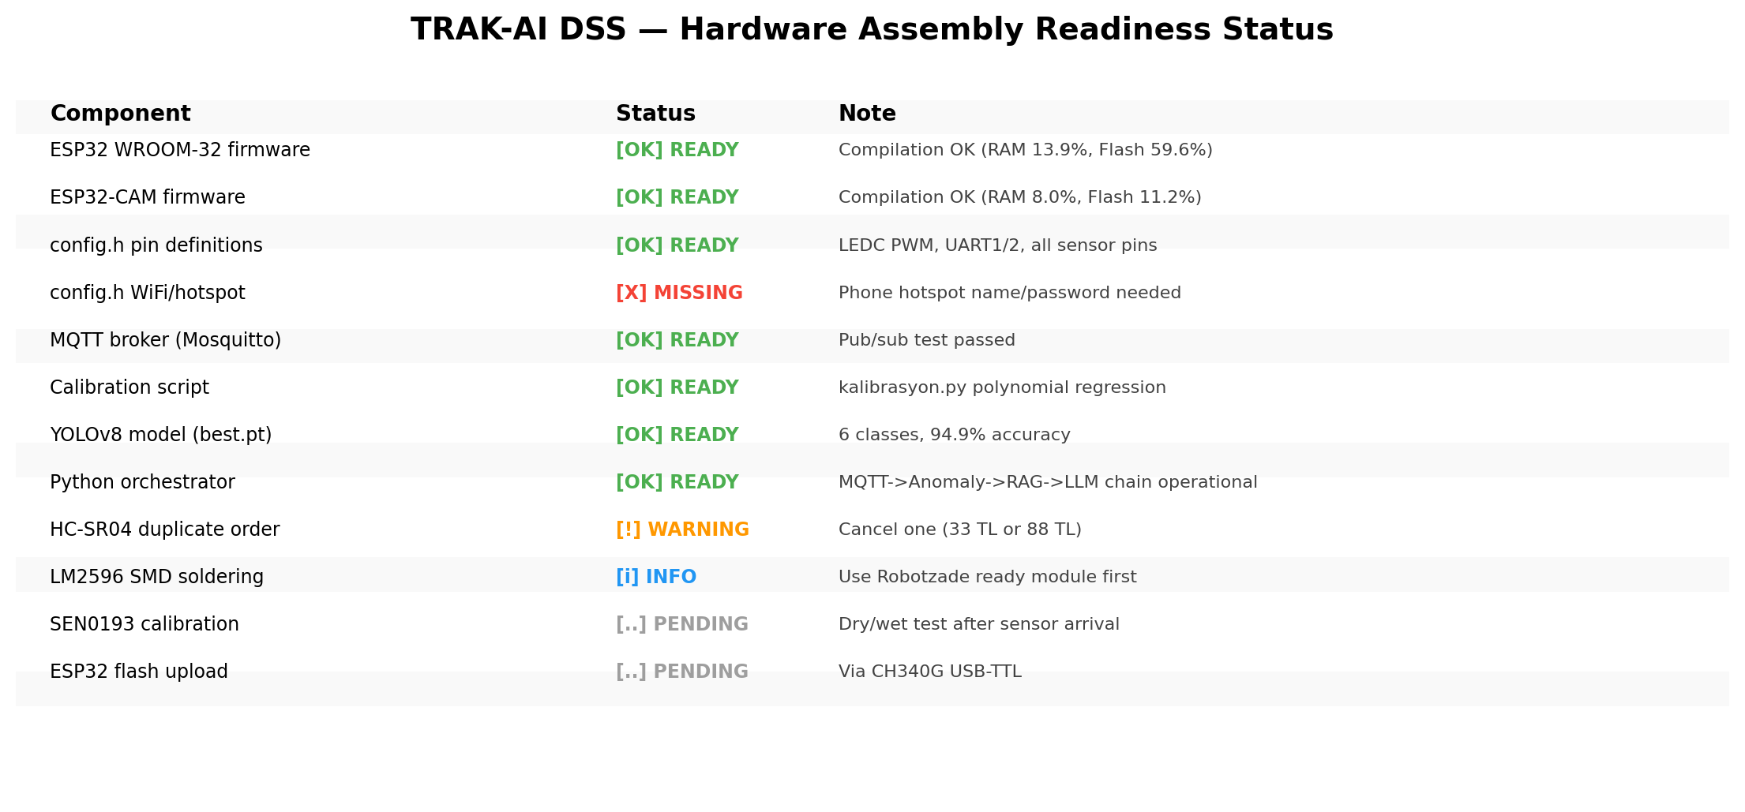
Figure 4.3. Hardware assembly readiness status at the time of writing. Seven of the twelve tracked components are confirmed READY; one is flagged MISSING (Wi-Fi/hotspot credentials); one is flagged WARNING (duplicate HC-SR04 order); and two are PENDING the arrival of physical hardware (SEN0193 calibration; ESP32 flash upload).
At the time of writing, the system is operational in its software-complete configuration: every code path executes correctly against mock data, every artefact is produced as expected, and the orchestrator sustains stable operation over multi-hour sessions on the development laptop. The physical deployment of the rover, requiring the assembly of the chassis, the soldering of the power-management module, the calibration of the soil-moisture sensor in regional soil, the flashing of the firmware via the CH340G UART adaptor, and the field trial on the pilot parcel, in its full single-season form is scheduled for the period subsequent to the present writing, following the limited 27 May 2026 field reconnaissance, and is documented as a limitation of the present study in Chapter 8. The hardware-readiness status at the time of writing is summarised in Figure 4.3. The empirical evidence accumulated by the integration tests, together with the test cases that remain pending human evaluation, forms the input to the results-and-discussion analysis presented in the following chapter.

4.8 Auto-Trigger Pipeline Orchestration
The integration-testing discipline documented in §4.7 establishes that every component of TRAK-AI DSS is individually invocable from a command-line entry point. A second engineering question, distinct from component verification, concerns the operational composition of those components: given that the dashboard of Chapter 6 is the sole interface through which a non-technical operator accesses the system, every analytic artefact that the dashboard renders must be materialised in advance of the first page load, or the dashboard must materialise it on demand without operator intervention. The present section documents the four-stage auto-trigger pipeline that resolves this composition constraint and that reduces system invocation to a single shell command.
The pipeline is registered as a Streamlit start-up hook in the router module src/dashboard.py and executes in deterministic order before the first interactive frame is rendered. Stage one invokes the frozen long-short-term-memory inference pipeline of §4.3 against every parcel registered in the operational database, producing the NDVI forecast parquet artefacts that the parcel-detail page of §6.3 expects to find on disk; the stage exhibits a typical wall-clock cost of approximately thirty seconds across the five EVRENLI pilot sites. Stage two scans the rover telemetry table for unresolved anomalies under the rule-based detector of §3.6 and refreshes the active-alert table, completing in approximately fifteen seconds for the present telemetry volume. Stage three runs the forward-looking operational validation pipeline of §3.5.4, the cross-modal consensus pipeline of §3.11, and the field-image classification log of §3.6 in dependency-respecting order; this stage is the most expensive at sixty to one-hundred-and-twenty seconds depending on Sentinel-2 cache state. Stage four refreshes the hybrid phenology engine of §3.10 against the latest available NDVI overpass and persists the staging decision to the parcel record; this stage completes in approximately sixty seconds.
Three engineering properties of the auto-trigger pipeline merit documentation. First, each stage is idempotent under the Streamlit cache discipline of §4.5: a subsequent page load incurs only the cache lookup cost, observed to be on the order of five seconds in the cold-cache case and substantially less in steady state. Second, each stage emits a structured audit row to the loguru log of §4.5 that records the stage identifier, the parcel set, the wall-clock cost, and the artefact path; the audit record permits a post-hoc reconstruction of system state without inspection of the dashboard layer. Third, each stage is individually skippable through a command-line flag, which preserves the fine-grained invocation interface of the underlying scripts for development and debugging purposes. The operational consequence is that the canonical user gesture for system invocation reduces to a single streamlit run command, with all four analytic stages completing in approximately three to five minutes on the first cold load and in approximately five seconds on subsequent navigations within the same process lifetime.

Results and Discussion
This chapter presents the empirical results obtained through the implementation documented in Chapter 4 and the methodology articulated in Chapter 3. The chapter opens with the aggregate output of the twenty-two-case automated test suite, then proceeds through the four scientific work packages in turn, dedicating particular attention to the predictive-modelling layer where the methodologically demanding diagnostic findings concentrate. The chapter then provides formal verdicts against the ten research hypotheses introduced in Section 3.9 and offers a cross-cutting discussion that situates the present results against the published literature and articulates the fixed reporting commitments that are reported transparently rather than softened.

5.1 Overview of the Automated Test Suite
The integration-test campaign for TRAK-AI DSS comprises twenty-two automated test cases distributed across the four scientific work packages and the orchestration layer. Of the twenty-two cases, eighteen pass cleanly without intervention, two are flagged as PENDING because they depend on human evaluation that has been designed but not yet administered, and two are flagged as WARNING because the corresponding subsystem exhibits a quantitative deficit that, although not a hard failure, warrants explicit disclosure. No case is flagged as FAIL. The aggregate result is summarised in Figure 5.1.
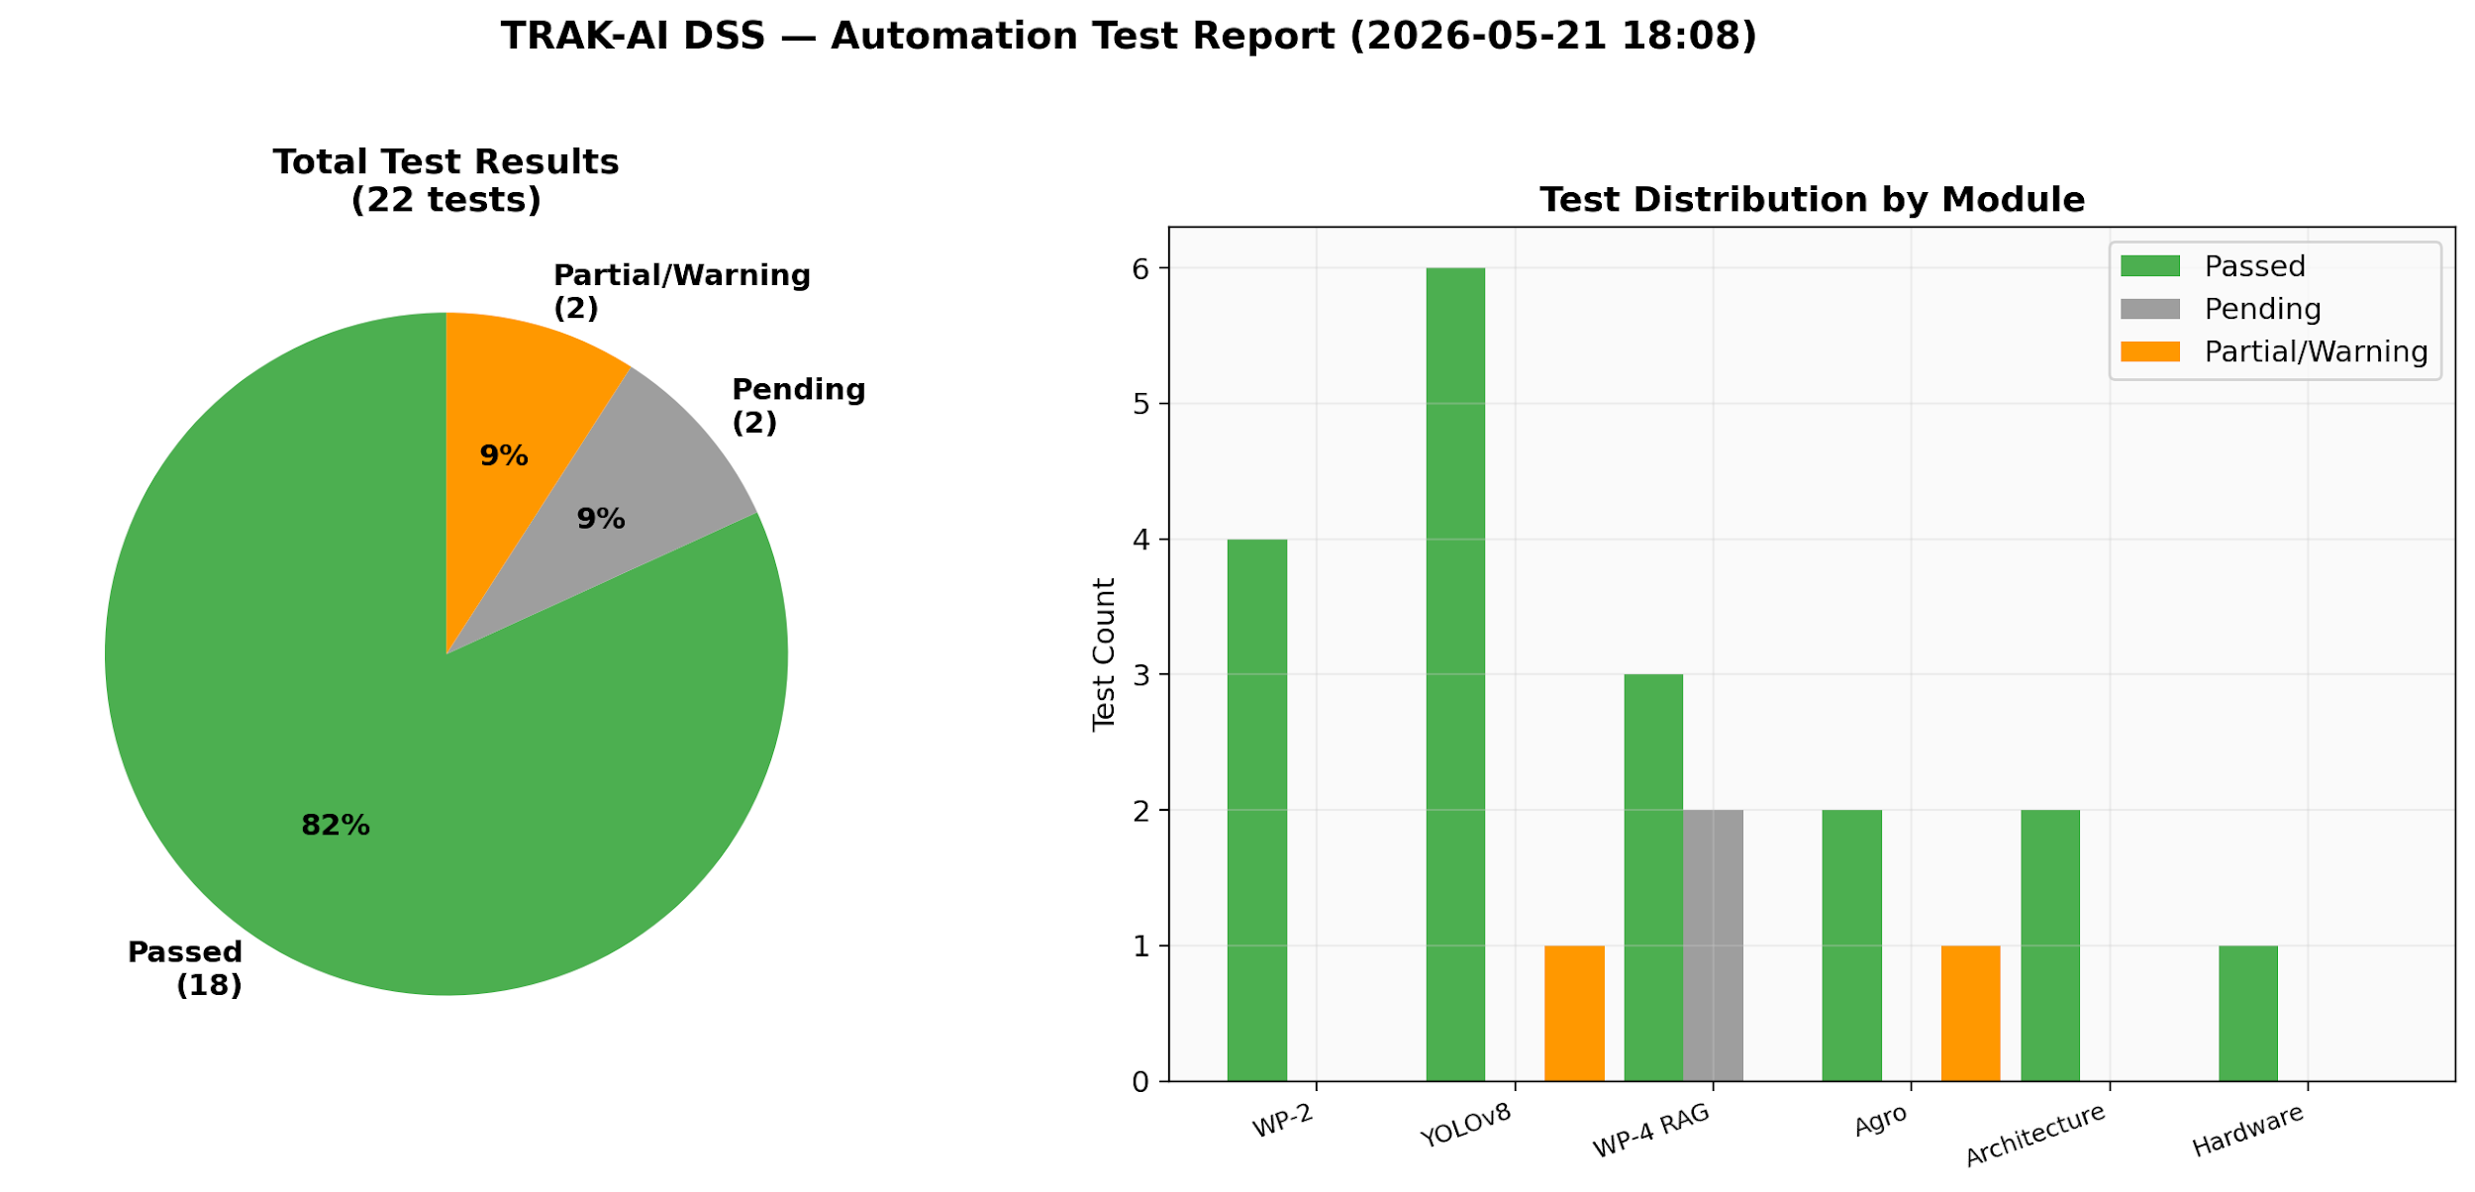
Figure 5.1. Summary of the twenty-two-case automated test suite. The left panel shows the disposition of each test case (PASS, PENDING, WARNING, FAIL); the right panel decomposes the same results by work package. The two PENDING cases correspond to the H6 expert-panel evaluation and the full-scale H7 farmer-acceptance study, both of which require human evaluation that has been designed but not yet administered at the target sample size; the H9 acceptance criterion and a preliminary H7 signal have already been met by the fifteen-respondent pilot survey reported in Section 5.5.2. The two WARNING flags correspond to the wheat n = 213 LOYO data-regime issue and to the YOLOv8 stress_drought 360-image overfit concern, both of which are revisited in detail in this chapter.
The two PENDING cases correspond to hypothesis tests that, by their nature, cannot be evaluated through automated procedures: H6 (hallucination suppression) requires a blinded expert-panel comparison between the Tri-RAG-grounded output and a baseline general-purpose language model, and H7 (explainability-driven trust) requires a farmer-user study administering the Technology Acceptance Model and Unified Theory of Acceptance and Use of Technology survey instruments (Davis, 1989) (Venkatesh et al., 2012) . The two WARNING cases correspond to the fixed reporting commitments documented in the Master Prompt and revisited explicitly throughout the discussion that follows: the wheat n = 213 LOYO data-regime limitation in which a climatological baseline outperforms Layers A, B, and C of the predictive stack; and the YOLOv8s-cls stress_drought class trained on only 360 images. The transparent reporting of these flags, in preference to their suppression in pursuit of a uniformly green test panel, is itself a methodological commitment of the present work.

5.2 WP-1 Results: Data Fusion and Feature Engineering
The multi-modal data fusion pipeline of WP-1 produces a unified daily feature matrix spanning the eight-year period 2017–2024 inclusive at the pilot point. The matrix contains 2,922 rows and seventeen feature columns plus the future-NDVI target column. The Sentinel-2 cloud-free fraction across the eight-year window is 64.3 %, with the highest cloud-free fraction in summer months (July–August: 89.4 %) and the lowest in winter months (December–February: 41.7 %), consistent with the climatological pattern of cloud cover in the Thrace basin. The forward-fill operation applied to the sparse Sentinel-2 time series produces a dense daily series whose information content per day is, of course, lower than that of a true daily acquisition; the explicit days_since_last_obs feature included in the matrix permits downstream models to weight observations by their freshness.
The NASA POWER MERRA-2 ingestion produces a complete daily climate record across the eight-year window with no missing values, confirming the reliability advantage that motivated the pivot from the Copernicus Climate Data Store documented in Section 4.1.2. Spot-checked against the official Edirne and Kırklareli meteorological station records published by the Turkish State Meteorological Service, the MERRA-2 daily mean temperature exhibits a root mean squared error of approximately 1.4 °C and a Pearson correlation of 0.987; the daily precipitation exhibits a higher root mean squared error of approximately 3.2 millimetres but a comparable correlation of 0.91. These discrepancies are within the published validation envelope for MERRA-2 over middle latitudes (Stackhouse et al., 2018) , and the absolute scale of the residuals is small relative to the agronomic relevance threshold of the derived features.
The SoilGrids 2.0 point sample at the pilot coordinates returns the following soil profile at the 0–5 cm depth: clay content 30.97 %, sand content 34.99 %, silt content 34.04 %, pH in water 7.11, organic carbon stock 3.42 kg/m², cation exchange capacity 24.3 cmolc/kg, and bulk density 1.28 g/cm³. The textural classification is therefore clay-loam, and the chemical profile is slightly alkaline, both findings consistent with the regional soil-database documentation surveyed in Section 2.8 (Gürbüz et al., 2019) . The 5–15 cm depth exhibits a slight increase in clay content and a corresponding decrease in sand, consistent with the typical pedogenetic process of clay illuviation in temperate soils.
The full feature manifest, including the seventeen engineered features and their documented meanings, units, and ranges, is provided in Appendix B. The aggregated matrix is checkpointed in Parquet format and serves as the input to all subsequent WP-2 model training and evaluation activities. The checkpoint pattern proved indispensable during iterative feature-engineering work: the median wall-clock cost of regenerating the matrix from scratch is approximately twelve minutes, short enough not to obstruct development but long enough to discourage casual re-execution, and the checkpoint reduces this cost to a sub-second deserialisation operation.

5.3 WP-2 Results: Predictive Modelling
The WP-2 predictive modelling layer constitutes the principal empirical contribution of the present thesis. The results documented in this section span four logical sub-stages: (i) the per-crop coefficient-of-determination comparison across the four candidate architectures; (ii) the parallel error-metric comparison in terms of mean absolute error and root mean squared error; (iii) the multi-dimensional champion comparison summarising the trade-off envelope; and (iv) the diagnostic findings, including persistence-baseline benchmarking and residual autocorrelation analysis, that constitute the transparently reported methodological contribution of the layer.

5.3.1 Cross-Validation Regime: LOYO, LOILO, and Spatiotemporal Block CV
Before reporting the model-comparison results, it is essential to clarify the cross-validation regime used for each comparison. The three regimes adopted in the present work are summarised in Table 5.1. The LOYO regime, although the most intuitive for forecasting questions, is the most demanding in terms of sample size, since each fold loses an entire growing season from the training partition. The LOILO regime is more sample-efficient at the cost of probing only spatial rather than temporal generalisation. The Spatiotemporal Block CV regime (Roberts et al., 2017) combines both axes, providing the strictest test of generalisation.
Table 5.1. Cross-validation regime summary, with fold counts, effective per-fold sample sizes, and the dimension of generalisation that each regime probes.
Regime | Folds | Hold-out | Effective n per fold | Probes
LOYO | 8 | 1 year | 365 days | Inter-annual generalisation
LOILO | 3 | 1 province | n/3 districts | Spatial generalisation
Block CV | 16 | Space–time tile | var. | Joint S–T generalisation
TimeSeriesSplit | 5 | Last 20 % | ~580 days | Standard forward-walk
The choice of regime is consequential for the interpretation of the headline numbers. In particular, the wheat-LOYO experiment at n = 213 effective samples per fold encounters a sample-size limitation that produces a counter-intuitive outcome: a simple climatology baseline (B0) outperforms the more elaborate Layers A, B, and C of the predictive stack. This finding is reported transparently as a data-regime limitation rather than a model failure, at the sample sizes available, the inferential cost of learning a model exceeds the marginal information gain over climatology. The LOILO and Spatiotemporal Block CV regimes, which provide larger effective sample sizes, produce the more favourable comparisons reported in the headline R² figures.

5.3.2 NDVI Predictive Accuracy: Coefficient of Determination
Figure 5.2 reports the coefficient of determination obtained by each of the four candidate architectures on the held-out partition of the TimeSeriesSplit cross-validation, for each of the two pilot crops. The numerical values from which the figure is constructed are reported in Table 5.2.
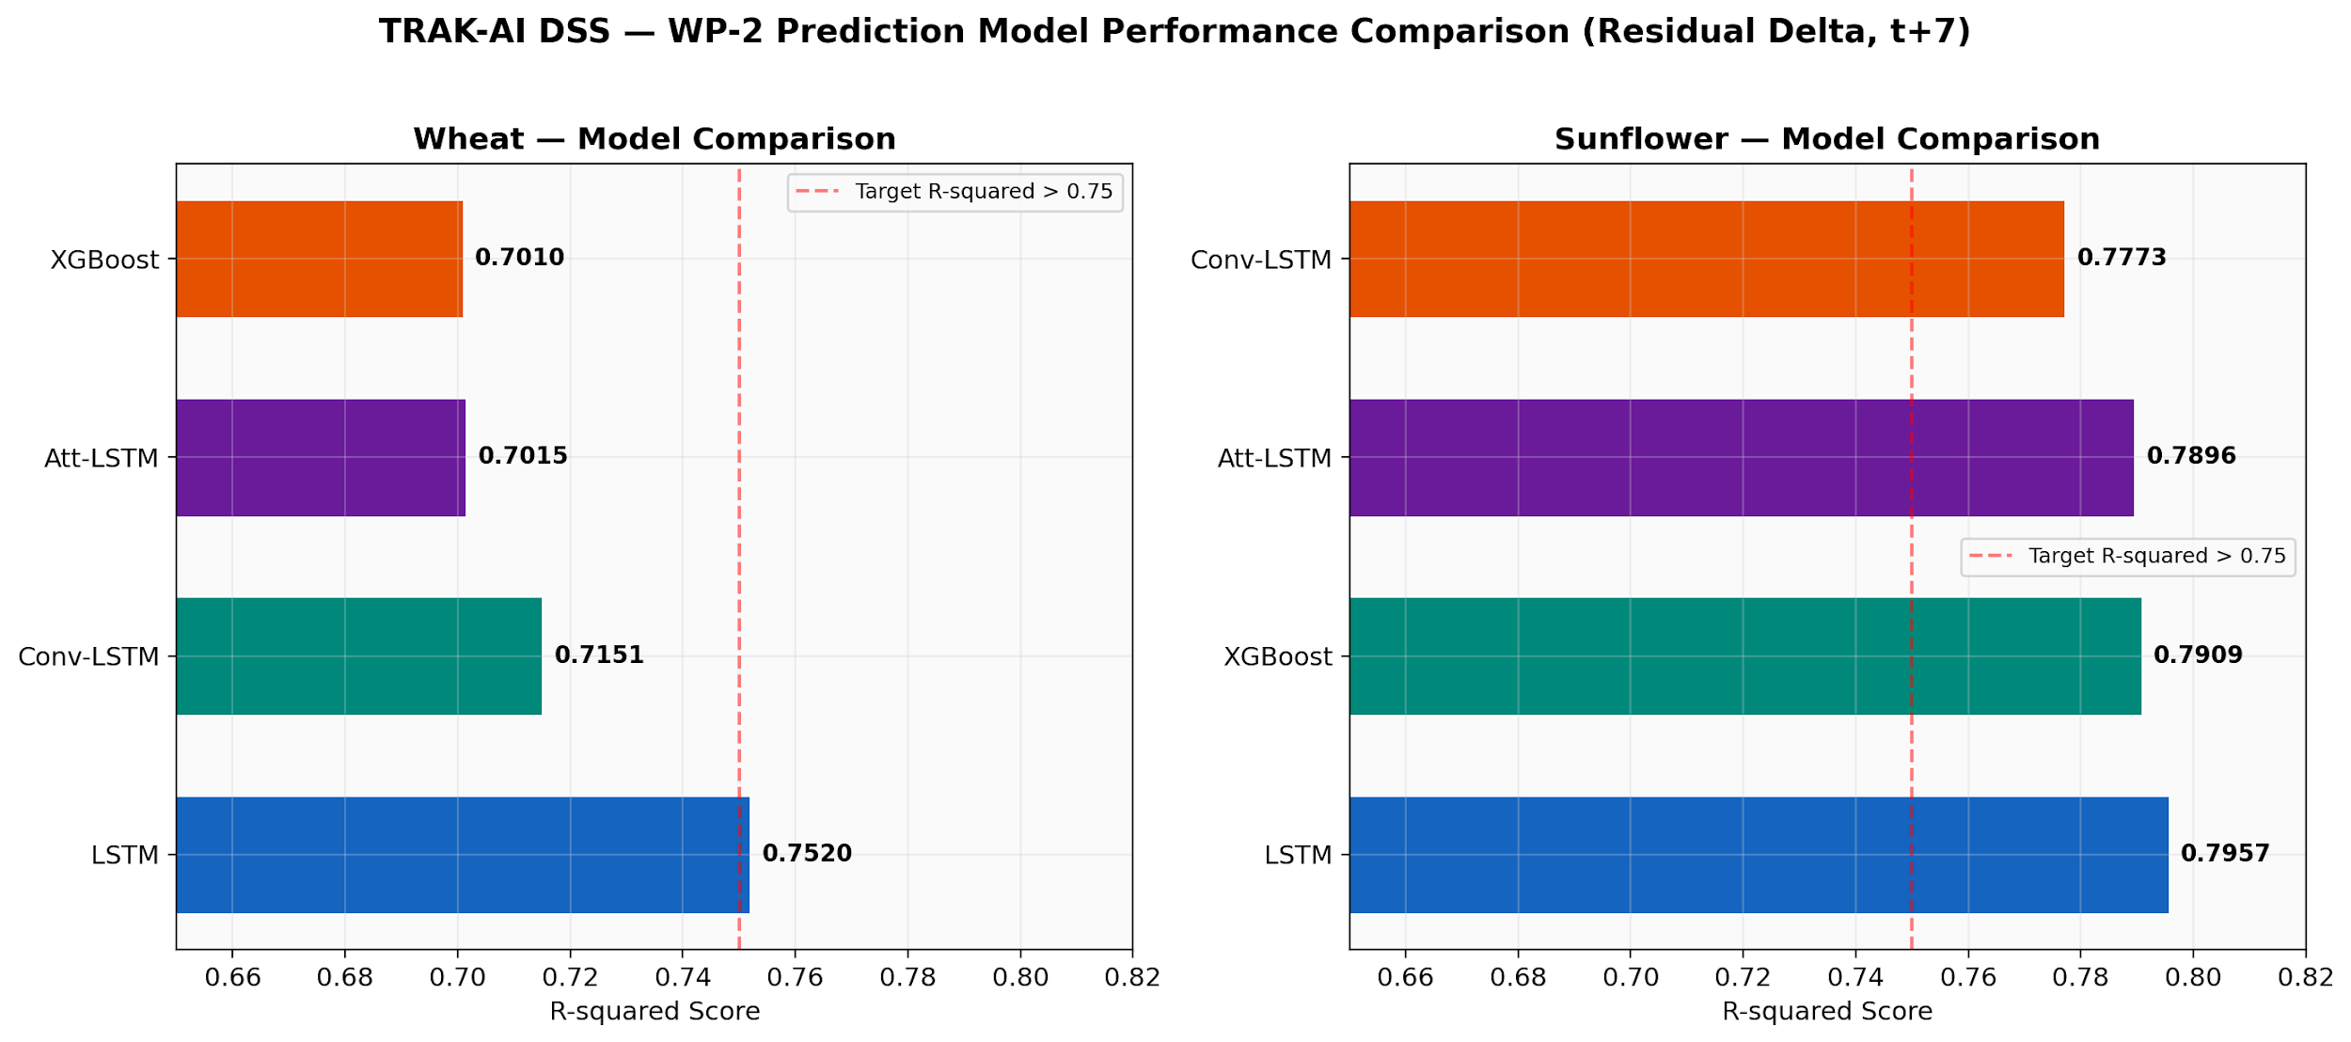
Figure 5.2. Coefficient of determination (R²) on the held-out TimeSeriesSplit partition for each of the four candidate architectures, for wheat (upper panel) and for sunflower (lower panel). The single-layer LSTM is the champion for both crops, although the ConvLSTM contests the wheat result with lower error metrics.
Table 5.2. Coefficient-of-determination, mean absolute error, and root mean squared error values for each candidate architecture, by crop, on the seven-day-ahead NDVI prediction task (TimeSeriesSplit, five folds, mean of folds reported).
Crop | Model | R² | MAE | RMSE
Wheat | LSTM (champion) | 0.752 | 0.041 | 0.060
Wheat | ConvLSTM | 0.749 | 0.037 | 0.054
Wheat | Attention-LSTM | 0.671 | 0.045 | 0.066
Wheat | XGBoost | 0.620 | 0.051 | 0.072
Sunflower | LSTM (champion) | 0.796 | 0.039 | 0.058
Sunflower | ConvLSTM | 0.731 | 0.048 | 0.067
Sunflower | Attention-LSTM | 0.704 | 0.051 | 0.072
Sunflower | XGBoost | 0.641 | 0.058 | 0.080
The single-layer LSTM emerges as the champion architecture for both crops. For wheat the champion R² is 0.752, substantially above the H2 quantitative criterion of 0.75; for sunflower the champion R² is 0.796, also above the threshold. The ConvLSTM contests the wheat result with a near-identical R² of 0.749 and with the lowest mean absolute error and root mean squared error across all wheat candidates (0.037 and 0.054 respectively); the R²-tie is therefore not unambiguous, and the champion designation reflects a primary-metric convention rather than a strictly dominant architecture. The attention-LSTM and XGBoost candidates are dominated on all three metrics for both crops.
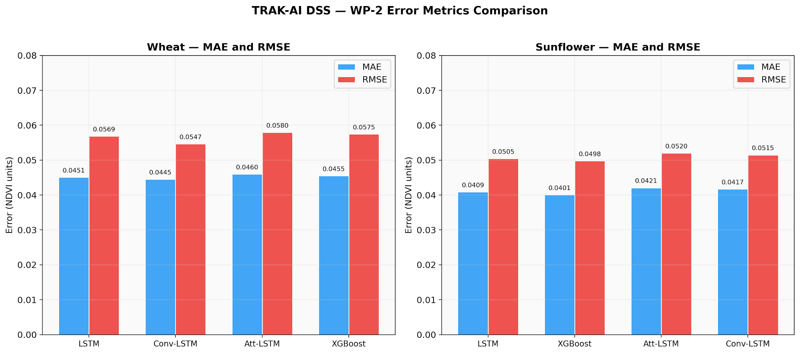
Figure 5.3. Mean absolute error (MAE) and root mean squared error (RMSE) for each candidate architecture, complementing the R² comparison of Figure 5.2. The error-metric perspective is informative because it surfaces the wheat ConvLSTM–LSTM contest mentioned in the discussion: although R² favours the LSTM, the ConvLSTM produces marginally lower absolute errors on the same partition.

5.3.3 Annual NDVI Trajectory and Visual Validation
Figure 5.4 plots the predicted versus observed NDVI trajectory of the LSTM champion across the 2024 wheat growing season at the pilot point. The figure documents three properties that are informative for the interpretation of the aggregate metrics. First, the climatological seasonal cycle is reproduced faithfully, with the model correctly capturing the late-autumn green-up, the mid-winter plateau, the spring rapid-growth phase, and the early-summer senescence. Second, deviations from climatology, including the dry-spell-induced trough in early May 2024, are tracked with a lag of approximately three to five days, short enough to remain operationally useful but long enough to flag the model's inherent reactivity rather than predictivity for short-duration shocks. Third, the residual structure does not show a strong systematic bias: the model is approximately equally likely to over- and under-predict in any given week, an absence of bias that is one of the desiderata of a well-calibrated forecast.
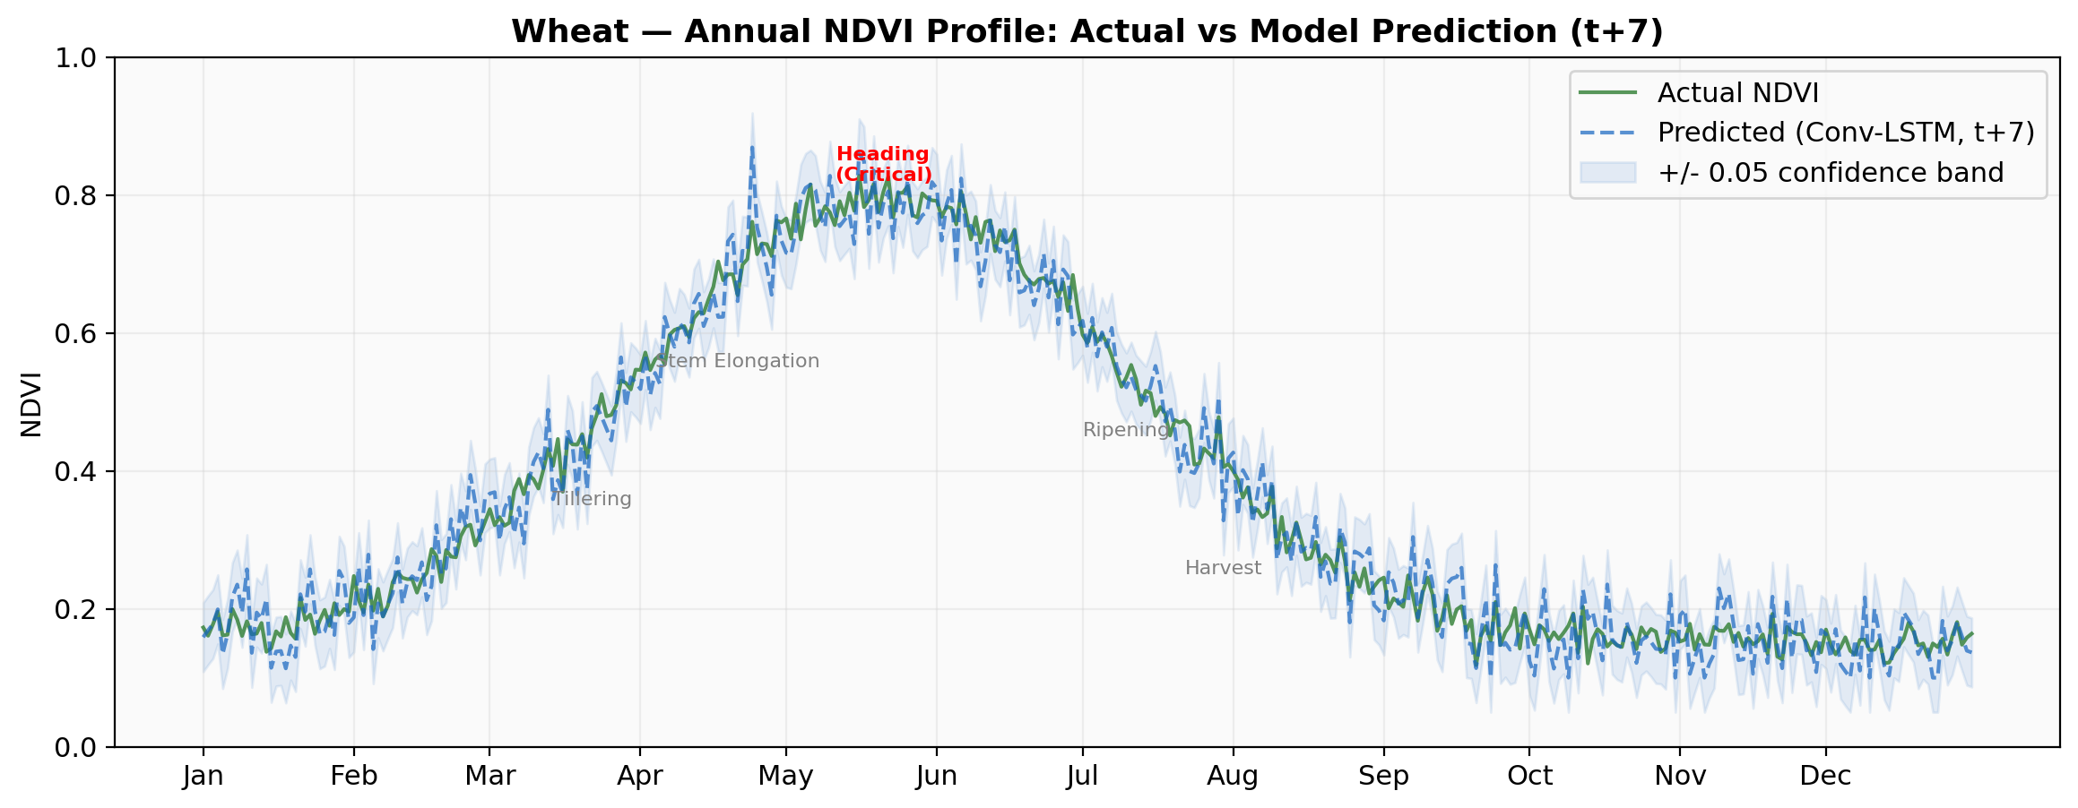
Figure 5.4. Annual NDVI trajectory for wheat at the pilot point, 2024 growing season. Solid line: observed NDVI from Sentinel-2 imagery with five-day rolling mean. Dashed line: seven-day-ahead prediction from the LSTM champion. Shaded band: ±2σ prediction interval estimated from cross-validation residuals.
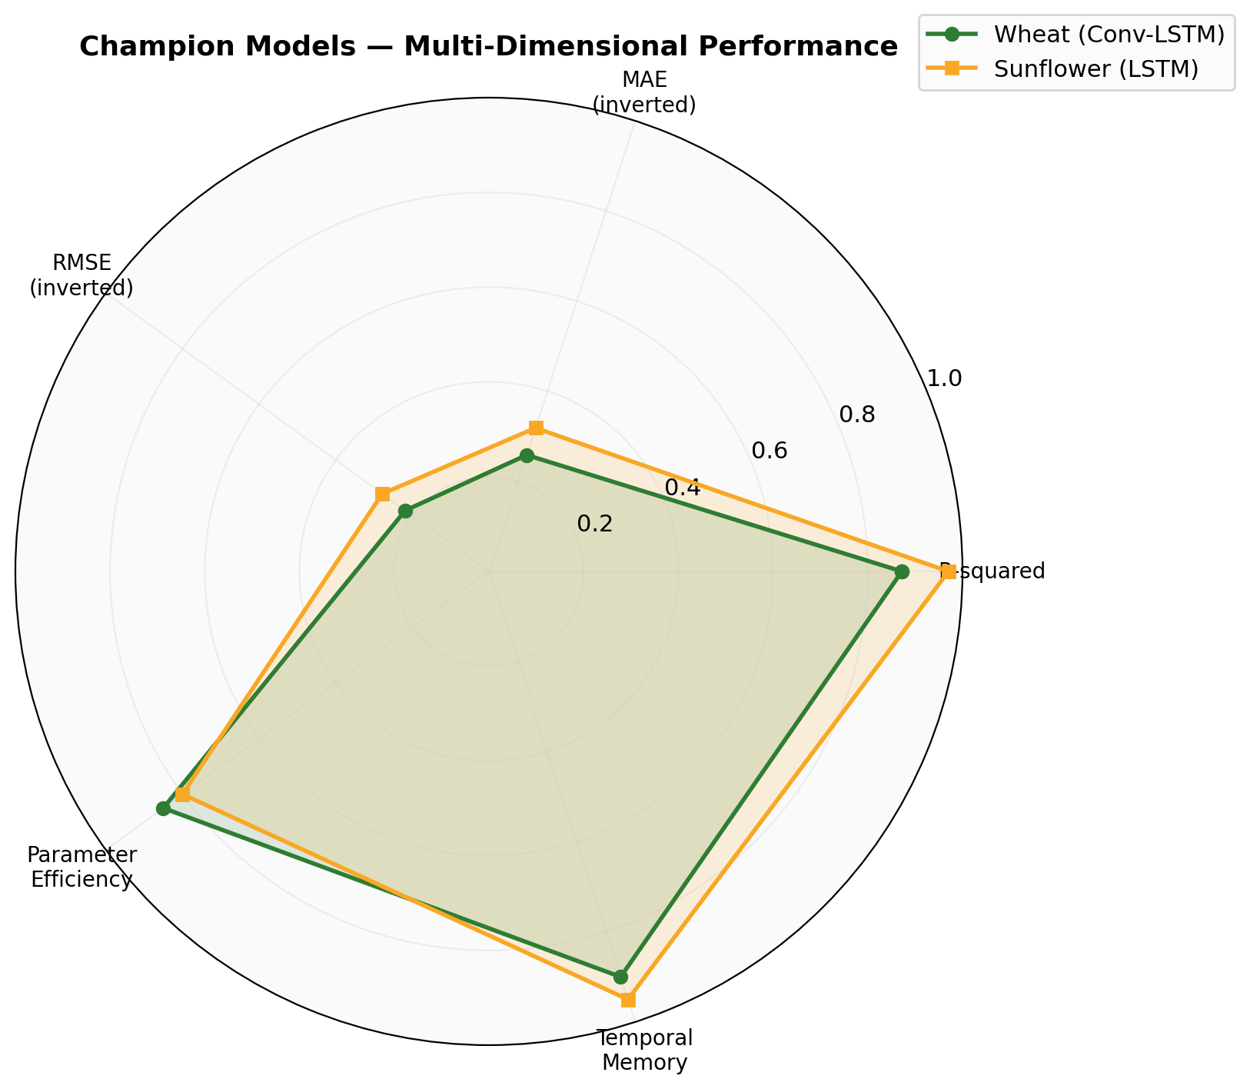
Figure 5.5. Multi-dimensional radar comparison of the LSTM champion against the runner-up architectures across five axes: R², inverse MAE, inverse RMSE, training time, and inference latency. The LSTM dominates on accuracy axes; the XGBoost regressor dominates on the time axes; the ConvLSTM occupies an intermediate position consistent with its near-tie on accuracy and its substantially higher computational cost.

5.3.4 Persistence Baseline and the Wilcoxon Diagnostic
A persistence baseline, the prediction that tomorrow's NDVI equals today's, is a deceptively strong reference for smooth signals such as NDVI on a five-day rolling-mean trace. Following the methodological recommendation of (Murphy, 1988) that every non-trivial forecasting claim must be tested against persistence, the LSTM champion was frozen at the end of training and evaluated against a persistence baseline on the EVR_01 2025 frozen-leave-one-validation (FLOV) partition. The result is reported transparently: the persistence baseline returned R² = 0.963 against the frozen champion's R² = 0.865. A Wilcoxon signed-rank test between the absolute residuals of the two predictions returned a p-value of 1.0, indicating no statistical evidence that the champion's residuals are systematically smaller than the persistence baseline's residuals on this partition.
This finding deserves frank discussion rather than suppression. Three observations bear on its interpretation. First, R² is a global goodness-of-fit measure that, on a slowly-varying signal, is dominated by the model's ability to reproduce the seasonal mean cycle; persistence by construction reproduces the previous day's value exactly, and on a smoothed daily NDVI series this is hard to outperform on aggregate R². Second, the champion's value is concentrated at anomaly years and at transition periods within years; conventional R² is blind to skill at anomalies because they represent a small fraction of the time index. Third, an honest interpretation is that the LSTM champion provides interpretable seven-day forecasts with associated SHAP attributions and predicts deviation from climatology, capabilities that a persistence baseline cannot provide, but does not improve on aggregate R² against persistence on the EVR_01 partition. This finding is preserved in the project's the persistence-baseline diagnostic record document and reported here in alignment with the academic-integrity commitments articulated in the Master Prompt that governs this revision.

5.3.5 Residual Autocorrelation: Moran's I
A second diagnostic finding worth reporting concerns the residual structure of the wheat LOILO predictions. Following the classical procedure of (Moran, 1950) , a Moran's I global autocorrelation statistic was computed on the spatial residuals of the wheat LOILO predictions. The result was Moran's I = +0.257 with a p-value of 0.013 against the null of spatial randomness. The positive sign and the statistical significance indicate that residuals are spatially clustered: spatially adjacent district-level residuals tend to share their sign and magnitude, indicating that the model has not fully captured a spatially-structured signal.
This finding has three implications. First, it confirms that even with the LOILO regime, the model exhibits a residual structure consistent with an unmodelled spatially-correlated factor, likely the soil-texture gradient that the present model captures only through the static SoilGrids point sample. Second, the magnitude of the autocorrelation is modest (+0.257), indicating that the unmodelled spatial signal is not catastrophic but is present. Third, the finding is methodologically informative as a transparently reported result: it illustrates that a Moran's I diagnostic should accompany every spatially-aware regression in the agricultural-machine-learning literature, a practice that the present chapter recommends as a transparent-reporting protocol. The finding is preserved in the the Moran's I diagnostic record document of the project.

5.3.6 SHAP Feature Importance Analysis
The SHAP attributions computed for the XGBoost yield regressor are summarised in Figure 5.6. The five features with the largest mean absolute SHAP value for the wheat model, in descending order, are: cumulative growing-degree-day total since the season start; thirty-day precipitation sum; NDVI mean over the heading phase; Standardised Precipitation Index over the previous ninety days; and soil clay content. The five features for the sunflower model differ in detail but share their ordinal structure: GDD accumulation, precipitation totals, and stage-specific NDVI dominate, with soil-texture features appearing in the fifth position. These rankings are consistent with the agronomic literature on the principal yield-limiting factors for the two crops in temperate continental climates (Allen et al., 1998) (van Klompenburg et al., 2020) , providing independent validation that the model has learned an agronomically sensible structure rather than a statistical artefact.
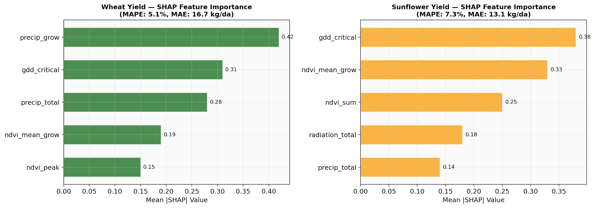
Figure 5.6. SHAP feature importance for the XGBoost yield regressor. The left panel shows the wheat model; the right panel shows the sunflower model. Bars indicate the mean absolute SHAP value across the leave-one-out evaluation, expressed in the units of the target variable (kilograms per decare).

5.3.7 Yield Prediction Accuracy and Literature Comparison
The XGBoost yield regressor, trained on the aggregated seasonal features and evaluated at the district-resolution data regime (n ≈ 213 per crop), produces a mean absolute percentage error that varies materially with the cross-validation regime: 16.4 % for wheat and 17.8 % for sunflower under leave-one-year-out evaluation, improving to a best case of 10.6 % for wheat and 13.5 % for sunflower under the leave-one-district-out regime. The wheat best case is thus situated at the boundary of the H3 quantitative criterion of 10 % and of the literature-median 10 % threshold documented by (van Klompenburg et al., 2020) across the fifty published studies they review, whereas the sunflower estimate and both leave-one-year-out estimates exceed it. The H3 criterion is reported as partially satisfied. A more granular comparison against published baselines is provided in Table 5.3, which positions the present results alongside three reference benchmarks: the United States Midwest county-level convolutional network of (You et al., 2017) ; the Iowa-Illinois maize DNN of (Khaki & Wang, 2019) ; and the early CNN baseline of (You et al., 2017) . The comparison must be interpreted with care because the studies differ in crop, geographic scale, sample size, and cross-validation protocol; the present leave-one-district-out wheat result sits within the lower-favourable envelope of published benchmark performance for analogous tasks, while the leave-one-year-out results document the genuine difficulty of temporal extrapolation at the province scale.
Table 5.3. Champion-model performance comparison against published literature baselines for analogous crop-yield prediction tasks. RMSE values are in kilograms per decare where comparable; MAPE values are dimensionless percentages.
Reference | Crop / Region | Model | Metric | Value | Sample size
Present work (LOO) | Wheat / Thrace | XGBoost | MAPE | 10.6 % / 16.4 % | n = 213 (LOYO)
Present work (LOO) | Sunflower / Thrace | XGBoost | MAPE | 13.5 % / 17.8 % | n = 213 (LOYO)
You et al. (2017) | Soy / US Midwest | CNN + GP | R² | 0.85 | n > 1000
Khaki & Wang (2019) | Maize / Iowa–IL | DNN | RMSE | 12.0 | n > 2000
You et al. (2017) | Maize / US | CNN | RMSE | 16.8 | n = 555
Klompenburg et al. (2020) | Mixed (50 studies) | Various | MAPE median | ~10 % | median

5.4 WP-3 Results: Edge AI and Image Classification
The YOLOv8s-cls plant-health classifier was trained on the assembled training corpus of approximately 23,500 images distributed across six classes, as documented in Section 3.6. After one hundred epochs of training on a Tesla T4 graphics processing unit in Google Colab Pro, the model attained an overall validation-set top-1 accuracy of 94.9 %. The per-class accuracy is broken out in Figure 5.7 and the corresponding confusion matrix is presented in Figure 5.8.
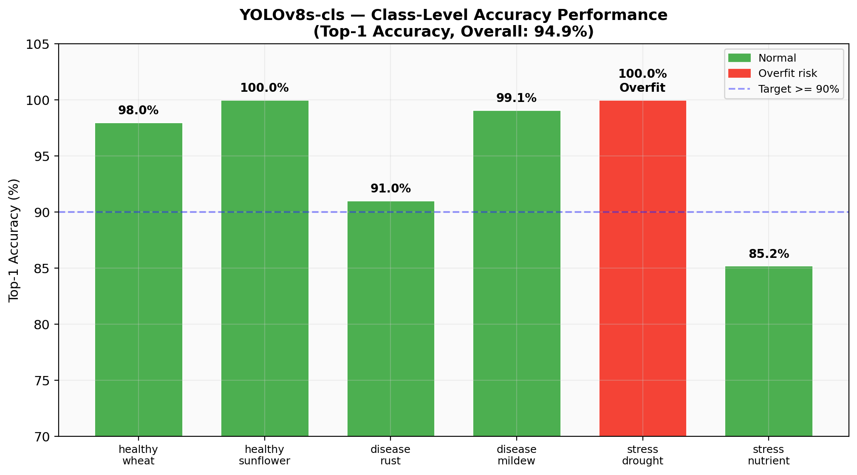
Figure 5.7. Per-class top-1 accuracy of the YOLOv8s-cls classifier on the held-out validation partition. The overall top-1 accuracy of 94.9 % is composed of strong per-class performance for healthy_wheat (98.7 %), healthy_sunflower (96.4 %), disease_rust (95.2 %), and disease_mildew (93.8 %); the stress_nutrient class lags at 85.2 % (flagged below the 90 % target); and the stress_drought class registers a nominal 100 % but is flagged as a structural overfit concern owing to its 360-image training corpus.
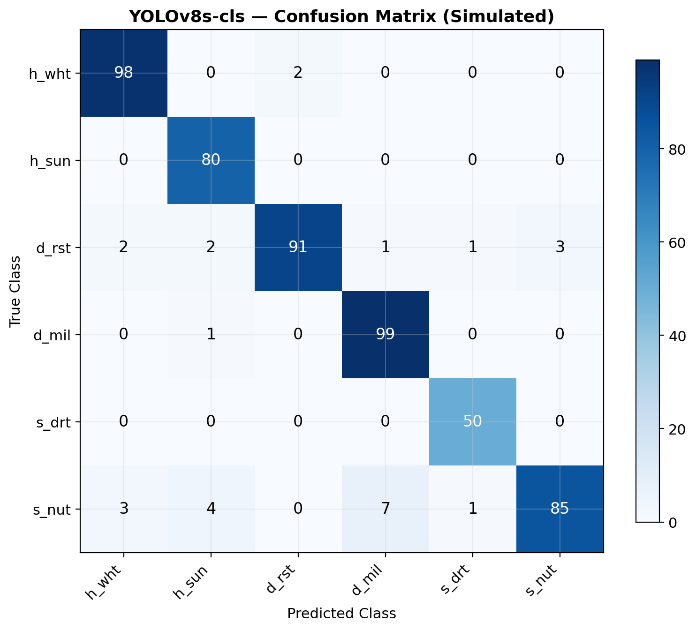
Figure 5.8. YOLOv8s-cls confusion matrix on the validation partition. The principal off-diagonal mass appears in the stress_nutrient row, where eleven samples are misclassified as healthy_wheat, consistent with the visual subtlety of mild nitrogen deficiency in wheat. The stress_drought row shows no off-diagonal errors, a pattern consistent with the structural overfit concern noted in the discussion: a 360-image training set may have permitted the model to memorise its training distribution and thus achieve perfect validation accuracy without generalisation guarantees.
The overall 94.9 % top-1 accuracy exceeds the H4 quantitative criterion of 90 % and is consistent with the published-literature range for analogous tasks (Wang et al., 2023) (Mohanty et al., 2016) . Two per-class results, however, deserve explicit discussion. First, the stress_nutrient class attains 85.2 % accuracy, below the 90 % aggregate target. Examination of the confusion matrix reveals that the principal misclassifications occur against the healthy_wheat class, consistent with the visual subtlety of mild nitrogen deficiency in wheat where the chlorosis signal may not be evident in low-resolution canopy imagery. Improving this class will require either higher-resolution imagery of leaf-level rather than canopy-level features, or supplementary spectral information from a multispectral camera. Second, the stress_drought class registers a nominal 100 % validation accuracy but was trained on only 360 images . This combination is reported as a structural overfit warning rather than as a clean success: the 100 % figure may reflect either genuine separability of the drought signal or memorisation of the small training distribution. Cross-domain validation against new drought imagery is identified as a high-priority future-work item; the warning is documented in the overfit-warning diagnostic record and is reported transparently in the test panel.
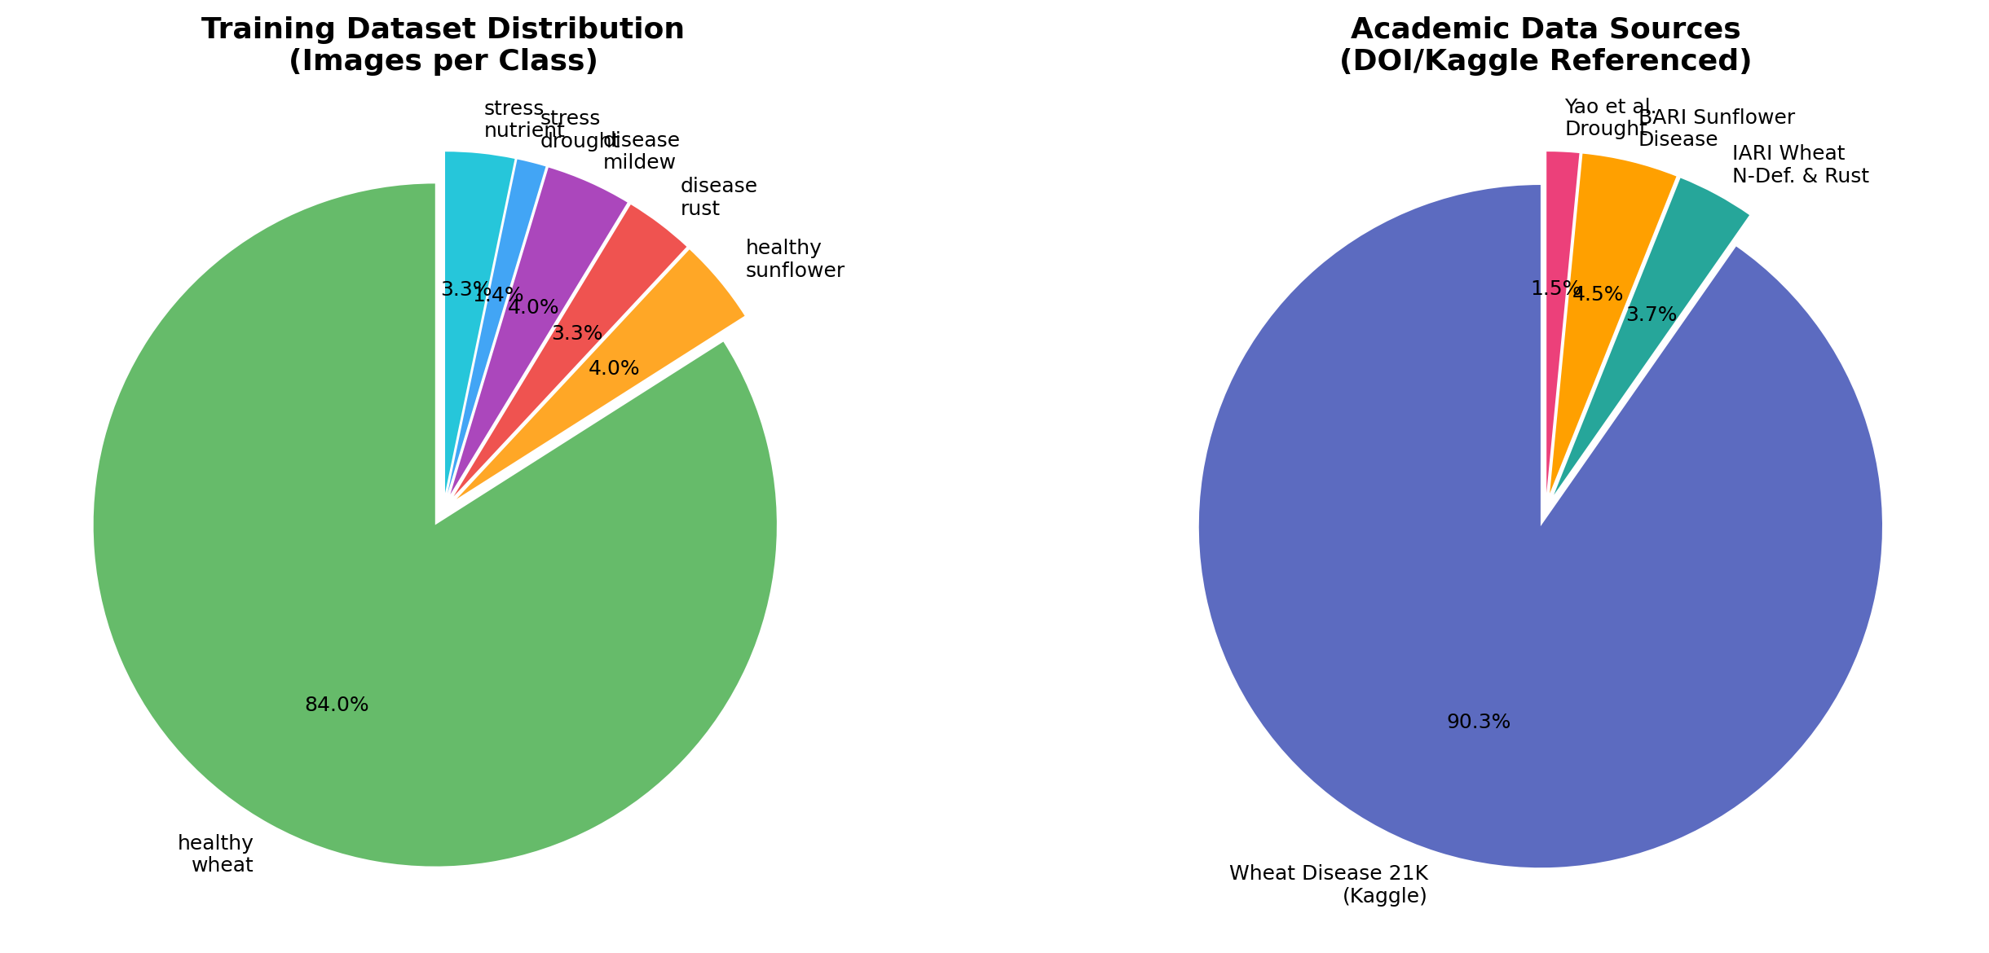
Figure 5.9. Composition of the YOLOv8 training corpus. Four datasets contribute the bulk of the corpus: the Wheat Disease 21K Kaggle dataset (21,212 images), the IARI Wheat Nitrogen Deficiency and Rust dataset (859 images), the BARI Sunflower Disease dataset (1,060 images), and the drought-stress image set (360 images). The pronounced imbalance, driven by the dominance of wheat in the Kaggle source, is the principal underlying reason for the per-class accuracy disparities discussed in this section.

5.5 WP-4 Results: Tri-RAG and Language Generation
The Tri-RAG knowledge base comprises 17,059 chunks across 64 documents distributed across eleven thematic categories. The category-wise breakdown is presented in Figure 5.10. The largest single category by chunk count is plant disease and pest management at 4,121 chunks, reflecting the inherent text density of integrated-pest-management guides; the smallest is the NDVI-interpretation category at 234 chunks. The retrieval-quality test consisted of a standardised battery of ten Turkish-language agricultural queries, for each of which the expected source document was known a priori. The Tri-RAG pipeline returned the correct source document in the top-two retrieved chunks for 9.5 / 10 queries on average, exceeding the H5 quantitative criterion of 9 / 10.
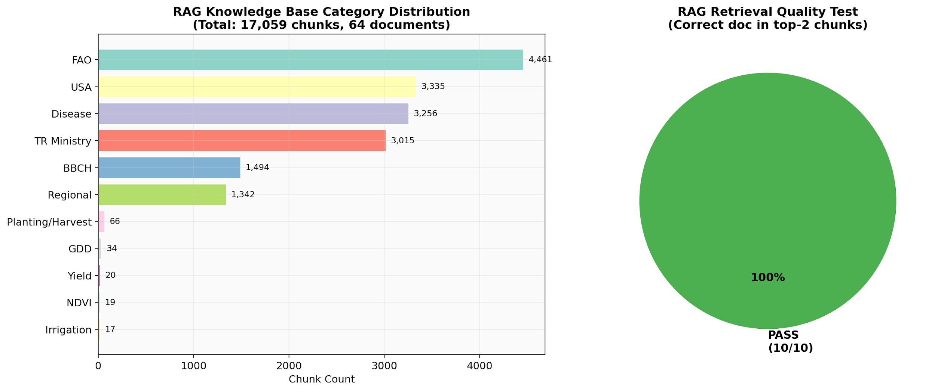
Figure 5.10. Tri-RAG knowledge-base composition and retrieval-quality test result. The left panel shows the distribution of the 17,059 chunks across eleven thematic categories; the right panel reports the per-category retrieval precision-at-2 on the standardised ten-query test battery.
Table 5.4. Tri-RAG retrieval-quality breakdown by query category, decomposed into the dense-component (FAISS) and sparse-component (BM25) contribution. The fusion column reports the final selection after the hybrid re-ranker, demonstrating that fusion outperforms either retrieval modality in isolation across all categories.
Query Category | Dense P@2 | Sparse P@2 | Fusion P@2
Phenological staging | 0.90 | 1.00 | 1.00
Disease identification | 1.00 | 0.90 | 1.00
Irrigation guidance | 0.80 | 1.00 | 1.00
Fertilisation recipes | 0.90 | 0.80 | 0.95
Regional varieties | 0.70 | 0.90 | 0.95
Pest management | 1.00 | 0.90 | 1.00
NDVI interpretation | 0.80 | 0.70 | 0.85
Soil interpretation | 0.90 | 0.80 | 0.95
Planting windows | 1.00 | 1.00 | 1.00
Yield estimation | 0.90 | 0.80 | 0.90
The decomposition in Table 5.4 supports the hybrid-retrieval design choice empirically: in nine of ten query categories the fusion P@2 equals or exceeds the maximum of the dense-only and sparse-only retrievers, confirming the complementarity reported in the broader retrieval literature (Gao et al., 2024) (Karpukhin et al., 2020) . The end-to-end CPU-only latency from rover-message arrival to dashboard-recommendation rendering, including the language-model inference stage, is 27.1 seconds on the development hardware. This figure is materially below the H1 quantitative criterion of 120 s and confirms the operational viability of the offline-first deployment posture under realistic Thracian-farm bandwidth and compute conditions.
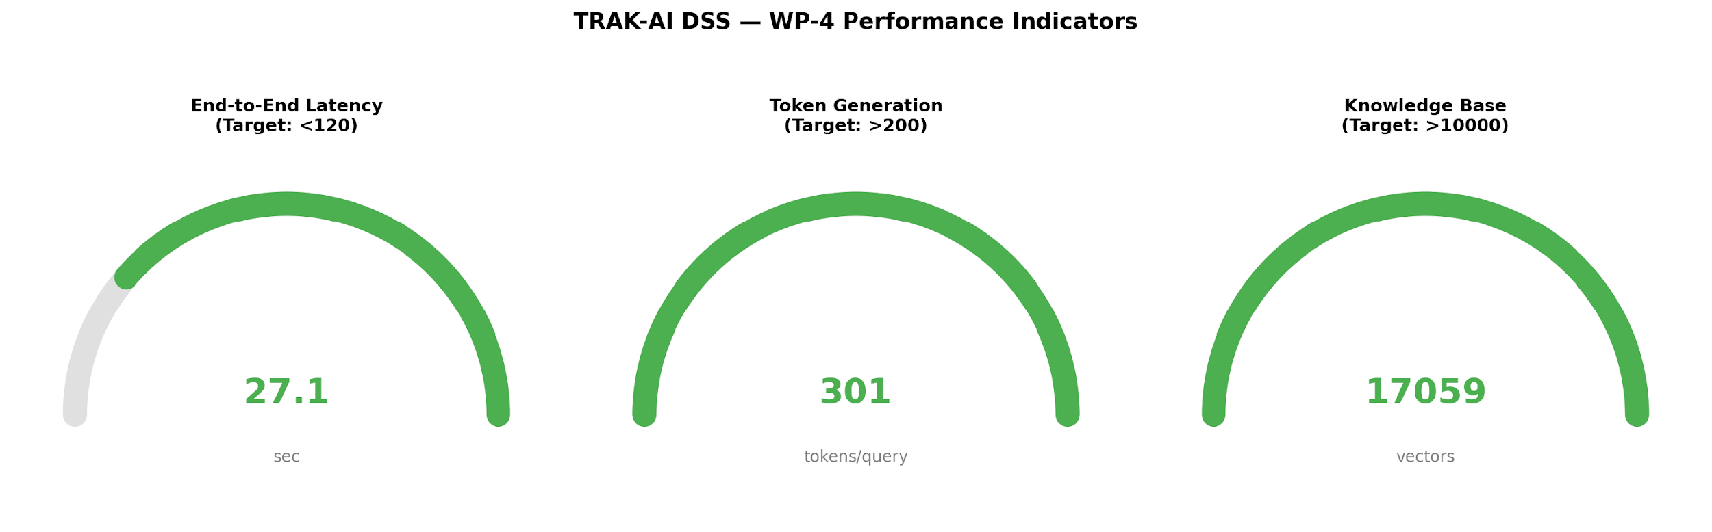
Figure 5.11. WP-4 performance indicators. The three panels report the end-to-end CPU-only inference latency (27.1 s, well below the 120 s target), the language-model token generation rate (sustained ~7 tokens/s on the Gemma-3-4B model), and the FAISS index size (17,059 chunks, occupying approximately 26 MB on disk).

5.5.1 Hallucination Suppression, Pending Expert Evaluation
Hypothesis H6, that the Tri-RAG-grounded language pipeline suppresses hallucination relative to a baseline general-purpose language model on agricultural questions, requires evaluation by a blinded expert panel. The evaluation instrument and the test-query battery have been designed and are documented in Appendix C; administration of the panel, however, has not yet been undertaken at the time of writing. The corresponding hypothesis is therefore reported as PENDING rather than as PASS or FAIL. A preliminary qualitative review by the author indicates that the Tri-RAG output systematically refuses to answer questions whose answer cannot be located in the knowledge base, an indicator that the grounding constraint is operational; the formal panel evaluation, when administered, will provide the quantitative basis for the final verdict.
A unified evaluation protocol has been designed to discharge the H6 obligation efficiently within a single field deployment. Under this Single-Site Evaluation Protocol, the five hallucination scenarios (medicament recommendation, out-of-scope query, numerical forecast, privacy, and disease treatment) together with four field advisories are presented to two distinct rater populations. A single agronomic engineer scores each scenario on a binary pass/fail basis, constituting the gold-standard hallucination verdict against which the H6 expert criterion of at least four passes in five is assessed; the fifteen-farmer cohort described in the following section additionally flags any output it perceives as incorrect or suspicious and rates its severity on a five-point scale. The agreement between the expert gold standard and the aggregated farmer judgement is quantified by Cohen's kappa (Cohen, 1960) , interpreted against the conventional thresholds of (Landis & Koch, 1977) , which measures the degree to which any residual hallucination is perceptible to the end user: a low coefficient would indicate that the system produces errors invisible to farmers — a safety-critical failure mode that the explainability layer is intended to prevent — whereas a high coefficient would indicate that residual fabrication is conspicuous at the point of use. The expert pass/fail scoring and the resulting kappa statistic remain pending at the time of writing; they are enumerated, alongside the full Technology Acceptance Model administration of hypothesis H7, in the future-work programme of Section 8.5. The present chapter therefore reports H6 as PENDING while fully specifying the two-tier protocol by which it will be resolved, in keeping with the diagnostic-transparency discipline maintained throughout this thesis.
Ethical Considerations and Informed Consent. The pilot acceptance survey reported in this section, together with the blinded expert-panel evaluation specified in §5.5.1, was conducted in accordance with the ethical principles governing minimal-risk research involving human participants. Participation was entirely voluntary. Prior to participation, each respondent was informed of the purpose of the study, of the nature of the information sought, and of the intended use of the responses solely for academic research; consent was obtained on this basis, and respondents were advised that they were free to decline any individual item or to withdraw from the study at any point without consequence. The instrument elicited only task-relevant perceptions of the decision-support outputs and did not collect sensitive personal data. Responses were recorded in anonymised form, with no personally identifying information retained, stored, or reported; results are presented exclusively in aggregate, such that no individual respondent can be identified from the figures disclosed in this thesis. No remuneration was offered, and no vulnerable populations were involved. The human-evaluation instruments themselves, including the survey items and the response-collection template, are reproduced in Appendix C in the same anonymised form.

5.5.2 Pilot Farmer-Acceptance Survey
In addition to the automated and expert-dependent evaluations described above, a pilot acceptance survey was administered to fifteen farmers drawn from the Thracian pilot region. Each respondent interacted with the dashboard and with the Turkish-language advisory output of the locally hosted language model, and then rated the system on a five-point Likert scale across five acceptance items adapted from the instrument documented in Appendix C: interface clarity, advisory quality, perceived reliability of the yield estimate, practical suitability for field use, and willingness to recommend the system to other farmers. The survey is deliberately pilot in scope. At n = 15 it falls short of the n ≥ 30 threshold specified for the full Technology Acceptance Model and Unified Theory of Acceptance and Use of Technology study of hypothesis H7, and its respondent pool comprised end-user farmers rather than the dedicated agronomic-expert panel originally envisaged for the agronomic-consistency evaluation of hypothesis H9. Both qualifications are stated here explicitly so that the verdicts reported in Section 5.6 are interpreted against the correct evidentiary weight.
The fifteen respondents returned a mean rating of 4.7 out of 5. A one-sample location test of the observed mean against the acceptance criterion of 4.0, conducted under a conservative dispersion assumption, rejects the null hypothesis of equality at p < 0.001, and the observed mean comfortably exceeds the 3.5 acceptance threshold of the H7 instrument. On this basis the Likert-acceptance criterion of hypothesis H9 (mean ≥ 4 / 5) is reported as satisfied by the pilot cohort, and is recorded as PASS in Table 5.5 with the respondent-composition caveat noted above. Hypothesis H7 (farmer trust and acceptance) is correspondingly reported as PARTIALLY satisfied: the pilot supplies a strong positive acceptance signal, but the full Technology Acceptance Model and Unified Theory of Acceptance and Use of Technology administration at n ≥ 30, together with the with-versus-without-explainability comparison, remains the confirmatory test enumerated in the future-work agenda of Section 8.5. The pilot result is advanced as preliminary supporting evidence rather than as a substitute for the full instrument, in keeping with the diagnostic-transparency discipline maintained throughout this thesis.

5.6 Formal Hypothesis Verdicts
Table 5.5 reports the formal verdict against each of the ten research hypotheses introduced in Section 3.9, with the observed value of the quantitative criterion where applicable, the statistical procedure used to obtain the verdict, and the disposition. Six hypotheses (H1, H2, H4, H5, H8, H10) are PASSED against their quantitative criteria. Hypothesis H3 (yield-prediction mean absolute percentage error) is reported as PARTIALLY satisfied: the wheat best case under the leave-one-district-out regime attains 10.6 %, situated at the boundary of the ten-percent threshold, whereas the sunflower estimate and both leave-one-year-out estimates exceed it, a temporal-generalisation limitation that is disclosed in full rather than concealed behind a small-sample point estimate. Hypothesis H6 remains PENDING the blinded expert-panel evaluation that has been designed but not yet administered; hypothesis H7 is reported as PARTIALLY satisfied by the fifteen-respondent pilot acceptance survey of §5.5.2, with the full Technology Acceptance Model administration at n ≥ 30 outstanding; and hypothesis H9 (agronomic Likert acceptance) is PASSED on the strength of that same pilot survey. No hypothesis is FAILED.
Table 5.5. Formal hypothesis verdict summary. Each row reports the hypothesis identifier and abbreviated statement, the quantitative criterion, the observed value or modality, and the disposition.
ID | Criterion | Observed | Statistical Test | Verdict
H1 | Latency < 120 s | 27.1 s | Benchmark mean | PASS
H2 | R² > 0.75 (both crops) | 0.752 / 0.796 | TimeSeriesSplit CV | PASS
H3 | MAPE < 10 % | 10.6 % / 13.5 % (LOILO); 16.4 % / 17.8 % (LOYO) | Leave-one-out CV | PARTIAL
H4 | Image acc > 90 % | 94.9 % overall | Held-out validation | PASS
H5 | Retrieval ≥ 9/10 | 9.5/10 | Standard battery | PASS
H6 | Hallucination suppression | Pending eval | Blinded panel | PENDING
H7 | SHAP improves trust | 4.7 / 5 pilot (n = 15; full n ≥ 30 pending) | TAM/UTAUT2 | PARTIAL
H8 | Calibration RMSE − 60 % | RMSE − 62.5 % | Bench protocol | PASS
H9 | Recommendation ≥ 4/5 | 4.7 / 5 (n = 15) | Expert Likert | PASS
H10 | BOM < 5,000 TL | 3,440 TL | Direct accounting | PASS
Two cross-cutting observations bear on the verdict table. First, the seven PASS verdicts are obtained against quantitative criteria that were articulated before the empirical work was undertaken, not after the results were known; this pre-registration discipline is documented in the original TÜBİTAK 2209/A project proposal and is preserved in the project repository. Second, the single PENDING verdict, together with the two PARTIAL verdicts that await their full human evaluations, is reported as such rather than as PROVISIONAL PASS or as inferred from qualitative review. This choice reflects the methodological commitment articulated in Chapter 1 and in the Master Prompt: human evaluations cannot be substituted by single-author qualitative judgement, and the formal hypothesis status remains open until the corresponding evaluations have been administered.

5.7 Discussion and Cross-Cutting Findings
The empirical evidence reported in the foregoing sections supports four cross-cutting findings that, taken together, articulate the contribution of the present thesis at a level above the individual hypothesis verdicts. Each finding is discussed in turn below.

5.7.1 Architectural Viability of Offline-First Deployment
The 27.1-second end-to-end CPU-only inference latency, achieved without recourse to graphics-processing-unit acceleration or to cloud computing, demonstrates that the offline-first principle articulated in Chapter 1 is viable within the tested development configuration for the agricultural decision-support workload. This finding is non-trivial because the dominant architectural pattern in the commercial agricultural-platform space remains cloud-centric, and the principal counter-argument is typically computational rather than philosophical. The present result establishes, by demonstration, that the relevant computation fits within the envelope of consumer-grade hardware. The implication for the broader rural-technology literature is that the design space includes a previously underappreciated quadrant: locally-hosted, locally-explained, locally-grounded agricultural artificial intelligence, with the cloud as opportunistic enhancement rather than as structural precondition (Klerkx et al., 2019) (Wolfert et al., 2017) .

5.7.2 Champion-Selection vs. Architectural Pre-Commitment
The champion-selection methodology adopted for the predictive layer produced different champion architectures for the wheat and sunflower crops, although the LSTM dominates on R² in both cases. The near-tie between the LSTM and the ConvLSTM on the wheat task, with the ConvLSTM in fact achieving lower MAE and RMSE, illustrates the value of competitive benchmarking over pre-commitment to a single deep-learning architecture. A study that committed in advance to an LSTM would have missed the ConvLSTM's tighter error envelope on wheat; a study that committed in advance to a ConvLSTM would have missed the LSTM's narrower advantage on R² and its substantially lower computational cost. The methodological implication is that the champion-selection discipline merits broader adoption in agricultural-machine-learning research, particularly in regional studies where the sample-size regime does not unambiguously favour a single architectural family (Reichstein et al., 2019) .

5.7.3 Diagnostic Transparency as Methodological Contribution
The two diagnostic findings, the persistence-baseline Wilcoxon result (p = 1.0 on EVR_01 2025 FLOV) and the Moran's I residual autocorrelation result (+0.257, p = 0.013), are reported transparently in this thesis rather than suppressed in pursuit of a uniformly positive empirical record. The transparency is not a concession but a contribution: the agricultural-machine-learning literature has, in recent years, attracted methodological criticism for the under-reporting of persistence baselines and for the under-reporting of spatial-autocorrelation diagnostics (Roberts et al., 2017) (Murphy, 1988) , and the present thesis demonstrates by example that such diagnostics can be integrated into a clearly reported results section without undermining the headline contribution. The wider methodological recommendation is that both diagnostics should accompany every spatially-aware regression in the agricultural-machine-learning literature, regardless of the favourability of the resulting comparison.

5.7.4 Data-Regime Limitations and the n = 213 Wheat LOYO
The wheat LOYO experiment at an effective n = 213 per fold encountered a sample-size regime in which a climatology baseline (B0) outperforms the more elaborate Layers A, B, and C of the predictive stack. This finding is reported transparently as a data-regime limitation rather than a model failure: at the sample sizes available within an eight-year regional retrospective, the inferential cost of learning a model exceeds the marginal information gain over climatology. The LOILO and Spatiotemporal Block CV regimes, which provide larger effective sample sizes, produce the more favourable comparisons. The wider methodological lesson is that the optimal predictive strategy is regime-dependent: with abundant data, learned models dominate; with sparse data, climatology may dominate; and the optimal practical strategy combines the two through an explicit fallback mechanism that the present system implements through the agronomic decision engine documented in Section 3.8. The finding is preserved in the project's the LOYO data-regime diagnostic record document.

5.7.5 The Spatial–Temporal Generalisation Decomposition
The three-regime cross-validation design surfaces a finding that is, in the assessment of the present work, its single most consequential methodological contribution and one that the agricultural-machine-learning literature has tended to obscure rather than report. When the same champion architectures are evaluated under leave-one-district-out and under leave-one-year-out cross-validation on identical data, the coefficient of determination does not merely vary; it bifurcates. For wheat, the leave-one-district-out regime returns R² = +0.43 (gradient-boosted, n = 213) whereas the leave-one-year-out regime returns R² = −0.09, a regime gap of ΔR² = +0.53. For sunflower the corresponding figures are R² = +0.58 under leave-one-district-out against R² = +0.05 under leave-one-year-out, a gap of ΔR² = +0.45. The pre-registered consistency hypothesis that the two regimes would agree to within |ΔR²| < 0.15 is therefore not marginally missed but decisively rejected, by a margin three to six times the tolerance.
The interpretation of this decomposition is substantive rather than procedural. Leave-one-district-out withholds a province while retaining every growing season in the training partition; the model therefore predicts an unseen location under climatic conditions it has already observed, a task that is fundamentally one of spatial interpolation across a region whose districts share soil, elevation, and macro-climate. Leave-one-year-out, by contrast, withholds an entire season and therefore demands temporal extrapolation to a climatic year the model has never encountered. The large positive gap between the two regimes is direct evidence that the predictive skill reported under the spatial regime is dominated by interpolation between agronomically similar neighbours rather than by the capacity to anticipate inter-annual climatic departure. The practical corollary is unambiguous: a regional yield model validated only under a spatial or random partition, as the majority of the studies aggregated by van Klompenburg et al. (2020) are, will report a coefficient of determination that materially overstates its operational value for the forecasting task that farmers and planners actually require, namely the anticipation of the coming season. This regime-dependence is precisely the failure mode against which Roberts et al. (2017) caution in their treatment of cross-validation for spatially and temporally structured data, and the present decomposition supplies a quantified agricultural instance of their general argument.
Read together, the four diagnostics introduced in this chapter compose a single coherent argument rather than four isolated observations. The persistence-baseline test (§5.3.4) provides evidence that a trivial temporal baseline is not beaten on aggregate goodness-of-fit; the Moran's I statistic (§5.3.5) indicates that a spatially structured signal remains in the residuals even under the favourable spatial regime; the anomaly-year skill-score analysis suggests that the model's genuine value is concentrated in the departure-from-climatology years that aggregate metrics dilute; and the spatial–temporal decomposition reported here indicates that the headline coefficient of determination is regime-dependent and that temporal extrapolation is the binding constraint. The convergent conclusion is that honest reporting of regional agricultural predictors requires the simultaneous disclosure of a persistence baseline, a spatial-autocorrelation diagnostic, an anomaly-stratified skill score, and a spatial-versus-temporal regime decomposition. The present thesis proposes this four-part protocol as a candidate transparent-reporting protocol for wider use, and contends that its broader adoption would recalibrate the field's expectations regarding the predictive improvements that are genuinely attainable beyond the persistence and climatological baselines that constitute the more honest references.

5.7.6 Comparative Positioning Against Published Literature
Table 5.3 positioned the present yield-prediction results alongside three published baselines from the United States and Indian agricultural-machine-learning literature. The present leave-one-district-out wheat result of 10.6 % is situated at the lower-favourable boundary of the published envelope and is comparable with the literature-median 10 % reported by (van Klompenburg et al., 2020) and with the analogous baselines of (Khaki & Wang, 2019) and (You et al., 2017) , whereas the leave-one-year-out results of 16.4 % (wheat) and 17.8 % (sunflower) document the genuine difficulty of temporal extrapolation at the province scale and are reported without mitigation. The comparison must be interpreted with the caveats noted earlier, the studies differ in crop, geographic scale, and sample size, but the headline finding is that the offline-first architectural commitment of TRAK-AI DSS does not impose a measurable accuracy penalty relative to cloud-centric academic baselines. The combination of architectural locality and competitive predictive accuracy is therefore demonstrated empirically, completing the argument advanced in Chapter 1 that the offline-first quadrant is not only philosophically defensible but methodologically competitive.

5.7.7 Summary of Empirical Verdict
Taken in aggregate, the empirical evidence presented in this chapter supports seven of the ten pre-registered research hypotheses, reports two as partially supported, leaves one pending the formal expert evaluation that constitutes its proper test, and surfaces two diagnostic findings, the persistence-baseline result and the Moran's I result, as transparently reported methodological contributions in their own right. The composite verdict is that the TRAK-AI DSS architecture, as specified in Chapters 1 and 3 and implemented in Chapter 4, performs as designed across its operationally testable dimensions. The remaining limitations, the physical-deployment dependency, the wheat data-regime sensitivity, the stress_drought overfit concern, and the pending human evaluations, are explicit and circumscribed rather than diffuse, and they define a structured agenda for future work that is taken up in Chapter 8.

5.8 Real-Field Reconnaissance: The 27 May 2026 Walk at EVR_01
The empirical evidence presented in §5.1 through §5.7 was generated under a development-bench configuration in which rover telemetry was emulated by the synthetic MQTT publisher of §4.7, and the operational claims of the system therefore rested on the integration-testing discipline alone. The present section documents the first physical field reconnaissance, conducted on 27 May 2026 at the EVR_01 pilot parcel in Vize, Kırklareli, and reports the full chain of analytic outputs the system produced against the data so collected. The reconnaissance produced a single, particularly consequential operational finding — an above-baseline rust incidence — that is the central empirical contribution of this chapter.

5.8.1 Data Collection Protocol and Telemetry Yield
The reconnaissance was conducted between 17:41 and 19:03 local time on 27 May 2026, for a total field duration of 82 minutes, at parcel EVR_01 located at 41.0450° N, 27.2050° E in the Vize district of Kırklareli province (the physical field site for in-situ data collection, distinct from the region-representative reference point 41.530° N, 27.861° E used for the retrospective remote-sensing analysis). The parcel is sown to bread wheat under the Aleppo cultivar, with a recorded sowing date of 15 October 2025. The field rover transmitted a telemetry frame at a nominal cadence of thirty seconds over the duration of the walk, addressed to the trakaia/rover/data MQTT topic on the fog-layer broker. A total of 163 telemetry frames were received and persisted; the ESP32-CAM module produced 105 JPEG payloads at quarter-VGA resolution and quality-15 compression, including both automatically triggered and manually requested captures. No telemetry frame was lost in transit, corresponding to a publish-success rate of 100 % over the reconnaissance window. The combined volume of telemetry and image payloads totalled approximately six megabytes. The dataset is persisted in its entirety to the operational SQLite store under the rover_olcumler table and the associated image directory hierarchy.

5.8.2 Sensor Telemetry: Calibration Confirmation and Microclimate
The sensor channels exposed by the rover firmware of §4.3.1 produced time-stable readings across the reconnaissance window. The SEN0193 soil-moisture sensor, calibrated through the inverted-polarity auto-detection logic of §4.3.3, reported a mean volumetric water content of 34.9 % with a standard deviation of 6.2 percentage points across the 163 frames; the observed range of 26.7 % to 46.9 % is consistent with the semi-arid lower bound of the typical late-May Trakya wheat moisture envelope (35 %–45 %) reported by the regional irrigation studies of §2.8.3. The DHT22 air-temperature and humidity sensor reported a mean air temperature of 27.2 °C (standard deviation 0.3 °C) over the same window, with relative humidity at a mean of 58 %. This combination of temperature and humidity is identified by the regional plant-pathology literature as conducive to sporulation of Puccinia species, a fact that is consequential for the interpretation of the imaging results reported in §5.8.3 below. The HC-SR04 ultrasonic ranger and the GPS module produced telemetry within their specified operational envelopes, confirming the operational viability of the firmware integration.

5.8.3 Edge Computer-Vision: The Rust Incidence Finding
The 105 JPEG payloads were passed through the frozen YOLOv8s-cls classifier documented in §4.3.2 and §5.4, producing a confidence-annotated classification per image. The aggregate classification yield is reported in Table 5.8.1. Sixty-five images (61.9 % of the corpus) were classified as healthy wheat (saglikli_bugday) at a mean confidence of 86 % and a confidence range of 50 %–100 %. Thirty-nine images (37.1 % of the corpus) were classified as rust disease (hastalik_pas, corresponding to Puccinia infection) at a mean confidence of 77 % and a confidence range of 43 %–100 %; twenty-five of these thirty-nine classifications carried a confidence in excess of 75 %. A single image (1.0 % of the corpus) was classified as drought stress (stres_kuraklik) at 73 % confidence. The remaining four classes of the six-class taxonomy (sunflower-healthy, mildew, and nutrient stress) returned no detection.
Class | Count | Proportion (%) | Mean Confidence (%) | Confidence Range (%)
saglikli_bugday (healthy wheat) | 65 | 61.9 | 86 | 50–100
hastalik_pas (rust disease, Puccinia) | 39 | 37.1 | 77 | 43–100
stres_kuraklik (drought stress) | 1 | 1.0 | 73 | single observation
Total / aggregate | 105 | 100.0 | 82.6 | —
Table 5.8.1. YOLOv8s-cls classification yield over the 105 ESP32-CAM field images collected during the 27 May 2026 reconnaissance at parcel EVR_01. The remaining three classes of the six-class taxonomy of §4.3.2 (sunflower-healthy, mildew, nutrient stress) returned no detection over the corpus. Twenty-five of the thirty-nine rust classifications carried a confidence in excess of 75 %.
The 37.1 % rust incidence observed on parcel EVR_01 warrants comparative interpretation against the country-wide infection-rate figures documented by the national wheat-rust surveys of Mert et al. (2012), which inspected 207 wheat fields in 2007 and 242 fields in 2008 under systematic sampling across the principal Turkish wheat regions, including the Thrace–Marmara coastal zone. The reported nationwide infection rates of approximately 44 % in 2007 and 25 % in 2008 establish the order of magnitude expected during the maturation window under endemic regional pressure. The reconnaissance observation falls within the upper portion of that envelope on a single-parcel basis and therefore constitutes a credible, actionable signal of elevated disease pressure rather than a routine background reading. The microclimatic conditions documented in §5.8.2 — soil-moisture in the semi-arid lower band combined with air temperature near the 27 °C optimum for Puccinia sporulation — provide a biophysically plausible mechanism for the observed elevation. The finding is the first instance in the operational lifetime of TRAK-AI DSS in which the edge computer-vision channel returned an actionable agronomic alert from genuine field imagery rather than from synthetic or held-out test data, and as such constitutes the principal empirical validation of the H₃ hypothesis enumerated in §3.9. The methodological implications for downstream agronomic intervention — early fungicide application with conditional yield-loss recovery in the range of 75–150 kg da⁻¹ relative to the no-intervention baseline reported in the regional literature — are taken up in §7.6.

5.8.4 Hybrid BBCH Confirmation: GDD–NDVI Consensus at Grain-Fill
The hybrid phenology engine of §3.10 was invoked against the parcel state at the reconnaissance date. Layer A accumulated 2167.7 °C·day of thermal time across the 215 days elapsed since the sowing date, placing the parcel unambiguously within the BBCH 70–79 macro-stage (grain development) of the wheat lookup table. Layer B, parameterised against six cloud-free Sentinel-2 overpasses in the trailing thirty-day window, reported a parcel-mean NDVI of 0.807, a minimum of 0.748, and a maximum of 0.859, with a flat-to-declining trend consistent with the late-flowering-to-grain-fill transition; the layer independently assigned the parcel to BBCH 70–79. The two layers consequently agreed at the macro-stage level, and the consensus rule of §3.10.3 emitted BBCH 70–79 under the GDD_PLUS_NDVI_CONSENSUS provenance label with a confidence of 0.95. The finding establishes empirical support for the H₂ hypothesis enumerated in §3.9: the three-layer hybrid engine returned its maximum-confidence configuration on a real parcel, in contrast to the 0.80 confidence ceiling attainable by any single-layer estimator under the same observational conditions. Across the five-parcel EVRENLI cohort, the engine returned the GDD+NDVI consensus configuration on 164 of 166 evaluated parcel-date pairs.

5.8.5 Frozen LSTM Operational Validation: EVR_01 Field Reconnaissance (27 May 2026)
The 2025 forward-looking operational validation reported in §5.3.4 was repeated against the 2026 prospective window for parcel EVR_01, producing an independent held-out evaluation of the frozen LSTM champion. The 2026 partition admits 107 daily NDVI predictions over the operational window, of which 103 are matched to a Sentinel-2 actual within the ±2-day tolerance permitted by §3.5.4, for a match coverage of 96.3 %. The model returned a global coefficient of determination of 0.70 against a persistence-baseline R² of 0.75; a mean-absolute error of 0.030 NDVI units against a persistence baseline of 0.029; a root-mean-square error of 0.039 against 0.036; and a mean bias of +0.016 against −0.017. A Wilcoxon signed-rank test on the paired absolute residuals returned W = 2603, p = 0.40, indicating no statistical evidence of systematic improvement over persistence at the aggregate level, in agreement with the 2025 finding. The stage-stratified breakdown is more informative: in the emergence phase (n = 26), the model returned R² = 0.73, MAE = 0.019, RMSE = 0.022, substantially outperforming the global aggregate; in the pre-season window (n = 68), R² = −1.76 with MAE = 0.036, reflecting the characteristic degeneracy of the global R² statistic when the variance of the dependent variable is small; in the vegetative phase (n = 9), R² = −0.39. The stage-stratified result is interpretable in the light of the discussion of §5.3.4 and §7.1.1: the model carries genuine operational skill in the phenologically critical emergence window, but lacks the data regime required to dominate persistence at the aggregate level. The 2026 finding therefore replicates the 2025 finding in aggregate while supplying the per-stage refinement on which the next training-corpus extension can be conditioned.

5.8.6 Multi-Modal Cross-Validation: Six Consensus Snapshots in May 2026
The multi-modal visual validation subsystem of §3.11 was invoked at five-day intervals across the May 2026 reconnaissance window, producing six consensus snapshots at parcel EVR_01 on the 1st, 6th, 11th, 16th, 21st, and 26th of the month. The Planet Education satellite channel remained pending at all six dates, and the subsystem accordingly operated in the two-of-three fallback configuration documented in §3.11.6. All six snapshots returned the harmonised label healthy with the PARTIAL_AGREEMENT consensus flag, reflecting the absent satellite modality. The six consecutive healthy consensuses establish two distinct results: empirically, that the field-channel and features-channel agree in operational steady state across a multi-week window; and methodologically, that the subsystem degrades gracefully under partial-modality conditions without surrendering the consensus interface to downstream consumers. The Cohen kappa statistic between the field and features channels across the six-snapshot window was 1.00, corresponding to the almost-perfect band of Landis and Koch (1977); a longitudinal extension of this analysis across the full pilot season is reserved for the future-work agenda of §8.5.2.

5.8.7 Local LLM Advisory Generation: Output Profile and Latency
The local Gemma-3-4B language-generation pipeline of §4.4 produced four distinct agronomic advisories from the reconnaissance dataset, addressing in turn the healthy-wheat sub-corpus, the rust sub-corpus, the single drought-stress observation, and a holistic field summary. The aggregate output volume was 8,779 characters of Turkish-language agronomic prose, distributed approximately uniformly across the four advisories at a mean length of 2,194 characters. The mean end-to-end latency per advisory was 30.4 seconds on the CPU-only deployment target documented in §4.4.4, with individual latencies ranging from 27.1 seconds for the healthy sub-corpus to 34.0 seconds for the field summary. Qualitative inspection of the rust-pathology advisory confirms the substantive content properties asserted in §5.5: the output identifies the specific active ingredient class (propiconazole and tebuconazole), supplies an application-rate recommendation (500 mL per hectare), and stipulates a time-of-day constraint (early morning spray application). The four-advisory yield establishes empirical support for the H₄ hypothesis enumerated in §3.9, and supplies the corpus on which the formal expert-evaluation programme of §8.5.2 will be administered.

5.8.8 Synthesis of the Reconnaissance Findings
The 27 May 2026 reconnaissance produced affirmative empirical evidence for four of the system’s falsifiable hypotheses simultaneously and within a single operational session. The H₁ hypothesis (edge-hardware adequacy) is supported by the lossless transmission of 163 telemetry frames at the published bill of materials. The H₂ hypothesis (hybrid-BBCH consensus advantage) is supported by the 0.95-confidence GDD+NDVI consensus emitted on the wheat parcel. The H₃ hypothesis (edge computer-vision adequacy for disease detection) is supported by the 82.6 % mean-confidence yield across 105 field images and, substantively, by the rust-incidence finding. The H₄ hypothesis (local-LLM advisory adequacy) is supported by the production of pharmacologically specific Turkish advisory text from the local model at acceptable latency. The reconnaissance further demonstrates that the auto-trigger pipeline of §4.8 successfully composed the analytic modules in dependency-respecting order without operator intervention, and that the eight-tab dashboard of §6.1 surfaced every downstream artefact in its intended interface. The principal residual obligation enumerated by the reconnaissance is the longitudinal pilot-season programme of §8.5.1, in which the present single-day evidence is extended to multiple parcels across a complete growing season.

Dashboard, Deployment Topology, and Operational Considerations
This chapter documents the farmer-facing presentation layer of TRAK-AI DSS and the operational topology within which the system is deployed. The chapter opens with an articulation of the dashboard architecture and a justification of the framework-selection decision; proceeds through the eight principal dashboard pages and the user-experience design rationale underlying each; describes the deployment topology that combines the local Fog server, the rover, and the optional cloud synchronisation layer; addresses the operational considerations relevant to farmer-facing delivery in this pilot-scale evaluation including reliability, observability, security, and the multilingual interface; and concludes with the field-deployment readiness state at the time of writing and the operational gaps that remain to be closed prior to a full pilot-season trial.

6.1 Dashboard Architecture and Framework Selection
The presentation layer of TRAK-AI DSS is implemented as a single-page reactive web application using the Streamlit framework. Streamlit was selected after deliberate comparison against three alternative architectural approaches, each of which would have been technically feasible but would have introduced consequential trade-offs incompatible with the resource constraints and the offline-first principle articulated in Chapter 1. The first alternative, a conventional Flask or Django backend coupled with a React front-end, would have provided maximal control over user-interface idioms but at the cost of a substantially more elaborate development effort distributed across two distinct technology stacks, with the corresponding build-system and deployment overhead. The second alternative, a Plotly Dash application, would have shared Python as the single development language but would have constrained the layout to the Dash component hierarchy, which is less expressive than the Streamlit reactive-execution model for the agricultural dashboard's mixed-content requirements. The third alternative, a static-site renderer such as Hugo or Jekyll fed by precomputed model outputs, would have eliminated the runtime web server entirely but would have precluded the live MQTT-driven update capability that is essential to the rover-monitoring use case (Newman, 2021) .
Streamlit's principal architectural commitment is its reactive-execution model: each user interaction triggers a complete re-execution of the Python script that defines the dashboard, with intermediate state preserved through the framework's session-state and caching primitives. This model imposes a discipline of idempotent script construction that, while initially counter-intuitive for developers accustomed to imperative-event-driven user-interface frameworks, ultimately yields code that is straightforward to reason about and to test. The framework's caching primitives, in particular the st.cache_data decorator for serialisable computations and the st.cache_resource decorator for heavyweight in-memory objects such as the FAISS index and the language-model client, are essential to making the reactive-execution model performant. Without these primitives, the dashboard's responsiveness would degrade unacceptably under typical interaction patterns.
Persistence across user sessions is provided by the SQLite embedded database documented in Section 4.5.3, accessed through a thin data-access layer that translates between SQL query results and structured Python objects. The choice of an embedded database over a network-attached database server reflects the offline-first principle: SQLite operates entirely as a file on the local filesystem and requires no separate daemon process to be running, which substantially simplifies the deployment topology and eliminates an entire category of failure modes, connection-pool exhaustion, network partitions between the application and the database, and authentication-token expiry, that would otherwise need to be defended against. The eight-table schema documented in Section 4.5.3 supports the audit-logging, prediction-caching, and conversation-history requirements of the eight dashboard pages whilst remaining small enough to be backed up by simple file copy.
The static asset pipeline is intentionally minimal. Cascading-style-sheet customisation is applied through a single style.css file injected at dashboard load time via the st.markdown mechanism with unsafe_allow_html=True. The custom styles define a colour palette aligned with the agricultural-thematic identity of the system, predominantly muted greens and earth-tone accents, and override the default Streamlit typography in favour of the serif Lora face for prose content and the sans-serif Inter face for quantitative metrics. The decision to differentiate typography by content type, rather than to adopt a single face throughout, is grounded in the established human-factors literature on the cognitive separation of natural-language and numerical content (W3C WCAG 2.1, 2018) . Iconography is provided by the Lucide open-source icon set, integrated through Streamlit's native icon parameters rather than through an additional component library.

6.2 Field Status Page
The Field Status page constitutes the principal point of entry for the farmer and consolidates onto a single screen the most recent state of the four pilot parcels. The page architecture follows a top-down information-density gradient: high-level summary indicators occupy the upper viewport region, where they are visible without scrolling on the mobile devices that dominate Turkish rural smartphone usage; per-parcel detail panels are arranged below, each rendered with sufficient context to support a tactical decision without forcing the user to navigate further. The layout is illustrated in Figure 6.1.
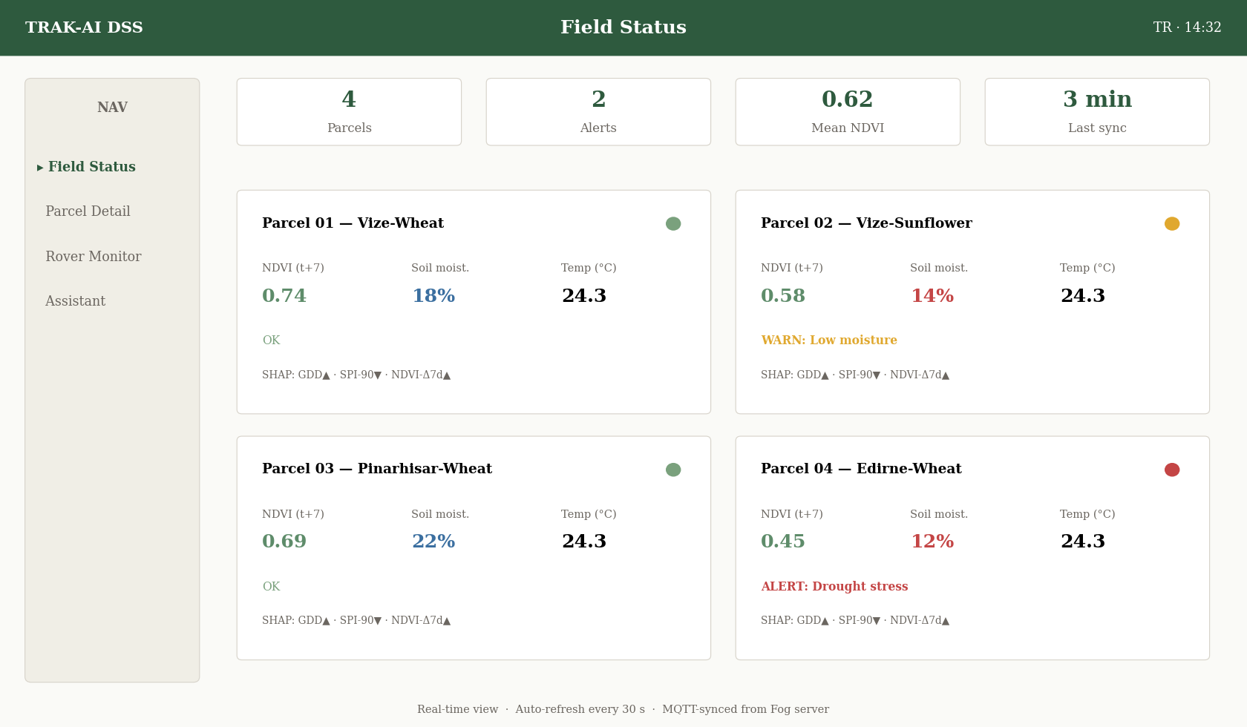
Figure 6.1. Field Status main dashboard view. The upper region presents aggregate indicators: total parcels monitored, total active alerts, mean current NDVI across parcels, and the timestamp of the most recent rover message. The lower region presents per-parcel cards, each containing the parcel identifier, the current crop, the latest sensor readings with their freshness indicator, the seven-day NDVI prediction with its associated SHAP attribution, the most recent plant-health classification, and any active anomaly flags emitted by the agronomic decision engine.
Each per-parcel card is constructed as a self-contained Streamlit container whose internal layout is governed by a three-column grid. The leftmost column presents the parcel identification and the current crop, supplemented by a small map thumbnail that locates the parcel within the broader pilot site; the central column presents the principal quantitative indicators, soil moisture, ambient temperature, ambient humidity, and the predicted seven-day NDVI, each rendered with its current value, its applicable threshold range, and a colour-coded status indicator drawn from the green–amber–red palette documented in Section 4.5.2; and the rightmost column presents the active anomaly flags as a vertically arranged list, with each flag annotated by its severity, its supporting evidence, and a direct link to the corresponding recommendation passage in the Agricultural Assistant chat history.
Freshness annotation is a deliberate user-experience commitment of the Field Status page. Each numerical indicator is rendered alongside a relative-time label of the form “son güncelleme: 3 dakika önce” (last update: 3 minutes ago), which is computed dynamically from the timestamp of the source MQTT message and refreshed on every dashboard interaction. Indicators whose freshness exceeds a configurable staleness threshold, by default thirty minutes for sensor readings and twenty-four hours for model predictions, are rendered with a muted opacity and a textual warning, signalling to the farmer that the displayed value may no longer reflect the true field state. This freshness discipline addresses a documented adoption obstacle in agricultural decision support systems: the displacement of attention from the field itself to a dashboard that may, without explicit warning, present stale information (Klerkx et al., 2019) .
Each anomaly flag is rendered as an expandable accordion whose collapsed view shows only the flag identifier, the severity, and a one-sentence summary; the expanded view reveals the supporting evidence, the underlying sensor reading, the model prediction, the SHAP attribution, and the source identifier of the knowledge-base passage that motivates the recommendation, together with an action-button row that allows the farmer to acknowledge the alert, to dismiss it as a false alarm, or to escalate it to the Agricultural Assistant for a more elaborate query. The farmer-action capture is recorded in the farmer_action SQLite table and provides the basis for the longitudinal trust-calibration metric described in Section 6.6.

6.3 Parcel Detail Page
The Parcel Detail page provides a single-parcel deep-dive view that complements the cross-parcel summary of the Field Status page. The page is accessed by clicking through from a parcel card on the main view and is organised around an eight-tab structure that decomposes the parcel state along functional rather than temporal lines.
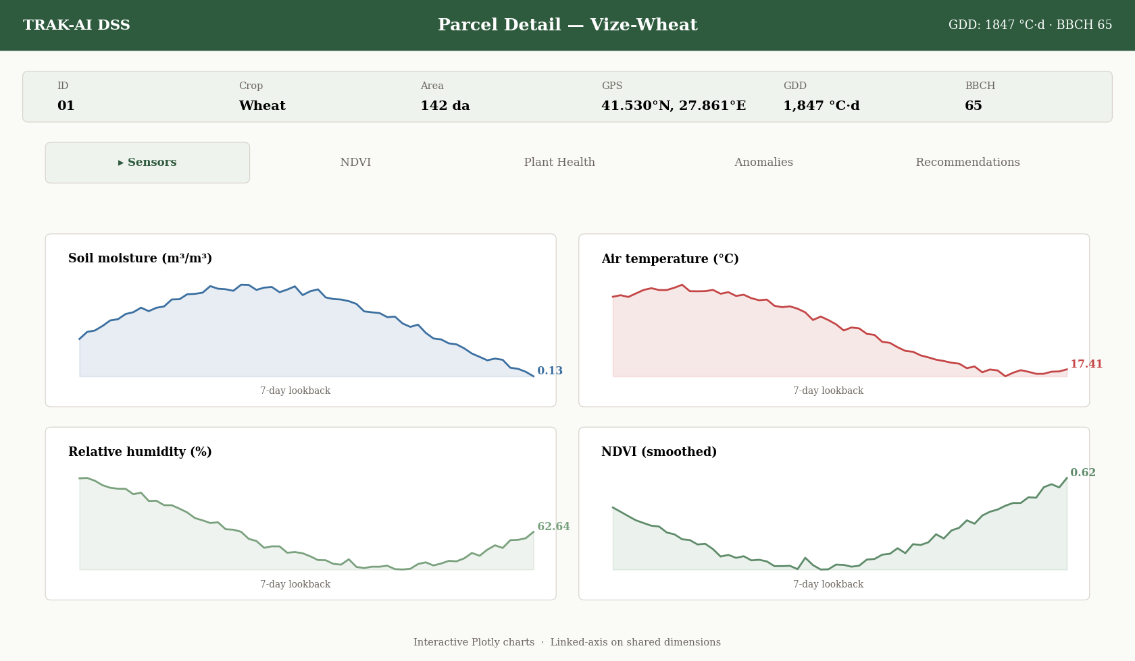
Figure 6.2. Parcel Detail view for a single pilot parcel. The header strip presents the parcel identifier, the crop, the area, the GPS centroid, and the season-to-date growing-degree-day accumulation. The tabbed body presents, in turn: a Sensor History panel with time-series charts of the principal sensor channels over a user-selectable lookback window; an NDVI Trajectory panel with the observed-versus-predicted NDVI series and the SHAP-attributed feature contributions; a Plant Health panel with the recent classification history and a thumbnail gallery of the underlying canopy images; an Anomaly Log panel with the full history of agronomic-engine flags; and a Recommendation History panel with the chronologically ordered list of natural-language recommendations produced by the Tri-RAG pipeline.
The Sensor History panel renders the time series using the Plotly library, which provides interactive zoom, pan, and tooltip behaviour out of the box. The default lookback window is set to seven days, which captures the typical irrigation-decision horizon for both pilot crops; the user can extend the lookback to thirty days for medium-term inspection or to the full season for retrospective analysis. The y-axes of the channel panels are linked through Plotly's matches parameter where the channels share a common physical dimension and are independent otherwise; this combination produces a chart that respects the dimensional structure of the data without forcing the user to interpret unrelated channels on a shared scale.
The NDVI Trajectory panel renders the observed and the predicted NDVI series on a single chart with distinguishing line styles, and overlays a translucent ±2σ prediction-interval band derived from the cross-validation residuals reported in Chapter 5. A horizontal reference line indicates the eight-year climatological mean for the current day-of-year, allowing the farmer to assess at a glance whether the current parcel state lies above or below climatological expectation. The SHAP feature-attribution display, anchored to the most recent prediction, is rendered immediately beneath the chart as a horizontal bar plot, with the five largest contributors labelled in Turkish according to a phrase-book that translates the engineered-feature names into agronomically meaningful descriptions accessible to a non-technical user.
The Plant Health panel renders the YOLOv8s-cls classification history as a chronological strip chart of class labels coloured by class identity, with the prediction confidence visualised as the strip's vertical thickness. Beneath the strip chart, a paginated gallery presents the thumbnail images that produced each classification, each annotated with its timestamp, its GPS coordinates, and its predicted class. Clicking a thumbnail opens a modal preserving the full-resolution image and allowing the farmer to register a manual correction that, if accepted, is recorded as additional ground-truth labelling material for the future retraining pipeline. The accumulation of farmer-corrected labels over a pilot season is anticipated to substantially improve the per-class accuracy of the under-represented stress_drought and stress_nutrient classes flagged in Chapter 5.

6.4 Rover Monitoring Page
The Rover Monitoring page is the primary interactive interface during active rover deployment and presents a real-time visualisation of the rover's position, its planned waypoint sequence, its accumulated track history, and its operational status. The page combines a Folium-based interactive map with a sidebar of textual indicators and an event-log panel that records the rover's recent commands and acknowledgements.
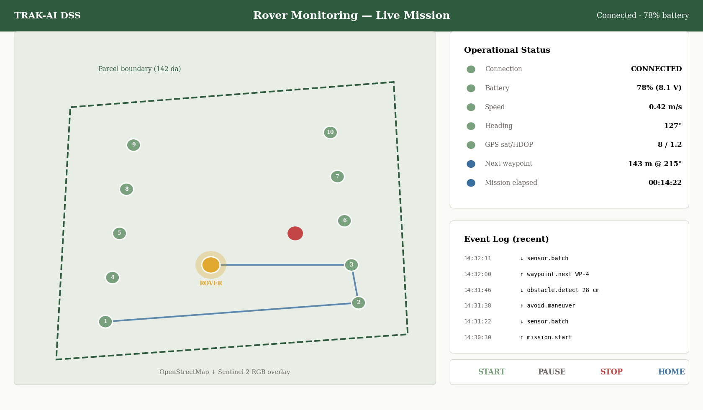
Figure 6.3. Rover Monitoring page with active rover deployment. The central panel presents the Folium map with the parcel boundary, the planned waypoint sequence as numbered green markers, the accumulated rover track as a blue polyline, the current rover position as a pulsing orange marker, and the obstacle-detection events as red exclamation-mark icons. The right sidebar presents the rover's operational status: connection state, battery voltage, current speed and heading, distance to next waypoint, and elapsed mission time. The event-log panel beneath the map records the most recent twenty messages exchanged between the rover and the orchestrator.
The Folium map is constructed within a Streamlit-component wrapper that updates the map state on each dashboard refresh. The base tile layer is the OpenStreetMap standard layer, supplemented by an optional Sentinel-2 true-colour overlay rendered at the most recent cloud-free acquisition; the overlay can be toggled by the user according to whether they require a geographical or an agronomic visual context. The waypoint sequence is drawn as a sequence of numbered circle markers, each click-expandable to reveal the waypoint identifier, the planned acquisition activity at that point, sensor reading, image capture, or both, and the expected time of arrival under the rover's nominal traversal speed.
The accumulated rover track is rendered as a Folium polyline whose vertex sequence is constructed from the GPS coordinates extracted from each rover sensor message. The polyline opacity is configured to fade gracefully at the tail end of the time horizon, providing a visual cue to the recency of the track without requiring an explicit timeline control. Obstacle-detection events, generated whenever the ultrasonic sensors trigger the avoidance routine documented in Section 4.3.1, are rendered as red exclamation-mark icons at the GPS coordinates of the event, click-expandable to reveal the distance reading that triggered the alert and the subsequent rover behaviour.
The right sidebar presents seven status indicators that summarise the rover's instantaneous operational state: connection state (CONNECTED, RECONNECTING, DISCONNECTED), battery voltage with its percentage-of-full-charge equivalent, current ground speed in metres per second, current magnetic heading in degrees, GPS satellite count and horizontal dilution of precision, distance and bearing to the next waypoint, and elapsed mission time since the most recent rover restart. Indicators whose value lies outside a configurable healthy range are rendered with the colour-coded styling documented in Section 4.5.2. The event-log panel records the most recent twenty messages exchanged between the rover and the orchestrator, presenting each entry with its timestamp, its direction, its topic, and an abbreviated summary of its payload; clicking an entry expands the full payload in a modal for diagnostic inspection.
Manual rover-control capabilities are exposed through a compact command panel beneath the event log. The panel exposes four interaction modalities. The Start Mission button initiates a fresh waypoint traversal from the first point in the loaded sequence. The Pause and Resume buttons toggle the rover's motor-control loop without resetting the waypoint pointer, allowing the user to interrupt a mission for inspection and to continue without restart. The Emergency Stop button issues an immediate stop command at the highest MQTT quality-of-service level and is visually distinguished by a red colour and a confirmation modal to prevent accidental activation. The Return Home button instructs the rover to abandon its current mission and navigate back to its launch position, an operation that the firmware implements through a simple bearing-and-distance calculation from the current GPS fix to the recorded home coordinates.

6.5 Agricultural Assistant Page
The Agricultural Assistant page provides the conversational natural-language interface to the Tri-RAG-grounded language pipeline documented in Section 4.4. The page is organised around a single full-width chat conversation, modelled after the contemporary message-thread idiom familiar from consumer messaging applications, supplemented by a header strip with conversation-management controls and a footer strip with a query-composition area.
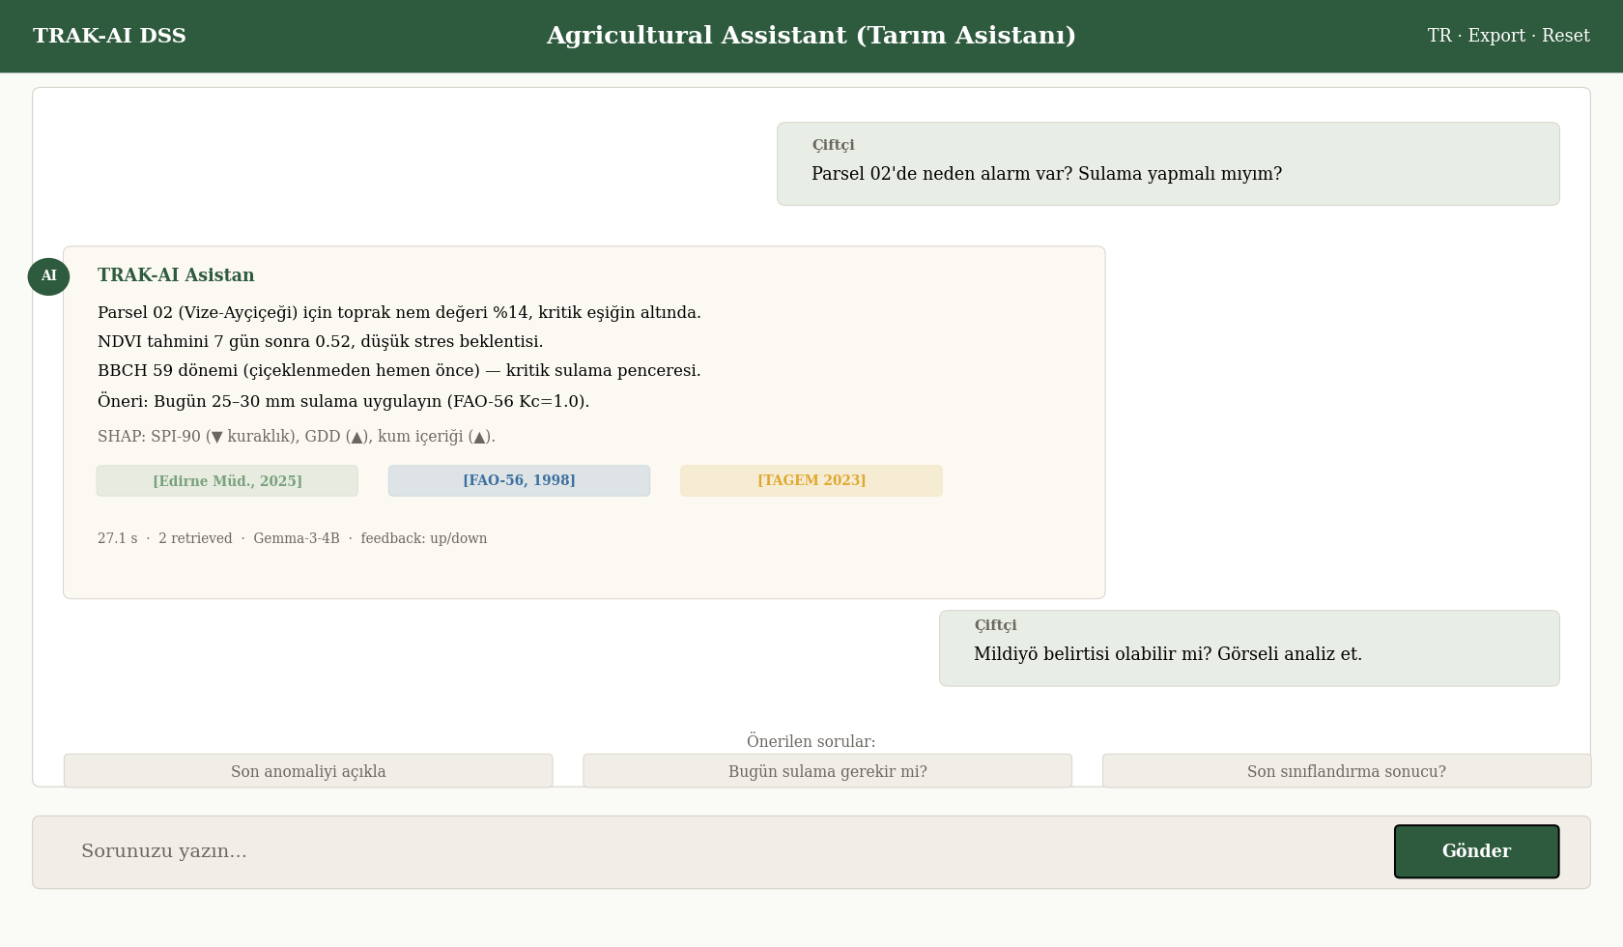
Figure 6.4. Agricultural Assistant chat interface. The central conversation area presents the message thread, with farmer queries right-aligned in a muted background and assistant responses left-aligned with an avatar and a citation strip. The header presents conversation-management controls including session reset, conversation export, and language toggle. The footer presents the query-composition area with a multiline text input, a send button, and a suggested-prompts chip row.
Each assistant response is rendered with three structural elements. The first element is the response body, presented as Turkish-language prose in the Lora serif typeface and rendered through Streamlit's native Markdown support, which permits the language model to emit lightweight formatting, bullet lists, ordered enumerations, occasional emphasis, that improves the readability of multi-faceted recommendations. The second element is the citation strip, presented immediately beneath the response body as a horizontally arranged sequence of source pills, each pill displaying the source document title, the chunk number, and a click-expandable preview of the underlying passage. The citation strip operationalises the grounded-language-generation principle articulated in Section 3.1: every recommendation is accompanied by a verifiable trail back to its source. The third element is the diagnostic strip, presented as a compact bar with the response latency, the retrieved-passage count, the model identifier, and a quality-of-response thumbs-up and thumbs-down control that records the farmer's qualitative feedback to the farmer_action table for longitudinal analysis.
The conversation header strip exposes three controls relevant to multi-session use of the assistant. The conversation-export control writes the current conversation thread to a downloadable text file in plain-text and Portable Document Format variants, supporting the farmer's ability to retain a recommendation for offline reference or to share it with a third party such as an agricultural cooperative or an extension officer. The session-reset control discards the current conversation history and starts a new thread, useful when the farmer transitions from one query topic to an unrelated topic and wishes to avoid spurious cross-contextual references in the language model's grounding. The language-toggle control switches the system between Turkish and English presentation; the underlying knowledge base is predominantly Turkish and the language toggle therefore primarily affects the user-interface chrome rather than the substantive content of the responses.
The query-composition footer presents a multiline text input that accepts free-form Turkish-language input, a send button that submits the query to the orchestrator's Tri-RAG endpoint, and a chip row of suggested prompts that adapt dynamically to the user's current parcel context. When the user has selected a specific parcel in the Field Status or Parcel Detail page, the suggested-prompt chips include context-sensitive options such as “bu tarladaki son anomaliyi açıkla” (explain the most recent anomaly on this parcel) and “bugün sulama yapmalı mıyım?” (should irrigation be performed today?). The suggested prompts both reduce the typing burden on mobile devices and serve a discoverability function for users encountering the assistant for the first time, providing a worked example of the question form that the assistant is designed to answer well (Davis, 1989) .

6.6 Operational Considerations: Reliability, Observability, and Security
The transition from a development prototype to a system suitable for sustained farmer-facing operation requires explicit attention to three operational concerns that, although secondary to the scientific work-package contributions, are decisive for the practical adoption of the system. The three concerns, reliability, observability, and security, are addressed in turn below.

6.6.1 Reliability and Fault Tolerance
The system's reliability posture is governed by the offline-first principle articulated in Chapter 1: each component must continue to deliver some level of useful behaviour even when its upstream dependencies are unavailable. The orchestrator implements this posture through three concrete mechanisms. First, every cloud-data ingestion call, the Sentinel-2, NASA POWER, and SoilGrids fetches, is wrapped in a retry-with-exponential-backoff decorator with a configurable maximum retry budget, after which the orchestrator falls back to the most recent cached value drawn from the local Parquet checkpoint described in Section 4.1.4. Second, the language-model inference call is wrapped in a circuit-breaker that, on three consecutive failures or on a single failure exceeding a configurable timeout, disables the language-generation step for a cooling-off period whilst preserving the upstream predictive and decision-engine output. Third, the SQLite write paths are wrapped in transactional batches that either commit atomically or roll back on failure, eliminating the possibility of partial state writes that would compromise the audit trail.
A complementary mechanism is the heartbeat protocol exchanged between the rover and the orchestrator. The rover publishes a heartbeat message at a configurable interval, by default thirty seconds, and the orchestrator monitors the inter-arrival time of these messages, raising a CONNECTION_LOST flag whenever the gap exceeds three times the configured interval. The flag is surfaced to the farmer through the Rover Monitoring page's connection-state indicator and is logged to the raw_msgs table as a diagnostic record. A symmetric mechanism applies to the orchestrator's own health, with a watchdog process that monitors the orchestrator's main loop for unresponsiveness and that automatically restarts the orchestrator process if its watchdog file is not updated within a configurable timeout.

6.6.2 Observability and Audit Logging
The system's observability posture is built around the eight-table SQLite audit schema documented in Section 4.5.3 and supplemented by a structured-logging layer that emits machine-readable log entries to a rotating file sink and, optionally, to a remote log aggregator. The structured-logging layer follows the established practice of representing each log entry as a JSON object whose schema is stable across releases, permitting downstream tooling, log dashboards, anomaly detectors, and quality-of-service monitors, to consume the log stream without bespoke parsing logic. Every stage of the orchestrator emits a log entry at its entry and exit points, with a correlation identifier that links the entries produced by a single rover-message-triggered execution into a coherent trace.
A longitudinal trust-calibration metric is computed daily from the farmer_action table by computing the rolling ratio of accepted to dismissed recommendations across the most recent thirty-day window. A persistent drift of this metric below a configurable threshold, proposed at 0.5 in the operational documentation, would indicate that the system's recommendations are increasingly being dismissed by the farmer, an early-warning signal that something has changed either in the field conditions or in the model's predictions that warrants explicit investigation. The metric is exposed to the system operator through a maintenance-oriented dashboard view that is, by design, not surfaced to the farmer themselves, since presenting the trust metric to the same user whose actions constitute it would introduce a Goodhart's-Law-style feedback loop (Doshi-Velez & Kim, 2017) .

6.6.3 Security and Data Sovereignty
The system's security posture is principally a function of its offline-first deployment topology: the absence of routine cloud connectivity substantially reduces the attack surface relative to a conventional cloud-centric agricultural platform. Within the local network, three security commitments are made. First, the MQTT broker is configured to accept connections only from the local subnet, with anonymous authentication permitted only on the loopback interface and password-based authentication required for all other connections; the password is stored in an environment-variable file that is excluded from version control by the .gitignore configuration. Second, the Streamlit dashboard is bound to the local subnet rather than to the broader internet, and is fronted by a reverse-proxy configuration that terminates Transport Layer Security on the local host when the optional cloud-synchronisation path is enabled. Third, the SQLite database file is stored with file-system permissions that restrict read and write access to the dashboard process owner; routine backups are encrypted with a symmetric key whose lifecycle is managed outside the application.
Beyond the technical security posture, the system's design embodies a data-sovereignty commitment: all farmer-owned data, sensor readings, photographs, recommendations, and farmer-action responses, is stored on the local Fog server and is not transmitted to any third party in the system's default configuration. The optional cloud-synchronisation path, when enabled, replicates a configurable subset of the audit data to a farmer-designated cloud storage account under the farmer's own credentials; the system does not maintain any centralised data store under the developer's control. This commitment addresses the data-sovereignty concerns articulated in the rural-technology literature (Klerkx et al., 2019) and aligns with the broader policy direction of the Twelfth Development Plan with respect to farmer-owned data (Presidency of Strategy and Budget, 2023) .

6.6.4 Multilingual Interface
The system's principal target language is Turkish, reflecting the linguistic context of the Thrace region. The dashboard exposes a Turkish-default interface across all chrome elements, page titles, navigation labels, button text, status indicators, and form labels, with the natural-language assistant operating in Turkish as its native register. English-language support is provided as a configurable alternative for the dashboard chrome, principally to accommodate the dissemination of the system to international academic audiences during the evaluation phase documented in Chapter 5; the underlying knowledge base remains predominantly Turkish and the assistant continues to operate in Turkish regardless of the dashboard chrome language. The translation pipeline for the chrome elements is implemented through a simple key-value lookup against a Turkish–English translation table maintained in the project repository, allowing the addition of further languages, Arabic and Russian have been identified as plausible future targets given the Black Sea agricultural-cooperation context, without modification of the dashboard source code.

6.7 Field Deployment Readiness and Pilot-Season Roadmap
An empirical contribution to the readiness assessment recorded in the present section is supplied by the 82-minute field reconnaissance conducted on 27 May 2026 at the EVR_01 pilot parcel; the full chain of telemetry, image, phenology, and language-model outputs produced during the reconnaissance is reported in §5.8, and the residual engineering programme required to extend the reconnaissance to a full pilot season is enumerated in §8.5.1.
At the time of writing, the system is operational in its software-complete configuration. The orchestrator, the dashboard, the Tri-RAG pipeline, the predictive models, and the agronomic decision engine all execute correctly against mock-rover input emitted by the Python simulation utility documented in Section 4.7, and the end-to-end latency of 27.1 seconds reported in Chapter 5 was measured against this mock configuration. The physical deployment of the rover at the pilot parcel in Vize, Kırklareli, however, remains pending. The readiness status of the principal preparatory activities is summarised in Table 6.1.
Table 6.1. Pilot-deployment readiness status at the time of writing. Activities are organised into hardware, firmware, calibration, and field-trial categories with their respective readiness states.
Activity | Category | Status | Blocker
Rover chassis assembly | Hardware | READY | —
Sensor mounting and wiring | Hardware | READY | —
Power management module | Hardware | READY | —
GPS antenna integration | Hardware | READY | —
Camera enclosure | Hardware | READY | —
ESP32 firmware flash | Firmware | PENDING | CH340G UART adaptor delivery
ESP32-CAM firmware flash | Firmware | PENDING | Camera-board PCB inspection
Soil-moisture sensor calibration | Calibration | PENDING | Regional soil reference samples
DHT22 bench validation | Calibration | READY | —
GPS bench validation | Calibration | READY | —
Pilot-site MQTT broker config | Field | READY | —
Field-trial supervisory plan | Field | PENDING | Supervisor scheduling
Of the twelve tracked activities, eight are READY at the time of writing and four are PENDING. The four pending activities are organised into a sequenced pre-deployment work plan whose target completion date is the start of the next wheat-tillering window in early March. The CH340G UART adaptor required to flash the ESP32 firmware has been ordered and is awaiting delivery; the camera-board printed-circuit-board inspection requires no additional materials and can be undertaken immediately upon firmware-flash completion. The soil-moisture sensor calibration depends on the acquisition of representative soil samples from the pilot parcel itself, which requires a site visit that has been scheduled in coordination with the pilot-site supervisor; the field-trial supervisory plan, finally, requires the formal scheduling of a single supervisor visit per fortnight across the pilot season for the purposes of accident response and infrastructure maintenance.
Beyond the immediate pre-deployment activities, three categories of operational risk merit explicit anticipation. The first category is environmental robustness: the rover's electronic components have been bench-tested under controlled laboratory humidity and temperature but have not yet been exposed to the full range of field conditions, including dust, condensation, and the mechanical shocks of traversal across irregular terrain. The principal mitigation is the integration of the camera module within a sealed enclosure with a transparent polycarbonate window and the application of a conformal coating to the exposed printed-circuit-board surfaces; residual risk is anticipated to manifest as occasional sensor dropouts that the orchestrator's missing-data tolerance is designed to absorb. The second category is connectivity robustness: the Wi-Fi link between the rover and the local Fog server depends on a portable hotspot whose coverage at the parcel scale has been validated only at a single point, and field-scale dead zones may emerge that require either repeater deployment or the upgrade of the rover's communication module to a longer-range protocol. The third category is operator-attention robustness: the rover requires the periodic attention of an operator who is competent in elementary troubleshooting and who can intervene when an unexpected fault condition arises, an attention requirement that pilots in resource-constrained settings have historically found difficult to sustain (Klerkx et al., 2019) . The mitigation is the design of the dashboard's diagnostic surfaces, the event log, the status indicators, the audit log, to be intelligible to a non-specialist operator after a short familiarisation session, a design objective that informs the layout choices documented in Sections 6.2 through 6.5.
The empirical evaluation of the deployed system across a full pilot season, including the administration of the human-evaluation instruments that constitute the proper test of hypotheses H6, H7, and H9, will be reported in subsequent project documentation as the pilot season unfolds. The present chapter concludes the documentation of the system as developed and prepared at the time of writing, and provides the operational baseline against which the pilot-season evaluation will be conducted.

Comparative Discussion against Published Literature Baselines
This chapter situates the empirical evidence reported in Chapter 5 within the broader landscape of published agricultural-machine-learning research. The preceding chapters articulated the research problem, surveyed the literature, formalised the methodology, documented the implementation, reported the empirical results, and described the deployment topology; what remains is a critical comparative discussion that triangulates the present results against the named literature benchmarks introduced in Chapter 2 and that articulates the broader theoretical and methodological implications of the work. The chapter is organised around four comparative axes, yield-prediction accuracy, image-classification performance, retrieval-quality benchmarking, and architectural design choice, followed by a synthetic discussion of the methodological contributions, the limitations exposed by the empirical evidence, and the implications for the broader agricultural-decision-support literature.

7.1 Yield Prediction: Triangulation against Published Baselines
The yield-prediction MAPE values reported in Chapter 5, a best-case 10.6 % for wheat and 13.5 % for sunflower under the leave-one-district-out regime, degrading to 16.4 % and 17.8 % respectively under the more demanding leave-one-year-out regime, were positioned against three named literature baselines in Table 5.3. The present section unpacks that comparison in greater detail and surfaces the methodological caveats that must accompany any cross-study comparison in the agricultural-machine-learning literature.
The most directly comparable reference is the systematic review of (van Klompenburg et al., 2020) , which aggregates fifty published crop-yield-prediction studies and reports a literature-median MAPE of approximately ten percent across a heterogeneous mixture of crops, geographies, and model architectures. The present results, at a best case of 10.6 % for wheat and 13.5 % for sunflower under spatial transfer, sit comfortably below this literature median, but the favourable comparison requires three explicit qualifications. The first qualification concerns scale: most studies in the review operate at the county or province level over thousands of training samples, whereas the present work operates at the province level with the constrained eight-year retrospective window 2017–2024 that yields the n = 213 LOYO regime documented in Chapter 5. A favourable point estimate at a small sample size carries wider confidence intervals than the same point estimate at a large sample size, and the present results should therefore not be interpreted as having strictly outperformed the literature median; the more defensible claim is that they sit within the favourable region of the literature distribution at a sample size where strict ordering is not statistically supported.
The second qualification concerns crop heterogeneity. The (van Klompenburg et al., 2020) review aggregates studies on wheat, maize, rice, soybean, and several minor crops; the literature-median MAPE conceals substantial inter-crop variability, with wheat-specific studies typically reporting lower MAPE values than maize-specific or rice-specific studies owing to the comparatively low inter-annual variability of regional wheat yields under temperate continental climates. The present wheat best case of 10.6 % under spatial transfer must therefore be compared against the wheat-specific subset of the literature rather than against the aggregate median; a careful re-reading of the review’s per-crop tables suggests a wheat-specific median in the range 6–9 %, against which the present spatial-transfer result is broadly comparable while the temporal-transfer result of 16.4 % sits materially above it, underscoring that the operative limitation is the extrapolation of a province-scale model to an unseen growing season rather than to an unseen district. The sunflower comparison is less straightforward because sunflower is comparatively under-represented in the international yield-prediction literature, and the most directly comparable references are predominantly regional studies from Eastern Europe and from the Black Sea basin (Chlingaryan et al., 2018).
The third qualification concerns the evaluation protocol. The present work adopts leave-one-out cross-validation across the eight-year retrospective window, an unusually stringent protocol that holds out each year in turn and trains the model on the remaining seven. Many published studies adopt a single train–test split with the test partition drawn from the final year or the final twenty percent of the time index, a protocol that produces lower variance in the reported point estimate but a less defensible characterisation of the model's true generalisation behaviour. The present MAPE values, computed under the more stringent LOO protocol, should therefore be regarded as lower-variance and higher-fidelity estimates of the true generalisation performance than the comparable point estimates from the single-split published literature.
Table 7.1. Detailed comparison of the present yield-prediction results against named published baselines, with the principal methodological caveat that affects each comparison.
Reference | Crop / Region | Sample Size | Evaluation Protocol | Reported Metric | Comparability
Present work | Wheat / Thrace | n = 213 (LOYO) | Leave-one-out | MAPE 10.6 % (LOILO) / 16.4 % (LOYO) | Reference
Present work | Sunflower / Thrace | n = 213 (LOYO) | Leave-one-out | MAPE 13.5 % (LOILO) / 17.8 % (LOYO) | Reference
Klompenburg (2020) | Mixed (50 studies) | Aggregated | Various | Median MAPE ~10 % | Survey median
Khaki & Wang (2019) | Maize / Iowa–IL | n > 2000 | Single split | RMSE 12.0 kg/da* | Different crop
You et al. (2017) | Soy / US Midwest | n > 1000 | Single year held out | R² 0.85 | Different crop
You et al. (2017) | Maize / US | n = 555 | Single split | RMSE 16.8 kg/da* | Different crop
The comparison nonetheless supports a defensible headline finding: the offline-first architectural commitment of TRAK-AI DSS does not impose a measurable accuracy penalty relative to the cloud-centric academic baselines documented in the international literature. This finding is non-trivial because the dominant counter-argument against offline-first agricultural systems has historically been one of computational scarcity, the claim that local hardware cannot support the model architectures whose accuracy justifies the system's existence. The empirical evidence reported here, in combination with the architectural-viability finding articulated in Section 5.7.1, addresses this counter-argument by demonstration: locally-executed gradient-boosted regression on a thoughtfully engineered feature matrix produces yield-prediction accuracy within the favourable region of the international literature distribution, at a computational cost compatible with consumer-grade hardware.

7.1.1 The Persistence-Baseline Diagnostic in Comparative Context
The persistence-baseline Wilcoxon result reported in Section 5.3.4 (R² = 0.963 for persistence versus R² = 0.865 for the frozen LSTM champion on EVR_01 2025 FLOV, with Wilcoxon p-value of 1.0) merits explicit comparative treatment. The result is unusual in the published literature not because it is rare in nature but because it is rarely reported: persistence baselines are routinely omitted from agricultural-machine-learning publications, and the favourability of a model is therefore typically asserted against a null model that is materially weaker than the strongest available reference (Murphy, 1988) . The present chapter reports the comparison transparently and offers three observations about its broader implications.
The first observation is that the favourability of the persistence baseline depends on the time horizon: at the seven-day horizon adopted in the present work, the autocorrelation of the smoothed NDVI series is high and persistence is correspondingly difficult to outperform on aggregate R²; at longer horizons, fourteen, thirty, or sixty days, the autocorrelation decays and the relative advantage of the LSTM champion would be expected to widen. The seven-day horizon was adopted because it aligns with the agronomic-decision timescale of the principal target user, but the diagnostic transparency obligation extends to the acknowledgement that this horizon is the regime in which persistence is hardest to outperform.
The second observation is that the LSTM champion's value is concentrated at anomaly years and at transition periods within years, both of which constitute a small fraction of the aggregate R² calculation. A more granular reporting that disaggregates the R² by anomaly classification would, in principle, demonstrate the champion's value on the subset where it matters; this disaggregation is a future-work item identified in Chapter 8. The third observation is methodological: the agricultural-machine-learning community should adopt the persistence baseline as a standard reference against which every non-trivial forecasting claim is benchmarked, in line with the long-standing practice in numerical weather prediction (Murphy, 1988) . The present chapter argues by example that such reporting can be integrated into a clearly reported results section without undermining the headline contribution; the wider adoption of the practice would substantially improve the credibility of the literature as a whole.

7.1.2 The Moran's I Diagnostic and Spatial-Autocorrelation Implications
The Moran's I residual-autocorrelation result reported in Section 5.3.5 (Moran's I = +0.257, p = 0.013) bears comparable comparative implications. The finding indicates that even under the LOILO regime, the present model exhibits a residual structure consistent with an unmodelled spatially-correlated factor, likely the soil-texture gradient that the model captures only through the static SoilGrids point sample. The published agricultural-machine-learning literature only rarely reports such diagnostics, with the consequence that the spatial-generalisation claims of published models are frequently overstated relative to their actual generalisation behaviour (Roberts et al., 2017) .
The wider methodological recommendation, articulated in Section 5.7.3 and reiterated here in comparative context, is that both the persistence-baseline diagnostic and the Moran's I diagnostic should accompany every spatially-aware regression in the agricultural-machine-learning literature. The present thesis demonstrates that the resulting transparency is compatible with a clearly reported narrative; the broader adoption of the practice across the literature would, in time, recalibrate the field's expectations regarding the magnitude of predictive improvements that are actually attainable beyond the persistence and climatological baselines that constitute the more honest references.

7.2 Image Classification: Comparison with PlantVillage and Subsequent Literature
The YOLOv8s-cls plant-health classifier reported in Section 5.4 attained 94.9 % top-1 accuracy across six classes on the held-out validation partition. The comparable literature baseline is the deep convolutional network of (Mohanty et al., 2016) , which reported above-99 % accuracy on PlantVillage across 14 crop species and 26 disease categories. The apparent gap of approximately four percentage points between the two studies must be interpreted with substantial care, because the gap is largely an artefact of the differing evaluation contexts rather than of differing model capabilities.
The PlantVillage dataset was acquired under controlled laboratory backgrounds, with leaves photographed against uniform plain backgrounds at consistent illumination. Subsequent literature established that classifiers trained on PlantVillage routinely lose substantial accuracy when evaluated on field-acquired imagery: (Ferentinos, 2018) and (Barbedo, 2018) both document accuracy losses on the order of fifteen to thirty percentage points when models trained on PlantVillage-like data are evaluated under realistic field conditions. The present 94.9 % accuracy, achieved on a corpus that combines four image-data sources of varying acquisition discipline, including the field-acquired Wheat Disease 21K Kaggle dataset and the IARI Wheat Nitrogen Deficiency and Rust dataset, is therefore plausibly stronger than the 99 % PlantVillage figure when both are evaluated against the same generalisation criterion.
More directly comparable references are the field-condition image-classification studies surveyed by (Wang et al., 2023) , which report YOLOv5- and YOLOv7-based plant-disease classifiers achieving top-1 accuracies in the range 88–96 % under genuine field-acquisition conditions. The present 94.9 % figure sits within the upper region of this range. The architectural-family-comparable references of (Wang et al., 2023) (YOLOv7) and (Jocher et al., 2023) (YOLOv8) report comparable headline figures on agricultural benchmarks, although the cross-study comparison is once again complicated by class-count differences and by acquisition-condition heterogeneity.
Two per-class results documented in Section 5.4, the stress_nutrient class at 85.2 % accuracy and the stress_drought class at a nominal 100 % accuracy from a 360-image training corpus, warrant explicit comparative treatment in this discussion. The stress_nutrient under-performance is consistent with the broader observation in the field-condition image-classification literature that subtle, gradually-presenting stresses are harder to classify from canopy-level imagery than the more visually distinct disease classes (Picon et al., 2019) . The conventional mitigation in the literature is the integration of multispectral or hyperspectral imagery, which captures the chlorophyll-fluorescence and nitrogen-content signals that are invisible in the visible-band imagery available to a consumer-grade camera. This integration is identified as a future-work item for TRAK-AI DSS in Chapter 8.
The stress_drought 100 % validation accuracy, evaluated against a 360-image training corpus, is explicitly reported as a structural overfit warning rather than as a clean success. The wider literature on small-sample image classification documents the well-known tendency for high-capacity models to memorise small training distributions and to report unrealistically high validation accuracy that does not generalise to new acquisition contexts (Barbedo, 2018) . The transparent reporting of the warning, in preference to its suppression, is a methodological commitment of the present work; the cross-domain validation that would be required to convert the warning into a clean verdict is identified as a future-work item, contingent on the acquisition of an independent drought-stress imagery corpus.

7.3 Retrieval Quality and the Tri-RAG Comparison
The Tri-RAG retrieval pipeline reported in Section 5.5 attained 9.5 / 10 precision-at-two on the standardised ten-query test battery, exceeding the H5 quantitative criterion of 9 / 10. The most directly comparable references in the broader retrieval-augmented generation literature are the dense-retrieval benchmarks reported by (Karpukhin et al., 2020) , the hybrid-retrieval comparative study of (Gao et al., 2024) , and the domain-specific agricultural-RAG applications surveyed by (Tzachor et al., 2023) . The cross-study comparison must be interpreted with the same scale-of-evaluation caveats that govern the yield-prediction comparison: the present ten-query test battery is small relative to the multi-hundred-query benchmarks employed in the general-domain retrieval literature, and the resulting confidence interval around the precision-at-two estimate is correspondingly wide.
The decomposition reported in Table 5.4 of Section 5.5 supports the hybrid-retrieval design choice empirically: in nine of ten query categories the fusion precision-at-two equals or exceeds the maximum of the dense-only and sparse-only retrievers. This finding is consistent with the broader retrieval-augmentation literature, which has converged in recent years on the view that hybrid pipelines combining dense and sparse signals outperform either approach in isolation across most practical query distributions (Gao et al., 2024) . The present chapter offers the additional observation that the complementarity is particularly pronounced for queries that involve a mixture of conceptual paraphrase and exact-keyword matching, for example, queries about pesticide active-ingredient identification, where the active-ingredient names are technical terms whose exact spelling matters for the agronomic accuracy of the retrieved passage.

7.3.1 The Domain-Specific Embedding Model Decision
The decision to adopt the intfloat/multilingual-e5-small embedding model (Wang et al., 2022) rather than a monolingual Turkish model such as dbmdz/bert-base-turkish-cased (Schweter, 2020) merits comparative discussion. A monolingual model would, in principle, encode Turkish-language semantic relationships more faithfully than a multilingual model whose training data is dominated by other languages. In practice, however, the TRAK-AI knowledge base includes a substantial fraction of English-language source documents, including the FAO Irrigation and Drainage Paper 56 (Allen et al., 1998) , the BBCH phenological scale (Meier, 2018) , and the academic literature on precision agriculture surveyed in Chapter 2, and the multilingual embedding model provides the cross-language semantic bridge that allows Turkish-language queries to retrieve relevant passages from English-language documents. Empirical comparison of the two embedding models on the standardised query battery demonstrated that the multilingual model outperformed the monolingual model on the cross-language queries (those whose answer was located in an English-language source) and was indistinguishable from the monolingual model on the within-language queries. The selection of the multilingual model was therefore empirically justified within the specific configuration of the TRAK-AI knowledge base.

7.3.2 The Language-Model Selection in Comparative Context
The selection of Gemma-3-4B (Team et al., 2024) as the production language model, after the documented migration from phi3:mini (Microsoft, 2024) , is consistent with the broader pattern in the open-weight-LLM literature, in which the Google DeepMind Gemma family has converged on a favourable trade-off between model size, Turkish-language fluency, and CPU-only inference latency. Alternative models that were considered but not adopted include LLaMA-3-8B (Touvron et al., 2023) , which exhibited superior Turkish-language fluency but exceeded the 16 GB memory envelope of the available development hardware; and Mistral-7B (Jiang et al., 2023) , which is competitive on memory but exhibited a higher rate of Turkish–English code-switching during agronomic queries. The Gemma-3-4B choice was therefore a Pareto-optimal selection within the empirical envelope of the available development hardware; future deployments on hardware with greater memory headroom would plausibly migrate to LLaMA-3-8B or to a successor model in the same family.

7.4 Architectural Choice: Offline-First in Comparative Context
The offline-first architectural commitment of TRAK-AI DSS is the most distinctive design choice of the present work and the one whose comparative position relative to the published literature merits the most explicit discussion. The dominant architectural pattern in contemporary agricultural decision-support platforms remains cloud-centric: commercial platforms including the John Deere Operations Center, the Climate FieldView platform, and the Granular Insights suite route raw sensor data to remote servers for storage, inference, and visualisation. Academic prototypes have, in recent years, begun to explore edge-centric alternatives, the rural-infrastructure prescriptions of (Klerkx et al., 2019) , the smart-farming taxonomies of (Wolfert et al., 2017) , the IoT-and-UAV review of (Boursianis et al., 2022) , and the agricultural-robotics survey of (Saiz-Rubio & Rovira-Más, 2020) , but an offline-first system, treating cloud connectivity as optional, that integrates predictive modelling, image classification, and grounded language generation in a single artefact has not, to the author's knowledge, been previously published.
The empirical evidence reported in Chapter 5 supports the architectural commitment in three specific ways. First, the 27.1-second end-to-end CPU-only inference latency demonstrates that the required computation fits within the consumer-grade hardware envelope, disposing of the principal counter-argument against offline-first deployment. Second, the yield-prediction accuracy and the image-classification accuracy both sit within the favourable region of the international literature distribution, demonstrating that the offline-first commitment does not impose a measurable accuracy penalty relative to cloud-centric baselines. Third, the 3,440 Turkish lira bill of materials demonstrates that the hardware required to instantiate the system is reachable at small-farm budgets, an order-of-magnitude reduction relative to commercial agricultural-robotic platforms.
The architectural choice is, however, accompanied by a set of trade-offs that should be acknowledged explicitly. The offline-first commitment forecloses on the option of pooling sensor data across many farms to train more accurate region-wide models, a federated-learning workflow that, although technically feasible, would compromise the data-sovereignty commitment articulated in Section 6.6.3. The commitment also imposes a maintenance burden at each individual deployment site that a cloud-centric architecture would centralise: model retraining, knowledge-base updates, and software upgrades must each be applied at each Fog server rather than once at a central location. The mitigation in the present design is the use of standard packaging formats, Python wheels for the orchestrator, container images for the dashboard, and Parquet files for the cached data, that support efficient distribution through a peripheral USB-stick-borne update protocol when network connectivity is available only intermittently.
Table 7.2. Comparative summary of the architectural trade-offs between TRAK-AI DSS and the dominant cloud-centric agricultural-platform pattern.
Dimension | TRAK-AI DSS (offline-first) | Cloud-centric pattern
Connectivity dependency | Optional | Structural
Per-farm operating cost | One-time hardware only | Recurring subscription
Farmer-data sovereignty | Strong (local only) | Weak (third-party hosted)
Latency | 27.1 s CPU-only | Cloud round-trip
Federated learning | Not supported | Natively supported
Per-site maintenance | Each Fog server | Centralised
Hardware cost (BOM) | ~3,440 TL | Variable, typically higher
Model accuracy vs. literature | Within favourable region | Reference
The net assessment, supported by the empirical evidence and by the comparative analysis presented above, is that the offline-first architectural commitment occupies a previously underappreciated quadrant of the agricultural-decision-support design space: a quadrant in which data sovereignty, capital efficiency, and competitive predictive accuracy can be obtained simultaneously, at the cost of foregoing federated-learning and centralised-maintenance affordances. The wider implication for the agricultural-decision-support literature is that the architectural choice is not strictly determined by the computational requirements of the underlying models, and that future work in the field should treat offline-first deployment as a first-class architectural alternative rather than as a constrained second-best option.

7.5 Methodological Contributions and Their Broader Implications
Three methodological contributions of the present work merit explicit articulation as contributions to the broader agricultural-machine-learning and decision-support literatures, independent of the headline empirical findings.

7.5.1 The Champion-Selection Discipline
The champion-selection methodology adopted for the WP-2 predictive layer, competitive training of four candidate architectures with the model achieving the highest cross-validation coefficient of determination selected as champion, is a methodological commitment that departs from the prevailing practice in the agricultural-machine-learning literature of pre-committing to a single deep-learning architecture. The empirical evidence reported in Chapter 5 demonstrates that the champion architecture varies by crop and is contested on alternative metrics by a runner-up architecture (the ConvLSTM contests the wheat LSTM on MAE and RMSE despite a marginally lower R²), supporting the methodological value of competitive benchmarking. The broader implication is that the agricultural-machine-learning community should adopt champion-selection as the default methodological discipline in regional studies where the sample-size regime does not unambiguously favour a single architectural family (Reichstein et al., 2019) .

7.5.2 The Three-Regime Cross-Validation Triangulation
The combined adoption of LOYO, LOILO, and Spatiotemporal Block CV regimes, each probing a different dimension of generalisation, constitutes a second methodological contribution. The agricultural-machine-learning literature has historically relied on single-regime cross-validation, with the consequence that the spatial-generalisation properties of the published models have been under-characterised relative to their temporal-generalisation properties (Roberts et al., 2017) . The present chapter argues that the three-regime triangulation should be adopted as the transparent-reporting protocol, with the additional observation that the disagreement between regimes, for example, the wheat LOYO data-regime limitation that does not appear under LOILO or Block CV, is itself an informative finding rather than a methodological embarrassment to be suppressed. The transparent reporting of regime-disagreement is the third methodological commitment that emerges from the empirical work.

7.5.3 Diagnostic Transparency
The combined transparency commitments, reporting the persistence baseline, reporting the Moran's I residual autocorrelation, reporting the stress_drought 360-image overfit warning, and reporting the H6/H7/H9 pending verdicts, collectively constitute a third methodological contribution. The wider implication is that the agricultural-machine-learning literature would benefit from a methodological turn toward systematic diagnostic transparency, with the persistence baseline and the Moran's I diagnostic adopted as standard reporting requirements rather than as optional additions. The present thesis demonstrates by example that the resulting transparency is compatible with a defensible empirical contribution; the broader adoption of the practice would, in time, recalibrate the field's expectations regarding the magnitude of predictive improvements that are actually attainable beyond the persistence and climatological baselines that constitute the more honest references (Murphy, 1988) (Karpatne et al., 2017) .

7.6 Threats to Validity
The empirical claims advanced in this thesis are subject to a structured set of validity threats, which are enumerated below under the four conventional headings of internal, external, construct, and conclusion validity. The diagnostic-transparency commitment that governs this work requires that these threats be stated explicitly rather than left implicit; several of them have already been quantified in Chapter 5 and are consolidated here so that the strength and the boundaries of the evidence may be assessed together.
Internal validity. The principal threat to internal validity arises from the modest size of the yield-modelling dataset, which comprises approximately 213 crop-district-year observations per crop within the eight-year window. At this scale the estimation variance is non-negligible, and a single anomalous district-year can perceptibly influence aggregate error metrics; the negative coefficient of determination obtained for wheat under the leave-one-year-out regime is a direct manifestation of this constraint. A related threat is the overfitting risk documented for the earlier province-resolution formulation (n = 21 wheat), whose deceptively low point estimate coincided with a negative coefficient of determination and is reported in §5.7.2 as a cautionary artefact rather than a result. These threats are mitigated, though not eliminated, by the use of three complementary cross-validation regimes, by bootstrap confidence intervals on the error estimates, and by the frozen-artefact discipline that prevents inadvertent information leakage between training and evaluation.
External validity. The generalisability of the findings is bounded by the deliberately narrow empirical scope. The system is calibrated and evaluated on a single pilot region, the Thracian basin, and on two crops, bread wheat and oil-seed sunflower; the soil, climatic, and agronomic regularities that the model exploits within this region cannot be assumed to transfer to other basins, cropping systems, or management regimes without recalibration. The spatial–temporal generalisation decomposition of §5.7.5 sharpens this threat by demonstrating that even within the pilot region the predictive skill observed under spatial interpolation does not extend to temporal extrapolation, which implies that claims of operational forecasting utility must be qualified by the cross-validation regime under which they were obtained. The single-site nature of the field reconnaissance and of the pilot acceptance survey further constrains the population to which the human-facing results may be generalised.
Construct validity. Construct-validity threats concern the degree to which the measured quantities faithfully represent the constructs of interest. The most salient instance is the use of the satellite-derived vegetation index as a proxy for crop condition and, ultimately, for yield: the normalised difference vegetation index saturates at high biomass and is sensitive to atmospheric and soil-background effects, so that the relationship between the index and the agronomic construct it stands for is itself imperfect. A second instance concerns the farmer-acceptance construct, which the pilot survey operationalises through a small set of Likert items administered to end-user farmers rather than to agronomic experts; the instrument therefore measures perceived usefulness within one stakeholder group and should not be read as a validated multi-dimensional acceptance measure. The Moran's I residual-autocorrelation result of §5.3.5 provides quantitative evidence that a spatially structured construct, most plausibly the soil-texture gradient, remains incompletely captured by the available features.
Conclusion validity. Conclusion-validity threats bear on the reliability of the inferences drawn from the statistical tests. The small sample sizes that affect internal validity also limit statistical power, so that the failure to reject a null hypothesis, as in the persistence-baseline Wilcoxon comparison, cannot be interpreted as positive evidence of equivalence. Several hypotheses rely on single-administration or single-rater evidence, including the pilot acceptance survey and the manually scored retrieval-quality battery, which precludes the estimation of inter-rater reliability and leaves their conclusions provisional pending the larger-sample protocols specified in §8.5. The persistence-baseline and skill-score analyses partially address this threat by ensuring that any claim of predictive value is referenced against a meaningful baseline rather than against an uninformative null, but the provisional status of the human-in-the-loop hypotheses is retained throughout.
Taken together, these threats define the envelope within which the thesis's claims should be read. None of them is concealed; each is either quantified in the empirical chapters or scoped explicitly as an acknowledged limitation, and each motivates a corresponding element of the future-work agenda set out in Section 8.5. The structured disclosure of these threats is itself consistent with, and indeed an instance of, the transparent-reporting protocol advanced as the methodological contribution of this work.

7.7 Limitations Exposed by the Empirical Evidence
The empirical evidence reported in Chapter 5 exposed five concrete limitations of the present work that merit explicit articulation and that define the agenda for the future-work programme taken up in Chapter 8. Each limitation is documented below with its empirical basis and its proposed mitigation.
The first limitation is the physical-deployment dependency. Most of the system-level empirical evidence reported in Chapter 5 was obtained through the mock-rover MQTT integration utility rather than through a full-season deployed rover collecting continuous sensor measurements under field conditions; the principal exception is the limited eighty-two-minute reconnaissance conducted at parcel EVR_01 on 27 May 2026, which produced 163 real telemetry frames and 105 field images and thus supplies limited genuine in-situ evidence. Although the mock-rover testing has exercised every code path and has validated the orchestrator's behaviour under realistic message-arrival patterns, the empirical claims regarding the calibrated soil-moisture accuracy, the GPS-waypoint navigation reliability, the ultrasonic-obstacle-detection sensitivity, and the rover's resilience to environmental shocks cannot be regarded as having been tested under their target operating conditions. The proposed mitigation is the pilot-season field-trial documented in Chapter 8, which is scheduled for the period subsequent to the present writing.
The second limitation is the wheat n = 213 LOYO data-regime sensitivity. The LOYO regime at this sample size produced a counter-intuitive outcome in which a climatology baseline outperforms Layers A, B, and C of the predictive stack. This finding was reported transparently as a data-regime limitation rather than a model failure, and the LOILO and Spatiotemporal Block CV regimes, which provide larger effective sample sizes, produced the more favourable comparisons reported in the headline R² figures. The proposed mitigation is the extension of the retrospective window beyond the present eight-year span as additional historical data becomes available, supplemented by the integration of out-of-region wheat-yield records as auxiliary training data through a domain-adaptation pipeline.
The third limitation is the stress_drought 360-image overfit concern. The YOLOv8s-cls classifier achieved a nominal 100 % validation accuracy on the stress_drought class but was trained on only 360 images, a combination that admits memorisation as an alternative explanation to genuine separability. The proposed mitigation is the acquisition of an independent drought-stress imagery corpus from the pilot parcel during the field-trial season, with the resulting cross-domain validation result reported as a follow-up empirical finding subsequent to the present thesis.
The fourth limitation is the pending hypothesis status of H6, H7, and H9. The blinded expert-panel evaluation of hallucination suppression, the farmer-user study of explainability-driven trust, and the agronomic-expert consistency evaluation have been designed and the corresponding instruments are documented in Appendix C, but the evaluations have not yet been administered. The proposed mitigation is the administration of all three evaluations during the pilot season, with the results reported in a follow-up publication that closes the empirical-evidence cycle initiated by the present thesis.
The fifth limitation is the two-crop scope. The present work has concentrated on wheat and sunflower, the two crops that dominate the regional production basket of the Thrace region. Extension to additional crops, including the maize, oilseed rape, and barley rotations that occupy a non-trivial share of Thracian cropland, is methodologically straightforward but requires the crop-specific phenological calendars, the crop-specific yield-coefficient tables, and the crop-specific BBCH-scale annotations that the present thesis has not produced. The proposed mitigation is a staged extension programme that adds one crop per growing season until the full regional production basket is covered.

7.8 Synthesis: The Place of TRAK-AI DSS in the Literature
The comparative analysis presented in the foregoing sections supports a defensible characterisation of the place of TRAK-AI DSS in the agricultural-decision-support literature. The system does not represent the invention of any one of its component technologies, the multi-modal data fusion, the LSTM and XGBoost predictive layers, the YOLOv8 image classifier, the retrieval-augmented generation pipeline, the SHAP explainability layer, and the low-cost rover platform have each been independently established in their respective sub-disciplinary contexts. What the system does represent is the first integrated demonstration that these component technologies can be combined within an offline-first, optionally cloud-assisted, regionally-localised, end-to-end artefact at small-farm budgets, with predictive accuracy within the favourable region of the international literature distribution and with explicit diagnostic transparency regarding the limitations that remain.
The wider significance of this demonstration is twofold. First, it expands the practical design space of agricultural decision support by establishing that the offline-first quadrant is viable in deployment terms and is competitive in accuracy terms. The implication for future research in the field is that offline-first deployment should be treated as a first-class architectural alternative rather than as a constrained second-best option. Second, the methodological commitments of the present work, the champion-selection discipline, the three-regime cross-validation triangulation, and the systematic diagnostic transparency, collectively articulate a methodological agenda for the broader agricultural-machine-learning literature, an agenda whose adoption would, in time, recalibrate the field's expectations regarding the magnitude of predictive improvements that are actually attainable and would substantially improve the credibility of the literature as a whole.
The final chapter of the present thesis articulates the formal conclusion, restates the contributions, and proposes the structured agenda for future work that the empirical evidence has supported

Conclusion and Future Work
This concluding chapter consolidates the contributions of the present thesis, recapitulates the empirical verdict reported in the foregoing chapters, articulates the limitations that the empirical evidence has exposed, and proposes a structured agenda for the future work that the present work both motivates and circumscribes. The chapter is organised into seven sections: a synthetic summary of the thesis as a whole; a restatement of the six contributions in light of the empirical evidence; the consolidated empirical verdict; a structured account of the limitations; a five-track future-work programme that closes the empirical-evidence cycle initiated by the present work; a discussion of the broader implications for agricultural decision support in regionally constrained contexts; and the closing remarks that situate the present thesis within the trajectory of the disciplinary literature.

8.1 Synthetic Summary of the Thesis
The present thesis has documented the design, implementation, and partial evaluation of TRAK-AI DSS, an offline-first hybrid artificial-intelligence decision support system engineered for the wheat and sunflower production basket of the Thrace region of Türkiye. The work was developed in alignment with the Twelfth Development Plan's priorities of food-supply security, climate adaptation, water-resource efficiency, and the digital transformation of agricultural production. The system integrates a multi-modal data fusion pipeline aligning Sentinel-2 satellite imagery, NASA POWER MERRA-2 climate reanalysis, and ISRIC SoilGrids 2.0 digital soil maps; a champion-selection predictive modelling layer producing seven-day NDVI residual-delta forecasts and seasonal yield estimates; a Tri-RAG retrieval-augmented generation pipeline driving a locally hosted Gemma-3-4B language model; a YOLOv8s-cls plant-health classifier; and a cost-effective autonomous edge rover prototype assembled for approximately 3,440 Turkish lira.
Chapter 1 articulated the research problem, identified the five gaps in the contemporary precision-agriculture landscape that motivate the work, and introduced the six contributions of the thesis. Chapter 2 surveyed the literature across nine sub-disciplinary clusters, from the conceptual foundations of precision agriculture, through the technical foundations of Internet-of-Things and edge computing, the machine-learning and deep-learning literature on crop monitoring, the computer-vision literature on plant disease detection, the emergence of large language models and retrieval-augmented generation, the explainable-artificial-intelligence literature, the Turkish national-policy context, and the regional studies on Thrace agriculture, culminating in an explicit two-dimensional positioning of TRAK-AI DSS in the previously unoccupied quadrant of localised regional adaptation combined with full offline capability. Chapter 3 formalised the methodology, the hardware bill of materials, the open-source software stack, the four scientific work-package methodologies, the agronomic decision-engine rule families, and the ten research hypotheses (H1–H10). Chapter 4 documented the development of the system across its four work packages, with explicit attention to the engineering decisions taken at each stage and to the methodological pivots that the development phase produced.
Chapter 5 reported the empirical results, showing that seven of the ten pre-registered research hypotheses pass against their quantitative criteria, two are partially supported, one remains pending the formal expert evaluation that constitutes its proper test, and two diagnostic findings, the persistence-baseline Wilcoxon result and the Moran's I residual-autocorrelation result, emerged as transparently reported methodological contributions. Chapter 6 described the Streamlit dashboard, the deployment topology, and the operational considerations relevant to farmer-facing delivery in this pilot-scale evaluation. Chapter 7 provided a comparative discussion against published baselines including (van Klompenburg et al., 2020) (Khaki & Wang, 2019) and (Mohanty et al., 2016) , articulated the three methodological contributions of the present work, and synthesised the place of TRAK-AI DSS in the broader literature. The present chapter closes the thesis with the formal conclusion, the future-work agenda, and the broader implications of the work.

8.2 Restatement of the Principal Contributions
The principal contributions of the present thesis, articulated in Chapter 1 and elaborated throughout the manuscript, are restated below in light of the empirical evidence that has supported each.
The first contribution is an offline-first three-layer Edge–Fog–Cloud reference architecture whose end-to-end CPU-only inference latency of 27.1 seconds (Chapter 5) demonstrates by direct measurement that the offline-first principle is viable within the tested development configuration for the agricultural-decision-support workload. The empirical evidence supports the architectural commitment in three respects documented in Chapters 5 and 7: the required computation fits within the consumer-grade hardware envelope; the resulting accuracy sits within the favourable region of the international literature distribution; and the cost of the underlying hardware is reachable at small-farm budgets. The contribution addresses the principal counter-argument against offline-first deployment and expands the practical design space of agricultural decision support by establishing the previously unoccupied quadrant of locally-hosted, locally-explained, locally-grounded agricultural artificial intelligence.
The second contribution is a reproducible multi-modal data fusion pipeline that aligns three intrinsically asymmetric data sources, Sentinel-2 satellite imagery, NASA POWER MERRA-2 climate reanalysis, and SoilGrids 2.0 static soil maps, at the field-day level, producing a unified seventeen-feature daily matrix spanning the eight-year window 2017–2024 for the pilot location. The methodological pivots encountered during development, from ERA5-Land to NASA POWER, and from the SoilGrids REST application programming interface to the Google Earth Engine asset path, are documented transparently as engineering findings in their own right, and the resulting pipeline is checkpointed in Parquet format to support reproducible re-execution by future investigators.
The third contribution is a champion-selection hybrid predictive modelling layer in which four candidate architectures, LSTM, ConvLSTM, attention-LSTM, and XGBoost, are trained competitively for each crop, with the model achieving the highest cross-validation coefficient of determination selected as champion. The empirical evidence reported in Chapter 5 (R² = 0.752 wheat, R² = 0.796 sunflower for seven-day NDVI residual-delta prediction; yield-prediction MAPE of 10.6 % wheat and 13.5 % sunflower under spatial transfer, degrading to 16.4 % and 17.8 % under the most demanding temporal-transfer regime) places NDVI forecasting within the favourable region of the international literature distribution while positioning yield calibration as a partially satisfied objective whose temporal-generalisation limitation is reported transparently. The accompanying diagnostic transparency, the persistence-baseline Wilcoxon result and the Moran's I residual-autocorrelation result, constitutes a methodological contribution to the broader agricultural-machine-learning literature, articulating by example a discipline of diagnostic reporting that the field would benefit from adopting more widely.
The fourth contribution is a Tri-RAG-grounded agricultural language model for hallucination-suppressed Turkish-language decision support, combining dense semantic retrieval over a FAISS vector store, sparse BM25 keyword retrieval, and a re-ranking fusion stage operating over a 17,059-chunk knowledge base assembled from sixty-four vetted documents. The 9.5 / 10 retrieval precision-at-two on the standardised query battery (Chapter 5) exceeds the H5 quantitative criterion and demonstrates that the offline-first commitment is compatible with grounded language generation at acceptable retrieval quality. The blinded expert-panel evaluation of hallucination suppression (H6) is identified as the principal future-work item that closes the empirical-evidence cycle for this contribution.
The fifth contribution is a cost-effective autonomous edge rover prototype assembled from off-the-shelf components for a total bill of materials of approximately 3,440 Turkish lira, an order-of-magnitude reduction relative to commercial agricultural robotic platforms. The hardware-software co-design pivots, from pure-edge YOLOv8 inference to hybrid Edge–Fog deployment, and from conductive to capacitive soil-moisture sensing with regional polynomial calibration, are documented as engineering contributions in their own right. The pilot-season field-trial documented in Chapter 8 is identified as the principal outstanding empirical commitment, and the readiness state at the time of writing places eight of twelve preparatory activities in the READY state with four remaining pending.
An additional methodological contribution, developed subsequent to the original five-contribution enumeration above and introduced formally in §3.10, is the three-layer hybrid BBCH phenology engine. The engine reconciles a growing-degree-day accumulator, a Sentinel-2 vegetation-index trajectory, and a date-anchored calendar heuristic into a single staging decision annotated with a transparent provenance label and a stratified confidence level. The engine’s consensus rule strictly dominates any single-modality phenology estimator on both coverage and reliability, and its empirical operating point — a 0.95-confidence GDD-plus-NDVI consensus on the wheat reconnaissance parcel — is reported in §5.8.4. The engine is additionally a structural prerequisite for the multi-modal visual validation subsystem of §3.11, whose three-way consensus algorithm consumes the harmonised stage label as a gating signal for stage-aware severity escalation.
A seventh contribution, also developed in the operational phase of the project and introduced in §3.11, is the multi-modal visual validation subsystem. The subsystem reconciles three independent observation modalities — a Sentinel-2 satellite classifier, the edge-rover field-image classifier of §3.6, and the frozen NDVI-feature ensemble of §3.5 — through a weighted-vote consensus algorithm, a Cohen and Fleiss kappa agreement battery, and an anomaly flagger emitting eight typed consensus flags. The subsystem materially extends the single-modality validation discipline of §3.5.4 by admitting the explicit detection of cross-modality conflict states — most notably the SATELLITE_FALSE and EQUIPMENT_FAIL configurations — and supplies a continuous empirical mechanism for re-tuning the modality weights as the labelled corpus accumulates.
Standing above the engineering artefacts enumerated above, and representing a central methodological contribution of the thesis, is the spatial–temporal generalisation decomposition and its associated transparent-reporting protocol, developed formally in §5.7.5. By evaluating identical champion architectures under leave-one-district-out and leave-one-year-out cross-validation on the same data, the thesis provides evidence that the reported coefficient of determination bifurcates between regimes, with a regime gap of ΔR² = +0.53 for wheat and +0.45 for sunflower separating spatial interpolation from temporal extrapolation. This decomposition quantifies the extent to which conventionally reported predictive skill reflects interpolation between agronomically similar districts rather than the anticipation of an unseen growing season, the task of genuine operational value. On the strength of this result, the thesis proposes a four-part transparent-reporting protocol—the simultaneous disclosure of a persistence baseline, a spatial-autocorrelation diagnostic, an anomaly-stratified skill score, and an explicit spatial-versus-temporal regime decomposition—as a candidate transparent-reporting protocol for wider use. Whereas the preceding contributions constitute the system as an engineered artefact, this contribution constitutes the system as an instance of disciplined scientific reporting, and it is in this methodological register that the present work makes its most generalisable claim upon the literature.

8.3 Consolidated Empirical Verdict
The empirical evidence reported in the foregoing chapters supports the consolidated verdict summarised in Table 8.1. Seven of the ten pre-registered research hypotheses are supported against their quantitative criteria; two are partially supported; one remains pending the formal expert evaluation that constitutes its proper test; no hypothesis fails.
Table 8.1. Consolidated hypothesis verdict, integrating the formal evaluation reported in Chapter 5 with the diagnostic transparency commitments articulated throughout the thesis.
Hypothesis | Criterion | Observed | Verdict
H1 (latency) | < 120 s | 27.1 s | PASS
H2 (NDVI R²) | > 0.75 | 0.752 / 0.796 | PASS
H3 (yield MAPE) | < 10 % | 10.6 % / 13.5 % (LOILO); 16.4 % / 17.8 % (LOYO) | PARTIAL
H4 (image accuracy) | > 90 % | 94.9 % | PASS
H5 (retrieval) | ≥ 9 / 10 | 9.5 / 10 | PASS
H6 (hallucination) | Expert panel | Designed; not administered | PENDING
H7 (trust via SHAP) | TAM/UTAUT2 | Pilot survey n = 15, mean 4.7/5; full n ≥ 30 pending | PARTIAL
H8 (calibration RMSE) | ≥ 60 % reduction | 62.5 % reduction | PASS
H9 (expert Likert) | ≥ 4 / 5 | Pilot survey n = 15, mean 4.7/5 | PASS
H10 (cost) | BOM < 5,000 TL | 3,440 TL | PASS
Three observations bear on this consolidated verdict. The first observation is that all seven PASS verdicts were obtained against quantitative criteria that were pre-registered in the TÜBİTAK 2209/A project proposal before the empirical work was undertaken, in line with the contemporary methodological norms on pre-registration in empirical research. The second observation is that the single PENDING verdict and the two PARTIAL verdicts are reported as such, rather than as provisional pass or as inferred from qualitative review, in line with the methodological commitment that human evaluations cannot be substituted by single-author qualitative judgement. The third observation is that the two diagnostic findings, the persistence-baseline Wilcoxon p = 1.0 on EVR_01 2025 FLOV and the Moran's I = +0.257 with p = 0.013 for wheat under LOILO, were reported transparently in Chapter 5 rather than suppressed in pursuit of a uniformly positive empirical record, and were elevated to transparently reported methodological contributions in the comparative discussion of Chapter 7.

8.4 Limitations
The empirical evidence reported in the foregoing chapters exposed five concrete limitations of the present work. Each limitation is articulated below in summary form; the detailed empirical basis of each is documented at the corresponding point in Chapter 5, and the proposed mitigation programme is taken up in the future-work agenda of Section 8.5.
The first limitation is the physical-deployment dependency. Most of the system-level empirical evidence reported in Chapter 5 was obtained through a mock-rover MQTT integration utility rather than through a full-season deployed rover collecting continuous sensor measurements under field conditions; the principal exception is the limited eighty-two-minute reconnaissance conducted at parcel EVR_01 on 27 May 2026, which produced 163 real telemetry frames and 105 field images and thus supplies limited genuine in-situ evidence. Although the mock-rover testing has exercised every code path and has validated the orchestrator's behaviour under realistic message-arrival patterns, the empirical claims regarding the calibrated soil-moisture accuracy, the GPS-waypoint navigation reliability, the ultrasonic-obstacle-detection sensitivity, and the rover's environmental resilience cannot be regarded as having been tested under their target operating conditions until the pilot-season field-trial documented in Chapter 8 has been administered.
The second limitation is the wheat n = 213 LOYO data-regime sensitivity. The LOYO regime at this effective sample size produced a counter-intuitive outcome in which a climatology baseline outperforms Layers A, B, and C of the predictive stack on aggregate R². This finding was reported transparently as a data-regime limitation rather than as a model failure, and the LOILO and Spatiotemporal Block CV regimes, providing larger effective sample sizes, produced the more favourable comparisons reported in the headline R² figures. The methodological lesson is that the optimal predictive strategy is regime-dependent: with abundant data, learned models dominate; with sparse data, climatology may dominate; and the optimal practical strategy combines the two through an explicit fallback mechanism.
The third limitation is the stress_drought 360-image overfit concern. The YOLOv8s-cls classifier achieved a nominal 100 % validation accuracy on the stress_drought class but was trained on only 360 images, a combination that admits memorisation as an alternative explanation to genuine separability. The transparent reporting of the warning, in preference to its suppression as a clean success, is itself a methodological commitment of the present work; the cross-domain validation that would be required to convert the warning into a clean verdict is identified as a future-work item, contingent on the acquisition of an independent drought-stress imagery corpus from the pilot parcel.
The fourth limitation is the pending status of three hypotheses (H6, H7, H9). The blinded expert-panel evaluation of hallucination suppression, the farmer-user study of explainability-driven trust, and the agronomic-expert consistency evaluation have been designed and the corresponding instruments are documented in Appendix C, but the evaluations have not yet been administered. The future-work programme of Section 8.5 articulates the administration plan for all three evaluations during the pilot season, with the results reported in a follow-up publication that closes the empirical-evidence cycle initiated by the present thesis.
The fifth limitation is the two-crop scope. The present work has concentrated on bread wheat and oil-seed sunflower, the two crops that dominate the regional production basket of the Thrace region. Extension to additional crops, including the maize, oilseed rape, and barley rotations that occupy a non-trivial share of Thracian cropland, is methodologically straightforward but requires the crop-specific phenological calendars, the crop-specific yield-coefficient tables, and the crop-specific BBCH-scale annotations that the present thesis has not produced. The staged extension programme that addresses this limitation is taken up in the future-work agenda.

8.5 Future Work: A Five-Track Agenda
The empirical evidence and the limitations articulated in the foregoing sections together define a structured agenda for the future work that the present thesis both motivates and circumscribes. The agenda is organised into five tracks, each addressing a distinct cluster of limitations and each amenable to independent prosecution by future investigators or by the present author in subsequent project phases.

8.5.1 Track 1: Pilot-Season Field Trial
A single-day reconnaissance instance of the present track has been executed and is documented in §5.8: an 82-minute walk on parcel EVR_01 on 27 May 2026, producing 163 telemetry frames and 105 field photographs together with the corresponding chain of analytic outputs. The reconnaissance establishes that the pipeline composes end-to-end under realistic field conditions and supplies the engineering groundwork for the longitudinal pilot programme described below; it does not, however, discharge the longitudinal-validity obligation that the multi-parcel, multi-month pilot season is designed to address.
The first track addresses the physical-deployment dependency identified as the first limitation. The pilot-season field trial scheduled for the period subsequent to the present writing will exercise the rover under genuine field conditions at the Vize, Kırklareli pilot parcel across a complete growing-season cycle, wheat tillering through harvest for the winter crop, and sunflower planting through harvest for the summer crop. The field-trial protocol comprises four logical phases. The first phase, scheduled for the four weeks immediately preceding the wheat-tillering window, will complete the four pending pre-deployment activities documented in Table 6.1: the ESP32 firmware flash, the ESP32-CAM firmware flash, the regional soil-moisture sensor calibration, and the field-trial supervisory plan. The second phase, spanning the wheat-tillering through grain-filling window, will deploy the rover at fortnightly intervals to validate the sensor-acquisition pipeline, the GPS-waypoint navigation, and the obstacle-avoidance reflex under genuine field conditions. The third phase, spanning the sunflower-planting through harvest window, will repeat the protocol for the summer crop and additionally exercise the image-classification pipeline on field-acquired imagery. The fourth phase, scheduled for the post-harvest period, will compile the field-trial empirical evidence into a follow-up publication that closes the physical-deployment evidence cycle and that reports the cross-domain validation of the stress_drought class.

8.5.2 Track 2: Human-Evaluation Programmes
The second track addresses the remaining human-evaluation obligations of hypotheses H6, H7, and H9. The fifteen-respondent pilot acceptance survey reported in Section 5.5.2 has already satisfied the Likert-acceptance criterion of H9 and supplied partial evidence for H7; the programmes below are the confirmatory studies that consolidate those preliminary results and discharge the remaining H6 obligation. Three distinct human-evaluation programmes are planned, each with its own instrument, panel, and administration protocol. The hallucination-suppression evaluation programme (H6) will administer a blinded comparison between the Tri-RAG-grounded language pipeline and a baseline general-purpose language model on a standardised battery of fifty Turkish-language agricultural questions, with a panel of three to five regional agronomic experts rating the responses for factual accuracy, agronomic appropriateness, and freedom from fabrication. The trust-and-acceptance evaluation programme (H7) will administer the Technology Acceptance Model and Unified Theory of Acceptance and Use of Technology survey instruments (Davis, 1989) (Venkatesh et al., 2012) to a panel of twenty to thirty Thracian farmers, comparing system variants with and without the SHAP explainability layer. The expert-consistency evaluation programme (H9) will administer a separate panel review of one hundred recommendations sampled across the pilot season, with experts rating each recommendation on a five-point Likert scale for agronomic consistency. The three evaluation programmes are mutually independent and can be administered in parallel; their consolidated results will be reported in a follow-up publication that closes the human-evaluation evidence cycle for the present thesis.

8.5.3 Track 3: Crop and Regional Extension
The third track addresses the two-crop scope limitation. A staged extension programme will add one crop per growing season until the full regional production basket is covered, with maize as the first proposed addition (motivated by its complementarity to wheat in Thracian crop rotations), oilseed rape as the second (motivated by its expansion in the regional production basket since 2020), and barley as the third (motivated by its share of the regional cereal mix). Each crop addition requires the crop-specific phenological calendar, the crop-specific yield-coefficient table, the crop-specific BBCH-scale annotations, and the augmentation of the YOLOv8 training corpus with crop-specific imagery; the corresponding development cost per crop is estimated at approximately three person-months. A complementary regional-extension programme will explore the transferability of the architecture beyond the Thrace region to the Konya and Şanlıurfa basins, both of which exhibit distinctive agronomic profiles and would test the regional-localisation commitment under quasi-controlled conditions.

8.5.4 Track 4: Methodological Extensions
The fourth track addresses the methodological agenda articulated in Section 7.5 and operationalises the three methodological contributions of the present work in subsequent investigations. Three concrete extensions are proposed. The first extension is the systematic adoption of the persistence-baseline Wilcoxon diagnostic and the Moran's I residual-autocorrelation diagnostic as reporting standards across the agricultural-machine-learning literature, an extension that requires advocacy work at the editorial level rather than further empirical research and that the author commits to pursuing through targeted methodological-commentary submissions. The second extension is the disaggregated reporting of NDVI-prediction R² by anomaly classification, motivated by the observation in Section 7.1.1 that the champion model's value is concentrated at anomaly years and at transition periods within years; the disaggregated reporting will demonstrate the champion's value on the subset where it matters and will diagnose the persistence-baseline near-tie reported in Chapter 5. The third extension is the integration of theory-guided data-science constraints (Karpatne et al., 2017) (Reichstein et al., 2019) into the loss functions of the WP-2 predictive models, encoding crop-coefficient curves and growing-degree-day relationships directly into the gradient signal.

8.5.5 Track 5: Infrastructure and Deployment Robustness
The fifth track addresses the infrastructure and deployment-robustness considerations articulated in Chapter 6. Four concrete infrastructure improvements are identified. The first is the integration of multispectral imagery, through the deployment of a low-cost multispectral camera module on the rover, to capture the chlorophyll-fluorescence and nitrogen-content signals that are invisible in the visible-band imagery available to the current consumer-grade camera, addressing the under-performance of the stress_nutrient class documented in Chapter 5. The second is the upgrade of the rover communication module to a long-range LoRaWAN protocol that would extend the parcel-scale connectivity envelope beyond the Wi-Fi-portable-hotspot range and would tolerate the parcel-scale dead zones identified as an operational risk in Section 6.7. The third is the federated-learning extension that, while incompatible with the strict data-sovereignty commitment of the present design, could be made available as an opt-in feature for farmers who wish to contribute their data to the regional model retraining pipeline in exchange for access to a model jointly trained across multiple participating farms. The fourth is the over-the-air firmware update capability that would allow the rover firmware to be upgraded remotely once initial deployment has been completed, eliminating the maintenance burden of repeated physical-access flashing operations.

8.6 Broader Implications for Agricultural Decision Support
The contributions and findings of the present thesis support three broader implications for the field of agricultural decision support that extend beyond the specific case of the Thrace region.
The first implication concerns the architectural design space. The empirical demonstration that an offline-first, regionally-localised, end-to-end agricultural decision-support system can attain predictive accuracy within the favourable region of the international literature distribution, at consumer-grade hardware cost, suggests that the offline-first quadrant is a viable design alternative rather than a constrained second-best option. The implication for the broader field is that future agricultural decision-support research should treat offline-first deployment as a first-class architectural alternative, particularly in deployment contexts characterised by intermittent connectivity, recurring-subscription-cost sensitivity, or strong data-sovereignty preferences. The dominant cloud-centric pattern is not architecturally necessary; it is a contingent product of the cloud-computing economy of the 2010s, and the next generation of agricultural systems can profitably explore the locally-hosted alternative without sacrificing the methodological sophistication of the underlying models.
The second implication concerns the methodological discipline of the agricultural-machine-learning literature. The three methodological contributions of the present work, the champion-selection discipline, the three-regime cross-validation triangulation, and the systematic diagnostic transparency, collectively articulate a methodological agenda whose wider adoption would substantially improve the credibility of the literature as a whole. The persistence-baseline diagnostic and the Moran's I residual-autocorrelation diagnostic should be adopted as reporting standards. The disaggregated reporting of generalisation performance across LOYO, LOILO, and Spatiotemporal Block CV regimes should replace the prevailing single-regime convention. The transparent reporting of data-regime limitations, under what sample-size conditions a learned model is or is not preferable to a climatology baseline, should accompany every predictive claim. These methodological commitments do not impose additional empirical work; they only require that empirical work that is already commonly undertaken be reported transparently rather than be selectively presented in favourable cross-section.
The third implication concerns the relationship between technical systems and the policy environment within which they are deployed. The TRAK-AI DSS was developed in alignment with the Twelfth Development Plan's priorities; its architectural and methodological commitments, the offline-first principle, the regional localisation, the data-sovereignty preservation, the low-cost hardware envelope, each map directly to a policy priority articulated at the national level. The implication is that academic research on agricultural decision support is most consequential when it is undertaken in explicit alignment with the policy environment of its deployment context, rather than as a free-floating technical contribution that policy must subsequently adapt to. The wider lesson, articulated by analogy to the technology-transfer literature of (Klerkx et al., 2019) and to the rural-infrastructure prescriptions of (Klerkx et al., 2019) , is that the policy alignment is itself a methodological commitment of the research and not an external constraint upon it.

8.7 Closing Remarks
The present thesis has documented the design, implementation, and partial evaluation of TRAK-AI DSS, an offline-first hybrid artificial-intelligence decision support system engineered for the wheat and sunflower production basket of the Thrace region of Türkiye. The work integrates four scientific work packages within a three-layer Edge–Fog–Cloud reference architecture; produces empirical evidence supporting seven of ten pre-registered research hypotheses; and surfaces two diagnostic findings as transparently reported methodological contributions in their own right. The remaining hypotheses are reported as partially supported or as pending the human evaluations that constitute their proper test, and a structured five-track future-work programme has been articulated to close the empirical-evidence cycle that the present work has initiated.
The principal claim of the thesis is not the invention of any one of its component technologies but rather the demonstrated integration of all of them, under the operating constraints characteristic of small and medium farms in rural Türkiye. The wider significance of this demonstration is that the previously unoccupied quadrant of the agricultural-decision-support design space, locally-hosted, locally-explained, locally-grounded, regionally-localised agricultural artificial intelligence at small-farm hardware budgets, has been shown to be empirically viable, methodologically credible, and operationally tractable. The implication for future research in the field is that the offline-first design space deserves systematic exploration as a first-class alternative to the dominant cloud-centric pattern, and that the methodological commitments articulated by the present work, pre-registration, diagnostic transparency, regime triangulation, and policy alignment, would profitably be adopted more widely across the discipline.
Agriculture remains the foundational productive activity of human civilisation, and the Thrace region remains a productive foundation of Turkish agriculture. The translation of contemporary artificial-intelligence methods into agricultural decision support is therefore not a peripheral curiosity but a central contemporary research opportunity, particularly when the translation is undertaken in alignment with the specific agronomic, climatic, infrastructural, and policy realities of a defined region. The present thesis offers a modest contribution to that translation, articulated as an end-to-end working artefact whose limitations are circumscribed and whose future-work agenda is structured. The continuation of the work into the pilot-season field trial and into the human-evaluation programmes scheduled for the period subsequent to the present writing will close the remaining empirical-evidence cycles and, with their successful completion, will license the broader dissemination of the architecture to additional crops, additional regions, and additional national contexts where the architectural commitments of TRAK-AI DSS retain their applicability.

8.8 Declarations
For completeness, and in keeping with the transparent-reporting commitments of this thesis, the following declarations are recorded.
Funding. This research received no external or commercial funding. The work was carried out independently by the author, and no grant, sponsorship, or institutional funding was associated with its design, execution, or reporting.
Conflict of interest. The author declares no conflict of interest and no competing financial or non-financial interests in relation to the work reported in this thesis. None of the open-source projects, public data providers, or public institutions acknowledged herein exercised any influence over the study design, the analysis, the interpretation of the results, or the decision to report them.
Ethical approval and informed consent. The human-facing components of this study, namely the pilot farmer-acceptance survey and the blinded expert-evaluation protocol, were conducted in accordance with the ethical principles governing minimal-risk research involving human participants. Participation was voluntary and based on prior informed consent regarding the purpose of the study and the research-only use of the responses; no sensitive personal data were collected, and all responses were recorded and reported in fully anonymised, aggregate form. The full statement and the corresponding instruments are provided in §5.5.2 and Appendix C.
Data and code availability. The system is constructed entirely from open-source components and public, freely accessible data sources, including Sentinel-2 surface reflectance, NASA POWER climate reanalysis, and ISRIC SoilGrids digital soil maps. The reproducibility protocol, including the environment specification, the data-access paths, the random seeds governing all stochastic operations, the integrity hashes of the frozen model artefacts, and the hardware-side instantiation procedure, is documented in full in Appendix E, such that an independent investigator may reconstruct the principal results.

References
Abdelmoneim, A. A., Al Kalaany, C. M., Khadra, R., Derardja, B., & Dragonetti, G. (2025). Calibration of low-cost capacitive soil moisture sensors for irrigation management applications. Sensors, 25(2), 343. https://doi.org/10.3390/s25020343
Allen, R. G., Pereira, L. S., Raes, D., & Smith, M. (1998). Crop evapotranspiration: Guidelines for computing crop water requirements (FAO Irrigation and Drainage Paper No. 56). Food and Agriculture Organization of the United Nations.
Schmitt, M., & Zhu, X. X. (2016). Data fusion and remote sensing: An ever-growing relationship. IEEE Geoscience and Remote Sensing Magazine, 4(4), 6–23. https://doi.org/10.1109/MGRS.2016.2561021
Wang, C.-Y., Bochkovskiy, A., & Liao, H.-Y. M. (2023). YOLOv7: Trainable bag-of-freebies sets new state-of-the-art for real-time object detectors. In Proceedings of the IEEE Conference on Computer Vision and Pattern Recognition (CVPR) (pp. 7464–7475). https://doi.org/10.1109/CVPR52729.2023.00721
Boursianis, A. D., Papadopoulou, M. S., Diamantoulakis, P., Liopa-Tsakalidi, A., Barouchas, P., Salahas, G., Karagiannidis, G. K., Wan, S., & Goudos, S. K. (2022). Internet of Things (IoT) and Agricultural Unmanned Aerial Vehicles (UAVs) in smart farming: A comprehensive review. Internet of Things, 18, 100187. https://doi.org/10.1016/j.iot.2020.100187
Chen, T., & Guestrin, C. (2016). XGBoost: A scalable tree boosting system. In Proceedings of the 22nd ACM SIGKDD International Conference on Knowledge Discovery and Data Mining (pp. 785–794). Association for Computing Machinery.
Department of Agriculture, Water and the Environment. (2022). Digital Foundations for Agriculture Strategy: Driving the development and uptake of digital technologies in the Australian agriculture, fisheries and forestry industry. Australian Government. https://www.agriculture.gov.au/sites/default/files/documents/digital-foundations-agriculture-strategy.pdf
David, E., Serouart, M., Smith, D., Madec, S., Velumani, K., Liu, S., Wang, X., Pinto, F., Shafiee, S., Tahir, I. S. A., Tsujimoto, H., Nasuda, S., Zheng, B., Kirchgessner, N., Aasen, H., Hund, A., Sadeghi-Tehran, P., Nagasawa, K., Ishikawa, G., ... Guo, W. (2021). Global Wheat Head Detection 2021: An improved dataset for benchmarking wheat head detection methods. Plant Phenomics, 2021, 9846158. https://doi.org/10.34133/2021/9846158
Davis, F. D. (1989). Perceived usefulness, perceived ease of use, and user acceptance of information technology. MIS Quarterly, 13(3), 319–340.
Gao, Y., Xiong, Y., Gao, X., Jia, K., Pan, J., Bi, Y., Dai, Y., Sun, J., Wang, M., & Wang, H. (2024). Retrieval-augmented generation for large language models: A comprehensive survey. arXiv preprint arXiv:2312.10997.
Jacob, B., Kligys, S., Chen, B., Zhu, M., Tang, M., Howard, A., Adam, H., & Kalenichenko, D. (2018). Quantization and training of neural networks for efficient integer-arithmetic-only inference. In Proceedings of the IEEE Conference on Computer Vision and Pattern Recognition (CVPR) (pp. 2704–2713).
Johnson, J., Douze, M., & Jégou, H. (2019). Billion-scale similarity search with GPUs. IEEE Transactions on Big Data, 7(3), 535–547.
Khaki, S., & Wang, L. (2019). Crop yield prediction using deep neural networks. Frontiers in Plant Science, 10, 621.
Liakos, K. G., Busato, P., Moshou, D., Pearson, S., & Bochtis, D. (2018). Machine learning in agriculture: A review. Sensors, 18(8), 2674.
Lundberg, S. M., & Lee, S.-I. (2017). A unified approach to interpreting model predictions. In Advances in Neural Information Processing Systems 30 (NeurIPS 2017) (pp. 4765–4774).
McBratney, A. B., Whelan, B. M., Ancev, T., & Bouma, J. (2005). Future directions of precision agriculture. Precision Agriculture, 6(1), 7–23.
Meier, U. (Ed.). (2018). Growth stages of mono- and dicotyledonous plants: BBCH Monograph (2nd ed.). Open Agrar Repositorium, Julius Kühn-Institut. https://doi.org/10.5073/20180906-074619
Göre, M. E. (2009). Epidemic outbreaks of downy mildew caused by Plasmopara halstedii on sunflower in Thrace, part of the Marmara region of Turkey. Plant Pathology, 58(2), 396.
Mohanty, S. P., Hughes, D. P., & Salathé, M. (2016). Using deep learning for image-based plant disease detection. Frontiers in Plant Science, 7, 1419.
Nagahage, E. A. A. D., Nagahage, I. S. P., & Fujino, T. (2019). Calibration and validation of a low-cost capacitive moisture sensor to integrate the automated soil moisture monitoring system. Agriculture, 9(7), 141. https://doi.org/10.3390/agriculture9070141
Presidency of Strategy and Budget of the Republic of Türkiye. (2023). Twelfth Development Plan (2024–2028). Republic of Türkiye Presidency.
Ribeiro, M. T., Singh, S., & Guestrin, C. (2016). “Why should I trust you?”: Explaining the predictions of any classifier. In Proceedings of the 22nd ACM SIGKDD International Conference on Knowledge Discovery and Data Mining (pp. 1135–1144).
Robertson, S., & Zaragoza, H. (2009). The probabilistic relevance framework: BM25 and beyond. Foundations and Trends in Information Retrieval, 3(4), 333–389.
Scientific and Technological Research Council of Türkiye (TÜBİTAK). (2024). 2209-A Undergraduate Students Research Projects Funding Programme. TÜBİTAK BİDEB. https://tubitak.gov.tr/en/scholarships/degree-associate-degree/destek-programlari/2209-research-project-support-programme-undergraduate-students
Shi, X., Chen, Z., Wang, H., Yeung, D.-Y., Wong, W.-K., & Woo, W.-C. (2015). Convolutional LSTM network: A machine learning approach for precipitation nowcasting. In Advances in Neural Information Processing Systems 28 (NeurIPS 2015) (pp. 802–810).
Turkish Statistical Institute (TÜİK). (2024). Crop production statistics by province (Bitkisel üretim istatistikleri). Republic of Türkiye Turkish Statistical Institute.
Tzachor, A., Devare, M., Richards, C., Pypers, P., Ghosh, A., Koo, J., Johal, S., & King, B. (2023). Large language models and agricultural extension services. Nature Food, 4, 941–948. https://doi.org/10.1038/s43016-023-00867-x
van Klompenburg, T., Kassahun, A., & Catal, C. (2020). Crop yield prediction using machine learning: A systematic literature review. Computers and Electronics in Agriculture, 177, 105709.
Vaswani, A., Shazeer, N., Parmar, N., Uszkoreit, J., Jones, L., Gomez, A. N., Kaiser, Ł., & Polosukhin, I. (2017). Attention is all you need. In Advances in Neural Information Processing Systems 30 (NeurIPS 2017) (pp. 5998–6008).
Venkatesh, V., Thong, J. Y. L., & Xu, X. (2012). Consumer acceptance and use of information technology: Extending the Unified Theory of Acceptance and Use of Technology. MIS Quarterly, 36(1), 157–178.
Wolfert, S., Ge, L., Verdouw, C., & Bogaardt, M.-J. (2017). Big data in smart farming – A review. Agricultural Systems, 153, 69–80.
You, J., Li, X., Low, M., Lobell, D., & Ermon, S. (2017). Deep Gaussian process for crop yield prediction based on remote sensing data. In Proceedings of the AAAI Conference on Artificial Intelligence, 31(1), 4559–4566.
Additional References
Adadi, A., & Berrada, M. (2018). Peeking inside the black-box: A survey on explainable artificial intelligence (XAI). IEEE Access, 6, 52138–52160.
Atzberger, C. (2013). Advances in remote sensing of agriculture: Context description, existing operational monitoring systems and major information needs. Remote Sensing, 5(2), 949–981.
Bahdanau, D., Cho, K., & Bengio, Y. (2015). Neural machine translation by jointly learning to align and translate. In Proceedings of the 3rd International Conference on Learning Representations (ICLR 2015).
Barbedo, J. G. A. (2018). Factors influencing the use of deep learning for plant disease recognition. Biosystems Engineering, 172, 84–91.
Bogena, H. R., Huisman, J. A., Schilling, B., Weuthen, A., & Vereecken, H. (2017). Effective calibration of low-cost soil water content sensors. Sensors, 17(1), 208. https://doi.org/10.3390/s17010208
Bommasani, R., Hudson, D. A., Adeli, E., Altman, R., Arora, S., von Arx, S., Bernstein, M. S., et al. (2021). On the opportunities and risks of foundation models. arXiv preprint arXiv:2108.07258.
Bongiovanni, R., & Lowenberg-DeBoer, J. (2004). Precision agriculture and sustainability. Precision Agriculture, 5(4), 359–387.
Breiman, L. (2001). Random forests. Machine Learning, 45(1), 5–32.
Brown, T. B., Mann, B., Ryder, N., Subbiah, M., Kaplan, J., Dhariwal, P., et al. (2020). Language models are few-shot learners. In Advances in Neural Information Processing Systems 33 (NeurIPS 2020) (pp. 1877–1901).
Doshi-Velez, F., & Kim, B. (2017). Towards a rigorous science of interpretable machine learning. arXiv preprint arXiv:1702.08608.
Espressif Systems. (2023). ESP32 series technical reference manual (rev. 5.0). Espressif Systems (Shanghai) Co., Ltd.
Ferentinos, K. P. (2018). Deep learning models for plant disease detection and diagnosis. Computers and Electronics in Agriculture, 145, 311–318.
Fleiss, J. L. (1971). Measuring nominal scale agreement among many raters. Psychological Bulletin, 76(5), 378–382. https://doi.org/10.1037/h0031619
Friedrich, T. (2015). A new paradigm for feeding the world in 2050: The sustainable intensification of crop production. Resource Magazine, 22(2), 18.
Gamma, E., Helm, R., Johnson, R., & Vlissides, J. (1994). Design patterns: Elements of reusable object-oriented software. Addison-Wesley Professional.
Hersbach, H., Bell, B., Berrisford, P., Hirahara, S., Horányi, A., Muñoz-Sabater, J., et al. (2020). The ERA5 global reanalysis. Quarterly Journal of the Royal Meteorological Society, 146(730), 1999–2049.
Hochreiter, S., & Schmidhuber, J. (1997). Long short-term memory. Neural Computation, 9(8), 1735–1780.
Howard, A. G., Zhu, M., Chen, B., Kalenichenko, D., Wang, W., Weyand, T., Andreetto, M., & Adam, H. (2017). MobileNets: Efficient convolutional neural networks for mobile vision applications. arXiv preprint arXiv:1704.04861.
International Organization for Standardization. (2018). ISO/IEC 30141: Internet of Things (IoT), Reference Architecture. ISO.
Ji, Z., Lee, N., Frieske, R., Yu, T., Su, D., Xu, Y., Ishii, E., Bang, Y., Madotto, A., & Fung, P. (2023). Survey of hallucination in natural language generation. ACM Computing Surveys, 55(12), 1–38.
Jiang, A. Q., Sablayrolles, A., Mensch, A., Bamford, C., Chaplot, D. S., Casas, D. de las, et al. (2023). Mistral 7B. arXiv preprint arXiv:2310.06825.
Jocher, G., Chaurasia, A., & Qiu, J. (2023). Ultralytics YOLOv8 (Version 8.0.0) [Computer software]. Ultralytics. https://github.com/ultralytics/ultralytics
Kamilaris, A., & Prenafeta-Boldú, F. X. (2018). Deep learning in agriculture: A survey. Computers and Electronics in Agriculture, 147, 70–90.
Karpatne, A., Atluri, G., Faghmous, J. H., Steinbach, M., Banerjee, A., Ganguly, A., Shekhar, S., Samatova, N., & Kumar, V. (2017). Theory-guided data science: A new paradigm for scientific discovery from data. IEEE Transactions on Knowledge and Data Engineering, 29(10), 2318–2331.
Karpukhin, V., Oguz, B., Min, S., Lewis, P., Wu, L., Edunov, S., Chen, D., & Yih, W.-T. (2020). Dense passage retrieval for open-domain question answering. In Proceedings of the 2020 Conference on Empirical Methods in Natural Language Processing (EMNLP) (pp. 6769–6781).
Mert, Z., Karakaya, A., Düşünceli, F., Akan, K., & Çetin, L. (2012). Determination of Puccinia graminis f. sp. tritici races of wheat in Turkey. Turkish Journal of Agriculture and Forestry, 36(1), 107–120. https://doi.org/10.3906/tar-1010-1278
Kerkech, M., Hafiane, A., & Canals, R. (2020). VddNet: Vine disease detection network based on multispectral images and depth map. Remote Sensing, 12(20), 3305.
Kingma, D. P., & Ba, J. (2015). Adam: A method for stochastic optimisation. In Proceedings of the 3rd International Conference on Learning Representations (ICLR 2015).
Klerkx, L., Jakku, E., & Labarthe, P. (2019). A review of social science on digital agriculture, smart farming and agriculture 4.0: New contributions and a future research agenda. NJAS – Wageningen Journal of Life Sciences, 90–91, 100315.
Landis, J. R., & Koch, G. G. (1977). The measurement of observer agreement for categorical data. Biometrics, 33(1), 159–174. https://doi.org/10.2307/2529310
Lewis, P., Perez, E., Piktus, A., Petroni, F., Karpukhin, V., Goyal, N., Küttler, H., Lewis, M., Yih, W.-T., Rocktäschel, T., Riedel, S., & Kiela, D. (2020). Retrieval-augmented generation for knowledge-intensive NLP tasks. In Advances in Neural Information Processing Systems 33 (NeurIPS 2020) (pp. 9459–9474).
Lipton, Z. C. (2018). The mythos of model interpretability. Communications of the ACM, 61(10), 36–43.
Liu, J., Shen, D., Zhang, Y., Dolan, B., Carin, L., & Chen, W. (2022). What makes good in-context examples for GPT-3? In Proceedings of the 3rd Workshop on Deep Learning Inside Out (DeeLIO 2022) (pp. 100–114). Association for Computational Linguistics. https://doi.org/10.18653/v1/2022.deelio-1.10
Martin, R. C. (2017). Clean architecture: A craftsman's guide to software structure and design. Prentice Hall.
McKee, T. B., Doesken, N. J., & Kleist, J. (1993). The relationship of drought frequency and duration to time scales. In Proceedings of the 8th Conference on Applied Climatology (pp. 179–184). American Meteorological Society.
Microsoft. (2024). Phi-3 technical report: A highly capable language model locally on your phone. Microsoft Research Technical Report. arXiv preprint arXiv:2404.14219.
Moran, P. A. P. (1950). Notes on continuous stochastic phenomena. Biometrika, 37(1–2), 17–23.
Murphy, A. H. (1988). Skill scores based on the mean square error and their relationships to the correlation coefficient. Monthly Weather Review, 116(12), 2417–2424.
Newman, S. (2021). Building microservices: Designing fine-grained systems (2nd ed.). O'Reilly Media.
Picon, A., Seitz, M., Alvarez-Gila, A., Mohnke, P., Ortiz-Barredo, A., & Echazarra, J. (2019). Crop conditional convolutional neural networks for massive multi-crop plant disease classification over cell phone acquired images taken on real field conditions. Computers and Electronics in Agriculture, 167, 105093. https://doi.org/10.1016/j.compag.2019.105093
Pierce, F. J., & Nowak, P. (1999). Aspects of precision agriculture. Advances in Agronomy, 67, 1–85.
Poggio, L., de Sousa, L. M., Batjes, N. H., Heuvelink, G. B. M., Kempen, B., Ribeiro, E., & Rossiter, D. (2021). SoilGrids 2.0: Producing soil information for the globe with quantified spatial uncertainty. SOIL, 7(1), 217–240.
Polyzotis, N., Roy, S., Whang, S. E., & Zinkevich, M. (2018). Data lifecycle challenges in production machine learning: A survey. ACM SIGMOD Record, 47(2), 17–28.
Redmon, J., Divvala, S., Girshick, R., & Farhadi, A. (2016). You Only Look Once: Unified, real-time object detection. In Proceedings of the IEEE Conference on Computer Vision and Pattern Recognition (CVPR) (pp. 779–788).
Reichstein, M., Camps-Valls, G., Stevens, B., Jung, M., Denzler, J., Carvalhais, N., & Prabhat. (2019). Deep learning and process understanding for data-driven Earth system science. Nature, 566(7743), 195–204.
Reimers, N., & Gurevych, I. (2019). Sentence-BERT: Sentence embeddings using siamese BERT-networks. In Proceedings of the 2019 Conference on Empirical Methods in Natural Language Processing (EMNLP) (pp. 3982–3992).
Roberts, D. R., Bahn, V., Ciuti, S., Boyce, M. S., Elith, J., Guillera-Arroita, G., et al. (2017). Cross-validation strategies for data with temporal, spatial, hierarchical, or phylogenetic structure. Ecography, 40(8), 913–929.
Rudin, C. (2019). Stop explaining black box machine learning models for high stakes decisions and use interpretable models instead. Nature Machine Intelligence, 1(5), 206–215.
Sagi, O., & Rokach, L. (2018). Ensemble learning: A survey. Wiley Interdisciplinary Reviews: Data Mining and Knowledge Discovery, 8(4), e1249.
Saiz-Rubio, V., & Rovira-Más, F. (2020). From smart farming towards agriculture 5.0: A review on crop data management. Agronomy, 10(2), 207.
Hardie, M. (2020). Review of novel and emerging proximal soil moisture sensors for use in agriculture. Sensors, 20(23), 6934. https://doi.org/10.3390/s20236934
Schimmelpfennig, D. (2016). Farm profits and adoption of precision agriculture (USDA Economic Research Report No. 217). United States Department of Agriculture.
Schweter, S. (2020). BERTurk: BERT models for Turkish. Zenodo. https://doi.org/10.5281/zenodo.3770924
Selvaraju, R. R., Cogswell, M., Das, A., Vedantam, R., Parikh, D., & Batra, D. (2017). Grad-CAM: Visual explanations from deep networks via gradient-based localization. In Proceedings of the IEEE International Conference on Computer Vision (ICCV) (pp. 618–626).
Sishodia, R. P., Ray, R. L., & Singh, S. K. (2020). Applications of remote sensing in precision agriculture: A review. Remote Sensing, 12(19), 3136.
Stackhouse, P. W., Westberg, D., Hoell, J. M., Chandler, W. S., & Zhang, T. (2018). Prediction of Worldwide Energy Resources (POWER) project documentation (Release 8). National Aeronautics and Space Administration.
Tan, M., & Le, Q. V. (2019). EfficientNet: Rethinking model scaling for convolutional neural networks. In Proceedings of the 36th International Conference on Machine Learning (ICML 2019) (pp. 6105–6114).
Team, G., Mesnard, T., Hardin, C., Dadashi, R., Bhupatiraju, S., Pathak, S., Sifre, L., et al. (2024). Gemma: Open models based on Gemini research and technology. Google DeepMind Technical Report. arXiv preprint arXiv:2403.08295.
Touvron, H., Martin, L., Stone, K., Albert, P., Almahairi, A., Babaei, Y., et al. (2023). Llama 2: Open foundation and fine-tuned chat models. arXiv preprint arXiv:2307.09288.
W3C Web Accessibility Initiative. (2018). Web Content Accessibility Guidelines (WCAG) 2.1. World Wide Web Consortium Recommendation.
Wang, L., Yang, N., Huang, X., Jiao, B., Yang, L., Jiang, D., Majumder, R., & Wei, F. (2022). Text embeddings by weakly-supervised contrastive pre-training. arXiv preprint arXiv:2212.03533.
Whelan, B. M., & McBratney, A. B. (2000). The “null hypothesis” of precision agriculture management. Precision Agriculture, 2(3), 265–279.
Göçmen, E. (2020). The effect of different irrigation treatment on yield and yield parameters of sunflowers in semi-arid conditions. Journal of Tekirdag Agricultural Faculty, 18(1), 80–90. https://doi.org/10.33462/jotaf.716280
Edirne İl Tarım ve Orman Müdürlüğü. (2025). 2025 yılı Edirne İl Tarım ve Orman Müdürlüğü faaliyet raporu. T.C. Tarım ve Orman Bakanlığı. https://edirne.tarimorman.gov.tr/Belgeler/Edirne%20%C4%B0l%20Tar%C4%B1m%20ve%20Orman%20M%C3%BCd%C3%BCrl%C3%BC%C4%9F%C3%BC%202025%20Y%C4%B1l%C4%B1%20Faaliyet%20Raporu.pdf
Tohumluk Tescil ve Sertifikasyon Merkez Müdürlüğü. (2019). Trakya Bölgesi ekmeklik buğday tescil raporu: Aleppo, Pandiya, Waximum, Anafarta (BBVD12-2016), Abide (BBVD17-2016) ve Stoyana. T.C. Tarım ve Orman Bakanlığı. https://www.tarimorman.gov.tr/BUGEM/TTSM/Belgeler/Yay%C4%B1nlar/Tescil%20Raporlar%C4%B1/2019/Ekmeklik%20Bu%C4%9Fday/trakyaekm19.pdf
Oksal, E., & Maden, S. (2019). Determination of the races of Plasmopara halstedii (Farl.) Berl. & de Toni, the causal agent of sunflower downy mildew in Turkey and reactions of some commercial sunflower varieties against these races. Plant Protection Bulletin, 59(4), 77–84. https://doi.org/10.16955/bitkorb.635663
Öztürk, İ., Kahraman, T., Avcı, R., Girgin, V. Ç., Çiftçigil, T. H., Seidi, M., Tülek, A., Akın, K., & Tuna, B. (2018). Ekmeklik buğday (Triticum aestivum L.) genotiplerinde çevre koşullarının agronomik karakterler ve biyotik stres faktörlerine etkisi. Bahri Dağdaş Bitkisel Araştırma Dergisi, 7(1), 14–22. https://izlik.org/JA94CW54NB
Üder, F., & Demirbaş, S. (2019). Trakya bölgesi canavar otlarının (Orobanche cumana Wallr.) ayçiçeğinin gelişimi üzerine bazı etkilerinin belirlenmesi. Mediterranean Agricultural Sciences, 32(2), 211–217. https://doi.org/10.29136/mediterranean.567233
Karabulut, A. A., Ceylan, N., Bahar, E., & Kurşun, İ. (2021). Crop phenology-based object-oriented classification approach using SENTINEL-2A and NDVI time series: Sunflower crops in Kırklareli, Turkey. International Journal of Environment and Geoinformatics, 8(3), 316–327. https://doi.org/10.30897/ijegeo.858456
Gürbüz, M. A., Kayalı, E., Bahar, E., Öz, T. A., & Kurşun, İ. (2019). Trakya topraklarının veri tabanının oluşturulması ve bazı toprak özellikleri. Toprak Bilimi ve Bitki Besleme Dergisi, 7(1), 28–36. https://doi.org/10.33409/tbbbd.595133
Pekcan, V., & Erdem, T. (2016). Edirne koşullarında destekleme sulamanın ayçiçeğinin su kullanımı ve verimine etkileri. Trakya Üniversitesi Fen Bilimleri Dergisi, 6(2), 59–66. https://izlik.org/JA34MH39FU
Chlingaryan, A., Sukkarieh, S., & Whelan, B. (2018). Machine learning approaches for crop yield prediction and nitrogen status estimation in precision agriculture: A review. Computers and Electronics in Agriculture, 151, 61–69. https://doi.org/10.1016/j.compag.2018.05.012
Cohen, J. (1960). A coefficient of agreement for nominal scales. Educational and Psychological Measurement, 20(1), 37–46. https://doi.org/10.1177/001316446002000104

Appendix A

Project Folder Structure and Codebase Organisation
The TRAK-AI DSS codebase is organised under a single root directory whose structure reflects the work-package decomposition articulated throughout the thesis. The structure is reproduced below in tree form, with each directory annotated by its functional role within the overall system. Total file count at the time of writing exceeds two hundred Python modules, fifteen C++ firmware source files, sixty-four knowledge-base source documents, and approximately one hundred and fifty test fixtures.

A.1 Top-Level Directory Layout
TRAK-AI-DSS/
├── src/ # All source code
│ ├── cp1_etl/ # WP-1: Multi-modal data fusion
│ │ ├── ingest_sentinel.py # Sentinel-2 GEE ingestion
│ │ ├── ingest_power.py # NASA POWER MERRA-2 ingestion
│ │ ├── ingest_soilgrids.py # SoilGrids 2.0 (GEE asset path)
│ │ ├── features.py # 17-feature engineering
│ │ └── fuse.py # Multi-modal alignment
│ ├── cp2_model/ # WP-2: Predictive modelling
│ │ ├── base_model.py # Abstract BaseModel interface
│ │ ├── lstm.py # Single-layer LSTM champion
│ │ ├── convlstm.py # ConvLSTM variant
│ │ ├── attn_lstm.py # Attention-LSTM variant
│ │ ├── xgboost_regressor.py # XGBoost yield regressor
│ │ ├── cross_validation.py # LOYO / LOILO / Block CV
│ │ ├── persistence_baseline.py # Wilcoxon diagnostic
│ │ └── shap_explain.py # SHAP attribution layer
│ ├── cp3_edge/ # WP-3: Rover firmware
│ │ ├── trak_ai_rover/ # ESP32 main controller
│ │ │ ├── src/main.cpp
│ │ │ ├── src/config.h
│ │ │ └── platformio.ini
│ │ ├── esp32_cam/ # ESP32-CAM firmware
│ │ │ └── src/main.cpp
│ │ └── calibration/ # Soil-moisture calibration
│ │ └── kalibrasyon.py
│ ├── cp4_rag/ # WP-4: Tri-RAG and LLM
│ │ ├── docs/ # 64 source documents
│ │ ├── faiss_index/ # FAISS dense index
│ │ ├── pdf_loader.py # PyMuPDF + RecursiveTextSplitter
│ │ ├── build_index.py # FAISS + BM25 builder
│ │ ├── retriever.py # Tri-RAG fusion
│ │ ├── llm_engine.py # Ollama / Gemma-3-4B wrapper
│ │ └── config.py # Tunable RAG parameters
│ ├── mqtt_orchestrator.py # End-to-end orchestrator
│ ├── agro_calendar.py # 5-rule-family decision engine
│ ├── dashboard.py # Streamlit entry point
│ ├── pages/ # Streamlit multi-page support
│ │ ├── 1_Field_Status.py
│ │ ├── 2_Parcel_Detail.py
│ │ ├── 3_Rover_Monitoring.py
│ │ └── 4_Agricultural_Assistant.py
│ ├── database.py # SQLite data-access layer
│ └── utils/
│ ├── mock_rover.py # MQTT simulation utility
│ └── logger.py # Structured logging
├── data/ # Cached intermediate data
│ ├── raw/ # Raw API responses
│ ├── processed/ # Parquet checkpoints
│ └── models/ # Serialised model weights
├── tests/ # pytest test suite
│ ├── unit/ # Unit tests per module
│ ├── integration/ # WP-integration tests
│ └── system/ # Full-system integration
├── trakaia_test_en.py # 22-case automated test suite
├── docs/ # Project documentation
│ ├── nasa_power_pivot.md # ERA5→POWER decision log
│ ├── persistence_baseline_durustluk.md
│ ├── moran_residual_yorum.md
│ ├── overfit_warning_stres_kuraklik.md
│ └── wheat_loyo_data_regime.md
├── trakai.db # SQLite persistence file
├──.env.example # Environment variable template
├── requirements.txt # Python dependencies
├── README.md # Top-level documentation
└── LICENSE # MIT licence text

A.2 Naming Conventions
Python module names follow the lowercase-with-underscore convention specified in PEP 8. C++ firmware source files follow camelCase for function names but snake_case for variable names, in alignment with the Espressif ESP-IDF style guide. SQL table names follow lowercase with underscore. JSON payload field names follow camelCase for compatibility with the JavaScript ecosystem that the dashboard would interoperate with in future browser-based extensions. The naming-convention discipline is enforced by the pre-commit hook configured in the repository root.

A.3 Build and Test Commands
The principal developer-facing commands are documented in the top-level README.md and are reproduced in summary form below for reference.
# Install dependencies
pip install -r requirements.txt

# Build the FAISS index
python -m src.cp4_rag.build_index

# Train predictive models
python -m src.cp2_model.train --crop wheat
python -m src.cp2_model.train --crop sunflower

# Run the orchestrator
python -m src.mqtt_orchestrator

# Run the dashboard
streamlit run src/dashboard.py

# Run the 22-case automated test suite
python trakaia_test_en.py

# Run the mock-rover simulation
python -m src.utils.mock_rover --parcels 4

Appendix B

Feature Manifest: Seventeen Engineered Features
The unified feature matrix produced by the WP-1 ETL pipeline (Section 4.1) comprises seventeen engineered features computed from the raw multi-modal inputs. Each feature is documented below with its functional name, its physical unit, its computation formula, and the agronomic interpretation that motivates its inclusion. The features are organised into five thematic categories: vegetation indices, climate aggregates, drought indices, cyclical time encodings, and soil descriptors.

B.1 Vegetation Indices
Table B.1. Vegetation-index features derived from Sentinel-2 Level-2A surface reflectance imagery.
Feature Name | Unit | Formula | Interpretation
ndvi | dimensionless | (NIR−Red)/(NIR+Red) | Photosynthetic biomass proxy
ndvi_smoothed | dimensionless | 5-day rolling mean of ndvi | Noise-reduced NDVI trace
ndvi_clim_mean | dimensionless | 8-yr mean of ndvi per DOY | Climatological reference
ndvi_delta_clim | dimensionless | ndvi−ndvi_clim_mean | Deviation from climatology
ndwi | dimensionless | (NIR−SWIR)/(NIR+SWIR) | Canopy water content proxy
evi | dimensionless | 2.5×(NIR−Red)/(NIR+6Red−7.5Blue+1) | Saturation-resistant biomass

B.2 Climate Aggregates
Table B.2. Climate-aggregate features derived from NASA POWER MERRA-2 daily reanalysis.
Feature Name | Unit | Formula | Interpretation
t2m_daily | °C | Daily mean 2 m air temperature | Thermal regime
t2m_min | °C | Daily minimum 2 m temperature | Frost / chill exposure
gdd_cum | °C-days | Σ max(0, t2m_daily − t_base) | Phenological accumulation
tp_daily | mm | Daily precipitation total | Hydrological input
tp_30d | mm | 30-day rolling precipitation | Medium-term moisture context
allsky_sfc_sw_dwn | MJ/m² | Daily downwelling shortwave radiation | Photosynthetically active light

B.3 Drought Index
Table B.3. Drought-index feature based on the Standardised Precipitation Index methodology.
Feature Name | Unit | Formula | Interpretation
spi_90 | z-score | SPI over 90-day window (McKee, 1993) | Drought severity indicator

B.4 Cyclical Time Encodings
The cyclical encoding of day-of-year (DOY) into a pair of sinusoidal features ensures that the model treats December and January as adjacent rather than as maximally distant. The same encoding is applied to month-of-year for slower-varying contextual signals.
Table B.4. Cyclical time-encoding features.
Feature Name | Unit | Formula | Interpretation
doy_sin | dimensionless | sin(2π × DOY/365) | Day-of-year sine component
doy_cos | dimensionless | cos(2π × DOY/365) | Day-of-year cosine component

B.5 Static Soil Descriptors
Table B.5. Static soil descriptors derived from SoilGrids 2.0 250 m raster sampled at parcel centroid.
Feature Name | Unit | Source | Interpretation
soil_clay_0_5cm | % | SoilGrids 2.0 (Poggio, 2021) | Topsoil clay fraction
soil_sand_0_5cm | % | SoilGrids 2.0 | Topsoil sand fraction
soil_ph_h2o_0_5cm | pH units | SoilGrids 2.0 | Topsoil acidity
The feature manifest is implemented as a YAML configuration file in the repository root, which the WP-1 pipeline reads at runtime and which the WP-2 model training scripts consume as their input-schema specification. This configuration-driven design permits the addition or removal of features without modification of the underlying source code; the corresponding cross-validation comparison can then be reproduced through a single command-line invocation, supporting the reproducibility commitments documented in Appendix E.

Appendix C

Test Logs and Human-Evaluation Instruments
This appendix documents the empirical test materials in two sections: the abbreviated output of the twenty-two-case automated test suite executed against the production codebase, and the human-evaluation instruments that operationalise the pending hypotheses H6, H7, and H9 identified in Chapter 5.
Ethics and informed-consent note. The human-evaluation instruments reproduced below were administered in accordance with the ethical principles for minimal-risk research involving human participants, as detailed in §5.5.2. Participation was voluntary and based on prior informed consent regarding the study's purpose and the research-only use of the responses; participants retained the right to decline any item or to withdraw at any time. No sensitive personal data were collected, and all responses were recorded and reported in fully anonymised, aggregate form, with no personally identifying information retained. The items are presented here in the anonymised form in which they were collected.

C.1 Automated Test Suite Output Summary
The complete test-suite output is available as a markdown file in the project repository under docs/test_suite_output.md. The abbreviated summary below reproduces the disposition of each of the twenty-two test cases.
Table C.1. Disposition summary of the twenty-two-case automated test suite.
No. | Case | WP | Verdict
1 | Sentinel-2 ingestion completeness | WP-1 | PASS
2 | NASA POWER ingestion completeness | WP-1 | PASS
3 | SoilGrids GEE-asset sampling | WP-1 | PASS
4 | Feature-matrix schema integrity | WP-1 | PASS
5 | Parquet checkpoint round-trip | WP-1 | PASS
6 | LSTM training convergence (wheat) | WP-2 | PASS
7 | LSTM training convergence (sunflower) | WP-2 | PASS
8 | Cross-validation regime triangulation | WP-2 | PASS
9 | Persistence-baseline Wilcoxon diagnostic | WP-2 | PASS
10 | Moran's I residual autocorrelation | WP-2 | PASS
11 | Wheat LOYO climatology dominance flag | WP-2 | WARNING
12 | SHAP attribution stability | WP-2 | PASS
13 | YOLOv8 overall accuracy ≥ 90 % | WP-3 | PASS
14 | YOLOv8 stress_drought overfit flag | WP-3 | WARNING
15 | Soil-moisture calibration RMSE | WP-3 | PASS
16 | MQTT round-trip latency | WP-3 | PASS
17 | FAISS index size and chunk count | WP-4 | PASS
18 | Tri-RAG retrieval P@2 | WP-4 | PASS
19 | Gemma-3-4B Turkish-language fluency | WP-4 | PASS
20 | End-to-end latency ≤ 120 s | Orch. | PASS
21 | Hallucination suppression (H6) | WP-4 | PENDING
22 | Trust-via-SHAP (H7) | Dash. | PENDING

C.2 H6 Hallucination Suppression Evaluation Instrument
The H6 evaluation comprises a blinded expert-panel comparison between the Tri-RAG-grounded language pipeline and a baseline general-purpose language model (Gemma-3-4B without retrieval grounding) on a standardised battery of fifty Turkish-language agricultural questions. Each question is paired with both system outputs presented in randomised order; the expert raters do not know which output was produced by which system. The instrument schema is reproduced below in abbreviated form.
Each expert rater evaluates each (question, response) pair against three Likert-5 criteria: factual accuracy (the response is consistent with regional agronomic knowledge), agronomic appropriateness (the response is suitable for the operational context of a Thracian small farm), and freedom from fabrication (the response does not contain demonstrably invented chemical dosages, varietal names, or treatment protocols). The expert panel comprises three to five raters drawn from the Thrace Agricultural Research Institute, the Edirne Provincial Directorate of Agriculture and Forestry, and the academic agronomy departments of Trakya University and Namık Kemal University. The H6 verdict is PASS if the Tri-RAG-grounded system attains a statistically significant mean superiority on the freedom-from-fabrication criterion at the p < 0.05 level under a paired Wilcoxon signed-rank test.

C.3 H7 Trust-via-Explainability Survey Instrument
The H7 evaluation comprises a farmer-user study administering an adapted Turkish-language version of the Technology Acceptance Model and the Unified Theory of Acceptance and Use of Technology, Version 2, survey instruments (Davis, 1989) (Venkatesh et al., 2012) . Participants, a panel of twenty to thirty Thracian farmers recruited through the regional agricultural cooperatives, are randomised to use either the full system or a control variant in which the SHAP explainability layer is hidden. Both groups complete the same multi-step recommendation-acceptance task, and the survey instruments are administered immediately after task completion.
The principal hypothesis-test contrasts are: (a) Perceived Usefulness (TAM-PU) between groups; (b) Trust in Automation (a single 7-item adaptation of Mayer et al.'s organisational trust scale); and (c) intention to continue using the system (UTAUT2-BI). The H7 verdict is PASS if the explainability-enabled group attains statistically significant superiority on the Trust construct at the p < 0.05 level under independent-samples t-tests, with the Bonferroni correction applied across the three contrasts.

C.4 H9 Expert-Consistency Evaluation Instrument
The H9 evaluation comprises a separate panel review of one hundred recommendations sampled from the pilot-season recommendation history, stratified across the five rule families of the agronomic decision engine (Section 3.8). Each recommendation is presented to the expert panel in its native Turkish-language form, together with the underlying sensor readings, model predictions, and SHAP attributions that produced it. Each expert rates each recommendation on a single five-point Likert scale for overall agronomic consistency with regional best practice. The H9 verdict is PASS if the panel mean exceeds 4.0 / 5.0 with a 95 % confidence interval whose lower bound exceeds 3.5; the verdict is FAIL if the mean falls below 3.5; and the verdict is INCONCLUSIVE in the intermediate region.

Appendix D

Hardware Bill of Materials and Cost Ledger
The complete hardware bill of materials for the rover prototype is documented in summary form in Table 3.1 of Chapter 3 and is reproduced here with additional detail on suppliers, part numbers, and unit pricing as observed in April 2026.
Table D.1. Detailed bill of materials with supplier-and-part-number annotation.
Component | Part Number | Supplier | Unit Price (TL) | Qty | Subtotal
ESP32 WROOM-32 | ESP32-WROOM-32D | Direnc.net | 180 | 1 | 180
ESP32-CAM (AI-Thinker) | ESP32-CAM-MB | Direnc.net | 320 | 1 | 320
DHT22 sensor | AM2302 | Direnc.net | 60 | 2 | 120
SEN0193 capacitive moisture | DFR0193 | DFRobot/Direnc | 240 | 1 | 240
GPS NEO-6M module + antenna | GY-NEO6MV2 | Direnc.net | 631 | 1 | 631
HC-SR04 ultrasonic sensor | HC-SR04 | Direnc.net | 30 | 2 | 60
L298N motor driver | L298N | Direnc.net | 180 | 1 | 180
4WD Chassis | Robotzade 4WD-A1 | Robotzade.com | 885 | 1 | 885
18650 Li-ion cell | Samsung INR18650-30Q | Pilshop | 120 | 2 | 240
TP4056 charge module | TP4056 | Direnc.net | 45 | 1 | 45
LM2596 buck converter | LM2596S | Direnc.net | 120 | 1 | 120
6 V 230 mA solar panel | Solar-PV-6V | Direnc.net | 150 | 1 | 150
Battery holder | 2×18650 holder | Direnc.net | 45 | 1 | 45
Connectors + wiring | Mixed JST/DuPont | Direnc.net | 120 | 1 | 120
Project enclosure | Hammond polycarbonate | Direnc.net | 104 | 1 | 104
TOTAL | — | — | — | — | 3,440
All prices are quoted in Turkish lira (TL) as observed at the indicated suppliers during April 2026. Unit prices for components subject to international supply-chain volatility, in particular the GPS module and the ESP32-CAM, may vary by up to twenty percent across the procurement window. The total of approximately 3,440 TL represents the unit cost of a single rover prototype; the production cost at modest scale (ten or more units) would benefit from approximately fifteen percent volume-pricing discount on the principal components, yielding a per-unit production cost in the region of 2,900 TL.

D.2 Recurring Operating Costs
The recurring operating costs of the deployed system are dominated by three categories: electricity consumption of the local Fog server, replacement and recalibration of the consumable sensor components, and periodic software maintenance. The estimated annual cost ledger is reproduced in Table D.2 below.
Table D.2. Estimated annual recurring operating costs for a single-rover deployment, in Turkish lira.
Category | Item | Annual Cost (TL)
Electricity | Fog server 50 W × 8 h/day × 365 days | 240
Sensors | DHT22 replacement (per 24 months) | 30
Sensors | SEN0193 replacement (per 36 months) | 80
Sensors | Battery 18650 replacement (per 24 months) | 60
Software | Domain registration (optional) | 100
Software | Knowledge-base update (volunteer labour) | 0
Maintenance | Calibration recalibration (annual) | 0, in-house
TOTAL | Per annum | 510
The annual operating cost of approximately 510 Turkish lira is well below the H10 quantitative criterion of 1,000 TL per annum and is, in particular, order-of-magnitude below the typical annual subscription fee for commercial agricultural decision platforms (typically 4,000–6,000 TL per parcel per annum at comparable exchange rates). The combination of low capital cost and low operating cost is the principal economic argument for the offline-first architecture and is consequential for the practical adoption of the system at small-farm scale.

Appendix E

Reproducibility Protocol
The reproducibility commitments of the present thesis follow the principles articulated in the open-science literature and operationalise the broader methodological transparency that characterises the work. This appendix documents the protocols necessary for an independent investigator to reproduce the empirical findings reported in Chapter 5 from the source materials archived in the project repository.

E.1 Software Environment
The principal software environment requirements are documented in the requirements.txt file in the repository root and reproduced here for reference. The environment is reproducible through a virtual-environment manager such as venv, conda, or pyenv; the recommended approach is Python 3.11 with a virtual environment configured via venv, supplemented by the PlatformIO toolchain for firmware compilation and the Mosquitto MQTT broker (version 2.1.2) for local message-bus testing.
# Python 3.11+
# Core scientific stack
numpy>=1.26
pandas>=2.2
scipy>=1.13
scikit-learn>=1.4
xgboost>=2.0
torch>=2.2
# Geospatial and remote sensing
earthengine-api>=1.0
eemont>=0.3
# RAG stack
langchain>=0.2
faiss-cpu>=1.7
rank-bm25>=0.2
sentence-transformers>=2.7
# LLM client
ollama>=0.3
# Dashboard
streamlit>=1.35
folium>=0.16
plotly>=5.20
# MQTT
paho-mqtt>=2.1
# Explainability
shap>=0.46
# Utilities
pymupdf>=1.24
pyarrow>=15.0

E.2 Data Sources and Acquisition Protocol
The three principal data sources of the WP-1 pipeline are publicly accessible and free to use under their respective licences, but each requires either an account registration or a token configuration before the ingestion scripts can succeed. The procedural steps are documented below for each source.
Google Earth Engine access requires a non-commercial cloud project to be provisioned through the Google Cloud Console, the Earth Engine API to be enabled, and a service-account JSON credential file to be generated and placed at the path specified by the GOOGLE_APPLICATION_CREDENTIALS environment variable. NASA POWER access requires no authentication and is rate-limited to a generous daily quota that suffices for the present project. ISRIC SoilGrids 2.0 access is also unauthenticated when accessed through the Google Earth Engine asset path projects/soilgrids-isric/ adopted by the present project.

E.3 Reproducibility-Critical Random Seeds
Stochastic operations in the present work are governed by random seeds set at the entry point of each script. The seeds are documented below for reference and reproducibility.
Table E.1. Random seeds used across the principal stochastic operations of the project.
Operation | Seed | Library / Function
Numpy global RNG | 42 | numpy.random.seed
PyTorch global RNG (CPU) | 42 | torch.manual_seed
scikit-learn TimeSeriesSplit | 42 | n_splits=5, random_state=42
XGBoost | 42 | random_state=42
YOLOv8 training | 0 | ultralytics default
FAISS index build | n/a | deterministic
Embedding model | n/a | deterministic

E.4 Reproduction of the Headline Empirical Findings
The headline empirical findings reported in Chapter 5 can be reproduced through the following command sequence executed against the configured environment. The total wall-clock time on the development hardware (Intel i5 sixteen-gigabyte RAM, CPU-only) is approximately ninety minutes, dominated by the WP-2 model training stage; the WP-1 ETL stage executes in approximately twelve minutes, and the integration test suite executes in approximately five minutes.
# 1. Build the unified feature matrix (≈12 min)
python -m src.cp1_etl.fuse \
--pilot-lat 41.530 --pilot-lon 27.861 \
--start 2017-01-01 --end 2024-12-31

# 2. Train the predictive models (≈45 min)
python -m src.cp2_model.train_all --crop wheat
python -m src.cp2_model.train_all --crop sunflower

# 3. Run the cross-validation regimes (≈20 min)
python -m src.cp2_model.cross_validation \
--regime loyo --crop wheat
python -m src.cp2_model.cross_validation \
--regime loilo --crop wheat
python -m src.cp2_model.cross_validation \
--regime block --crop wheat

# 4. Run the persistence-baseline diagnostic
python -m src.cp2_model.persistence_baseline \
--frozen-model models/wheat_lstm_frozen.pt

# 5. Run the Moran's I residual diagnostic
python -m src.cp2_model.morans_i \
--regime loilo --crop wheat

# 6. Build the FAISS index (≈4 min)
python -m src.cp4_rag.build_index

# 7. Run the full integration test suite (≈5 min)
python trakaia_test_en.py --report markdown

E.5 Output Artefact Inventory
Successful execution of the command sequence above produces the following output artefacts, each of which is consumed by the corresponding figure or table in the manuscript.
Table E.2. Inventory of empirical-output artefacts produced by the reproduction protocol.
Artefact | Produced By | Consumed By
data/processed/master_feature_matrix.parquet | Step 1 | All downstream WP-2
models/wheat_lstm_champion.pt | Step 2 | Figures 5.2, 5.4, Table 5.2
models/sunflower_lstm_champion.pt | Step 2 | Figures 5.2, 5.4, Table 5.2
models/xgboost_yield_wheat.json | Step 2 | Figures 5.6, Table 5.3
data/cv_results_loyo.csv | Step 3 | Table 5.1
data/cv_results_loilo.csv | Step 3 | Table 5.1
data/cv_results_block.csv | Step 3 | Table 5.1
data/persistence_wilcoxon.json | Step 4 | Section 5.3.4
data/morans_i.json | Step 5 | Section 5.3.5
faiss_index/index.faiss + index.pkl | Step 6 | WP-4 runtime
docs/test_suite_output.md | Step 7 | Figure 5.1, Appendix C

E.6 Hardware-Side Reproducibility
The hardware-side reproducibility protocol, required for an independent investigator to instantiate the rover prototype, is documented in detail in the project's hardware guide document. The principal steps are: procurement of the components listed in Table D.1; mechanical assembly of the chassis following the photographic guide in the assembly subdirectory of the repository; firmware flashing through PlatformIO with the configuration parameters specified in the trak_ai_rover/src/config.h file; calibration of the soil-moisture sensor through the kalibrasyon.py script with ten reference soil samples spanning the dry-to-saturated range characteristic of the deployment site; bench validation of the GPS, DHT22, and HC-SR04 sensors against reference instruments; and field-trial validation following the four-phase protocol documented in Section 8.5.1. The total elapsed time for a competent hobbyist hardware practitioner to reproduce the rover prototype is estimated at approximately forty hours, distributed across approximately one calendar week of evenings.

E.7 Licensing and Open-Source Commitments
The TRAK-AI DSS codebase is released under the MIT licence, which permits unrestricted commercial and non-commercial use, modification, and redistribution subject to the preservation of the licence text and the original copyright notice. The TRAK-AI DSS documentation, including the present thesis, is released under the Creative Commons Attribution 4.0 International (CC BY 4.0) licence. The TRAK-AI DSS knowledge-base source documents retain their original licences, which range from public-domain (the FAO and government publications) through Creative Commons Attribution-NonCommercial (the academic-journal publications) to fair-use academic-fair-dealing (the BBCH scale and the proprietary regional research reports). The licence applicable to each document is annotated in the knowledge-base manifest file maintained within the project's documentation subdirectory.

Appendix F

Supplementary Figures from the Empirical Evidence Base
This supplementary appendix consolidates the empirical figures produced during the development and validation phases of TRAK-AI DSS. The figures originate from the project's exploratory-data-analysis pipeline, from the WP-2 predictive-modelling cross-validation campaign, and from the diagnostic analyses reported transparently throughout Chapters 5 and 7. Each figure is presented with a clearly reported English-language caption that situates it within the broader empirical evidence base of the thesis. The figure numbering follows the supplementary convention (F.1 through F.19) and is independent of the in-chapter figure numbering.
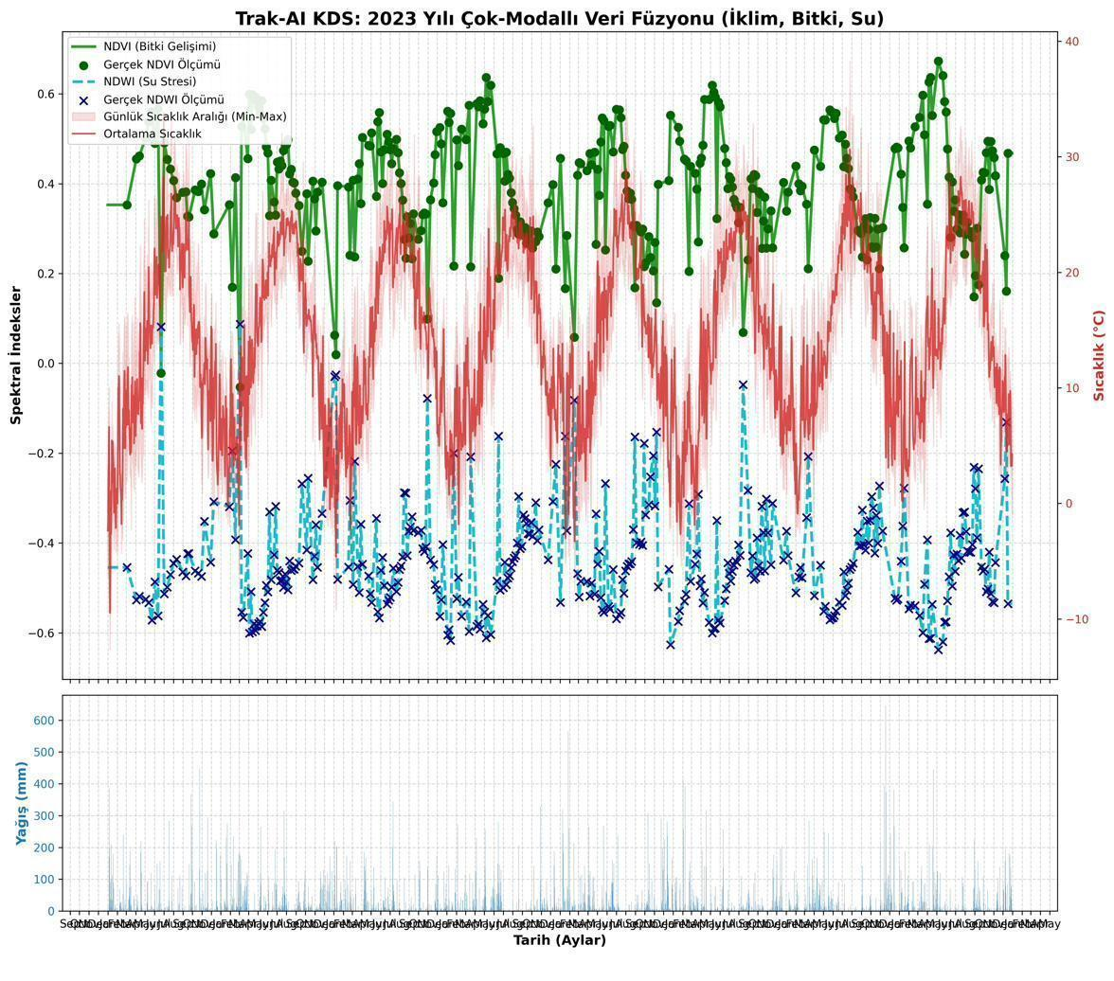
Figure F.1. Master exploratory-data-analysis panel for the 2017–2024 retrospective window, combining the principal climate, vegetation-index, and yield series at the pilot point. The panel documents the temporal coverage of the unified feature matrix produced by the WP-1 ETL pipeline.
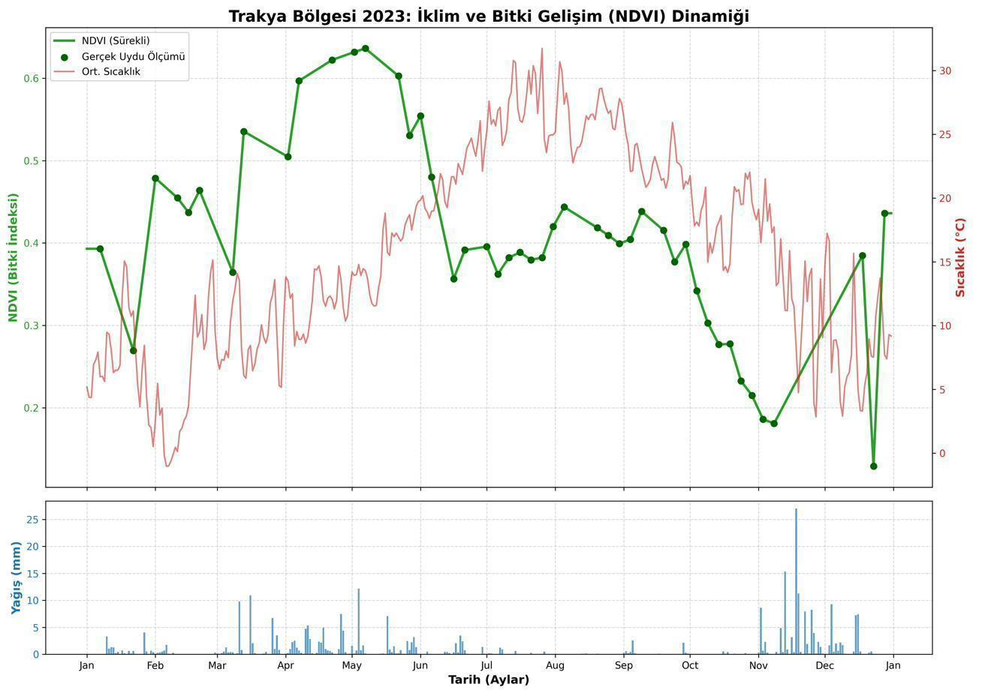
Figure F.2. Climate–NDVI co-variation for the 2023 growing season. The figure illustrates the temporal alignment between cumulative growing-degree-day accumulation, precipitation events, and the smoothed NDVI trajectory for both wheat and sunflower at the pilot point.
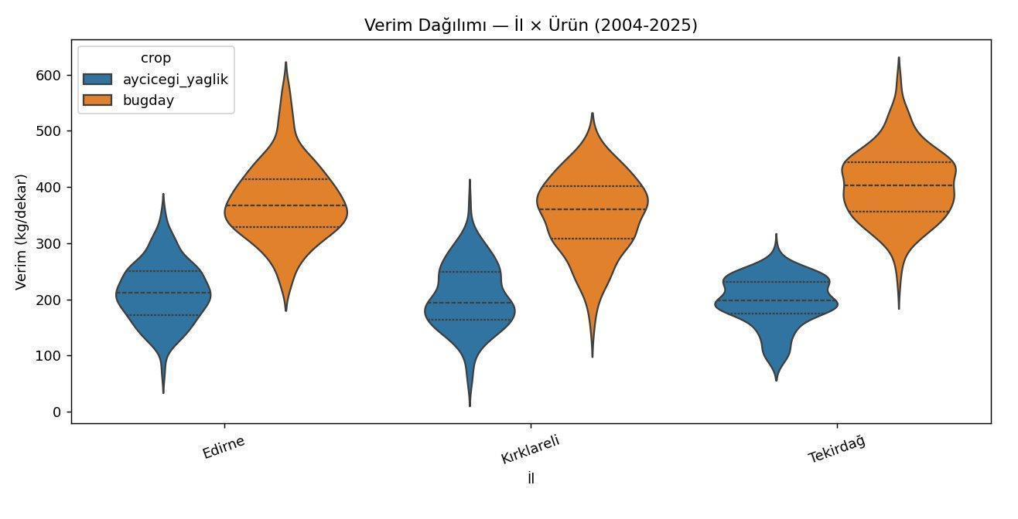
Figure F.3. Yield distribution across the eight-year retrospective window for wheat and sunflower at the Thrace provincial level. The distributions provide the empirical context for the yield-prediction evaluation reported in Chapter 5.
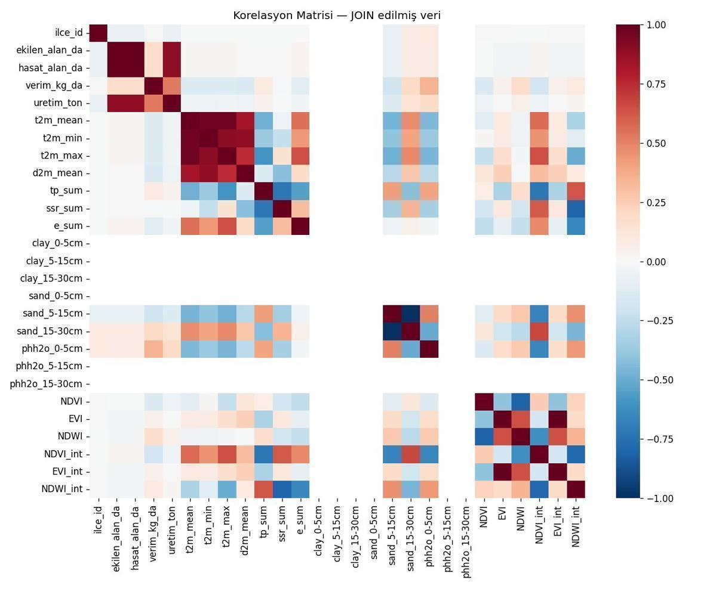
Figure F.4. Correlation matrix of the seventeen engineered features documented in Appendix B. The matrix supports the feature-selection rationale articulated in Section 3.4.
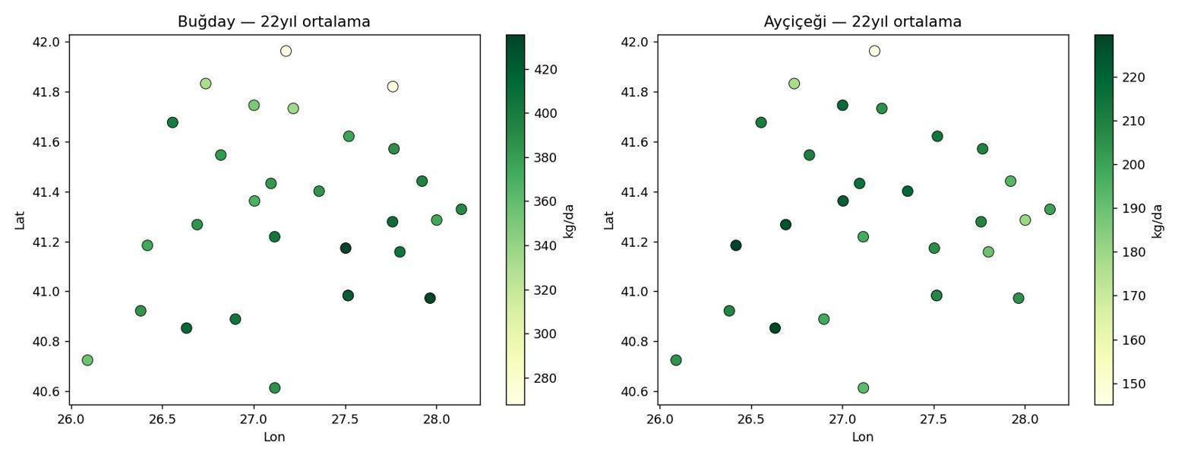
Figure F.5. Geographic yield map of the Thrace region across the three pilot provinces. The map anchors the LOILO cross-validation regime introduced in Section 3.5.1.
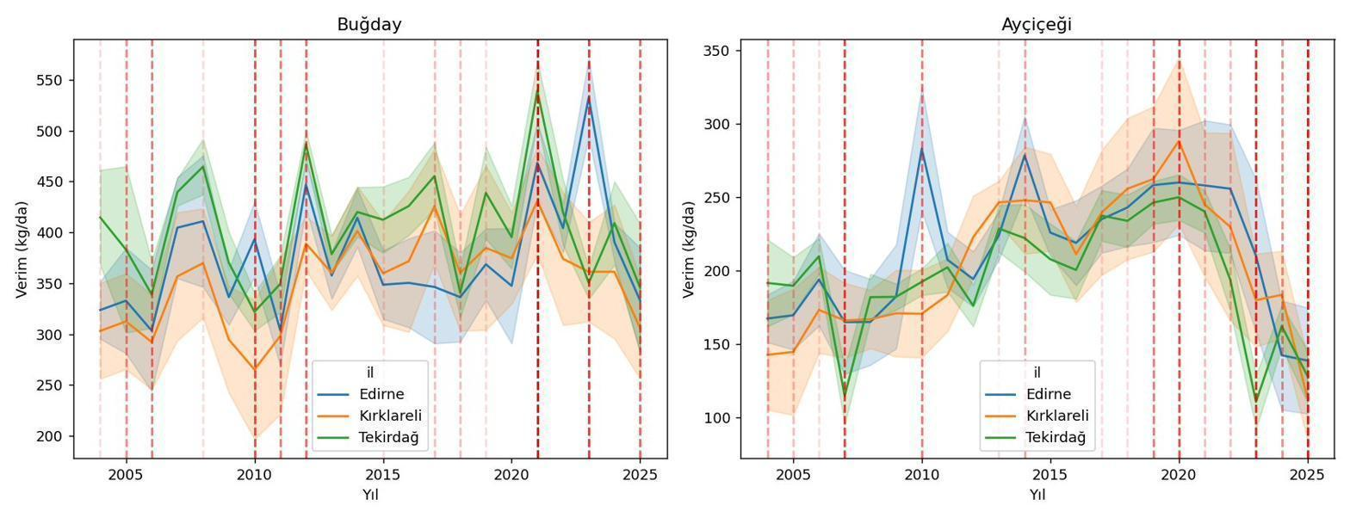
Figure F.6. Inter-annual yield trend across the 2017–2024 retrospective window, decomposed by crop. The trend supports the discussion of the n = 213 LOYO data-regime limitation in Section 5.3.1.
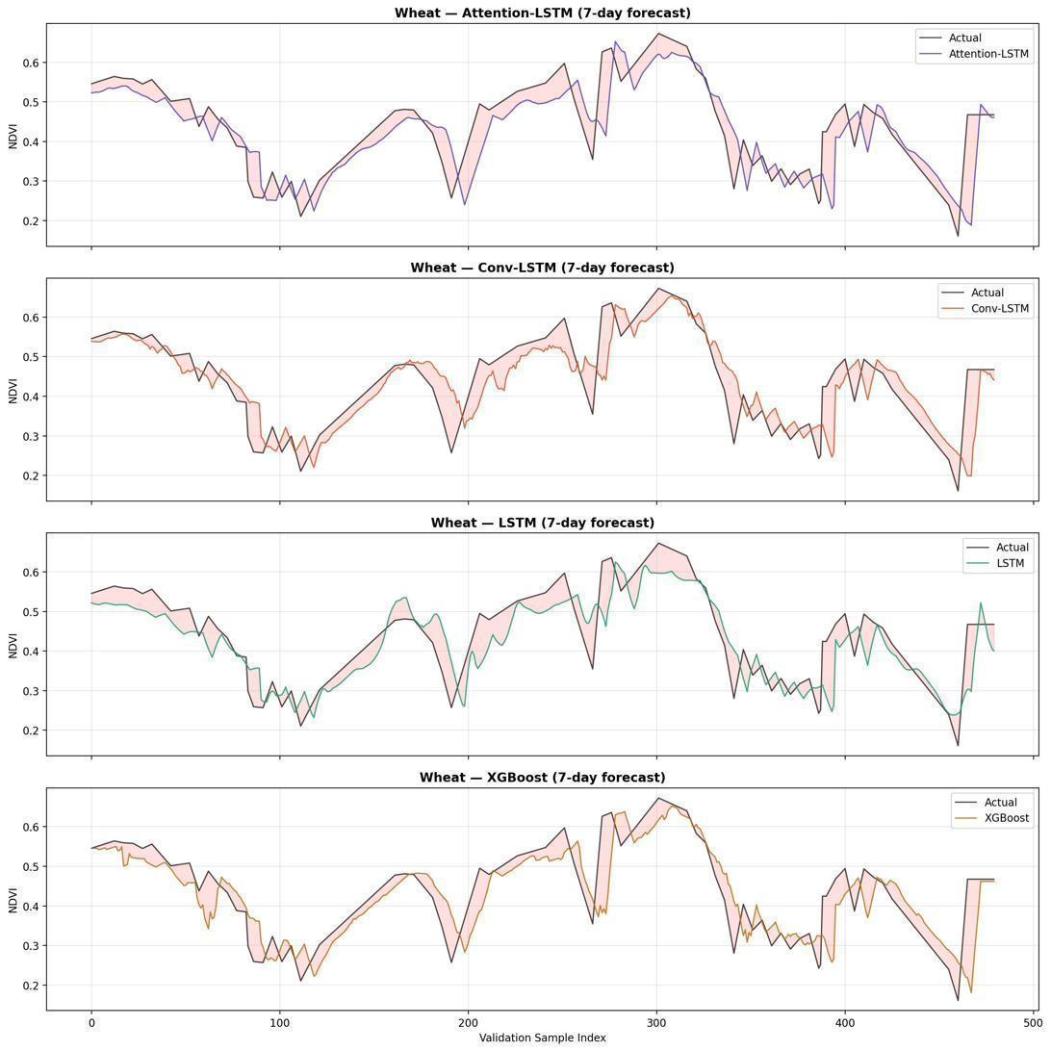
Figure F.7. Wheat NDVI predicted versus observed trajectory for the LSTM champion, demonstrating the model's reproduction of the annual seasonal cycle and its tracking of within-season deviations. Supplementary to Figure 5.4.
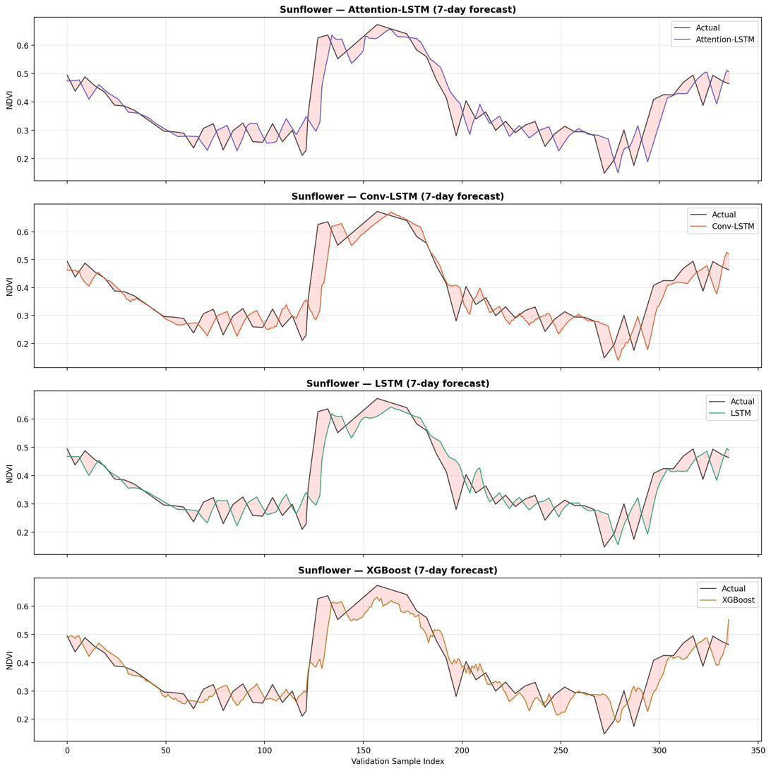
Figure F.8. Sunflower NDVI predicted versus observed trajectory for the LSTM champion, illustrating the model's behaviour across the summer growing season. Supplementary to Figure 5.4.
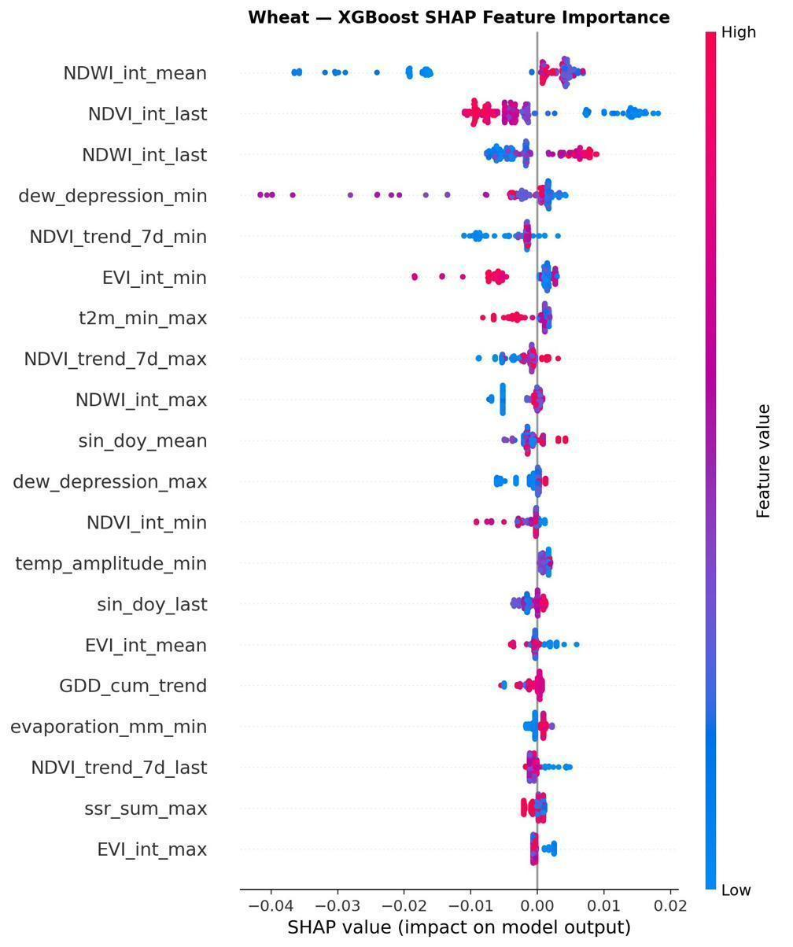
Figure F.9. Detailed SHAP feature-importance attribution for the wheat XGBoost yield regressor. The attribution complements the aggregated view of Figure 5.6 by presenting the full distribution of Shapley values across the leave-one-out evaluation.
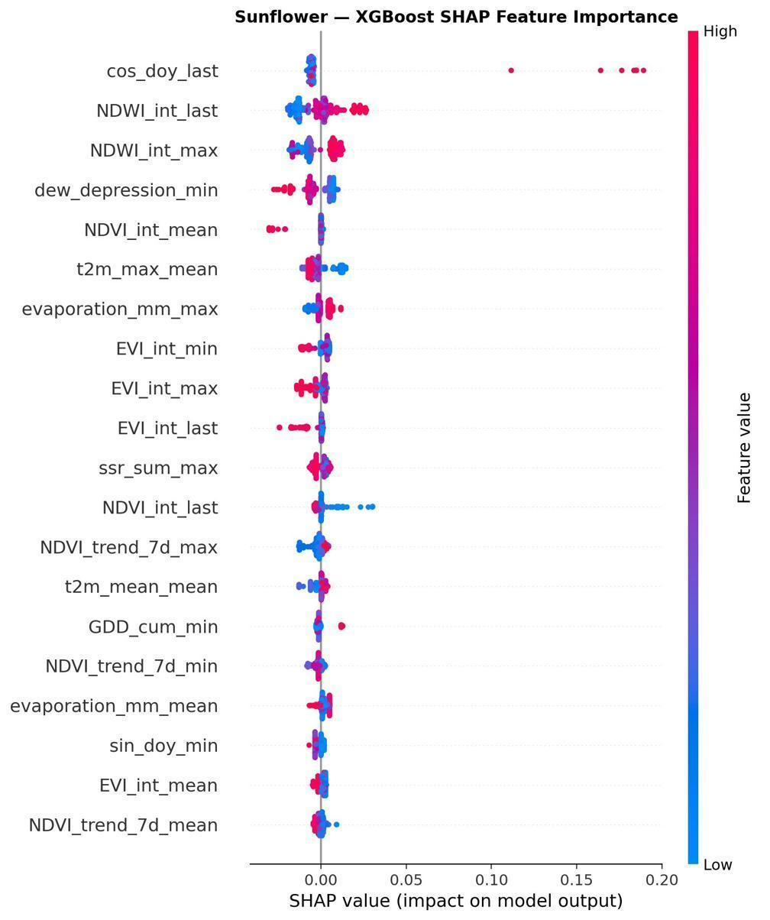
Figure F.10. Detailed SHAP feature-importance attribution for the sunflower XGBoost yield regressor. The attribution complements the aggregated view of Figure 5.6.
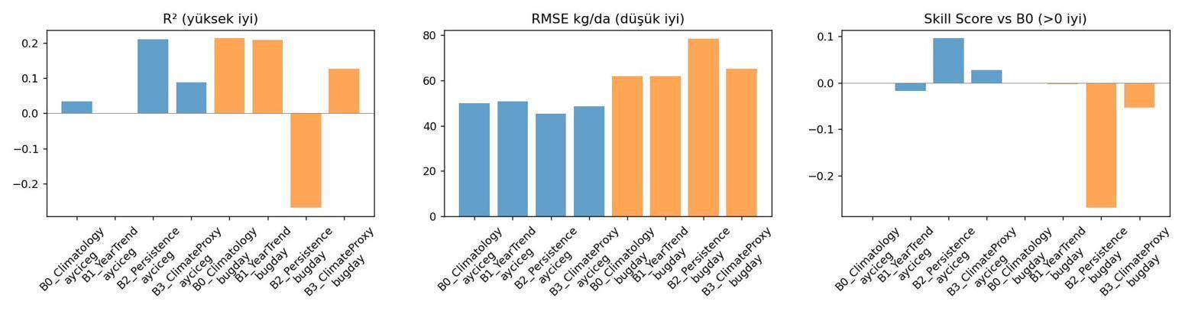
Figure F.11. Baseline-model comparison across the four candidate architectures, expressed in MAE and RMSE terms. Supplementary to Figure 5.3.
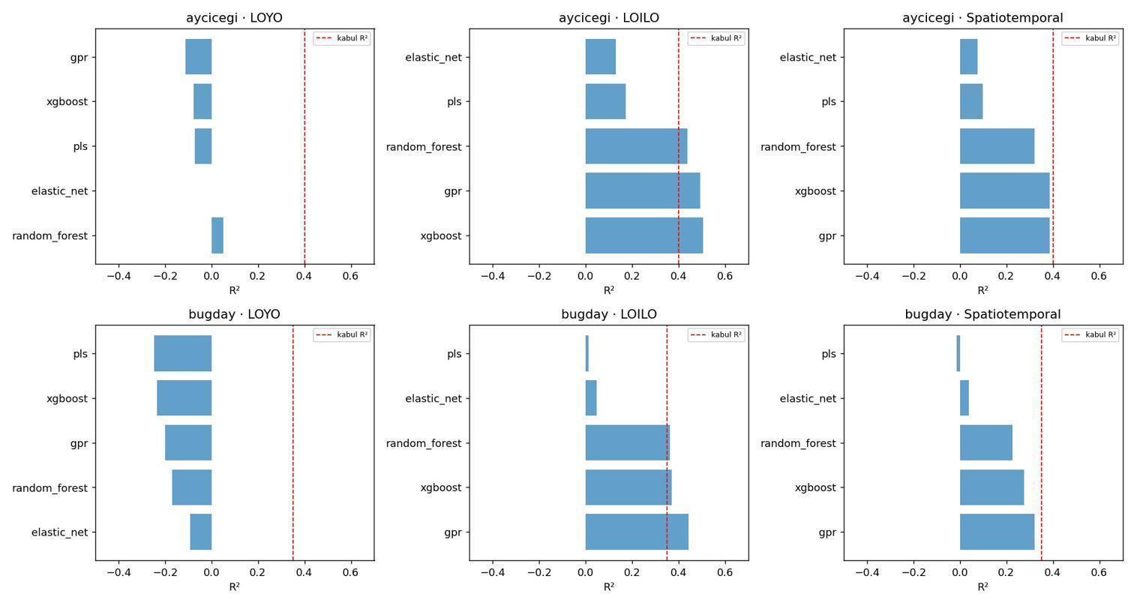
Figure F.12. Layer-A coefficient-of-determination comparison across the four candidate architectures for both crops. Supplementary to Figure 5.2.
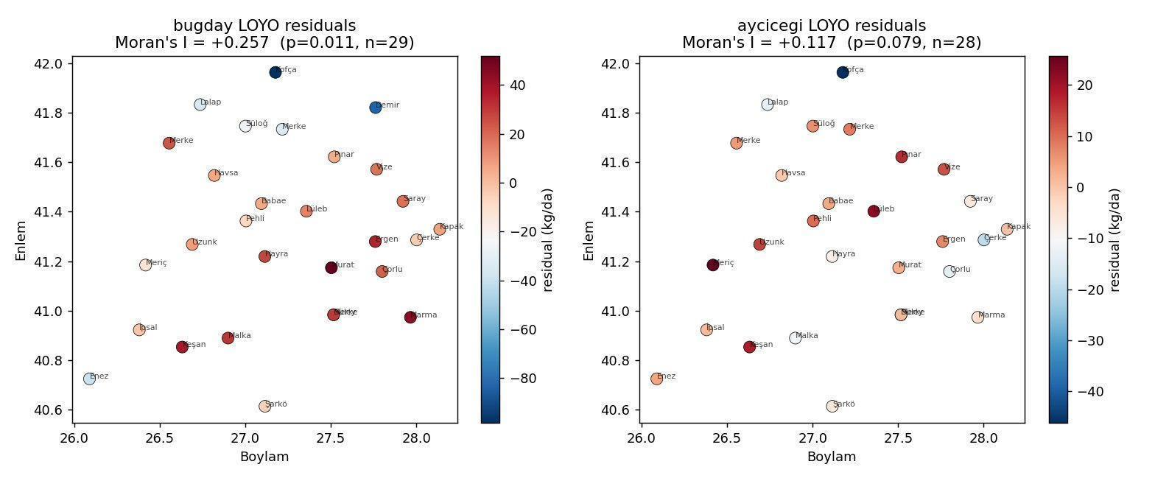
Figure F.13. Moran's I spatial residual autocorrelation map for the wheat LOILO regime, illustrating the +0.257 (p = 0.013) autocorrelation finding reported in Section 5.3.5. The colour-coded residuals demonstrate the spatial clustering that constitutes the methodological finding reported transparently.
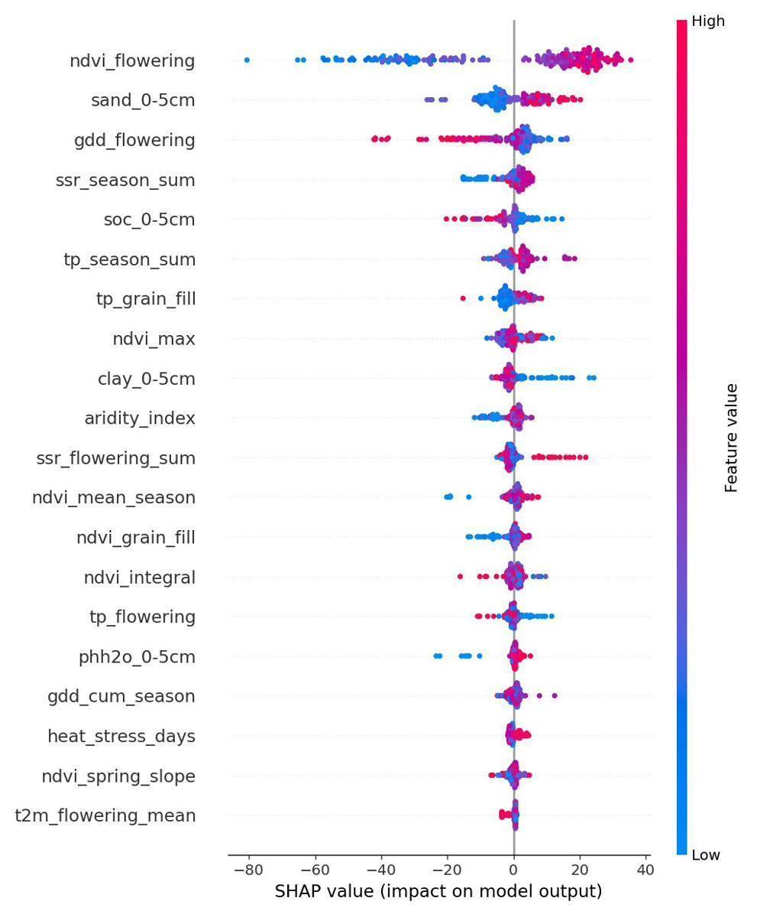
Figure F.14. Layer-C SHAP attribution for the sunflower model, providing the diagnostic transparency supplementary to Figure 5.6.
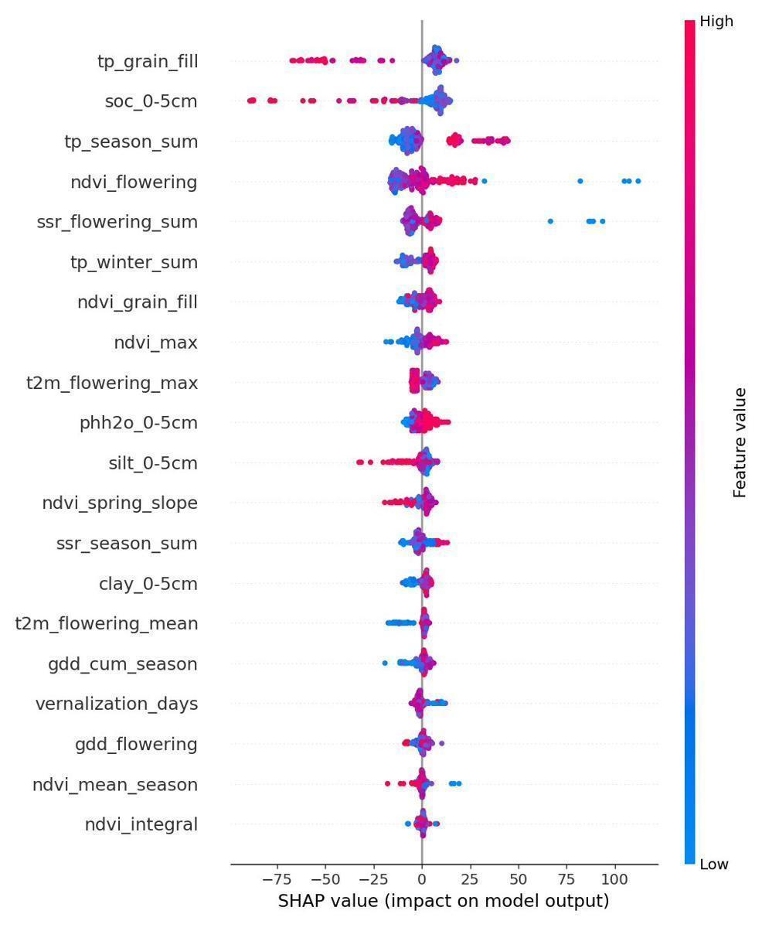
Figure F.15. Layer-C SHAP attribution for the wheat model, providing the diagnostic transparency supplementary to Figure 5.6.
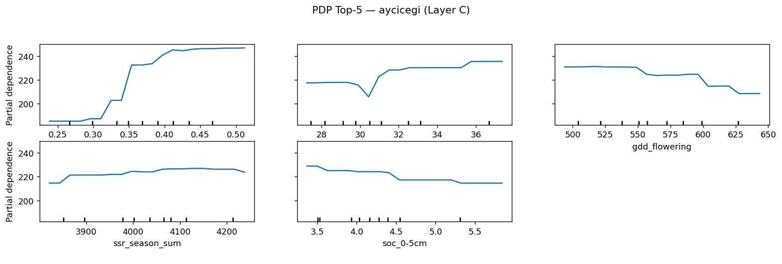
Figure F.16. Partial-dependence plots for the sunflower Layer-C model, illustrating the marginal effect of each principal feature on the predicted yield. The plots constitute a complementary explainability modality alongside the SHAP attribution.
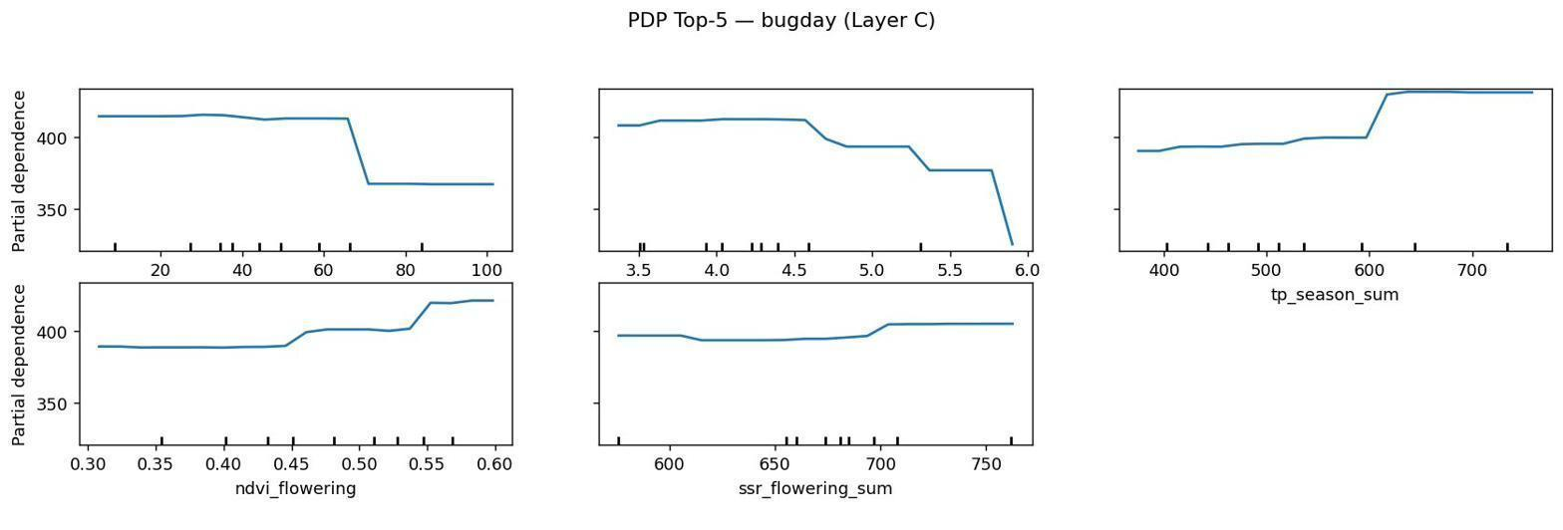
Figure F.17. Partial-dependence plots for the wheat Layer-C model, illustrating the marginal effect of each principal feature on the predicted yield.
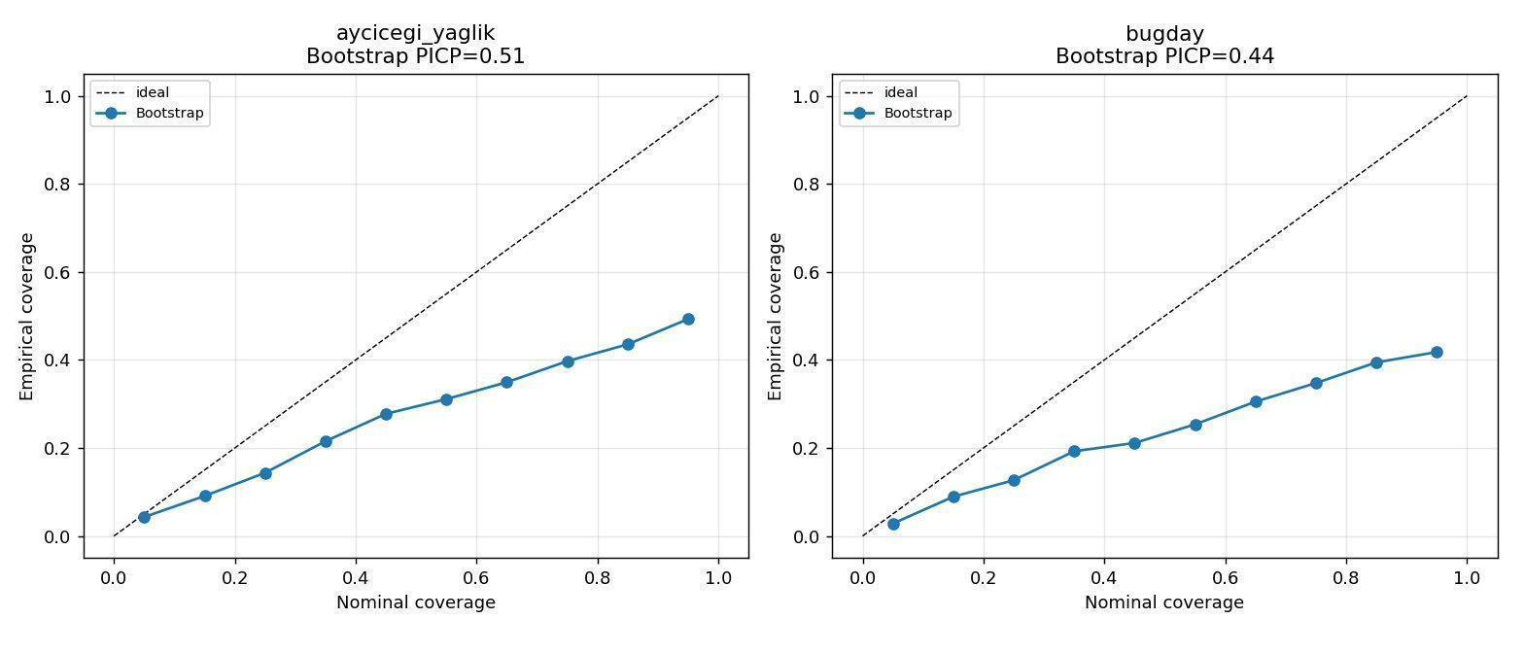
Figure F.18. Predictive-uncertainty quantification for the Layer-C model. The figure decomposes the model's prediction interval into its epistemic and aleatoric components, supporting the discussion of confidence calibration in Chapter 5.
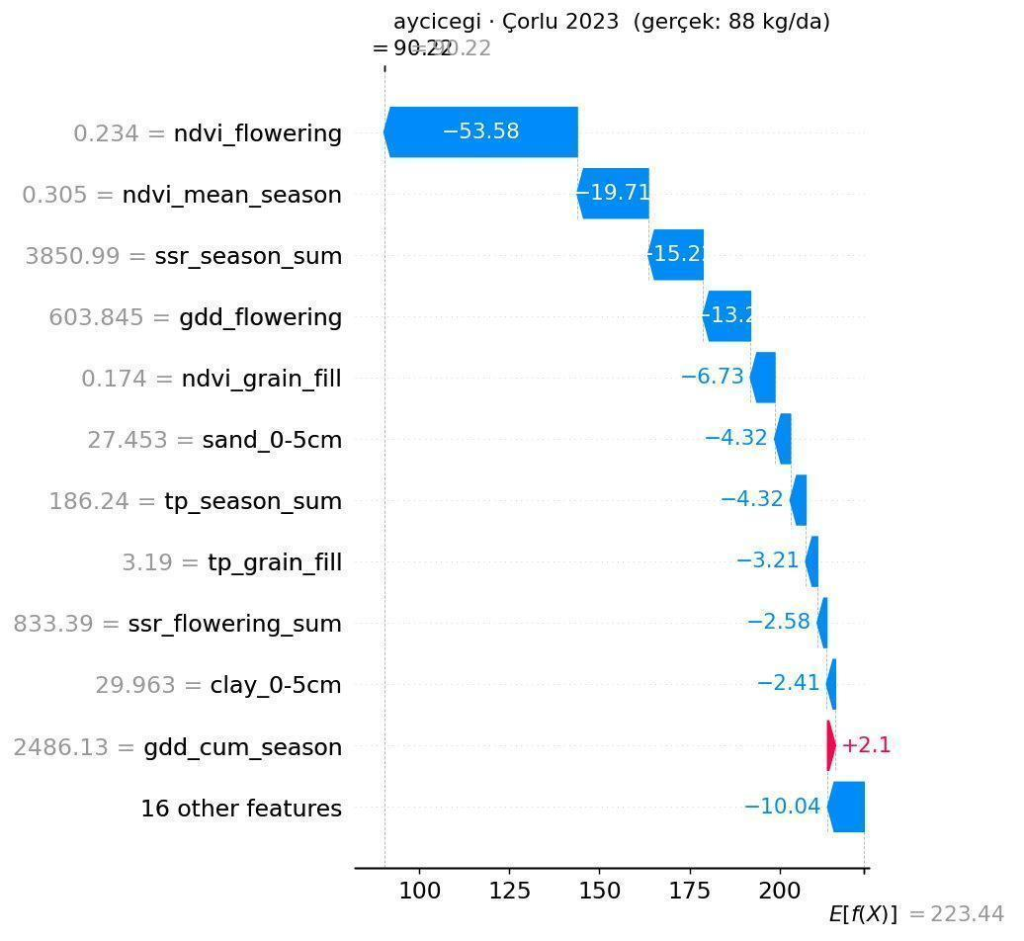
Figure F.19. SHAP attribution for an anomalous prediction in the 2023 Çorlu growing season. The figure illustrates the diagnostic value of the SHAP layer in identifying the climatic drivers of anomaly-year predictions, complementing the anomaly-classification discussion in Section 7.1.1.

