BLM3120 Term Project Report

Subject
News Classifier

Lecturer
Prof. Dr. Mehmet Sıddık AKTAS

Students
Melih Yelman - 21011702
Konuralp Bol - 22011618

Purpose and Importance of the Project

This project aims to automatically categorize news articles using machine learning techniques. Today, millions of news articles are published daily on digital media platforms. Manually categorizing these articles is a time-consuming and costly process.
Project Goals
- Automatically classify news articles into 4 main categories (World, Sports, Business, Sci/Tech)
- Compare different supervised learning algorithms and identify the model with the best performance
- Provide real-time classification capabilities through a user-friendly web interface

Importance of the Project
- Time savings: Categorizing thousands of news articles in seconds
- Consistency: Minimizing errors caused by human factors
- Scalability: Ability to work with large data sets
- Practical application: A valuable tool for news portals, content management systems, and media organizations

Description of Dataset

AG News Classification Dataset
The dataset used in this project is one of the benchmark datasets commonly used in the field of text classification.
https://www.kaggle.com/datasets/amananandrai/ag-news-classification-dataset

Dataset Analysis and Statistics
Dataset Dimensions:
Table 1 has been prepared to reveal the overall size and structure of the data set. This table shows the scale of the data used to feed the model.
Feature | Value
Training Set | 120,000 Samples
Test Set | 7,600 Samples
Total | 127,600 Samples
Number of Features (TF-IDF) | 10,000
Sparsity Ratio | 99.78%
Table 1: Summary of Dataset
Dataset Structure:
The column structure and data types of the raw dataset are presented in Table 2. This table has been included in the report to show the raw format of the processed data (such as the title and description).
Column | Description | Type
label | Category Label | Integer
title | News Title | String
description | News Description | String
Table 2: Structure of Dataset
Category Distribution:
The category distribution of the dataset is presented in Table 3. This table shows that the dataset has perfect balance. Each category has the same number of examples.
Label | Category | Number of Samples | Percentage
1 | World | 30,000 | 25%
2 | Sports | 30,000 | 25%
3 | Business | 30,000 | 25%
4 | Sci/Tech | 30,000 | 25%
Table 3: Distribution of Categories

TF-IDF Vectorization Parameters
The parameters used to convert text data into numerical vectors are listed in Table 4.
Parameter | Value | Description
max_features | 10,000 | Maximum number of features
ngram_range | (1,2) | Unigram and bigram usage
min_df | 2 | Minimum document frequency
max_df | 0.95 | Maximum document frequency
Table 4: TF-IDF

Technologies Used
The software libraries used in the development of the project and their purposes are summarized in Table 5.
Technology | Purpose
Python | Primary Programming Language
FastAPI | REST API Development
scikit-learn | Machine learning algorithms
pandas | Data manipulation
NumPy | Numerical computations
NLTK | Natural Language Processing
React | Frontend Library
Matplotlib | Graph Plotting
Jupyter Notebook | Interactive model development
Table 5: Tech Stack
Algorithms Used and Reasons for Selection
Three different supervised learning algorithms were applied and compared in the project:

Multinomial Naive Bayes
Parameters: alpha=1.0 (Laplace smoothing)

Reasons for Selection:

It is a classic and reliable method for text classification

Works well with TF-IDF vectors thanks to its probabilistic approach

Offers fast training time and low computational cost

It is used as a baseline model

Logistic Regression
Parameters: max_iter=1000, C=1.0, solver='lbfgs'

Reasons for Selection:

It is an effective linear model for multi-class classification problems

Prevents overfitting with regularization support

Its ability to provide probability estimates enables the calculation of confidence scores

Performs well with high-dimensional TF-IDF vectors

Support Vector Machine (LinearSVC)
Parameters: C=1.0, max_iter=10000

Reasons for Selection:

Works effectively in high-dimensional spaces

Widely preferred for text classification

Creates optimal decision boundaries between classes

High generalization capability

Performance Evaluation Metrics
Model performances were evaluated using the metrics specified in Table 6.

Accuracy | The ratio of correctly classified examples to the total number of examples.
Precision | The ratio of those predicted as positive to those that are actually positive.
Recall | The ratio of true positives that are correctly identified.
F1-Score | The harmonic mean of Precision and Recall.
Table 6: Performance Evaluation Metrics

Experimental Results and Evaluation
Model Comparison Table

Table 7 is provided to compare the performance of three different algorithms.

Model | Accuracy | Precision | Recall | F1-Score
Naive Bayes | 0.8966 | 0.8962 | 0.8966 | 0.8962
Logistic Regression | 0.9155 | 0.9153 | 0.9155 | 0.9153
SVM | 0.9155 | 0.9150 | 0.9151 | 0.9150
Table 7: Comparison Table for Models

This table shows the performance of the three algorithms on the test set. The Logistic Regression model achieved the highest values across all metrics.
Best Model: Logistic Regression
Logistic Regression was selected as the best-performing model with an F1-Score of 91.53%.

The performance of the best model for each category is shown in Table 8. The Sports category shows the highest success, while the Business and Sci/Tech categories have similar levels of difficulty.

Category | Precision | Recall | F1-Score | Support
World | 0.93 | 0.91 | 0.92 | 1900
Sports | 0.95 | 0.98 | 0.97 | 1900
Business | 0.89 | 0.89 | 0.89 | 1900
Sci/Tech | 0.89 | 0.89 | 0.89 | 1900
Table 8: Category Based Performance of Logistic Regression
Evaluation of Results
- The Sports category showed the highest performance (97% F1-Score). This is due to sports news having its own unique terminology and being distinctly different from other categories.
- The Business and Sci/Tech categories showed similar performance (~89% F1 Score). There is overlap in word clusters between these two categories due to technology companies and economic topics.
- Logistic Regression and SVM showed nearly identical performance. This indicates that TF-IDF vectorization is suitable for both linear models.
- Naive Bayes performed approximately 2% lower than the others. This may be due to the independence assumption of Naive Bayes not being fully met in the text data.

Graphical Results
Figure 1 shows the class distribution in the training and test sets. The dataset is balanced (30,000 training and 1,900 test examples in each category).

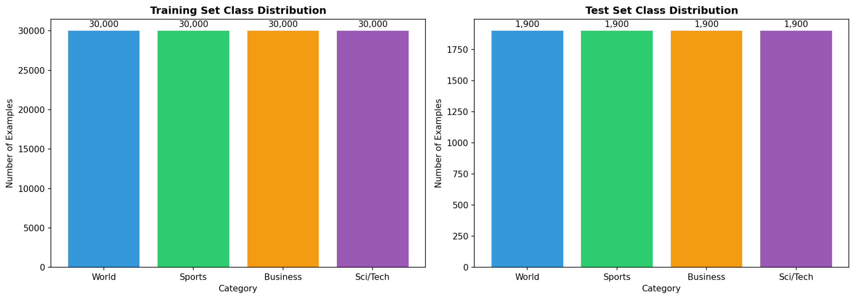
Figure 1: Class Distribution of Dataset
The text length distribution by category is shown in Figure 2. Average text lengths range from 223 to 241 characters.

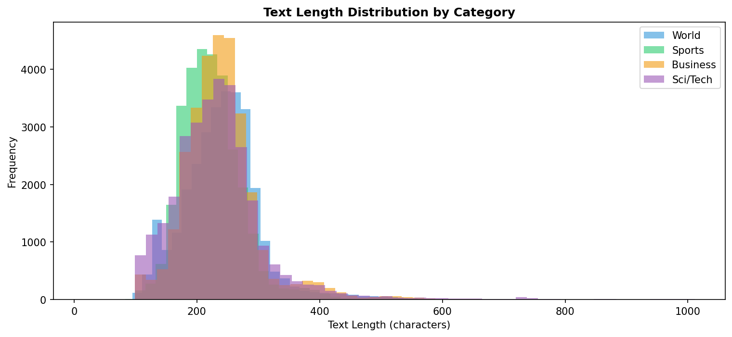
Figure 2: Text Length Distribution by Category

The performance metrics of the models are compared in Figure 3.

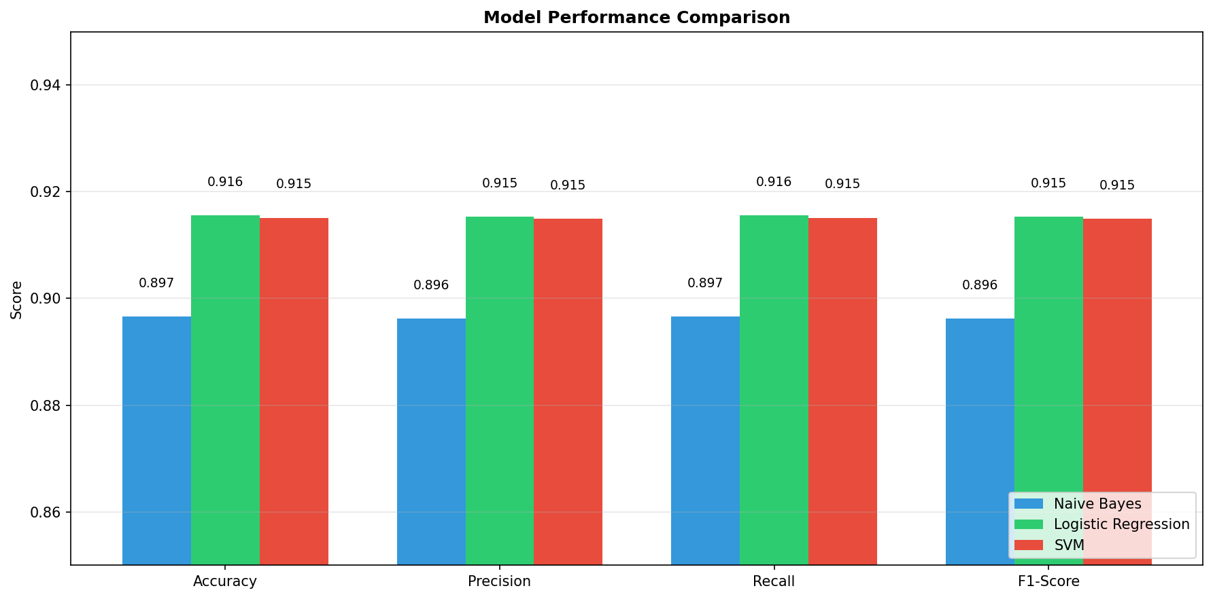
Figure 3: Model Performance Comparison
The confusion matrix of the best model (Logistic Regression) is shown in Figure 4. This matrix reveals which categories the model confuses with each other.

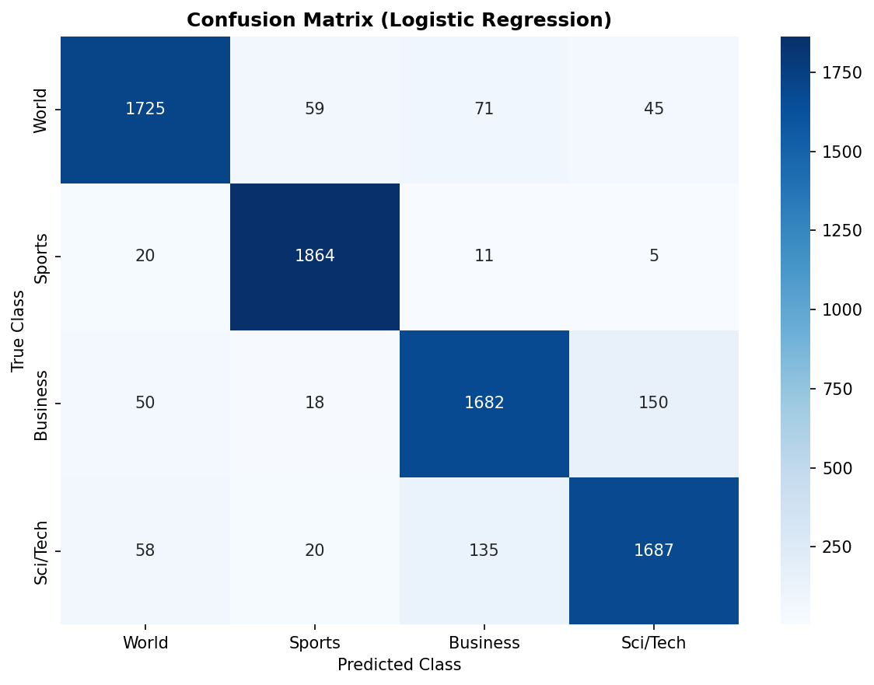
Figure 4: Confusion Matrix of Logistic Regression

User Interfaces
System Architecture
The project is designed as a web application based on a client-server architecture.

Frontend: Current news content is retrieved using the GNews API. The news retrieved using the API developed in the project is classified.

Backend: Using FastAPI, the text to be classified is sent to the best recorded model, and the result is returned.
Endpoint: (POST) localhost:8000/predict
Request Format: {“title”: “News Headline”, “description”: “News Content”}
Response Format: {“category”: “Business”, “category_index”: 3, “confidence”: 0.87, “processed_text”: “processed text”}

An API key is already included in the source code. However, you can use this key as a backup: 9c630a89b6070512efc2760dc1a8af7a
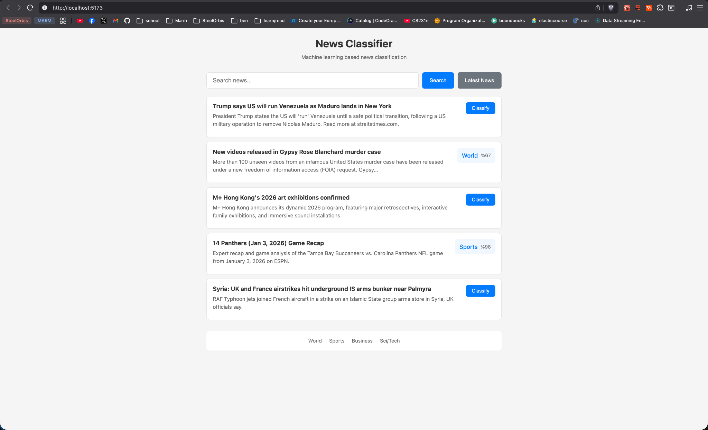
Result
In this project, the automatic classification of news texts was successfully achieved using the AG News dataset. Three different machine learning algorithms (Naive Bayes, Logistic Regression, SVM) were compared, and the Logistic Regression model showed the best performance with an F1-Score of 91.53%.

The developed system is presented as a fully functional web application using FastAPI backend and React frontend. This application allows users to classify news texts in real time.

