**Lone Cabbage Area Oyster Population Characterization: Winter 2017-2018**

Oyster Size Frequency Distribution:

*Live Oysters:*

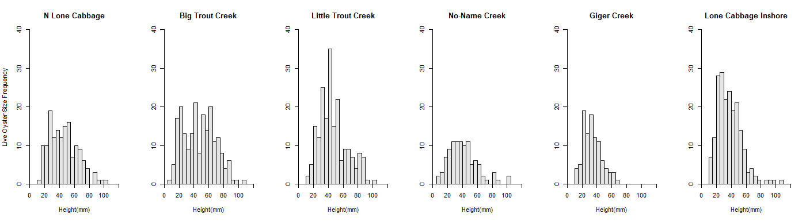

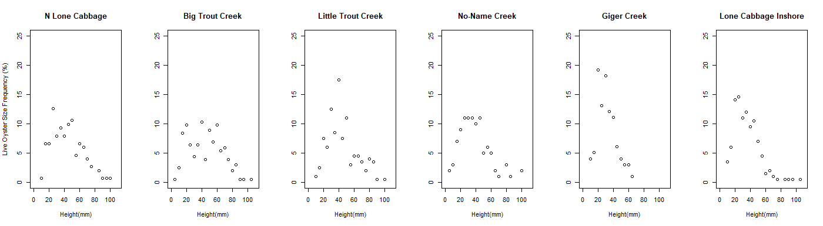

BT LT NN GC LC

LT 1.0000 - - - -

NN 0.0609 0.0466 - - -

GC 5.0e-07 3.0e-07 0.1633 - -

LC 1.1e-05 6.5e-06 0.8094 0.6692 -

NLC 0.9781 0.9588 0.3288 5.5e-05 0.0017

*Mortality Size Distribution:*

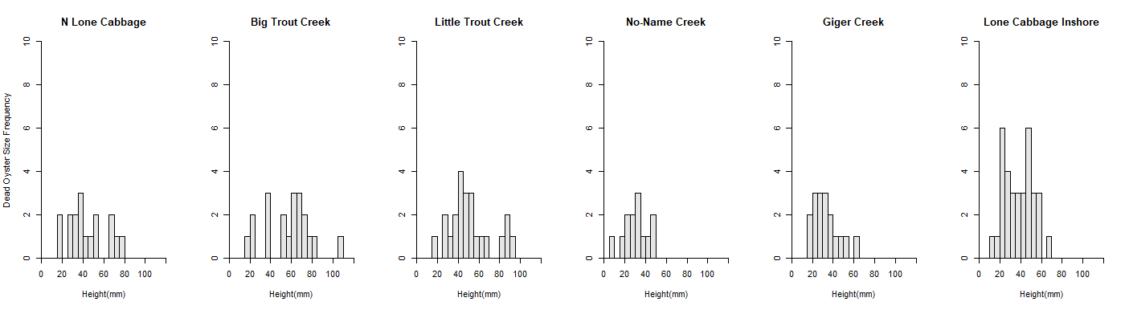

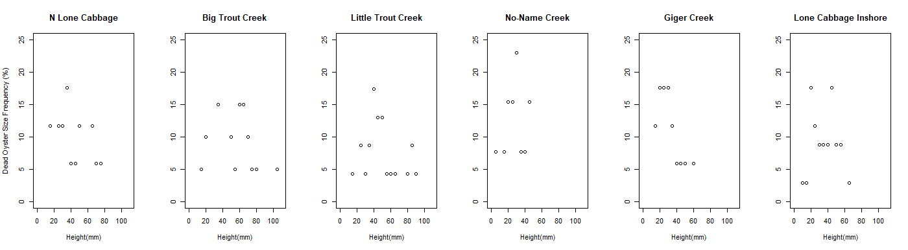

BT LT NN GC LC

LT 0.9729 - - - -

NN 0.0018 0.0148 - - -

GC 0.0029 0.0248 0.9990 - -

LC 0.0278 0.1886 0.6374 0.8270 -

NLC 0.4395 0.8538 0.3150 0.4710 0.9583

Oyster Density:

*Total Live Oyster Density*

*Oyster Density by Size Class*

*<25mm*

*25-75mm*

*>75mm*

*Percent Mortality*