**Lone Cabbage Oyster Reef Restoration Project: Oyster Recruitment Monitoring**

**Introduction:**

Indices of recruitment are an important component of fish population assessments. Applying stock-recruitment relationships to commercial shellfish species is confounded by the highly variable and prolific nature of spawning patterns. Defining the stock-recruitment relationship in oysters is further complicated by the availability of hard settlement substrate; essential for oyster survival past the planktonic larval stage. Here an oyster is considered recruited to the fishery post-settlement; these small oysters are referred to as spat. This is when oysters are first able to be impacted by harvest activities; fishing mortality can occur to sub-market size oysters through field culling and sorting processes.

A minimal oyster recruitment monitoring program was established in order to provide basic information on oyster spawning patterns throughout the project area. This program was coupled with a water quality monitoring program in order to increase efficiency of field operations, and also in order to associate continuous water quality data with observed recruitment patterns. While developing a stock-recruitment relationship is currently beyond the scope of this monitoring program, it will provide a simple index of oyster recruitment.

**Methods:**

In order to monitor oyster recruitment, spat collectors were used. Collector design and deployment time were initially unclear. Shell spat collectors were deployed at each project water quality station in April-October 2018 (Figure 1). Tile spat collectors have been deployed June 2018 to present. The initial shell collector deployment time was two months. Starting in June 2018, spat collectors were deployed for one month before being retrieved and replaced. After retrieval, collectors are placed into zip-lock bags and frozen until processing.

Shell Spat Collectors:

Shell spat collectors consisted of ten clean market-size oyster shells enclosed in clam bag mesh. Clean oyster shell was acquired from an oyster processing facility in Cedar Key. After the collector was constructed, total volume (mL) was determined through displacement. Total mass (g) was also collected. Each shell spat collector was attached to water quality sensor housings, located immediately above the water bottom (Figure 2).

When processing, collectors were thawed and shell was removed from the mesh. Length, width, height (mm) were recorded for each shell. Total spat count for each side of shell (interior/exterior) was recorded, along with the height (mm) of the largest spat on each side. Shell spat collectors were deployed April-October 2018, when it was decided only tile spat collectors would be used.

Tile Spat Collectors:

Tile spat collectors each consist of a 0.151 x 0.151 x 0.012 m (surface area = 0.058 m2). A small hole was drilled in the center of each tile and secured to the water quality sensor anchor chain with a buoy so the tile was oriented horizontally 0.151m above the water bottom (Figure 2).

When processing, collectors were thawed and total spat count for each side of tile (top/bottom/side) was recorded. The heights (mm) of the three largest spat per side were also recorded. Tile spat collectors have been deployed June 2018 to present.

Supplemental data collected for both collectors included estimates of barnacle coverage and evidence of multiple spawning events (spat on spat) and predators (gastropod eggs).

Analysis:

-Shell totals (convert to mass and volume)

-Shell mean

-Shell side comparison

-Spat size

-Spat size by side

-Barnacle

X-Tile totals

X-Tile side comparison

X-Spat size

X-Spat size by side

X-Barnacle

-Tile vs shell totals

-Mean monthly salinity

-cumulative number readings >7ppt (check lit

-Mean temp

GLM or GAM

WQ variables plus barnacle coverage on totals and size

**Results:**

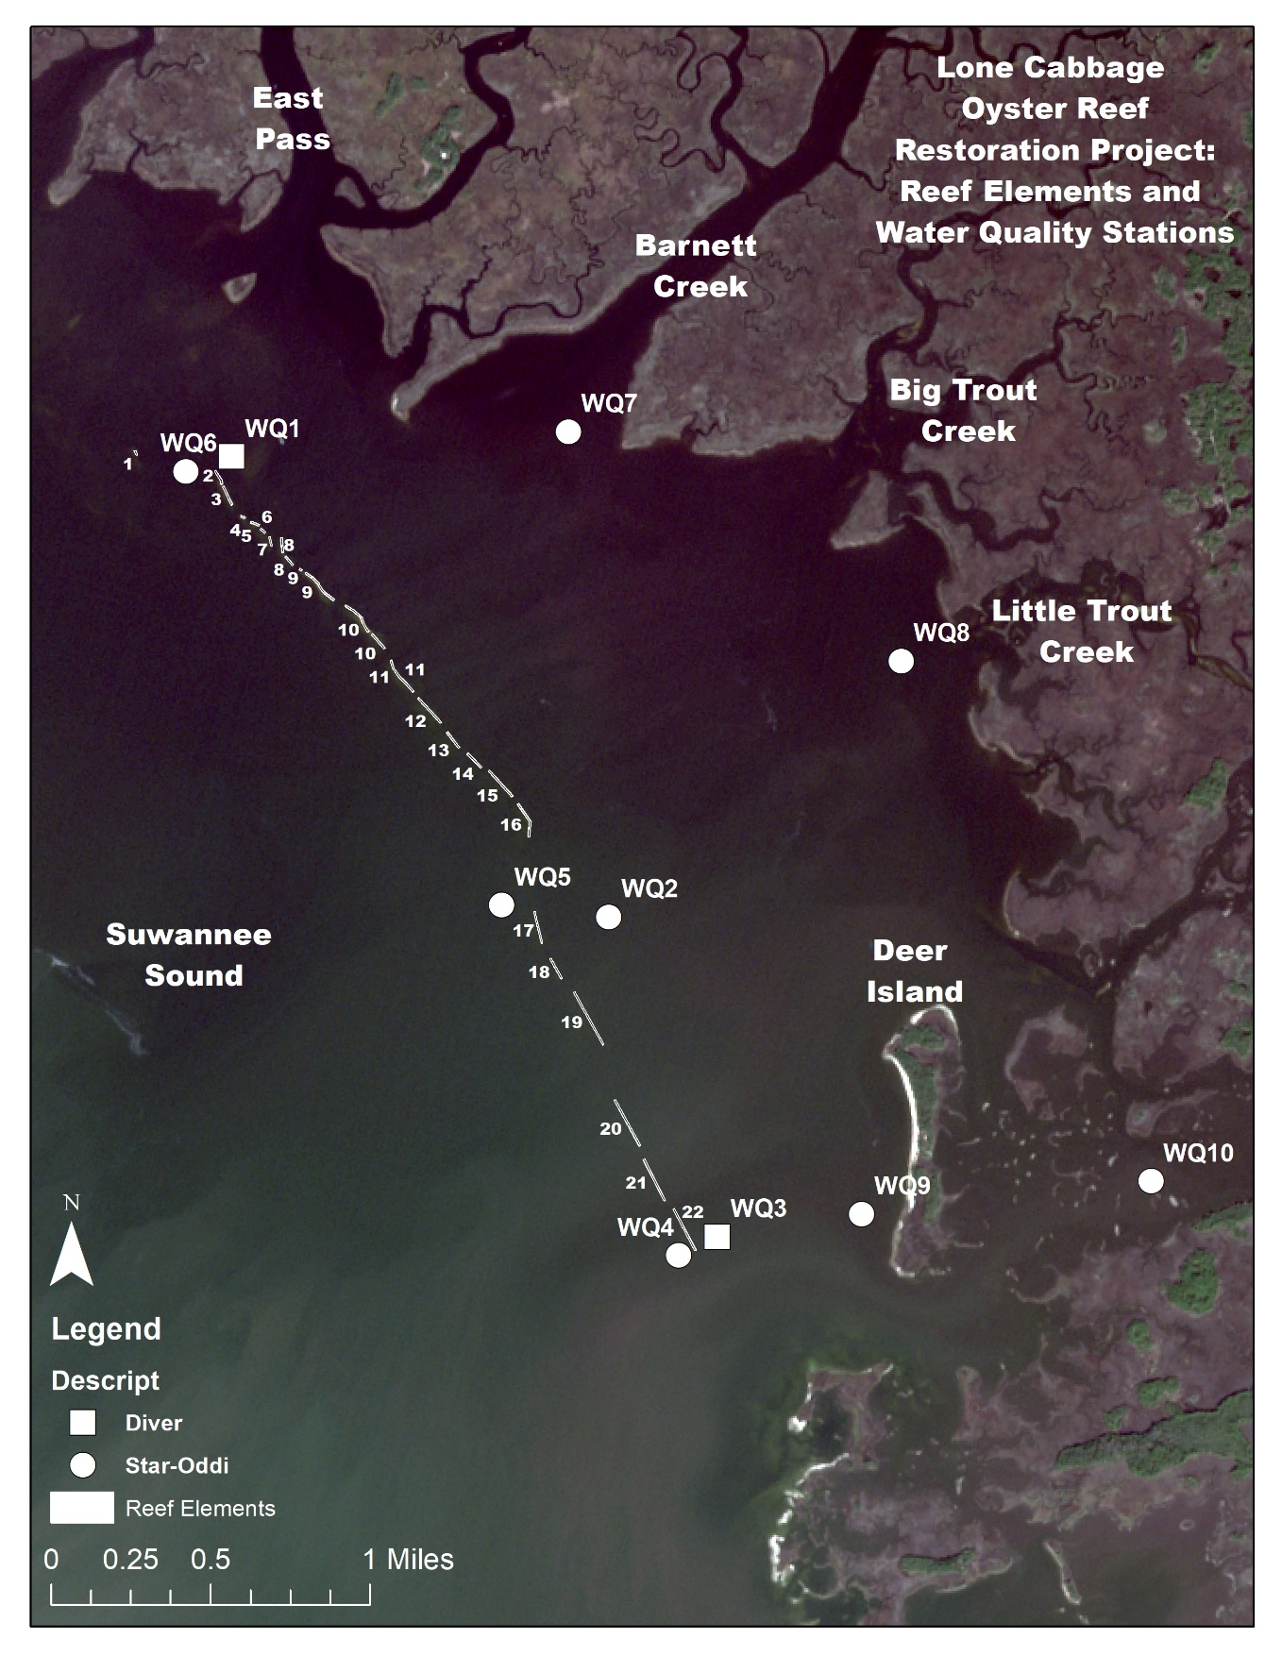

Figure 1: Location of the Lone Cabbage Reef elements and water quality stations. Spat collectors were deployed on water quality sensor anchors.



Figure: Total spat counts observed on tile spat collectors from June 2018-May 2019. Missing values indicate tiles were lost, or the station was removed during reef construction. Station WQ10 was established March 2019.



Figure: Mean spat counts (+ standard error) observed on tile spat collectors by tile side from June 2018-May 2019.



Figure: Mean spat counts (+ standard error) observed on tile spat collectors by tile side and month from June 2018-May 2019.



Figure: Mean spat counts (+ standard error) observed on tile spat collectors by tile side, month, and station from June 2018-May 2019. Missing values indicate tiles were lost, or the station was removed during reef construction. Station WQ10 was established March 2019.



Figure: Mean maximum spat size (+ standard error) observed on tile spat collectors by tile side from June 2018-May 2019.



Figure: Mean maximum spat size (+ standard error) observed on tile spat collectors by tile side and month from June 2018-May 2019. Missing values indicate no spat was present.



Figure: Mean spat size (+ standard error) observed on tile spat collectors by tile side, month, and station from June 2018-May 2019. Missing values indicate tiles were lost, the station was removed during reef construction, or no spat was present. Station WQ10 was established March 2019.



Figure: Barnacle coverage observed on tile spat collectors by tile side, month, and station from June 2018-May 2019. Missing values indicate tiles were lost, or the station was removed during reef construction. Station WQ10 was established March 2019.