Preliminary June 2018 Benthic Invertebrate Data Exploration

Table 1: Key to family and species codes. Common species (>1% total abundance) are in bold(*).

|  |  |  |  |  |  |
| --- | --- | --- | --- | --- | --- |
| class/order | family | fam_code | species | sp_code |  |
| **Amphipoda** | **Ampelliscidae** | **AMPE** | **Ampelisca sp.** | **AMSP** | **\*** |
| Amphipoda | Gammaridae | GAMM | Gammerus mucronatus | GAMU |  |
| **Amphipoda** | **Ischyroceridae** | **ISCH** | **Cerapus sp.** | **CESP** | **\*** |
| **Bivalvia** | **Lucinidae** | **LUCI** | **Parvilucina multilineata** | **PAMU** | **\*** |
| **Bivalvia** | **Mytilidae** | **MYTI** | **Amygdalum papyrium** | **AMPA** | **\*** |
| Bivalvia | Mytilidae | MYTI | Brachiodonted exustus | BREX |  |
| Bivalvia | Pharidae | PHAR | Ensis sp. | ENSP |  |
| Bivalvia | Pisidium | PISI |  |  |  |
| Bivalvia | Tellinidae | TELL |  |  |  |
| Bivalvia | Veneridae | VENE |  |  |  |
| Brachiopoda | Lingulidae | LING | Glottidia pyramidata | GLPY |  |
| Cumacea | Diastylidae | DIAS | Oxyurostylis smithi | OXSM |  |
| Decapoda | Pinnotheridae | PINN | Pinnixa sp. | PISP |  |
| Decapoda | Xanthidae | XANT |  |  |  |
| Gastropoda | Acteocinidae | ACTE | Acteocina sp | ACSP |  |
| Gastropoda | Caecidae | CAEC |  |  |  |
| Gastropoda | Columbellidae | COLU |  |  |  |
| Gastropoda | Epitoniidae | EPIT | Epitonium sp. | EPSP |  |
| Gastropoda | Nassariidae | NASS | Nassarius vibex | NAVI |  |
| Gastropoda | Naticidae | NATI |  |  |  |
| Gastropoda | Pyramidellidae | PYRA | Boonea sp. | BOSP |  |
| Gastropoda | Pyramidellidae | PYRA | Odostomia sp. | ODSP |  |
| Gastropoda | Terebridae | TERE |  |  |  |
| Hexanauplia | Balanidae | BALA | Balanus sp. | BASP |  |
| **Isopoda** | **Anthuridae** | **ANTH** | **Cyathura polita** | **CYPO** | **\*** |
| Isopoda | Idoteidae | IDOT | Edotia sp. | EDSP |  |
| **Oligochaeta** |  | **OLIG** |  |  | **\*** |
| **Ophuroidea** | **Amphiuridae** | **AMPI** |  |  | **\*** |
| Ophuroidea | Ophiactidae | OPHI | Hemipholis chordifera | HECO |  |
| Ophuroidea | Unknown Brittlestar | OPHU |  |  |  |
| Phoronid | Phoronida | PHOR |  |  |  |
| Polychaeta | Ampharetidae | AMPH | Melinna sp. | MESP |  |
| **Polychaeta** | **Capitellidae** | **CAPI** |  |  | **\*** |
| Polychaeta | Chaetopteridae | CHAE |  |  |  |
| **Polychaeta** | **Cirratulidae** | **CIRR** | **Tharyx sp.** | **THSP** | **\*** |
| Polychaeta | Glyceridae | GLYC | Glycera sp. | GLSP |  |
| Polychaeta | Maldanidae | MALD |  |  |  |
| Polychaeta | Nereididae | NERE | Alitta succinea | ALSP |  |
| Polychaeta | Onuphidae | ONUP | Diopatra sp. | DISP |  |
| Polychaeta | Onuphidae | ONUP | Onuphis sp. | ONSP |  |
| **Polychaeta** | **Oweniidae** | **OWEN** | **Owenia sp.** | **OWSP** | **\*** |
| **Polychaeta** | **Paraonidae** | **PARA** | **Aricidea sp.** | **ARSP** | **\*** |
| Polychaeta | Pectinariidae | PECT | Pectinaria gouldii | PEGO |  |
| Polychaeta | Phyllodocidae | PHYL | Phyllodoce mucosa | PHMU |  |
| Polychaeta | Sabellidae | SABE |  |  |  |
| **Polychaeta** | **Spionidae** | **SPIO** | **Paraprionospio pinnata** | **PAPI** | **\*** |
| Polychaeta | Unknown Polychaete | UKPO |  |  |  |
|  |  | N_A |  | N_A |  |

NUMBER OF SPECIES



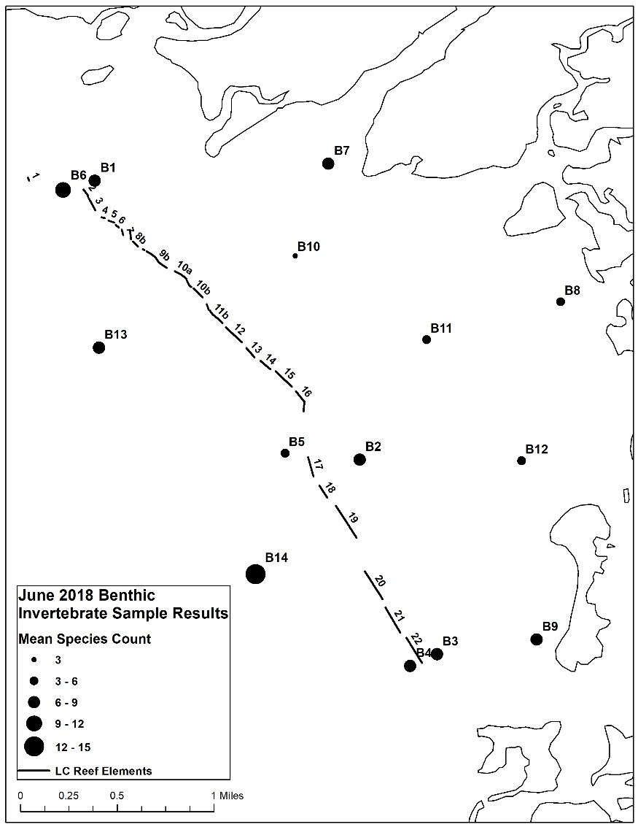

SPECIES ABUNDANCE





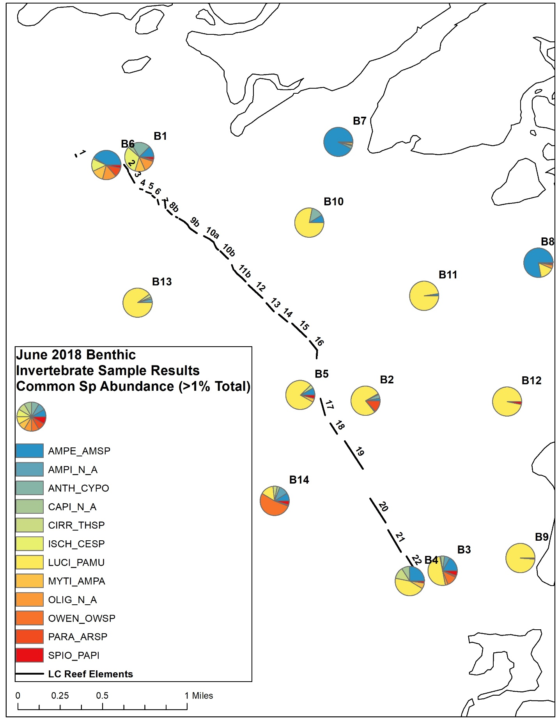

COARSE SEDIMENT



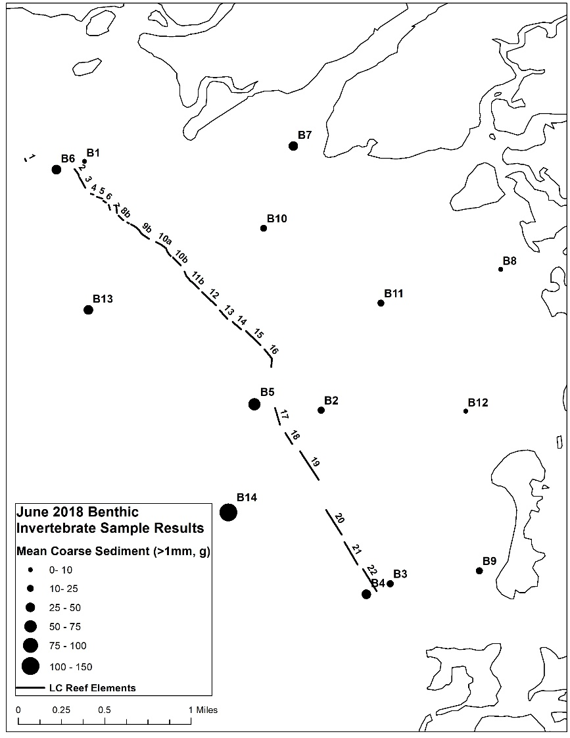

ORGANIC CARBON



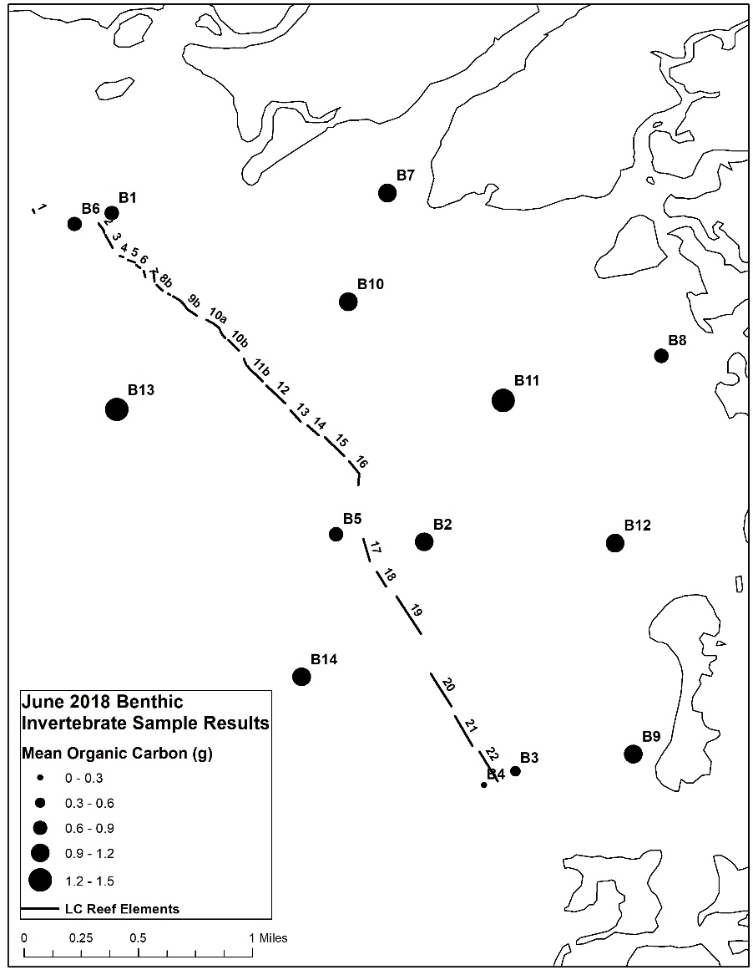

SEDIMENT/SPECIES RELATIONSHIP



