**Lone Cabbage Oyster Reef Restoration Project: Benthic Invertebrate Monitoring**

**Introduction:**

The purpose of this sampling effort was to characterize and monitor the soft-bottom benthic invertebrate community throughout the Lone Cabbage Reef project area. This community is of interest for use as an indicator to determine if oyster reef restoration 1) alters estuarine hydrology and sediment characteristics to an ecologically meaningful extent, and 2) affects gulf sturgeon (*Acipenser oxyrincus desotoi*) prey availability.

The Lone Cabbage Reef Restoration Project has the potential to substantially alter hydrologic patterns and increase eastern oyster (*Crassostrea virginica*) abundance in Suwannee Sound. The dynamic tidal and river discharge regime of the area creates difficulties in identifying changes of hydrologic patterns. Benthic invertebrate populations have been frequently used to determine the condition of aquatic systems for a multitude of reasons (reviewed in Pinto et al 2009). The Suwannee Sound benthic invertebrate community was last sampled in an attempt to identify preferred sturgeon foraging grounds (Harris et al 2005, Brooks and Sulak 2005). Utilizing similar methods (core samples) is beneficial to enable examination of benthic change in the area over a longer time period as well to examine pre- and post-oyster restoration effects at large spatial scales. Coupling benthic community data to ongoing continuous water quality, oyster, fish, bird, and habitat data collection efforts will facilitate comprehensive ecosystem modeling efforts.

**Methods:**

During June 2018, subtidal soft-bottom benthic invertebrate samples were collected using a suction pole corer with a sample chamber 10cm in diameter and 15cm in height (total volume = 1178mL). At each of the nine existing water quality (WQ) sites plus five additional sites chosen for uniform spatial coverage, three replicate samples were collected (14 stations X 3 samples each = 42 samples total, Figure 1). Replicate samples at each station were haphazardly located 10m apart. Each sample was sieved (1mm mesh) and remaining contents were preserved in 90% isopropyl alcohol. Prior to sieving, the sample was homogenized by hand, characterized by texture, and a 100mL sub-sample was collected and frozen to determine the amount of organic matter present. Additional field parameters collected include bottom water quality variables (dissolved oxygen, temperature, salinity) and depth of the anoxic layer if present.

Organisms were removed from samples, identified to the lowest possible taxon, and counted. The remaining material in each sample was dried at 105﮿C for 24 hours and weighed to determine the amount of coarse material (>1mm) present. The 100mL sub-samples were thawed and homogenized and 50g of each sub-sample was dried at 105﮿C for 24 hours and weighed. Dried sub-samples were then combusted at 550﮿C for 12 hours, weighed, and the amount of organic matter was determined by subtracting combusted weight from dry weight.

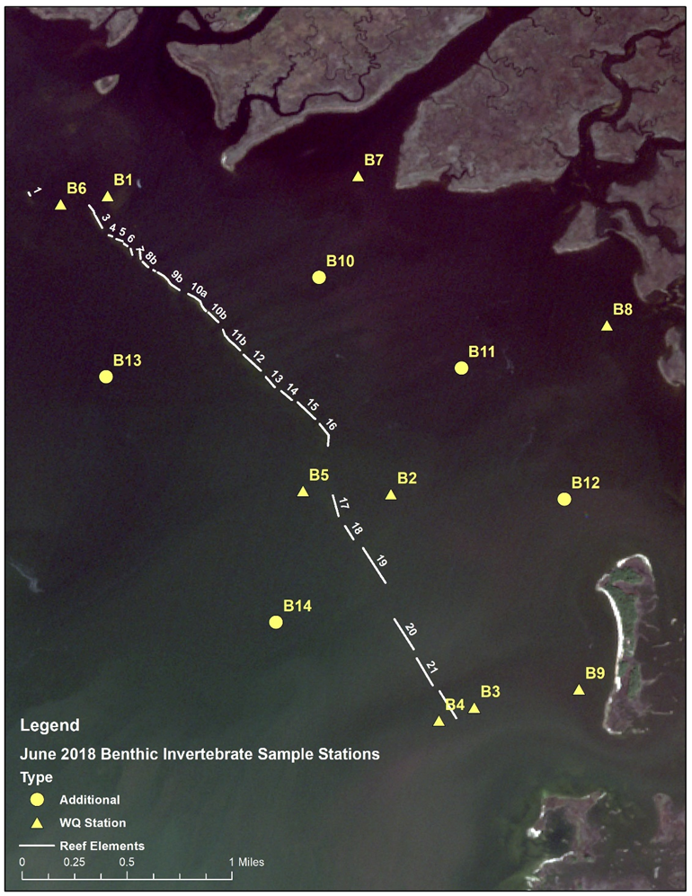

**Figure 1:** June2018 benthic invertebrate sample stations.

**Literature Cited:**

Brooks, RA, KJ Sulak. 2005. Quantitative assessment of benthic food resources for juvenile gulf sturgeon,*Acipenser oxyrinchus desotoi* in the Suwannee River Estuary, Florida, USA. *Estuaries.* 25-5:787-775.

Harris, JE, DC Parkyn, DJ Murie. 2005. Distribution of Gulf of Mexico sturgeon in relation to benthic invertebrate prey resources and environmental parameters in the Suwannee River Estuary, Florida. *Transactions of the American Fisheries Society.* 134-4:975-990.

Pinto, R, J Patricio, A Baeta, BD Fath, JM Neto, JC Marques. 2009. Review and evaluation of estuarine biotic indices to assess benthic condition. *Ecological Indicators.* 9:1-25.

Wang, Q, Y Li, Y Wang. 2011. Optimizing the weight loss-on-ignition methodology to quantify organic and carbonate carbon of sediments from diverse sources. *Environmental Monitoring and Assessment.* 174:241-257.