**Lone Cabbage Oyster Reef Restoration Project: Oyster Recruitment Sampling Protocol**

Oyster recruitment will be monitored for the Lone Cabbage Oyster Reef Restoration Project using tile spat collectors. These collectors will be deployed/replaced monthly and located at the nine existing water quality stations. To prevent potential confounding factors associated with cleaning/reusing collector materials, fresh/new materials will be used to construct collectors.

Quantifying spat (young oysters) on retrieved collectors is difficult. Spat are small and well camouflaged. We will only count spat if it is identifiable with the naked eye. Here are some tips:

1. Look over a shell using visual transects to ensure you examine the entire shell
2. They often appear as small red dots
3. Spat often have a dark or light stripe that stands out from the rest of the shell
4. Smooth and dark (barnacles are rough/more 3D, white, and opening is usually visible)
5. Wet shell and reflect light to see spat outline/shape
6. Push on suspected spat, outline may become visible and fluid will release
7. They are often only visible as an area with a slightly different pattern/color from the rest of shell
8. Once you find spat on a shell go back and look again to make sure you didn’t miss any
9. Spat vary in appearance, but are more likely to be similar in appearance on each collector
10. Slipper shells are often mistaken for spat, but they are white, translucent, and move easily
11. Be aware of bias: It is more difficult to identify spat on the exterior surface of the shell than the internal surface of the shell and tiles. Be consistent.
12. If it is too small to identify as spat, do not count it. This is typically <1mm.
13. On tiles with abundant spat, use straight edges to divide the tile into 4 rows and total counts.

**Tile Spat Collectors:**

Material needed for 10 tile spat collectors (single deployment, one for each WQ station):

-10 6x6 inch (15.24x15.24cm) metro quarry tiles (ordered from FD tile and flooring supply: mayflower red 77310)

-Drill press

-1/4 inch masonry bit

-Vise

-6.3m of paracord (70cm for each tile) Initial deployment

-lighter

-18 8” zip-ties (2 for each tile)

-9 large zip-ties (1 for each tile)

-27 small foam buoys (3 for each tile- there is a stock of these in buckets in the boat shed cage)

-Small container padded with burlap sack

-Nine zip-lock bags

-Write in rain paper

-Tray

-Calipers

-Laptop with spat collector spreadsheet

1. Fill small square container with water & adjust drill press to proper height
2. Mark center of tile
3. Place marked tile on top of two broken tile pieces (broken tiles in cage- ensure that you don’t drill through container)
   1. If you can’t find the broken pieces, just drill a hole 3/4 way through the tile then put in vice and punch hole the rest of the way through with a screw driver and hammer
4. Drill hole, Repeat for each of the other 9 tiles
   1. We usually keep 2 extra
5. Place tiles in padded container. They do not need uniquely identified with WQ station number until retrieval.
6. Cut 70cm of paracord. Tie ends together using a square knot, forming a loop. With cord doubled, tie an overhand knot 15cm from one end, this will form a stopper so each tile will sit horizontally, 15 cm above water bottom. Melt knot with lighter. Repeat for the other 8 tiles.
7. Deploy on WQ station anchor chain 1 m from WQ sensor. Place tile on short end of paracord loop, ROUGH SIDE DOWN. Secure 3 small buoys to short top paracord loop with large zip-tie. Fasten bottom paracord loop to chain with 2 zip-ties. Tile should float horizontally in the water column.
8. Record deployment date on “tile_spat_count_entry” spreadsheet.
9. When retrieving tile collectors, cut zip-ties but re-use paracord loop (bring spare loops). Place tile in a labeled zip-lock bag and place in a padded container in an icechest. Back at UF, place in freezer until processing.

Processing: tile_spat_count_entry.xlsx

1. Remove tiles from freezer, dunk tile in water bath to thaw for about 10 seconds or until tile is thawed.
2. Record retrieval date on spreadsheet.
3. Collect the following data for each tile:
   1. Spat count on tile top (smooth side)
   2. Spat count on tile bottom (rough side)
   3. Largest 3 spat heights (mm) on each side
   4. Barnacle fouling category (see above)
4. Make sure all cells in spreadsheet contain a value. If a metric does not apply, use -999 for numeric values (example: if spat count = 0, max spat size = -999), and use N_A for missing character values (example: if a collector was lost).
5. Place tile aside- we usually pile them up out behind the lab and recycle later

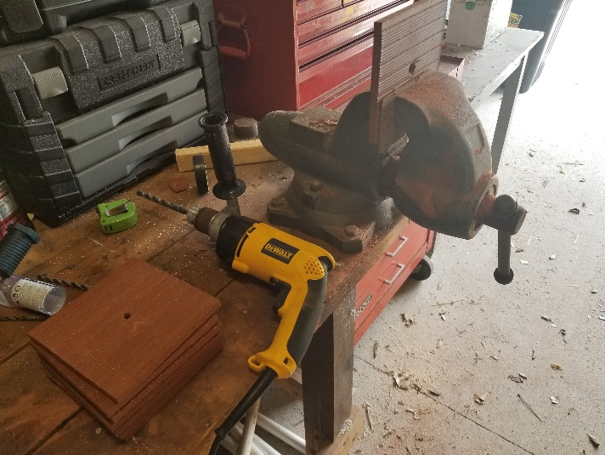

**Figure 2:** Drilling holes in tile spat collectors.

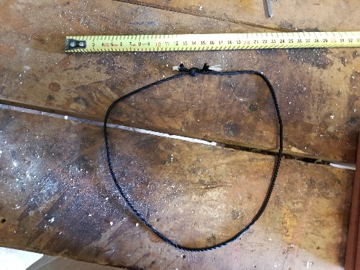 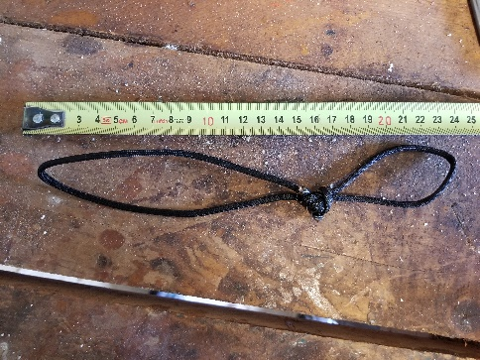

**Figure 3:** Paracord loop construction

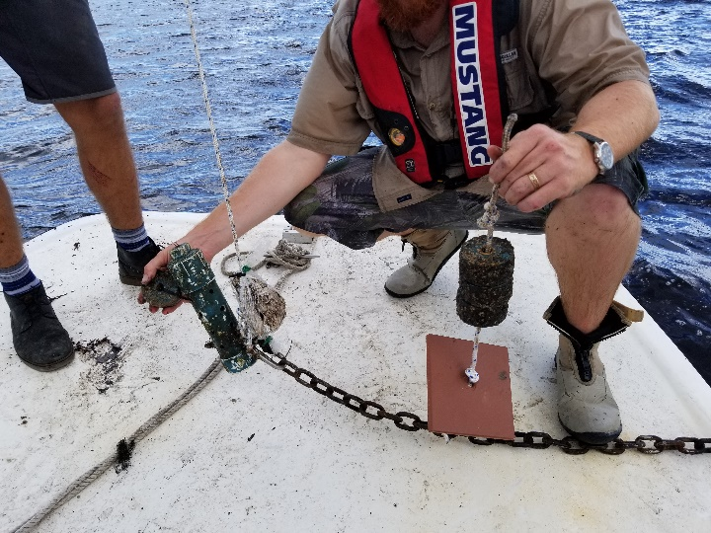

**Figure 4:** Shell and Tile spat collectors deployed on WQ sensor anchor chain.

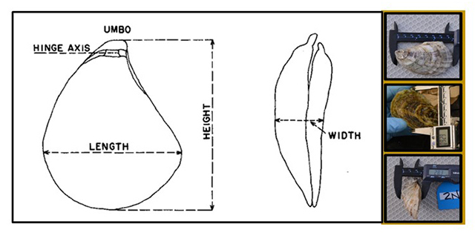

**Figure 5:** How to measure oyster height, length, and width.