A synopsis of Big Bend oyster sampling 2010-2018: Next steps winter 2018/2019

Bill Pine

October 13, 2018

Data science and analytical ideas and support from: Mel Moreno, Jennifer Moore, Erica Christensen, Katie Zarada, Dan Maxwell, Joe Aufmuth, Steve Beck, Ben Tok Koh, Stephen Longmire, Jake Tetzlaff, and Matt Lauretta

This is a living document designed to be updated, improved, and revised.

*Purpose*

This report is an effort to compile, present, and make available the most recent iteration of fisheries independent oyster sampling for Suwannee Sound region of Florida’s Big Bend. The purpose is to provide a base to work from to document efforts that have taken place and link these efforts to the available data. This is important at this time with a large number of new people involved in the project. This compilation will help us in planning future efforts by providing information to focus on what we know and what we think we know and limit the power an anecdotes. This compilation presents: (1) excerpts of raw data so the reader can “see” the data structure, (2) a large variety of summary statistics as tables and graphics, (3) analyses in the form of basic generalized linear models (GLM), and (4) basic guidance and simple discussion of future sampling efforts for fall winter 2018/2019 informed by empirical tests of capture probability (paper rock experiments) as well as simple power analyses. The figures and tables are rough in places in terms of formatting, but, all work is easily reproducible through Git repositories. The general structure follows a handout from Ben Bolker that offers a concise review of a lot of the key topics that we need to consider in this type of sampling effort (see <http://rpubs.com/bbolker/stats_intro>).

These data are from irregular fisheries independent sampling that has occurred since 2010 through efforts led by Peter Frederick at UF. These sampling efforts and related data have primarily focused on intertidal oyster reefs, defined loosely as reefs exposed to the air at mean low tides. This allows oysters to be counted and measured when the bars are dewatered. These bars are not exposed at all low tides throughout the year. Peter Frederick has made general observations that at about 0.8 ft MLLW the “higher” elevation bars are beginning to be out of the water as measured at the Cedar Key NOAA station 8727529. The best link to this station is <https://tidesandcurrents.noaa.gov/waterlevels.html?id=8727520> which allows you change the reference points on the graph to MLLW. There is also R script which can be used to graph predicted tidal heights in reference to target elevations as part of the Lone Cabbage construction <https://github.com/billpine/tide_inundation>. These tides generally occur with greatest frequency during late fall and winter periods of the year. Sampling has been done primarily using line transects to count the number of live and dead oysters in a known area and also with quadrats to collect size structure information. This report will just focus on data from transect samples with a later effort focused on quadrat information.

*Sampling Epochs*

Oyster sampling can broadly be defined as three epochs. The first from 2010-2012 included sampling that took place at four localities in the Big Bend, Horseshoe Beach, Lone Cabbage, Cedar Key, and Corrigan’s Reef. At each of these localities three different sites labeled as inshore, nearshore, and offshore were defined and within each of these sites multiple oyster bars were sampled. Horseshoe Beach is located north of the Suwannee River, Lone Cabbage was located just south of the East Pass of the Suwannee River, Cedar Key sites were primarily near the #4 channel, and Corrigan’s Reef sites were south of the town of Cedar Key (Figure X). The Cedar Key site was not sampled as frequently as other locations and total sampling effort is described in tables. A KML files (Google Earth) is available that details all historic oyster sampling sites. Epoch 1 focused on assessing oyster distribution at each locality and site and linking this information to aerial imagery collected in 2010 with funding from Frederick/Pine and Seagrant. This work provides the key information published in

Seavey, J.R., Pine III, W.E., Frederick, P., Sturmer, L. and Berrigan, M., 2011. Decadal changes in oyster reefs in the Big Bend of Florida’s Gulf Coast. *Ecosphere*, *2*(10), p.114.

The important message from this paper was the documentation of large losses (about 66%) in oyster reef distribution in the area from Horseshoe to Suwannee Sound since the early 1980’s. This paper did not identify mechanisms for these losses, but speculated that it was related to observed changes in river discharge levels that occurred during the same period of time that led to reduced oyster reef resilience.

Epoch 2 focused on the “pilot project” restoration of Lone Cabbage reef which involved placing rocks the size of basketballs on small patches of reef. This project lasted from 2013-2015 and is detailed below. Epoch 3 is the present effort associated with the large-scale restoration of Lone Cabbage Reef funded by NFWF with construction occurring during summer/fall 2018.

*Suwannee River discharge and available water quality data*

The Suwannee River is one of the largest nonregulated (undammed) rivers by length in the Gulf of Mexico and the second largest river by discharge in Florida. The river starts in the area of Okefenokee National Wildlife Refuge where it flows west before turning south-southwest entering the Gulf of Mexico near the town of Suwannee, Florida. A large portion of the Suwannee River watershed is in Georgia. While the river system does not have any dams or large surface water diversions (i.e., canals, diversion channels etc.), large portions of the river flow across a highly karstic landscape where surface to sub-surface water connections are common through springs and sinks. The Suwannee River basin has extensive ground water withdrawals occurring throughout for agricultural, municipal, and mining operations (mostly phosphate). Whereas in most river basins river discharge-per-unit-rainfall has increased in recent decades due to changes on the landscape of many watersheds such as conversion from forest to agriculture or increase in impervious surfaces, in the Suwannee River the opposite trend has been observed where river discharge has actually declined-per-unit-rainfall possibly due to recurring low groundwater levels. Low groundwater levels can have impacts to human users such as the collapse of the drinking water supply system in Cedar Key during 2012.

Saetta, D., Ishii, S.K., Pine III, W.E. and Boyer, T.H., 2015. Case study and life cycle assessment of a coastal utility facing saltwater intrusion. *Journal‐American Water Works Association*, *107*(10), pp.E543-E558.

There are several river gauges available to measure Suwannee River discharge. Not all gauges have the same period of record and some river gauges can be influenced by tidal bore. A river gauge I have frequently used is USGS gauge 02323500 located near Wilcox, Florida. This gauge is generally not strongly tidally influenced except under very low river discharge. The period of record also a long-term record dating to October 1930 and efforts have been underway to update the period of record to eliminate gaps in the 1930’s and 1940’s. These updates may now be completed by USGS. Below are summary figures for river discharge from this gauge beginning January 1950 until October 2018. The data used are mean daily discharge (CFS), that are then summarized in different ways. In several of these figures a red LOWESS smoothing line is included to help identify general trends. Of interest is the decline in mean daily discharge by year since about 1980 and a general increase in CV over time. Recent years (since 2000) have seen periods of highly variable river discharge with long-periods of low river discharge often punctuated by tropical rainfall events which bring large volumes of rain over short time periods. A research need exists to further quantify the rainfall-discharge relationship in the Suwannee Basin to see if this discharge is consistent within the basin. Recent work by UF PhD student Katie Glodzik is useful to help assess these questions further (dissertation available electronically from UF library).

We have also obtained three different data sets that may be useful to characterize water quality (generally salinity, temperature, DO, and some chlorophyll data) for the lower Suwannee River, Suwannee River Sound, and areas just to the north and south of Cedar Key. The FDACS data begin in the late 1980’s and include water quality samples from fixed stations collected at monthly intervals mostly using hand held instruments. These stations were later expanded both in space and time to generally collect water samples from random samples from a list of fixed stations twice per month. The second dataset of water quality data are instrument based samples from the monthly FWC-FIM sampling efforts that are random stratified point samples that are taken along with the fisheries independent monitoring seining effort beginning in the mid-1990’s. The third dataset is Tom Frazer’s (UF, now Director of SNRE) monthly water quality sampling from the mid-1990’s that occurred at fixed stations. These data have been compiled and are available for use. Leslie Sturmer with UF-SFRC has also maintained autonomous water quality sensors at Gulf Jackson and Dog Island at regular intervals beginning in the early 1990’s. These various water quality data are likely key for work Simeon Yurek with USGS is considering. The FDACS data are also currently being examining by a student of Matthew Deitch and his proposed dissertation work will link groundwater models for the Suwannee Basin/north Florida region to Suwannee River discharge and ultimately try and predict salinity with Suwannee Sound. At present he is assessing relationships between salinity observations, river discharge, sea-level trends, and other factors.

*Lone Cabbage Water Quality Monitoring Network*

Beginning in August 2017 we launched a series of autonomous monitoring stations to monitor temperature and conductivity (and derive salinity) as a pre-construction monitoring network for the Lone Cabbage Reef restoration project. This network of 9 sensors records these observations hourly and these data are transferred approximately every 14 days to a MySQL database developed with the UF Academic Research Consulting Services (http://arcs.uflib.ufl.edu/). UF library staff including Dan Maxwell, Joe Aufmuth, Robert Phillips, and Plato Smith have coordinated this portion of the project. Mel Moreno has been the student point person on these efforts. The database development began approximately 2 months prior to sensor deployment. The database contains a variety of QA/QC features and is designed for export for simple visualization through an R Shiny App mounted here

<https://lcroysterproject.github.io/oysterproject/>

These continuous data are also augmented by monthly grab samples of water for processing by the UF Lakewatch lab which provides additional measurements including TN, TP, and chlorophyll. Lakewatch sample processing costs are not funded by the project and their future is uncertain. The MySQL instance can be expanded when funding are available to capture other project data streams. The database and visualization tools are an excellent tool for our project both from a research and outreach component.

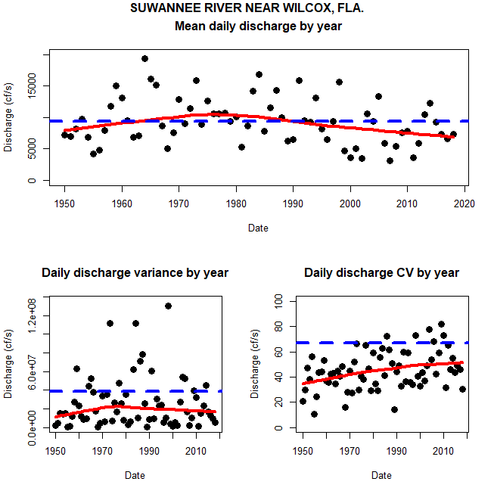

Figure. Mean daily discharge by year and associated variance and CV of discharge (CF/S by convention) for the Suwannee River measured at USGS Wilcox gauge from January 1950 to October 2018. Red LOWESS smoothing line provided to show general trends in discharge. Blue dashed line is the average mean daily discharge, variance, or CV from 1950-2018. Code available on Github https://github.com/LCRoysterproject/transect

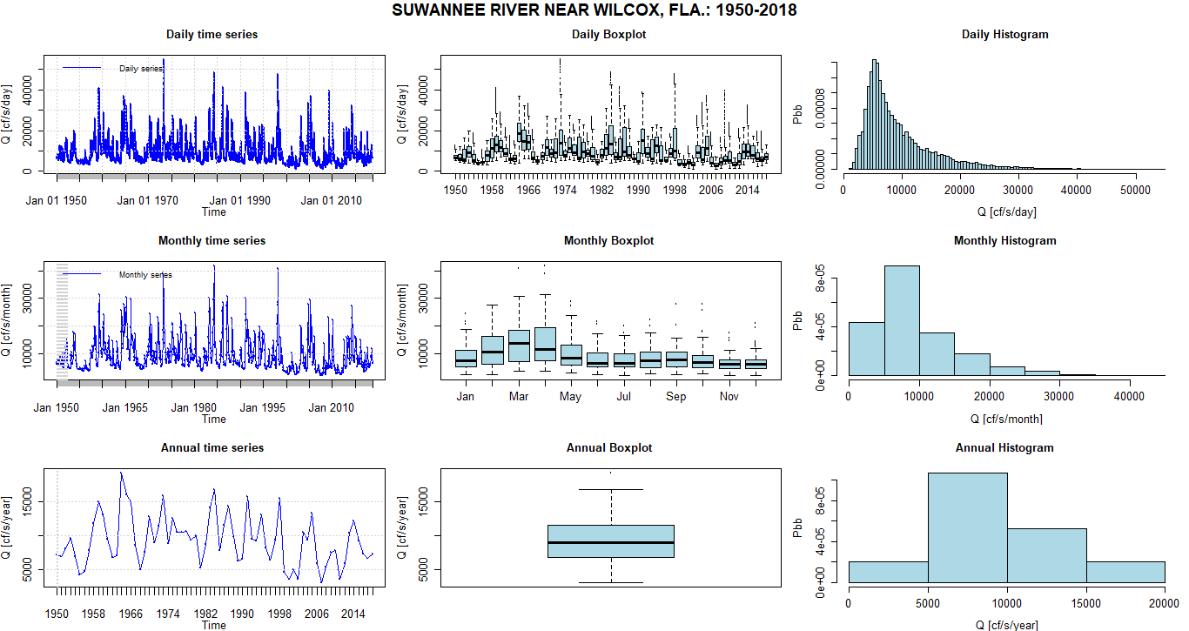

Figure. Daily discharge statistics (CF/S, by convention) for Suwannee River USGS Wilcox gauge from 1950-2018. Automated summaries from the hydroTSM package.

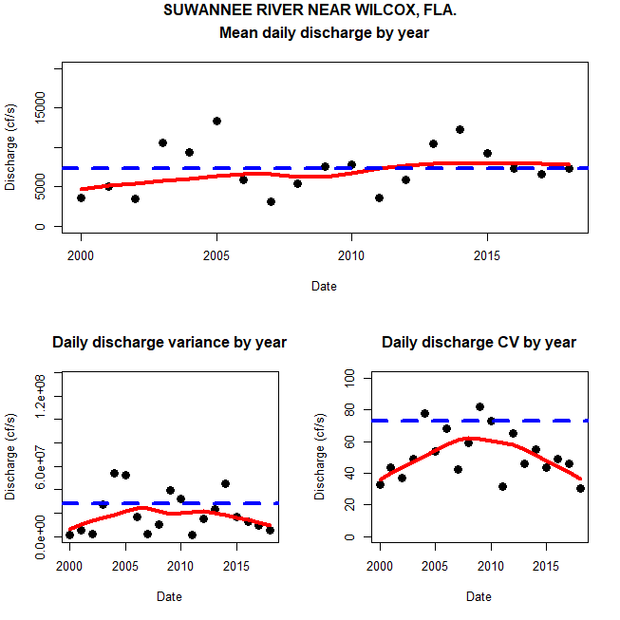

Figure. Mean annual daily discharge, annual daily variance, and annual daily CV of discharge (CF/S by convention) for the Suwannee River measured at USGS Wilcox gauge from January 2000 to October 2018. Red LOWESS smoothing line provided to show general trends in discharge. Blue dashed line is the average discharge, variance, or CV from 1950-2018.

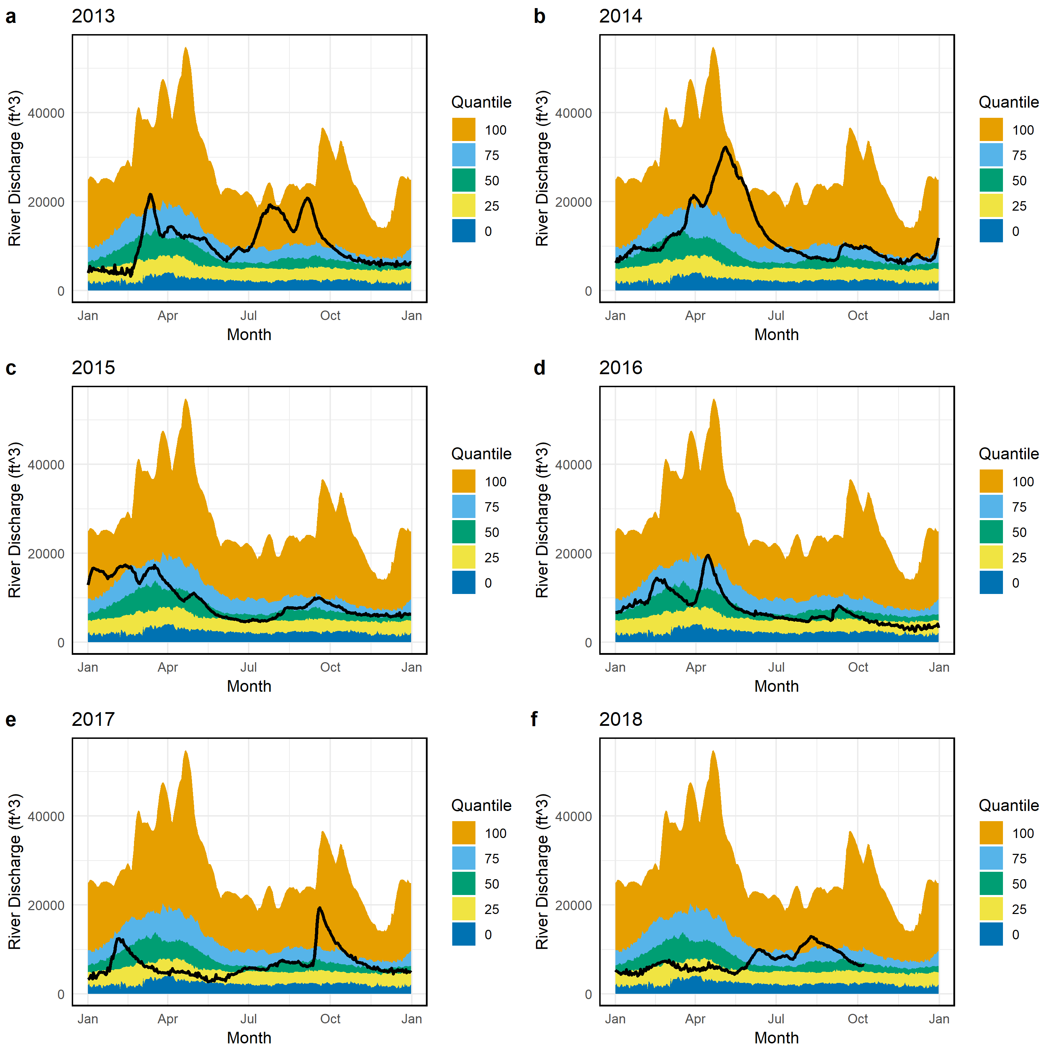

Figure

*Commercial oyster landings*

Cedar Key and Suwannee Sound have a long history of commercial oyster fishing which are documented in various dissertations available in the UF library (see Zaruru 1975 “Mullet Springs” as an example; Hepburn 1975 DEP report is also important). In Florida oysters are managed jointly by two state agencies, FWC and FDACS. Rulemaking authority for fishery practices (seasons, gear, etc.) is with FWC but rule making once harvested is with FDACS. Cedar Key historically supported cannery operations, but those have long closed and harvest has focused on shucked product and now mostly half-shell markets. As elsewhere in Florida, oysters tongs are the primary harvest tool from public fishing areas and on low tides fishermen also “pick-up” oysters. These tides are called “pick-up” tides for this reason. Limited efforts have been made to replace oyster shell removed from harvested areas by managers or industry. Clam shell was used as cultch material with limited success. Management actions for oysters in Cedar Key generally follow a combination of bag and size limits as well as seasonal closures. Unlike Apalachicola, Cedar Key does not have an open summer harvest season. Other management actions that have occurred include “relay” of oysters from areas that are closed to harvest (often due to *E. coli* levels or small oyster size) to areas that are open to harvest, then allow the oysters to grow and “clean” and then allow harvest. This has not occurred since about 2010 due to lack of funds from FDACS. These efforts may restart with funding from the DWH (Deepwater Horizon) oil spill. While relay may provide job opportunities for oystermen during periods when the oyster season is closed, from a biological perspective relay may be a very risky management action. This is an area for future work.

The Cedar Key/Suwannee Sound area (Levy, Taylor, Dixie counties) has historically been the second highest region of Florida in terms of oyster landings, but the landings from this region are much smaller than the landings and effort from Apalachicola. Following the most recent collapse of the Apalachicola oyster fishery in 2012, landings and trips have increased in Cedar Key area and in the last 3-4 years Cedar Key region has equaled or exceeded Apalachicola landings, while trips have remained higher in Apalachicola region. When examining landings data, 1986 is an important year because this is the first year that mandatory TRIP ticket program was implemented. Landings data prior to 1986 were a voluntary reporting system. This is discussed further in Fisch and Pine (2016) related to Apalachicola, but is relevant here as well.

Fisch, N.C. and Pine III, W.E., 2016. A Complex Relationship between Freshwater Discharge and Oyster Fishery Catch Per Unit Effort in Apalachicola Bay, Florida: an Evaluation from 1960 to 2013. *Journal of Shellfish Research*, *35*(4), pp.809-825.

Landings prior to 1986 are available from various state reports and these have been compiled and cross-referenced for the region dating back to 1950 by FWC and Stephen Longmire (UF). These records are available on <https://github.com/LCRoysterproject>.

C:\Users\Owner\Documents\Git\quarterly_reports\landings\pic\alllandslines86_18.tiff

Figure. provisional for 2018

C:\Users\Owner\Documents\Git\quarterly_reports\landings\pic\suw_plots86_18.tiff

Figure provisional for 2018

*Description of sampling*

*Epoch 1*

Efforts in Epoch 1 (2010-2012) were focused on sampling oyster bars from near the town of Horseshoe Beach (aka Horseshoe Cove) to Corrigan’s Reef (Figure X). At each of these localities oyster bars were designated as Inshore, Nearshore, or Offshore and then individual oyster bars within each of these sites were chosen for sampling (generally 3 unique bars within each site and locality). These data were collected using transects at fixed locations on each bar. The transect width was 15.24 cm and transect length was the “width” of the oyster bar with the bar oriented parallel to the coast. If the bar was a rectangle, we would sample the narrowest dimension of the rectangle extending the transect over the higher elevation “crown” of the oyster bar. Live and dead oysters would be counted in each transect (Figure X). We also used quadrats placed a random distance “along” the transect line and then “away” from the transect line to both count oysters and take size measurements (Figure). This report focuses on count data from these transects.

*Epoch 2 “pilot project”*

Based on information from commercial fishermen (Jerry Beckham) reports from the literature, and personal observations of Peter’s it was identified that a key role played by oyster reefs in the Big Bend was likely related to detaining freshwater on the landward side of the reef thus promoting estuarine conditions between the land and the oyster bar. This was in part motivated by several key papers by Al Hine and colleagues from USF and key references include:

Wright, E.E., Hine, A.C., Goodbred Jr, S.L. and Locker, S.D., 2005. The effect of sea-level and climate change on the development of a mixed siliciclastic–carbonate, deltaic coastline: Suwannee River, Florida, USA. *Journal of Sedimentary Research*, *75*(4), pp.621-635.

Hine, A.C., Belknap, D.F., Hutton, J.G., Osking, E.B. and Evans, M.W., 1988. Recent geological history and modern sedimentary processes along an incipient, low-energy, epicontinental-sea coastline; Northwest Florida. *Journal of Sedimentary Research*, *58*(4), pp.567-579.

Beginning in 2013 efforts were made to secure funding to experimentally restore a portion of Lone Cabbage Reef to both produce more oysters but also to promote estuarine conditions by placing “durable substrate” aka rocks on the reef. The idea was to promote resilience for oyster reefs in this area by providing a substrate that would persist even in years when the oyster bar had died back due to unknown factors. In years when conditions were favorable, the rocks would provide a stable substrate for oyster spat to settle and grow. These funds were secured from NOAA with TNC involvement and a pilot project launched to place rocks on the reef in 2014/2015. Results from this effort are documented in a paper referenced below and the data from this project are included in this synthesis.

Frederick, P., Vitale, N., Pine, B., Seavey, J. and Sturmer, L., 2016. Reversing a rapid decline in oyster reefs: effects of durable substrate on Oyster populations, elevations, and aquatic bird community composition. *Journal of shellfish research*, *35*(2), pp.359-367.

A related paper that focuses on the freshwater detention issues is

Kaplan, D.A., Olabarrieta, M., Frederick, P. and Valle-Levinson, A., 2016. Freshwater detention by oyster reefs: quantifying a keystone ecosystem service. *PloS one*, *11*(12), p.e0167694.

Several key distinctions exist between Epoch 1 and Epoch 2. In Epoch 1 the primary factors of interest were (1) do oyster densities differ between localities (Horseshoe Beach, Lone Cabbage, Cedar Key, and Corrigan’s Reef. (2) do oyster densities differ between sites (Inshore, Nearshore, Offshore) within a locality. Epoch 1 used replicate transects taken on randomly selected reefs within each locality and site. As an example 3 different reefs would have been chosen for Site = Inshore and Locality = Lone Cabbage and one transect would have been conducted on each reef. Each of these reefs are labeled in the dataset as Reef 1, Reef 2, Reef 3 etc. for each Locality and Site. This is duplicated in the dataset via the use of a “station” name which is a unique name for each location oysters were collected and is a combination of Locality, Site, and Reef. For Epoch 2 the primary question was (1) is there a response in terms of oyster density from adding rock substrate to the reef? During Epoch 2 sampling was only conducted at the Lone Cabbage offshore location (Locality = Lone Cabbage; Site = Offshore in data). No sampling was done at other localities or sites. For Epoch 2 sampling was also done such that multiple transects were conducted on a single reef. For the 2016 paper, oyster densities were calculated for each transect on an individual reef, and then the average oyster density calculated from these multiple transects. For the analyses I have completed, I sum the total length of all transects conducted on a reef, and then sum the counts of oysters from all transects on a reef, and then calculate density from these two sums. In this way I “collapse” the multiple transects on a reef from Epoch 2 into a single transect conducted on each reef.



Figure. General map of the Big Bend region of Florida where oyster sampling has taken place. This is the general spatial outline for how sampling was conducted during Epoch 1.

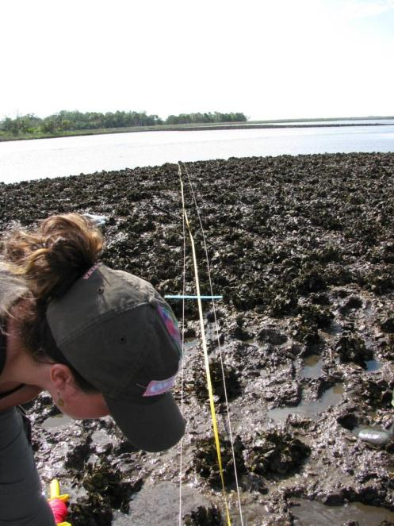

Figure. Image showing transect sampling from an inshore oyster bar. Note the white lines are the transect lines and the yellow line is the measuring tape. One concern is that frequent walking on “soft” oyster bars like this appear to be deleterious to the oyster bar in that it created channels for water to flow across the bar likely changing elevations. Stepping on oysters can cause damage as well. Every effort should be made to minimize walking on oyster bars.

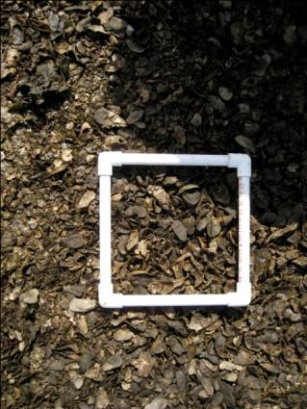

Figure. Example quadrat on an oyster bar. Quadrat data are not included in this synthesis.

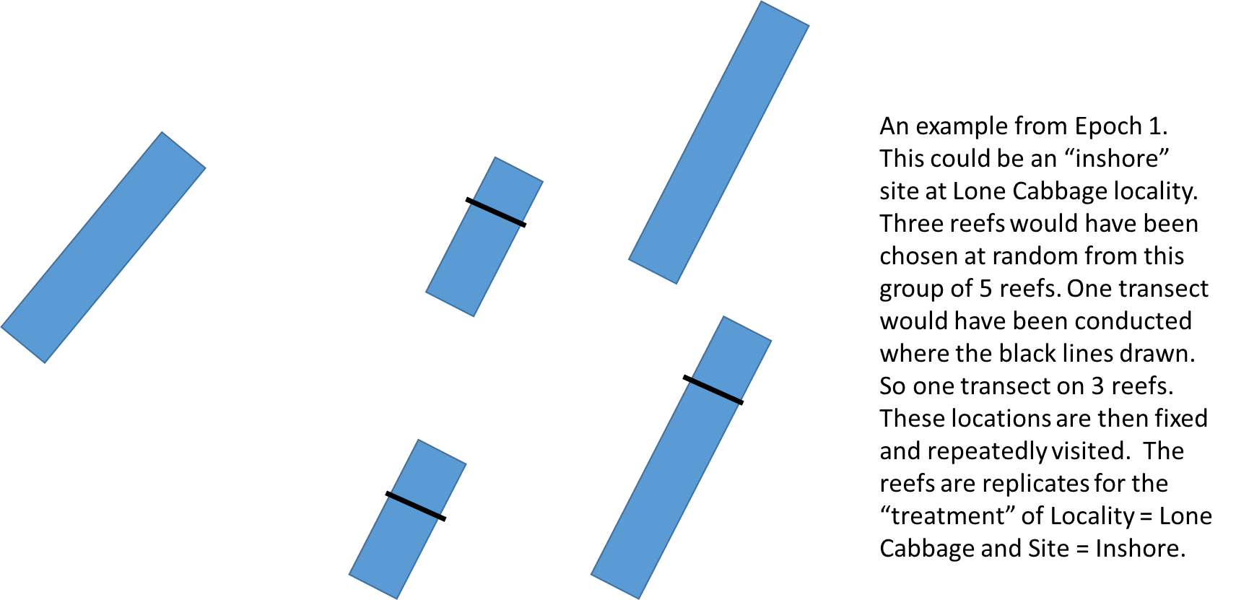

Figure. Schematic of example reef as sampled during Epoch 2. See description inside Figure.

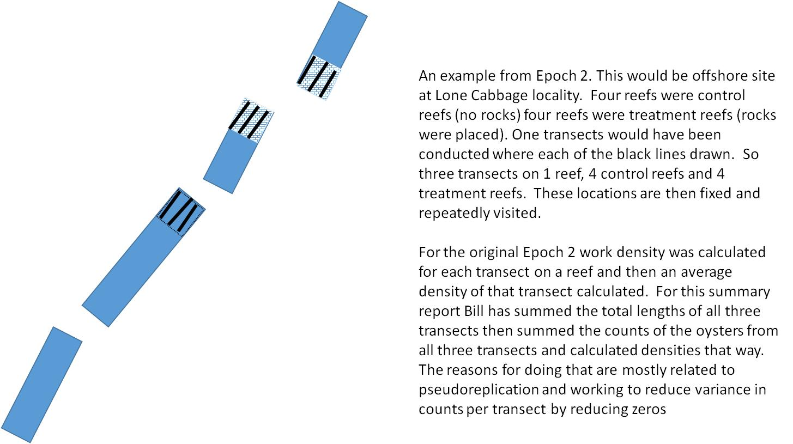

Figure. Schematic of example reef as sampled during Epoch 2. See description inside Figure.

*Data description*

The next portion of his summary provides data in the original and “collapsed” structure for review in tabular and graphical form. These data are summarized for Epoch 1 and then Epoch 2 with Epoch 2 focusing on Lone Cabbage offshore sites. All data are available on LCRoysterproject Git Hub page https://github.com/LCRoysterproject.

Table 1. All data in “collapsed” form where multiple transects per bar on a sampling date are combined (summed) both in terms of transect length and number of oysters counted.

|  |  |  |  |  |  |  |  |  |  |  |
| --- | --- | --- | --- | --- | --- | --- | --- | --- | --- | --- |
| day | month | year | Season | treatment | locality | site | bar | station | count\_live | tran\_length\_m |
| 27 | 5 | 2010 | Summer | control | CK | I | 1 | CKI1 | 1231 | 24.9 |
| 27 | 5 | 2010 | Summer | control | CK | I | 2 | CKI2 | 540 | 29.2 |
| 27 | 5 | 2010 | Summer | control | CK | I | 3 | CKI3 | 811 | 21.9 |
| 27 | 5 | 2010 | Summer | control | CK | N | 1 | CKN1 | 350 | 15.3 |
| 27 | 5 | 2010 | Summer | control | CK | N | 2 | CKN2 | 83 | 41 |
| 27 | 5 | 2010 | Summer | control | CK | N | 3 | CKN3 | 940 | 16.5 |
| 27 | 5 | 2010 | Summer | control | CK | O | 1 | CKO1 | 54 | 23.2 |
| 27 | 5 | 2010 | Summer | control | CK | O | 2 | CKO2 | 26 | 25.7 |
| 27 | 5 | 2010 | Summer | control | CK | O | 3 | CKO3 | 226 | 33 |
| 24 | 5 | 2010 | Summer | control | CR | I | 1 | CRI1 | 711 | 23.4 |
| 27 | 5 | 2010 | Summer | control | CR | I | 2 | CRI2 | 1089 | 18.6 |
| 27 | 5 | 2010 | Summer | control | CR | I | 3 | CRI3 | 693 | 13.9 |
| 23 | 5 | 2010 | Summer | control | CR | N | 1 | CRN1 | 136 | 20.3 |
| 24 | 5 | 2010 | Summer | control | CR | N | 2 | CRN2 | 97 | 21.6 |
| 24 | 5 | 2010 | Summer | control | CR | N | 3 | CRN3 | 1107 | 35 |
| 24 | 5 | 2010 | Summer | control | CR | O | 1 | CRO1 | 318 | 50 |
| 24 | 5 | 2010 | Summer | control | CR | O | 2 | CRO2 | 1664 | 45 |
| 24 | 5 | 2010 | Summer | control | CR | O | 3 | CRO3 | 20 | 40 |
| 25 | 5 | 2010 | Summer | control | HB | I | 1 | HBI1 | 1211 | 32.5 |
| 25 | 5 | 2010 | Summer | control | HB | I | 2 | HBI2 | 1152 | 16 |
| 25 | 5 | 2010 | Summer | control | HB | I | 3 | HBI3 | 1314 | 26 |
| 25 | 5 | 2010 | Summer | control | HB | I | 4 | HBI4 | 93 | 17.5 |
| 25 | 5 | 2010 | Summer | control | HB | N | 1 | HBN1 | 46 | 18.1 |
| 25 | 5 | 2010 | Summer | control | HB | N | 2 | HBN2 | 14 | 23.3 |
| 25 | 5 | 2010 | Summer | control | HB | N | 3 | HBN3 | 45 | 16.5 |
| 25 | 5 | 2010 | Summer | control | HB | O | 1 | HBO1 | 4 | 31.2 |
| 25 | 5 | 2010 | Summer | control | HB | O | 2 | HBO2 | 11 | 15.6 |
| 25 | 5 | 2010 | Summer | control | HB | O | 3 | HBO3 | 62 | 50 |
| 26 | 5 | 2010 | Summer | control | LC | I | 1 | LCI1 | 611 | 20 |
| 26 | 5 | 2010 | Summer | control | LC | I | 2 | LCI2 | 771 | 20.3 |
| 26 | 5 | 2010 | Summer | control | LC | I | 3 | LCI3 | 619 | 20 |
| 26 | 5 | 2010 | Summer | control | LC | N | 1 | LCN1 | 40 | 12.3 |
| 25 | 5 | 2010 | Summer | control | LC | N | 2 | LCN2 | 30 | 17.7 |
| 26 | 5 | 2010 | Summer | control | LC | N | 3 | LCN3 | 50 | 32.6 |
| 26 | 5 | 2010 | Summer | control | LC | O | 3 | LCO3 | 117 | 21.3 |
| 26 | 5 | 2010 | Summer | control | LC | O | 8A | LCO8A | 45 | 14.3 |
| 26 | 5 | 2010 | Summer | control | LC | O | 9B | LCO9B | 79 | 20.3 |
| 9 | 7 | 2010 | Summer | control | CK | I | 1 | CKI1 | 737 | 29.2 |
| 9 | 7 | 2010 | Summer | control | CK | I | 2 | CKI2 | 1178 | 25 |
| 9 | 7 | 2010 | Summer | control | CK | I | 3 | CKI3 | 797 | 21.8 |
| 9 | 7 | 2010 | Summer | control | CK | N | 1 | CKN1 | 436 | 15 |
| 9 | 7 | 2010 | Summer | control | CK | N | 2 | CKN2 | 78 | 35 |
| 9 | 7 | 2010 | Summer | control | CK | N | 3 | CKN3 | 1455 | 17.5 |
| 9 | 7 | 2010 | Summer | control | CK | O | 1 | CKO1 | 67 | 23.3 |
| 9 | 7 | 2010 | Summer | control | CK | O | 2 | CKO2 | 61 | 30.4 |
| 9 | 7 | 2010 | Summer | control | CK | O | 3 | CKO3 | 320 | 33 |
| 9 | 7 | 2010 | Summer | control | CR | I | 1 | CRI1 | 820 | 23.3 |
| 6 | 7 | 2010 | Summer | control | CR | I | 2 | CRI2 | 1160 | 18.6 |
| 9 | 7 | 2010 | Summer | control | CR | I | 3 | CRI3 | 540 | 13.9 |
| 9 | 7 | 2010 | Summer | control | CR | N | 1 | CRN1 | 214 | 20.5 |
| 9 | 7 | 2010 | Summer | control | CR | N | 2 | CRN2 | 120 | 21.6 |
| 10 | 7 | 2010 | Summer | control | CR | N | 3 | CRN3 | 726 | 30 |
| 6 | 7 | 2010 | Summer | control | CR | O | 1 | CRO1 | 172 | 50 |
| 6 | 7 | 2010 | Summer | control | CR | O | 3 | CRO3 | 24 | 21 |
| 6 | 7 | 2010 | Summer | control | CR | O | 4 | CRO4 | 1664 | 25 |
| 7 | 7 | 2010 | Summer | control | HB | I | 1 | HBI1 | 806 | 32.5 |
| 7 | 7 | 2010 | Summer | control | HB | I | 2 | HBI2 | 838 | 16 |
| 7 | 7 | 2010 | Summer | control | HB | I | 3 | HBI3 | 902 | 25.9 |
| 7 | 7 | 2010 | Summer | control | HB | N | 1 | HBN1 | 664 | 18 |
| 7 | 7 | 2010 | Summer | control | HB | N | 2 | HBN2 | 1545 | 23.5 |
| 7 | 7 | 2010 | Summer | control | HB | N | 3 | HBN3 | 1521 | 17.5 |
| 7 | 7 | 2010 | Summer | control | HB | N | 5 | HBN5 | 226 | 18 |
| 7 | 7 | 2010 | Summer | control | HB | N | 6 | HBN6 | 704 | 22.7 |
| 7 | 7 | 2010 | Summer | control | HB | O | 1 | HBO1 | 1634 | 31.5 |
| 8 | 7 | 2010 | Summer | control | LC | I | 1 | LCI1 | 509 | 19.6 |
| 8 | 7 | 2010 | Summer | control | LC | I | 2 | LCI2 | 416 | 20.2 |
| 8 | 7 | 2010 | Summer | control | LC | I | 3 | LCI3 | 586 | 19.4 |
| 8 | 7 | 2010 | Summer | control | LC | N | 1 | LCN1 | 31 | 12.5 |
| 8 | 7 | 2010 | Summer | control | LC | N | 2 | LCN2 | 351 | 18.3 |
| 8 | 7 | 2010 | Summer | control | LC | N | 4 | LCN4 | 80 | 18.5 |
| 8 | 7 | 2010 | Summer | control | LC | N | 5 | LCN5 | 80 | 36 |
| 8 | 7 | 2010 | Summer | control | LC | O | 3 | LCO3 | 223 | 21.8 |
| 8 | 7 | 2010 | Summer | control | LC | O | 8A | LCO8A | 76 | 14.6 |
| 8 | 7 | 2010 | Summer | control | LC | O | 9B | LCO9B | 32 | 20.8 |
| 8 | 8 | 2010 | Summer | control | CK | I | 1 | CKI1 | 2027 | 25 |
| 8 | 8 | 2010 | Summer | control | CK | I | 2 | CKI2 | 682 | 29 |
| 8 | 8 | 2010 | Summer | control | CK | N | 1 | CKN1 | 233 | 15 |
| 8 | 8 | 2010 | Summer | control | CK | N | 2 | CKN2 | 21 | 37.5 |
| 8 | 8 | 2010 | Summer | control | CK | N | 3 | CKN3 | 1176 | 17.5 |
| 8 | 8 | 2010 | Summer | control | CK | O | 1 | CKO1 | 281 | 25 |
| 8 | 8 | 2010 | Summer | control | CK | O | 2 | CKO2 | 182 | 29.9 |
| 8 | 8 | 2010 | Summer | control | CK | O | 3 | CKO3 | 658 | 32.5 |
| 5 | 8 | 2010 | Summer | control | CR | I | 1 | CRI1 | 542 | 22 |
| 5 | 8 | 2010 | Summer | control | CR | I | 2 | CRI2 | 1128 | 18.5 |
| 5 | 8 | 2010 | Summer | control | CR | I | 3 | CRI3 | 474 | 13 |
| 5 | 8 | 2010 | Summer | control | CR | N | 1 | CRN1 | 379 | 17.5 |
| 5 | 8 | 2010 | Summer | control | CR | N | 2 | CRN2 | 63 | 20 |
| 5 | 8 | 2010 | Summer | control | CR | N | 3 | CRN3 | 2131 | 32.5 |
| 5 | 8 | 2010 | Summer | control | CR | O | 1 | CRO1 | 415 | 57.5 |
| 5 | 8 | 2010 | Summer | control | CR | O | 2 | CRO2 | 3008 | 45 |
| 5 | 8 | 2010 | Summer | control | CR | O | 3 | CRO3 | 10 | 35 |
| 6 | 8 | 2010 | Summer | control | HB | I | 1 | HBI1 | 1435 | 32 |
| 6 | 8 | 2010 | Summer | control | HB | I | 2 | HBI2 | 876 | 16 |
| 6 | 8 | 2010 | Summer | control | HB | I | 3 | HBI3 | 1341 | 27.5 |
| 6 | 8 | 2010 | Summer | control | HB | N | 1 | HBN1 | 308 | 18 |
| 6 | 8 | 2010 | Summer | control | HB | N | 2 | HBN2 | 194 | 25 |
| 6 | 8 | 2010 | Summer | control | HB | N | 3 | HBN3 | 503 | 17.5 |
| 6 | 8 | 2010 | Summer | control | HB | O | 1 | HBO1 | 154 | 32.5 |
| 7 | 8 | 2010 | Summer | control | LC | I | 1 | LCI1 | 645 | 19.5 |
| 7 | 8 | 2010 | Summer | control | LC | I | 2 | LCI2 | 709 | 20 |
| 7 | 8 | 2010 | Summer | control | LC | I | 3 | LCI3 | 976 | 20 |
| 7 | 8 | 2010 | Summer | control | LC | N | 1 | LCN1 | 161 | 12.2 |
| 7 | 8 | 2010 | Summer | control | LC | N | 2 | LCN2 | 54 | 33 |
| 7 | 8 | 2010 | Summer | control | LC | N | 3 | LCN3 | 145 | 32 |
| 7 | 8 | 2010 | Summer | control | LC | N | 4 | LCN4 | 18 | 17.5 |
| 7 | 8 | 2010 | Summer | control | LC | O | 3 | LCO3 | 457 | 20 |
| 7 | 8 | 2010 | Summer | control | LC | O | 8A | LCO8A | 325 | 14 |
| 7 | 8 | 2010 | Summer | control | LC | O | 9B | LCO9B | 56 | 17.5 |
| 25 | 10 | 2010 | Winter | control | CR | I | 1 | CRI1 | 1238 | 23 |
| 25 | 10 | 2010 | Winter | control | CR | I | 2 | CRI2 | 2002 | 18.5 |
| 25 | 10 | 2010 | Winter | control | CR | I | 3 | CRI3 | 960 | 13.5 |
| 25 | 10 | 2010 | Winter | control | CR | N | 1 | CRN1 | 358 | 20 |
| 25 | 10 | 2010 | Winter | control | CR | N | 2 | CRN2 | 359 | 22.5 |
| 25 | 10 | 2010 | Winter | control | CR | N | 3 | CRN3 | 1145 | 35 |
| 25 | 10 | 2010 | Winter | control | CR | O | 1 | CRO1 | 515 | 60 |
| 25 | 10 | 2010 | Winter | control | CR | O | 2 | CRO2 | 1894 | 25 |
| 25 | 10 | 2010 | Winter | control | CR | O | 3 | CRO3 | 169 | 40 |
| 27 | 10 | 2010 | Winter | control | HB | I | 1 | HBI1 | 1938 | 32.3 |
| 27 | 10 | 2010 | Winter | control | HB | I | 2 | HBI2 | 1421 | 16 |
| 27 | 10 | 2010 | Winter | control | HB | I | 3 | HBI3 | 1385 | 25.5 |
| 27 | 10 | 2010 | Winter | control | HB | N | 1 | HBN1 | 116 | 18 |
| 27 | 10 | 2010 | Winter | control | HB | N | 2 | HBN2 | 20 | 23 |
| 27 | 10 | 2010 | Winter | control | HB | N | 3 | HBN3 | 54 | 16.5 |
| 27 | 10 | 2010 | Winter | control | HB | O | 1 | HBO1 | 44 | 32.5 |
| 27 | 10 | 2010 | Winter | control | HB | O | 2 | HBO2 | 0 | 16 |
| 25 | 10 | 2010 | Winter | control | LC | I | 1 | LCI1 | 950 | 19.5 |
| 26 | 10 | 2010 | Winter | control | LC | I | 2 | LCI2 | 946 | 20 |
| 26 | 10 | 2010 | Winter | control | LC | I | 3 | LCI3 | 1587 | 20 |
| 26 | 10 | 2010 | Winter | control | LC | N | 1 | LCN1 | 82 | 12.3 |
| 26 | 10 | 2010 | Winter | control | LC | N | 2 | LCN2 | 78 | 17.5 |
| 26 | 10 | 2010 | Winter | control | LC | N | 3 | LCN3 | 146 | 25 |
| 26 | 10 | 2010 | Winter | control | LC | N | 4 | LCN4 | 14 | 20 |
| 26 | 10 | 2010 | Winter | control | LC | O | 3 | LCO3 | 333 | 21.2 |
| 26 | 10 | 2010 | Winter | control | LC | O | 8A | LCO8A | 142 | 14.3 |
| 26 | 10 | 2010 | Winter | control | LC | O | 9B | LCO9B | 18 | 20 |
| 6 | 12 | 2010 | Winter | control | CR | I | 1 | CRI1 | 540 | 23.4 |
| 6 | 12 | 2010 | Winter | control | CR | I | 2 | CRI2 | 1406 | 18.6 |
| 6 | 12 | 2010 | Winter | control | CR | I | 3 | CRI3 | 1008 | 13.9 |
| 6 | 12 | 2010 | Winter | control | CR | N | 1 | CRN1 | 652 | 17.5 |
| 6 | 12 | 2010 | Winter | control | CR | N | 2 | CRN2 | 408 | 21.64 |
| 6 | 12 | 2010 | Winter | control | CR | N | 3 | CRN3 | 800 | 35 |
| 6 | 12 | 2010 | Winter | control | CR | O | 1 | CRO1 | 516 | 65 |
| 6 | 12 | 2010 | Winter | control | CR | O | 2 | CRO2 | 1664 | 45 |
| 6 | 12 | 2010 | Winter | control | CR | O | 3 | CRO3 | 48 | 40 |
| 8 | 12 | 2010 | Winter | control | HB | I | 1 | HBI1 | 1192 | 32.5 |
| 8 | 12 | 2010 | Winter | control | HB | I | 2 | HBI2 | 1256 | 16 |
| 8 | 12 | 2010 | Winter | control | HB | I | 3 | HBI3 | 1892 | 26 |
| 8 | 12 | 2010 | Winter | control | HB | N | 1 | HBN1 | 40 | 18.1 |
| 8 | 12 | 2010 | Winter | control | HB | N | 2 | HBN2 | 24 | 23.3 |
| 8 | 12 | 2010 | Winter | control | HB | N | 5 | HBN5 | 50 | 17.5 |
| 8 | 12 | 2010 | Winter | control | HB | N | 6 | HBN6 | 816 | 22.5 |
| 8 | 12 | 2010 | Winter | control | HB | O | 1 | HBO1 | 16 | 31.2 |
| 8 | 12 | 2010 | Winter | control | HB | O | 2 | HBO2 | 0 | 15.6 |
| 8 | 12 | 2010 | Winter | control | HB | O | 3 | HBO3 | 24 | 50 |
| 7 | 12 | 2010 | Winter | control | LC | I | 1 | LCI1 | 982 | 20 |
| 7 | 12 | 2010 | Winter | control | LC | I | 2 | LCI2 | 652 | 20.29 |
| 7 | 12 | 2010 | Winter | control | LC | I | 3 | LCI3 | 1186 | 20 |
| 7 | 12 | 2010 | Winter | control | LC | N | 1 | LCN1 | 0 | 12.3 |
| 7 | 12 | 2010 | Winter | control | LC | N | 2 | LCN2 | 72 | 17.7 |
| 7 | 12 | 2010 | Winter | control | LC | N | 3 | LCN3 | 56 | 32.6 |
| 7 | 12 | 2010 | Winter | control | LC | N | 4 | LCN4 | 30 | 20 |
| 7 | 12 | 2010 | Winter | control | LC | O | 3 | LCO3 | 286 | 21.3 |
| 7 | 12 | 2010 | Winter | control | LC | O | 8A | LCO8A | 132 | 14.3 |
| 7 | 12 | 2010 | Winter | control | LC | O | 9B | LCO9B | 34 | 20.3 |
| 12 | 7 | 2011 | Summer | control | CR | I | 1 | CRI1 | 2225 | 23 |
| 12 | 7 | 2011 | Summer | control | CR | I | 2 | CRI2 | 2182 | 18.5 |
| 12 | 7 | 2011 | Summer | control | CR | I | 3 | CRI3 | 1357 | 13.6 |
| 12 | 7 | 2011 | Summer | control | CR | N | 1 | CRN1 | 56 | 22.9 |
| 12 | 7 | 2011 | Summer | control | CR | N | 2 | CRN2 | 101 | 22.4 |
| 12 | 7 | 2011 | Summer | control | CR | N | 3 | CRN3 | 436 | 35.8 |
| 12 | 7 | 2011 | Summer | control | CR | O | 1 | CRO1 | 145 | 63.8 |
| 12 | 7 | 2011 | Summer | control | CR | O | 3 | CRO3 | 118 | 40 |
| 12 | 7 | 2011 | Summer | control | CR | O | 4 | CRO4 | 882 | 28.7 |
| 11 | 7 | 2011 | Summer | control | HB | I | 2 | HBI2 | 1585 | 16 |
| 11 | 7 | 2011 | Summer | control | HB | I | 3 | HBI3 | 2350 | 25 |
| 10 | 7 | 2011 | Summer | control | HB | N | 2 | HBN2 | 107 | 23.5 |
| 10 | 7 | 2011 | Summer | control | HB | N | 3 | HBN3 | 398 | 16.8 |
| 10 | 7 | 2011 | Summer | control | HB | O | 1 | HBO1 | 1609 | 32.5 |
| 10 | 7 | 2011 | Summer | control | HB | O | 2 | HBO2 | 152 | 16 |
| 10 | 7 | 2011 | Summer | control | HB | O | 3 | HBO3 | 14 | 54 |
| 11 | 7 | 2011 | Summer | control | LC | I | 1 | LCI1 | 361 | 20 |
| 11 | 7 | 2011 | Summer | control | LC | I | 2 | LCI2 | 1583 | 20 |
| 11 | 7 | 2011 | Summer | control | LC | I | 3 | LCI3 | 1518 | 19.3 |
| 11 | 7 | 2011 | Summer | control | LC | N | 1 | LCN1 | 0 | 12.7 |
| 11 | 7 | 2011 | Summer | control | LC | N | 2 | LCN2 | 6 | 20.1 |
| 11 | 7 | 2011 | Summer | control | LC | N | 3 | LCN3 | 5 | 18.5 |
| 11 | 7 | 2011 | Summer | control | LC | O | 3 | LCO3 | 231 | 21.3 |
| 11 | 7 | 2011 | Summer | control | LC | O | 8A | LCO8A | 197 | 14.25 |
| 11 | 7 | 2011 | Summer | control | LC | O | 9B | LCO9B | 87 | 20.4 |
| 17 | 10 | 2012 | Winter | control | CK | I | 1 | CKI1 | 1691 | 22.5 |
| 16 | 10 | 2012 | Winter | control | CK | I | 2 | CKI2 | 510 | 25 |
| 16 | 10 | 2012 | Winter | control | CK | N | 1 | CKN1 | 176 | 16 |
| 17 | 10 | 2012 | Winter | control | CK | N | 2 | CKN2 | 70 | 35 |
| 16 | 10 | 2012 | Winter | control | CK | N | 3 | CKN3 | 809 | 27.5 |
| 16 | 10 | 2012 | Winter | control | CK | O | 1 | CKO1 | 4 | 40 |
| 16 | 10 | 2012 | Winter | control | CK | O | 2 | CKO2 | 13 | 67.5 |
| 16 | 10 | 2012 | Winter | control | CK | O | 3 | CKO3 | 93 | 37.5 |
| 16 | 10 | 2012 | Winter | control | CR | I | 1 | CRI1 | 866 | 30 |
| 16 | 10 | 2012 | Winter | control | CR | I | 2 | CRI2 | 1098 | 22.5 |
| 16 | 10 | 2012 | Winter | control | CR | I | 3 | CRI3 | 542 | 15 |
| 16 | 10 | 2012 | Winter | control | CR | N | 1 | CRN1 | 135 | 20 |
| 16 | 10 | 2012 | Winter | control | CR | N | 2 | CRN2 | 362 | 22.5 |
| 16 | 10 | 2012 | Winter | control | CR | N | 3 | CRN3 | 795 | 35 |
| 16 | 10 | 2012 | Winter | control | CR | O | 1 | CRO1 | 29 | 65 |
| 16 | 10 | 2012 | Winter | control | CR | O | 3 | CRO3 | 20 | 40 |
| 16 | 10 | 2012 | Winter | control | CR | O | 4 | CRO4 | 341 | 22.5 |
| 17 | 10 | 2012 | Winter | control | LC | I | 1 | LCI1 | 831 | 20 |
| 17 | 10 | 2012 | Winter | control | LC | I | 2 | LCI2 | 584 | 22.5 |
| 17 | 10 | 2012 | Winter | control | LC | I | 3 | LCI3 | 484 | 24 |
| 17 | 10 | 2012 | Winter | control | LC | N | 1 | LCN1 | 18 | 32.5 |
| 17 | 10 | 2012 | Winter | control | LC | N | 2 | LCN2 | 0 | 20 |
| 17 | 10 | 2012 | Winter | control | LC | N | 3 | LCN3 | 113 | 30 |
| 17 | 10 | 2012 | Winter | control | LC | N | 4 | LCN4 | 1 | 17.5 |
| 17 | 10 | 2012 | Winter | control | LC | O | 3 | LCO3 | 29 | 17.5 |
| 17 | 10 | 2012 | Winter | control | LC | O | 8A | LCO8A | 3 | 20 |
| 17 | 10 | 2012 | Winter | control | LC | O | 9B | LCO9B | 0 | 37.5 |
| 14 | 11 | 2012 | Winter | control | HB | I | 1 | HBI1 | 2019 | 33 |
| 14 | 11 | 2012 | Winter | control | HB | I | 2 | HBI2 | 1324 | 16 |
| 14 | 11 | 2012 | Winter | control | HB | I | 3 | HBI3 | 629 | 25 |
| 14 | 11 | 2012 | Winter | control | HB | N | 1 | HBN1 | 7 | 18.1 |
| 14 | 11 | 2012 | Winter | control | HB | N | 2 | HBN2 | 18 | 25 |
| 14 | 11 | 2012 | Winter | control | HB | N | 3 | HBN3 | 7 | 16.65 |
| 24 | 4 | 2013 | Summer | control | LC | O | 10 | LCO10A | 5 | 66 |
| 23 | 4 | 2013 | Summer | control | LC | O | 10 | LCO10B | 131 | 66 |
| 23 | 4 | 2013 | Summer | control | LC | O | 11 | LCO11A | 31 | 66 |
| 23 | 4 | 2013 | Summer | control | LC | O | 11 | LCO11B | 27 | 66 |
| 23 | 4 | 2013 | Summer | control | LC | O | 12 | LCO12 | 146 | 66 |
| 24 | 4 | 2013 | Summer | control | LC | O | 8B | LCO8B | 49 | 66 |
| 24 | 4 | 2013 | Summer | control | LC | O | 9A | LCO9A | 7 | 66 |
| 24 | 4 | 2013 | Summer | control | LC | O | 9C | LCO9C | 8 | 66 |
| 28 | 10 | 2014 | Winter | rocks | LC | O | 10 | LCO10B | 2488 | 64.8 |
| 27 | 10 | 2014 | Winter | rocks | LC | O | 11 | LCO11A | 747 | 64.8 |
| 27 | 10 | 2014 | Winter | control | LC | O | 12 | LCO12 | 748 | 63.01 |
| 28 | 10 | 2014 | Winter | control | LC | O | 9A | LCO9A | 1771 | 65.6 |
| 11 | 11 | 2014 | Winter | control | LC | O | 10 | LCO10A | 375 | 64.6 |
| 11 | 11 | 2014 | Winter | control | LC | O | 11 | LCO11B | 1012 | 64 |
| 11 | 11 | 2014 | Winter | rocks | LC | O | 8B | LCO8B | 1136 | 60.7 |
| 5 | 12 | 2014 | Winter | control | LC | O | 9C | LCO9C | 211 | 20.8 |
| 21 | 1 | 2015 | Winter | control | LC | O | 9C | LCO9C | 1171 | 43.3 |
| 17 | 5 | 2015 | Summer | control | LC | O | 10 | LCO10A | 307 | 63.58 |
| 18 | 5 | 2015 | Summer | rocks | LC | O | 10 | LCO10B | 1109 | 65.29 |
| 31 | 5 | 2015 | Summer | control | LC | O | 11 | LCO11B | 328 | 64.54 |
| 31 | 5 | 2015 | Summer | control | LC | O | 12 | LCO12 | 442 | 61 |
| 16 | 5 | 2015 | Summer | rocks | LC | O | 8B | LCO8B | 254 | 64.14 |
| 16 | 5 | 2015 | Summer | rocks | LC | O | 9A | LCO9A | 1180 | 63.8 |
| 17 | 5 | 2015 | Summer | control | LC | O | 9C | LCO9C | 2181 | 65.78 |
| 1 | 6 | 2015 | Summer | rocks | LC | O | 11 | LCO11A | 1288 | 63.01 |
| 7 | 11 | 2017 | Winter | control | LC | O | 10 | LCO10A | 79 | 66 |
| 7 | 11 | 2017 | Winter | rocks | LC | O | 10 | LCO10B | 1294 | 66 |
| 7 | 11 | 2017 | Winter | rocks | LC | O | 11 | LCO11A | 1092 | 66 |
| 8 | 11 | 2017 | Winter | control | LC | O | 11 | LCO11B | 64 | 66 |
| 8 | 11 | 2017 | Winter | control | LC | O | 12 | LCO12 | 134 | 66 |
| 7 | 11 | 2017 | Winter | rocks | LC | O | 8B | LCO8B | 322 | 66 |
| 7 | 11 | 2017 | Winter | rocks | LC | O | 9A | LCO9A | 556 | 66 |
| 6 | 11 | 2017 | Winter | control | LC | O | 9C | LCO9C | 409 | 66 |
| 30 | 1 | 2018 | Winter | control | LT | I | 1 | LTI1 | 445 | 27.5 |

Table. Locality, year of sampling, month of sampling, and number of transects for all sampling events. CK= Cedar Key, CR = Corrigans Reef, HB= Horseshoe Beach, LC= Lone Cabbage, LT= Little Trout.

|  |  |  |  |
| --- | --- | --- | --- |
| locality | Year | month | number\_transects |
| CK | 2010 | 5 | 9 |
| CK | 2010 | 7 | 9 |
| CK | 2010 | 8 | 8 |
| CK | 2012 | 10 | 8 |
| CR | 2010 | 5 | 9 |
| CR | 2010 | 7 | 9 |
| CR | 2010 | 8 | 9 |
| CR | 2010 | 10 | 9 |
| CR | 2010 | 12 | 9 |
| CR | 2011 | 7 | 9 |
| CR | 2012 | 10 | 9 |
| HB | 2010 | 5 | 10 |
| HB | 2010 | 7 | 9 |
| HB | 2010 | 8 | 7 |
| HB | 2010 | 10 | 8 |
| HB | 2010 | 12 | 10 |
| HB | 2011 | 7 | 7 |
| HB | 2012 | 11 | 6 |
| LC | 2010 | 5 | 9 |
| LC | 2010 | 7 | 10 |
| LC | 2010 | 8 | 10 |
| LC | 2010 | 10 | 10 |
| LC | 2010 | 12 | 10 |
| LC | 2011 | 7 | 9 |
| LC | 2012 | 10 | 10 |
| LC | 2013 | 4 | 24 |
| LC | 2014 | 10 | 12 |
| LC | 2014 | 11 | 9 |
| LC | 2014 | 12 | 1 |
| LC | 2015 | 1 | 2 |
| LC | 2015 | 5 | 21 |
| LC | 2015 | 6 | 3 |
| LC | 2017 | 11 | 24 |
| LT | 2018 | 1 | 1 |

Table. Locality, year of sampling, month of sampling, and number of collapsed transects for all sampling events. A collapsed transect occurs when multiple transects are measured on one reef in a given sampling trip. Those transects are then summed by length and counts and considered one transect. CK= Cedar Key, CR = Corrigans Reef, HB= Horseshoe Beach, LC= Lone Cabbage, LT= Little Trout.

|  |  |  |  |
| --- | --- | --- | --- |
| locality | Year | month | number\_transects |
| CK | 2010 | 5 | 9 |
| CK | 2010 | 7 | 9 |
| CK | 2010 | 8 | 8 |
| CK | 2012 | 10 | 8 |
| CR | 2010 | 5 | 9 |
| CR | 2010 | 7 | 9 |
| CR | 2010 | 8 | 9 |
| CR | 2010 | 10 | 9 |
| CR | 2010 | 12 | 9 |
| CR | 2011 | 7 | 9 |
| CR | 2012 | 10 | 9 |
| HB | 2010 | 5 | 10 |
| HB | 2010 | 7 | 9 |
| HB | 2010 | 8 | 7 |
| HB | 2010 | 10 | 8 |
| HB | 2010 | 12 | 10 |
| HB | 2011 | 7 | 7 |
| HB | 2012 | 11 | 6 |
| LC | 2010 | 5 | 9 |
| LC | 2010 | 7 | 10 |
| LC | 2010 | 8 | 10 |
| LC | 2010 | 10 | 10 |
| LC | 2010 | 12 | 10 |
| LC | 2011 | 7 | 9 |
| LC | 2012 | 10 | 10 |
| LC | 2013 | 4 | 8 |
| LC | 2014 | 10 | 4 |
| LC | 2014 | 11 | 3 |
| LC | 2014 | 12 | 1 |
| LC | 2015 | 1 | 1 |
| LC | 2015 | 5 | 7 |
| LC | 2015 | 6 | 1 |
| LC | 2017 | 11 | 8 |
| LT | 2018 | 1 | 1 |

*Data summaries as tables and figures*

Summary code was developed to calculate oyster densities and counts in various ways. Below are summary statistics for the “collapsed” transect data from all samples, years, and treatments combined. It is key to remember that the “locality” sampling that included Horseshoe, Lone Cabbage, Corrigans, and Cedar Key only occured during 2010-2012.

Table . Summary stats for oyster density/m2 from all samples, all years and treatments using the collapsed transect data.

|  |  |  |  |  |  |  |  |  |
| --- | --- | --- | --- | --- | --- | --- | --- | --- |
| NobsTotal | Mean | Median | Sd | Var | CV | Se | L95se | U95se |
| 256 | 154.34 | 94.09 | 170.38 | 29030.83 | 1.1 | 10.78 | 133.22 | 175.46 |

Bootstram samples of oyster density/m2 for same data as above.

|  |  |  |
| --- | --- | --- |
| Bstrapmean | L95bstrap | U95bstrap |
| 154.53 | 132.09 | 175.08 |

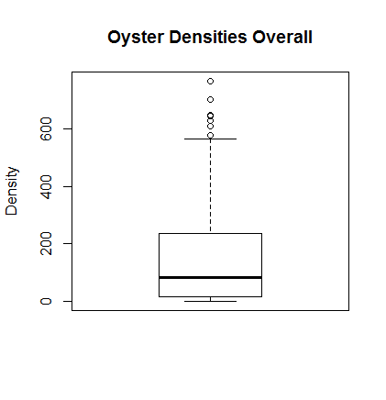

Figure 1. Box plot of oyster density/m2 from all transects, all months, all years, and all locations combined. The thick black line is the median, 50% of the data are greater than this value and 50% are less. The top of the box is the upper quartile, which means that 25% of the data are greater than this value. The bottom of the box is the lower quartile, which means that 25% of the data are less than this value. The whiskers define the minimum and maximum values excluding the outliers. Outliers are the circles and these values are greater than 1.5 times the upper quartile value.

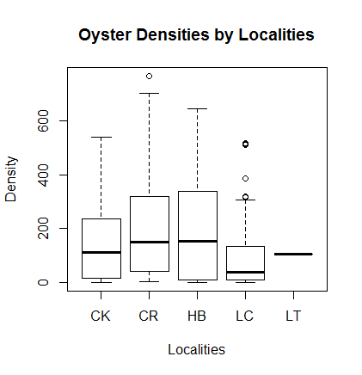

Figure 2. Oyster density/m2 from each locality based on transect samples from all years and months. CK= Cedar Key, CR= Corrigans reef, HB= Horseshoe Beach, LC= Lone Cabbage, LT = Little Trout. The thick black line is the median, 50% of the data are greater than this value and 50% are less. The top of the box is the upper quartile, which means that 25% of the data are greater than this value. The bottom of the box is the lower quartile, which means that 25% of the data are less than this value. The whiskers define the minimum and maximum values excluding the outliers. Outliers are the circles, and these values are greater than 1.5 times the upper quartile value.

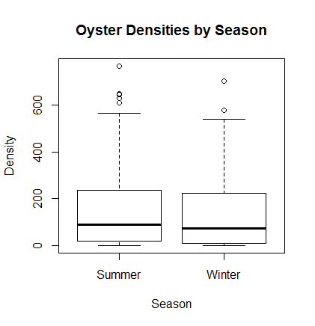

Figure 3. Oyster density/m2 from all locations by season. Summer = February- September and Winter = October-January. No sampling has occurred in February or March. See tables to review months of sampling. The thick black line is the median, 50% of the data are greater than this value and 50% are less. The top of the box is the upper quartile, which means that 25% of the data are greater than this value. The bottom of the box is the lower quartile, which means that 25% of the data are less than this value. The whiskers define the minimum and maximum values excluding the outliers. Outliers are the circles and these values are greater than 1.5 times the upper quartile value. While these counts are similar the size structure information from the quadrat data may reveal different results.

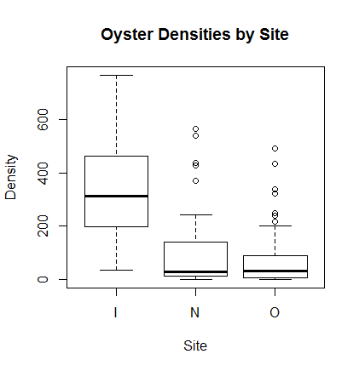

Figure 4. Oyster density/m2 from all locations by site across all locations. I = Inshore, N = Nearshore, O= Offshore. The thick black line is the median, 50% of the data are greater than this value and 50% are less. The top of the box is the upper quartile, which means that 25% of the data are greater than this value. The bottom of the box is the lower quartile, which means that 25% of the data are less than this value. The whiskers define the minimum and maximum values excluding the outliers. Outliers are the circles and these values are greater than 1.5 times the upper quartile value.

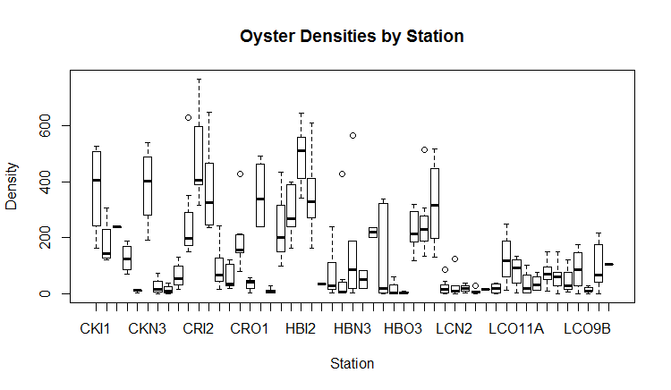

Figure 5. Oyster density/m2 for all stations, all years and months combined. This includes years 2010-2018, Epochs 1 and 2. The thick black line is the median, 50% of the data are greater than this value and 50% are less. The top of the box is the upper quartile, which means that 25% of the data are greater than this value. The bottom of the box is the lower quartile, which means that 25% of the data are less than this value. The whiskers define the minimum and maximum values excluding the outliers. Outliers are the circles and these values are greater than 1.5 times the upper quartile value.

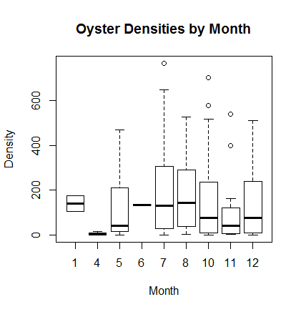

Figure. Oyster density/m2 by month from all stations and years combined. Note no sampling has occurred in February, March, or September. The thick black line is the median, 50% of the data are greater than this value and 50% are less. The top of the box is the upper quartile, which means that 25% of the data are greater than this value. The bottom of the box is the lower quartile, which means that 25% of the data are less than this value. The whiskers define the minimum and maximum values excluding the outliers. Outliers are the circles and these values are greater than 1.5 times the upper quartile value.

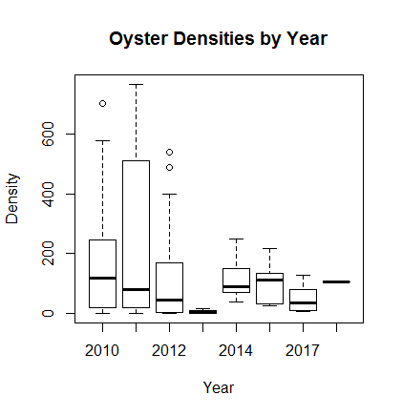

Figure 6. Oyster density/m2 by year from all stations and years combined. Note no sampling in 2016. The thick black line is the median, 50% of the data are greater than this value and 50% are less. The top of the box is the upper quartile, which means that 25% of the data are greater than this value. The bottom of the box is the lower quartile, which means that 25% of the data are less than this value. The whiskers define the minimum and maximum values excluding the outliers. Outliers are the circles and these values are greater than 1.5 times the upper quartile value.

*Lone Cabbage Reef summaries*

The tables and figures that follow this section focus on Lone Cabbage Reef.

Table. Summary stats from Lone Cabbage Reef samples, all years and treatments. Look at the mean:variance.

|  |  |  |  |  |  |  |  |  |
| --- | --- | --- | --- | --- | --- | --- | --- | --- |
| NobsTotal | Mean | Median | Sd | Var | CV | Se | L95se | U95se |
| 101 | 97.79 | 43.29 | 117.62 | 13834.17 | 1.2 | 11.94 | 74.39 | 121.2 |

Below are the bootstrap means and CI.

|  |  |  |
| --- | --- | --- |
| Bstrapmean | L95bstrap | U95bstrap |
| 98.52 | 76.34 | 122.97 |

Table Summary stats from Lone Cabbage Reef samples for the rock treatments. Note these are the “collapsed” oyster transects such that multiple transects on a reef are summed in terms of length and count. Look at the mean:variance.

|  |  |  |  |  |  |  |  |  |
| --- | --- | --- | --- | --- | --- | --- | --- | --- |
| NobsTotal | Mean | Median | Sd | Var | CV | Se | L95se | U95se |
| 11 | 105.06 | 110.3 | 61.43 | 3773.03 | 0.58 | 18.52 | 68.76 | 141.36 |

Below are the bootstrap means and CI.

|  |  |  |
| --- | --- | --- |
| Bstrapmean | L95bstrap | U95bstrap |
| 104.81 | 73.53 | 144.32 |

Table Summary stats from Lone Cabbage Reef samples for the control sites, all years. Look at the mean:variance.

|  |  |  |  |  |  |  |  |  |
| --- | --- | --- | --- | --- | --- | --- | --- | --- |
| NobsTotal | Mean | Median | Sd | Var | CV | Se | L95se | U95se |
| 90 | 96.86 | 36.68 | 123.18 | 15172.88 | 1.27 | 13.28 | 70.83 | 122.9 |

Below are the bootstrap means and CI.

|  |  |  |
| --- | --- | --- |
| Bstrapmean | L95bstrap | U95bstrap |
| 97.25 | 71.54 | 123.81 |

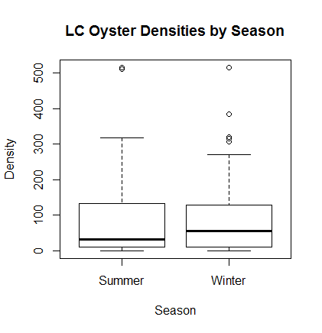

Figure. Oyster density/m2 (y-axis) and season (x-axis) from transect samples for Lone Cabbage Reef. The thick black line is the median, 50% of the data are greater than this value and 50% are less. The top of the box is the upper quartile, which means that 25% of the data are greater than this value. The bottom of the box is the lower quartile, which means that 25% of the data are less than this value. The whiskers define the minimum and maximum values excluding the outliers. Outliers are the circles and these values are greater than 1.5 times the upper quartile value.

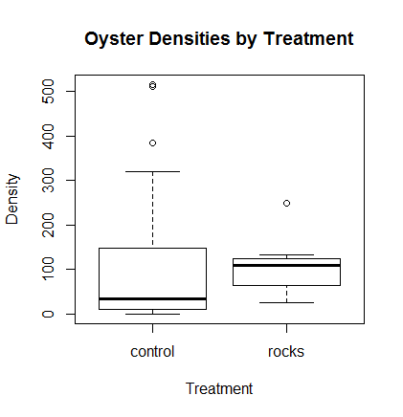

Figure. Oyster density/m2 (y-axis) and treatment (x-axis, control [no rocks] and rocks) from transect samples for Lone Cabbage Reef. The thick black line is the median, 50% of the data are greater than this value and 50% are less. The top of the box is the upper quartile, which means that 25% of the data are greater than this value. The bottom of the box is the lower quartile, which means that 25% of the data are less than this value. The whiskers define the minimum and maximum values excluding the outliers. Outliers are the circles and these values are greater than 1.5 times the upper quartile value.

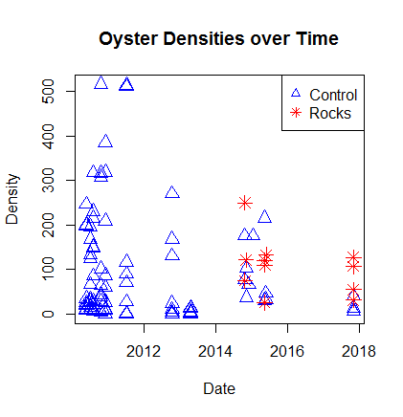

Figure Oyster density/m2 (y-axis) and sampling date (x-axis) from transect samples for all transects on Lone Cabbage Reef. The blue triangles are the control sites (no rocks) and the red stars are the rock sites. Note that a site can transition from control to rock after rocks were placed on the sites in 2014/2015.

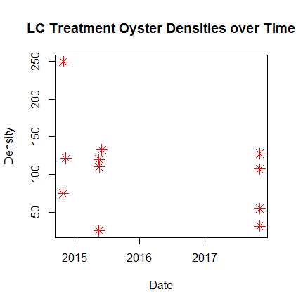

Figure. Oyster density/m2 (y-axis) and sampling date (x-axis) from transect samples for treatment sites (red stars, rock additions) on Lone Cabbage Reef.

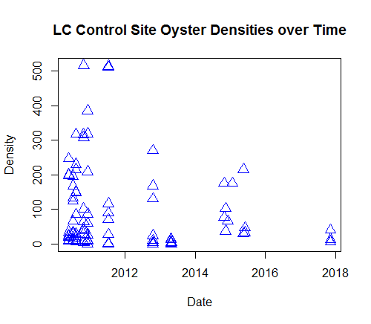

Figure. Oyster density/m2 (y-axis) and sampling date (x-axis) from transect samples for control sites (blue triangles, no rock additions) on Lone Cabbage Reef. In this plot I include sites that were sampled before the rocks were placed on that reef. This is why there are sites dating back to 2011.

*Epoch 3 Lone Cabbage Reef Restoration*

With funding from NFWF a large section of Lone Cabbage Reef was covered with rocks during summer/fall 2018. This restoration effort was done on the footprint of the historic Lone Cabbage Reef based on surveys conducted in the 1800’s and documented here in reports by Ellen Raabe now retired from USGS.

Raabe, E.A., Streck, A.E. and Stumpf, R.P., 2004. *Historic topographic sheets to satellite imagery—A methodology for evaluating coastal change in Florida's Big Bend tidal marsh* (No. 2002-211). US Geological Survey.

https://pubs.er.usgs.gov/publication/ofr2002211

The restoration effort created a linear chain of oyster reefs from north to south beginning to the west of the East Pass of the Suwannee River and continuing south towards Cedar Key and Deer Island. The reef “elements” are numbered 1-22 but reef 1 did not have rocks placed on it thus only reef elements 2-22 have rocks. Reef elements are on average 10-m wide and range in length from 10’s to 100’s of meters. Construction will be completed in October 2018. Efforts are ongoing to ensure constructed reef meets a revised set of construction criteria that were developed to address unforeseen complications in construction.

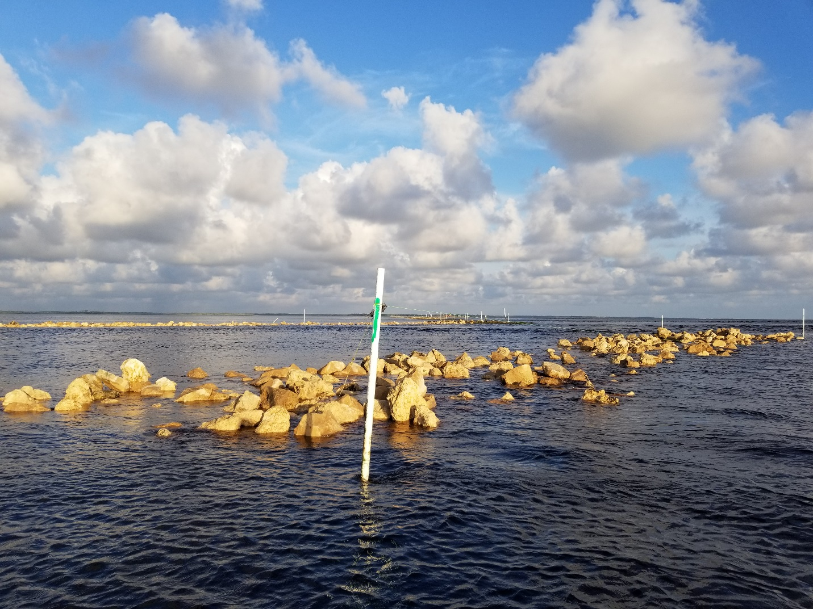

Figure. Example of rocks placed on Lone Cabbage Reef at low tide during construction phase. Many of these rocks in the picture are likely above elevation grade and they have been modified to meet elevation specifications.

Rocks were placed on the reefs to meet specified guidelines related to elevation profiles (between -1.2 and -1.95 ft MLLW with some tolerance allowed). The final elevations of all reefs have not been provided but we do have elevation profiles for reef elements 2-18 (Figure). The construction aspects of the project were complicated and the resulting reef has two size classes of rocks that were used. Reef elements 2-12 used a large size class of rock and reef elements 13-22 used a larger size class of rock.

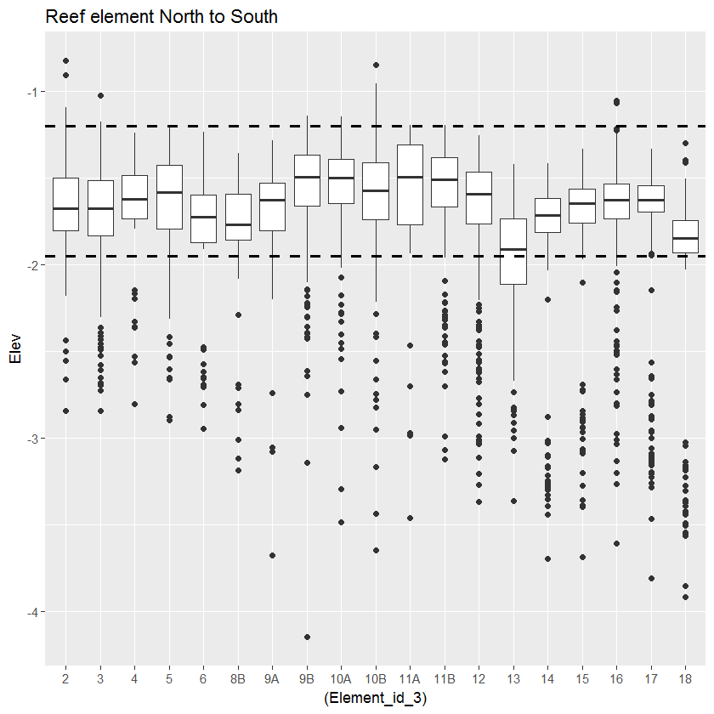

Figure. Box plots for individual reef elements (x-axis) of elevation (y-axis) based on survey points collected at the top of individual rocks placed on the reef. The dashed horizontal lines represent the target elevations from the construction specifications.

Once construction is complete on a reef element and the elevations accepted by UF, Cedar Key based Clamtastics Shellfish Company is spreading a thin layer of oyster shell on all rock elements. For reef elements 2-8 found near the northern end of the reef chain, wild oysters were present on the footprint of the reef where the construction was to take place. These oysters were moved by local oystermen to a refuge spot away from the construction and will be returned to reef elements 2-8 (approximately, final to be determined) once shell has been spread on the reef. This “oyster addition” should also be considered in any design elements related to oyster restoration assessment. Finally the Lone Cabbage Reef complex between reef elements 2-16 is in waters “closed” to harvest while reef elements 17-22 are in areas open to harvest during harvest season. This also should be considered in any design elements to assess oyster population response to restoration. Key point – there is an opportunity to quantify the amount of shell and live oysters starting on each reef based on what has been spread by fishermen as a starting point.

*Epoch 3 Questions to Address*

The Lone Cabbage Reef restoration project has two fundamental questions. These are really the ideas that motivated the research and are not necessarily the same as “student projects” or other research elements. The first is a “local effects” question related to how the addition of rock substrate promote oyster reef recovery and resilience. In simplest measures this is a “body count” type question in terms of how many oysters are growing in an area that has been restored. This is the type of metric that has to be reported to the funding agency. The second is an “ecosystem” level question related to how detention of freshwater by the reef and the expansion/promotion of estuarine conditions on the nearshore side of the reef (across some unknown area) promotes responses across multiple trophic scales. This type of question can be reported to the funding agency via simple assessments of our water quality graphs. This synthesis focuses on the first “local” effects question. The hope is that students, cooperators, and anyone else will leverage the restoration project in ways to dig deeper into these or other questions.

Next, what is the response variable? In general the response variable is either the density or the counts of live oysters. Density is continuous, counts are discrete. I account for effort (size of area counted) using an offset when working with counts. It may not work to compare the absolute number of oysters between the control (wild) sites and the rocks because the wild sites may have significantly more oysters because they reefs are older. I have thought some about working with relative counts of oysters between the treatment and control site (a ratio statistic of treatment/control by strata). This would be useful because the rations are proportional to the response sizes. I talk about this a little more later on as it relates to a possible Bayesian approach. See Conner et al. (2016).

Assessing local responses on Lone Cabbage Reef is challenging. In a traditional “BACI” (before-after-control-impact) design we have limited assessment of oyster reef populations at Lone Cabbage and elsewhere from the Epoch 1 and Epoch 2 efforts. The scale of the Lone Cabbage project in epoch 3 is much larger than the restoration efforts in Epoch 2. Lone Cabbage Reef also likely has a salinity gradient from north to south based on the distance from the Suwanee River. Based on our water quality monitoring it appears that the daily variance in salinity is much higher for sites on the northern end of Lone Cabbage compared to the southern (https://lcroysterproject.github.io/oysterproject/). Rock size, oyster additions, open/closed areas to harvest are all factors that should be considered in assessment design. It is important to remember that the treatments have differed between Epoch 1, 2, and 3. In Epoch 1 the treatments were locality (Lone Cabbage, Horseshoe Beach, etc.) as well as site (Inshore, Nearshore, Offshore) whereas in Epoch 2 the treatments were rock addition and a comparison between sites in the same locality and site (Lone Cabbage Offshore) with and without rocks in a before/after context. In Epoch 3 the treatment is the addition of rocks to the entire Lone Cabbage Reef. From a basic experimental design perspective, you have to think about what our replicates are and what are our controls? To prevent pseudoreplication we have to keep in mind that a replicate is “…the smallest experimental unit that a treatment can be assigned and dealt with independently” (Hurlbert 2009).

Hurlbert SH. The ancient black art and transdisciplinary extent of pseudoreplication. Journal of Comparative Psychology. 2009 Nov;123(4):434.

In Epoch 3 we have one treatment (rocks). Some people would treat each reef element (termed locality in our dataset) as an independent sample. I am not sure that is correct. My current thinking is that none of the reefs are independent populations (the spat likely mix between reefs as free-swimming larvae, the reefs also likely self-fertilize) so the populations are not independent from a population perspective. I also think each reef has a lot of autocorrelation such that reefs close to each other are more likely to be similar than reefs far apart, but how you define “far apart” is something I’m not sure of. Is Lone Cabbage to Horseshoe far apart? Is Reef Element 2 to 12 in Lone Cabbage far apart? I also think that if you “dewatered” all of Suwannee Sound the reefs in a natural state many would likely have some sort of connection, or have had some sort of connection to each other in the past that are now interrupted by channels and gaps. In this way, if you think of the reefs in side profile, when we see the “top” of an oyster bar we are really just looking at the tops of the bar (the tops of a mountain range) where the “low parts” may all be connected in different ways. This is a good topic for discussion. From an analyses perspective I think about treating the individual reefs (stations) as a random effect which as described in Kery (2010) random effects are “…set of effects (e.g., group means) is constricted to come from some distribution…”. The same can likely be said for the sites (Inshore, Nearshore, Offshore) from Epoch 1. We do not have any control plots on Lone Cabbage Reef without rock, but we could perhaps move some rock to create control plots. However, this may promote erosion on the reef. We could consider adjacent reefs that are near Lone Cabbage Offshore, such as the Lone Cabbage Inshore or Nearshore sites from Epoch 1 as controls because they did not receive rock treatments - but, we would have to account for these reefs being in different locations spatially (if that matters). All of this is a good area for work.

There are also a couple of important definitions related to these same design elements. One is the term “strata” as used in “stratified random sampling” and other types of designs. Again, going back to Snedecor and Cochran “If we can form strata so that a heterogeneous population is divided into parts, each of which is fairly homogenous, we may expect a substantial gain in precision over simple random sampling. In stratified sampling, we can choose the size of sample to be taken from stratus. This freedom of choice gives us scope to do an efficient job of allocating resources to the sampling within strata. Furthermore, when different parts of the population present different problems of listing and sampling, stratification enables these problems to be handled separately.” This is important because we have some strata we likely have to consider in Epoch 3 such as the different sizes of rocks on each reef element (station), open/closed areas to fishing, and reef elements that receive oyster plants (live oysters).

The term “covariate” is also used to describe different variables. Also from Snedecor and Cochran, a covariate is something that is taken or measured on each sampling units that predicts to some degree the final response variable. So in our work covariates might be things like salinity, reef elevation, depth, inundation time of the reef (proportional to feeding time), etc. Could you take a factor like salinity and design the study such that salinity defined strata? You probably could but we don’t have enough information on salinity to define those strata. Plus we think salinity changes with river discharge, wind, and other factors. So the “strata” would be dynamic in that case, which I don’t think is a good design. We may also have “offsets”, which are similar in some ways to covariates, but affect the response variable in a known direction. Following guidelines from NOAA and others, I have used effort (total length of transects in this example) as an offset. This assumes that if we survey more oyster bar area then we will count more oysters. The interactions between these and other covariates and the use of fixed and random effects are areas for further work via simulation.

*Using Generalized Linear Models to assess factors influencing oyster counts*

Generalized linear models (GLM) are a very robust “class” of statistical models that are basically extensions of simple linear regression model but allow the dependent variable (i.e., counts of oysters) to be non-normal. We used GLM models to make a preliminary assessment of factors including Year, Locality (i.e., Horseshoe, Lone Cabbage etc.), Site (Inshore, Nearshore, Offshore), and Treatment (Rock, No Rock) influence oyster counts. We assumed that oyster counts were likely to increase as more oyster bar area was assessed so we included effort (total transect length from the collapsed transects) as an offset. We also conducted an exploratory analyses of how Suwannee River discharge (USGS gauge 02323500), as a proxy for salinity, nutrients, and other factors, influenced counts on oyster reefs. We assessed how river discharge in year of sampling as well as a 1 year lag of river discharge influenced oyster counts.

We defined the analyses as part of three epochs similar to described elsewhere. Epoch 1 years = 2010-2013 and included all localities and sites. No restoration was done in Epoch 1. Epoch 2 years included all years (2010-2018) but only the Locality = Lone Cabbage and restoration effects were assessed from the “pilot project” reefs. The Epoch 3 analyses included all years 2010-2018 and all localities and sites, including restoration effects. We built a small subset of models that examined basic questions for each epoch. Epoch 1 focused on whether differences in oyster counts were apparent between localities and sites. Epoch 2 examined the influence of the pilot restoration project on Lone Cabbage reef, and Epoch 3 assessed over all years and treatments what factors had the largest influence on counts.

*Assessing distribution of data*

We chose to work with counts of oysters instead of oyster density to allow us to incorporate sampling effort as an offset in our model. To assess the distribution these data come from we considered the following: count data are discrete, the variance of counts exceeds the mean (see earlier tables), and we graphically examined fit of a negative binomial model a histogram of oyster counts from Epoch 3 (all data). The negative binomial appears to describe these count data and was assumed for all GLM models presented.

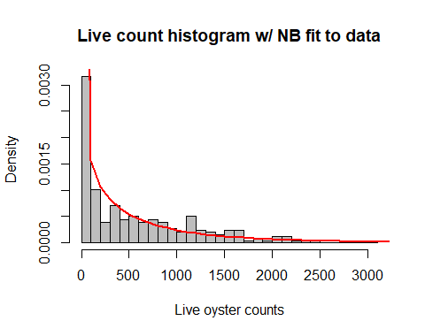

Figure. Histogram of density (y-axis) of live oysters counted (x-axis) from collapsed transects across all sites and years (Epoch 3 in the GLM discussion). The red line represents the predicted density of oyster counts if these data follow a negative binomial distribution. Visual assessment of model fit appears good.

*Candidate models*

We fit a series of single factor models using locality as a random effect and effort as an offset. Factors considered included Site, Season, mean annual daily discharge, and a 1 year time lag on mean and monthly annual discharge (i.e., discharge in the previous year or month influenced oyster counts in the present year). A limited set of models were fit of biological or project interest. We used a forward selection process where we fit each parameter individually and then retained statistically significant factors (p<0.1). Final model comparison was then made with AIC when appropriate.

*All data all years combined, no random effects*

The full dataset included all years, effort, locations, and treatment. We fit a negative binomial GLM to these data and examined the relationship between oyster counts and Year, Locality, Site, Treatment, 1 year lag on annual discharge, and log(effort) as an offset.

> summary(full.mod.all)

Call:

glm.nb(formula = count\_live ~ year + locality + site + treatment +

ann\_dis\_lag\_sc + offset(log(tran\_length)) - 1, data = d,

init.theta = 0.8250328677, link = log)

Deviance Residuals:

Min 1Q Median 3Q Max

-2.9843 -1.0918 -0.3747 0.2851 2.2437

Coefficients:

Estimate Std. Error z value Pr(>|z|)

year -0.03374 0.05609 -0.602 0.5475

localityCK 70.56687 112.82327 0.625 0.5317

localityCR 70.71074 112.82576 0.627 0.5308

localityHB 70.39406 112.82728 0.624 0.5327

localityLC 69.68484 112.87681 0.617 0.5370

localityLT 69.43443 113.26755 0.613 0.5399

siteN -1.52363 0.17748 -8.585 < 2e-16 \*\*\*

siteO -1.79954 0.18473 -9.742 < 2e-16 \*\*\*

treatmentrocks 0.78981 0.43616 1.811 0.0702 .

ann\_dis\_lag\_sc 2.65379 0.52772 5.029 4.94e-07 \*\*\*

---

Signif. codes: 0 ‘\*\*\*’ 0.001 ‘\*\*’ 0.01 ‘\*’ 0.05 ‘.’ 0.1 ‘ ’ 1

(Dispersion parameter for Negative Binomial(0.825) family taken to be 1)

Null deviance: 8340.5 on 256 degrees of freedom

Residual deviance: 304.2 on 246 degrees of freedom

AIC: 3628.7

Number of Fisher Scoring iterations: 1

Theta: 0.8250

Std. Err.: 0.0654

2 x log-likelihood: -3606.7220

We found no significant effect between Year and Locality but did find significant effects by Site, Treatment, and a 1 year lag on annual discharge. Largest effects were by Site (inshore, nearshore, or offshore). So the largest effect on mean oyster counts per transect come from the site (inshore is the highest density, then nearshore, offshore) and river discharge the year before has a positive benefit on mean oyster counts. Model comparison using AIC between models with and without the annual discharge lag suggested improvement in model fit when information on discharge was included (delta AIC ~ 22).

*Epoch 1 only*

We fit a model to the Epic 1 data (all data prior to 2014) to assess the relationship between year, locality, siate, and 1 year lag on annual discharge on counts of live oysters. We used log(effort) as an offset.

> summary(full.mod.e1)

Call:

glm.nb(formula = count\_live ~ year + locality + site + ann\_dis\_lag\_sc +

offset(log(tran\_length)) - 1, data = d1, init.theta = 0.7804103593,

link = log)

Deviance Residuals:

Min 1Q Median 3Q Max

-2.9368 -1.0873 -0.3953 0.2730 2.1187

Coefficients:

Estimate Std. Error z value Pr(>|z|)

year -0.3155 0.1581 -1.996 0.0459 \*

localityCK 637.9586 318.2812 2.004 0.0450 \*

localityCR 638.1299 318.3059 2.005 0.0450 \*

localityHB 637.8407 318.3063 2.004 0.0451 \*

localityLC 637.0968 318.3360 2.001 0.0454 \*

siteN -1.5615 0.1825 -8.556 <2e-16 \*\*\*

siteO -1.8014 0.1910 -9.430 <2e-16 \*\*\*

ann\_dis\_lag\_sc 0.9114 1.1383 0.801 0.4233

---

Signif. codes: 0 ‘\*\*\*’ 0.001 ‘\*\*’ 0.01 ‘\*’ 0.05 ‘.’ 0.1 ‘ ’ 1

(Dispersion parameter for Negative Binomial(0.7804) family taken to be 1)

Null deviance: 7483.77 on 230 degrees of freedom

Residual deviance: 274.82 on 222 degrees of freedom

AIC: 3222.6

Number of Fisher Scoring iterations: 1

Theta: 0.7804

Std. Err.: 0.0650

2 x log-likelihood: -3204.5920

We found significant effects of locality and site but not lag of annual discharge in this model. This may be because contrast in river discharge was not high in these years.

We then fit the same model but treated site as a random effect. This model did not converge. Perhaps because there is a lot of information in the site variable because of the strong contrast. This is an area for further work.

Interestingly, if you drop year from this same model, then the model will converge

> summary(localityd1.2)

Generalized linear mixed model fit by maximum likelihood (Laplace Approximation) [glmerMod]

Family: Negative Binomial(0.7645) ( log )

Formula: count\_live ~ locality + ann\_dis\_lag\_sc + (1 | site) + offset(log(tran\_length))

Data: d1

AIC BIC logLik deviance df.resid

3235.4 3259.5 -1610.7 3221.4 223

Scaled residuals:

Min 1Q Median 3Q Max

-0.8725 -0.6883 -0.3198 0.2672 4.1704

Random effects:

Groups Name Variance Std.Dev.

site (Intercept) 0.6169 0.7854

Number of obs: 230, groups: site, 3

Fixed effects:

Estimate Std. Error z value Pr(>|z|)

(Intercept) 1.6130 0.6039 2.671 0.007564 \*\*

localityCR 0.1534 0.2500 0.613 0.539549

localityHB -0.1592 0.2537 -0.627 0.530346

localityLC -0.8970 0.2510 -3.574 0.000352 \*\*\*

ann\_dis\_lag\_sc 2.6531 0.6464 4.105 4.05e-05 \*\*\*

---

Signif. codes: 0 ‘\*\*\*’ 0.001 ‘\*\*’ 0.01 ‘\*’ 0.05 ‘.’ 0.1 ‘ ’ 1

Correlation of Fixed Effects:

(Intr) lcltCR lcltHB lcltLC

localityCR -0.229

localityHB -0.173 0.640

localityLC -0.205 0.686 0.665

ann\_ds\_lg\_s -0.569 -0.075 -0.157 -0.132

and Locality = Cedar Key and Locality = Lone Cabbage are significant as is the 1 year lag on annual discharge.

Overall it seems that site is important and that there may be a positive relationship between river discharge the previous year and oyster counts. Need to spend more time thinking about whether Site should be used as factor or random effect.

*Epoch 2 the pilot project*

Using all years but for the Lone Cabbage offshore site only, we fit a model that included year, treatment, and the 1 year lag on annual discharge.

> summary(fullmod.e2)

Call:

glm.nb(formula = count\_live ~ year + treatment + ann\_dis\_lag\_sc +

offset(log(tran\_length)) - 1, data = d2.1, init.theta = 1.07135215,

link = log)

Deviance Residuals:

Min 1Q Median 3Q Max

-2.8232 -0.9940 -0.3429 0.4075 1.5338

Coefficients:

Estimate Std. Error z value Pr(>|z|)

year -0.15518 0.06341 -2.447 0.0144 \*

treatmentcontrol 311.05752 127.51265 2.439 0.0147 \*

treatmentrocks 312.14893 127.67712 2.445 0.0145 \*

ann\_dis\_lag\_sc 4.51355 0.74513 6.057 1.38e-09 \*\*\*

---

Signif. codes: 0 ‘\*\*\*’ 0.001 ‘\*\*’ 0.01 ‘\*’ 0.05 ‘.’ 0.1 ‘ ’ 1

(Dispersion parameter for Negative Binomial(1.0714) family taken to be 1)

Null deviance: 785.96 on 54 degrees of freedom

Residual deviance: 62.53 on 50 degrees of freedom

AIC: 723.96

Number of Fisher Scoring iterations: 1

Theta: 1.071

Std. Err.: 0.190

2 x log-likelihood: -713.961

Results of this model suggest significant treatment and river discharge effects. Note the results are different if you include all of the LC control data and not just the offshore. This is because of the influence of site. Again, these data are only the Lone Cabbage offshore data.

If we add a station as a random effect to the model above, treatment is no longer significant

> summary(m1d2)

Generalized linear mixed model fit by maximum likelihood (Laplace Approximation) [glmerMod]

Family: Negative Binomial(1.1153) ( log )

Formula: count\_live ~ treatment + ann\_dis\_lag\_sc + (1 | station) + offset(log(tran\_length))

Data: d2

AIC BIC logLik deviance df.resid

1348.6 1361.7 -669.3 1338.6 96

Scaled residuals:

Min 1Q Median 3Q Max

-1.0454 -0.5828 -0.1985 0.3573 3.3241

Random effects:

Groups Name Variance Std.Dev.

station (Intercept) 1.119 1.058

Number of obs: 101, groups: station, 19

Fixed effects:

Estimate Std. Error z value Pr(>|z|)

(Intercept) -0.5928 0.5513 -1.075 0.282

treatmentrocks 0.7617 0.5312 1.434 0.152

ann\_dis\_lag\_sc 3.7421 0.7326 5.108 3.25e-07 \*\*\*

---

Signif. codes: 0 ‘\*\*\*’ 0.001 ‘\*\*’ 0.01 ‘\*’ 0.05 ‘.’ 0.1 ‘ ’ 1

Correlation of Fixed Effects:

(Intr) trtmnt

tretmntrcks -0.068

ann\_ds\_lg\_s -0.863 -0.099

This is really pretty interesting because if you look at the stddev of the random effect (station) you see that it is larger than the effect size for treatment. Need to think about this more but this may mean that the variability with the reefs is greater than the treatment effect, but, as the treatment is on the reefs then this may be a confounded result. Either way the magnitude of the treatment effect needs to be examined more closely as it may be biologically significant but not statistically significant at times.

*Key take away points*

Site is very important and site effects can dwarf any other effects. May need to move into a “ratio” approach of treatment:control if control sites are going to be from a different site. There also seems to be a potential relationship between the river discharge the year prior and oyster counts. But this warrants further work.

*More to do related to GLMs*

There is a lot more to do related to the GLM models. Chapter 6 in the Kery (2010) book is a nice deliberate way to walk through these types of models to present the models graphically. Need to take a closer look at the discharge data. Need to standardize the covariates relative to each other. Need to better understand when to consider a parameter as a fixed or random effect and if there are ways to compare these models (Bolker mentions this somewhere..a pseudo r-square?). What about changing from counts as a reponse variable to working with the ratios of treatment:control? Need to figure out how to calculate the variance using delta or MC methods as discussed with Fred and Julien. These are all good things to go over with Jose-Miguel Ponciano.

*Power analyses*

Based on our previous sampling efforts we have developed a simple power analyses to help us determine the number of transect samples that need to be done to detect specified differences in means of oyster counts. These differences could be between reefs with and without rocks as an example. What is power? Power is the ability of a statistical test at a defined significance level (the alpha) that it will reject a false null hypothesis. Statistical power is the inverse of the Beta value. Beta is the probability of making a Type II error. A Type II error is a false negative which happens when you do not see an effect that is actually there. Basically statistical power is the likelihood that our study will detect an effect when there is an effect to be detected. If we design the study such that the statistical power is high, the chance that we will conclude that there is not an effect when there actually is one, goes down. Statistical power is affected primarily by the "effect size" and the size of the sample used to detect a difference. Effect size is basically the difference you are trying to detect. So if the effect size is large, such as really big differences in the mean density of oysters between one location and another, then that is easier to detect than a small difference in mean density. Along with effect size power is also influenced by the variance of the means you have measured. So if two oyster bars have high variance in their estimated density, it will be difficult to detect a difference unless the effect size is large and a large number of samples are taken. If the variance is really high, it may not be possible to detect a significant response even with thousands of samples and effect sizes approaching extirpation. This is one of the reasons continuous variables such as density require a lot more sampling than binary responses such as live/dead or presence/absence.

We can use our earlier studies to get an idea of the variance, the means, and possible effect sizes (based on the Epoch 2 pilot project). We can then use this information to solve for how many samples (transects) we need to take to have study with acceptable levels of power. In general a rule of thumb is to use a level of power of about 20% or a Beta value of 80%. In simplest terms this would mean that our study has an 80% chance of detecting an effect when there actually is an effect and a 20% chance of concluding there is no effect when actually one did occur.

The power analyses are based on information in Chapter 7 of the Krebs (1999). Krebs has put all of his books on his web page for free (<http://www.zoology.ubc.ca/~krebs/books.html>) and you can review Ecological Methodology Chapter 7 on this site. Krebs approach is originally from Snedecor and Cochran (1967).

Snedecor, G.W. and Cochran, W.G., 1967. Statistical methods, 593 pp. *Iowa State Univ., Ames*.

In this approach we define the alpha level of probability (confidence level = zalpha = z0.05= 1.96), zbeta as the stand normal deviate for the probability of a Type II error (Power, 1-Beta, = 0.80 or a two-tailed zbeta = 0.84), the population variance (v), and then the difference in means we want to detect. The choice of variance is important. If we have information on two different reefs, such as a rock reef and a control reef, I use the larger of the two variances to be conservative. Using the summaries of oyster densities presented earlier, the R code is written to use any of the variance or treatment means from any combination of year or treatment to calculate the number of samples that should be taken for the given alpha and beta levels. A key point is that the number of samples estimated is the number of samples that must come from both populations (treatment and control). Additionally, in this structure the number of transects are equal to the length of the “collapsed” transects. These are are generally 66-m in length (the sum of the three 22-m transects conducted on each reef during Epoch 2). The range of transect lengths looks like this

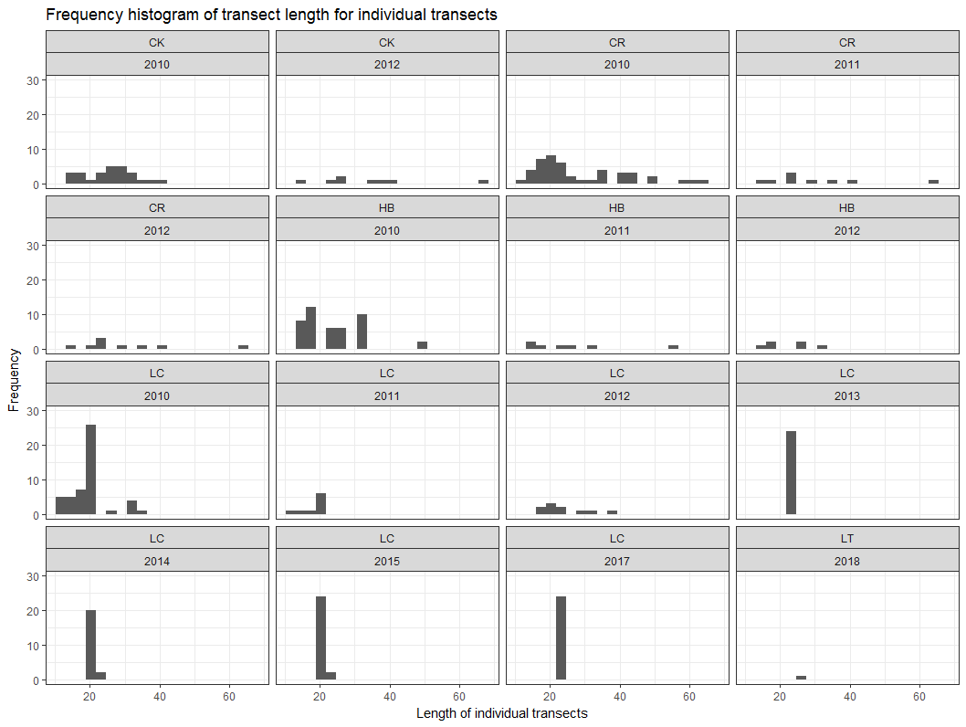

Figure. Length (x-axis in meters) and frequency (y-axis) of individual, unique transects, conducted at each locality in each year.

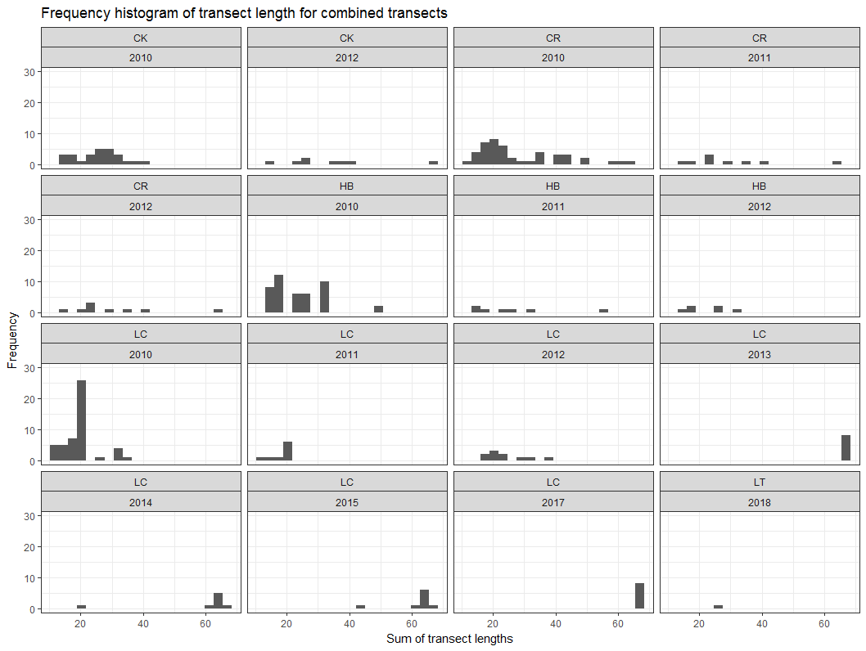

Figure: Collapsed or combined transect lengths (in meters, x-axis) and frequency (y-axis) for each locality in each year. These are the sums of the individual transects conducted at an individual reef (station).

As an example, let’s hypothesize that we think the 2018/2019 winter response on the Lone Cabbage Reef to the addition of rocks is going to be similar to some combination of year and location observed in the past. Based on work in Epoch 2 we have an idea of the magnitude in response on an oyster reef once rocks are placed on the reef. If we assume that the response in Epoch 3 is similar to this response in Epoch 2, then we can use the data from Epoch 2 to estimate the number of samples we need to take in Epoch 3. This is shown in the next figure where this estimate of sample size is based on the difference in means observed between the control sites (no rocks) in 2012 (blue triangles above) and the rock sites (treatment) in 2014 (red stars), at the alpha and beta specified

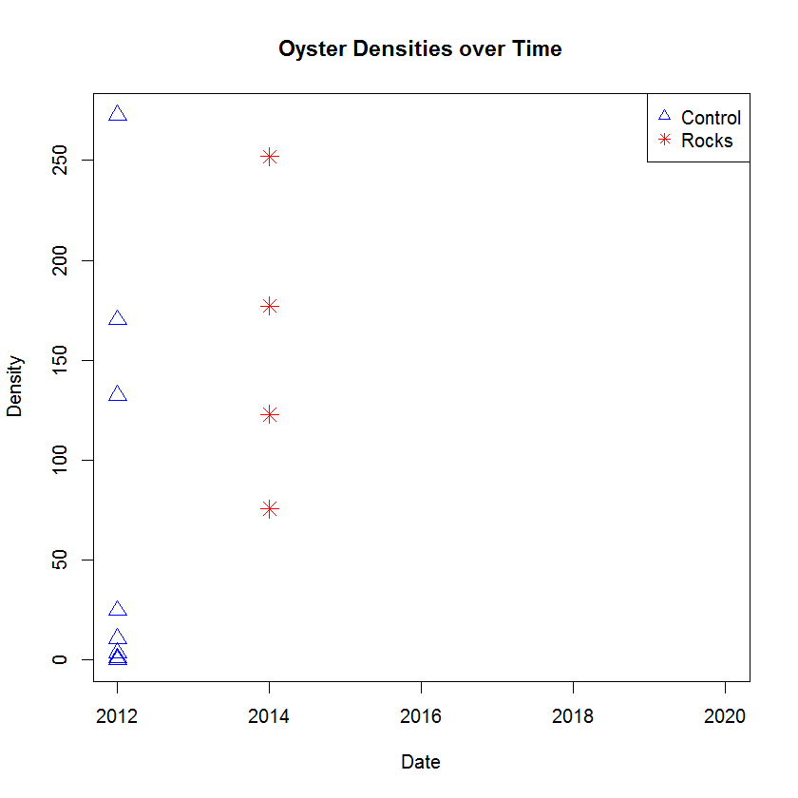

Figure Oyster density/m2 (y-axis) and sampling date (x-axis) from transect samples for all transects on Lone Cabbage Reef in 2012 and 2014. The blue triangles are the control sites (no rocks) and the red stars are the rock sites. Note that a site can transition from control to rock after rocks were placed on the sites in 2014/2015. Mean density for control = 61.6 oysters/m2 (var=5735.8) and for rock = 156.9 oysters/m2 (9295.9).

In this figure I have drawn a black ellipse around the 2012 control samples. Note the summary stats in the Figure description. The variance of both control and treatment is very high (see spread in the symbols). We want to know how many collapsed transect samples do we need to take to compare these control sites to the red stars inside the red ellipse from 2014 with the alpha and beta specified. This would represent the density of oysters on the rock sites in the first winter after treatment. Using our power tool, and the conditions described above, we would need to take a minimum of 16 transects in the control site and then 16 transects in the treatment site. How long should these transects be? Transect length has varied (see histograms above) but the average during the Epoch 2 pilot samples with the rock treatment (collapsed transect) would be 64-m. So that is a total of 16 transects that average 64-m in length or about 1024-m of surveying in both the treatment and control plot. The restored Lone Cabbage Reef (Epoch 3) is 10-m wide, so that would be about 103 transects of the narrowest width of a restored reef element just for the rock treatment. The good news is if the variance is smaller (similar to the variance observed on the control site) then we would only need 10 transects (about 660-m of length) on control and 10 in treatment (also 660-m in length).

What if we hypothesized that we think 2018/2019 sampling is similar to oyster densities from summer 2015 rock samples to summer 2015 control samples? Graphically that would look like this comparing the red and blue within the two ellipses.

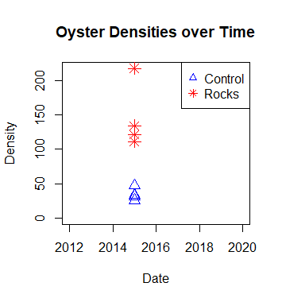

Figure Oyster density/m2 (y-axis) and sampling date (x-axis) from transect samples for all transects on Lone Cabbage Reef in 2015. The blue triangles are the control sites (no rocks) and the red stars are the rock sites. Note that a site can transition from control to rock after rocks were placed on the sites in 2014/2015. Mean density for control = 34.6 oysters/m2 (var=83.9) and for rock = 146.1 oysters/m2 (var= 2354.0).

Based on the same alpha and beta as before, we would only need to sample 3 transects each in the control and treatment sites (6 total, each about 66-m). Why the fewer number? Look at the graph again and you will see there is not a lot of overlap between the control and treatment observations, so the means are less similar (bigger relative difference) and the variance is a lot smaller.

The last example would be a comparison of the rock and control sites from 2017, basically 4 years after the pilot project. A graphical representation of this comparison is below where we compare the red and black ellipses.

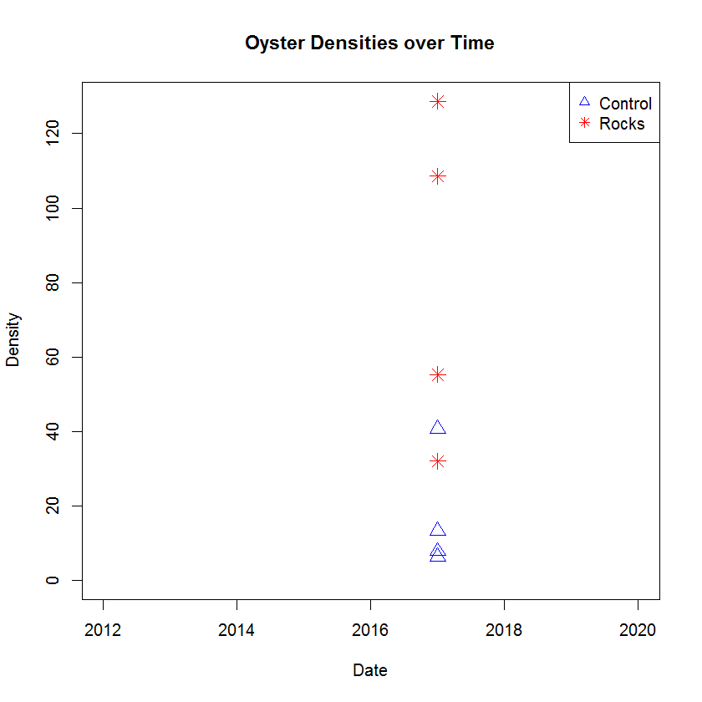

Figure Oyster density/m2 (y-axis) and sampling date (x-axis) from transect samples for all transects on Lone Cabbage Reef in 2017. The blue triangles are the control sites (no rocks) and the red stars are the rock sites. Mean density for control = 17.1 oysters/m2 (var=256.7) and for rock = 81.1 oysters/m2 (2030.5).

Based on our power tool 8 collapsed transects would need to be done in both the treatment and control site or 16 transects total, average length about 66-m each transect.

*Power and Bayesian approaches*

Conner et al. (2016) point out that if you are working with ratios of control:treatment response variables in a Bayesian framework you don’t have to be as concerned about type I and type II error. This is because in a Bayesian framework you can estimate the probability of observing an effect size (or range of effect size) condition on the data. This is different than calculating the probability of observing the data conditional on the hypothesis as we do with a traditional power analyses. I think there is some on this in the most recent edition of the Gelman book. This is something we need to work on really soon. Maybe USGS colleagues can help.

Conner, M.M., Saunders, W.C., Bouwes, N. and Jordan, C., 2016. Evaluating impacts using a BACI design, ratios, and a Bayesian approach with a focus on restoration. *Environmental monitoring and assessment*, *188*(10), p.555.

*Capture probability*

Our power analyses assumes that our transect samples count a consistent portion of the oysters during the two surveys (rocks and control). This is a capture probability (p) or because effort is constant, it is the same as catchability (q) of oysters for a given unit of transect effort. However, we know from our paper rock exercises that there is a wide variation in oyster counts depending on who does the counting. This is demonstrated in the figure below. We need to incorporate this into the power analyses as well.

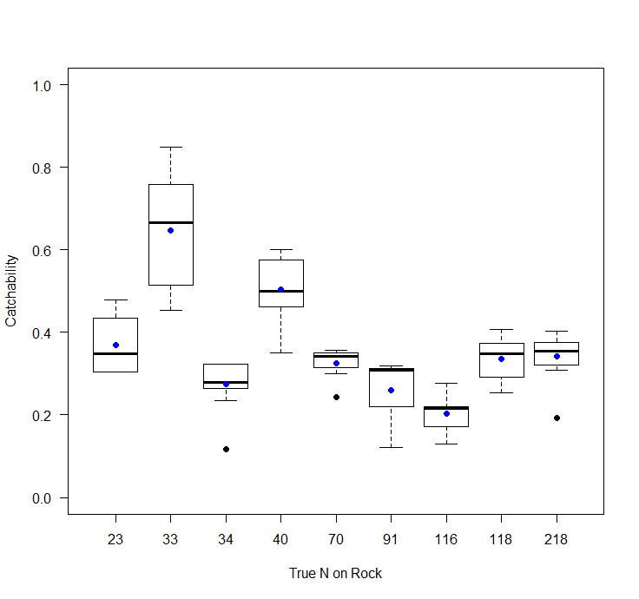

Figure. Catchability (y-axis) and true number of paper oysters on a paper rock (x-axis). The box plots represent the variation in counts on these rocks based on the different people that counted the oysters on the rock. The blue dot represents the mean catchability per rock.

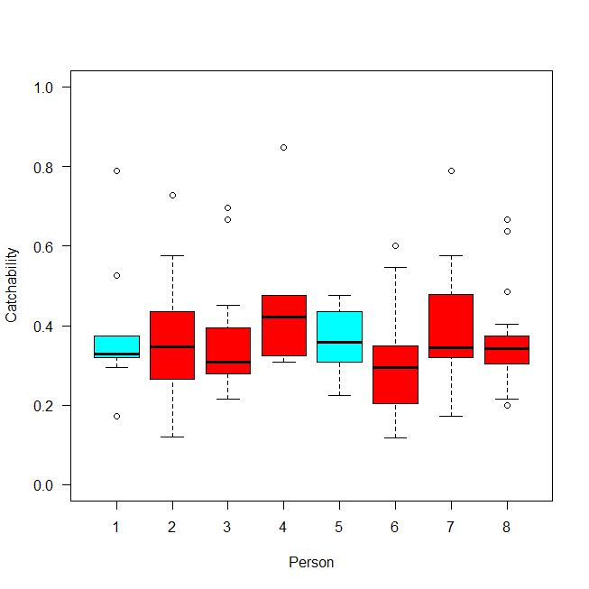

Figure 10. Catchability (y-axis) of paper oysters from transects by observer (unique person, x-axis). The blue boxes are experienced observers and the red boxes are inexperienced observers.

*Winter 2018/2019 Sampling Effort*

I built a table that defined the strata that a priori I thought could influence the response variable of counts of live oysters. In a hierarchical context, the highest level of comparison would be between the reefs that received rocks and those that did not receive rocks (control). The control reefs would be located in the Lone Cabbage nearshore or inshore areas in the region around salinity sensors 7:9. The response variable is counts of live oysters during winter. In simplest terms the model could be written as a regression like this.

where the beta terms are the coefficients, x is the slope, and epsilon is the error term. We can parameterize the model to ask “is there a difference in oyster counts between rock and treatment areas” by simply testing whether the slope differs from zero.

The strata that I then identified within the treatment area that could influence oyster counts were (1) whether a bar had large rocks or small rocks,

(2) whether or not oysters were seeded on the oyster bar,

(3) whether or not the bar was open to fishing.

The strata that I identified for the control area were (4) whether or not the bar was open to fishing.

The actual functional form of the models is dependent on the structure of the data and model assumptions. The models would not all be additive. These are just examples.

I then built a table that would represent each of the strata and labeled each of the constructed reef elements (2-22) as the different strata would apply to these reef elements.

Table. Strata column identifies the sampling strata by number, element is an individual oyster bar of varying size that has been constructed at Lone Cabbage Offshore, bar\_type defines whether the bar is a large rock bar (l\_rock), small rock bar (s\_rock), of a wild bar (wild), oyster\_addition defines whether or not live oysters were added to the bar (yes or no), fishing defines whether that spatial location is open or closed to fishing. For the “wild” bars I just listed open and closed to fishing and no specific “reef” such as a reef element. In the text I describe how to choose the reefs for the wild bars.

|  |  |  |  |  |
| --- | --- | --- | --- | --- |
| strata | element | bar\_type | oyster\_addition | fishing |
| 1 | 2 | l\_rock | y | closed |
| 1 | 3 | l\_rock | y | closed |
| 1 | 4 | l\_rock | y | closed |
| 1 | 5 | l\_rock | y | closed |
| 1 | 6 | l\_rock | y | closed |
| 1 | 7 | l\_rock | y | closed |
| 1 | 8 | l\_rock | y | closed |
| 1 | 9 | l\_rock | y | closed |
| 2 | 10 | l\_rock | n | closed |
| 2 | 11 | l\_rock | n | closed |
| 2 | 12 | l\_rock | n | closed |
| 3 | 13 | s\_rock | n | closed |
| 3 | 14 | s\_rock | n | closed |
| 3 | 15 | s\_rock | n | closed |
| 3 | 16 | s\_rock | n | closed |
| 4 | 17 | s\_rock | n | open |
| 4 | 18 | s\_rock | n | open |
| 4 | 19 | s\_rock | n | open |
| 4 | 20 | s\_rock | n | open |
| 4 | 21 | s\_rock | n | open |
| 4 | 22 | s\_rock | n | open |
| 5 | 101 | Wild | n | open |
| 6 | 102 | Wild | n | closed |

For strata 5 and 6 there are more wild bars that meet these conditions than there are bars that meet the conditions in strata 1:4.

Using the results from the first power example that suggested we needed to sample about 16 collapsed transects (about 66-m in length each, total about 1056-m) in both the treatment and control areas (divide 1056 by 10-m [the width of the constructed reef], so about 106 transects across the narrowest width of the constructed reef, 212 total). I then thought about how to allocate the individual small transects to each of the strata. Key elements that have to be kept in mind for doing this include (1) minimize walking on each bar as to not damage the bar, (2) capturing the variability in oyster densities that occur within a strata, (3) minimizing travel and setup time. One and three in the list above are in conflict because reduced travel time requires sampling on any one individual bar more intensely.

First we have to recognize that we need to allocate about 106 transects that average 10-m to both the treatment and control areas. In actuality this is not so much about the number of transects, but, about the total area of reef surveyed. For simplicity I am assuming all the transects are about the same length, and we have used a fixed width, so I am using transect as the unit of effort.

For the control areas there is only 1 strata, open or closed to fishing. So we could employ a balanced design and allocate 53 transects to wild reefs that are open to fishing and 53 transects to reefs that are closed to fishing. Because of our interest in the salinity-oyster possible relationships, these areas for sampling should be fairly close to areas where we are monitoring salinity. Fortuitously we are monitoring salinity at sites 6:9 that are located inshore of Lone Cabbage. How fortunate. One approach would be to randomly choose reefs that are located in the closed and then open to fishing areas near salinity stations 6:9. Do not “high grade” the possible bars on this list of random bars for bars known high densities. Then use GIS to place transects across the narrowest part of the bars on this list (similar to Epoch 1) and space these theoretical transects some specified distance apart such as every 10-m. Then number all of these transects from 1:x. Then randomly draw 51 numbers between 1:x. This would be the 51 transects that were conducted. Because the Epoch 1 reefs were also chosen randomly, I would by default include the Epoch 1 transects that are near salinity stations 6:9 as part of the 53 transects. So the potential list of transects would be 53 – (# reefs in Epoch 1 that can be revisited). This would be done for both the open and closed fishing areas for the control reefs.

For the treatment reefs I would follow a similar approach. However, the additional strata of oyster\_addition, bar\_type, and again fishing would have to be included. As seen in the table above, the number of constructed reefs between each element are not equal. So whereas we used a balanced allocation of transects between the strata for the control bars, for the treatment bars we will either need to allocate the effort proportional to their availability or allocate the effort in a balanced design. As an example, about 38% of the rock reefs (8 out of 21) are in strata 1. Would we then want to allocated 38% x 106 transects = 40 transects to strata 1? Alternatively in a balanced design we would allocate 106 transects into 4 strata which would be 27 transects per strata. I’m not sure which is better. My initial thought is to use a balanced design in both the control and treatment plots. I recognize that this could place a lot of effort (transects) on the “smaller” strata such as strata 2 which only has 3 possible reef elements and it would be allocated 27 transects in a balanced design. This is particularly challenging because the reef elements in the northern part of the constructed reef chain are smaller in length than the reef elements at the southern end. Perhaps we don’t include the reef elements that have oysters added to them to remove one of the strata. This is an area for further discussion.

I have sketched this out as if we would conduct individual transects across the narrow part of the reef. In reality the unit of measure is the total area sampled, so if we had longer transects on each reef that would be fewer reefs. One idea is to sample the length of the reefs. Another is to use Rob Ahrens idea that is similar to a radial point count where we would go to the centroid of each reef element, and then choose a number randomly between 1:360. This would be the cardinal direct along the reef axis to conduct a transect (full length, in cardinal direction and direction – 180). This would be repeated for 3-4 transects per reef.

*Transient dynamics*

Purely from a design perspective it is likely best to really allocate the 16 collapsed transects (103 small transects) to each of the strata. That is not possible. If there is a lot of variance in counts by strata and/or the difference in counts between the strata is not large, then the strata will not be significant and those terms will drop out of the model. However, the power to detect these differences is obviously low and we have to recognize that. This does not mean that the strata are not important. In fact, it may be that the effects of the strata or any term on the model are not apparent until beyond year t+1. Broadly this is a type of “transient dynamic” problem where, as an example, oyster reefs in a strata are transitioning from one equilibrium state to another. If these transitions were really abrupt, then they would be easy to assess, but because they take place over years, they are a lot harder to assess. These types of transient dynamics are really a challenge to overcome. In a perfect world, we would have restored a part of the Lone Cabbage Reef one year, monitored the response for a year or two, then restored another part of the reef, and monitored for several years, etc. until all the reef were restored. For cost reasons that was not possible. We will work to deal with some of these transient dynamics in the GLM model given how we treat time. A closely related approach would be to transition the hierarchical models into Bayesian framework. Conner et al. (2016) point out that if you are working with ratios of control:treatment response variables in a Bayesian framework you don’t have to be as concerned about type I and type II error. This is because in a Bayesian framework you can estimate the probability of observing an effect size (or range of effect size) condition on the data. This is different than calculating the probability of observing the data conditional on the hypothesis. This would obviously work best if we could inform the priors for the parameters.

I think these transient effects may also differ for young oysters (age-0) vs. older. So that may require better framing of the response variable (counts of oysters). Maybe we are talking about counts of age-0 oysters (spat) vs. adult (age-1+) oysters, or both combined. This is an area that requires a lot of thought. It is an interesting area of reading as well. It is interesting these transient issues seems to be most carefully considered by the usual people we cooperate with and reference (C Walters, AJ Underwood, S Carpenter, J Post). I have searched for other examples of how to deal with this outside of natural resources without success. This earlier work on assessing transitory responses seems to be related to work on tipping points. This could potentially be a really, really, interesting area of work.

A different approach to assess these effects is through a population (not statistical) model that would have different population characteristics for strata, or time, or other factors. We could then compare the observed vs. model predicted counts (or size structure, etc.). This type of modeling effort could integrate well with a simplified version of the oyster model Simeon Yurek is working on or a simplified version of the earlier models Ed Camp, Carl Walters, and I worked on. It would require more ecological knowledge than we are currently planning to capture information such as growth within the strata. There are workarounds for some of this such as simply assessing size structure as proxies for growth etc. Again, this is an area for discussion and thought.

Walters, C.J., Collie, J.S. and Webb, T., 1988. Experimental designs for estimating transient responses to management disturbances. Canadian Journal of Fisheries and Aquatic Sciences, 45(3), pp.530-538.

Underwood, A.J., 1993. The mechanics of spatially replicated sampling programmes to detect environmental impacts in a variable world. Australian Journal of ecology, 18(1), pp.99-116.

Carpenter, S.R., Frost, T.M., Heisey, D. and Kratz, T.K., 1989. Randomized intervention analysis and the interpretation of whole-ecosystem experiments. Ecology, 70(4), pp.1142-1152.

Glasby, T.M., 1997. Analysing data from post-impact studies using asymmetrical analyses of variance: A case study of epibiota on marinas. Australian Journal of Ecology, 22(4), pp.448-459.

McAllister, M.K. and Peterman, R.M., 1992. Experimental design in the management of fisheries: a review. North American Journal of Fisheries Management, 12(1), pp.1-18.

Conner, M.M., Saunders, W.C., Bouwes, N. and Jordan, C., 2016. Evaluating impacts using a BACI design, ratios, and a Bayesian approach with a focus on restoration. *Environmental monitoring and assessment*, *188*(10), p.555.

\*the above is of particular interest

*Conclusions*

This level of sampling is substantial and requires a lot of thought both a logistics and effects of sampling on the reef perspective. If the effect sizes are larger or the variances smaller than what has been observed from Epoch 1 and Epoch 2 sampling, then fewer transect samples will be required. However, sampling still must occur in each strata. From a logistics perspective in the past we have used “bio-blitz” approaches sometimes where a large crew of people is assembled and divided among multiple boats and a large number of transects conducted at one time on a particular low tide. This works well from a UF staffing perspective because we can identify the tides and look for the people to fill out the crews. However, if the weather does not cooperate on that day, then it may be hard to re-organize a large crew given class schedules. I also think we could develop a list of sites/transects that need to be completed and again work with a trained and experienced group of oystermen. If we developed a “price per reef” instead of a price per day, then the oystermen may be willing and able to conduct these surveys a few reefs at a time. I think of this like transitioning from a derby fishery to an ITQ. The fishermen can work when it works for them as long as they are finished by a certain day we provide. Whoever does the work it is clear from our limited sampling with known populations on the paper rocks that the variability between people (experienced or not) has to go be estimated. The variance within and among people can likely be improved through training with the paper rocks. I also think we will have to implement double counting on at least a sub-set of transects. This is something to discuss with Julien Martin.

There may be approaches related to sampling a smaller sub-set of reefs at a high intensity and then extrapolate those on-the-ground samples to aerial images of different reefs and then draw inference on other reefs from aerial surveys + low intensity sampling. We may be able to use quadrats for some aspects of the sampling on “high density” bars that take a long time to count all of the oysters. Each of these types of approaches has an added complexity of how to extrapolate from one type of sampling or sampling scale to another.

*Recommendations for 2018/2019*

For 2018/2019 I suggest a large-scale intensive field effort. I think this is critical in the “year 1” of the project to provide the baseline for going forward. There are funds available in the budget to hire fishermen and OPS staff to help accomplish project needs. The sampling in this year will provide key information such as improved understanding of the distribution and characteristics of oyster counts within different strata. This information could also be used to update 2018/2019 sampling as it is occurring. As an example, instead of simply focusing on completing all of the sampling with specific strata before moving to the next strata, a sub-set of required samples should be taken from each strata in a rotational framework. This would allow the data from each strata to be processed as it is coming in from the field. The power analyses can be updated and the number of samples adaptively revised based on this new information. Other considerations may become apparent such as acute limitations imposed by travel/set up times. Efficiencies could be gained by being smart about the sampling such as if a transect is assigned in a location that is very low density, then perhaps the transect only has to be measured and a count quickly made. If the transect locations on the individual reefs are marked before the sampling occurs, then the set-up time is greatly reduced.

*Key points*

(1) Do not collect bad data. Be a professional in all phases.

(2) Dedicate significant effort to minimizing mistakes in the field related to naming conventions, spatial locations, writing of data. Assign senior person, not volunteer, to maintain data collections in the field. (3) Develop and track scoring system for data collection performance. Low performance = termination. Poor data records do not pay sub-contractors doing data collection. Data integrity second only to safety.

(4) Practice all aspects of the field efforts with the paper rocks. This includes setting up transects, data sheets, data entry.

(5) Expect high variance in oyster counts within strata.

(6) Rotationally sample strata during 2018/2019 to adaptively inform sampling during 2018/2019.

(7) Train field crews on paper rocks and use double counting of counts on transects to better understand within and between observer variability.

(8) Develop simulation methods to assess different analytical approaches.

(9) Constantly and iteratively develop and assess analytical approaches with field and simulated data.

(10) Figure out Bayesian power analyses. Talk to USGS colleagues maybe they can help.

(11) Do not cannibalize or modify sampling effort. As an example, do not decide on the fly to “sample the rocks from Epoch 2” if the assignment is to sample rocks from Epoch 3. If sampling rocks from Epoch 2 is of interest to someone, that is a separate sampling effort from a sampling effort dedicated to Epoch 3.

*Areas of concern*

(1) Field work moving faster than data support in terms of data sheet design, data capture, data entry development, QA/QC.

(2) Dedicated analytical support: Informing adaptive sampling during 2018/2019 effort + ongoing simulation development and analytical testing of new approaches. Do we need to try and buy our way out of this problem in short term? Dan Gwinn? Brett van Poorten? Jose Miguel Poncianno?

(3) Execution of design in field. Logistically what is feasible? What is our time-period for sampling? November – April? How many “good” low tide days are there in that window? Use R tide code to figure this out. <https://github.com/billpine/tide_inundation>

(4) Training and staffing of field efforts.

*Needs*

(1) Likely need more sets of field equipment (GPS, H stakes for transects, counters, clipboards).

(2) Choose and mark transects on field sites prior to sampling.

(3) Lots of mapping/spatial needs to delineate possible sites within strata for random selection.